October 2020 ERCOT Monthly Operations Report
Reliability and Operations Subcommittee Meeting
December 3, 2020

Table of Contents
1. Report Highlights 2
2. Frequency Control 3
2.1. Frequency Events 3
2.2. Responsive Reserve Events 4
2.3. Load Resource Events 4
3. Reliability Unit Commitment 4
4. Wind Generation as a Percent of Load 5
5. Largest Net-Load Ramp 5
6. COP Error Analysis 6
7. Congestion Analysis 8
7.1. Notable Constraints 8
7.2. Generic Transmission Constraint Congestion 12
7.3. Manual Overrides 12
7.4. Congestion Costs for Calendar Year 2020 12
8. System Events 14
8.1. ERCOT Peak Load 14
8.2. Load Shed Events 14
8.3. Stability Events 14
8.4. Notable PMU Events 14
8.5. DC Tie Curtailment 14
8.6. TRE/DOE Reportable Events 14
8.7. New/Modified/Removed RAS 14
8.8. New Procedures/Forms/Operating Bulletins 14
9. Emergency Conditions 15
9.1. OCNs 15
9.2. Advisories 15
9.3. Watches 15
9.4. Emergency Notices 15
10. Application Performance 15
10.1. TSAT/VSAT Performance Issues 15
10.2. Communication Issues 15
10.3. Market System Issues 16
11. Model Updates 16
Appendix A: Real-Time Constraints 18

Report Highlights
- The unofficial ERCOT peak load was 63,060 MW.
- There were 7 frequency events.
- There were 6 instances where Responsive Reserves were deployed.
- There was 1 RUC commitment which was ONOPTOUT by QSE.
- Congestion in the Panhandle can be attributed to wind generation in the area as well as multiple transmission outages. There were 25 days of congestion on the Panhandle GTC, 22 days on the North Edinburg to Lobo GTC, 19 days on the McCamey GTC, 11 days on the West to Central Texas GTC, and 3 days on the Raymondville to RioHondo GTC. There was no activity on the remaining GTCs during the month. There was no activity on the remaining GTCs during the month.
- Load Shed Events
  - On Monday, October 19th at ~17:00, ONCOR reported ~45 MW load tripped when the ONCOR 138 Riverton Switch-Culberson Switch-Horseshoe Springs and Sand Lake Switch operated. ONCOR also reported the CULB RAS operated as designed.

Frequency Control

Frequency Events
The ERCOT Interconnection experienced three frequency events, which resulted from unit’s trips. The average event duration was 00:05:42.

A summary of the frequency events is provided below. The reported frequency events meet one of the following criteria: Delta Frequency is 60 mHz or greater; the MW loss is 350 MW or greater; resource trip event triggered RRS deployment. Frequency events that have been identified as Frequency Measurable Events (FME) for purposes of BAL-001-TRE-1 analysis are highlighted in blue. When analyzing frequency events, ERCOT evaluates PMU data according to industry standards. Events with an oscillating frequency of less than 1 Hz are considered to be inter-area, while higher frequencies indicate local events. Industry standards specify that damping ratio for inter-area oscillations should be 3.0% or greater. For the frequency events listed below, the ERCOT system met these standards and transitioned well after each disturbance.

Date and Time | Delta Frequency | Max/Min Frequency | Duration of Event | PMU Data |  | MW Loss | Load | Wind | Inertia
 | (Hz) | (Hz) |  | Oscillation Mode (Hz) | Damping Ratio |  | (MW) | % | (GW-s)
10/8/2020 11:09 | 0.085 | 59.909 | 0:08:09 | 0.650 | 12% | 364.52 | 45,174 | 9% | 270,005
10/10/2020 14:18 | 0.104 | 59.866 | 0:06:25 | 0.630 | 12% | 561.38 | 54,728 | 3% | 312,365
10/10/2020 16:44 | 0.126 | 59.828 | 0:04:43 | 0.560 | 16% | 541.79 | 58,602 | 4% | 317,166
10/13/2020 17:13 | 0.082 | 59.900 | 0:06:28 | 0.640 | 16% | 473.23 | 54,686 | 6% | 294,969
10/19/2020 14:30 | 0.123 | 59.890 | 0:05:56 | 0.660 | 15% | 627.71 | 50,391 | 7% | 281,865
10/26/2020 13:23 | 0.134 | 59.876 | 0:03:35 | 1.250 | 16% | 468.97 | 46,105 | 19% | 234,219
10/27/2020 8:41 | 0.155 | 59.818 | 0:04:39 | 0.650 | 8% | 845 | 43,616 | 7% | 264,949

(Note: All data on this graph encompasses frequency event analysis based on BAL-001-TRE-1.)

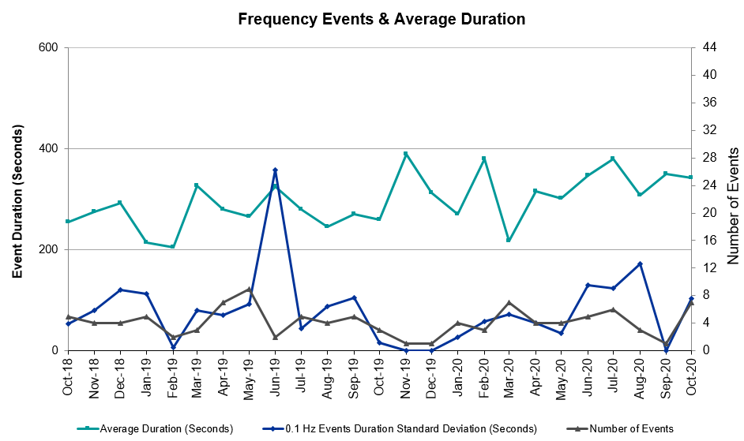

Note that the large standard deviation in June 2019 is due to coincidental extreme high and low durations for a small set of events (2).

Responsive Reserve Events
There were 6 events where Responsive Reserve MWs were released to SCED. The events highlighted in blue were related to frequency events reported in Section 2.1 above.

Date and Time Released to SCED | Date and Time Recalled | Duration of Event | Maximum MWs Released | Comments
10/10/2020 14:18:50 | 10/10/2020 14:25:26 | 00:06:36 | 975
10/10/2020 16:44:38 | 10/10/2020 16:50:02 | 00:05:24 | 1150
10/13/2020 17:13:50 | 10/13/2020 17:20:14 | 00:06:24 | 620
10/19/2020 14:30:56 | 10/19/2020 14:36:20 | 00:05:24 | 598
10/26/2020 13:23:30 | 10/26/2020 13:26:50 | 00:03:20 | 606
10/27/2020 8:41:42 | 10/27/2020 8:46:26 | 00:04:44 | 1151

Load Resource Events
None.

Reliability Unit Commitment
ERCOT reports on Reliability Unit Commitments (RUC) on a monthly basis. Commitments are reported grouped by operating day and weather zone. The total number of hours committed is the sum of the hours for all the units in the specified region. Additional information on RUC commitments can be found on the MIS secure site at Grid Generation Reliability Unit Commitment.

There were no DRUC commitments.

There was 1 HRUC commitment which was ONOPTOUT by QSE.

Resource Location | # of Resources | Operating Day | Total # of Hours Committed | Total MWhs | Reason for Commitment
North Central | 1 | 10/27/2020 | 4 | 2,060 | DTHSLCS5

Wind Generation as a Percent of Load
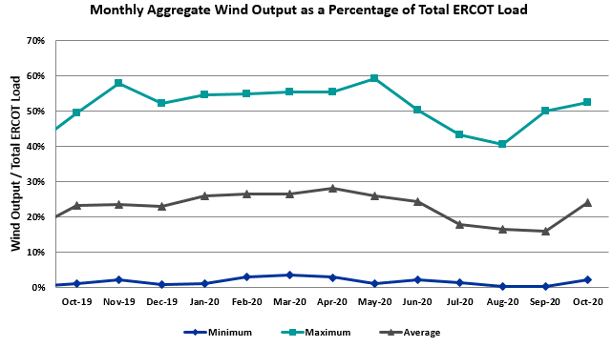

Wind Generation Record: 21,375 MW on 6/28/2020 at 23:22
Wind Penetration Record: 59.30% on 05/02/2020 at 02:10

Largest Net-Load Ramp
The net-load ramp is defined as the change in net-load (load minus wind and PVGR generation) during the defined time horizon. Such a variation in net-load needs to be accommodated in grid operations to ensure that the reliability of the grid is satisfactorily maintained. The largest net-load ramp during 5-min, 10-min, 15-min, 30-min and 60-min in October 2020 are 1048 MW, 1600 MW, 2488 MW, 3578 MW, and 6269 MW, respectively. The comparison with respect to the historical values is given in the table below.

Month and Year | 5 min | 10 min | 15 min | 30 min | 60 min
October 2020 | 1048 MW | 1600 MW | 2488 MW | 3578 MW | 6269 MW
October 2014 | 780 MW | 1796 MW | 2152 MW | 2780 MW | 4579 MW
October 2015 | 1141 MW | 1553 MW | 1839 MW | 2779 MW | 4606 MW
October 2016 | 863 MW | 1543 MW | 2035 MW | 3213 MW | 5335 MW
October 2017 | 812 MW | 1338 MW | 1820 MW | 3029 MW | 5347 MW
October 2018 | 860 MW | 1386 MW | 1907 MW | 2824 MW | 5346 MW
October 2019 | 1192 MW | 1728 MW | 2465 MW | 3537 MW | 6408 MW
All Months in 2014-2019 | 1494 MW | 1991 MW | 2780 MW | 4109 MW | 7786 MW

COP Error Analysis
COP Error is calculated as the capacity difference between the COP HSL and real-time HSL of the unit. Mean Absolute Error (MAE) stayed high over 10,000 MW until Day-Ahead at 12:00, then dropped significantly to 3,525 MW by Day-Ahead at 14:00. In the following chart, Under-Scheduling Error indicates that COP had less generation capacity than real-time and Over-Scheduling Error indicates that COP had more generation capacity than real-time. Under-Scheduling persisted from beginning of Day-Ahead to end of the Operating Day.
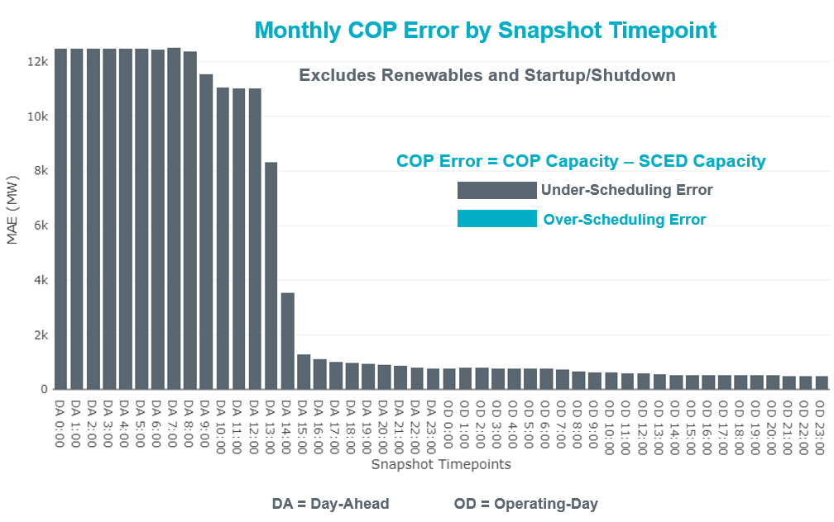
Monthly MAE for the Latest COP at the end of the Adjustment Period was 501 MW with median ranging from -860 MW for Hour-Ending (HE) 20 to 45 MW for HE 13. HE 14 on the 14th had the largest Over-Scheduling Error (1,334 MW) and HE 22 on the 26th had the largest Under-Scheduling Error (-3,683 MW).

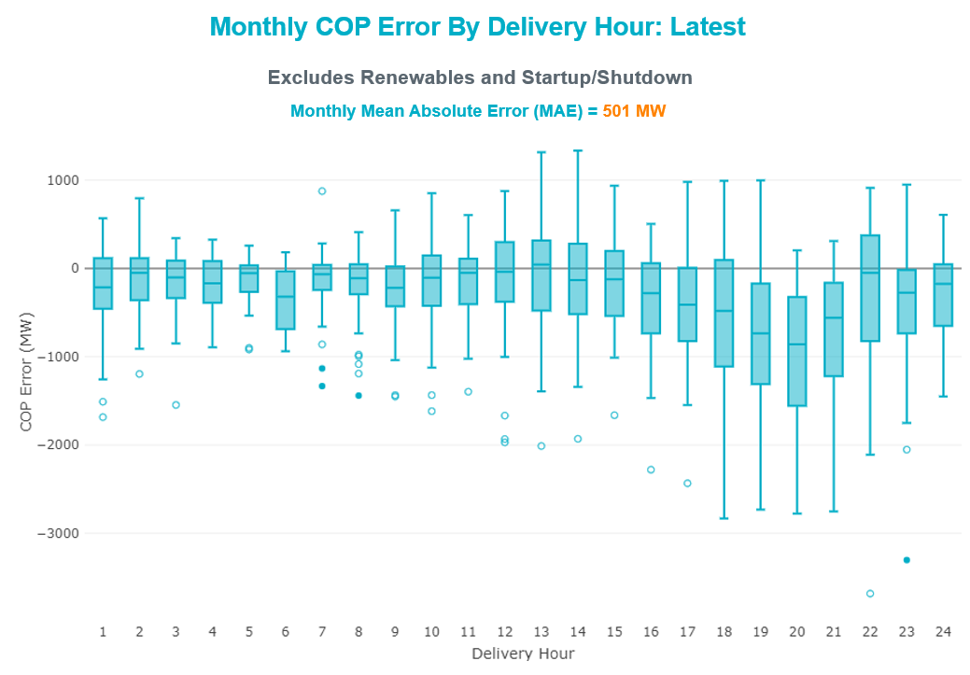

Monthly MAE for the Day-Ahead COP at 12:00 was 11,024 MW with median ranging from -15,003 MW for Hour-Ending (HE) 19 to -6,410 MW for HE 3. HE 20 on the 27th had the largest Under-Scheduling Error (-22,982 MW) and HE 8 on the 3rd had the largest Over-Scheduling Error (-801 MW).

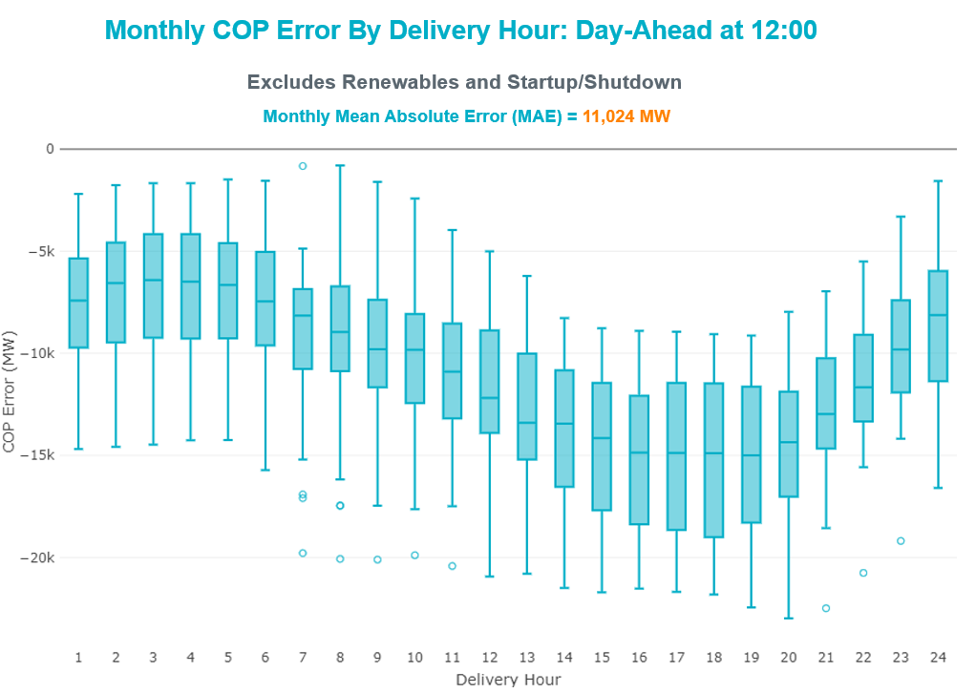

Congestion Analysis

Notable Constraints
Nodal protocol section 3.20 specifies that ERCOT shall identify transmission constraints that are active or binding three or more times within a calendar month. As part of this process, ERCOT reports congestion that meets this criterion to ROS. In addition ERCOT also highlights notable constraints that have an estimated congestion rent exceeding $1,000 for a calendar month. These constraints are detailed in the table below. Rows highlighted in blue indicate the congestion was affected by one or more outages. For a list of all constraints activated in SCED, please see Appendix A at the end of this report.

Contingency Name | Overloaded Element | # of Days Constraint Active | Congestion Rent | Transmission Project
Basecase | PNHNDL GTC | 25 | $18,097,708.02 | Panhandle GTC Exit Plan - "PANHANDLE RENEWABLE ENERGY ZONE (PREZ)  STUDY REPORT" on MIS, CONSTRUCT OGALLALA TO BLACKWATER DRAW 345 KV LINE (52245), CONSTRUCT BLACKWATER DRAW TO FOLSOM POINT345 KV LINE (52258), CONSTRUCT BLACKWATER DRAW TO DOUBLE MOUNTAIN (52299), CONSTRUCT DOUBLE MOUNTAIN TO FIDDLEWOOD TO FARMLAND 345 KV L (522307)
CRLNW TO LWSSW 345 DBLCKT | Ti Tnp - West Tnp 138kV | 17 | $15,634,685.44 | Lewisville - Lewisville Jones - Lakepointe 138 kV Line (45537)
WDGSW TO BNBSW 138 DBLCKT | Mistletoe Heights - Hemphill 138kV | 12 | $9,224,152.39 | Handley - Hemphill 138 kV Line (4270); Handley - Sherry 138 kV line (14TPIT0010); Cresson - Rocky Creek 138 kV Line (4834)
Basecase | NE_LOB GTC | 22 | $4,884,362.60 | GTC Exit plan in the North Edinburg - Lobo Stability Study Report posted in the ERCOT MIS website
Elmcreek-Sanmigl 345kV | Pawnee Switching Station - Calaveras 345kV | 7 | $4,385,647.34
Berghe-Haysen 345kv & Riveoa-Henne 138kv | Cranes Mill - Sattler 138kV | 2 | $3,954,009.68
ODEHV-MOSSW 345&ODEHV-WLFSW 345_DBLCKT | Odessa North - Odessa 138kV | 19 | $3,385,539.62 | Riverton-Odessa EHV/Moss 345 kV Line (5445)
ODEHV-MOSSW 345&ODEHV-WLFSW 345_DBLCKT | Big Three Odessa Tap - Odessa Ehv Switch 138kV | 14 | $3,325,152.63 | Riverton-Odessa EHV/Moss 345 kV Line (5445)
ODLAW SWITCHYARD to ASPHALT MINES LIN 1 | Hamilton Road - Maverick 138kV | 28 | $3,107,638.59 | Brackettville to Escondido: Construct 138 kV line (5206)
SHRSW TO VENSW 345 AND SHRSW TO EVRSW 345 DBLCKT | Fish Creek Switch - Cedar Hill Switch 138kV | 1 | $2,397,085.82 | Cedar Hill Switch - Liggett 138 kV line (14TPIT0057)
Austro-Daffin&Dunlap-Decker 138kV | Mcneil Aen - Howard Lane Aen 138kV | 13 | $2,111,646.08 | Reconductor 138kV ckt 972 Howard Lane to McNeil to 3000A (48327)
PORTLAND to Gibbs LIN 1 | Whitepoint - Rincon 138kV | 2 | $1,977,041.55 | Whitepoint Area Improvements (50950)
Berghe-Kendal 345kv & Welfar-Boerne 138kv | Mason Creek - Bandera 138kV | 8 | $1,882,138.28
Fowlerton to LOBO 345 LIN1 | Lobo - Freer 69kV | 8 | $1,673,319.37 | GTC Exit plan in the North Edinburg - Lobo Stability Study Report posted on the ERCOT MIS website
GAS PAD to FLAT TOP TNP LIN 1 | Lynx - Tombstone 138kV | 13 | $1,669,942.79 | Lynx: Expand 138 kV station (45503)
WA PARISH GEN WAP_G5 | Britmoore - Hayes 138kV | 4 | $1,658,685.87 | Hayes to WA Parish Ckt.09A Upgrades (52523A,52523B,52523C)
BIG SPRING SWITCH to CHALK_69kV and McDonald Road_138kV | Tall City - Sharyland Utilities - Telephone Road - Sharyland Utilities 138kV | 3 | $1,584,259.81 | Tall City - Telephone Road 138 kV Line Rebuild (57915)
THSES TO LCSES 345 AND THSES TO TMPRCR 345 DBLCKT | Lake Hall Switch - Lake Creek Ses 345kV | 2 | $1,574,139.74 | Lake Creek - Waco East 138 kV Line (45471); Waco West - Waco East 138 kV Line (45517)
ZORN - HAYSEN 345KV | Welfare - Kendall 138kV | 5 | $1,504,735.82
COMANCHE SWITCH (Oncor) to COMANCHE PEAK SES LIN _A | Comanche Tap - Comanche Switch (Oncor) 138kV | 18 | $1,430,189.88
ZORN - HAYSEN 345KV | Mason Creek - Bandera 138kV | 2 | $1,355,255.43
COMFORT to CYPRESS CREEK LIN 1 | Raymond F Barker - Comfort 138kV | 4 | $1,317,848.49
SAN MIGUEL GEN to FOWLERTON LIN 1 | San Miguel Gen 345kV | 11 | $1,289,822.42 | San Miguel 345/138 kV autotransformer replacements (5218A, 5218B)
NORTH ALVIN TNP to HASTINGS TNP LIN 1 | League City Tnp - Hidden Lakes Tnp 138kV | 1 | $1,239,541.43
Basecase | MCCAMY GTC | 19 | $1,232,412.76 | McCamey GTC Exit Plan posted on the ERCOT MIS website (Far West Transmission Project 2)
ASHERTON to Bevo Substation LIN 1 | Bevo - Brundage Sub 69kV | 5 | $1,220,818.21 | Rebuild BEVO to Brundage to Big Wells 69 kV lines. (6255B)
GAS PAD to FLAT TOP TNP LIN 1 | Lynx - Rio Pecos 138kV | 7 | $1,206,010.70 | Rebuild Rio Pecos-Lynx Ckt 2 (1926 ACSS) (54255)
GREENS BAYOU - KING 345KV | Greens Bayou 345kV | 8 | $1,058,153.79 | Greens Bayou 138kV Reconfigurations (43456A, 43456B, 43456C)
Fowlerton to LOBO 345 LIN1 | North Laredo Switch - Piloncillo 138kV | 11 | $978,680.55 | GTC Exit plan in the North Edinburg - Lobo Stability Study Report posted in the ERCOT MIS website
NORTH EDINBURG TRX 1382 345/138 | North Edinburg 138kV | 4 | $978,118.75 | Stewart Road: Construct 345 kV cut-in with two 450 MVA 345/138 autotransformers connected to Stewart Rd 138 station (5604, 6382)
TWR (345) HLJ-WAP64 & BLY-WAP72 | Dow Chemical - Jones Creek 345kV | 4 | $873,913.68 | Freeport - Master Plan (6668A)
SWESW TO MULBERRY AND SWESW TO LNCRK 345 DBLCKT | Bluff Creek - Abilene Mulberry Creek 345kV | 5 | $845,271.24 | Mulberry Creek: Rebuild 345 kV station (48816))
Melon Creek to RINCON LIN 1 | Heard Tap - Refugio 69kV | 7 | $843,760.00
MANUAL TWR(138) DL-WAP02 & HOC-WAP05 | Alief - Hayes 138kV | 7 | $776,710.26 | Hayes to WA Parish Ckt.09A Upgrades (52523A,52523B,52523C)
JEWET TO SNG 345 DBLCKT | Gibbons Creek - Twin Oak Switch 345kV | 5 | $727,714.41
Fowlerton to LOBO 345 LIN1 | Asherton - Catarina 138kV | 3 | $712,640.74 | Brackettville to Escondido: Construct 138 kV line (5206)
GREENS BAYOU - KING 345KV | Uvalde - Greens Bayou 138kV | 5 | $705,405.91 | Greens Bayou 138kV Reconfigurations (43456A, 43456B, 43456C)
Bighil-Kendal 345kV | Yellow Jacket - Treadwell 138kV | 9 | $660,587.63 | Treadwell GTC Exit Plan posted on the ERCOT MIS website
Pig Creek to Solstice LIN 1 | Fort Stockton Plant - Tombstone 138kV | 25 | $628,239.10 | Barrilla Junction to Ft. Stockton SW: Rebuild 69 kV line (7027)  Solstice: Install 138 kV PST and capacitor bank (44359)
Berghe-Kendal 345kv & Welfar 138kv | Mason Creek - Bandera 138kV | 8 | $621,215.98
HAMILTON ROAD to CORRAL LIN 1 | Maxwell - Whiting 138kV | 3 | $609,087.11 | Brackettville to Escondido: Construct 138 kV line (5206)
Bighil-Kendal 345kV | Yellow Jacket - Hext Lcra 69kV | 11 | $604,855.46 | Yellowjckt to Menard Phillips T 69 kV line: Rebld 69 kV line (6345)
BOSQUE SWITCH to ELM MOTT LIN 1 | Bosque Switch - Rogers Hill Bepc 138kV | 11 | $574,854.32 | Upgrade Elm Mott - Bosque 138 kV Line (52149)
FORT MASON to YELLOW JACKET LIN 1 | Mason Switching Station - Hext Lcra 69kV | 18 | $566,864.11 | Mason to North Brady: Rebuild 69 kV line (50900)
Bighil-Kendal 345kV | Mason Switching Station - Hext Lcra 69kV | 6 | $532,422.73 | Mason to North Brady: Rebuild 69 kV line (50900)
CHB-KG & CBY-JOR 345kV | Cedar Bayou - Cedar Bayou Plant 138kV | 6 | $449,567.62 | Cedar Bayou 138kV - West Bus In-Series 10-Ohm Reactor (52141)
CPSES TO JONSW 345 AND CPSES TO EVRSW 345 DBLCKT | Mitchell Bend Switch - Decordova Ses 345kV | 4 | $415,159.38 | Mitchell Bend - Rocky Creek 345 kV line (5312)
Berghe-Kendal 345kv & Boerne-Espera 138kv | Mason Creek - Bandera 138kV | 8 | $414,995.83
JACKSBORO SWITCHING to COBB SWITCHING STATION LIN _A | Garvey Road Switch - Graham Ses 345kV | 3 | $341,047.85
BRACKETTVILLE to HAMILTON ROAD LIN 1 | Hamilton Road - Maverick 138kV | 16 | $306,932.98 | Brackettville to Escondido: Construct 138 kV line (5206)
ODEHV-MOSSW 345&ODEHV-WLFSW 345_DBLCKT | Odessa Ehv Switch 345kV | 11 | $300,366.80 | Riverton-Odessa EHV/Moss 345 kV Line (5445)
ODEHV-WLFSW 345&ODEHV-WLFSW 138____TRPLCKT-2of3 | Odessa North - Odessa 138kV | 4 | $279,253.19 | Riverton-Odessa EHV/Moss 345 kV Line (5445)
Ferguson-Sherwood Shores & Ferguson-Granite Mountain 138kV | Johnson City - Wirtz 138kV | 26 | $244,108.01 | Wirtz to Johnson City to Mountain Top Rebuild to 138kV (6789)
PAREDES SWITCHING STATION to CENTRAL AVENUE SUB LIN 1 | Rio Hondo - East Rio Hondo Sub 138kV | 12 | $234,998.97 | Rebuild Rio Hondo to East Rio Hondo (6687)
JACKSBORO SWITCHING to COBB SWITCHING STATION LIN _A | North Star - Wichita Falls South Switch 138kV | 3 | $230,466.69
FIREROCK TO BRNWD 138 AND FIREROCK TO BANGS 69 DBLCKT | Cottonwood Road Switch - Olney Pod 69kV | 6 | $204,940.37
FORT MASON to YELLOW JACKET LIN 1 | Yellow Jacket - Hext Lcra 69kV | 23 | $196,674.77 | Yellowjckt to Menard Phillips T 69 kV line: Rebld 69 kV line (6345)
Bighil-Kendal 345kV | Hamilton Road - Maverick 138kV | 4 | $168,075.69 | Brackettville to Escondido: Construct 138 kV line (5206)
GRSES TO PKRSW 345 DBLCKT | Barton Chapel Wind Farm - Oran Sub 138kV | 10 | $164,240.37
Loss of (White Point & Nueces Bay 138kV) and (White Point & Portland & Gibbs 138kV) | Whitepoint - Rincon 138kV | 5 | $158,678.94 | Whitepoint Area Improvements (50950)
RILEY TO BOMSW 345 DBLCKT | Fisher Road Switch - Riley 345kV | 4 | $150,410.35
COLEMAN LAKE IVIE TAP to EAST COLEMAN TAP LIN 1 | Santa Anna Tap - Dressey 69kV | 4 | $148,647.81 | Conan: Build new 69 kV box bay (52072)
Melon Creek to RINCON LIN 1 | Bonnieview - Rincon 69kV | 9 | $147,700.94
SALSW TO KLNSW 345 DBLCKT | Harker Heights South - Killeen Switch 138kV | 4 | $143,222.22
Bighil-Kendal 345kV | San Angelo Power Station - Treadwell 138kV | 9 | $141,471.97
HAYS ENERGY to ZORN LIN 1 | Zorn - Hays Energy 345kV | 3 | $132,464.34
CPSES TO CMNSW 345 AND CPSES TO STNVL 138 DBLCKT | Santa Anna Tap - Dressey 69kV | 4 | $125,520.60 | Conan: Build new 69 kV box bay (52072)
SCURRY SWITCH to SALT CREEK BEPC LIN 1 | Hamlin Rea - Radium 69kV | 3 | $122,815.70 | Salt Creek to Cogdell (5834)
Pig Creek to Solstice LIN 1 | Lynx - Rio Pecos 138kV | 19 | $116,206.03 | Rebuild Rio Pecos-Lynx Ckt 2 (1926 ACSS) (54255)
LAQUINTA to LOBO LIN 1 | Bruni Sub 138kV | 4 | $106,687.58
Fowlerton to LOBO 345 LIN1 | Laredo Vft North - Las Cruces 138kV | 3 | $103,947.80 | Laredo - Del Mar: 138 kV Line Rebuild (45511)
FORT MASON to YELLOW JACKET LIN 1 | Yellow Jacket - Hext Lcra 69kV | 23 | $99,791.18 | Yellowjckt to Menard Phillips T 69 kV line: Rebld 69 kV line (6345)
Basecase | WESTEX GTC | 11 | $98,988.60
BRACKETTVILLE to ODLAW SWITCHYARD LIN 1 | Ganso - Maverick 138kV | 2 | $98,829.34 | Brackettville to Escondido: Construct 138 kV line (5206)
LNGSW TO MDSSW 345 AND MGSES TO QALSW 345 DBLCKT | Lamesa - Jim Payne Poi 138kV | 3 | $94,651.05
GREENS BAYOU - KING 345KV | Greens Bayou 138kV | 3 | $92,788.28 | Greens Bayou 138kV Reconfigurations (43456A, 43456B, 43456C)
BRACKETTVILLE to ODLAW SWITCHYARD LIN 1 | Hamilton Road - Maverick 138kV | 6 | $88,024.36 | Brackettville to Escondido: Construct 138 kV line (5206)
NORTH EDINBURG TRX NEDIN_3_1 345/138 | Burns Sub - Rio Hondo 138kV | 3 | $78,265.09 | Stewart Road: Construct 345 kV cut-in with two 450 MVA 345/138 autotransformers connected to Stewart Rd 138 station (5604, 6382)
RIO HONDO to LAS PULGAS LIN 1 | Raymondville 2 138kV | 7 | $73,298.73 | Harlingen SS - Raymondville #2: Convert to 138 kV (6167)
ODEHV-MOSSW 345&ODEHV-WLFSW 345_DBLCKT | Trigas Odessa Tap - Odessa Ehv Switch 138kV | 3 | $72,771.55 | Riverton-Odessa EHV/Moss 345 kV Line (5445)
Bighil-Kendal 345kV | Yellow Jacket - Fort Mason 138kV | 7 | $72,439.79
South Texas # 1 & # 2 | Blessing - Lolita 138kV | 3 | $72,361.14 | Tidehaven: Construct New Distribution Station (48776)
LNGSW TO MDSSW 345 AND MGSES TO QALSW 345 DBLCKT | Big Spring West - Stanton East 138kV | 6 | $71,153.66 | Big Spring - Buzzard Draw 69 kV Line Conversion (46259)
DL-WAP02 & KR-HOC26 | Alief - Hayes 138kV | 4 | $69,607.81 | Hayes to WA Parish Ckt.09A Upgrades (52523A,52523B,52523C)
BLUFF CREEK TRX BLUF_CRK_3_1 345/138 | Bluff Creek 345kV | 7 | $63,254.89
MOSSW TO HLTSW & MCNSW 345 | Andrews North - Exxon Means Tap 138kV | 3 | $58,468.75
ODEHV-WLFSW 345&ODEHV-WLFSW 138____TRPLCKT-2of3 | Big Three Odessa Tap - Odessa Ehv Switch 138kV | 4 | $52,977.33 | Riverton-Odessa EHV/Moss 345 kV Line (5445)
CALF CREEK POI to NATURAL DAM LIN _A | Big Spring West - Stanton East 138kV | 3 | $49,647.43 | Big Spring - Buzzard Draw 69 kV Line Conversion (46259)
FORT MASON to YELLOW JACKET LIN 1 | Mason Switching Station - Hext Lcra 69kV | 18 | $40,290.81 | Mason to North Brady: Rebuild 69 kV line (50900)
Basecase | RV_RH GTC | 3 | $37,110.24 | GTC Exit plan in the Raymondville-RioHondo GTC Study Report posted in the ERCOT MIS website
COLEMAN LAKE IVIE TAP to EAST COLEMAN TAP LIN 1 | Ballinger - Ballinger Humble Tap 69kV | 4 | $32,650.17 | Ballinger to Concho: Rebuild 69 kV line (55421); Ballinger to Eden 69 kV line: Rebuild taps (6572)
CISCO to PUTNAM 138kv LIN 1 | Abilene South - Vinson 138kV | 3 | $29,343.49
COLETO CREEK to VICTORIA LIN 1 | Coleto Creek - Victoria 138kV | 4 | $19,412.92 | Coleto Creek - Rosata: Line Rebuild (50870)
Fergus-Granmo&Wirtz-Starck 138kV | Johnson City - Wirtz 138kV | 8 | $19,385.98 | Wirtz to Johnson City to Mountain Top Rebuild to 138kV (6789)
GUNSIGHT SWITCH to GETTY VEALMOOR TAP LIN _A | Chevron Ackerly Tap - Buzzard Draw Switch 69kV | 5 | $17,999.84 | Big Spring - Buzzard Draw 69 kV Line Conversion (46259)
CISCO to PUTNAM 138kv LIN 1 | Estes - Pecan Bayou 138kV | 5 | $14,938.98
ODEHV-MOSSW 345&ODEHV-WLFSW 345_DBLCKT | Lynx - Tombstone 138kV | 3 | $10,599.14 | Lynx: Expand 138 kV station (45503)
MERCERS GAP SW to COMANCHE SWITCH (Oncor) LIN _A | Camp Bowie (Oncor) - Brownwood South 138kV | 4 | $9,974.15
FORT LANCASTER to ILLINOIS #4 LIN 1 | Hamilton Road - Maxwell 138kV | 5 | $9,842.47 | Hamilton Road to Picacho ckt #2, rebuild 138 kV line (6373)
TWR(138) HOC-WAP 02 & WAP-WZ 05 | Alief - Hayes 138kV | 3 | $7,226.31 | Hayes to WA Parish Ckt.09A Upgrades (52523A,52523B,52523C)
KLEBERG AEP to LOYOLA SUB LIN 1 | Loyola Sub 138kV | 3 | $5,139.02
ODLAW SWITCHYARD to ASPHALT MINES LIN 1 | Escondido - Ganso 138kV | 5 | $4,406.93 | Brackettville to Escondido: Construct 138 kV line (5206)
Arrowhead Tap to Lotebush LIN 1 | Lynx - Rio Pecos 138kV | 19 | $1,518.64 | Rebuild Rio Pecos-Lynx Ckt 2 (1926 ACSS) (54255)

Generic Transmission Constraint Congestion
There were 25 days of congestion on the Panhandle GTC, 22 days on the North Edinburg to Lobo GTC, 19 days on the McCamey GTC, 11 days on the West to Central Texas GTC, and 3 days on the Raymondville to RioHondo GTC. There was no activity on the remaining GTCs during the month.

Note: This is how many times a constraint has been activated to avoid exceeding a GTC limit, it does not imply an exceedance of the GTC occurred or that the GTC was binding.

Manual Overrides
None.

Congestion Costs for Calendar Year 2020
The following table represents the top twenty active constraints for the calendar year based on the estimated congestion rent attributed to the congestion. ERCOT updates this list on a monthly basis.

Contingency | Overloaded Element | # of 5-min SCED | Estimated | Transmission Project
MOSS SWITCH to ECTOR COUNTY NORTH SWITCHING STATION LIN _A | #N/A | 12277 | 115237549.4
Basecase | PNHNDL GTC | 28447 | 84124731.65 | Panhandle GTC Exit Plan - "PANHANDLE RENEWABLE ENERGY ZONE (PREZ)  STUDY REPORT" on MIS, CONSTRUCT OGALLALA TO BLACKWATER DRAW 345 KV LINE (52245), CONSTRUCT BLACKWATER DRAW TO FOLSOM POINT345 KV LINE (52258), CONSTRUCT BLACKWATER DRAW TO DOUBLE MOUNTAIN (52299), CONSTRUCT DOUBLE MOUNTAIN TO FIDDLEWOOD TO FARMLAND 345 KV L (522307)
WINK to DUNE SWITCH and YUKON | #N/A | 10924 | 76533287.97 | 0
MANUAL Nedin-Mv_Wedn4 Dbl Ckt 138kV | Hidalgo Energy Center - Azteca Sub 138kV | 1656 | 62254257.21 | Stewart Road: Construct 345 kV cut-in with two 450 MVA 345/138 autotransformers connected to Stewart Rd 138 station (5604, 6382)
Manual MDSSW_TRX1_345/138 | Trigas Odessa Tap - Odessa Ehv Switch 138kV | 1787 | 38328997.67 | Riverton-Odessa EHV/Moss 345 kV Line (5445)
WEST EDNBURG SUB to ALTON SUB LIN 1 | Weslaco Switch - North Alamo 138kV | 681 | 33768437.92 | Stewart Road: Construct 345 kV cut-in with two 450 MVA 345/138 autotransformers connected to Stewart Rd 138 station (5604, 6382)
NORTH EDINBURG TRX 1382 345/138 | North Edinburg 345kV | 1714 | 31194087.83 | Stewart Road: Construct 345 kV cut-in with two 450 MVA 345/138 autotransformers connected to Stewart Rd 138 station (5604, 6382)
CRLNW TO LWSSW 345 DBLCKT | Ti Tnp - West Tnp 138kV | 9152 | 29834527.08 | Lewisville - Lewisville Jones - Lakepointe 138 kV Line (45537)
NORTH PHARR to WESLACO SWITCH LIN 1 | Key Switch - North Mcallen 138kV | 526 | 27451240.28 | Stewart Road: Construct 345 kV cut-in with two 450 MVA 345/138 autotransformers connected to Stewart Rd 138 station (5604, 6382)
HCKSW TO SAGNA 138 DBLCKT | Eagle Mountain Ses - Morris Dido 138kV | 5716 | 26725680.9 | Upgrade the Saginaw - Eagle Mountain 138 kV Double Circuit Line (6273)
WINK to DUNE SWITCH and YUKON | #N/A | 2002 | 23188211.21
WEST EDNBURG SUB to NORTH EDINBURG LIN 1 | North Edinburg - West Ednburg Sub 138kV | 529 | 22020286.78 | Stewart Road: Construct 345 kV cut-in with two 450 MVA 345/138 autotransformers connected to Stewart Rd 138 station (5604, 6382)
MOSS SWITCH to ECTOR COUNTY NORTH SWITCHING STATION LIN _A | #N/A | 1316 | 21247827.71
JEWET TO SNG 345 DBLCKT | Jack_Creek - Twin Oak Switch 345kV | 1193 | 17477432.7
TWR (345) HLJ-WAP64 & BLY-WAP72 | South Texas Project - Wa Parish 345kV | 4967 |  | Freeport - Master Plan (6668B)
ODLAW SWITCHYARD to ASPHALT MINES LIN 1 | Hamilton Road - Maverick 138kV | 19241 | 14399200.46 | Brackettville to Escondido: Construct 138 kV line (5206)
Basecase | NE_LOB GTC | 15062 | 13906600.28 | GTC Exit plan in the North Edinburg - Lobo Stability Study Report posted in the ERCOT MIS website
POMELO to NORTH EDINBURG LIN 1 | Lobo - Freer 69kV | 7377 | 10626337.75 | GTC Exit plan in the North Edinburg - Lobo Stability Study Report posted in the ERCOT MIS website
CRLNW TO LWSSW 345 DBLCKT | Argyle - Highlands Tnp 138kV | 3922 | 10613392.34 | Lewisville - Lewisville Jones - Lakepointe 138 kV Line (45537)
Loss of NEDIN train | North Edinburg 345kV | 90 | 9831038.841 | Stewart Road: Construct 345 kV cut-in with two 450 MVA 345/138 autotransformers connected to Stewart Rd 138 station (5604, 6382)

System Events

ERCOT Peak Load
The unofficial ERCOT peak load for the month was 63,060 MW and occurred on the 11th, during hour ending 17:00.

Load Shed Events
On Monday, October 19th at ~17:00, ONCOR reported ~45 MW load tripped when the ONCOR 138 Riverton Switch-Culberson Switch-Horseshoe Springs and Sand Lake Switch operated. ONCOR also reported the CULB RAS operated as designed.

Stability Events
None.

Notable PMU Events
ERCOT analyzes PMU data for any significant system disturbances that do not fall into the Frequency Events category reported in section 2.1. The results are summarized in this section once the analysis has been completed.

There were no PMU events outside of those reported in section 2.1.

DC Tie Curtailment
None

TRE/DOE Reportable Events
- AEP submitted an OE-417 for 10/14/2020. Reportable Event Type: Transmission loss.
- CenterPoint submitted an OE-417 for 10/23/2020. Reportable Event Type: Loss of electric service to more than 50,000 customers for 1 hour or more.
- ERCOT ISO submitted an OE-417 for 10/28/2020. Reportable Event Type: Electrical; System Separation (Islanding) due to multiple Forced Outages in the Panhandle area due to severe icing.

New/Updated Constraint Management Plans
Modifications were made to MP_2019_06.

New/Modified/Removed RAS
The Culberson Loop RAS was revised.

New Procedures/Forms/Operating Bulletins
Procedure Title | POB
DC Tie Desk | 957
Reliability Unit Commitment Desk | 958
Shift Supervisor Desk | 959
Transmission and Security Desk | 960

Emergency Conditions

OCNs

Date and Time | Message
October 7 2020 15:00 CPT | ERCOT issued an OCN for possible landfall of Hurricane Delta in the ERCOT region on October 9 2020.
October 23 2020 20:45 CPT | ERCOT issued an OCN for modifying the WESTEX Generic Transmission Constraint due to transmission outage topology.
October 28  2020 05:00 CPT | ERCOT issued an OCN due to multiple forced outages caused by freezing precipitation in the South and West of Lubbock area, Panhandle and including the Childress area.
October 31 2020 00:45 CPT | ERCOT issued an OCN for modifying PNHNDL Generic Transmission Constraint due to transmission outage topology.

Advisories

Date and Time | Message
October 1 2020 13:30 CPT | ERCOT has postponed the posting of the DAM Solution for Operating Day October 2, 2020 due to delay in clearing DAM.
October 5 2020 13:30 CPT | ERCOT has postponed the posting of the DAM Solution for Operating Day October 6, 2020 due to delay in clearing DAM.
October 19 2020 13:30 CPT | ERCOT has postponed the posting of the DAM Solution for Operating Day October 20, 2020 due to delay in clearing DAM.
October 20 2020 13:30 CPT | ERCOT has postponed the posting of the DAM Solution for Operating Day October 21, 2020 due to delay in clearing DAM.
October 21 2020 13:30 CPT | ERCOT has postponed the posting of the DAM Solution for Operating Day October 22, 2020 due to delay in clearing DAM.
October 25 2020 13:30 CPT | ERCOT has postponed the posting of the DAM Solution for Operating Day October 26, 2020 due delay in clearing DAM.

Watches
None.

Emergency Notices
Date and Time | Message
October 28 2020 11:30 CPT | ERCOT issued an Emergency Notice for the freezing precipitation event which caused multiple forced Transmission outages in the Panhandle region.

Application Performance

TSAT/VSAT Performance Issues
None.

Communication Issues
None.

Market System Issues
None.

Model Updates
The Downstream Production Change (DPC) process allows ERCOT to make changes in the on-line Network Operations Model without loading a completely new model. The purpose of this process is to allow for reliable grid operations as system conditions change between designated Network Operations Model database loads. The DPC process is limited in scope to just those items listed below, with equipment ratings updates being the most common. ERCOT has seen a rise in the use of the DPC process to make on-line updates to the Network Operations Model in recent years, instead of through the standard Network Operations Model Change Request process.

- Static Line ratings (Interim Update)
- Dynamic Line ratings (non-Interim Update)
- Autotransformer ratings (non-Interim Update)
- Breaker and Switch Normal status (Interim Update)
- Contingency Definitions (Interim Update)
- RAP and RAS changes or additions (Interim Update)
- Net Dependable and Reactive Capability (NDCRC) values (Interim Update)
- Impedance Updates (non-Interim)

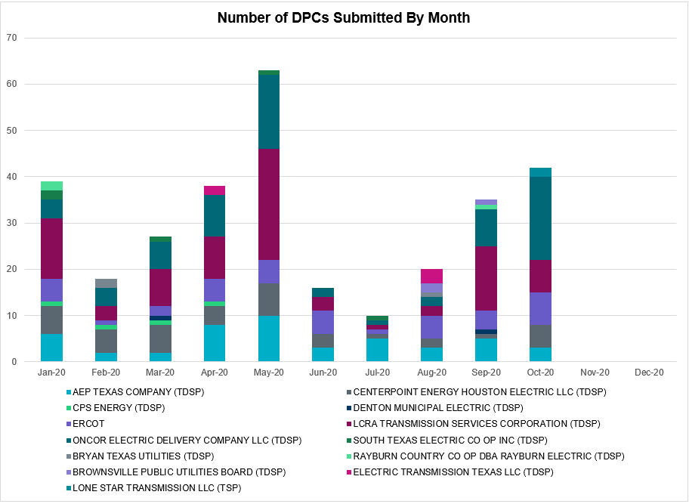

Transmission Operator | Number of DPCs
AEP TEXAS COMPANY (TDSP) | 3
BRAZOS ELECTRIC POWER CO OP INC (TDSP) | 0
BROWNSVILLE PUBLIC UTILITIES BOARD (TDSP) | 0
BRYAN TEXAS UTILITIES (TDSP) | 0
CENTERPOINT ENERGY HOUSTON ELECTRIC LLC (TDSP) | 5
CITY OF AUSTIN DBA AUSTIN ENERGY (TDSP) | 0
CITY OF COLLEGE STATION (TDSP) | 0
CITY OF GARLAND (TDSP) | 0
CPS ENERGY (TDSP) | 0
DENTON MUNICIPAL ELECTRIC (TDSP) | 0
ELECTRIC TRANSMISSION TEXAS LLC (TDSP) | 0
ERCOT | 7
LCRA TRANSMISSION SERVICES CORPORATION (TDSP) | 7
LONE STAR TRANSMISSION LLC (TSP) | 2
ONCOR ELECTRIC DELIVERY COMPANY LLC (TDSP) | 18
RAYBURN COUNTRY CO OP DBA RAYBURN ELECTRIC (TDSP) | 0
SHARYLAND UTILITIES LP (TDSP) | 0
SOUTH TEXAS ELECTRIC CO OP INC (TDSP) | 0
TEXAS MUNICIPAL POWER AGENCY (TDSP) | 0
TEXAS-NEW MEXICO POWER CO (TDSP) | 2

Appendix A: Real-Time Constraints
The following is a complete list of constraints activated in SCED. Full contingency descriptions can be found in the Standard Contingencies List located on the MIS secure site at Grid Generation Reliability Unit Commitment.

Contingency Name | Overloaded Element | From Station | To Station | Count of Days
SBRAUVA8 | HAMILT_MAVERI1_1 | HAMILTON | MAVERICK | 28
DFERGRM8 | 318T313_1 | WIRTZ | JOHNCI | 26
DFERGRM8 | 318T313_1 | JOHNCI | WIRTZ | 26
SPIGSOL8 | FTST_TOMBST1_1 | FTST | TOMBSTNE | 25
BASE CASE | PNHNDL | n/a | n/a | 25
SARRLOT8 | FTST_TOMBST1_1 | FTST | TOMBSTNE | 24
SFORYEL8 | HEXT_YELWJC1_1 | YELWJCKT | HEXT | 23
SFORYEL8 | HEXT_YELWJC1_1 | HEXT | YELWJCKT | 23
BASE CASE | NE_LOB | n/a | n/a | 22
BASE CASE | MCCAMY | n/a | n/a | 19
SARRLOT8 | LYNX_RIOPEC1_1 | LYNX | RIOPECOS | 19
SPIGSOL8 | LYNX_RIOPEC1_1 | LYNX | RIOPECOS | 19
DODEMOS5 | 6475__F | ODESA | ODNTH | 19
SFORYEL8 | HEXT_MASONS1_1 | HEXT | MASONSW | 18
SFORYEL8 | HEXT_MASONS1_1 | MASONSW | HEXT | 18
SCMNCPS5 | 651__B | CMNSW | CMNTP | 18
DCRLLSW5 | 588_A_1 | LWSVW | LWVTI | 17
SBRAHAM8 | HAMILT_MAVERI1_1 | HAMILTON | MAVERICK | 16
DODEMOS5 | 6500__B | ODEHV | BTHOT | 14
DAUSDUN8 | CKT_972_1 | HWRDLN | MCNEIL | 13
SHACPB38 | LYNX_TOMBST1_1 | LYNX | TOMBSTNE | 13
DWDGBNB8 | 6125__C | MSTLT | HMPHL | 12
SMV_PAR8 | RIOHND_ERIOHND_1 | MV_RIOHO | RIOHONDO | 12
SSANFOW5 | SANMIGL_ATAH | SANMIGL | SANMIGL | 11
SBOSELM5 | 1030__B | BOSQUESW | RGH | 11
DODEMOS5 | ODEHV_MR2H | ODEHV | ODEHV | 11
SLOBSA25 | NLARSW_PILONC1_1 | NLARSW | PILONCIL | 11
BASE CASE | WESTEX | n/a | n/a | 11
DBIGKEN5 | HEXT_YELWJC1_1 | YELWJCKT | HEXT | 11
DGRSPKR5 | 6377__A | BRTSW | ORANS | 10
SMELRIN8 | BONIVI_RINCON1_1 | RINCON | BONIVIEW | 9
DBIGKEN5 | TREADW_YELWJC1_1 | TREADWEL | YELWJCKT | 9
DBIGKEN5 | SAPOWE_TREADW1_1 | SAPOWER | TREADWEL | 9
DFERSTA8 | 318T313_1 | WIRTZ | JOHNCI | 8
SLOBSA25 | FREER_LOBO1_1 | LOBO | FREER | 8
DBERBO58 | 583T583_1 | BANDER | MASOCR | 8
SMELRIN8 | HEARDT_REFUGI1_1 | HEARDTAP | REFUGIO | 8
DBERES58 | 583T583_1 | BANDER | MASOCR | 8
SMELRIN8 | HEARDT_REFUGI1_1 | REFUGIO | HEARDTAP | 8
DBERWE58 | 583T583_1 | BANDER | MASOCR | 8
DGBY_KG5 | GBY_AT2 | GBY | GBY | 8
SRAYRI28 | RAYMND2_69A1 | RAYMND2 | RAYMND2 | 7
DELMSAN5 | PAWNEE_SPRUCE_1 | PAWNEE | CALAVERS | 7
SHACPB38 | LYNX_RIOPEC1_1 | RIOPECOS | LYNX | 7
DELMSAN5 | PAWNEE_SPRUCE_1 | CALAVERS | PAWNEE | 7
DBIGKEN5 | FORTMA_YELWJC1_1 | YELWJCKT | FORTMA | 7
XBL2U58 | BLUF_CRK_T1_H | BLUF_CRK | BLUF_CRK | 7
SPIGSOL8 | LYNX_TOMBST1_1 | TOMBSTNE | LYNX | 7
MDL_HOC8 | AF_HY_09_A | AF | HY | 7
DCHBJOR5 | CBYCD_84_A | CBY | CD | 6
DMGSQAL5 | 6144__A | BSPRW | STASW | 6
DODEMOS5 | 6500__D | ODESW | MOSSW | 6
SODLBRA8 | HAMILT_MAVERI1_1 | HAMILTON | MAVERICK | 6
DBIGKEN5 | HEXT_MASONS1_1 | HEXT | MASONSW | 6
DGRMGRS8 | 6830__B | CRDSW | OLNEY | 6
SARRLOT8 | LYNX_TOMBST1_1 | TOMBSTNE | LYNX | 6
DJEWSNG5 | 256_A_1 | TOKSW | GIBCRK | 5
DSWELNC5 | BLUF_C_MULBER1_1 | BLUF_CRK | MULBERRY | 5
SILLFTL8 | HAMILT_MAXWEL1_1 | MAXWELL | HAMILTON | 5
SSPUMW18 | CONA_SHHA1_1 | SHHA | CONA | 5
DGBY_KG5 | GBYUV_03_A | GBY | UV | 5
BASE CASE | N_TO_H | n/a | n/a | 5
SCISPUT8 | ESTES_PECAN_1_1 | PECAN_BY | ESTES | 5
BASE CASE | BEARKT | n/a | n/a | 5
DWHIGIB8 | RINCON_WHITE_2_1 | WHITE_PT | RINCON | 5
DZORHAY5 | 584T584_1 | KENDAL | WELFAR | 5
SBEVASH8 | BEVO_BRUNDAGE_1 | BRUNDGS | BEVO | 5
SBRAUVA8 | ESCOND_GANSO1_1 | GANSO | ESCONDID | 5
SAVMBSP8 | 6610__A | BUZSW | CHATP | 5
DBEFAI58 | 392T392_1 | MASOCR | PIPECR | 4
DCPSST58 | DRSY_SANA_T1_1 | SANA_TAP | DRSY | 4
DODEWL58 | 6475__F | ODESA | ODNTH | 4
SLAQLOB8 | BRUNI_69_1 | BRUNI | BRUNI | 4
DWAPHLJ5 | DOWJCK27_A | JCK | DOW | 4
DBERBE58 | 583T583_1 | BANDER | MASOCR | 4
DCPSST58 | 651__B | CMNSW | CMNTP | 4
DDL_KR_8 | AF_HY_09_A | AF | HY | 4
SVICCO28 | COLETO_VICTOR2_1 | COLETO | VICTORIA | 4
DBIGKEN5 | HAMILT_MAVERI1_1 | HAMILTON | MAVERICK | 4
SCOLBAL8 | DRSY_SANA_T1_1 | SANA_TAP | DRSY | 4
DRILBOW5 | 6011__B | RILEY | FSHSW | 4
SZEPCMN8 | 670__C | CMPBW | BRNSO | 4
UWAPWAP1 | BM_HY_09_A | BM | HY | 4
DSALKLN5 | 630__B | KLNSW | HHSTH | 4
DODEWL58 | 6500__B | ODEHV | BTHOT | 4
SCOLBAL8 | BALLIN_HUMBLT1_1 | BALLINGE | HUMBLTAP | 4
XNED258 | NEDIN_138L | NEDIN | NEDIN | 4
SCOMCYP8 | 122T122_1 | COMFOR | RAYBAR | 4
DMARPA_8 | 318T313_1 | WIRTZ | JOHNCI | 4
DCPSJON5 | 6017__A | MBDSW | DCSES | 4
DODEMOS5 | LYNX_TOMBST1_1 | LYNX | TOMBSTNE | 3
SKLELOY8 | LOYOLA_69_1 | LOYOLA | LOYOLA | 3
BASE CASE | RV_RH | n/a | n/a | 3
SCISPUT8 | SOUTHA_VINSON1_1 | SOUTHABI | VINSON | 3
DMGSQAL5 | 6095__D | LMESA | JPPOI | 3
DCPSST58 | 651__C | CMNTP | SHILO | 3
DHOC_WZ8 | AF_HY_09_A | AF | HY | 3
DGBY_KG5 | GBY_AT2L | GBY | GBY | 3
SCOMHA38 | MAXWEL_WHITIN1_1 | MAXWELL | WHITING | 3
SSTABS18 | 6144__A | BSPRW | STASW | 3
SLOBSA25 | ASHERT_CATARI1_1 | ASHERTON | CATARINA | 3
XNED358 | BURNS_RIOHONDO_1 | RIOHONDO | MV_BURNS | 3
SODLBRA8 | GANSO_MAVERI1_1 | GANSO | MAVERICK | 3
SODLBRA8 | GANSO_MAVERI1_1 | MAVERICK | GANSO | 3
SSPUMW18 | HAMR_RADIUM1_1 | RADIUM | HAMR | 3
DFLCMGS5 | TALLCITY_TELPR_1 | TELPH_RD | TALLCITY | 3
DODEMOS5 | 6475__C | ODEHV | TROTP | 3
SHAYZO25 | 6T227_1 | HAYSEN | ZORN | 3
SBOMJC25 | 35020__B | GRVSW | GRSES | 3
SBOMJC25 | 6085__E | WFSSW | NSTAR | 3
DMCNMOS5 | 6094__D | ANDNR | EXMTP | 3
SSCLWF18 | 6840__B | NVKSW | ANARN | 3
DSTEXP12 | BLESSI_LOLITA1_1 | LOLITA | BLESSING | 3
SLOBSA25 | LARDVN_LASCRU1_1 | LARDVNTH | LASCRUCE | 3
DCPSJON5 | 6125__C | MSTLT | HMPHL | 3
SBRAHAM8 | ESCOND_GANSO1_1 | GANSO | ESCONDID | 3
SBRAHAM8 | ESCOND_GANSO1_1 | ESCONDID | GANSO | 3
DODEMOS5 | 6144__A | BSPRW | STASW | 2
DMTSCOS5 | 6240__C | SACRC | DPCRK | 2
DZORHAY5 | BERGHE_AT1H | BERGHE | BERGHE | 2
SPIGTAY8 | LYNX_RIOPEC1_1 | LYNX | RIOPECOS | 2
DMGSMDS5 | MDSSW_MR1H | MDSSW | MDSSW | 2
SPORGIB8 | RINCON_WHITE_2_1 | WHITE_PT | RINCON | 2
XMDL58 | TALLCITY_TELPR_1 | TELPH_RD | TALLCITY | 2
DBERBO58 | 122T122_1 | COMFOR | RAYBAR | 2
DBERRI58 | 254T331_1 | SATTLE | CRANMI | 2
DTHSLCS5 | 282__A | LCSES | LHLSW | 2
DBUZLME8 | 6610__A | BUZSW | CHATP | 2
SCENLOB5 | BRUNI_69_1 | BRUNI | BRUNI | 2
MHARNED5 | BURNS_RIOHONDO_1 | RIOHONDO | MV_BURNS | 2
MHARRIO5 | BURNS_RIOHONDO_1 | RIOHONDO | MV_BURNS | 2
SBRAHAM8 | GANSO_MAVERI1_1 | MAVERICK | GANSO | 2
DWH_STP5 | NCARBI_SEADRF1_1 | NCARBIDE | SEADRFTC | 2
DTWIDIV5 | NICOLE_TENNYS1_1 | NICOLE | TENNYSON | 2
DLWSRNK5 | 570__A | CRNTH | ARGYL | 2
DSALKLN5 | 610__A | BLTON | TMSTH | 2
SCMNCPS5 | 651__C | CMNTP | SHILO | 2
SRICGRS8 | 6840__B | NVKSW | ANARN | 2
SCREBRU8 | BRUNI_69_1 | BRUNI | BRUNI | 2
DBIGKEN5 | HAMILT_MAXWEL1_1 | MAXWELL | HAMILTON | 2
SLOLFOR8 | RUPLET_V_DUPS2_1 | RUPLETP | V_DUPSW | 2
SGODLON5 | VICTO_WARBU_1A_1 | VICTORIA | WARBURTN | 2
DBERHE58 | 254T331_1 | SATTLE | CRANMI | 2
DEVRCRT5 | 6125__C | MSTLT | HMPHL | 2
DSHREVR5 | 6125__C | MSTLT | HMPHL | 2
DSCOFAR5 | 6216__B | WLVSW | SHRNE | 2
SHENPAI8 | CONA_SHHA1_1 | SHHA | CONA | 2
SPIGTAY8 | FTST_TOMBST1_1 | FTST | TOMBSTNE | 2
DBERBO58 | H3_K0_1 | K0 | H3 | 2
SCOLPAW5 | LOOP_VICTORIA_1 | VICTORIA | L_463S | 2
SLOLFOR8 | RUPLET_VICTOR2_1 | VICTORIA | RUPLETP | 2
XKEN458 | 583T583_1 | BANDER | MASOCR | 2
SZORMAR5 | 6T227_1 | HAYSEN | ZORN | 2
SN_SLON5 | CELANE_KLEBER1_1 | CELANEBI | KLEBERG | 2
SCENLOB5 | GODDAR_PAWNEE1_1 | GODDARD | PAWNEE | 2
DGBY_KG5 | LY_PSA03_A | LY | PSA | 2
DELMSAN5 | MAGRUD_VICTOR2_1 | VICTORIA | MAGRUDER | 2
DTHSLCS5 | 281__A | LHLSW | THSES | 2
DBERBO58 | 392T392_1 | MASOCR | PIPECR | 2
SBIGTWI5 | MAXWEL_WHITIN1_1 | MAXWELL | WHITING | 2
DNAVLEG5 | 50__A | BBSES | JEWET | 2
SGRMGRS8 | 6830__B | CRDSW | OLNEY | 2
DWAPCRB8 | AF_HY_09_A | AF | HY | 2
SGODPAW5 | BONIVI_RINCON1_1 | RINCON | BONIVIEW | 2
SFTLMES8 | CROSSO_NORTMC1_1 | NORTMC | CROSSOVE | 2
SKINODE5 | FTST_SOLSTI1_1 | FTST | SOLSTICE | 2
DBERWE58 | H3_K0_1 | K0 | H3 | 2
DELMMAR5 | HILL_MAR_2_1 | MARION | HILLCTRY | 2
DJCKDOW5 | JCKVL_02_A | JCK | VL | 2
DBIGKEN5 | MAXWEL_WHITIN1_1 | MAXWELL | WHITING | 2
DMGSQAL5 | 14040__A | PCTSW | DEWTP | 2
DBERWE58 | 392T392_1 | MASOCR | PIPECR | 2
DZORHAY5 | 583T583_1 | BANDER | MASOCR | 2
DHCKRNK5 | 6125__C | MSTLT | HMPHL | 2
DBUZLME8 | 6610__A | CHATP | BUZSW | 2
SFLCMDL5 | TALLCITY_TELPR_1 | TELPH_RD | TALLCITY | 2
DMGSQAL5 | CONCHO_SAMATH1_1 | CONCHO | SAMATHIS | 1
STGFLC8 | EL_CAM_LANCTY1_1 | LANCTYPM | EL_CAMPO | 1
DRILBOW5 | GRAYBC_VERN1_1 | VERN | GRAYBCKT | 1
SCOMHA38 | HAMILT_MAXWEL1_1 | MAXWELL | HAMILTON | 1
SHOLWES8 | HOLLY4_SOUTH_1_1 | HOLLY4 | SOUTH_SI | 1
DGBY_KG5 | JFSSC_06_A | JFS | SC | 1
XNED258 | NEDIN_138H | NEDIN | NEDIN | 1
SCRNLC38 | PRONGHRN_SMIDL_1 | SMIDLAND | PRONGHRN | 1
SARMRA38 | RAYMND2_69A1 | RAYMND2 | RAYMND2 | 1
DVICEDN8 | RUPLET_V_DUPS2_1 | RUPLETP | V_DUPSW | 1
SSARTWI5 | SAPOWE_SAST1_1 | SAPOWER | SAST | 1
SBIGTWI5 | SAPOWE_TREADW1_1 | TREADWEL | SAPOWER | 1
SMYRSPR8 | SJO_SJO2 | SJO | SJO | 1
DLWSRNK5 | 587__A | ARGYL | LWSVH | 1
DMTSCOS5 | 6437__A | BCKSW | KNAPP | 1
DMTSCOS5 | 6437__F | SCRCV | KNAPP | 1
SSCLWF28 | 6840__A | ANARN | CRDSW | 1
SABNABN8 | ANSN_RADIUM1_1 | RADIUM | ANSN | 1
SCOMHA38 | CARVER_TINSLE1_1 | CARVER | TINSLEY | 1
SILLFTL8 | CARVER_TINSLE1_1 | CARVER | TINSLEY | 1
SSANFOW5 | CATARI_PILONC1_1 | PILONCIL | CATARINA | 1
SPOMNED5 | FREER_LOBO1_1 | LOBO | FREER | 1
SLCDYN8 | GEBWA_65_A | WA | GEB | 1
SSKYSB28 | PRONGHRN_SMIDL_1 | SMIDLAND | PRONGHRN | 1
DMGSLNG5 | TALLCITY_TELPR_1 | TELPH_RD | TALLCITY | 1
DBEFAI58 | 460T460_1 | MEDILA | W1 | 1
DBEFAI58 | 583T583_1 | BANDER | MASOCR | 1
SCOBBOM5 | 6085__E | WFSSW | NSTAR | 1
DGRSBOW5 | 6840__B | NVKSW | ANARN | 1
SLONBUN8 | CAL_ROBS_1 | CALALS | ROBSTOS | 1
SLOBSA25 | CATARI_PILONC1_1 | PILONCIL | CATARINA | 1
XJOR258 | CBYCD_84_A | CBY | CD | 1
XBAL89 | CONCHO_VRBS1_1 | CONCHO | VRBS | 1
DGBY_KG5 | EXSLY_03_A | EXS | LY | 1
DAUSGAR5 | LYTTON_S_AT1H | LYTTON_S | LYTTON_S | 1
SGODLON5 | RUPLET_VICTOR2_1 | VICTORIA | RUPLETP | 1
MDMTFI25 | SOUTHA_VINSON1_1 | SOUTHABI | VINSON | 1
DBEFAI58 | V3_W1_1 | V3 | W1 | 1
DCDHMCS8 | 3150__A | CDCSW | OKCLS | 1
DBERBO58 | 415T415_1 | MILLER | HENLY | 1
DMTSCOS5 | 6429__D | ENCRT | BRAND | 1
DMTSCOS5 | 6474__A | SUNSW | MGSES | 1
SKEYWLV8 | 6610__D | BSPSW | BSCTP | 1
DPRSVLS5 | 870__A | COMSW | COMSO | 1
SAJORI25 | CELANE_KLEBER1_1 | CELANEBI | KLEBERG | 1
SHLJSTP5 | CKT_3124_1 | STP | HLJ | 1
DHIVBAL8 | CKT_972_1 | HWRDLN | MCNEIL | 1
SPGWC8 | EL_CAM_LANCTY1_1 | LANCTYPM | EL_CAMPO | 1
SHASTNN8 | G138_8B_1 | HDNLAKES | LEAGCITY | 1
DGIDTAH8 | LYTTON_S_AT1H | LYTTON_S | LYTTON_S | 1
DMGSMDS5 | MDSSW_MR1L | MDSSW | MDSSW | 1
SGODPAW5 | NORMAN_PETTUS1_1 | PETTUS | NORMANNA | 1
SABEABR9 | ONYXRE_QUAINT1_1 | ONYXREA | QUAINT | 1
DHECWHI8 | RINCON_WHITE_2_1 | WHITE_PT | RINCON | 1
DVICEDN8 | RUPLET_VICTOR2_1 | VICTORIA | RUPLETP | 1
SBEVASH8 | UVALDE_W_BATE1_1 | W_BATESV | UVALDE | 1
SBOSELM5 | 1030__A | RGH | ELMOT | 1
DPRSVLS5 | 1561__B | PRSSW | DPREA | 1
DRALDHI8 | 6094__D | ANDNR | EXMTP | 1
DGRSLNC5 | 6380__D | PAINTCRE | MURRAY | 1
SSCLWF28 | 6840__B | NVKSW | ANARN | 1
SSPUSLT8 | ASPM_CONA1_1 | ASPM | CONA | 1
DAUSSND5 | CKT_972_1 | HWRDLN | MCNEIL | 1
DTGFLC_8 | EL_CAM_LANCTY1_1 | LANCTYPM | EL_CAMPO | 1
MFIGKI25 | ESTES_PECAN_1_1 | PECAN_BY | ESTES | 1
DGBY_KG5 | EXSUV_03_A | UV | EXS | 1
SGRICOL5 | HEARDT_REFUGI1_1 | REFUGIO | HEARDTAP | 1
DCC1DUKE | NEDIN_138H | NEDIN | NEDIN | 1
DCC1DUKE | NEDIN_138L | NEDIN | NEDIN | 1
DFLCMGS5 | 6462__C | MCNSW | MKNGB | 1
XBOM58 | 6558__B | FSHSW | WFALS | 1
DPHRBBP8 | CA_DE_96_A | DE | CA | 1
D_JN_BI5 | JN_AT1L | JN | JN | 1
BASE CASE | LOBO_A2 | LOBO | LOBO | 1
SPIGTAY8 | LYNX_TOMBST1_1 | TOMBSTNE | LYNX | 1
DAUSDUN8 | LYTTON_S_AT1H | LYTTON_S | LYTTON_S | 1
DHWIND89 | MORRIS_NUECES1_1 | NUECES_B | MORRIS | 1
SBENUPT8 | PRONGHRN_SMIDL_1 | SMIDLAND | PRONGHRN | 1
SCOLBAL8 | SANA_FMR1 | SANA | SANA | 1
DBWNKLN5 | SOUTHA_VINSON1_1 | SOUTHABI | VINSON | 1
SGODPAW5 | VICTO_WARBU_1A_1 | VICTORIA | WARBURTN | 1
SSTHSAR8 | 3140__F | SARRD | SATP2 | 1
SCOBBOM5 | 35020__B | GRVSW | GRSES | 1
SHIGSAL8 | 367T347_1 | MAXZUE | GAYHIL | 1
DZORHAY5 | 493T493_1 | BERGHE | ANTLER | 1
DBERWE58 | 587T587_1 | MOUNTO | BLANCO | 1
DODEMOS5 | 6217__A | WLVSW | GAILS | 1
SPLDLME8 | 6610__A | BUZSW | CHATP | 1
DELMSAN5 | BLESSI_LOLITA1_1 | BLESSING | LOLITA | 1
SCREFAL8 | BRUNI_69_1 | BRUNI | BRUNI | 1
SLCDYN8 | EB_WA_65_A | EB | WA | 1
SN_SLON5 | KINGSV_KLEBER1_1 | KLEBERG | KINGSVIL | 1
DODEMOS5 | LYNX_RIOPEC1_1 | RIOPECOS | LYNX | 1
SSCLWF28 | NVKSW_FMR1 | NVKSW | NVKSW | 1
BASE CASE | RANDAD_ZAPATA1_1 | RANDADO | ZAPATA | 1
SCRNLC38 | TALLCITY_TELPR_1 | TELPH_RD | TALLCITY | 1
DBERBE58 | V3_W1_1 | V3 | W1 | 1
DBERES58 | V3_W1_1 | V3 | W1 | 1
DSHREVR5 | 3180__A | CDHSW | FCRSW | 1
DBERES58 | 392T392_1 | MASOCR | PIPECR | 1
DBERWE58 | 415T415_1 | MILLER | HENLY | 1
SBOMJC25 | 6085__B | NSTAR | LKARH | 1
DHCKRNK5 | 6270__B | BLMND | SAGNA | 1
SMCNMOS5 | 6461__A | MOSSW | ECTHM | 1
DGRMGRS8 | 6840__B | NVKSW | ANARN | 1
DCBYJOR5 | CBYCD_84_A | CBY | CD | 1
DMARZOR5 | CLEASP_AT2H | CLEASP | CLEASP | 1
SDOWMOO8 | DOWNIES_AX1H | DOWNIES | DOWNIES | 1
DMGSQAL5 | HARGRO_TWINBU1_1 | TWINBU | HARGROVE | 1
SGODPAW5 | HEARDT_REFUGI1_1 | REFUGIO | HEARDTAP | 1
SCOLPAW5 | MAGRUD_VICTOR2_1 | VICTORIA | MAGRUDER | 1
SABOABP9 | OILMIT_SAWGRA1_1 | SAWGRASS | OILMITAP | 1
DCREALN5 | 3740__A | MSLSW | MSHLN | 1
DLWSRNK5 | 6125__C | MSTLT | HMPHL | 1
DMGSLNG5 | 6144__A | BSPRW | STASW | 1
DMCNMOS5 | 6461__A | MOSSW | ECTHM | 1
XCDH58 | 931__C | CDHIL | DCVSO | 1
SSANFOW5 | ASHERT_CATARI1_1 | ASHERTON | CATARINA | 1
DELMTEX5 | BLESSI_LOLITA1_1 | BLESSING | LOLITA | 1
DONISTO8 | CKT_972_1 | HWRDLN | MCNEIL | 1

This is the hourly integrated peak demand as published in the ERCOT D&E report.

