CRR Credit Frequently Asked Questions (FAQ)
Table of Contents

- What is the credit pre-screening?

- What is the difference between the CP allocated credit limit and a CRRAH self-imposed credit limit?

- How is the pre-screen exposure calculated?

  - PTP Obligation Bids Exposure
    - Example 1: Exposure calculation for pre-auction screening for PTP Obligation bids for PeakWD in a Long-Term Auction Sequence with multi-month bids
    - Example 2: Exposure calculation for pre-auction screening for PTP Obligation bids with 24-hour Time of Use (TOU) in a Monthly Auction
  - PTP Option Bids Exposure
    - Example 1: Exposure calculation for pre-auction screening for multi-month PTP Option bids in a Long-Term Auction Sequence
    - Example 2: Exposure calculation for pre-auction screening for 24-hour PTP Option bids in a Monthly Auction
  - PTP Obligation Offers Exposure
    - Example 1: Exposure calculation for pre-auction screening for multi-month PTP Obligation offers in a Long-Term Auction Sequence
    - Example 2: Exposure calculation for pre-auction screening for PTP Obligation offers in a Monthly Auction

- What do I use for ACI99 and/or ACP when my path is not listed in the posted Path Specific Adder/Credit Coefficient report?

- Why are the Seq6 Path Specific Adder/Credit Coefficient reports posted with no records?

- How does the pre-screen calculation differ from the way credit is consumed during the auction optimization?

- What happens if my CP does not lock credit? And other scenarios

- What is the difference between a budget record, or budget constraint, and a binding budget constraint?

- I submitted bids that were not awarded, even though my bid prices exceeded the clearing prices. My credit limit was greater than my CRR Auction Invoice amount. Why wasn’t I awarded?

- How does NPRR867 impact the amount of credit that is locked?

- Why does the Available Credit Limit in the Credit Limit Editor for my Counter-Party change during the credit window?

- What is the credit pre-screening?
The credit pre-screening process calculates credit exposure at the time the auction bid and credit windows close, both at the Counter-Party (CP) level, and at the CRR Account Holder (CRRAH) level. If the CP’s locked credit limit is greater than the CP’s credit exposure in the pre-screen calculation, then the CP will not have a budget constraint in the auction optimization. Similarly, for each CRRAH of a CP who locked credit for an auction, if the CRRAH’s self-imposed credit limit is greater than that CRRAH’s calculated credit exposure, then the CRRAH will not have a budget constraint in the auction optimization.
If the CRRAHs under a CP do not submit self-imposed credit limits, the credit locked by the CP will be used as the self-imposed credit limit for each CRRAH under the same CP. To receive awards for bids, the CP must lock credit for an auction, but the CRRAH is not required to do so.
- What is the difference between a CP allocating credit for an auction and its CRRAH self-imposing a credit limit?
The most important distinction between CP allocated credit and CRRAH self-imposed credit limits, is that the CP must allocate credit for their CRRAH(s) to receive any awards for bids. The CP’s allocated credit limit applies to all the CRRAHs that the CP represents. If the CP does not allocate credit for an auction, and its CRRAH does not own baseload CRRs for the auction period, the CRRAH’s bid portfolio(s) will be retracted from the auction at the close of the bid and credit submission windows at 5:00 PM on the day the auction closes.
A CRRAH self-imposed credit limit is not required at all. It is intended to provide a way for a CRRAH to impose a lower credit limit on itself than the CP has allocated. If the CRRAH of a CP does not self-impose a credit limit, then the CP’s allocated credit limit will also become the CRRAH’s credit limit by default, even if the CP represents multiple CRRAHs.
- How is the pre-screen exposure calculated?
The calculated exposure for the pre-auction screening for each CRR Account Holder is the sum of the credit exposure for PTP Obligation bids, PTP Obligation offers, and PTP Option bids for that CRR Account Holder. The calculated exposure for the pre-auction screening for each Counter-Party is the sum of the credit exposure for PTP Obligation bids, PTP Obligation offers, and PTP Option bids for all CRRAHs represented by that Counter-Party. PTP Option offers have zero credit exposure.
Separately, for PTP Obligation bids, PTP Obligation offers, and PTP Option bids, for each source/sink Settlement Point combination, the credit exposure will use the bid price and MW quantity that produces the maximum credit exposure that could result from the CRR Auction for that source/sink Settlement Point combination. This method is referred to as ‘bid stacking’ Introduced by NPRR357.
Option sells incur no risk, and therefore are not part of the pre-auction screening.
The following examples demonstrate how the different exposures are calculated.
PTP Obligation Bids Exposure
To perform this calculation, you will need to download the “Credit Coefficient” file from the Common->Market tab in the CRR application Downloads page so that you have the ACI99 and ACP values for the PTP Obligation bids.
Calculate the value using the following equation for each bid
APOBLB_{j} = ∑_{k} [H _{j,k}*max(P_{j},0) - H _{j,k}*Min(0,A _{ci99, j}, ACP _{j, k} )]
The above variables are defined as follows:
Variable | Unit | Description
APOBLB _{j} | $/MW | Adjusted bid price for PTP Obligation buy bid j in dollars per MW considering Path-specific DAM-based Adder and Historical Auction Clearing Price
P_{j} | $/MW per  hour | Bid price for PTP Obligation buy bid j.
H _{j, k} | Hour | Total Number of Hours – The total number of operating hours in the month of k in the TOU of PTP Obligation buy bid j
A _{ci 99, j} | $/MW per hour | Path-Specific DAM-Based Adder – The path-specific DAM-based adder with the source, sink and TOU of bid j
ACP_{j, k} | $/MW per hour | Historical Auction Clearing Price – The auction clearing price with the source, sink and TOU of bid j for the month of k. The ACP is omitted if its value is not available. If TOU of bid j is 24-hour, use ACPs for the source, sink and TOUs for PeakWD, PeakWE and Off-peak for the month of k.

Sort the CRR Account Holder’s or Counter-Party’s obligation bids which have the same source, sink, TOU and effective period in descending order of adjusted bid prices (APOBLB). Create a multiple segment bid curve in such a way that each segment has MW quantity and bid price as:
$$\left({QOBLB}_{i},{APOBLB}_{i}\right)=\sum_{r=1}^{i}{{MW}_{r}},{APOBLB}_{i}$$
where i = segment number, QOBLB_{i} ≥ QOBLB_{i-1}, APOBLB_{i} ≤ APOBLB_{i-1}, MW_{r} is the bid MW of the bid at the rank r while r ≤ i.
Use A_{ci99} and ACP to calculate credit exposure for PTP Obligation bids for a CRR Account Holder or Counter-Party (CEOBLBID) in the pre-auction screening process as:
CEOBLBID_{b} = max [QOBLB _{b,I,k} * APOBLB _{b,I,k}, QOBLB _{b,i+1,k} * APOBLB _{b,i+1,k},
…, QOBLB _{b,i=R,k} * APOBLB _{b,i=R,k}]

The above variables are defined as follows:
Variable | Unit | Description
CEOBLBID_{b} | $ | Credit Exposure for PTP Obligation bids having the same source, sink, TOU and effective period for a CRR Account Holder or Counter-Party b.
APOBLB _{b,i,k} | $/MW | Bid price segment i for PTP Obligation buy bid aggregated per effective period, source, sink and TOU k submitted by Account Holder or Counter-Party b
QOBLB _{b,i,k} | MWh | Bid MW segment i for PTP Obligation buy bid aggregated per effective period, source, sink and TOU k submitted by Account Holder or Counter-Party b
R | none | Total number of segments for PTP Obligation bids aggregated per effective period, source, sink and TOU submitted by an Account Holder or Counter-Party.

Example 1: Exposure calculation for pre-auction screening for PTP Obligation bids for PeakWD in a Long-Term Auction Sequence with multi-month bids
The following table contains data from the downloaded Credit Coefficient file for the auction and the corresponding hours in each TOU:
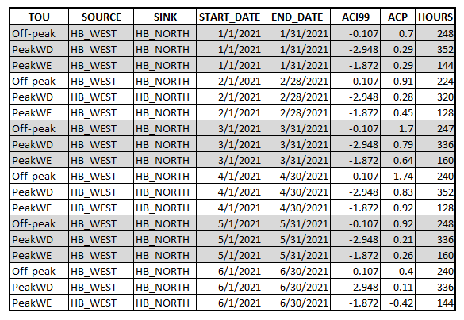
Below are PTP Obligation bids grouped by source, sink, TOU, and effective dates. Note that bids for the same source, sink, TOU and start date are grouped separately based on end dates.
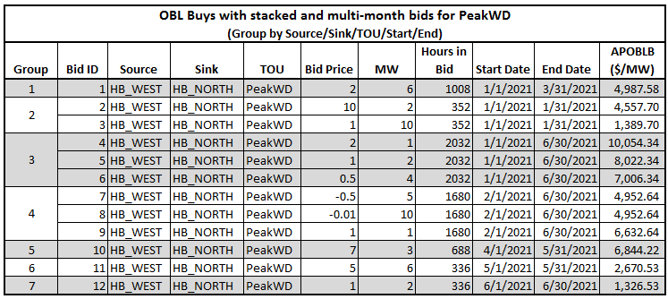

APOBLB for Bid 4 in Group 3 =
$$\{(Total Hours *(\max\left(0,Bid Price\right)\} – \{(Jan Hours*min⁡(0,Jan ACI99,Jan ACP))+ (Feb Hours*min⁡(0,Feb ACI99,Feb ACP))+(Mar Hours*min⁡(0,Mar ACI99, Mar ACP))+(Apr Hours*min⁡(0,Apr ACI99,Apr ACP))+(May Hours*min⁡(0,May ACI99,MayACP))+(Jun Hours*\min\left(0,Jun ACI99, Jun ACP\right))\}$$
= {(2032 * max(0,2)} – {(352 * min(0,-2.948,.29)) + (320 * min(0,-2.948,.28)) + (336 * min(0,-2.948,.79)) + (352 * min(0,-2.948,.83)) + (336 * min(0,-2.948,.21)) + (336 * min(0,-2.948,-.11))}
= (2032 * 2) – {(-1037.696) + (-943.36) + (-990.528) + (-1037.696) + (-990.528) + (-990.528)}
= 4064 – (- 5990.336)
= 4064 + 5990.336
= 10054.336
Each multi-month bid’s APOBLB is computed using the individual ACI99 and ACP coefficients for each month of the effective period of the bid.
The next step is to reverse sort on APOBLB in each group, and then aggregate the total MW in each group. Multiply the aggregated bid MW times the sorted APOBLB for each line to get the individual bid exposures. The max exposure for all PTP Obligation bids is the sum of the maximum value for each group, not the sum of the individual bid exposures.
Note: in the case where the APOBLB is the same (as in negatively priced PTP Obligation bids within the same TOU), the sub-sort is based on descending order of the bid price (highest price to lowest price), then on descending order of bid MW (highest MW bid to least MW).
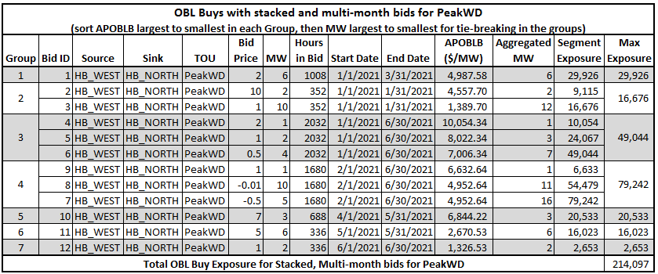

Example 2: Exposure calculation for pre-auction screening for PTP Obligation bids with 24-hour Time of Use (TOU) in a Monthly Auction
The following table contains data from the downloaded Credit Coefficient file for the auction and the corresponding hours in each TOU:
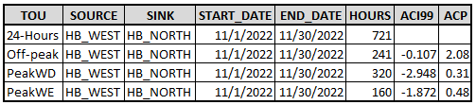
Below are PTP Obligation bids grouped by source, sink, TOU and effective dates, with APOBLB computed per bid. Note that the 24-hour bid APOBLB is a composite of each of the TOU hours, ACI99 and ACP values.
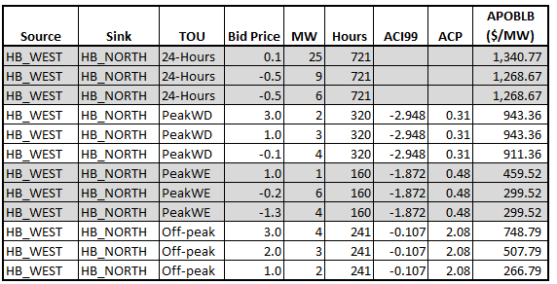
APOBLB for the first line in the above table =
$\{(Total Hours *(\max\left(0,Bid Price\right)\} – \{(PWD Hours*min⁡(0,PWD ACI99,PWD ACP))+ (PWE Hours*min⁡(0, PWE ACI99, PWE ACP))+(OP Hours*min⁡(0,OP ACI99, OP ACP))\}$
= {(721 * max(0,0.1)} – {(320 * min(0, -2.948, .31)) + (160 * min(0,-1.872, .48)) + (241 * min(0, -0.107, 2.08))}
= (721 * .1) – {(-943.36) + (-299.52) + (-25.787)}
= 72.1 – (- 1268.667)
= 72.1 + 1268.667
= 1340.77
Sort each bid based on APOBLB. Note: in the case where the APOBLB is the same (as in negatively priced PTP Obligation bids within the same TOU), the sub-sort is based on descending order of the bid price (highest price to lowest price), and then MW largest to smallest.
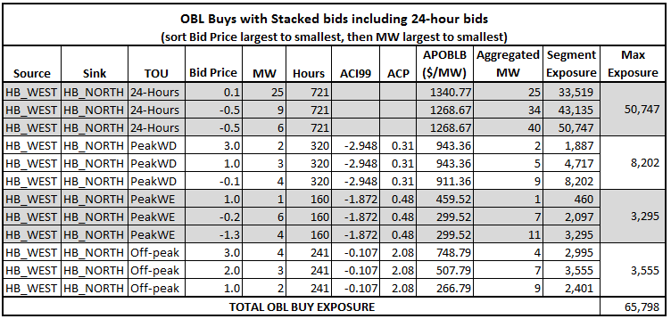
PTP Option Bids Exposure
PTP Option bids do not utilize credit coefficients in calculating credit exposure. To calculate the credit exposure for Option bids, first sort the Option bids in descending order of bid prices. Create a multiple segment bid curve in such a way that each segment has MW quantity and bid price as:
$$\left({MW}_{i},{Price}_{i}\right)=\sum_{r=0}^{i}{{MW}_{r}},{Price}_{i}$$
where i = segment number, and MW_{i} ≥ MW_{i-1} and Price_{i} ≤ Price_{i-1}
Calculate credit exposure of each segment in the multiple-segment bid curve by using the following equation:
$${Exposure}_{i}\left(\text{OPT Bid}\right)={MW}_{i}*Hour*P_{i}$$
where i = segment number,
Hour = number of effective hours of bid (every bid in the group has the same number of effective hours)

Example 1: Exposure calculation for pre-auction screening for multi-month PTP Option Bids in a Long-Term Auction Sequence
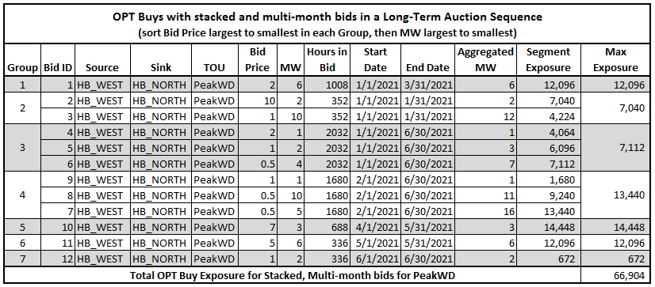

Example 2: Exposure calculation for pre-auction screening for 24-hour PTP Option bids in a Monthly Auction
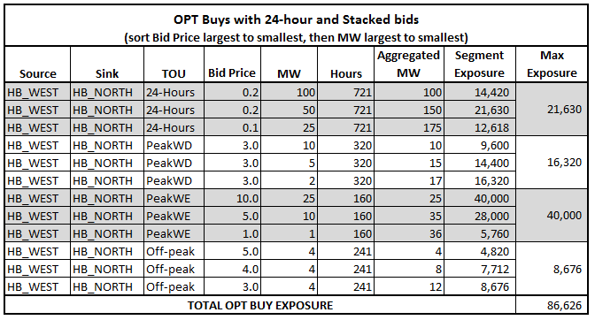

PTP Obligation Offers Exposure
PTP Obligation Offers also do not utilize credit coefficients in calculating credit exposure. To calculate the credit exposure for PTP Obligation Offers, first sort the obligation offers in ascending order of bid prices. Create a multiple segment bid curve in such a way that each segment has MW quantity and bid price as:
$$\left({MW}_{i},{Price}_{i}\right)=\sum_{r=0}^{i}{{MW}_{r}},{Price}_{i}$$
where i = segment number, and MW_{i} ≥ MW_{i-1} and Price_{i} ≥ Price_{i-1}
Calculate credit exposure of each segment in the multiple-segment bid curve by using the following equation:
$${Exposure}_{i}\left(\text{OBL Offer}\right)={MW}_{i}*Hour*\left\{-\min\left(P_{i},0\right)\right\}$$
where i = segment number,
Hour = number of effective hours of bid (every bid in the group has the same number of effective hours)
Example 1: Exposure calculation for pre-auction screening for multi-month PTP Obligation offers in a Long-Term Auction Sequence
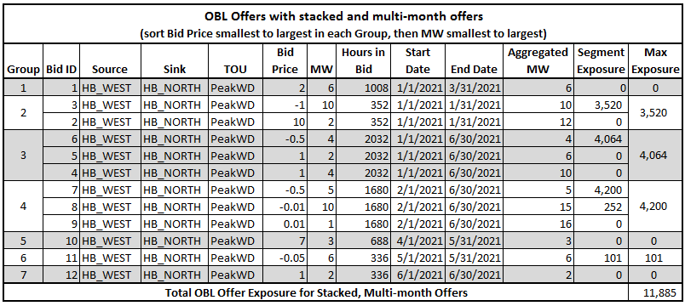

Example 2: Exposure calculation for pre-auction screening for PTP Obligation offers in a Monthly Auction
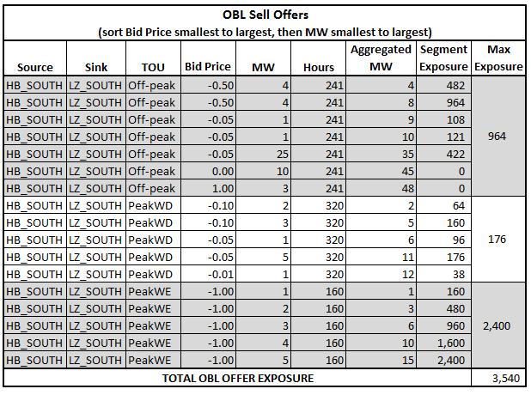
- I cannot find my OBL path in the Path Specific Adder/Credit Coefficient report. What do I use for Aci99 and/or ACP when my path is not listed in the posted Path Specific Adder/Credit Coefficient report?

The coefficient file only includes paths with existing obligation CRRs for the applicable auction period; it does not include every possible path. The day after the auction bid window closes, the Credit Coefficient file in the Download->Common->Market page in the application Market User Interface (MUI) is updated to include the paths with existing obligation CRRs as well as any new obligation paths that were bid on in the auction. The Path Specific Adder report that is posted on MIS prior to the bid window is not updated.
When there are no adders for a specific path posted prior to the auction, it is up to the market participant to determine what they want to use. Recent adders from other auctions can be used as an approximation or they may attempt to calculate the Aci99 values by using historical DAM prices. It can be done using the protocol definition of the Aci99 found in either section 7.5.5.3(3) or section 16.11.4.5(3). To do so, they will need the Day-Ahead Market settlement point prices for the two settlement points for the last three years to calculate the monthly rolling average for each TOU (18 days for PeakWD, 8 days for PeakWE, and 28 days for Off-peak). The look-back period for DAM settled prices is the target date, which is defined in the coefficient file and is always the day before the coefficient file is posted, minus three years. Once they have calculated the rolling averages for each settlement point, then they can take the sink minus source prices (for the desired month and TOU) to determine the Aci99 value for that path. It may be necessary to submit a data request for historical settlement point prices to do this.
- Why are the Seq6 Path Specific Adder/Credit Coefficient reports posted with no records?

Path Specific Adders/Credit Coefficients are posted only for Obligations that exist in the CRR inventory for the applicable auction months. Because the Seq6 auctions are the first auctions for the given auction months, Obligations will exist in CRR inventory for the Seq6 auction months only if PCRRs are allocated as Obligations during the annual PCRR allocation process. To date, PCRRs have only been nominated and allocated as Options, so the Seq6 Path Specific Adders/Credit Coefficients reports are posted with no records. The target date, which defines the starting date for the three-year look-back period associated with the auction, will be posted separately in a Text document in the Path Specific Adder/Credit Coefficients zip file, as well as a Common Message in the MUI for the affected Seq6 auctions.

- How does the pre-screen calculation differ from the way credit is consumed during the auction optimization?
The pre-screen calculation differs from the way credit is consumed during the auction optimization in two ways:
- The prescreening calculation determines a maximum exposure value by using the full bid MW instead of potentially awarded MW as the quantity. The optimization consumes credit during the clearing process using the potentially awarded MW as the quantity, which may be less than the full bid MW quantity.
- The prescreening calculation also uses a bid stacking methodology for bids of the same product and differing quantities/prices. The auction optimization does not use bid stacking; instead, each individual bid/offer is assessed individually.

- What happens if my CP does not lock credit? And other scenarios
Table 1: Counter-Party Budget Constraint Creation
Scenario | Counter-Party Self-imposed Credit Limit | Counter-Party Credit Exposure | Records to Engine
1 | Any number or No Entry | N/A because CRRAHs under the CP submit only OPT sell offers | No budget constraint for CP
2 | $xx | > $xx | Create a budget constraint for CP where limit = $xx
3 | $xx | <= $xx | No budget constraint for CP
4 | No Entry | Any number | Create a budget constraint for CP where limit = $0

Table 2: CRR Account Holder Budget Constraint Creation
Scenario | CRRAH Self-imposed Credit Limit | CRRAH Creditworthy? | CRRAH Credit Exposure | Records to Engine
1 | Any number or No Entry | Yes or no | N/A because CRRAH submits only OPT sell offers | No budget constraint for CRRAH
2 | $xx | Yes | > $xx | Create a budget constraint for CRRAH where limit = $xx
3 | $xx | Yes | <= $xx | No budget constraint for CRRAH
4 | No Entry | Yes | Any number | No budget constraint for CRRAH
5 | Any number or No Entry | No | Any number | Create a budget constraint for CRRAH where limit = $0

- What is the difference between a budget record, or budget constraint, and a binding budget constraint?

A budget record is created for a CP or CRRAH when pre-screening credit exposure exceeds the Available Credit Limit locked for the auction. This budget record is sent to the engine as a constraint that limits what a CP or CRRAH can be awarded in the auction optimization; this type of constraint is called a budget constraint or credit constraint. The auction optimization selects an award set based on the best overall welfare of the market while respecting all network constraints, including these credit constraints. Note: a CRRAH will not have a budget record if the CRRAH did not self-impose a credit limit. In this case, if a credit constraint is encountered, it is for the CP’s locked credit limit.

A CRRAH can view whether they had a budget constraint in the auction by checking the “Credit Consumed” column in their private auction results. If there are no values in the “Credit Consumed” column, then the allocated credit limit exceeded the potential credit exposure, and the credit limit was not used as a budget constraint in the optimization.

If there was a budget constraint for the CRRAH, the credit consumed value will be:

- For OBL bids: MW Awarded x (Max(0,Bid Price) – Min(0,A_{CI99},ACP)) x TOU Hours
- For OBL offers: MW Awarded x Min(0,Offer Price) x TOU Hours
- For OPT bids: MW Awarded x Bid Price x TOU Hours
- For OPT offers: null (option offers do not consume credit)
A budget constraint becomes binding when a CRRAH’s awards are limited due to their budget constraint. For a given CRR bid, if a CRRAH’s awarded MW are less than their bid MW, and their bid price exceeded the shadow price, then the CRRAH’s award was limited due to their budget constraint binding during the auction clearing process.

- I submitted bids that were not awarded, even though my bid prices exceeded the clearing prices. My credit limit was greater than my CRR Auction Invoice amount. Why wasn’t I awarded?

If a CRRAH’s total pre-screen credit exposure exceeds their allocated credit limit, the CRRAH will have a budget constraint in the auction optimization, and the auction cannot award the CRRAH more than their credit allows. Credit consumed during the auction is based on the bid price, not the clearing price, which is why in some cases the total locked credit is not fully consumed by the awards. The auction optimization selects an award set based on the best overall welfare of the market while respecting all network constraints (including capacity, non-thermals, and budget constraints). If the engine wants to award more MW for a bid, but there is a budget record, the engine will calculate the best welfare of the entire auction based on how much it can award and still respect all the constraints, including the budget constraints. As a result, the CRRAH may not be awarded enough CRRs to fully consume their locked credit amount.

When a CRRAH’s bid price exceeds the clearing price, and they were awarded fewer MW than they requested, that indicates their budget constraint was binding. In other words, the CRRAH’s credit available to the engine curtailed their awards.

- How does NPRR867 impact the amount of credit that is locked?
Since the implementation of NPRR867 in September 2021, ERCOT assigns the Available Credit Limit (ACL) locked for a CRR Auction for each Counter-Party participating in an auction as the lower of the Counter-Party’s:
  - Allocated credit limit;
  - Available Credit Limit for the CRR Auction (ACLC) at the time of the closure of the auction bid submission window; or
  - Pre-auction screening credit exposure amount.

- Why does the Available Credit Limit in the Credit Limit Editor for my Counter-Party change during the credit window?
The CRR system communicates with the Credit Management System (CMM) and receives updated ACLCs from CMM daily. During auction bid windows, ACLCs can be sent to the CRR system multiple times during the day to provide the best information to the Counter-Party for the bidding process. It is possible to lock credit for an auction that exceeds a subsequently updated ACLC. If this happens, the locked credit amount is reduced to the ACLC at the time the bid window closes. If it is reduced for a Long-Term Auction Sequence, credit allocated to each TOU is reduced proportionally.

