System Planning
Monthly Status Report

Report Highlights

- ERCOT is currently reviewing proposed transmission improvements with a total estimated cost of $1,153.14 Million as of October 31, 2020.
- Transmission Projects endorsed in 2020 total $903.01 Million as of October 31, 2020.
- All projects (in engineering, routing, licensing and construction) total approximately $7.6 Billion as of October 1, 2020.
- Transmission Projects energized in 2020 total about $1.20 Billion as of October 1, 2020.

Regional Planning Group Reviews
- AEPSC has submitted the LRGV Import Project. This is a Tier 1 project that is estimated to cost $73.4 million. AEPSC has also requested that ERCOT provide a conditional endorsement for an additional $357.2 million project. The ERCOT Independent Review has been conducted in accordance with Protocol Section 3.11.4.9(3), and this project is currently placed on hold until the LNG loads are confirmed.
- STEC has submitted the Lower Rio Grande Valley Transmission Expansion Project. This is a Tier 1 project that is estimated to cost $511 million. The ERCOT Independent Review has been conducted in accordance with Protocol Section 3.11.4.9(3), and this project is currently placed on hold until the LNG loads are confirmed.
- BEC has submitted a request to withdraw the Moffat to Hasse Voltage Conversion Project. This project is no longer under ERCOT Independent Review.
- Oncor has submitted the Tall City – Telephone Road 138-kV Line Rebuild Project. This is a Tier 3 project that is estimated to cost $23.5 million. This project completed the RPG review on October 7, and ERCOT has issued an acceptance letter.
- AEPSC has submitted the Alamito Creek to Alpine 69-kV Line Rebuild Transmission Project. This is a Tier 3 project that is estimated to cost $37 million. This project completed the RPG review on October 22, and ERCOT has issued an acceptance letter.
- Oncor has submitted the Nacogdoches Southeast Switch – Redland Switch – Lufkin Switch 345-kV Loop Project. This is a Tier 2 project that is estimated to cost $71.26 million. This project is currently in the RPG comment period.
- AEPSC has submitted the Lake Pauline Area Improvement Project. This is a Tier 3 project that is estimated to cost $47.5 million. This project is currently in the RPG comment period.
- CNP has submitted the Wallis to Peters Ckt 65 138-kV Line Rebuild Project. This is a Tier 3 project that is estimated to cost $64.78 million. This project is currently in the RPG comment period.
- AEPSC has submitted the Burma to Sterling City 69-kV Line Rebuild Project. This is a Tier 3 project that is estimated to cost $28 million. This project is currently in the RPG comment period.

More information on current and past RPG projects can be found on the ERCOT MIS Secure (digital certificate required): https://mis.ercot.com/pps/tibco/mis/Pages/Grid+Information/RegionalPlanning
Past email communication on RPG projects can be found on the ERCOT listserve by signing up for the REGPLANGROUP list: http://lists.ercot.com/scripts/wa-ERCOT.exe?A0=REGPLANGROUP

Planning Model Activities
The short-term calendar of major planning model events is as follows:
- By March 1, 2021 20SSWG Update 2 cases and TPIT are posted
- By March 31, 2021 20SSWGU2 Contingency definitions and Planning Data Dictionary are posted
The following table shows interconnection projects that met Planning Guide section 6.9(1) and 6.9(2) and were modeled in the SSWG cases as a full model or as a simple model in accordance with Planning Guide section 6.9. 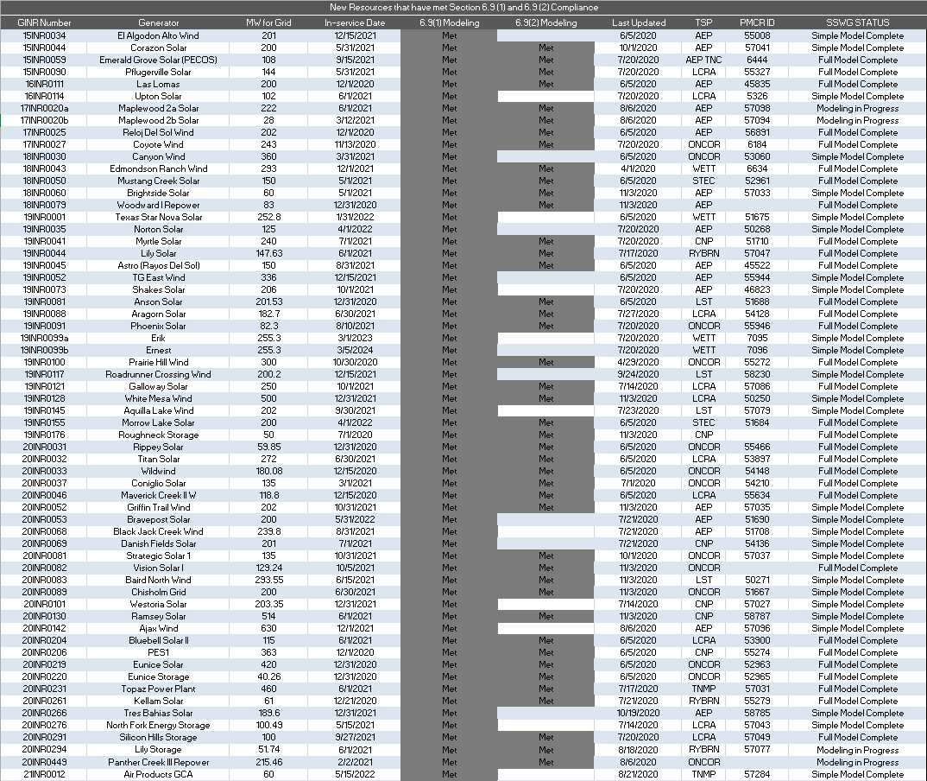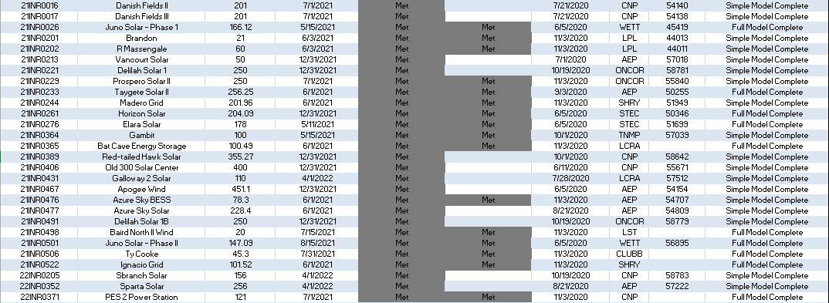

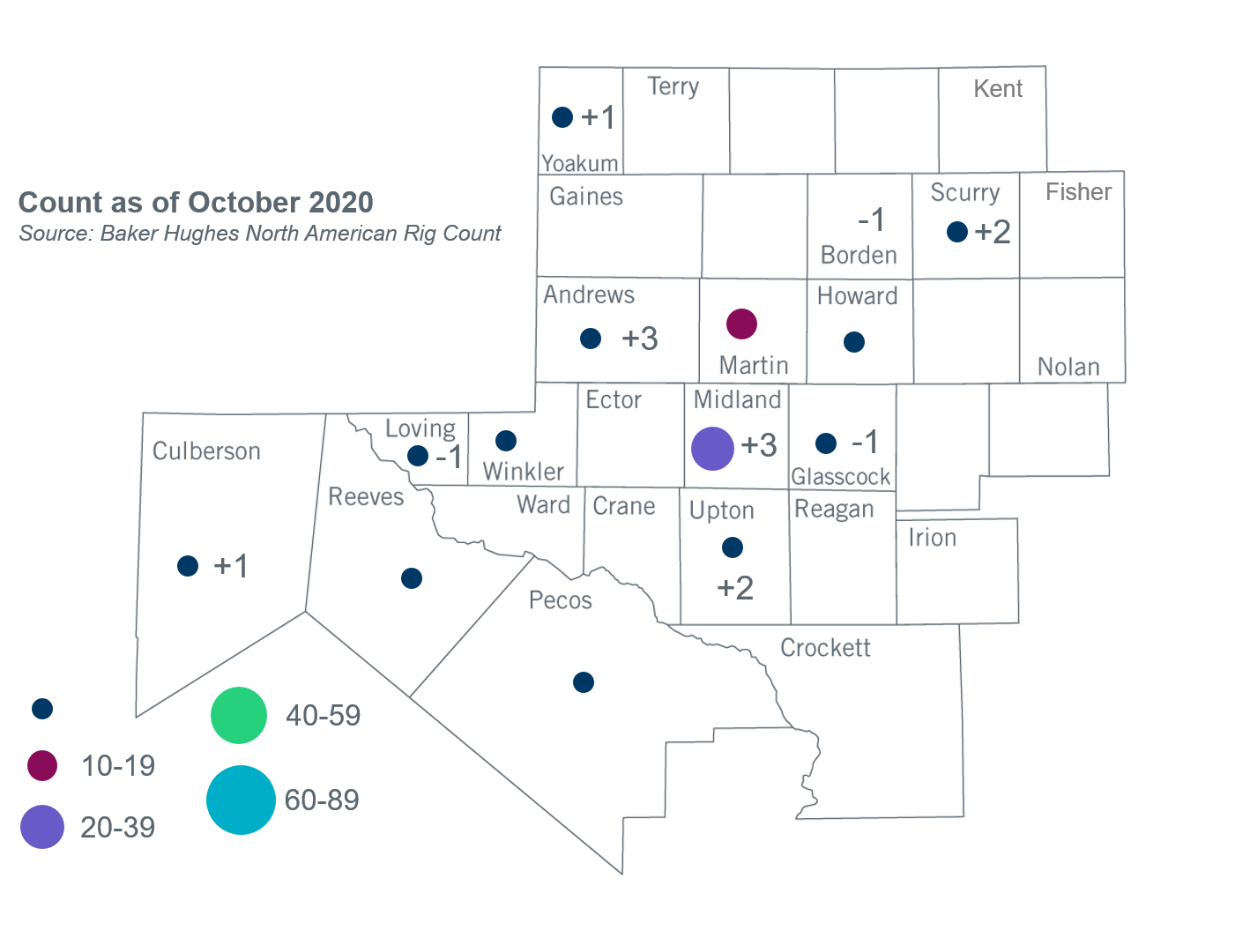
Permian Basin Oil Rig Count
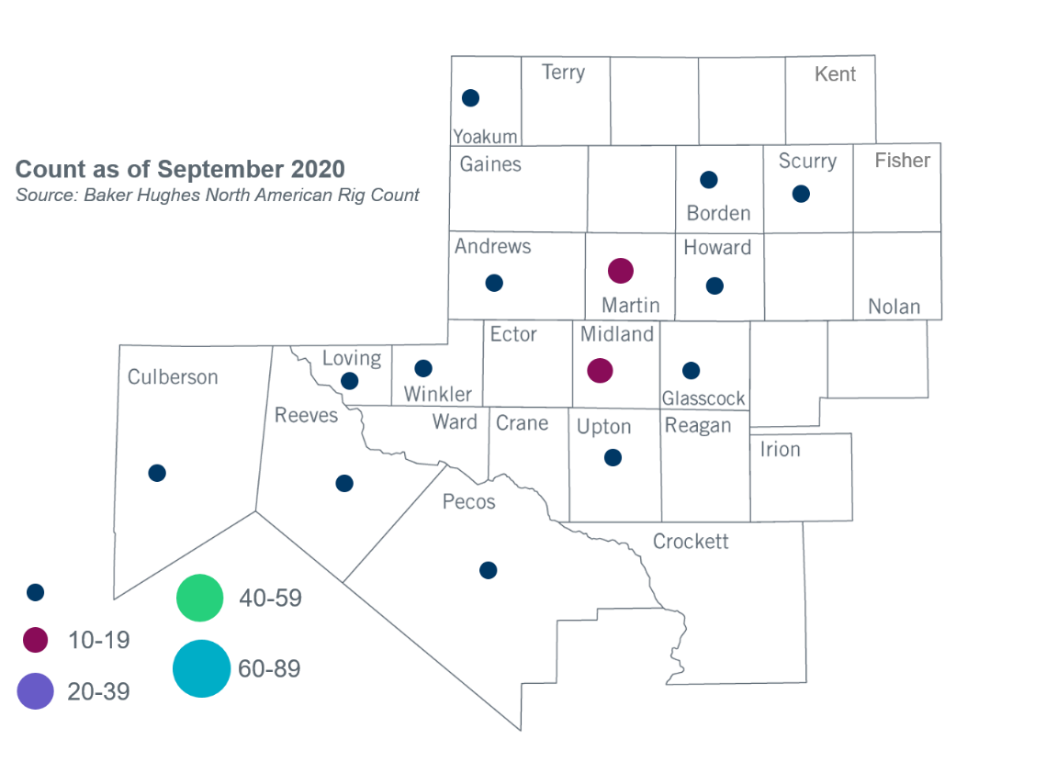

Other Notable Activities
- ERCOT has completed the 2020 annual review of financial assumptions used to determine first-year revenue requirement for the economic planning criteria. Details were posted to MIS Secure and shared with the Regional Planning Group (RPG) in October.
- ERCOT presented an update on 2020 Regional Transmission Plan (RTP) economic analysis to the RPG in October.
- ERCOT posted preliminary secure reliability cases for the 2020 RTP to MIS Secure in October.
- ERCOT presented an update on the Benchmark Geomagnetic Disturbance Vulnerability Assessment (GMDVA) to the RPG in October.
- ERCOT continued discussion of the near-term proposal for including distributed energy resources (DER) in planning models with the RPG and SSWG in October.
- ERCOT will conduct a special study to develop a potential roadmap of transmission solutions for West Texas export constraints. ERCOT presented the study scope of the Long-Term West Texas Export Special Study to the RPG in September and asked for stakeholders’ comments by September 30, 2020.

+/- symbol indicates the increase or decrease from the previous month in oil rigs present in each county. There are 93 rigs, including a total increase of 8 oil rigs, in the Permian Basin from September to October 2020.

