LPGRR Number |  | LPGRR Title | Add BUSLRG and BUSLRGDG Profile Types
Date Posted
Requested Resolution |  | Normal status
Load Profiling Guide Sections Requiring Revision
Related Documents Requiring Revision/Related Revision Requests |  | Profile Decision Tree (PDT), Appendix D, Load Profiling Guide
Revision Description |  | Add two new PROFILETYPECODEs to be used for premises billed on a 4CP tariff where the TDSP can support a 4CP billing rate with an AMS profile. BUSLRG will be created for premises that do not have distributed generation and BUSLRGDG will be created for those premises that do have distributed generation. Existing BUSIDRRQ will remain an option for premises billed on a 4CP tariff.
Reason for Revision |  | Addresses current operational issues.  Meets Strategic goals (tied to the ERCOT Strategic Plan or directed by the ERCOT Board).  Market efficiencies or enhancements  Administrative  Regulatory requirements  Other: (explain)  (please select all that apply)
Business Case |  | The requirement for IDR Meters at premises connected at transmission voltage and/or having a peak demand greater than 700kW/700kVA is no longer necessary due to the advent of Advanced Meters and efforts of competitive TDSPs to modify their systems to support 4CP billing for premises with Advanced Meters. Competitive TDSPs are bound by their tariffs and all of the tariffs require 4CP billing for premises having a peak demand greater than 700kW/700kVA. Interval load data for the ERCOT System’s largest customers will be available for Initial Settlement.

Sponsor
Name
E-mail Address
Company
Phone Number
Cell Number
Market Segment

Market Rules Staff Contact
Name
E-Mail Address
Phone Number

Proposed Guide Language Revision

Profile Decision Tree, Appendix D, Load Profiling Guide, Tab: Definitions

IDRRQ | Denotes a Profile Segment for which an Interval Data Recorder is required.premises billed on a 4CP tariff where the TDSP cannot support a 4CP billing rate with an AMS profile (aka IDR Metered premise). |  | Segment Assignment tab
LRG | Denotes premises billed on a 4CP tariff where the TDSP can support a 4CP billing rate with an AMS profile and does not have distributed generation. |  | Segment Assignment tab
LRGDG | Denotes premises billed on a 4CP tariff where the TDSP can support a 4CP billing rate with an AMS profile and has distributed generation. |  | Segment Assignment tab

Profile Decision Tree, Appendix D, Load Profiling Guide, Tab: Segment Assignment

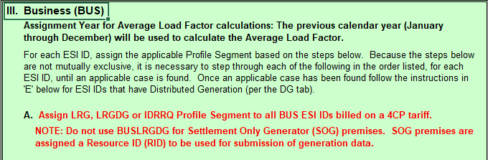

Profile Decision Tree, Appendix D, Load Profiling Guide, Tab: Valid Profile IDs

