September 2020 ERCOT Monthly Operations Report
Reliability and Operations Subcommittee Meeting
November 5, 2020

Table of Contents
1. Report Highlights 2
2. Frequency Control 3
2.1. Frequency Events 3
2.2. Responsive Reserve Events 4
2.3. Load Resource Events 4
3. Reliability Unit Commitment 4
4. Wind Generation as a Percent of Load 5
5. Largest Net-Load Ramp 5
6. COP Error Analysis 6
7. Congestion Analysis 8
7.1. Notable Constraints 8
7.2. Generic Transmission Constraint Congestion 12
7.3. Manual Overrides 12
7.4. Congestion Costs for Calendar Year 2020 12
8. System Events 14
8.1. ERCOT Peak Load 14
8.2. Load Shed Events 14
8.3. Stability Events 14
8.4. Notable PMU Events 14
8.5. DC Tie Curtailment 14
8.6. TRE/DOE Reportable Events 14
8.7. New/Modified/Removed RAS 14
8.8. New Procedures/Forms/Operating Bulletins 14
9. Emergency Conditions 15
9.1. OCNs 15
9.2. Advisories 15
9.3. Watches 15
9.4. Emergency Notices 15
10. Application Performance 15
10.1. TSAT/VSAT Performance Issues 15
10.2. Communication Issues 15
10.3. Market System Issues 16
11. Model Updates 16
Appendix A: Real-Time Constraints 18

Report Highlights
- The unofficial ERCOT peak was 64,795 MW.
- There were 1 frequency events.
- There were 2 instances where Responsive Reserves were deployed.
- There were no RUC commitments.
- Congestion in the Panhandle can be attributed to high wind generation as well as Transmission Outages. There were 23 days of congestion on the Panhandle GTC, 9 days on the McCamey GTC, 15 days on the North Edinburg to Lobo GTC, 5 days on Bearkat GTC, 4 days on the Nelson Sharpe to Rio Hondo GTC, 2 days on the North to Houston GTC, and 2 days on the West to Central Texas GTC. There was no activity on the remaining GTCs during the month.
- On 09/01/2020 at 15:00 ERCOT issued a Transmission Emergency, procured 160 MW of emergency energy from CENACE, deployed a Load Resource of 0.3MW of RRS and between 15:28 and 16:23, ERCOT instructed approximately 16.1 MW of load to be shed in the Rio Grande Valley due to base case overloads on the North Edinburg 345/138 kV Autotransformer and the Magic Valley Burns – Rio Hondo 138 kV line.
- There were 2 DC Tie curtailments.

Frequency Control

Frequency Events
The ERCOT Interconnection experienced three frequency events, which resulted from unit’s trips. The average event duration was 00:05:50.

A summary of the frequency events is provided below. The reported frequency events meet one of the following criteria: Delta Frequency is 60 mHz or greater; the MW loss is 350 MW or greater; resource trip event triggered RRS deployment. Frequency events that have been identified as Frequency Measurable Events (FME) for purposes of BAL-001-TRE-1 analysis are highlighted in blue. When analyzing frequency events, ERCOT evaluates PMU data according to industry standards. Events with an oscillating frequency of less than 1 Hz are considered to be inter-area, while higher frequencies indicate local events. Industry standards specify that damping ratio for inter-area oscillations should be 3.0% or greater. For the frequency events listed below, the ERCOT system met these standards and transitioned well after each disturbance.

Date and Time | Delta Frequency | Max/Min Frequency | Duration of Event | PMU Data |  | MW Loss | Load | Wind | Inertia
 | (Hz) | (Hz) |  | Oscillation Mode (Hz) | Damping Ratio |  | (MW) | % | (GW-s)
9/19/2020 16:02 | 0.119 | 59.895 | 0:05:50 | 0.680 | 12% | 493.45 | 50,481 | 9% | 277,061

(Note: All data on this graph encompasses frequency event analysis based on BAL-001-TRE-1.)

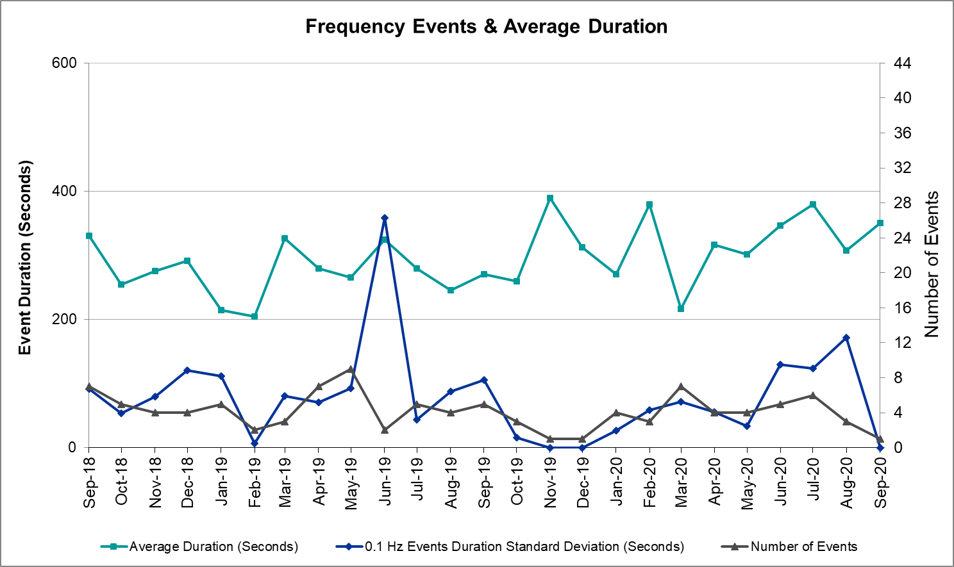

Note that the large standard deviation in June 2019 is due to coincidental extreme high and low durations for a small set of events (2).

Responsive Reserve Events
There were 2 events where Responsive Reserve MWs were released to SCED. The events highlighted in blue were related to frequency events reported in Section 2.1 above.

Date and Time Released to SCED | Date and Time Recalled | Duration of Event | Maximum MWs Released | Comments
9/19/2020 16:02:12 | 9/19/2020 16:08:02 | 00:05:50 | 559
9/22/2020 21:04:46 | 9/22/2020 21:09:34 | 00:04:48 | 779 | A combine cycle train generating 1147 MW had a runback, which caused the frequency to drop to 59.89Hz

Load Resource Events
There was one Load Resource deployment of 0.3 MW on 9/1/20 between 15:28:40 and 16:23:51.

Reliability Unit Commitment
ERCOT reports on Reliability Unit Commitments (RUC) on a monthly basis. Commitments are reported grouped by operating day and weather zone. The total number of hours committed is the sum of the hours for all the units in the specified region. Additional information on RUC commitments can be found on the MIS secure site at Grid Generation Reliability Unit Commitment.

There were no DRUC commitments.

There were no HRUC commitments.

Wind Generation as a Percent of Load
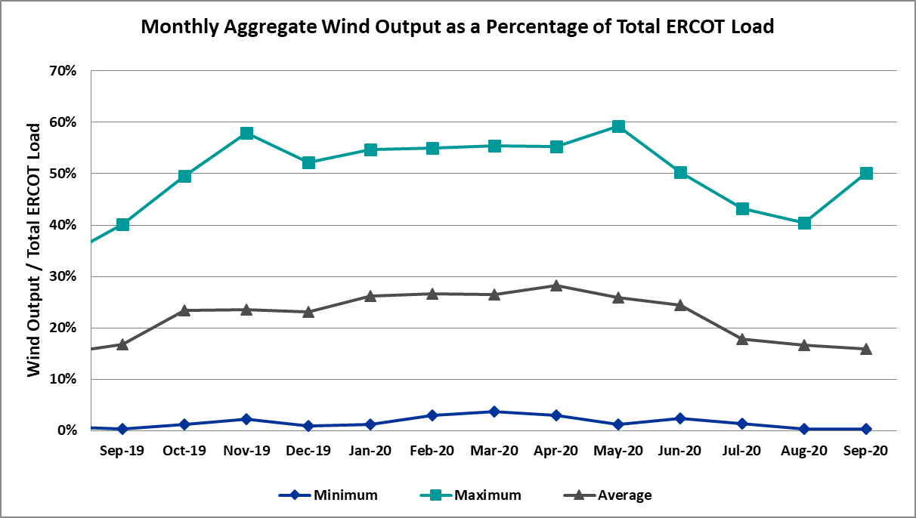

Wind Generation Record: 21,375 MW on 6/28/2020 at 23:22
Wind Penetration Record: 59.30% on 05/02/2020 at 02:10

Largest Net-Load Ramp
The net-load ramp is defined as the change in net-load (load minus wind and PVGR generation) during the defined time horizon. Such a variation in net-load needs to be accommodated in grid operations to ensure that the reliability of the grid is satisfactorily maintained. The largest net-load ramp during 5-min, 10-min, 15-min, 30-min and 60-min in September 2020 are 776 MW, 1285 MW, 1763 MW, 2728 MW, and 5087 MW, respectively. The comparison with respect to the historical values is given in the table below.

Month and Year | 5 min | 10 min | 15 min | 30 min | 60 min
September 2020 | 776 MW | 1285 MW | 1763 MW | 2728 MW | 5087 MW
September 2014 | 1054 MW | 1531 MW | 1695 MW | 2628 MW | 4898 MW
September 2015 | 993 MW | 1457 MW | 1779 MW | 2952 MW | 5659 MW
September 2016 | 827 MW | 1260 MW | 1688 MW | 2880 MW | 5464 MW
September 2017 | 730 MW | 1251 MW | 1758 MW | 3298 MW | 5716 MW
September 2018 | 1129 MW | 1991 MW | 2372 MW | 3391 MW | 6015 MW
September 2019 | 867 MW | 1207 MW | 1643 MW | 3134 MW | 5716 MW
All Months in 2014-2019 | 1494 MW | 1991 MW | 2780 MW | 4109 MW | 7786 MW

COP Error Analysis
COP Error is calculated as the capacity difference between the COP HSL and real-time HSL of the unit. Mean Absolute Error (MAE) stayed high over 9,000 MW until Day-Ahead at 12:00, then dropped significantly to 1,988 MW by Day-Ahead at 14:00. In the following chart, Under-Scheduling Error indicates that COP had less generation capacity than real-time and Over-Scheduling Error indicates that COP had more generation capacity than real-time. Under-Scheduling persisted from beginning of Day-Ahead to end of the Operating Day.
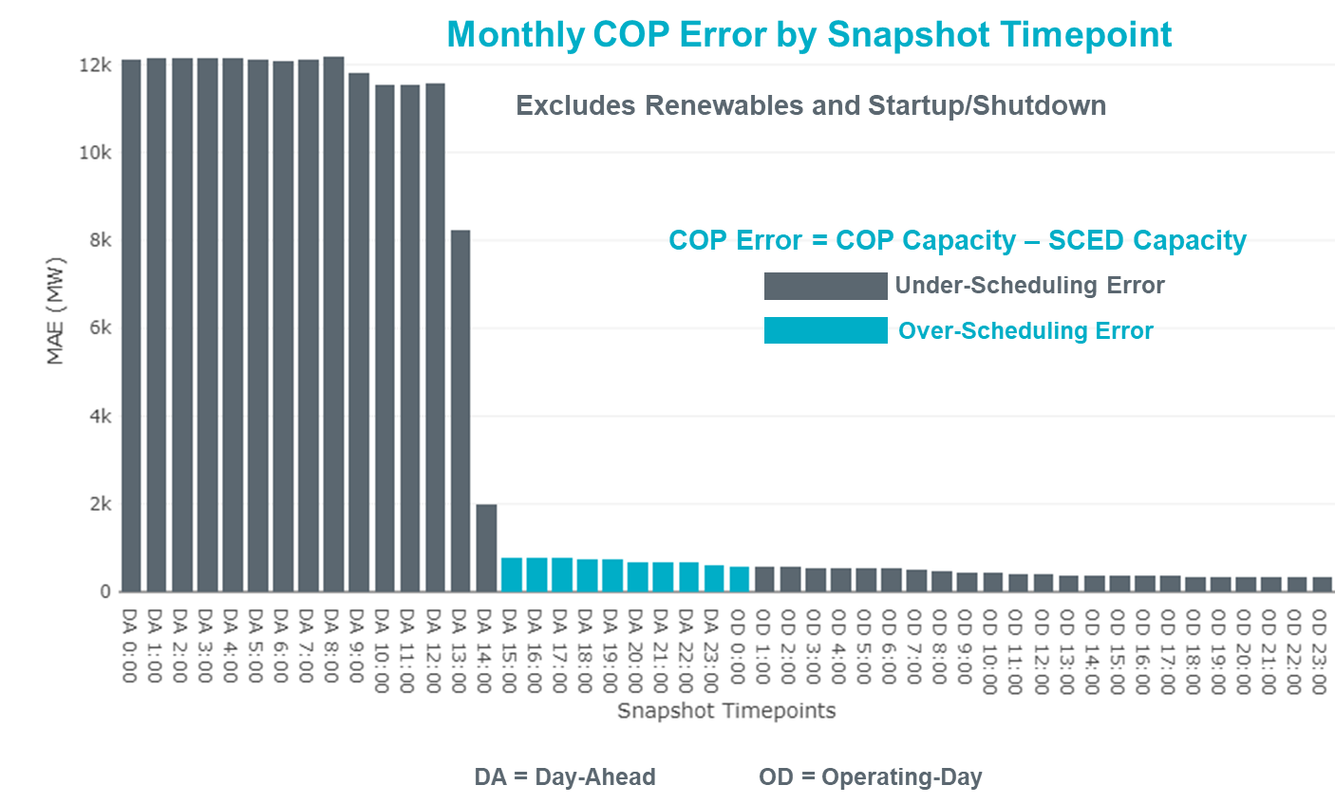
Monthly MAE for the Latest COP at the end of the Adjustment Period was 333 MW with median ranging from -473 MW for Hour-Ending (HE) 18 to 58 MW for HE 8. HE 1 on the 10th had the largest Over-Scheduling Error (1,476 MW) and HE 20 on the 12th had the largest Under-Scheduling Error (-2,961 MW).

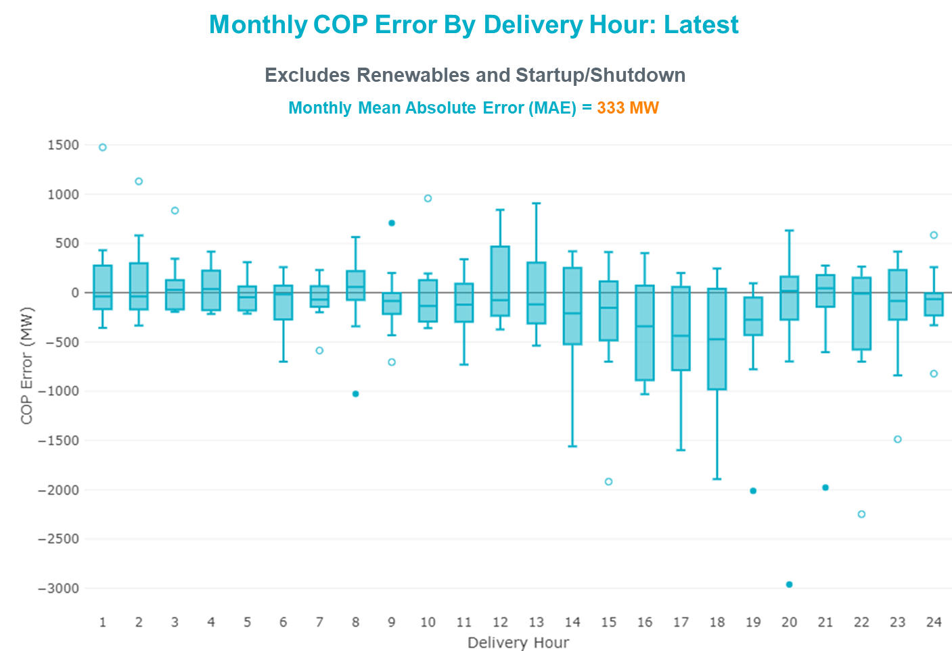

Monthly MAE for the Day-Ahead COP at 12:00 was 11,587 MW with median ranging from -14,969 MW for Hour-Ending (HE) 18 to -8,677 MW for HE 2. HE 17 on the 15th had the largest Under-Scheduling Error (-23,081 MW) and HE 24 on the 25th had the largest Over-Scheduling Error (-964 MW).

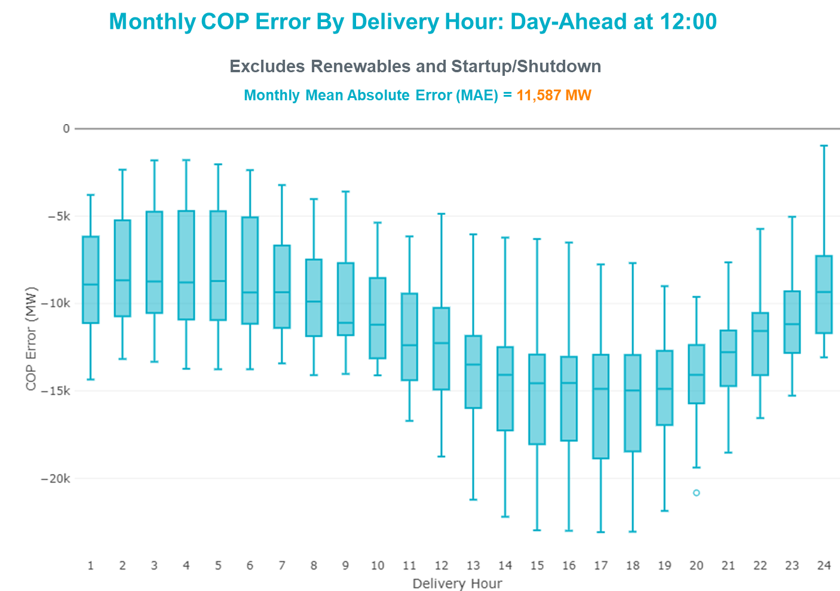

Congestion Analysis

Notable Constraints
Nodal protocol section 3.20.1 specifies that ERCOT evaluate constraints on an ongoing basis, and provide the results to the appropriate TAC subcommittee. As part of this process, ERCOT reports congestion that meets this criterion to ROS. In addition ERCOT also highlights notable constraints that have an estimated congestion rent exceeding $1,000 for a calendar month. These constraints are detailed in the table below. Rows highlighted in blue indicate the congestion was affected by one or more outages. For a list of all constraints activated in SCED, please see Appendix A at the end of this report.

Contingency Name | Overloaded Element | # of Days Constraint Active | Congestion Rent | Transmission Project
Basecase | PNHNDL GTC | 23 | $15,777,073.46 | Panhandle GTC Exit Plan - "PANHANDLE RENEWABLE ENERGY ZONE (PREZ)  STUDY REPORT" on MIS, CONSTRUCT OGALLALA TO BLACKWATER DRAW 345 KV LINE (52245), CONSTRUCT BLACKWATER DRAW TO FOLSOM POINT345 KV LINE (52258), CONSTRUCT BLACKWATER DRAW TO DOUBLE MOUNTAIN (52299), CONSTRUCT DOUBLE MOUNTAIN TO FIDDLEWOOD TO FARMLAND 345 KV L (522307) (PREZ)
NORTH EDINBURG TRX 1382 345/138 | North Edinburg 345kV | 2 | $6,338,918.55 | Stewart Road: Construct 345 kV cut-in with two 450 MVA 345/138 autotransformers connected to Stewart Rd 138 station (5604, 6382)
Basecase | NE_LOB GTC | 15 | $3,578,525.06 | GTC Exit plan in the North Edinburg - Lobo Stability Study Report posted in the ERCOT MIS website
HCKSW TO SAGNA 138 DBLCKT | Eagle Mountain Ses - Morris Dido 138kV | 5 | $2,793,435.77 | Upgrade the Saginaw - Eagle Mountain 138 kV Double Circuit Line (6273)
CPSES TO JONSW 345 AND CPSES TO EVRSW 345 DBLCKT | Mitchell Bend Switch - Decordova Ses 345kV | 2 | $2,404,542.68 | Mitchell Bend - Rocky Creek 345 kV line (5312)
Basecase | Burns Sub - Rio Hondo 138kV | 1 | $2,277,807.52
GAS PAD to FLAT TOP TNP LIN 1 | Lynx - Tombstone 138kV | 12 | $2,216,993.08 | Lynx: Expand 138 kV station (45503)
PORTLAND to Gibbs LIN 1 | Whitepoint - Rincon 138kV | 2 | $1,968,663.34 | Whitepoint Area Improvements (50950)
Basecase | North Edinburg 345kV | 1 | $1,862,674.64 | Stewart Road: Construct 345 kV cut-in with two 450 MVA 345/138 autotransformers connected to Stewart Rd 138 station (5604, 6382)
CRLNW TO LWSSW 345 DBLCKT | Ti Tnp - West Tnp 138kV | 5 | $1,569,437.75 | Lewisville - Lewisville Jones - Lakepointe 138 kV Line (45537)
GAS PAD to FLAT TOP TNP LIN 1 | Lynx - Rio Pecos 138kV | 11 | $1,524,323.94 | Rebuild Rio Pecos-Lynx Ckt 2 (1926 ACSS) (54255)
ODLAW SWITCHYARD to ASPHALT MINES LIN 1 | Hamilton Road - Maverick 138kV | 9 | $1,186,843.65 | Brackettville to Escondido: Construct 138 kV line (5206)
SAN MIGUEL GEN to FOWLERTON LIN 1 | San Miguel Gen 345kV | 7 | $1,173,034.52 | San Miguel 345/138 kV autotransformer replacements (5218A, 5218B)
Berghe-Kendal 345kv & Welfar 138kv | Helotes - Ranchtwn 138kV | 4 | $871,654.72
Basecase | MCCAMY GTC | 9 | $818,162.53 | McCamey GTC Exit Plan posted on the ERCOT MIS website (Far West Transmission Project 2)
Austro-Daffin&Dunlap-Decker 138kV | Mcneil Aen - Howard Lane Aen 138kV | 4 | $804,577.53 | Reconductor 138kV ckt 972 Howard Lane to McNeil to 3000A (48327)
Gibcrk-Toksw & Jk_Ck 345kV | Btu_Jack_Creek - Btu_Tabor 138kV | 4 | $711,979.14
KENDALL to COMFORT LIN 1 | Kerrville Stadium - Kendall 138kV | 3 | $690,629.68
BIG SPRING SWITCH to CHALK_69kV and McDonald Road_138kV | Tall City - Sharyland Utilities - Telephone Road - Sharyland Utilities 138kV | 3 | $667,561.86 | Tall City - Telephone Road 138 kV Line Rebuild (57915)
COMANCHE SWITCH (Oncor) to COMANCHE PEAK SES LIN _A | Comanche Tap - Comanche Switch (Oncor) 138kV | 3 | $346,086.29
Pig Creek to Solstice LIN 1 | Fort Stockton Plant - Tombstone 138kV | 14 | $304,632.96 | Barrilla Junction to Ft. Stockton SW: Rebuild 69 kV line (7027)  Solstice: Install 138 kV PST and capacitor bank (44359)
LON HILL to NELSON SHARPE LIN 1 | Celanese Bishop - Kleberg Aep 138kV | 3 | $303,719.31
ODEHV-MOSSW 345&ODEHV-WLFSW 345_DBLCKT | Odessa Ehv Switch 345kV | 3 | $261,772.81 | Riverton-Odessa EHV/Moss 345 kV Line (5445)
MANUAL FTST to LYNX 138 kV | Fort Stockton Plant - Airport Tnp 138kV | 3 | $250,905.56
TWR (345) JN-WAP64 & JN-WAP72 | Wa Parish - Obrien 345kV | 5 | $248,386.60 | Freeport - Master Plan (6668B)
MCELMURRAY to ESKOTA SWITCH LIN 1 | Eskota Switch - Trent 69kV | 7 | $205,640.64
Basecase | BEARKT GTC | 5 | $125,421.92 | Bearkat Loop - Bearkat to Longshore (45399) - Bearkat GTC Exit Strategy
PAREDES SWITCHING STATION to CENTRAL AVENUE SUB LIN 1 | Rio Hondo - East Rio Hondo Sub 138kV | 13 | $105,862.46 | Rebuild Rio Hondo to East Rio Hondo (6687)
TWR(345) DOW-JCK18 & DOW-JCK27 | Freeport - Surfsi 138kV | 3 | $92,989.20 | Install two distribution transfomers at Jones Creek (6325)
FORT MASON to YELLOW JACKET LIN 1 | Yellow Jacket - Hext Lcra 69kV | 6 | $84,547.06 | Heartland to Yellowjacket: Build 69 kV line (3754)
TWR (345) HLJ-WAP64 & BLY-WAP72 | South Texas Project - Wa Parish 345kV | 6 | $71,526.26 | Freeport - Master Plan (6668B)
RIO HONDO to LAS PULGAS LIN 1 | Raymondville 2 138kV | 3 | $70,687.06 | Harlingen SS - Raymondville #2: Convert to 138 kV (6167)
BOSQUE SWITCH to ELM MOTT LIN 1 | Bosque Switch - Rogers Hill Bepc 138kV | 15 | $68,103.29 | Upgrade Elm Mott - Bosque 138 kV Line (52149)
HIWAY_9 - CITGO_NO & INDUSTRI 69kV & 138 kV | Morris Street - Nueces Bay 138kV | 5 | $61,756.97 | Nueces Area 69kV Reinforcement (4487)
PH ROBINSON to MEADOW LIN A | Mainland Tnp - Alvin Tnp 138kV | 5 | $60,102.77 | Rebuild Alvin-Mainland-Freeway Park (795 ACSS) (54118)
Basecase | NELRIO GTC | 4 | $55,096.17 | GTC Exit plan in the Nelson Sharpe - Rio Hondo Stability Study Report posted in the ERCOT MIS website
BRACKETTVILLE to HAMILTON ROAD LIN 1 | Hamilton Road - Maverick 138kV | 4 | $37,775.51 | Brackettville to Escondido: Construct 138 kV line (5206)
Ferguson-Sherwood Shores & Ferguson-Granite Mountain 138kV | Johnson City - Wirtz 138kV | 13 | $36,175.56 | Wirtz to Johnson City to Mountain Top Rebuild to 138kV (6789)
Fergus-Granmo&Wirtz-Starck 138kV | Johnson City - Wirtz 138kV | 10 | $23,336.46 | Wirtz to Johnson City to Mountain Top Rebuild to 138kV (6789)
OASIS to MEADOW LIN A | Wa Parish - Obrien 345kV | 4 | $19,357.22 | Freeport - Master Plan (6668B)
GRSES TO PKRSW 345 DBLCKT | Barton Chapel Wind Farm - Oran Sub 138kV | 3 | $15,721.79
FORT LANCASTER to ILLINOIS #4 LIN 1 | Hamilton Road - Maxwell 138kV | 5 | $12,747.42 | Hamilton Road to Picacho ckt #2, rebuild 138 kV line (6373)
FORT MASON to YELLOW JACKET LIN 1 | Mason Switching Station - Hext Lcra 69kV | 4 | $10,297.27 | Mason to North Brady: Rebuild 69 kV line (50900)
Pig Creek to Solstice LIN 1 | Lynx - Rio Pecos 138kV | 11 | $8,761.56 | Rebuild Rio Pecos-Lynx Ckt 2 (1926 ACSS) (54255)
Fowlerton to LOBO 345 LIN1 | North Laredo Switch - Piloncillo 138kV | 4 | $8,585.92 | GTC Exit plan in the North Edinburg - Lobo Stability Study Report posted in the ERCOT MIS website
CALF CREEK POI to NATURAL DAM LIN _A | Big Spring West - Stanton East 138kV | 4 | $8,194.87 | Big Spring - Buzzard Draw 69 kV Line Conversion (46259)
Basecase | Rambler Solar - Twin Buttes 345kV | 6 | $7,095.98
COLETO CREEK to VICTORIA LIN 1 | Coleto Creek - Victoria 138kV | 4 | $2,339.82 | Coleto Creek - Rosata: Line Rebuild (50870)
FORT MASON to YELLOW JACKET LIN 1 | Yellow Jacket - Hext Lcra 69kV | 6 | $2,244.35 | Heartland to Yellowjacket: Build 69 kV line (3754)
JEWET TO SNG 345 DBLCKT | Gibbons Creek - Twin Oak Switch 345kV | 4 | $1,714.16
FORT MASON to YELLOW JACKET LIN 1 | Mason Switching Station - Hext Lcra 69kV | 4 | $1,593.13 | Mason to North Brady: Rebuild 69 kV line (50900)
Marbfa-Lakewy &Wirtz-Palefa 138kV | Johnson City - Wirtz 138kV | 6 | $1,194.18 | Wirtz to Johnson City to Mountain Top Rebuild to 138kV (6789)

Generic Transmission Constraint Congestion
There were 23 days of congestion on the Panhandle GTC, 9 days on the McCamey GTC, 15 days on the North Edinburg to Lobo GTC, 5 days on Bearkat GTC, 4 days on the Nelson Sharpe to Rio Hondo GTC, 2 days on the North to Houston GTC, and 2 days on the West to Central Texas GTC. There was no activity on the remaining GTCs during the month.

Note: This is how many times a constraint has been activated to avoid exceeding a GTC limit, it does not imply an exceedance of the GTC occurred or that the GTC was binding.

Manual Overrides
None.

Congestion Costs for Calendar Year 2020
The following table represents the top twenty active constraints for the calendar year based on the estimated congestion rent attributed to the congestion. ERCOT updates this list on a monthly basis.

Contingency | Overloaded Element | # of 5-min SCED | Estimated | Transmission Project
MOSS SWITCH to ECTOR COUNTY NORTH SWITCHING STATION LIN _A | #N/A | 12277 | 115237549.4
WINK to DUNE SWITCH and YUKON | #N/A | 10924 | 76533287.97
MANUAL Nedin-Mv_Wedn4 Dbl Ckt 138kV | Hidalgo Energy Center - Azteca Sub 138kV | 1656 | 62254257.21 | Stewart Road: Construct 345 kV cut-in with two 450 MVA 345/138 autotransformers connected to Stewart Rd 138 station (5604, 6382)
Basecase | PNHNDL GTC | 23254 | 60588258.94 | Panhandle GTC Exit Plan - "PANHANDLE RENEWABLE ENERGY ZONE (PREZ)  STUDY REPORT" on MIS, CONSTRUCT OGALLALA TO BLACKWATER DRAW 345 KV LINE (52245), CONSTRUCT BLACKWATER DRAW TO FOLSOM POINT345 KV LINE (52258), CONSTRUCT BLACKWATER DRAW TO DOUBLE MOUNTAIN (52299), CONSTRUCT DOUBLE MOUNTAIN TO FIDDLEWOOD TO FARMLAND 345 KV L (522307)
Manual MDSSW_TRX1_345/138 | Trigas Odessa Tap - Odessa Ehv Switch 138kV | 1787 | 38328997.67 | Riverton-Odessa EHV/Moss 345 kV Line (5445)
WEST EDNBURG SUB to ALTON SUB LIN 1 | Weslaco Switch - North Alamo 138kV | 681 | 33768437.92 | Stewart Road: Construct 345 kV cut-in with two 450 MVA 345/138 autotransformers connected to Stewart Rd 138 station (5604, 6382)
NORTH EDINBURG TRX 1382 345/138 | North Edinburg 345kV | 1714 | 31194087.83 | Stewart Road: Construct 345 kV cut-in with two 450 MVA 345/138 autotransformers connected to Stewart Rd 138 station (5604, 6382)
CRLNW TO LWSSW 345 DBLCKT | Ti Tnp - West Tnp 138kV | 8433 | 29244418.92 | Lewisville - Lewisville Jones - Lakepointe 138 kV Line (45537)
NORTH PHARR to WESLACO SWITCH LIN 1 | Key Switch - North Mcallen 138kV | 526 | 27451240.28 | Stewart Road: Construct 345 kV cut-in with two 450 MVA 345/138 autotransformers connected to Stewart Rd 138 station (5604, 6382)
WINK to DUNE SWITCH and YUKON | #N/A | 2002 | 23188211.21
WEST EDNBURG SUB to NORTH EDINBURG LIN 1 | North Edinburg - West Ednburg Sub 138kV | 529 | 22020286.78 | Stewart Road: Construct 345 kV cut-in with two 450 MVA 345/138 autotransformers connected to Stewart Rd 138 station (5604, 6382)
HCKSW TO SAGNA 138 DBLCKT | Eagle Mountain Ses - Morris Dido 138kV | 4392 | 21889329.29 | Upgrade the Saginaw - Eagle Mountain 138 kV Double Circuit Line (6273)
MOSS SWITCH to ECTOR COUNTY NORTH SWITCHING STATION LIN _A | #N/A | 1316 | 21247827.71
JEWET TO SNG 345 DBLCKT | Btu_Jack_Creek - Twin Oak Switch 345kV | 1193 | 17477432.7
ODLAW SWITCHYARD to ASPHALT MINES LIN 1 | Hamilton Road - Maverick 138kV | 17974 | 14204513.23 | Brackettville to Escondido: Construct 138 kV line (5206)
Basecase | NE_LOB GTC | 13351 | 12821269.51 | GTC Exit plan in the North Edinburg - Lobo Stability Study Report posted in the ERCOT MIS website
TWR (345) HLJ-WAP64 & BLY-WAP72 | South Texas Project - Wa Parish 345kV | 3163 | 12364319.54 | Freeport - Master Plan (6668B)
POMELO to NORTH EDINBURG LIN 1 | Lobo - Freer 69kV | 7377 | 10626337.75 | GTC Exit plan in the North Edinburg - Lobo Stability Study Report posted in the ERCOT MIS website
CRLNW TO LWSSW 345 DBLCKT | Argyle - Highlands Tnp 138kV | 3922 | 10613392.34 | Lewisville - Lewisville Jones - Lakepointe 138 kV Line (45537)
Loss of NEDIN train | North Edinburg 345kV | 90 | 9831038.841 | Stewart Road: Construct 345 kV cut-in with two 450 MVA 345/138 autotransformers connected to Stewart Rd 138 station (5604, 6382)

System Events

ERCOT Peak Load
The unofficial ERCOT peak load for the month was 64,795 MW and occurred on the 1st, during hour ending 15:00.

Load Shed Events
On 09/01/2020 at 15:00 ERCOT issued a Transmission Emergency, procured 160 MW of emergency energy from CENACE, deployed a Load Resource of 0.3MW of RRS and between 15:28 and 16:23, ERCOT instructed approximately 16.1 MW of load to be shed in the Rio Grande Valley due to base case overloads on the North Edinburg 345/138 kV Autotransformer and the Magic Valley Burns – Rio Hondo 138 kV line.

Stability Events
None.

Notable PMU Events
ERCOT analyzes PMU data for any significant system disturbances that do not fall into the Frequency Events category reported in section 2.1. The results are summarized in this section once the analysis has been completed.

There were no PMU events outside of those reported in section 2.1.

DC Tie Curtailment
Date | DC Tie | Curtailing Period | # of Tags Curtailed | Initiating Event | Curtailment Reason
9/03/2020 | DC-L | HE16 – HE24 | 3 | Unplanned outage | Unplanned outage
9/04/2020 | DC-L | HE14 – HE16 | 2 | Unplanned outage | Unplanned outage

TRE/DOE Reportable Events
None.

New/Updated Constraint Management Plans
None.

New/Modified/Removed RAS
None.

New Procedures/Forms/Operating Bulletins
Procedure Title | POB
Communications Protocols | 951
DC Tie Desk | 952
Reliability Risk Desk | 953
Scripts | 954
Shift Supervisor Desk | 955
Transmission and Security Desk | 956

Emergency Conditions

OCNs

Date and Time | Message
September 18 2020 17:00 CPT | ERCOT issued an OCN for Tropical Storm Beta probability of making landfall in the ERCOT region.

Advisories

Date and Time | Message
September 12 2020 15:30 CPT | ERCOT issued an Advisory due to Physical Responsive Capability being below 3,000 MW.
September 14 2020 17:20 CPT | ERCOT issued an Advisory due to Physical Responsive Capability being below 3,000 MW.
September 18 2020 10:45 CPT | ERCOT issued an Advisory due to Voltage Security Assessment Tool being unavailable.
September 26 2020 13:30 CPT | ERCOT has postponed the posting of the DAM solution for Operating Day September 27, 2020 due to a delay in clearing DAM.

Watches
None.

Emergency Notices
Date and Time | Message
September 1 2020 15:00 CPT | ERCOT issued a Transmission Emergency for the Rio Grande Valley due to a Basecase overload.

Application Performance

TSAT/VSAT Performance Issues
None.

Communication Issues
None.

Market System Issues
None.

Model Updates
The Downstream Production Change (DPC) process allows ERCOT to make changes in the on-line Network Operations Model without loading a completely new model. The purpose of this process is to allow for reliable grid operations as system conditions change between designated Network Operations Model database loads. The DPC process is limited in scope to just those items listed below, with equipment ratings updates being the most common. ERCOT has seen a rise in the use of the DPC process to make on-line updates to the Network Operations Model in recent years, instead of through the standard Network Operations Model Change Request process.

- Static Line ratings (Interim Update)
- Dynamic Line ratings (non-Interim Update)
- Autotransformer ratings (non-Interim Update)
- Breaker and Switch Normal status (Interim Update)
- Contingency Definitions (Interim Update)
- RAP and RAS changes or additions (Interim Update)
- Net Dependable and Reactive Capability (NDCRC) values (Interim Update)
- Impedance Updates (non-Interim)

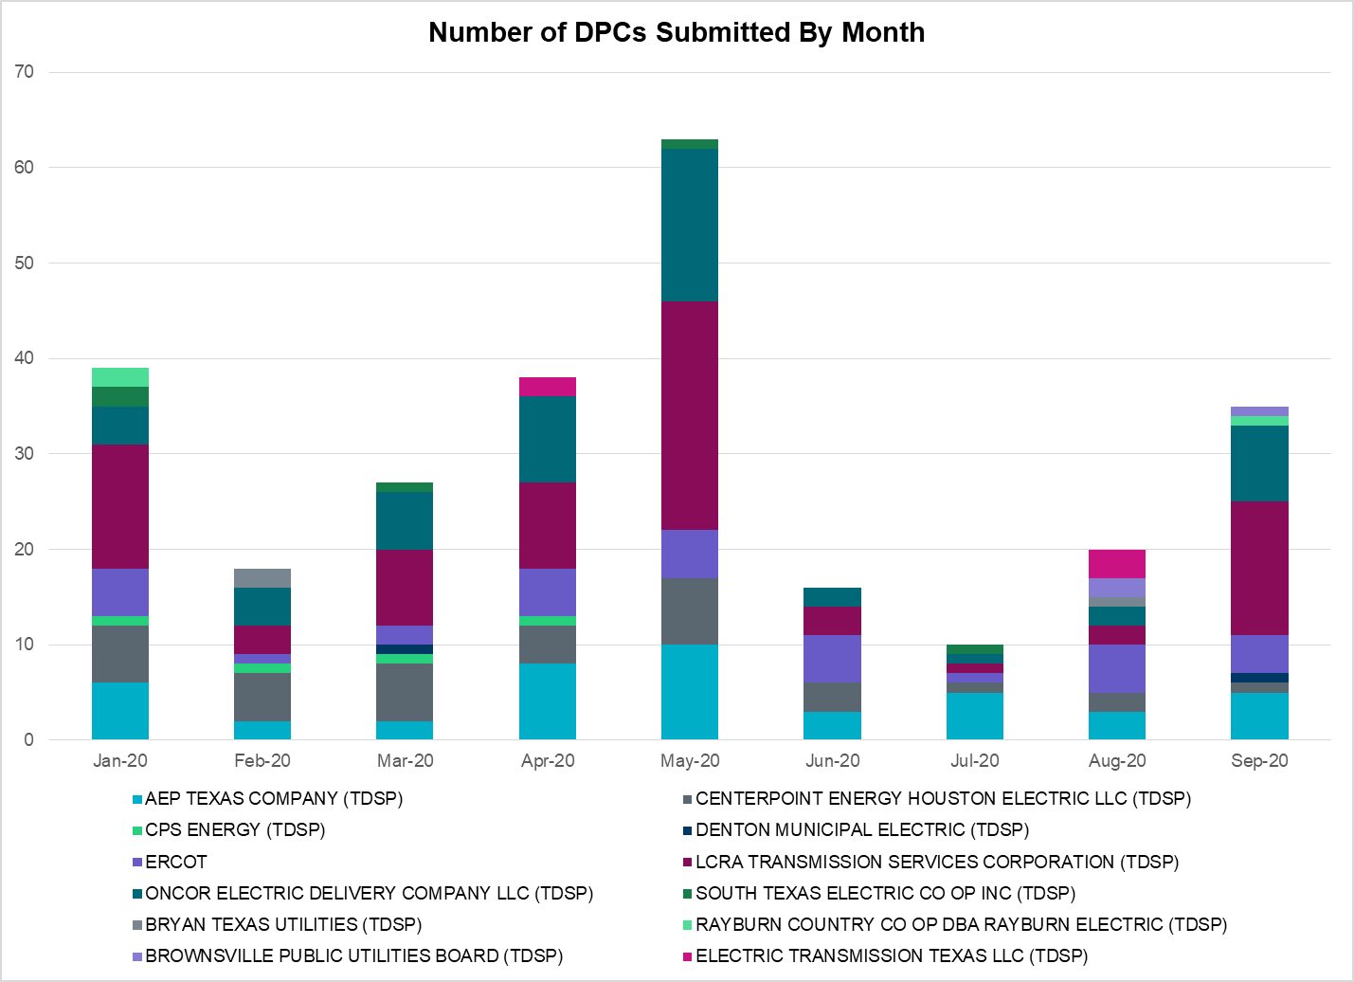

Transmission Operator | Number of DPCs
AEP TEXAS COMPANY (TDSP) | 5
BRAZOS ELECTRIC POWER CO OP INC (TDSP) | 0
BROWNSVILLE PUBLIC UTILITIES BOARD (TDSP) | 1
BRYAN TEXAS UTILITIES (TDSP) | 0
CENTERPOINT ENERGY HOUSTON ELECTRIC LLC (TDSP) | 1
CITY OF AUSTIN DBA AUSTIN ENERGY (TDSP) | 0
CITY OF COLLEGE STATION (TDSP) | 0
CITY OF GARLAND (TDSP) | 0
CPS ENERGY (TDSP) | 0
DENTON MUNICIPAL ELECTRIC (TDSP) | 1
ELECTRIC TRANSMISSION TEXAS LLC (TDSP) | 3
ERCOT | 4
LCRA TRANSMISSION SERVICES CORPORATION (TDSP) | 14
ONCOR ELECTRIC DELIVERY COMPANY LLC (TDSP) | 8
RAYBURN COUNTRY CO OP DBA RAYBURN ELECTRIC (TDSP) | 1
SHARYLAND UTILITIES LP (TDSP) | 0
SOUTH TEXAS ELECTRIC CO OP INC (TDSP) | 0
TEXAS MUNICIPAL POWER AGENCY (TDSP) | 0
TEXAS-NEW MEXICO POWER CO (TDSP) | 0

Appendix A: Real-Time Constraints
The following is a complete list of constraints activated in SCED. Full contingency descriptions can be found in the Standard Contingencies List located on the MIS secure site at Grid Generation Reliability Unit Commitment.

Contingency Name | Overloaded Element | From Station | To Station | Count of Days
BASE CASE | PNHNDL | n/a | n/a | 23
SBOSELM5 | 1030__B | BOSQUESW | RGH | 15
SPIGSOL8 | FTST_TOMBST1_1 | TOMBSTNE | FTST | 15
BASE CASE | NE_LOB | n/a | n/a | 15
SPIGSOL8 | FTST_TOMBST1_1 | FTST | TOMBSTNE | 15
SARRLOT8 | FTST_TOMBST1_1 | TOMBSTNE | FTST | 15
SARRLOT8 | FTST_TOMBST1_1 | FTST | TOMBSTNE | 15
SMV_PAR8 | RIOHND_ERIOHND_1 | MV_RIOHO | RIOHONDO | 13
DFERGRM8 | 318T313_1 | WIRTZ | JOHNCI | 13
SARRLOT8 | LYNX_RIOPEC1_1 | LYNX | RIOPECOS | 12
SARRLOT8 | LYNX_RIOPEC1_1 | RIOPECOS | LYNX | 12
SHACPB38 | LYNX_TOMBST1_1 | LYNX | TOMBSTNE | 12
SPIGSOL8 | LYNX_RIOPEC1_1 | LYNX | RIOPECOS | 11
SHACPB38 | LYNX_RIOPEC1_1 | RIOPECOS | LYNX | 11
SPIGSOL8 | LYNX_RIOPEC1_1 | RIOPECOS | LYNX | 11
DFERSTA8 | 318T313_1 | WIRTZ | JOHNCI | 10
SBRAUVA8 | HAMILT_MAVERI1_1 | HAMILTON | MAVERICK | 9
BASE CASE | MCCAMY | n/a | n/a | 9
SSANFOW5 | SANMIGL_ATAH | SANMIGL | SANMIGL | 7
SMCEESK8 | ESKSW_TRNT1_1 | ESKSW | TRNT | 7
BASE CASE | RAMBLER_GENTIE_1 | TWINBU | RAMBLER | 6
DWAPHLJ5 | STPWAP39_1 | STP | WAP | 6
DMARPA_8 | 318T313_1 | WIRTZ | JOHNCI | 6
BASE CASE | RAMBLER_GENTIE_1 | RAMBLER | TWINBU | 6
SFORYEL8 | HEXT_YELWJC1_1 | YELWJCKT | HEXT | 6
SFORYEL8 | HEXT_YELWJC1_1 | HEXT | YELWJCKT | 6
DCRLLSW5 | 588_A_1 | LWSVW | LWVTI | 5
DHCKSAG8 | 6265__A | EMSES | MRSDO | 5
DHWIND89 | MORRIS_NUECES1_1 | NUECES_B | MORRIS | 5
DWAP_JN5 | OB_WAP98_A | WAP | OB | 5
SMDOPHR5 | 138_ALV_MNL_1 | ALVIN | MAINLAND | 5
BASE CASE | BEARKT | n/a | n/a | 5
SILLFTL8 | HAMILT_MAXWEL1_1 | MAXWELL | HAMILTON | 5
SFORYEL8 | HEXT_MASONS1_1 | MASONSW | HEXT | 4
DJEWSNG5 | 256_A_1 | TOKSW | GIBCRK | 4
DBERWE58 | H3_K0_1 | K0 | H3 | 4
SVICCO28 | COLETO_VICTOR2_1 | COLETO | VICTORIA | 4
SSTABS18 | 6144__A | BSPRW | STASW | 4
SLOBSA25 | NLARSW_PILONC1_1 | NLARSW | PILONCIL | 4
BASE CASE | NELRIO | n/a | n/a | 4
DGIBTOK5 | JK_CK_TABOR_1 | JK_CK | TABOR | 4
SBRAHAM8 | HAMILT_MAVERI1_1 | HAMILTON | MAVERICK | 4
SFORYEL8 | HEXT_MASONS1_1 | HEXT | MASONSW | 4
SMDOOAS5 | OB_WAP98_A | WAP | OB | 4
SLYNRIO8 | TNAF_FTS_1 | FTST | TNAF | 4
DAUSDUN8 | CKT_972_1 | HWRDLN | MCNEIL | 4
DGRSPKR5 | 6377__A | BRTSW | ORANS | 3
SCOMKEN8 | 115T123_1 | KENDAL | KERRST | 3
SN_SLON5 | CELANE_KLEBER1_1 | CELANEBI | KLEBERG | 3
MFTSLYN8 | TNAF_FTS_1 | FTST | TNAF | 3
SBRAUVA8 | GANSO_MAVERI1_1 | MAVERICK | GANSO | 3
DJCKDOW5 | FP_SRF59_A | FP | SRF | 3
SCMNCPS5 | 651__B | CMNSW | CMNTP | 3
SRAYRI28 | RAYMND2_69A1 | RAYMND2 | RAYMND2 | 3
DODEMOS5 | ODEHV_MR2H | ODEHV | ODEHV | 3
DFLCMGS5 | TALLCITY_TELPR_1 | TELPH_RD | TALLCITY | 3
SJNWA1P5 | OB_WAP98_A | WAP | OB | 3
SCOLBAL8 | BALLIN_HUMBLT1_1 | BALLINGE | HUMBLTAP | 2
DBONNED5 | BURNS_RIOHONDO_1 | RIOHONDO | MV_BURNS | 2
SPORGIB8 | RINCON_WHITE_2_1 | WHITE_PT | RINCON | 2
DEVRCPS5 | 800__C | DCSES | GODLY | 2
SLAQLOB8 | BRUNI_69_1 | BRUNI | BRUNI | 2
DWAPHLJ5 | DOWJCK27_A | JCK | DOW | 2
DWAP_JN5 | OB_WAP99_A | WAP | OB | 2
SSPUASP8 | ROTN_WOLFGA1_1 | WOLFGANG | ROTN | 2
DODESLT8 | TALLCITY_TELPR_1 | TELPH_RD | TALLCITY | 2
MRIOLYN8 | TNAF_FTS_1 | FTST | TNAF | 2
DODEMOS5 | 6475__F | ODESA | ODNTH | 2
DCPSJON5 | 6017__A | MBDSW | DCSES | 2
BASE CASE | N_TO_H | n/a | n/a | 2
SSILPRI8 | SILASRAY_T1 | SILASRAY | SILASRAY | 2
DBIGKEN5 | TREADW_YELWJC1_1 | TREADWEL | YELWJCKT | 2
SBRAUVA8 | ESCOND_GANSO1_1 | GANSO | ESCONDID | 2
DGRMGRS8 | 6830__B | CRDSW | OLNEY | 2
DFLCMGS5 | 6462__C | MCNSW | MKNGB | 2
SLOBSA25 | ASHERT_CATARI1_1 | ASHERTON | CATARINA | 2
XNED258 | NEDIN_138H | NEDIN | NEDIN | 2
BASE CASE | W_TO_C | n/a | n/a | 2
DRILBOW5 | 6011__B | RILEY | FSHSW | 2
DRILKRW5 | 6085__E | WFSSW | NSTAR | 2
DMTSCOS5 | 6437__F | SCRCV | KNAPP | 2
MHARRIO5 | BURNS_RIOHONDO_1 | RIOHONDO | MV_BURNS | 2
MHARNED5 | HAINE__LA_PAL1_1 | LA_PALMA | HAINE_DR | 2
SKLELOY8 | LOYOLA_69_1 | LOYOLA | LOYOLA | 2
DWAPHLJ5 | 155T217_1 | BELLSO | PT | 1
DJCKDOW5 | SRFVL_59_A | SRF | VL | 1
SAVMBSP8 | 6610__A | BUZSW | CHATP | 1
DBIGKEN5 | HAMILT_MAXWEL1_1 | MAXWELL | HAMILTON | 1
DELMSAN5 | MAGRUD_VICTOR2_1 | VICTORIA | MAGRUDER | 1
DCAGCI58 | 255T279_1 | PIPECR | MEDILA | 1
SCMNCPS5 | 651__C | CMNTP | SHILO | 1
BASE CASE | ALPINE_BRONCO1_1 | BRONCO | ALPINE | 1
SSOLFTS8 | ALPINE_BRONCO1_1 | BRONCO | ALPINE | 1
BASE CASE | BURNS_RIOHONDO_1 | RIOHONDO | MV_BURNS | 1
SMCCGIB8 | RINCON_WHITE_2_1 | RINCON | WHITE_PT | 1
SMELRIN8 | HEARDT_WOODSB1_1 | WOODSBOR | HEARDTAP | 1
DSTPWHI5 | NCARBI_SEADRF1_1 | NCARBIDE | SEADRFTC | 1
SMDOOAS5 | OB_WAP99_A | WAP | OB | 1
SSKYSB28 | TALLCITY_TELPR_1 | TELPH_RD | TALLCITY | 1
SREFB8 | BM_HY_09_A | BM | HY | 1
SLCDYN8 | EB_WA_65_A | EB | WA | 1
SLOBSA25 | LARDVN_LASCRU1_1 | LARDVNTH | LASCRUCE | 1
SN_SLON5 | N_SHARPE_PS3 | N_SHARPE | N_SHARPE | 1
DCAGCO58 | 656T656_1 | KENDAL | BERGHE | 1
DWAP_BM8 | BM_HY_09_A | BM | HY | 1
XCAG158 | CAGNON_MR4H | CAGNON | CAGNON | 1
DBERBO58 | H3_K0_1 | K0 | H3 | 1
DZORHAY5 | H3_K0_1 | K0 | H3 | 1
SODLBRA8 | HAMILT_MAVERI1_1 | HAMILTON | MAVERICK | 1
SCOMHA38 | HAMILT_MAXWEL1_1 | MAXWELL | HAMILTON | 1
SLGEI_D8 | I_DUPS_LGE1_1 | LGE | I_DUPSW | 1
DWH_STP5 | NCARBI_SEADRF1_1 | NCARBIDE | SEADRFTC | 1
XOKL58 | VERN_69T1 | VERN | VERN | 1
SBOMJC25 | 6085__E | WFSSW | NSTAR | 1
DCAGCI58 | 656T656_1 | KENDAL | BERGHE | 1
SN_SLON5 | CELANE_N_SHAR1_1 | N_SHARPE | CELANEBI | 1
SLCDYN8 | GEBWA_65_A | WA | GEB | 1
SGODLON5 | NCARBI_SEADRF1_1 | NCARBIDE | SEADRFTC | 1
DELMSAN5 | PAWNEE_SPRUCE_1 | PAWNEE | CALAVERS | 1
DPRSVLS5 | PRSSW_MR1H | PRSSW | PRSSW | 1
DSTEXP12 | BLESSI_LOLITA1_1 | LOLITA | BLESSING | 1
SPIGTAY8 | LYNX_RIOPEC1_1 | LYNX | RIOPECOS | 1
BASE CASE | NEDIN_138H | NEDIN | NEDIN | 1
DCPSST58 | 651__C | CMNTP | SHILO | 1
SCMNCPS5 | 651__F | SHILO | HAS | 1
DLONOR58 | BESSEL_LON_HI1_1 | LON_HILL | BESSEL | 1
SMELRIN8 | BONIVI_RINCON1_1 | RINCON | BONIVIEW | 1
MHARRIO5 | HAINE__LA_PAL1_1 | LA_PALMA | HAINE_DR | 1
SLYNRIO8 | RIOPEC_WOODW21_1 | WOODWRD2 | RIOPECOS | 1
SCISPUT8 | SOUTHA_VINSON1_1 | SOUTHABI | VINSON | 1
DPRSVLS5 | 1561__A | DPREA | RCSES | 1

This is the hourly integrated peak demand as published in the ERCOT D&E report.
All DC Tie Curtailments are posted publically on the ERCOT Market Information System. See that posting for additional details for the event(s) in question.
See DC Tie Operating Procedure (http://www.ercot.com/mktrules/guides/procedures) for more details.

