System Planning
Monthly Status Report

Report Highlights

- ERCOT is currently reviewing proposed transmission improvements with a total estimated cost of $1,057.3 Million as of September 30, 2020.
- Transmission Projects endorsed in 2020 total $842.51 Million as of September 30, 2020.
- All projects (in engineering, routing, licensing and construction) total approximately $7.26 Billion as of June 1, 2020.
- Transmission Projects energized in 2020 total about $1.06 Billion as of June 1, 2020.

Regional Planning Group Reviews
- AEPSC has submitted the LRGV Import Project. This is a Tier 1 project that is estimated to cost $73.4 million. AEPSC has also requested that ERCOT provide a conditional endorsement for an additional $357.2 million project. The ERCOT Independent Review has been conducted in accordance with Protocol Section 3.11.4.9(3), and this project is currently placed on hold until the LNG loads are confirmed.
- STEC has submitted the Lower Rio Grande Valley Transmission Expansion Project. This is a Tier 1 project that is estimated to cost $511 million. The ERCOT Independent Review has been conducted in accordance with Protocol Section 3.11.4.9(3), and this project is currently placed on hold until the LNG loads are confirmed.
- TNMP has submitted the Texas City Transmission Improvement Project. This is a Tier 2 project that is estimated to cost $29.3 million. ERCOT completed the independent review on September 16 and has issued an endorsement letter.
- BEC has submitted the Moffat to Hasse Voltage Conversion Project. This is a Tier 2 project that is estimated to cost $55.2 million. This project is currently under ERCOT Independent Review.
- Oncor has submitted the Everman Switching Station Rebuild Project. This is a Tier 3 project that is estimated to cost $36 million. This project completed the RPG review on September 10, and ERCOT has issued an acceptance letter.
- AEPSC has submitted the Coleto Creek to Kenedy SS 138-kV Transmission Project. This is a Tier 3 project that is estimated to cost $54.7 million. This project completed the RPG review on September 11, and ERCOT has issued an acceptance letter.
- CNP has submitted the Mont Belvieu Reliability Upgrades Project. This is a Tier 3 project that is estimated to cost $27.28 million. This project completed the RPG review on September 24, and ERCOT will issue an acceptance letter.
- Oncor has submitted the Tall City – Telephone Road 138-kV Line Rebuild Project. This is a Tier 3 project that is estimated to cost $23.5 million. This project is currently in the RPG comment period.
- AEPSC has submitted the Alamito Creek to Alpine 69-kV Line Rebuild Transmission Project. This is a Tier 3 project that is estimated to cost $37 million. This project is currently in the RPG comment period.

More information on current and past RPG projects can be found on the ERCOT MIS Secure (digital certificate required): https://mis.ercot.com/pps/tibco/mis/Pages/Grid+Information/RegionalPlanning
Past email communication on RPG projects can be found on the ERCOT listserve by signing up for the REGPLANGROUP list: http://lists.ercot.com/scripts/wa-ERCOT.exe?A0=REGPLANGROUP

Planning Model Activities
The short-term calendar of major planning model events is as follows:
- By Oct 15, 2020 20SSWG Update 1 cases and TPIT are posted
- By Oct 31, 2020 20SSWGU1 Contingency definitions and Planning Data Dictionary are posted
The following table shows interconnection projects that met Planning Guide section 6.9(1) and 6.9(2) and were modeled in the SSWG cases as a full model or as a simple model in accordance with Planning Guide section 6.9.

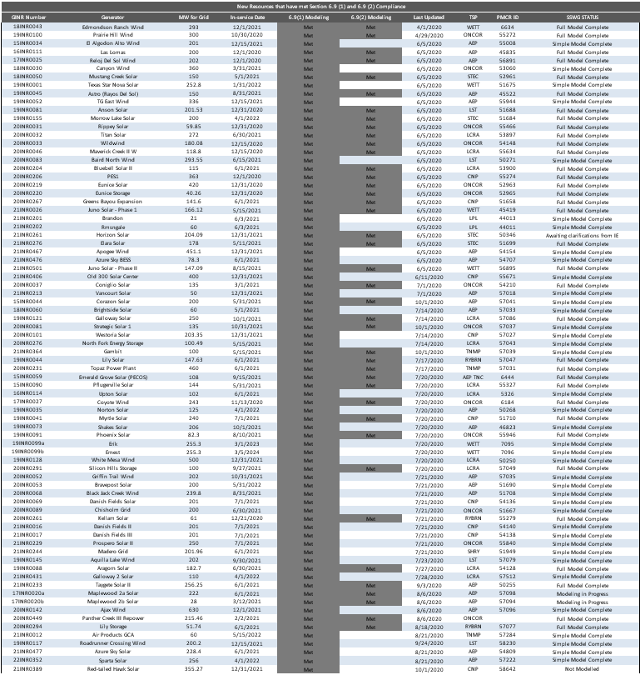

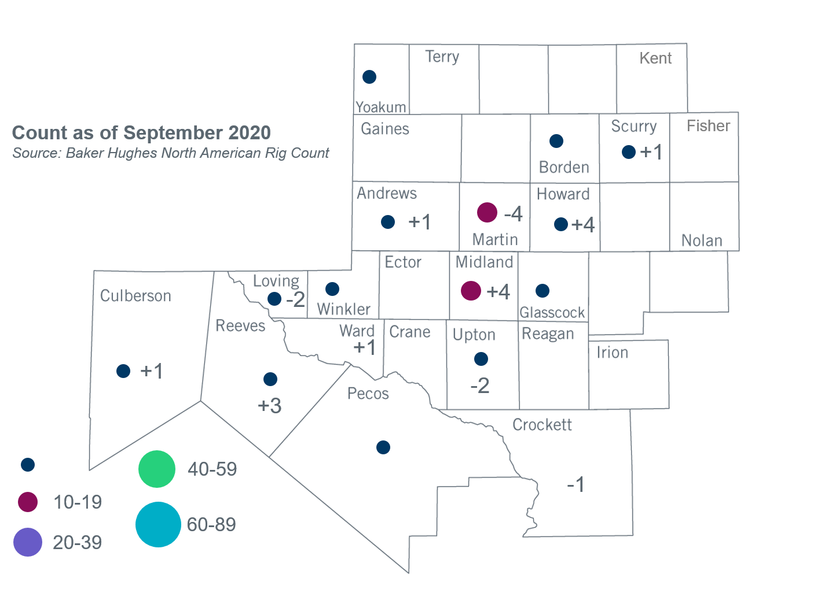
Permian Basin Oil Rig Count
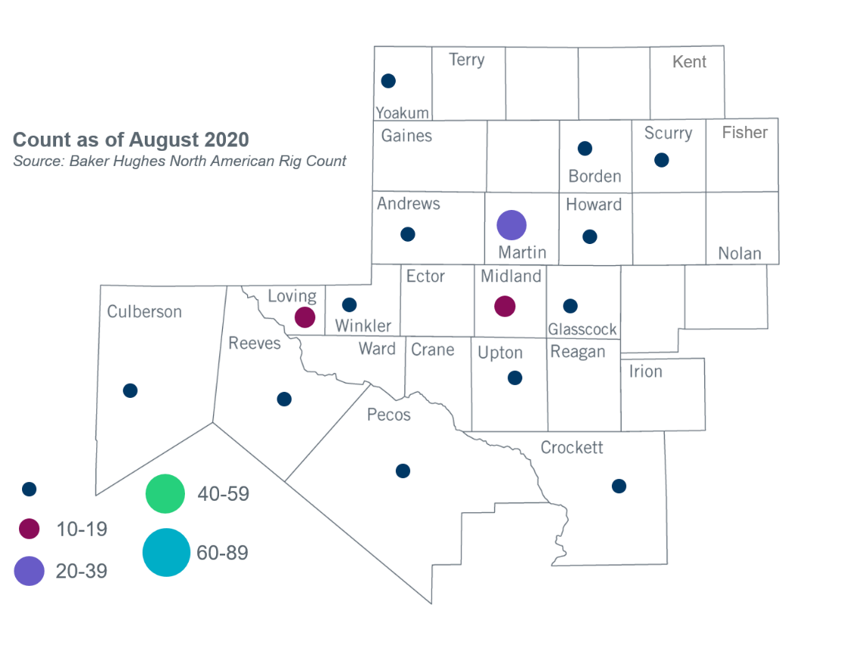

Other Notable Activities
- ERCOT presented plans for 2020 Regional Transmission Plan (RTP) reliability sensitivity analysis to the Regional Planning Group (RPG) in September.
- ERCOT engaged in discussion of near-term and long-term proposals for including distributed energy resources (DER) in planning models with SSWG and DWG at meetings held in July and August. An update on the status of those discussions was presented to RPG in September.
- ERCOT presented an update on the 2020 Long-Term System Assessment (LTSA) to RPG in September.
- ERCOT will conduct a special study to develop a potential roadmap of transmission solutions for West Texas export constraints. ERCOT presented the study scope of the Long-Term West Texas Export Special Study to the RPG in September and asked for stakeholders’ comments by September 30, 2020.

+/- symbol indicates the increase or decrease from the previous month in oil rigs present in each county. There are 85 rigs, including a total increase of 7 oil rigs, in the Permian Basin from August to September 2020.

