August 2020 ERCOT Monthly Operations Report
Reliability and Operations Subcommittee Meeting
October 8, 2020

Table of Contents
1. Report Highlights 2
2. Frequency Control 3
2.1. Frequency Events 3
2.2. Responsive Reserve Events 4
2.3. Load Resource Events 4
3. Reliability Unit Commitment 4
4. Wind Generation as a Percent of Load 5
5. Largest Net-Load Ramp 5
6. COP Error Analysis 6
7. Congestion Analysis 8
7.1. Notable Constraints 8
7.2. Generic Transmission Constraint Congestion 12
7.3. Manual Overrides 12
7.4. Congestion Costs for Calendar Year 2020 12
8. System Events 14
8.1. ERCOT Peak Load 14
8.2. Load Shed Events 14
8.3. Stability Events 14
8.4. Notable PMU Events 14
8.5. DC Tie Curtailment 14
8.6. TRE/DOE Reportable Events 14
8.7. New/Modified/Removed RAS 14
8.8. New Procedures/Forms/Operating Bulletins 14
9. Emergency Conditions 15
9.1. OCNs 15
9.2. Advisories 15
9.3. Watches 15
9.4. Emergency Notices 15
10. Application Performance 15
10.1. TSAT/VSAT Performance Issues 15
10.2. Communication Issues 15
10.3. Market System Issues 16
11. Model Updates 16
Appendix A: Real-Time Constraints 18

Report Highlights
- The unofficial ERCOT peak was 74,328 MW.
- There were 3 frequency events.
- There were 2 instances where Responsive Reserves were deployed.
- There were 9 RUC commitments.
- Congestion in the Panhandle can be attributed to high wind generation as well as Transmission Outages. There were 26 days of congestion on the Panhandle GTC, 18 days on the McCamey GTC, 11 days on the North Edinburg to Lobo GTC, and 11 days on Bearkat GTC. There was no activity on the remaining GTCs during the month.
- There were 3 DC Tie curtailments.

Frequency Control

Frequency Events
The ERCOT Interconnection experienced three frequency events, which resulted from unit’s trips. The average event duration was 00:05:08.

A summary of the frequency events is provided below. The reported frequency events meet one of the following criteria: Delta Frequency is 60 mHz or greater; the MW loss is 350 MW or greater; resource trip event triggered RRS deployment. Frequency events that have been identified as Frequency Measurable Events (FME) for purposes of BAL-001-TRE-1 analysis are highlighted in blue. When analyzing frequency events, ERCOT evaluates PMU data according to industry standards. Events with an oscillating frequency of less than 1 Hz are considered to be inter-area, while higher frequencies indicate local events. Industry standards specify that damping ratio for inter-area oscillations should be 3.0% or greater. For the frequency events listed below, the ERCOT system met these standards and transitioned well after each disturbance.

Date and Time | Delta Frequency | Max/Min Frequency | Duration of Event | PMU Data |  | MW Loss | Load | Wind | Inertia
 | (Hz) | (Hz) |  | Oscillation Mode (Hz) | Damping Ratio |  | (MW) | % | (GW-s)
8/9/2020 15:23 | 0.071 | 59.910 | 0:07:53 | No PMU Data Available |  | 456.78 | 67,212 | 22% | 323,532
8/16/2020 21:53 | 0.080 | 59.938 | 0:02:10 | No PMU Data Available |  | 449.61 | 58,612 | 22% | 349,497
8/22/2020 23:46 | 0.114 | 59.883 | 0:05:21 | No PMU Data Available |  | 664.48 | 45,225 | 27% | 290,745

(Note: All data on this graph encompasses frequency event analysis based on BAL-001-TRE-1.)

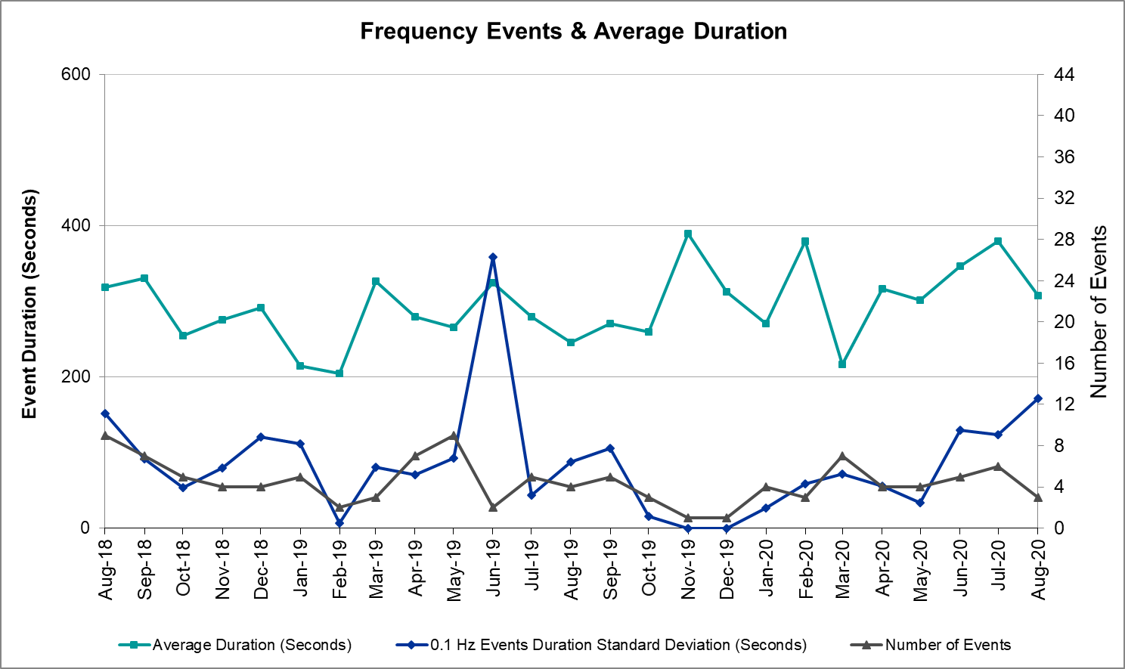

Note that the large standard deviation in June 2019 is due to coincidental extreme high and low durations for a small set of events (2).

Responsive Reserve Events
There were 2 events where Responsive Reserve MWs were released to SCED. The events highlighted in blue were related to frequency events reported in Section 2.1 above.

Date and Time Released to SCED | Date and Time Recalled | Duration of Event | Maximum MWs Released | Comments
8/2/2020 15:17:56 | 8/2/2020 15:22:19 | 00:04:23 | 725 | Frequency dragged to 59.899 Hz mainly due to under generation from Thermal resources and a solar ramp down of about 540 MW across a 4 minute period. Wind was on a slight up ramp and the available 215 MW of regulation up was fully deployed.
8/22/2020 23:47:04 | 8/22/2020 23:51:32 | 00:04:28 | 587

Load Resource Events
No Load Resource Events.

Reliability Unit Commitment
ERCOT reports on Reliability Unit Commitments (RUC) on a monthly basis. Commitments are reported grouped by operating day and weather zone. The total number of hours committed is the sum of the hours for all the units in the specified region. Additional information on RUC commitments can be found on the MIS secure site at Grid Generation Reliability Unit Commitment.

There were no DRUC commitments.

There were 9 HRUC commitments.

Resource Location | # of Resources | Operating Day | Total # of Hours Committed | Total MWhs | Reason for Commitment
Southern | 1 | 8/1/2020 | 24 | 7,486 | XNED258
Southern | 1 | 8/2/2020 | 15 | 4,671 | XNED258
Southern | 1 | 8/3/2020 | 15 | 4,681 | XNED258
Southern | 1 | 8/4/2020 | 24 | 7,734 | XNED258
Southern | 1 | 8/5/2020 | 24 | 7,730 | XNED258
Southern | 1 | 8/6/2020 | 24 | 7,667 | XNED258
Southern | 1 | 8/7/2020 | 16 | 5,119 | XNED258
Southern | 1 | 8/8/2020 | 9 | 2,846 | XNED258
North Central | 1 | 8/12/2020 | 8 | 976 | DCDHMCS8

Wind Generation as a Percent of Load

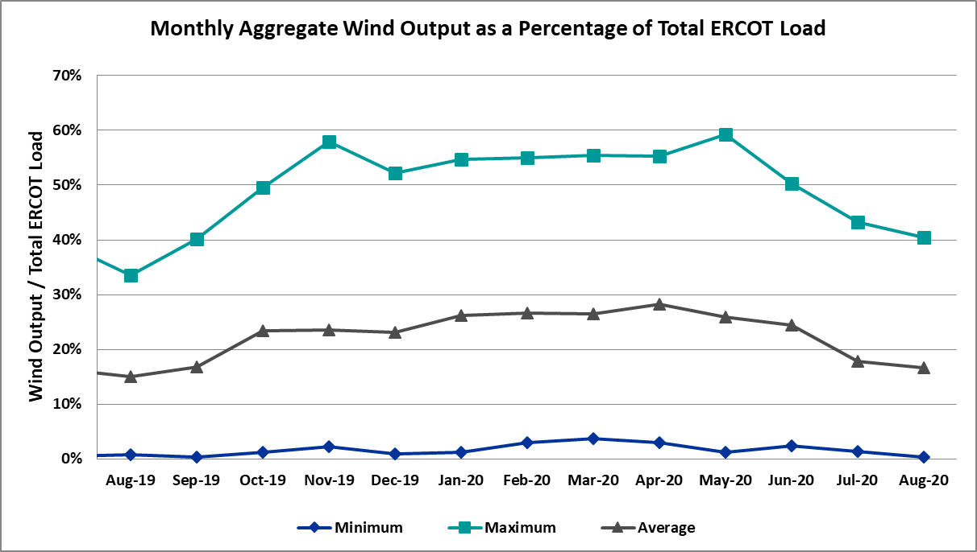

Wind Generation Record: 21,375 MW on 6/8/2020 at 23:22
Wind Penetration Record: 59.30% on 05/02/2020 at 02:10

Largest Net-Load Ramp
The net-load ramp is defined as the change in net-load (load minus wind and PVGR generation) during the defined time horizon. Such a variation in net-load needs to be accommodated in grid operations to ensure that the reliability of the grid is satisfactorily maintained. The largest net-load ramp during 5-min, 10-min, 15-min, 30-min and 60-min in August 2020 are 954 MW, 1536 MW, 2221 MW, 4101 MW, and 7690 MW, respectively. The comparison with respect to the historical values is given in the table below.

Month and Year | 5 min | 10 min | 15 min | 30 min | 60 min
August 2020 | 954 MW | 1536 MW | 2221 MW | 4101 MW | 7690 MW
August 2014 | 674 MW | 1169 MW | 1589 MW | 2854 MW | 5201 MW
August 2015 | 776 MW | 1231 MW | 1754 MW | 3303 MW | 6260 MW
August 2016 | 834 MW | 1350 MW | 1881 MW | 3230 MW | 6319 MW
August 2017 | 797 MW | 1421 MW | 1953 MW | 3167 MW | 5798 MW
August 2018 | 1333 MW | 1854 MW | 2780 MW | 3205 MW | 6604 MW
August 2019 | 830 MW | 1460 MW | 2084 MW | 3795 MW | 7375 MW
All Months in 2014-2019 | 1494 MW | 1991 MW | 2780 MW | 4109 MW | 7786 MW

COP Error Analysis
COP Error is calculated as the capacity difference between the COP HSL and real-time HSL of the unit. Mean Absolute Error (MAE) stayed high over 9,000 MW until Day-Ahead at 12:00, then dropped significantly to 3,300 MW by Day-Ahead at 14:00. In the following chart, Under-Scheduling Error indicates that COP had less generation capacity than real-time and Over-Scheduling Error indicates that COP had more generation capacity than real-time. Under-Scheduling persisted from beginning of Day-Ahead to end of the Operating Day. 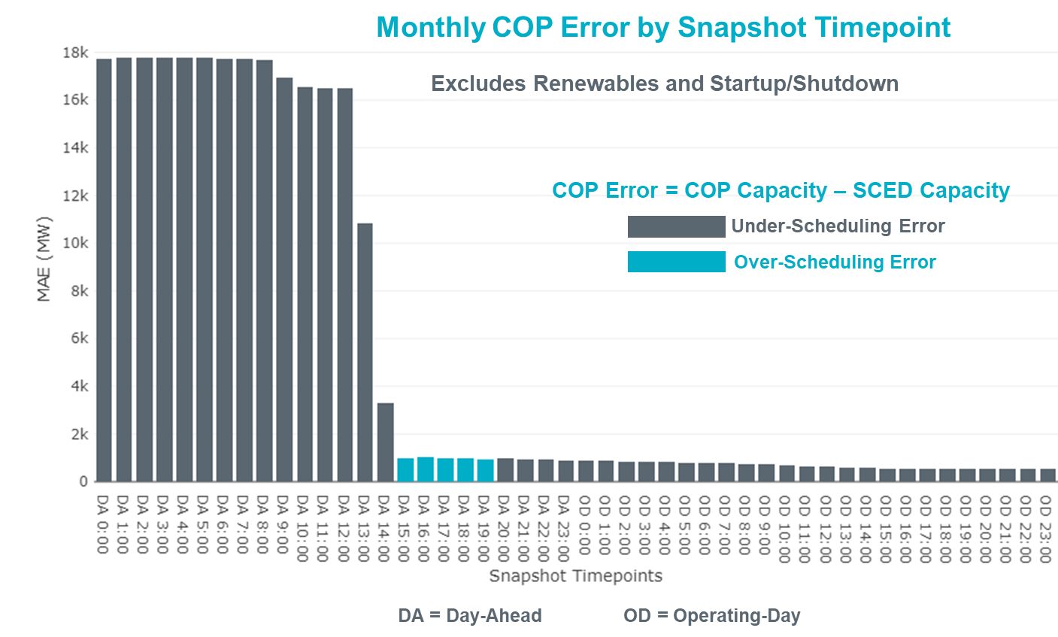
Monthly MAE for the Latest COP at the end of the Adjustment Period was 437 MW with median ranging from -1,070 MW for Hour-Ending (HE) 19 to 193 MW for HE 24. HE 4 on the 9th had the largest Over-Scheduling Error (1,134 MW) and HE 21 on the 31st had the largest Under-Scheduling Error (-3,865.2 MW).
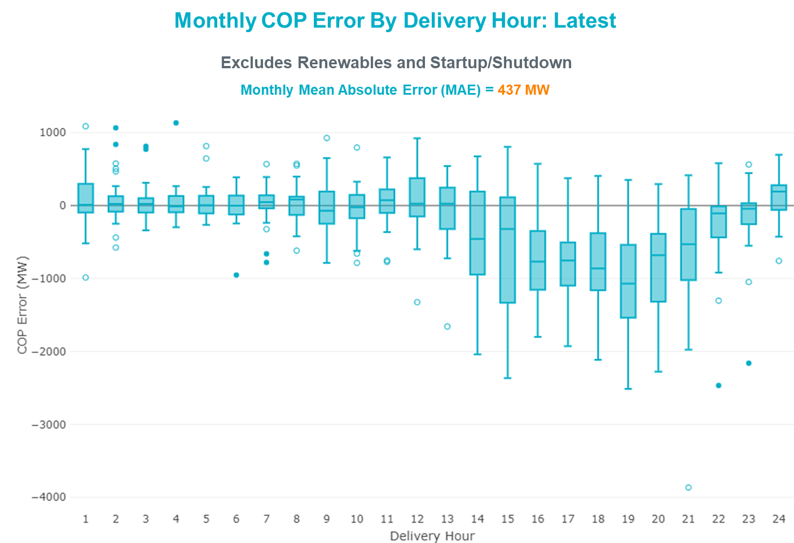

Monthly MAE for the Day-Ahead COP at 12:00 was 16,473 MW with median ranging from -23,661 MW for Hour-Ending (HE) 17 to -11,626 MW for HE 5. HE 16 on the 31st had the largest Under-Scheduling Error (-27,733 MW) and HE 3 on the 7th had the largest Over-Scheduling Error (-5,498 MW).

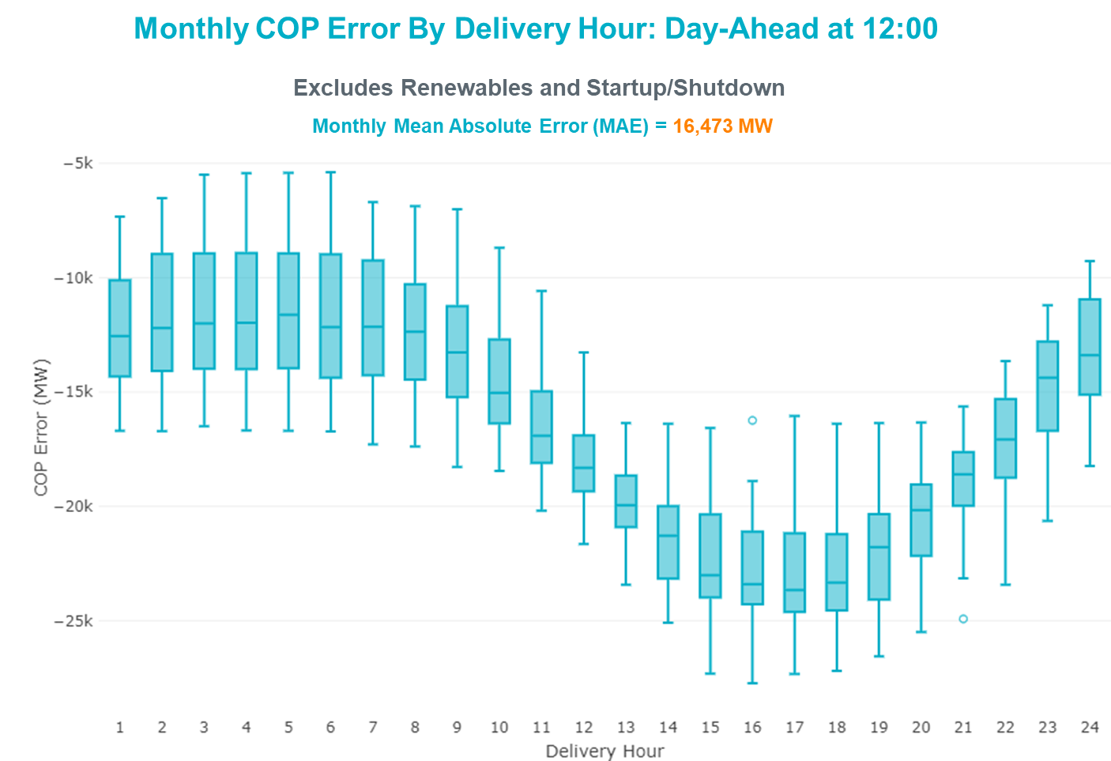

Congestion Analysis

Notable Constraints
Nodal protocol section 3.20 specifies that ERCOT shall identify transmission constraints that are active or binding three or more times within a calendar month. As part of this process, ERCOT reports congestion that meets this criterion to ROS. In addition ERCOT also highlights notable constraints that have an estimated congestion rent exceeding $1,000 for a calendar month. These constraints are detailed in the table below. Rows highlighted in blue indicate the congestion was affected by one or more outages. For a list of all constraints activated in SCED, please see Appendix A at the end of this report.

Contingency Name | Overloaded Element | # of Days Constraint Active | Congestion Rent | Transmission Project
MANUAL Nedin-Mv_Wedn4 Dbl Ckt 138kV | Hidalgo Energy Center - Azteca Sub 138kV | 9 | $44,000,036.71 | Stewart Road: Construct 345 kV cut-in with two 450 MVA 345/138 autotransformers connected to Stewart Rd 138 station (5604, 6382)
WEST EDNBURG SUB to ALTON SUB LIN 1 | Weslaco Switch - North Alamo 138kV | 7 | $32,088,835.35 | Stewart Road: Construct 345 kV cut-in with two 450 MVA 345/138 autotransformers connected to Stewart Rd 138 station (5604, 6382)
NORTH PHARR to WESLACO SWITCH LIN 1 | Key Switch - North Mcallen 138kV | 7 | $27,451,240.28 | Stewart Road: Construct 345 kV cut-in with two 450 MVA 345/138 autotransformers connected to Stewart Rd 138 station (5604, 6382)
WEST EDNBURG SUB to NORTH EDINBURG LIN 1 | North Edinburg - West Ednburg Sub 138kV | 4 | $15,378,806.23 | Stewart Road: Construct 345 kV cut-in with two 450 MVA 345/138 autotransformers connected to Stewart Rd 138 station (5604, 6382)
NORTH EDINBURG TRX 1382 345/138 | North Edinburg 345kV | 8 | $13,965,626.15 | Stewart Road: Construct 345 kV cut-in with two 450 MVA 345/138 autotransformers connected to Stewart Rd 138 station (5604, 6382)
TWR (345) JN-WAP64 & JN-WAP72 | Wa Parish - Obrien 345kV | 9 | $7,601,037.35 | Freeport - Master Plan (6668B)
WEST EDNBURG SUB to ALTON SUB LIN 1 | Moore Field - North Edinburg 138kV | 2 | $7,592,873.26
Basecase | PNHNDL GTC | 26 | $4,726,644.87 | "Panhandle GTC Exit Plan - ""PANHANDLE RENEWABLE ENERGY ZONE (PREZ)
TWR (345) HLJ-WAP64 & BLY-WAP72 | South Texas Project - Wa Parish 345kV | 8 | $4,385,707.03 | Freeport - Master Plan (6668B)
HCKSW TO SAGNA 138 DBLCKT | Eagle Mountain Ses - Morris Dido 138kV | 10 | $3,832,185.62 | Upgrade the Saginaw - Eagle Mountain 138 kV Double Circuit Line (6273)
Basecase | MCCAMY GTC | 18 | $3,248,276.47 | McCamey GTC Exit Plan posted on the ERCOT MIS website (Far West Transmission Project 2)
ODLAW SWITCHYARD to ASPHALT MINES LIN 1 | Hamilton Road - Maverick 138kV | 20 | $2,570,984.68 | Brackettville to Escondido: Construct 138 kV line (5206)
KEY SWITCH to ALTON SUB LIN 1 | Moore Field - North Edinburg 138kV | 2 | $2,192,199.99
KEY SWITCH to ALTON SUB LIN 1 | Weslaco Switch - North Alamo 138kV | 1 | $2,192,151.95 | Stewart Road: Construct 345 kV cut-in with two 450 MVA 345/138 autotransformers connected to Stewart Rd 138 station (5604, 6382)
BATES to PALMHURST LIN 1 | Key Switch - North Mcallen 138kV | 2 | $2,122,767.26 | Stewart Road: Construct 345 kV cut-in with two 450 MVA 345/138 autotransformers connected to Stewart Rd 138 station (5604, 6382)
Basecase | Burns Sub - Rio Hondo 138kV | 4 | $1,919,333.66
Basecase | NE_LOB GTC | 11 | $1,789,110.38 | GTC Exit plan in the North Edinburg - Lobo Stability Study Report posted in the ERCOT MIS website
BATES to PALMHURST LIN 1 | West Ednburg Sub - Alton Sub 138kV | 2 | $1,661,465.94 | New Tres Lagos Substation (6931)
NORTH PHARR to WESLACO SWITCH LIN 1 | West Ednburg Sub - Alton Sub 138kV | 1 | $1,469,202.58 | New Tres Lagos Substation (6931)
ASHERTON to Bevo Substation LIN 1 | Bevo - Brundage Sub 69kV | 8 | $1,349,531.23 | Rebuild BEVO to Brundage to Big Wells 69 kV lines. (6255B)
SAN MIGUEL GEN to FOWLERTON LIN 1 | San Miguel Gen 345kV | 10 | $951,307.18 | San Miguel 345/138 kV autotransformer replacements (5218A, 5218B)
Bighil-Kendal 345kV | Yellow Jacket - Treadwell 138kV | 13 | $819,261.43 | Treadwell GTC Exit Plan posted on the ERCOT MIS website
Koch Upriver - Tortuga & Lon Hill - Nueces Bay 138KV | Champlin - Weil Tract 138kV | 8 | $730,308.43 | Nueces Area 69kV Reinforcement (4487)
COMANCHE SWITCH (Oncor) to COMANCHE PEAK SES LIN _A | Comanche Tap - Comanche Switch (Oncor) 138kV | 8 | $715,440.57
NORTH CARBIDE to SEADRIFT SUB LIN 1 | North Carbide - Port Lavaca Tap 69kV | 9 | $668,325.84
MCCARTY LANE to REDWOOD LIN 1 | Mccarty Lane - Ranch Road 12 138kV | 4 | $641,986.50 | McCarty Lane - Ranch Road 12 Transmission Line Upgrade (54105)
CDHSW TO VENSW 345 AND CDHSW TO EVRSW 345 DBLCKT | Fish Creek Switch - Cedar Hill Switch 138kV | 4 | $495,028.79
Bighil-Kendal 345kV | Bondroad - Sonora 69kV | 8 | $426,533.02 | Friess Ranch to Sonora: Rebuild 69 kV line (51001)
Basecase | BEARKT GTC | 11 | $401,915.34 | Bearkat Loop - Bearkat to Longshore (45399) - Bearkat GTC Exit Strategy
DMTSW TO SCOSW 345 DBLCKT | Knapp - Scurry Chevron 138kV | 5 | $374,159.40 | Ennis Creek - Cogdell 69 kV Line (4554) & Ennis Creek 138 kV Switching Station (6269)
TWR (345) JN-WAP64 & JN-WAP72 | Wa Parish - Obrien 345kV | 5 | $358,468.16 | Freeport - Master Plan (6668B)
wett_sand_bluff to wett_bearkat LIN 1 | Carterville - Einstein 138kV | 15 | $347,862.72 | Bearkat Loop - Bearkat to Longshore (45399)
DUPONT SWITCH - INGLESIDE to GREGORY POWER LIN 1 | Dupont Switch - Ingleside - Lge 138kV | 19 | $249,767.50 | North Shore: 345 kV (Chienere LNG) RPG (50966)
CHB-KG & CBY-JOR 345kV | Langston - Mont Belvieu 138kV | 5 | $249,687.05 | Mont Belvieu Reliability Project (56003 A-G)
MBDSW TO DCSES AND MBDSW TO RKCRK 345 DBLCKT | Comanche Tap - Comanche Switch (Oncor) 138kV | 3 | $217,164.83
FORT LANCASTER to ILLINOIS #4 LIN 1 | Hamilton Road - Maxwell 138kV | 18 | $168,594.04 | Hamilton Road to Picacho ckt #2, rebuild 138 kV line (6373)
BIG SPRING SWITCH TRX FMR1 138/69 | Chevron Ackerly Tap - Buzzard Draw Switch 69kV | 4 | $162,762.75 | Big Spring - Buzzard Draw 69 kV Line Conversion (46259)
B_Davis-Airline&Rodd_Fld 138kV | Naval Base - Barney Davis 138kV | 7 | $140,443.41
ODEHV-MOSSW 345&ODEHV-WLFSW 345_DBLCKT | Trigas Odessa Tap - Odessa Ehv Switch 138kV | 5 | $127,208.29 | Riverton-Odessa EHV/Moss 345 kV Line (5445)
BRACKETTVILLE to HAMILTON ROAD LIN 1 | Hamilton Road - Maverick 138kV | 8 | $126,178.43 | Brackettville to Escondido: Construct 138 kV line (5206)
FORT LANCASTER to ILLINOIS #4 LIN 1 | Carver - Tinsley Tap 138kV | 3 | $103,006.92 | Carver - Maxwell: Line Rebuild (52070)
OKLAUNION TRX OKLA_3_1 345/138 | Southwest Vernon - Sand Road 69kV | 4 | $94,737.37
Gibcrk-Toksw & Jk_Ck 345kV | Btu_Jack_Creek - Btu_Tabor 138kV | 4 | $79,848.71
PAREDES SWITCHING STATION to CENTRAL AVENUE SUB LIN 1 | Rio Hondo - East Rio Hondo Sub 138kV | 13 | $74,459.84 | Rebuild Rio Hondo to East Rio Hondo (6687)
LAQUINTA to LOBO LIN 1 | Bruni Sub 138kV | 3 | $70,542.24
Elmcreek-Sanmigl 345kV | Pawnee Switching Station - Calaveras 345kV | 3 | $62,331.77
VICTORIA TRX 69A2 138/69 | Magruder - Victoria 138kV | 3 | $50,540.98 | Port Lavaca - Victoria: Line Rebuild (50876)
SAN MIGUEL 345_138 KV SWITCHYARDS to LOBO LIN 1 | Laredo Vft North - Las Cruces 138kV | 3 | $46,872.68 | Laredo - Del Mar: 138 kV Line Rebuild (45511)
GUNSIGHT SWITCH to GETTY VEALMOOR TAP LIN _A | Chevron Ackerly Tap - Buzzard Draw Switch 69kV | 8 | $45,654.59 | Big Spring - Buzzard Draw 69 kV Line Conversion (46259)
Fergus-Granmo&Wirtz-Starck 138kV | #N/A | 10 | $42,778.76
Bighil-Kendal 345kV | Hamilton Road - Maxwell 138kV | 12 | $35,677.38 | Hamilton Road to Picacho ckt #2, rebuild 138 kV line (6373)
OASIS to MEADOW LIN A | Wa Parish - Obrien 345kV | 5 | $28,501.58 | Freeport - Master Plan (6668B)
I_DUPSW-MCCAMPBE #1 & HECKER | Dupont Switch - Ingleside - Mccampbell 138kV | 3 | $25,324.91 | North Shore: 345 kV (Chienere LNG) RPG (50966)
Solstice to FORT STOCKTON PLANT LIN 1 | Alpine - Bronco 69kV | 5 | $15,243.44 | Solstice: Build 345 kV station (5530)
CISCO to PUTNAM 138kv LIN 1 | Abilene South - Vinson 138kV | 3 | $11,061.09
BOSQUE SWITCH to ELM MOTT LIN 1 | Bosque Switch - Rogers Hill Bepc 138kV | 12 | $9,781.48 | Upgrade Elm Mott - Bosque 138 kV Line (52149)
ODEHV-MOSSW 345&ODEHV-WLFSW 345_DBLCKT | Fort Stockton Plant - Solstice 138kV | 5 | $6,822.80 | Solstice: Build 345 kV station (5530)
Pig Creek to Solstice LIN 1 | Lynx - Rio Pecos 138kV | 3 | $6,714.42 | Rebuild Rio Pecos-Lynx Ckt 2 (1926 ACSS) (54255)
SAN MIGUEL 345_138 KV SWITCHYARDS to LOBO LIN 1 | North Laredo Switch - Piloncillo 138kV | 3 | $4,438.49 | GTC Exit plan in the North Edinburg - Lobo Stability Study Report posted in the ERCOT MIS website
COLETO CREEK to PAWNEE SWITCHING STATION LIN 1 | Loop 463 Sub - Victoria 138kV | 4 | $4,133.20
Austro-Daffin&Dunlap-Decker 138kV | Mcneil Aen - Howard Lane Aen 138kV | 3 | $3,102.16 | Reconductor 138kV ckt 972 Howard Lane to McNeil to 3000A (48327)
Basecase | Re Roserock Solar Plant - Linterna 138kV | 5 | $1,580.79

Generic Transmission Constraint Congestion
There were 26 days of congestion on the Panhandle GTC, 18 days on the McCamey GTC, 11 days on the North Edinburg to Lobo GTC, and 11 days on Bearkat GTC. There was no activity on the remaining GTCs during the month.

Note: This is how many times a constraint has been activated to avoid exceeding a GTC limit, it does not imply an exceedance of the GTC occurred or that the GTC was binding.

Manual Overrides
None.

Congestion Costs for Calendar Year 2020
The following table represents the top twenty active constraints for the calendar year based on the estimated congestion rent attributed to the congestion. ERCOT updates this list on a monthly basis.

Contingency | Overloaded Element | # of 5-min SCED | Estimated | Transmission Project
MOSS SWITCH to ECTOR COUNTY NORTH SWITCHING STATION LIN _A | #N/A | 12277 | 115237549.4
WINK to DUNE SWITCH and YUKON | #N/A | 10924 | 76533287.97
MANUAL Nedin-Mv_Wedn4 Dbl Ckt 138kV | Hidalgo Energy Center - Azteca Sub 138kV | 1656 | 62254257.21 | Stewart Road: Construct 345 kV cut-in with two 450 MVA 345/138 autotransformers connected to Stewart Rd 138 station (5604, 6382)
Basecase | PNHNDL GTC | 20338 | 47714400.19 | "Panhandle GTC Exit Plan - ""PANHANDLE RENEWABLE ENERGY ZONE (PREZ)
Manual MDSSW_TRX1_345/138 | Trigas Odessa Tap - Odessa Ehv Switch 138kV | 1787 | 38328997.67 | Riverton-Odessa EHV/Moss 345 kV Line (5445)
WEST EDNBURG SUB to ALTON SUB LIN 1 | Weslaco Switch - North Alamo 138kV | 681 | 33768437.92 | Stewart Road: Construct 345 kV cut-in with two 450 MVA 345/138 autotransformers connected to Stewart Rd 138 station (5604, 6382)
NORTH EDINBURG TRX 1382 345/138 | North Edinburg 345kV | 1714 | 31194087.83 | Stewart Road: Construct 345 kV cut-in with two 450 MVA 345/138 autotransformers connected to Stewart Rd 138 station (5604, 6382)
CRLNW TO LWSSW 345 DBLCKT | Ti Tnp - West Tnp 138kV | 7685 | 27522817.84 | Lewisville - Lewisville Jones - Lakepointe 138 kV Line (45537)
NORTH PHARR to WESLACO SWITCH LIN 1 | Key Switch - North Mcallen 138kV | 526 | 27451240.28 | Stewart Road: Construct 345 kV cut-in with two 450 MVA 345/138 autotransformers connected to Stewart Rd 138 station (5604, 6382)
WINK to DUNE SWITCH and YUKON | #N/A | 2002 | 23188211.21
WEST EDNBURG SUB to NORTH EDINBURG LIN 1 | North Edinburg - West Ednburg Sub 138kV | 529 | 22020286.78 | Stewart Road: Construct 345 kV cut-in with two 450 MVA 345/138 autotransformers connected to Stewart Rd 138 station (5604, 6382)
MOSS SWITCH to ECTOR COUNTY NORTH SWITCHING STATION LIN _A | #N/A | 1316 | 21247827.71
HCKSW TO SAGNA 138 DBLCKT | Eagle Mountain Ses - Morris Dido 138kV | 4110 | 19828016.74 | Upgrade the Saginaw - Eagle Mountain 138 kV Double Circuit Line (6273)
JEWET TO SNG 345 DBLCKT | Btu_Jack_Creek - Twin Oak Switch 345kV | 1193 | 17477432.7
ODLAW SWITCHYARD to ASPHALT MINES LIN 1 | Hamilton Road - Maverick 138kV | 16229 | 12657413.72 | Brackettville to Escondido: Construct 138 kV line (5206)
TWR (345) HLJ-WAP64 & BLY-WAP72 | South Texas Project - Wa Parish 345kV | 3020 | 12356696.3 | Freeport - Master Plan (6668B)
Basecase | NE_LOB GTC | 12256 | 10674630.75 | GTC Exit plan in the North Edinburg - Lobo Stability Study Report posted in the ERCOT MIS website
POMELO to NORTH EDINBURG LIN 1 | Lobo - Freer 69kV | 7377 | 10626337.75 | GTC Exit plan in the North Edinburg - Lobo Stability Study Report posted in the ERCOT MIS website
CRLNW TO LWSSW 345 DBLCKT | Argyle - Highlands Tnp 138kV | 3922 | 10613392.34 | Lewisville - Lewisville Jones - Lakepointe 138 kV Line (45537)
Loss of NEDIN train | North Edinburg 345kV | 90 | 9831038.841 | Stewart Road: Construct 345 kV cut-in with two 450 MVA 345/138 autotransformers connected to Stewart Rd 138 station (5604, 6382)

System Events

ERCOT Peak Load
The unofficial ERCOT peak load for the month was 74,328 MW and occurred on the 13th, during hour ending 17:00.

Load Shed Events
None.

Stability Events
None.

Notable PMU Events
ERCOT analyzes PMU data for any significant system disturbances that do not fall into the Frequency Events category reported in section 2.1. The results are summarized in this section once the analysis has been completed.

There were no PMU events outside of those reported in section 2.1.

DC Tie Curtailment
Date | DC Tie | Curtailing Period | # of Tags Curtailed | Initiating Event | Curtailment Reason
8/10/2020 | DC-L | HE23 – HE24 | 2 | Unplanned outage | Unplanned outage
8/18/2020 | DC-R | HE13 – HE19 | 3 | Unplanned outage | Unplanned outage
8/21/2020 | DC-R | HE17 | 2 | Unplanned outage | Unplanned outage

TRE/DOE Reportable Events
- AEP submitted an OE-417 for 08/01/2020. Reportable Event Type: Media appeal.
- BPUB submitted an OE-417 for 08/01/2020. Reportable Event Type: Damage or destruction of its facility.
- 174 Power Global (RE) submitted an OE-417 for 08/03/2020. Reportable Event Type: Damage or destruction of its facility.
- Rio Grande Electric Cooperative (RGEC) submitted an EOP-004-4 for 08/06/2020. Reportable Event Type: Physical threat to its facilities.
- Oncor submitted an OE-417 for 08/16/2020. Reportable Event Type: Loss of electric service to more than 50,000 customers for 1 hour or more.
- Oncor submitted an EOP-004-4 for 08/18/2020. Reportable Event Type: Transmission loss. Oncor submitted an OE-417 for 08/18/2020. Reportable Event Type: Transmission loss.
- City of Garland submitted an OE-417 for 08/24/2020. Reportable Event Type: Physical threat to its facilities.

New/Updated Constraint Management Plans
There was one CMP modified, PCAP_2010_02.

New/Modified/Removed RAS
The activation of Bearkat RAS.

New Procedures/Forms/Operating Bulletins
Procedure Title | POB
Shift Supervisor Desk | 949
Transmission and Security Desk | 950

Emergency Conditions

OCNs

Date and Time | Message
August 12 2020 09:30 CPT | ERCOT issued an OCN for extreme hot weather with forecasted temperatures above 103°F.
August 24 2020 15:00 CPT | ERCOT issued an OCN for Tropical Storm Laura possibility of making landfall in the ERCOT region.

Advisories

Date and Time | Message
August 03 2020 13:30 CPT | ERCOT has postponed the posting of the DAM solution for Operating Day August 04, 2020 due to a delay in clearing DAM.
August 04 2020 13:30 CPT | ERCOT has postponed the posting of the DAM solution for Operating Day August 05, 2020 due to a delay in clearing DAM.
August 14 2020 14:55 CPT | ERCOT issued an Advisory due to Physical Responsive Capability being below 3,000 MW.
August 15 2020 15:15 CPT | ERCOT issued an Advisory due to Physical Responsive Capability being below 3,000 MW.
August 16 2020 14:30 CPT | ERCOT issued an Advisory due to Physical Responsive Capability being below 3,000 MW.
August 18 2020 15:30 CPT | ERCOT issued an Advisory due to Physical Responsive Capability being below 3,000 MW.
August 25 2020 10:00 CPT | ERCOT issued an Advisory for the Hurricane Laura projected to impact the ERCOT Region.
August 25 2020 15:25 CPT | ERCOT issued an Advisory due to Physical Responsive Capability being below 3,000 MW.
August 31 2020 15:30 CPT | ERCOT issued an Advisory due to Physical Responsive Capability being below 3,000 MW.

Watches
None.

Emergency Notices
Date and Time | Message
August 04 2020 16:25 CPT | ERCOT issued a Transmission Emergency for the Rio Grande Valley due to forced outages to import Emergency Energy across the Railroad DC Tie.

Application Performance

TSAT/VSAT Performance Issues
None.

Communication Issues
None.

Market System Issues
None.

Model Updates
The Downstream Production Change (DPC) process allows ERCOT to make changes in the on-line Network Operations Model without loading a completely new model. The purpose of this process is to allow for reliable grid operations as system conditions change between designated Network Operations Model database loads. The DPC process is limited in scope to just those items listed below, with equipment ratings updates being the most common. ERCOT has seen a rise in the use of the DPC process to make on-line updates to the Network Operations Model in recent years, instead of through the standard Network Operations Model Change Request process.

- Static Line ratings (Interim Update)
- Dynamic Line ratings (non-Interim Update)
- Autotransformer ratings (non-Interim Update)
- Breaker and Switch Normal status (Interim Update)
- Contingency Definitions (Interim Update)
- RAP and RAS changes or additions (Interim Update)
- Net Dependable and Reactive Capability (NDCRC) values (Interim Update)
- Impedance Updates (non-Interim)

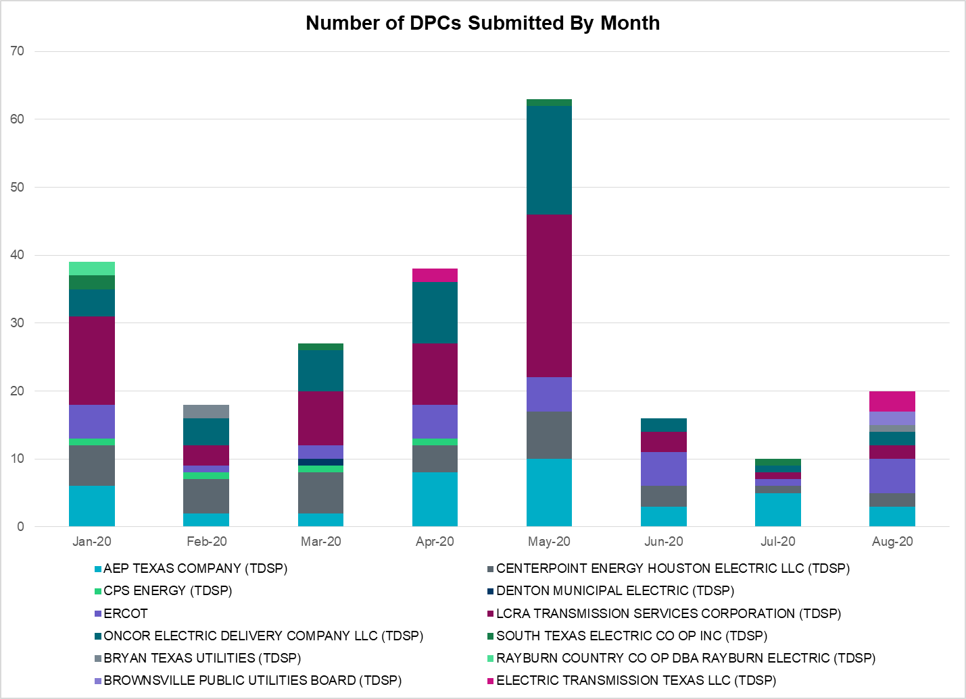

Transmission Operator | Number of DPCs
AEP TEXAS COMPANY (TDSP) | 3
BRAZOS ELECTRIC POWER CO OP INC (TDSP) | 0
BROWNSVILLE PUBLIC UTILITIES BOARD (TDSP) | 2
BRYAN TEXAS UTILITIES (TDSP) | 1
CENTERPOINT ENERGY HOUSTON ELECTRIC LLC (TDSP) | 2
CITY OF AUSTIN DBA AUSTIN ENERGY (TDSP) | 0
CITY OF COLLEGE STATION (TDSP) | 0
CITY OF GARLAND (TDSP) | 0
CPS ENERGY (TDSP) | 0
DENTON MUNICIPAL ELECTRIC (TDSP) | 0
ELECTRIC TRANSMISSION TEXAS LLC (TDSP) | 3
ERCOT | 5
LCRA TRANSMISSION SERVICES CORPORATION (TDSP) | 2
ONCOR ELECTRIC DELIVERY COMPANY LLC (TDSP) | 2
RAYBURN COUNTRY CO OP DBA RAYBURN ELECTRIC (TDSP) | 0
SHARYLAND UTILITIES LP (TDSP) | 0
SOUTH TEXAS ELECTRIC CO OP INC (TDSP) | 0
TEXAS MUNICIPAL POWER AGENCY (TDSP) | 0
TEXAS-NEW MEXICO POWER CO (TDSP) | 0

Appendix A: Real-Time Constraints
The following is a complete list of constraints activated in SCED. Full contingency descriptions can be found in the Standard Contingencies List located on the MIS secure site at Grid Generation Reliability Unit Commitment.

Contingency Name | Overloaded Element | From Station | To Station | Count of Days
BASE CASE | PNHNDL | n/a | n/a | 26
SBRAUVA8 | HAMILT_MAVERI1_1 | HAMILTON | MAVERICK | 20
SLGEI_D8 | I_DUPS_LGE1_1 | LGE | I_DUPSW | 19
BASE CASE | MCCAMY | n/a | n/a | 18
SILLFTL8 | HAMILT_MAXWEL1_1 | MAXWELL | HAMILTON | 18
SW_BW_25 | CRTVLE_EINSTEN_1 | EINSTEIN | CRTRVLLE | 15
DBIGKEN5 | TREADW_YELWJC1_1 | TREADWEL | YELWJCKT | 13
SMV_PAR8 | RIOHND_ERIOHND_1 | MV_RIOHO | RIOHONDO | 13
SBOSELM5 | 1030__B | BOSQUESW | RGH | 12
DBIGKEN5 | HAMILT_MAXWEL1_1 | MAXWELL | HAMILTON | 12
BASE CASE | BEARKT | n/a | n/a | 11
BASE CASE | NE_LOB | n/a | n/a | 11
SSANFOW5 | SANMIGL_ATAH | SANMIGL | SANMIGL | 10
DFERSTA8 | 1318T313_1 | WIRTZ | JOHNCI | 10
DHCKSAG8 | 6265__A | EMSES | MRSDO | 10
SPORNCA9 | NCARBI_PV_TAP1_1 | NCARBIDE | PV_TAP | 9
DWAP_JN5 | OB_WAP98_A | WAP | OB | 9
DNEDWED8 | AZTECA_HEC1_1 | HEC | AZTECA | 9
SBEVASH8 | BEVO_BRUNDAGE_1 | BRUNDGS | BEVO | 8
DKOCNUE8 | CHAMPL_WEIL_T1_1 | WEIL_TRC | CHAMPLIN | 8
SAVMBSP8 | 6610__A | BUZSW | CHATP | 8
DWAPHLJ5 | STPWAP39_1 | STP | WAP | 8
SCMNCPS5 | 651__B | CMNSW | CMNTP | 8
SBRAHAM8 | HAMILT_MAVERI1_1 | HAMILTON | MAVERICK | 8
DBIGKEN5 | BONDRO_SONR1_1 | SONR | BONDROAD | 8
XNED258 | NEDIN_138H | NEDIN | NEDIN | 8
SMV_ALT8 | 479T479_1 | WESLACO | N_ALAMO | 7
DB_DAIR8 | B_DAVI_NAVALB1_1 | B_DAVIS | NAVALBAS | 7
SPHAWES8 | KEY_SW_N_MCAL1_1 | KEY_SW | N_MCALLN | 7
SMDOOAS5 | OB_WAP98_A | WAP | OB | 5
BASE CASE | REROCK_TLINE_1 | REROCK | LINTERNA | 5
DODEMOS5 | 6475__C | ODEHV | TROTP | 5
SSOLFTS8 | ALPINE_BRONCO1_1 | BRONCO | ALPINE | 5
DWAP_JN5 | OB_WAP99_A | WAP | OB | 5
SHACPB38 | FTST_SOLSTI1_1 | FTST | SOLSTICE | 5
DODEMOS5 | FTST_SOLSTI1_1 | FTST | SOLSTICE | 5
DMTSCOS5 | 6437__F | SCRCV | KNAPP | 5
DCHBJOR5 | LANMB_86_A | MB | LAN | 5
XBSP89 | 6610__A | BUZSW | CHATP | 4
SKINODE5 | FTST_SOLSTI1_1 | FTST | SOLSTICE | 4
XOKL58 | SANDRO_VERS1_1 | VERS | SANDROAD | 4
DCDHVEN5 | 3180__A | FCRSW | CDHSW | 4
DGIBTOK5 | JK_CK_TABOR_1 | JK_CK | TABOR | 4
BASE CASE | BURNS_RIOHONDO_1 | RIOHONDO | MV_BURNS | 4
SCOMHA38 | HAMILT_MAXWEL1_1 | MAXWELL | HAMILTON | 4
SCOLPAW5 | LOOP_VICTORIA_1 | VICTORIA | L_463S | 4
SMV2NED8 | NEDIN_MVWED_1A_1 | NEDIN | MV_WEDN4 | 4
DFERSTA8 | 318T313_1 | WIRTZ | JOHNCI | 4
SREDMCC8 | 102T375_1 | MCCALA | RNRD12 | 4
DMDBDCS5 | 651__B | CMNSW | CMNTP | 3
DELMSAN5 | MAGRUD_VICTOR2_1 | VICTORIA | MAGRUDER | 3
SCO2EUL8 | COLETO_ROSATA1_1 | COLETO | ROSATA | 3
XVIC89 | MAGRUD_VICTOR2_1 | VICTORIA | MAGRUDER | 3
SLAQLOB8 | BRUNI_69_1 | BRUNI | BRUNI | 3
DAUSDUN8 | CKT_972_1 | HWRDLN | MCNEIL | 3
SODLBRA8 | HAMILT_MAVERI1_1 | HAMILTON | MAVERICK | 3
SLOBSA25 | NLARSW_PILONC1_1 | NLARSW | PILONCIL | 3
SHCKRNK5 | 106__A | HCKSW | ALLNC | 3
SILLFTL8 | CARVER_TINSLE1_1 | CARVER | TINSLEY | 3
DDUPHE18 | I_DUPS_MCCAMP2_1 | I_DUPSW | MCCAMPBE | 3
SCISPUT8 | SOUTHA_VINSON1_1 | SOUTHABI | VINSON | 3
SLOBSA25 | LARDVN_LASCRU1_1 | LARDVNTH | LASCRUCE | 3
SPIGSOL8 | LYNX_RIOPEC1_1 | LYNX | RIOPECOS | 3
DELMSAN5 | PAWNEE_SPRUCE_1 | PAWNEE | CALAVERS | 3
DNEDWED8 | ADERHO_HEC1_1 | HEC | ADERHOLD | 2
SMCEABS8 | MKLT_TRNT1_1 | TRNT | MKLT | 2
DCRLLSW5 | 588_A_1 | LWSVW | LWVTI | 2
SCITNE28 | KEY_SW_N_MCAL1_1 | KEY_SW | N_MCALLN | 2
SMCEESK8 | MKLT_TRNT1_1 | TRNT | MKLT | 2
DCPSST58 | 651__B | CMNSW | CMNTP | 2
SCITNE28 | ALTON_WESTED_1 | MV_WEDN4 | ALTON_MV | 2
SALTKEY8 | MOORE__NEDIN1_1 | NEDIN | MOORE_FL | 2
SSCUSU28 | SPUR_69_1 | SPUR | SPUR | 2
SLOBSA25 | ASHERT_CATARI1_1 | ASHERTON | CATARINA | 2
DBONRIO5 | BURNS_RIOHONDO_1 | RIOHONDO | MV_BURNS | 2
SMV_ALT8 | MOORE__NEDIN1_1 | NEDIN | MOORE_FL | 2
SMDOOAS5 | OB_WAP99_A | WAP | OB | 2
DVENLIG5 | 530__C | VENSW | BRTRD | 2
DAUSLOS5 | 608T608_1 | GIDEON | BASTCI | 2
BASE CASE | NEDIN_138L | NEDIN | NEDIN | 2
SSANFOW5 | SANMIGL_ATAL | SANMIGL | SANMIGL | 2
SHAYZO25 | 6T227_1 | HAYSEN | ZORN | 2
DBONNED5 | BURNS_RIOHONDO_1 | RIOHONDO | MV_BURNS | 2
SL_4VIC8 | NCARBI_PV_TAP1_1 | NCARBIDE | PV_TAP | 2
DNEDWED8 | VAL_VERD_WSLCO_1 | MV_VALV4 | WESLACO | 2
SCOMHA38 | CARVER_TINSLE1_1 | CARVER | TINSLEY | 2
DNEDWED8 | VAL_VERD_WSLCO_1 | WESLACO | MV_VALV4 | 2
SFTLMES8 | CROSSO_NORTMC1_1 | NORTMC | CROSSOVE | 2
DMARPA_8 | 1318T313_1 | WIRTZ | JOHNCI | 1
DWIRSTA8 | 1318T313_1 | WIRTZ | JOHNCI | 1
XHAM88 | BONDRO_SONR1_1 | SONR | BONDROAD | 1
DCHBJOR5 | CBYCD_84_A | CBY | CD | 1
DSPRDAF8 | CKT_917_1 | DECKER | WALNUT | 1
SCOMHA38 | CTHR_DOLAN1_1 | CTHR | DOLAN | 1
SMVRLA_8 | PHARR_YOUNG1_1 | PHARR | YOUNG | 1
STORSAN8 | RAY_WES_1 | RAYBURN | WESSER | 1
DEVRCPS5 | 152__A | MBDSW | RKCRK | 1
SCLNWLC8 | 1580__B | PAYNE | PNKHL | 1
DMARPA_8 | 318T313_1 | WIRTZ | JOHNCI | 1
DSCOFAR5 | 6216__B | WLVSW | SHRNE | 1
SALTKEY8 | CITRUS_MOORE_1_1 | MOORE_FL | CITRUSCY | 1
DFERHOR8 | 1318T313_1 | WIRTZ | JOHNCI | 1
DBWNTWI5 | 134T429_1 | SCHKAD | SAPOWER | 1
SALTKEY8 | 479T479_1 | WESLACO | N_ALAMO | 1
DGRMGRS8 | 6830__B | CRDSW | OLNEY | 1
SBATFRO8 | ALTON_WESTED_1 | MV_WEDN4 | ALTON_MV | 1
DWH_STP5 | BLESSI_LOLITA1_1 | LOLITA | BLESSING | 1
DBIGKEN5 | HEXT_MASONS1_1 | HEXT | MASONSW | 1
SFORYEL8 | HEXT_MASONS1_1 | HEXT | MASONSW | 1
SBATFRO8 | KEY_SW_N_MCAL1_1 | KEY_SW | N_MCALLN | 1
SLOLFOR8 | NCARBI_PV_TAP1_1 | NCARBIDE | PV_TAP | 1
BASE CASE | NEDIN_138H | NEDIN | NEDIN | 1
DGRMGRS8 | OLN_FMR2 | OLN | OLN | 1
SSCUSU28 | ROTN_WOLFGA1_1 | WOLFGANG | ROTN | 1
DGIDTAH8 | 608T608_1 | GIDEON | BASTCI | 1
SPHAWES8 | ALTON_WESTED_1 | MV_WEDN4 | ALTON_MV | 1
DDECMCN8 | CKT_917_1 | DECKER | WALNUT | 1
SMARMUN8 | LIBR_PAUL1_1 | PAUL | LIBR | 1
BASE CASE | VFTNORTH_LEC5_1 | LARDVFTN | LARDVNTH | 1
SRINRIN8 | WHITE_PT_69A1 | WHITE_PT | WHITE_PT | 1
SMDOPHR5 | 138_ALV_MNL_1 | ALVIN | MAINLAND | 1
DCDHMCS8 | 3160__A | CDCSW | OKCLS | 1
DWLYELM8 | 568__A | NEVADA | RYSSW | 1
SRICGRS8 | 6840__B | NVKSW | ANARN | 1
SCOLBAL8 | BALLIN_HUMBLT1_1 | BALLINGE | HUMBLTAP | 1
DSTPWHI5 | BLESSI_LOLITA1_1 | BLESSING | LOLITA | 1
DVICEDN8 | LOOP_VICTORIA_1 | VICTORIA | L_463S | 1
DMCEBUT8 | MKLT_TRNT1_1 | TRNT | MKLT | 1
XNED258 | NEDIN_138L | NEDIN | NEDIN | 1
DBIGKEN5 | SAPOWE_TREADW1_1 | SAPOWER | TREADWEL | 1
DCAGCO58 | 583T583_1 | BANDER | MASOCR | 1
UWAPWAP1 | BM_HY_09_A | BM | HY | 1
SBERONI8 | CKT_917_1 | DECKER | WALNUT | 1
SMELRIN8 | HEARDT_WOODSB1_1 | WOODSBOR | HEARDTAP | 1
DNEDWED8 | HEC_NEDIN1_1 | NEDIN | HEC | 1
DHWIND89 | MORRIS_NUECES1_1 | NUECES_B | MORRIS | 1
SJNWA1P5 | OB_WAP98_A | WAP | OB | 1
DCAGCO58 | 656T656_1 | KENDAL | BERGHE | 1
XNOR258 | 730__D | LIGSW | IBLT2 | 1
SORLPAU8 | CHLC_V_VERN1_1 | VERN | CHLC_VER | 1
SWRDYN8 | PG_WC_04_A | PG | WC | 1
XBLE58 | SAR_FRAN_1 | FRANKC | SARGNTS | 1
SVEROK28 | VERN_69T1 | VERN | VERN | 1
SPALWIR8 | 1318T313_1 | WIRTZ | JOHNCI | 1
DCPSJON5 | 152__A | MBDSW | RKCRK | 1
DCDHVEN5 | 310__A | LIGSW | NORSW | 1
XDCS58 | 651__B | CMNSW | CMNTP | 1
DSTEXP12 | BLESSI_LOLITA1_1 | LOLITA | BLESSING | 1
SCISPUT8 | ESTES_PECAN_1_1 | PECAN_BY | ESTES | 1
SMV_RIO8 | HAINE__LA_PAL1_1 | LA_PALMA | HAINE_DR | 1
SDELLAR8 | LARDVN_LASCRU1_1 | LARDVNTH | LASCRUCE | 1
DODESLT8 | TALLCITY_TELPR_1 | TELPH_RD | TALLCITY | 1

This is the hourly integrated peak demand as published in the ERCOT D&E report.
All DC Tie Curtailments are posted publically on the ERCOT Market Information System. See that posting for additional details for the event(s) in question.
See DC Tie Operating Procedure (http://www.ercot.com/mktrules/guides/procedures) for more details.

