System Planning
Monthly Status Report

Report Highlights

- ERCOT is currently reviewing proposed transmission improvements with a total estimated cost of $1,116.8 Million as of August 31, 2020.
- Transmission Projects endorsed in 2020 total $691.4 Million as of August 31, 2020.
- All projects (in engineering, routing, licensing and construction) total approximately $7.26 Billion as of June 1, 2020.
- Transmission Projects energized in 2020 total about $1.06 Billion as of June 1, 2020.

Regional Planning Group Reviews
- AEPSC has submitted the LRGV Import Project. This is a Tier 1 project that is estimated to cost $73.4 million. AEPSC has also requested that ERCOT provide a conditional endorsement for an additional $357.2 million project. The ERCOT Independent Review has been conducted in accordance with Protocol Section 3.11.4.9(3), and this project is currently placed on hold until the LNG loads are confirmed.
- STEC has submitted the Lower Rio Grande Valley Transmission Expansion Project. This is a Tier 1 project that is estimated to cost $511 million. The ERCOT Independent Review has been conducted in accordance with Protocol Section 3.11.4.9(3), and this project is currently placed on hold until the LNG loads are confirmed.
- TNMP has submitted the Texas City Transmission Improvement Project. This is a Tier 2 project that is estimated to cost $29.3 million. This project is currently under ERCOT Independent Review.
- BEC has submitted the Moffat to Hasse Voltage Conversion Project. This is a Tier 2 project that is estimated to cost $55.2 million. This project is currently under ERCOT Independent Review.
- Oncor has submitted the Horseshoe Springs Switch – Riverton Switch 138-kV Second Circuit Project. This is a Tier 3 project that is estimated to cost $52.3 million. This project completed the RPG review on August 4, and ERCOT has issued an acceptance letter.
- Oncor has submitted the Everman Switching Station Rebuild Project. This is a Tier 3 project that is estimated to cost $36 million. This project is currently in the RPG comment period.
- AEPSC has submitted the Coleto Creek to Kenedy SS 138-kV Transmission Project. This is a Tier 3 project that is estimated to cost $54.7 million. This project is currently in the RPG comment period.

More information on current and past RPG projects can be found on the ERCOT MIS Secure (digital certificate required): https://mis.ercot.com/pps/tibco/mis/Pages/Grid+Information/RegionalPlanning
Past email communication on RPG projects can be found on the ERCOT listserve by signing up for the REGPLANGROUP list: http://lists.ercot.com/scripts/wa-ERCOT.exe?A0=REGPLANGROUP

Planning Model Activities
The short-term calendar of major planning model events is as follows:
- By Oct 15, 2020 20SSWG Update 1 cases and TPIT are posted
- By Oct 31, 2020 20SSWGU1 Contingency definitions and Planning Data Dictionary are posted
The following table shows interconnection projects that met Planning Guide section 6.9(1) and 6.9(2) and were modeled in the SSWG cases as a full model or as a simple model in accordance with Planning Guide section 6.9.

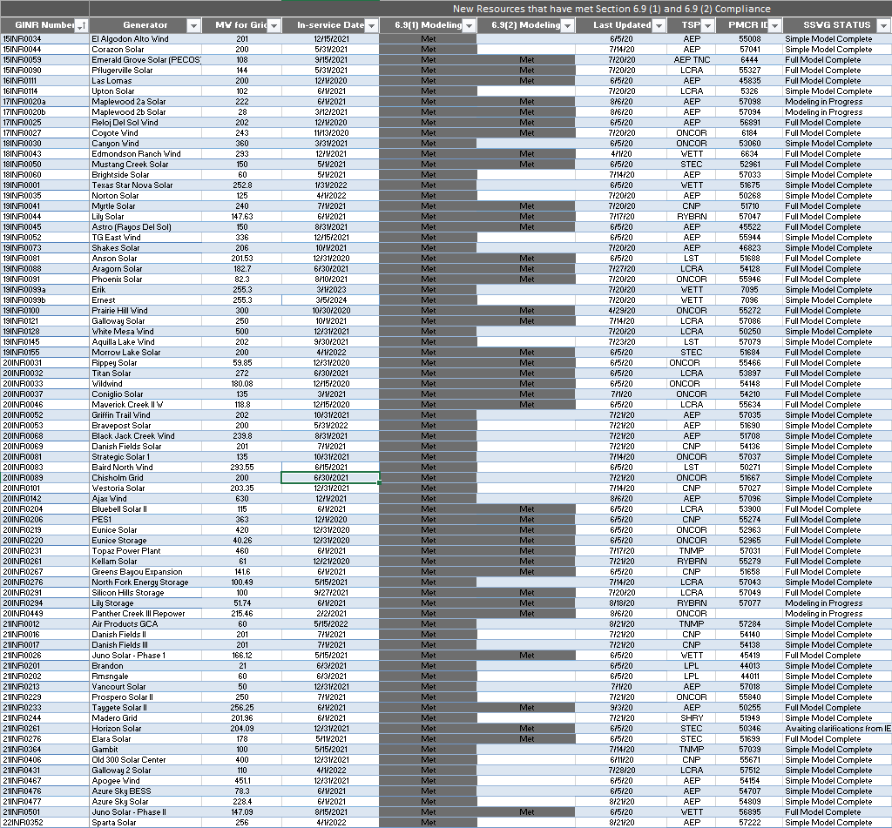

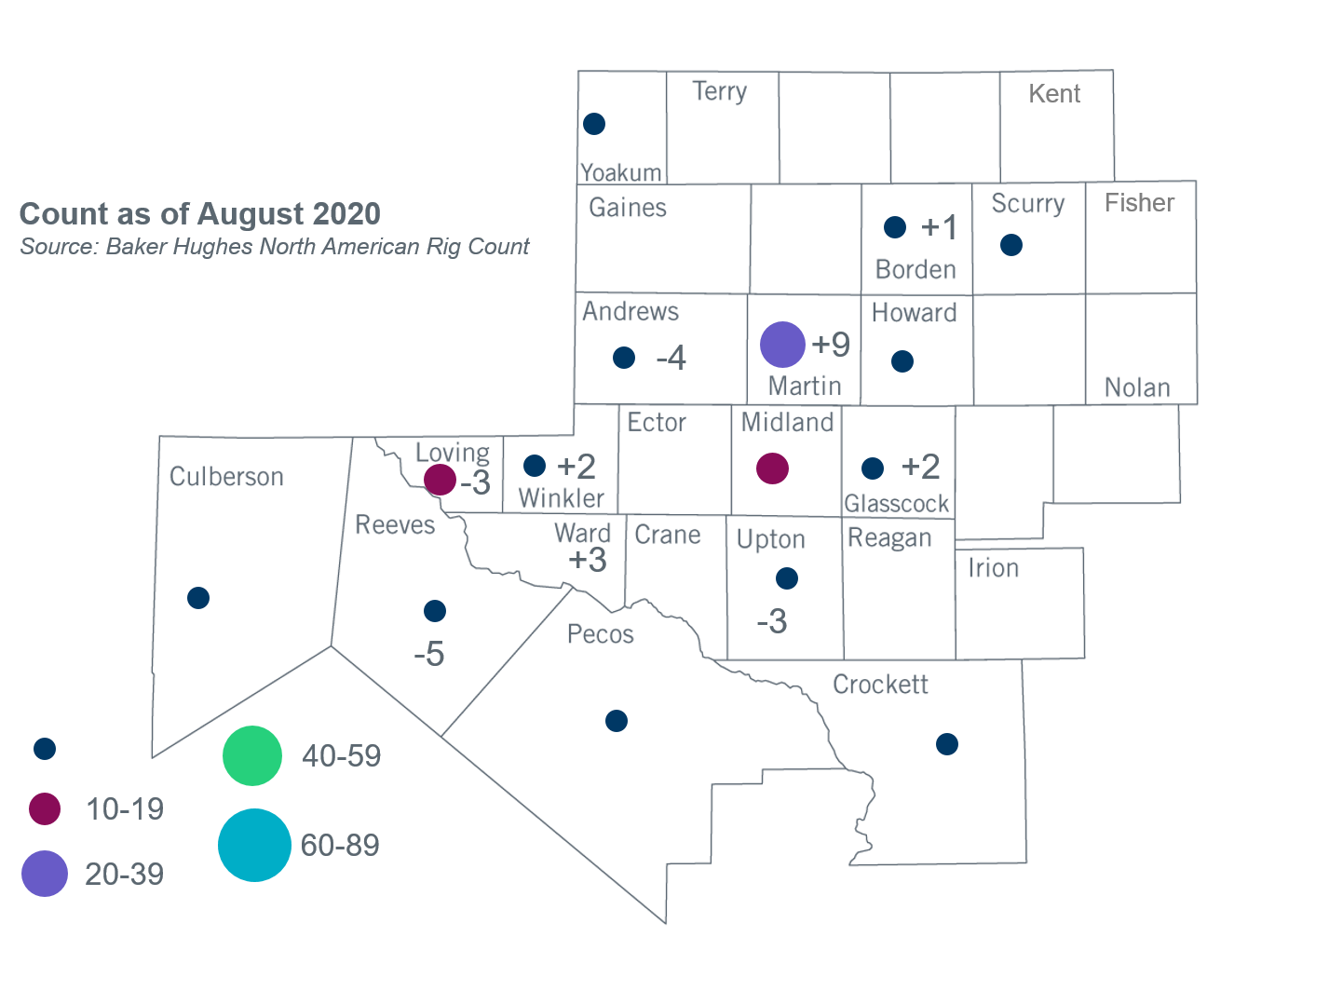
Permian Basin Oil Rig Count
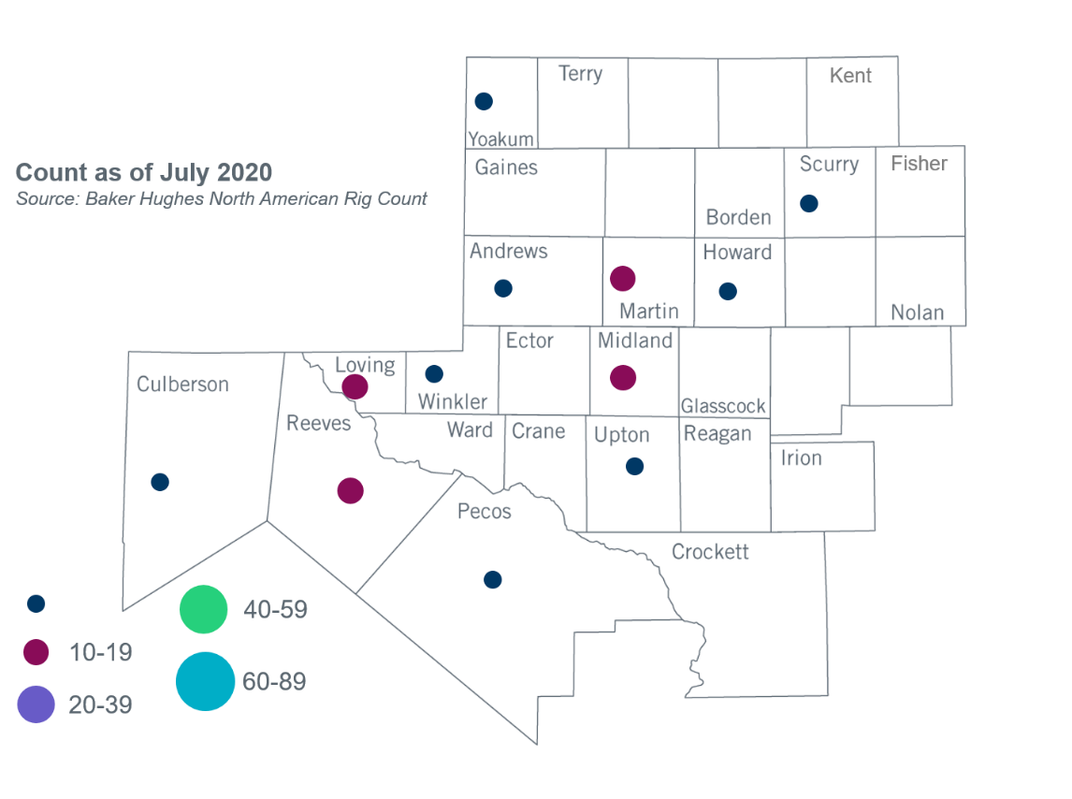

Other Notable Activities
- The SPWG completed and posted the 2020 FY base cases on July 17, 2020
- ERCOT posted the final report for the West Texas Export Stability Assessment in July.

+/- symbol indicates the increase or decrease from the previous month in oil rigs present in each county. There are 78 rigs, including a total increase of 3 oil rigs, in the Permian Basin from July to August 2020.
http://www.ercot.com/content/wcm/lists/197392/2020_West_Texas_Export_report_final.pdf

