OBDRR Number | 023 | OBDRR Title | Related to NPRR984, Change ERS Standard Contract Terms
Date of Decision |  | August 26, 2020
Action |  | Recommended Approval
Proposed Effective Date |  | February 1, 2021 and upon system implementation of NPRR984
Priority and Rank Assigned |  | Not applicable
Other Binding Document Requiring Revision |  | Emergency Response Service Procurement Methodology
Supporting Protocol or Guide Section(s) / Related Documents |  | Nodal Protocol Revision Request (NPRR) 984, Change ERS Standard Contract Terms
Revision Description |  | This Other Binding Document Revision Request (OBDRR) aligns the Emergency Response Service Procurement Methodology with changes proposed in NPRR984.
Reason for Revision |  | Addresses current operational issues.  Meets Strategic goals (tied to the ERCOT Strategic Plan or directed by the ERCOT Board).  Market efficiencies or enhancements  Administrative  Regulatory requirements  Other: (explain)  (please select all that apply)
Business Case |  | This OBDRR is necessary to align the Emergency Response Service Procurement Methodology with Protocol changes proposed in NPRR984.
TAC Decision |  | On 8/26/20, TAC voted via roll call to recommend approval of OBDRR023 as submitted with a recommended effective date of February 1, 2021. There was one opposing vote from the Independent Power Marketer (IPM) (Morgan Stanley) Market Segment. All Market Segments were present for the vote.
Summary of TAC Discussion |  | On 8/26/20, ERCOT staff provided an overview of OBDRR023 and noted the requested effective date outlined in the 8/7/20 ERCOT comments to NPRR984.
ERCOT Opinion |  | ERCOT supports approval of OBDRR023.

Sponsor
Name | Mark Patterson
E-mail Address | Mark.Patterson@ercot.com
Company | ERCOT
Phone Number | 512-248-3912
Cell Number
Market Segment | Not applicable

Market Rules Staff Contact
Name | Phillip Bracy
E-Mail Address | Phillip.Bracy@ercot.com
Phone Number | 512-248-6917

Comments Received
Comment Author | Comment Summary
None

Market Rules Notes
None
Proposed Other Binding Document Language Revision

A. Document Description
This document describes the mechanism for procuring ERS and is considered an “Other Binding Document,” as that term is defined in the ERCOT Protocols.

B. Change Control Process
ERCOT Staff will provide a period for stakeholder review and comment for proposed revisions to this document as follows:
(1) ERCOT shall post proposed revisions to the Emergency Response Service Procurement Methodology to the ERCOT website.
(2) ERCOT shall also electronically notify stakeholders of the proposed revisions via the TAC and Others distribution list and define the comment period which shall be at least 14 days after initial posting.
(3) To receive consideration, comments should be submitted via email to ERS@ercot.com by the deadline set forth in the notification.
(4) Upon Market Participant written request, ERCOT will conduct a conference call and online review of the submitted comments.
(5) ERCOT will review proposed document revisions with the Technical Advisory Committee (TAC).
(6) ERCOT will submit proposed document revisions for ERCOT Board approval.
(7) Within three Business Days of ERCOT Board approval, ERCOT shall post the revised document to the ERCOT website.

C. ERS Capacity Demand Curve
ERCOT will develop a capacity demand curve for each ERS Time Period, and all ERS products will be procured together within the limits of that curve. ERCOT shall maximize the MW procured subject to the expenditure limit for the relevant Time Period. Each demand curve is derived from the three following parameters, which ERCOT will specify in the Request for Proposal (RFP) for ERS procurement:
(1) ERS Offer Cap
(2) ERS Time Period Capacity Inflection Point
(3) ERS Time Period Expenditure Limit

MW
$/MW/Hr
Offer Cap
Expenditure Limit
Capacity
Demand
Curve
Capacity
Inflection
Point

D. ERS Offer Cap
The ERS offer cap establishes a maximum possible procurement price of $80/MW/hr for every ERS Time Period during the ERS budget year. ERCOT will automatically reject any offers above the offer cap. This cap is consistent with the prices historically paid to Loads participating in TDSP Standard Offer Load Management Programs.

E. ERS Expenditure Limit
P.U.C. Substantive Rule 25.507 restricts ERCOT’s ERS expenditures to an annual cost cap of $50 million. ERCOT will allocate the $50 million available expenditure within its ERS budget year, which starts with the December through March Standard Contract Term and ends with the October and November Standard Contract Term.
No later than 60 days before each new ERS budget year, ERCOT will make an initial allocation of the annual expenditure limit to each ERS Time Period in each ERS Standard Contract Term based on the expected risk of reaching an EEA in that ERS Time Period, in accordance with the formula detailed below. ERCOT will assign a high (H), moderate (M), or low (L) risk designation to each ERS Time Period and will assign a risk-weighting factor (a value from 1 to 100 with 1 being the lowest risk value and 100 being the highest risk value) for each risk designation. ERCOT’s risk assessment will consider a number of factors, including, but not limited to, forecasted operating reserves, forecasted Load, and Resource outage information.
Prior to issuing an RFP for an upcoming Standard Contract Term, ERCOT will update the ERS Time Period Expenditure Limits for each remaining ERS Time Period in the budget year to reflect updated forecasts and any expected remaining funds from ERS Standard Contract Terms within the same ERS budget year. Unless the offer submission deadline for the upcoming Standard Contract Term has passed, ERCOT may update the ERS Time Period Expenditure Limits and issue a revised RFP if funds originally allocated to the upcoming Standard Contract Term must be reallocated to fund an ERS renewal Contract Period in the current Standard Contract Term. Any funds remaining at the end of an ERS budget year will not be carried forward into a new ERS budget year.
For each ERS Time Period, the expenditure limit is calculated as follows:
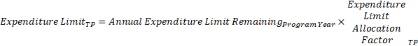
Where
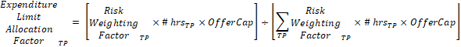

F. Capacity Inflection Point
The capacity inflection point establishes the point on the capacity demand curve where capacity can only be procured at an offer price less than the ERS Time Period offer cap while respecting the expenditure limit for that ERS Time Period. The capacity inflection point for each time period is calculated as follows:

Table A below provides hypothetical calculations of the expenditure limits and capacity inflection point for each ERS Time Period in each budget year.

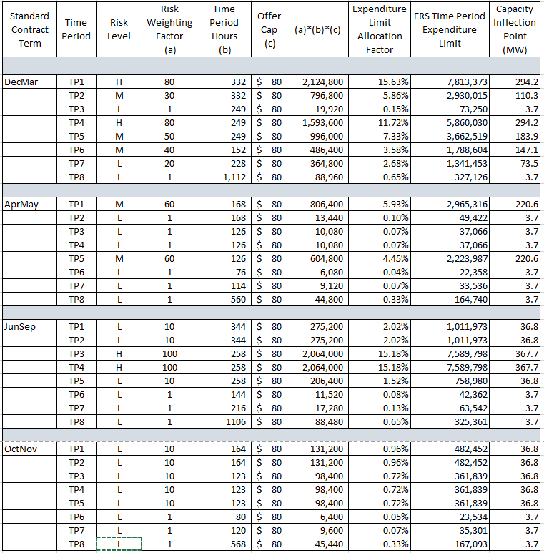
Table A. ERS Time Period Expenditure Limit Allocation and Capacity Inflection Point Calculations

G. Clearing Price
The highest offer accepted for an ERS Time Period from will set the clearing price for all ERS Resources cleared in that ERS Time Period. All ERS service types specified in the Protocols will be procured using a common ERS capacity demand curve for each ERS Time Period and the highest offer accepted for an ERS Time Period will set the clearing price for all ERS service types.
If the procurement of all offers at the same price for an ERS Time Period would exceed the ERS Expenditure Limit for that ERS Time Period, ERCOT shall consider each such offer in an order established at random.
If awarding an offer would not exceed the ERS Expenditure Limit that offer will be awarded for the full capacity offered.
If awarding an offer for the full amount of the offered capacity would exceed the ERS Expenditure Limit, the following steps will be taken:
(1) If awarding an offer for the full amount of the offered capacity would exceed the ERS Expenditure Limit, the following steps will be taken: If the QSE has indicated on its offer that capacity proration is not allowed for that ERS Resource, the offer will be rejected.
(2) If the QSE has indicated on its offer that capacity proration is allowed for that ERS Resource, and if the capacity following proration is greater than or equal to the Proration Lower Limit specified on the offer, the offer will be accepted and the prorated capacity will be awarded.
(3) If the QSE has indicated on its offer that capacity proration is allowed by the QSE for that ERS Resource, and if the prorated capacity is less than the Proration Lower Limit specified on the offer, the offer will be rejected.

H. ERS Capacity provided through ERS Self Provision
For any ERS self-provision, ERCOT will reduce the Time Period expenditure limit for any offers to self-provide part or all of a QSE’s ERS Obligation by the clearing price for ERS.

Due to the implementation of NPRR984, Change ERS Standard Contract Terms, the 2021 ERS budget year will be truncated and will include a February through May Standard Contract Term, a June through September Standard Contract Term, and an October through November Standard Contract Term. During this 10-month ERS budget year, ERCOT will allocate ERS spending based on an expenditure limit of $41.6 million (i.e., 10/12ths of the $50 million ERS annual spending limit).

