**TDTMS**

**August 19th, 2020**

**WebEx only**

|  |  |  |  |  |  |
| --- | --- | --- | --- | --- | --- |
| Attendee | Company | Attendee | Company | Attendee | Company |
| Diana Rehfeldt | TNMP | Trish Matus | ERCOT |  |  |
| Sam Pak | Oncor | Dave Michelson | ERCOT |  |  |
| Kathy Scott | CenterPoint | Eric Blakey | Just Energy |  |  |
| Sheri Wiegand | TXU | Steven Pliler | TXU |  |  |
| Jordan Troublefield | ERCOT | Johan Krebbers | ERCOT |  |  |
| Kyle Patrick | NRG | Paul Williamson | ePSolutions |  |  |
| Mick Hanna | ERCOT |  |  |  |  |
|  | | | | | |

**Minutes & Antitrust**

* Antitrust Admonition was read by Sheri
* Minutes from 7/23/20 were approved
* Noted, TDTMS did experience a few unwanted guests on the WebEx, however they were not disruptive

**ERCOT System Instances And MarkeTrak Monthly Performance Review**

* One incident in July on 7/7 -with a migration in the past, a debug setting was not updated which caused a file to grow to an excessive size impacting performance. Setting was corrected so going forward, query will only look at lack of unsuccessful actions
* August 9th was a scheduled release weekend, however, ERCOT did not have plans to utilize. Market participants requested if a scheduled release is cancelled to kindly send out a market notice as retail operations typically acknowledge those release dates in their operational calendar
* MT SLAs were good – despite above incident, issues were not ‘caught’ with monitoring tool

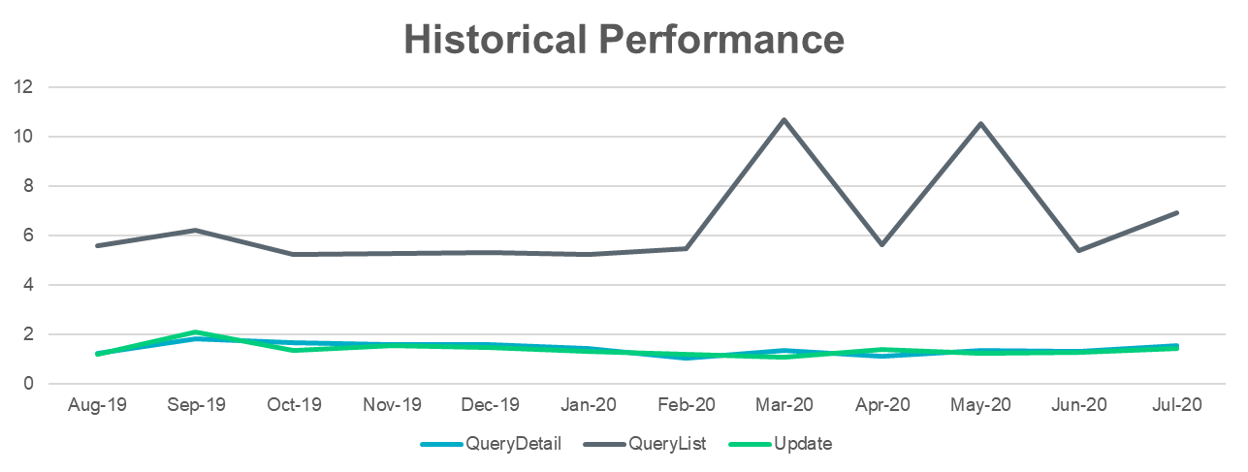

**Transport Layer Security (TLS) Discussion/Timeline/ERCOT NAESB Upgrade**

* Dave Michelson and team have been working with REPs and EDI Service Providers on configurations and compatibility issues to ensure all market participants can migrate to TLS 1.2.
  + Plan A: ERCOT with one market participant whose system requires an upgrade in order to convert to TLS 1.2. ERCOT cannot make the transition until this mp is ready
  + Plan B: ERCOT may have a new public key all market participants may need to import to remain compatible (30 second import)
  + Plan C: may have to move the migration date of 11/2 further out
* Dave will hold another Friday call with the IT folks to address any questions. A market notice should go out.

**MarkeTrak Subtype Analysis – Six month review of trends**

* Observations from the high level review of 6 months of MarkeTrak data:
  + IAS family has declined 19% in the last six months and 26% from same time last year likely due to effects of COVID – suspension of Door to Door activity, fewer transactions. It was point out, even with the pandemic IAD ‘does not go away’.
  + Usage & Billing Missing have nearly tripled – thoughts on impacts: CNP system conversion, cancel/rebills with ERP program – also observed last time U&B MTs saw a dramatic uptick was went another TDU performed a major system conversion
  + Projects has increased – the subtype used for Meter Cycle Change requests – supporting the need for a new subtype
  + Other – typically an indicator for education or a new subtype – per TDSP, this is the subtype used for the activity around AMS/IDR meters where a customer can elect to keep a BUS profile vs BUSIDRRQ profile
  + Switch Hold Removal MTs have dropped likely due to ERP activity – could see an increase upon program conclusion
  + Market Rule subtype has over 27,000 MTs submitted due to Electricity Relief Program (ERP)

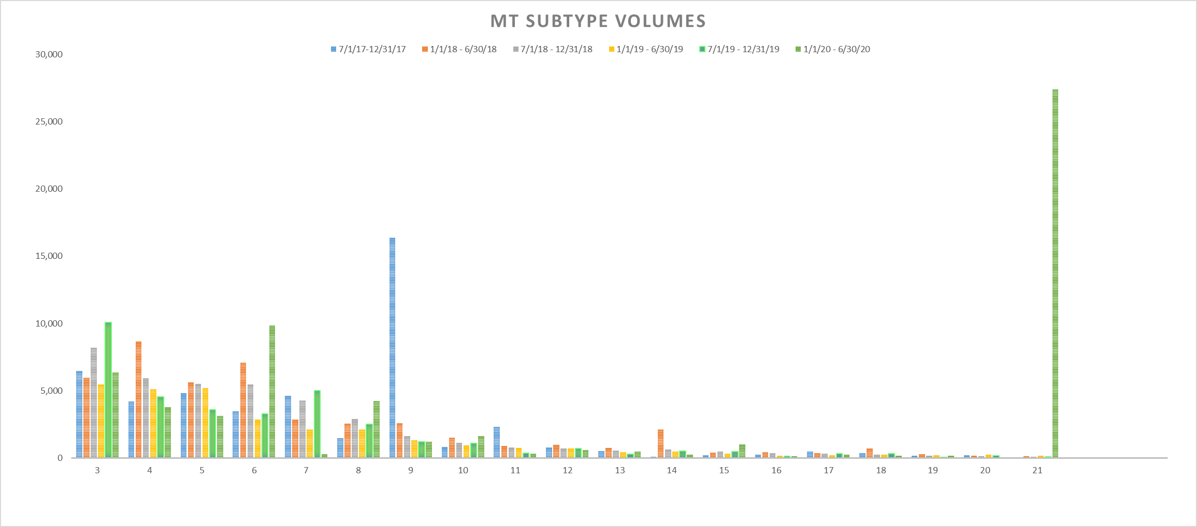



**IAG Proposal/Solution**

Matrix was not reviewed other than to point out the PUSH vs PULL options, which reflects who is responsible for initiating the BDMVI, the Gaining REP with a DROP or the status quo with the Losing REP issuing a BDMVI. The WG is holding on further discussion until the data set can provide specific timelines for the following workflow. ACTION: Sam, Kyle, Sheri, and Dave Michelson will review data set.

|  |  |  |  |
| --- | --- | --- | --- |
| Inadvertent Situation Flow | | | |
| Time elapsed | | | |
| 1 → 2 | original transaction to submittal of MT | |  |
| 2 → 4 | agreement between CRs |  |  |
| 4 → 6 | Losing CR to send BDMVI |  |  |
| 5 → 6 | Ready to Receive to submittal of BDMVI | | |
| 2 → 8 | total resolution time |  |  |

The WG agreed to ensure the IAG solution is thorough and not to rush to complete to meet TAC deadline as noted below.

**MarkeTrak Enhancement Discussion**

* WG reviewed all proposed MT enhancements and with the assistance of Dave Michelson classified each as either an SCR – more administrative OR a validation – aligning with a TXSET 5.0 Project. Attached is the revised spreadsheet separating the two.
* Next meeting the WG will begin to organize for the submittal of an SCR

**Switch Holds**

Kyle noted one market participant has exhibited concerning behavior on their interpretation of the Retail Market Guide as it relates to the release of switch holds and the supporting documentation validating a disassociation of the current occupant to the proposed occupant. The WG will briefly review the Guides to determine if language changes are needed to clarify the removal of a switch hold.

**AGENDA for 9/17/20 Meeting**

1. ERCOT Update
   1. System Instances and MarkeTrak Monthly Performance Review
   2. Consent of 2021 SLAs for Market Data Transparency and MarkeTrak Performance
   3. Transport Layer Security (TLS) Discussion – ERCOT NAESB Project
2. Review Switch Hold Removal guides – Retail Market Guide
3. IAG Subtype Analysis – timeline data (MT historical data points)



1. IAG Proposed Solution – does the data support one option over the other?
2. MT Enhancements- review of SCR items
   1. Rolodex entries
   2. Unexecutable reasons
3. Review of the lower volume of MT Subtype data – can subtypes be removed from tool?