

Digital Certificate
Troubleshooting and Settings Guide
For Market Participants
Market Participant Identity Management (MPIM)

Version 5

August 20, 2020

Document Revisions
Date | Version | Description
10/7/2010 | 1.0 | Troubleshooting Guide for MPIM Digital Certificate downloading
1/16/2012 | 2.0 | Updates
9/16/2014 | 3.0 | Add 2048 root information
2/3/2015 | 4.0 | Remove root info since it’s located on ercot.com
8/22/2020 | 5.0 | Update Advance Settings screenshot

- Troubleshooting Renewal Certificate:

- Resolution for Problem 1:

ERCOT’s certificate vendor, DigitCert, has provided an Enterprise Solution that takes the place of the Active-X requirement. This Windows installation file can be downloaded by following the link provided and either installed directly or distributed to the end USERs for installation.

https://mis.ercot.com/misdocs/idm/OnSiteMSI.msi

Deploy the MSI Packages
There are four methods for deploying the MSI packages:
􀂄 Publish software to a USER. When you publish software to a USER, you make it available to the USER for installation through the Add/Remove Programs utility in the Control Panel the next time the USER logs in. The USER launches the Add/Remove Program utility, clicks Add New Programs, and chooses to add the published software. This completely installs the software on the USER's machine. The USER does not need to be a power USER or have any special privileges to install published software.
􀂄 Assign software to a USER. When you assign software to a USER, it is partially installed the next time the USER logs in. The installation is completed the first time the USER tries to use the software. This feature provides an install-on-demand mode of installation. The USER does not need to be a power USER or have any special privileges to completely install assigned software.
􀂄 Assign software to a machine. When you assign software to a machine, it is completely installed on the machine when the machine is rebooted. Once installed, the software is available to all USERs on that machine.
􀂄 Launch the MSI package. By double-clicking the MSI package, a USER can install the software contained within the MSI package. However, the USER needs to be an administrator on the machine where the installation is being launched in this mode. This mode does not require active directory or group policy support.

The first three methods of deployment, described in this section, require a Windows domain with an Active Directory. The administrator of this domain can specify how the software should be deployed (published to the USER or assigned to USER/machine) by specifying a group policy. The end-USER machine where the software is installed must be one of the following:
􀂄 Windows XP
􀂄 Windows 2000
􀂄 Windows 7
Publish the OnSiteMSI package to a USER
The following steps outline the process for publishing the OnSiteMSI package to a USER:
1 In the Active Directory, right-click the OU corresponding to the USERs to whom the software is to be published.
2 Select Properties.
3 In the Group Policy tab, select the Group Policy that applies to the OU if one exists, or create a new one if it does not.
4 Click Edit. This brings up another window that specifies the group policies.
5 Select USER Configuration and expand the tree corresponding to this selection.
6 In the expanded tree, right-click Software Installation, then select New Package.
7 Select the MSI file that contains the software that should be published. A dialog box appears asking if the package should be published or assigned. Select Published.

Assign the OnSiteMSI package to a machine
The following steps outline the process for assigning the OnSiteMSI package to a machine:
1 In the Active Directory, right-click the OU corresponding to the machine to which the software is to be published.
2 Select Properties.
3 In the Group Policy tab, select the Group Policy that applies to the OU if one exists, or create a new one if it does not.
4 Click Edit. This brings up another window that specifies the group policies.
5 Select Computer Configuration and expand the tree corresponding to this selection.
6 In the expanded tree, right-click Software Installation, then select New Package.
7 Select the MSI file that contains the software to be published. A dialog box appears asking if the package should be published or assigned. Select Assigned.

Assign the OnSiteMSI to a USER

The following steps outline the process for assigning the MSI package:

1 In the Active Directory, right-click the OU corresponding to the USERs to whom the software is to be assigned.
2 Select Properties.
3 In the Group Policy tab, select the Group Policy that applies to the OU if one exists, or create a new one if it does not.
4 Click Edit. This brings up another window that specifies the group policies.
5 Select USER Configuration and expand the tree corresponding to this selection.
6 In the expanded tree, right-click Software Installation, then select New Package.
7 Select the MSI file that contains the software to be assigned. A dialog box appears asking if the package should be published or assigned. Select Assigned.

- The settings documentation can be found by clicking the appropriate link below:

Public Data
- IE 11.x Configuration Guide
(May 22, 2020 – docx – 1.4 MB)
- IE 7.0 Configuration Guide
(Apr 06, 2009 – doc – 1.1 MB)
- IE 8.0 Configuration Guide
(Dec 21, 2011 – doc – 1.3 MB)

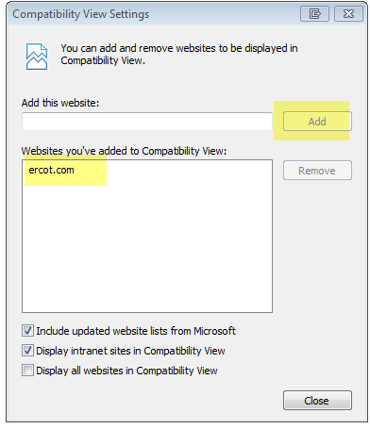

NOTE: User may require Admin privileges on the machine.

Browser – Tools menu – Internet Options…

      - Security tab – Click Trusted sites, then Click the Sites button…
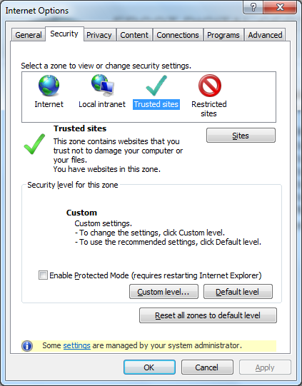
Add *.ercot.com to the Trusted sites. Uncheck “Require server verification (https:) for all sites in this zone”. Click close when complete.

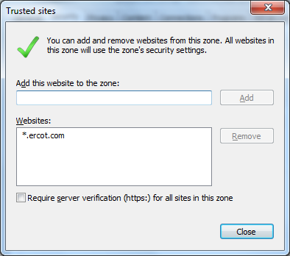

      - Security Tab – Click Trusted sites, then Click the Custom Level button (after adding .ercot.com to trusted sites)

These are suggested settings for this Zone. If any conflicts with your company’s policies or you are unable to change the settings, please contact your internal IT team for help.

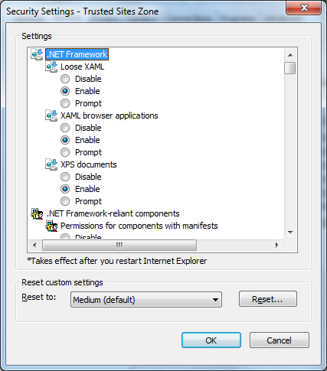

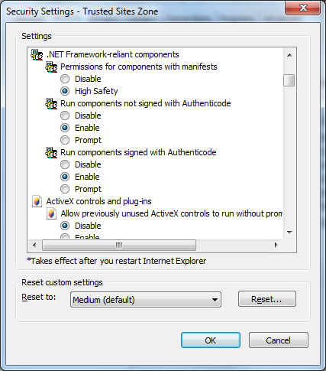

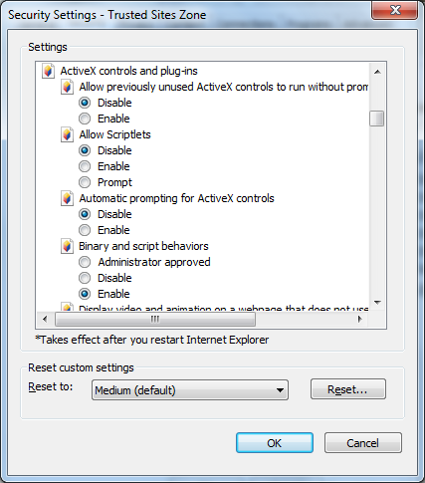

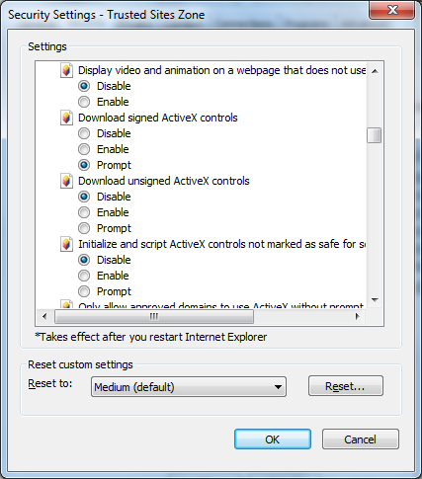

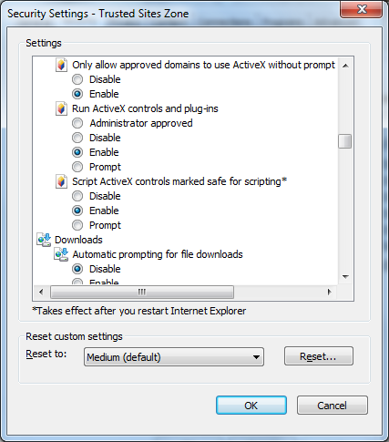

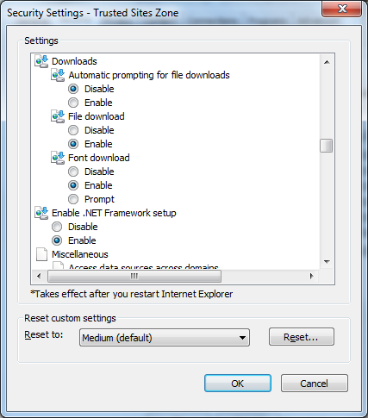

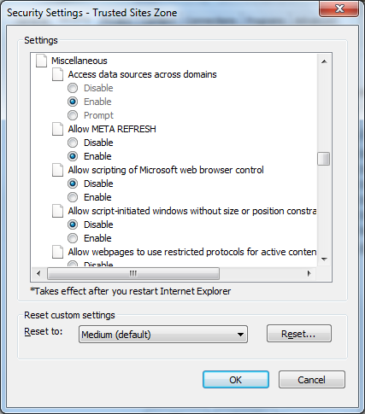

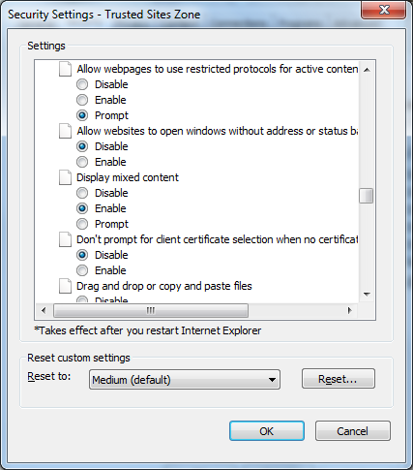

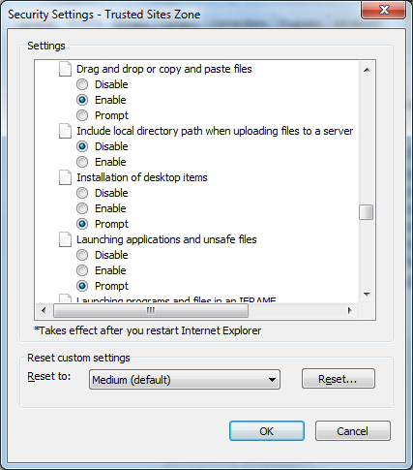

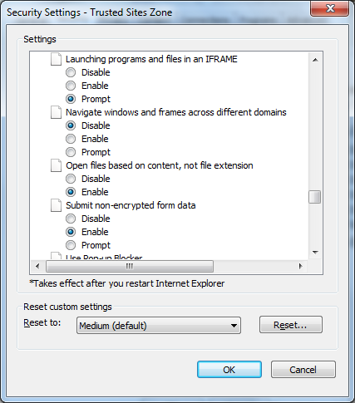

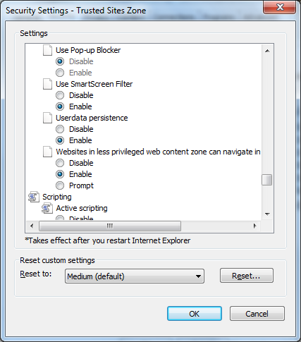

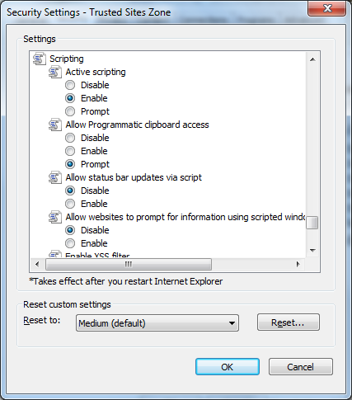

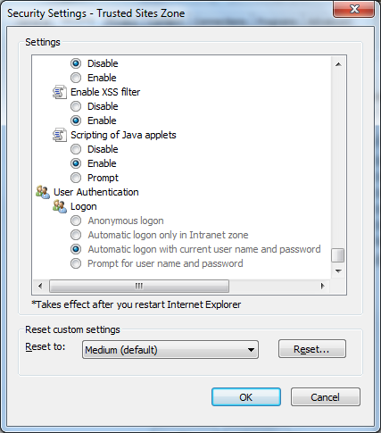

      - Advanced Tab – These are suggested settings for this Tab. If any conflicts with your company’s policies or you are unable to change the settings, please contact your internal IT team for help.

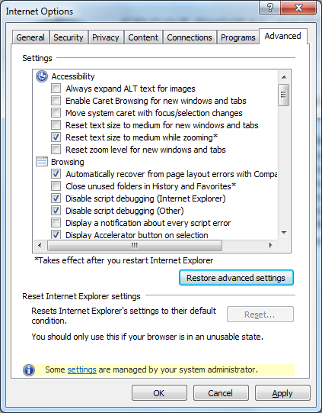

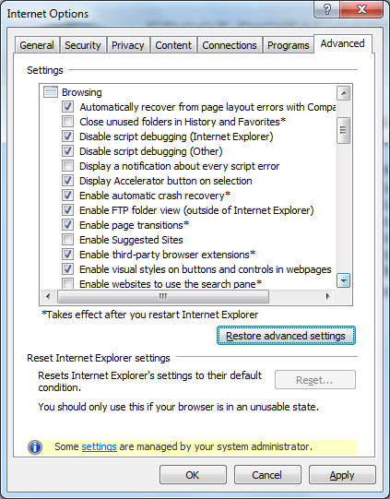

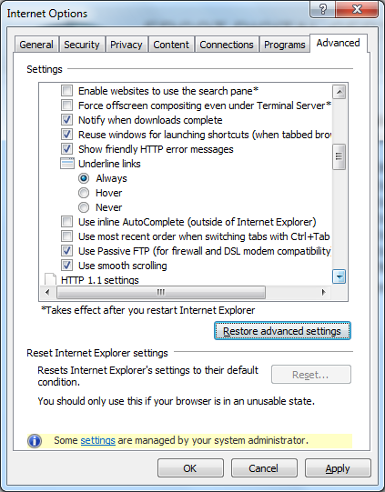

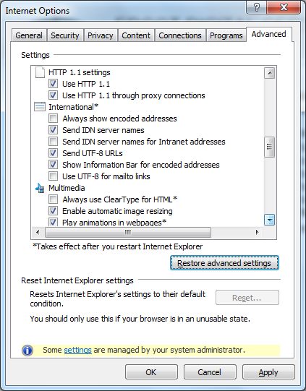

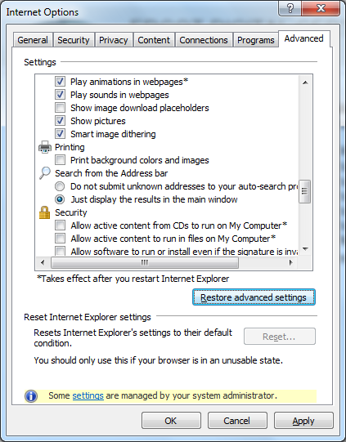

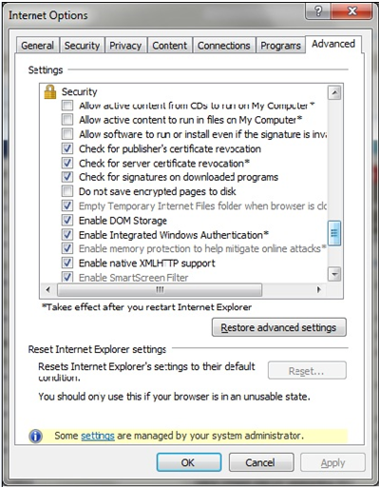

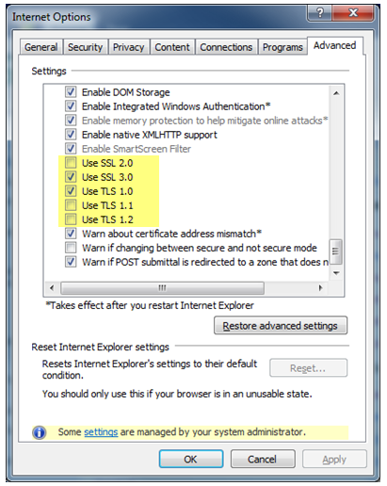

      - Once the EDC has been downloaded in Win7/VISTA, the user will receive a “Grant/Deny” prompt each time he/she logs in. To remove the prompt the certificate needs to be exported and re imported into the certificates store. To achieve this, do the following:

Using the Windows MMC program:

  - - Click on the Start Menu
  - - Enter mmc in the ‘Search programs ad files’ text box and hit Enter
  - - Click ‘Yes’ if prompted to allow the Microsoft Management Console to make changes.
  - - In the console that opens up click on File – then – Add/Remove Snap-In…
  - - Select ‘Certificates’ in the Available snap-ins list and add to the Selected snap-ins list
  - - Select ‘My user account’ and click Finish for the ‘This snap-in will always manage certificates for:’ prompt.
  - - Click OK in the ‘Add or Remove Snap-Ins’ window.
  - - Back in the console (usually named Console1) there should be a ‘certificates’ entry in the left pane. Double click on it to expand.
  - - Double click on the ‘Personal’ folder to expand it.
  - - Click on the ‘certificates’ folder and the list of certificates installed will show in the right pane.
  - - Locate the certificate to export and right click on it – Select: All Tasks > Export…
  - - The Export certificate wizard start (follow below steps)

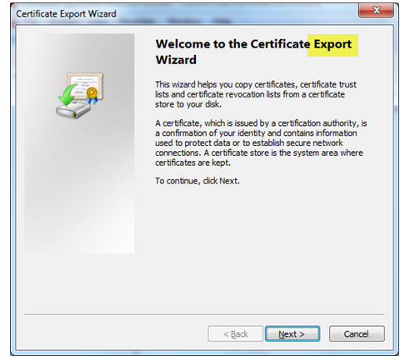

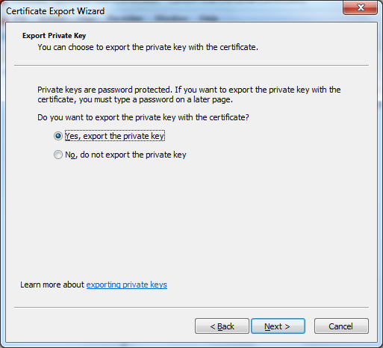

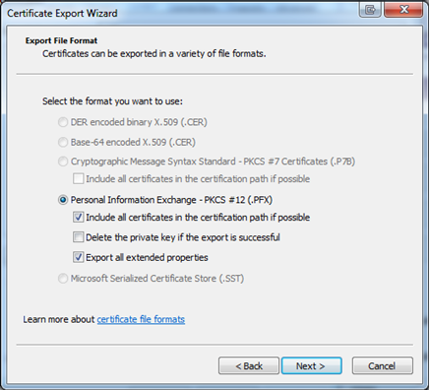

In order to keep your certificate safe, a password is required. Remember your password, as you will need it to import your certificate. Click “Next” after you have created your password.

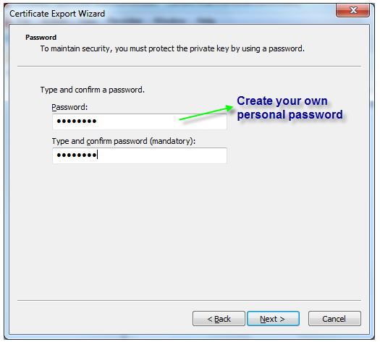

Name the certificate, give it a meaningful name and save it to a location you can remember. You will need to go back this location to import. Click “Next”.

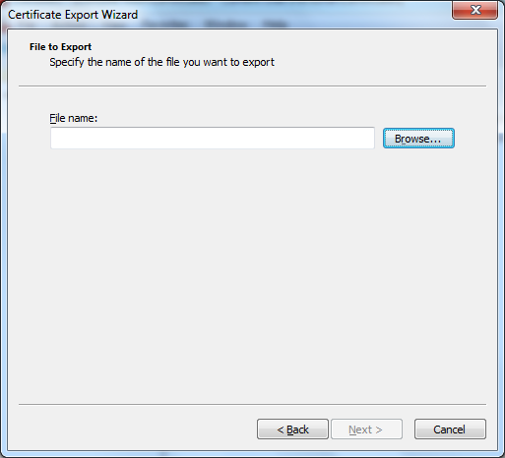

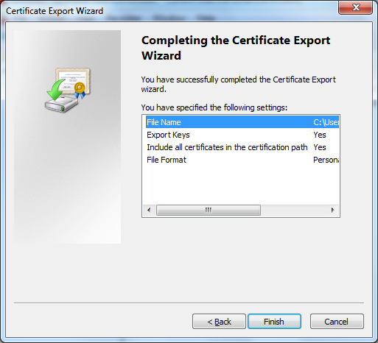

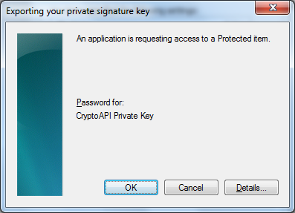

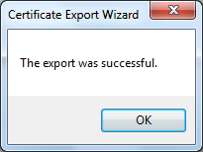

      - Once the certificate has been successfully exported, delete the installed certificate instance from the MMC certificate store.

Back in the MMC Console1:

      - Locate the certificate that was recently exported and right click on it
-Select: Delete and confirm.
      - Right click (left pane) the Certificates folder under Personal folder
-Select: All Tasks > Import…
      - Follow the Certificate Import Wizard to select the certificate you just exported in previous section.

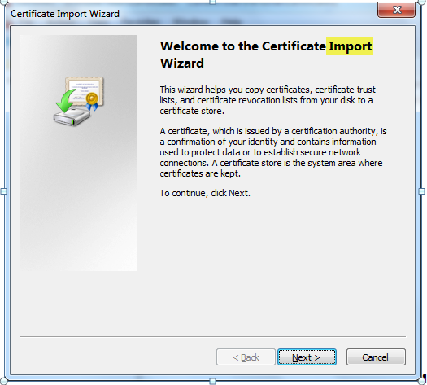

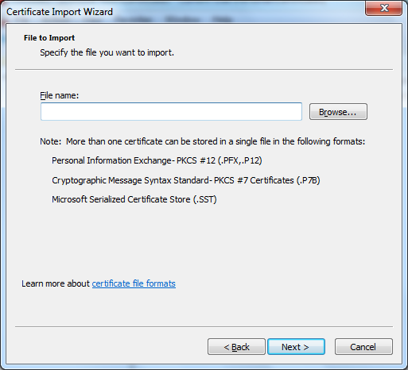

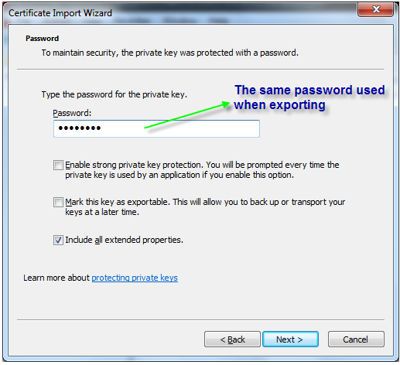

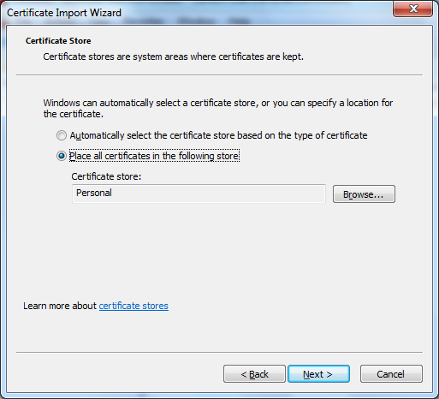

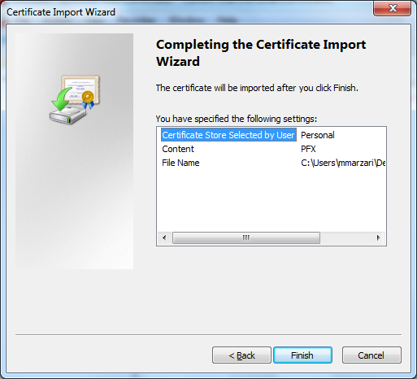

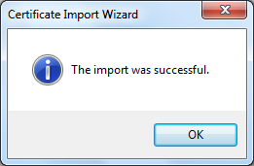

Note: You can close the Console1 MMC window; you don’t need to save it

- IE8 Validation / Session Sharing

This is an issue when a User has multiple digital certificates and not allowed to choose between the certificates without closing all browsers.

This is related to a new ‘feature’ of IE8 called ‘Loosely Coupled IE8’ or ‘IE8 Session Sharing’.

There are several workarounds to prevent sessions from being shared across multiple frames:

- From an existing IE window click ‘File -> New Session’ Or ‘Alt+F-> I -> Enter’
- Create a new shortcut for IE, right-click on it and select ‘Properties’, then add ‘-noframemerging’ (without the quotes) to the end of the command line in the ‘Target:’ field.
e.g. "C:\Program Files\Internet Explorer\iexplore.exe" –noframemerging
- From a command prompt or the ‘Run’ line run type: ‘iexplore.exe –noframemerging’ (without the quotes)
- The first 3 only disable session sharing on an ‘as needed’ basis. To fully and permanently disable it for all IE sessions for a user you can add the following registry dword value: [HKEY_CURRENT_USER\Software\Microsoft\Internet Explorer\Main] “TabProcGrowth" = dword : 00000000
This is the default behavior for IE7.
This will only disable session sharing for the currently logged on user.

Note: This apparently only disables session sharing across individual browser windows. There does not appear to be a method for disabling it across multiple tabs within the same browser window. This is also the default behavior for IE7.

For information regarding this feature, please refer to the link below:

http://blogs.msdn.com/b/ie/archive/2008/03/11/ie8-and-loosely-coupled-ie-lcie.aspx

- If the MP USA/USER still cannot download their EDC, contact the ERCOT Helpdesk at (512) 248-6800.

Please have the following information available:

- Name
- Company Name
- Phone
- Email
- DUNS
- Operating System
- Browser/Version
- Nature of Problem
- If it’s related to a digital certificate issue, are you the USA?
  - If so, what is the EmployeeID of the user having issues?
  - If not, contact the USA for assistance and have them open the ticket on your behalf if needed.
- Have you verified with your USA that you have the appropriate roles required to access the system in question?
- Do you have any logs/screenshots/errors to provide us?

