July 2020 ERCOT Monthly Operations Report
Reliability and Operations Subcommittee Meeting
September 3, 2020

Table of Contents
1. Report Highlights 2
2. Frequency Control 3
2.1. Frequency Events 3
2.2. Responsive Reserve Events 4
2.3. Load Resource Events 4
3. Reliability Unit Commitment 4
4. Wind Generation as a Percent of Load 5
5. Largest Net-Load Ramp 5
6. COP Error Analysis 6
7. Congestion Analysis 8
7.1. Notable Constraints 8
7.2. Generic Transmission Constraint Congestion 12
7.3. Manual Overrides 12
7.4. Congestion Costs for Calendar Year 2020 12
8. System Events 14
8.1. ERCOT Peak Load 14
8.2. Load Shed Events 14
8.3. Stability Events 14
8.4. Notable PMU Events 14
8.5. DC Tie Curtailment 14
8.6. TRE/DOE Reportable Events 14
8.7. New/Modified/Removed RAS 14
8.8. New Procedures/Forms/Operating Bulletins 14
9. Emergency Conditions 15
9.1. OCNs 15
9.2. Advisories 15
9.3. Watches 15
9.4. Emergency Notices 15
10. Application Performance 15
10.1. TSAT/VSAT Performance Issues 15
10.2. Communication Issues 15
10.3. Market System Issues 16
11. Model Updates 16
Appendix A: Real-Time Constraints 18

Report Highlights
- The unofficial ERCOT peak was 74,311 MW.
- There were 6 frequency events.
- There were 4 instances where Responsive Reserves were deployed.
- There were 3 RUC commitments.
- Congestion in the Panhandle can be attributed to high wind generation as well as Transmission Outages. There were 23 days of congestion on the Panhandle GTC, 27 days on the McCamey GTC, and 21 days on the North Edinburg to Lobo GTC. There was no activity on the remaining GTCs during the month.
- Hurricane Hanna caused multiple Forced Outages in the Valley area. The last of the Outages returned to service on August 10.
- There were no DC Tie curtailments.

Frequency Control

Frequency Events
The ERCOT Interconnection experienced six frequency events, which resulted from unit’s trips. The average event duration was 00:06:19.

A summary of the frequency events is provided below. The reported frequency events meet one of the following criteria: Delta Frequency is 60 mHz or greater; the MW loss is 350 MW or greater; resource trip event triggered RRS deployment. Frequency events that have been identified as Frequency Measurable Events (FME) for purposes of BAL-001-TRE-1 analysis are highlighted in blue. When analyzing frequency events, ERCOT evaluates PMU data according to industry standards. Events with an oscillating frequency of less than 1 Hz are considered to be inter-area, while higher frequencies indicate local events. Industry standards specify that damping ratio for inter-area oscillations should be 3.0% or greater. For the frequency events listed below, the ERCOT system met these standards and transitioned well after each disturbance.

Date and Time | Delta Frequency | Max/Min Frequency | Duration of Event | PMU Data |  | MW Loss | Load | Wind | Inertia
 | (Hz) | (Hz) |  | Oscillation Mode (Hz) | Damping Ratio |  | (MW) | % | (GW-s)
7/1/2020 18:28 | 0.123 | 59.847 | 0:04:37 | No PMU Data Available |  | 800.92 | 66,356 | 19% | 353,136
7/5/2020 16:44 | 0.104 | 59.909 | 0:08:42 | No PMU Data Available |  | 432.92 | 64,821 | 4% | 359,952
7/6/2020 15:09 | 0.172 | 59.808 | 0:06:09 | 0.370 | 10% | 762.19 | 63,148 | 6% | 342,816
7/9/2020 20:14 | 0.140 | 59.838 | 0:05:44 | 0.680 | 4% | 842.66 | 64,409 | 26% | 338,134
7/16/2020 15:13 | 0.089 | 59.882 | 0:06:43 | 0.630 | 12% | 510.85 | 72,245 | 11% | 360,193
7/20/2020 11:47 | 0.159 | 59.815 | 0:06:00 | 0.710 | 13% | 806.31 | 59,603 | 5% | 341,428

(Note: All data on this graph encompasses frequency event analysis based on BAL-001-TRE-1.)

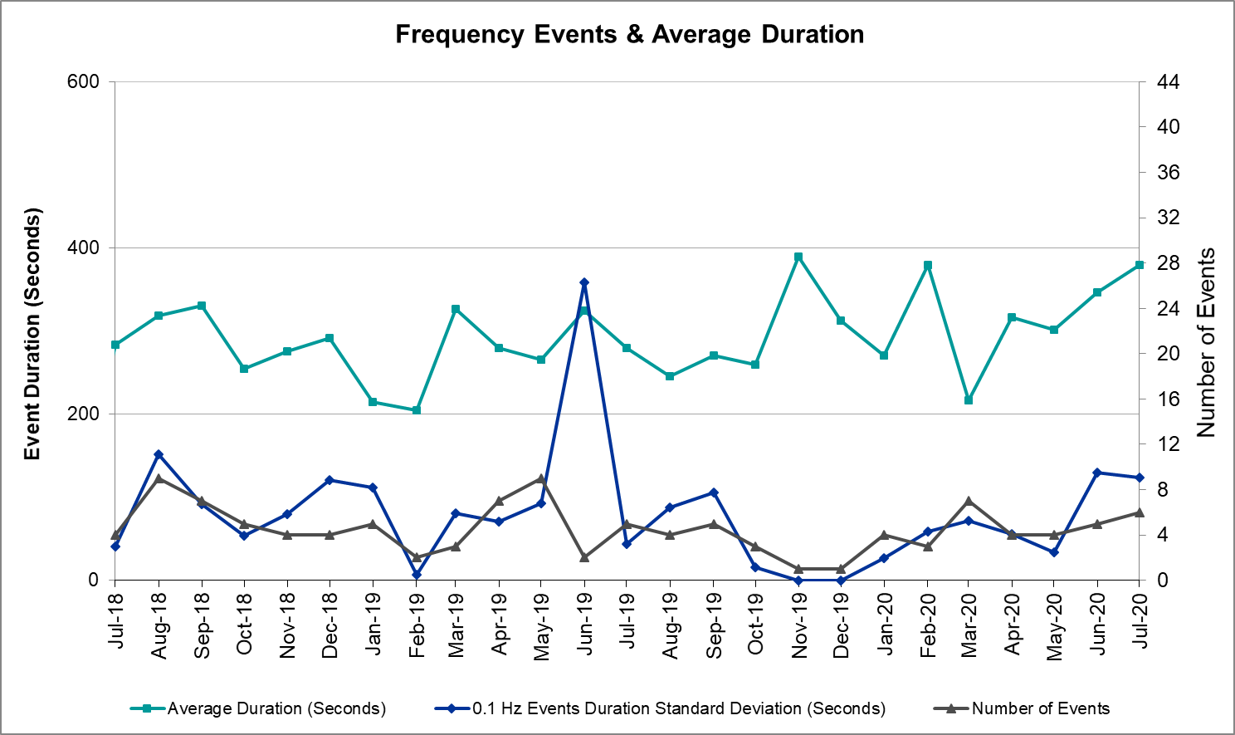

Note that the large standard deviation in June 2019 is due to coincidental extreme high and low durations for a small set of events (2).

Responsive Reserve Events
There were 5 events where Responsive Reserve MWs were released to SCED. The events highlighted in blue were related to frequency events reported in Section 2.1 above.

Date and Time Released to SCED | Date and Time Recalled | Duration of Event | Maximum MWs Released | Comments
7/1/2020 18:28:10 | 7/1/2020 18:33:38 | 00:05:28 | 1162
7/6/2020 15:09:34 | 7/6/2020 15:15:42 | 00:06:08 | 1164
7/9/2020 20:14:20 | 7/9/2020 20:20:03 | 00:05:43 | 1163
7/16/2020 15:13:32 | 7/16/2020 15:20:16 | 00:06:44 | 794
7/20/2020 11:47:52 | 7/20/2020 11:54:00 | 00:06:08 | 1163

Load Resource Events
No Load Resource Events.

Reliability Unit Commitment
ERCOT reports on Reliability Unit Commitments (RUC) on a monthly basis. Commitments are reported grouped by operating day and weather zone. The total number of hours committed is the sum of the hours for all the units in the specified region. Additional information on RUC commitments can be found on the MIS secure site at Grid Generation Reliability Unit Commitment.

There were no DRUC commitments.

There were 3 HRUC commitments.

Resource Location | # of Resources | Operating Day | Total # of Hours Committed | Total MWhs | Reason for Commitment
Southern | 2 | 7/30/2020 | 8 | 2,427 | XNED258
Southern | 1 | 7/31/2020 | 24 | 7,355 | XNED258

Wind Generation as a Percent of Load
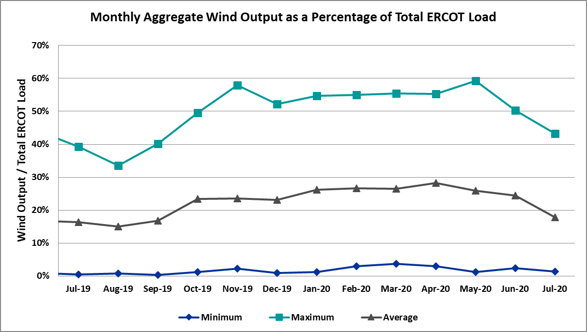

Wind Generation Record: 21,375 MW on 6/8/2020 at 23:22
Wind Penetration Record: 59.30% on 05/02/2020 at 02:10

Largest Net-Load Ramp
The net-load ramp is defined as the change in net-load (load minus wind and PVGR generation) during the defined time horizon. Such a variation in net-load needs to be accommodated in grid operations to ensure that the reliability of the grid is satisfactorily maintained. The largest net-load ramp during 5-min, 10-min, 15-min, 30-min and 60-min in July 2020 are 859 MW, 1522 MW, 2022 MW, 3849 MW, and 7257 MW, respectively. The comparison with respect to the historical values is given in the table below.

Month and Year | 5 min | 10 min | 15 min | 30 min | 60 min
July 2020 | 859 MW | 1522 MW | 2022 MW | 3849 MW | 7257 MW
July 2014 | 1074 MW | 1424 MW | 1713 MW | 2809 MW | 5392 MW
July 2015 | 905 MW | 1257 MW | 1688 MW | 3075 MW | 5843 MW
July 2016 | 863 MW | 1660 MW | 1885 MW | 3390 MW | 5900 MW
July 2017 | 880 MW | 1243MW | 1756 MW | 3048 MW | 5738 MW
July 2018 | 1399 MW | 1779 MW | 2202 MW | 3572 MW | 6698 MW
July 2019 | 1120 MW | 1699 MW | 2291 MW | 3561 MW | 6546 MW
2014-2019 | 1494 MW | 1991 MW | 2780 MW | 4109 MW | 7786 MW

COP Error Analysis
COP Error is calculated as the capacity difference between the COP HSL and real-time HSL of the unit. Mean Absolute Error (MAE) stayed high over 9,000 MW until Day-Ahead at 12:00, then dropped significantly to 1,902 MW by Day-Ahead at 14:00. In the following chart, Under-Scheduling Error indicates that COP had less generation capacity than real-time and Over-Scheduling Error indicates that COP had more generation capacity than real-time. Under-Scheduling persisted from beginning of Day-Ahead to end of the Operating Day.
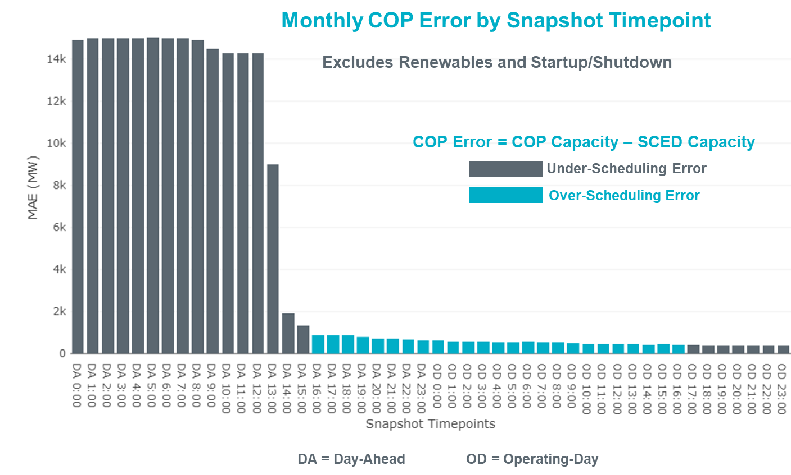
Monthly MAE for the Latest COP at the end of the Adjustment Period was 369 MW with median ranging from -411.5 MW for Hour-Ending (HE) 17 to 213 MW for HE 24. HE 22 on the 9th had the largest Over-Scheduling Error (1,532 MW) and HE 20 on the 21th had the largest Under-Scheduling Error (-2,511 MW).
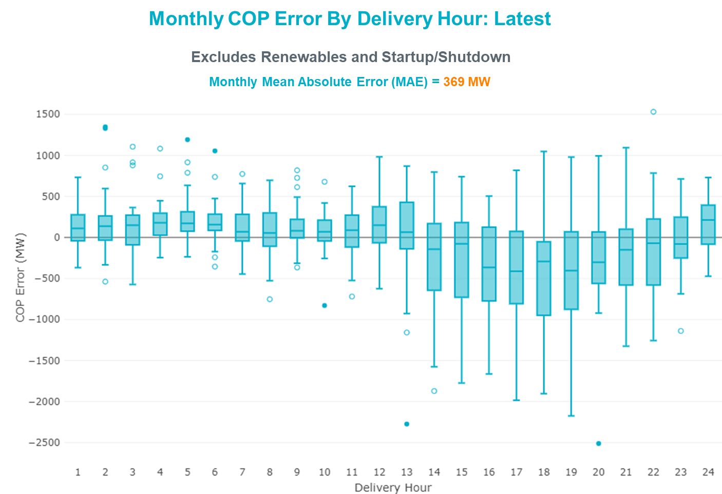

Monthly MAE for the Day-Ahead COP at 12:00 was 11,700 MW with median ranging from -20,830 MW for Hour-Ending (HE) 16 to -9,341 MW for HE 4. HE 15 on the 23rd had the largest Under-Scheduling Error (-24,432 MW) and HE 3 on the 9th had the largest Over-Scheduling Error (-5,460 MW).

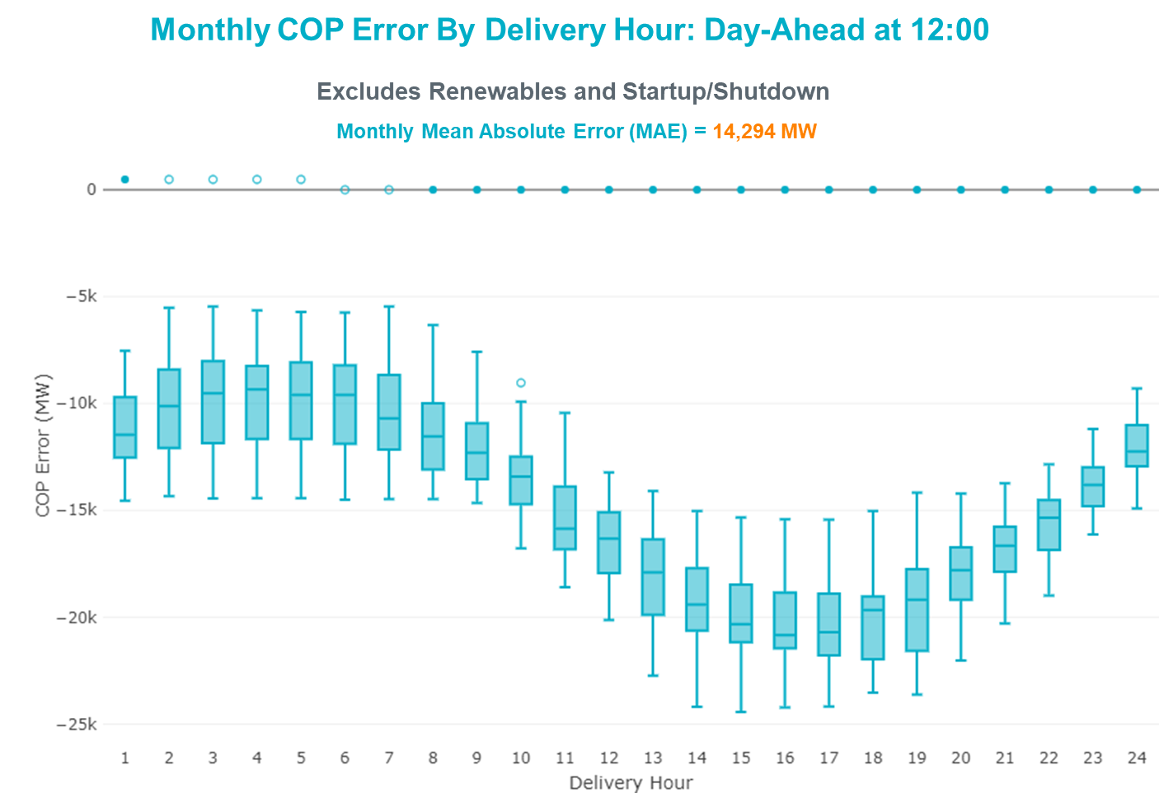

Congestion Analysis

Notable Constraints
Nodal protocol section 3.20 specifies that ERCOT shall identify transmission constraints that are active or binding three or more times within a calendar month. As part of this process, ERCOT reports congestion that meets this criterion to ROS. In addition ERCOT also highlights notable constraints that have an estimated congestion rent exceeding $1,000 for a calendar month. These constraints are detailed in the table below. Rows highlighted in blue indicate the congestion was affected by one or more outages. For a list of all constraints activated in SCED, please see Appendix A at the end of this report.

Contingency Name | Overloaded Element | # of Days Constraint Active | Congestion Rent | Transmission Project
MANUAL Nedin-Mv_Wedn4 Dbl Ckt 138kV | Hidalgo Energy Center - Azteca Sub 138kV | 5 | $18,254,220.50 | Stewart Road: Construct 345 kV cut-in with two 450 MVA 345/138 autotransformers connected to Stewart Rd 138 station (5604, 6382)
HCKSW TO SAGNA 138 DBLCKT | Eagle Mountain Ses - Morris Dido 138kV | 19 | $7,171,038.79 | Upgrade the Saginaw - Eagle Mountain 138 kV Double Circuit Line (6273)
WEST EDNBURG SUB to NORTH EDINBURG LIN 1 | North Edinburg - West Ednburg Sub 138kV | 2 | $6,641,480.55 | Stewart Road: Construct 345 kV cut-in with two 450 MVA 345/138 autotransformers connected to Stewart Rd 138 station (5604, 6382)
TWR (345) HLJ-WAP64 & BLY-WAP72 | South Texas Project - Wa Parish 345kV | 15 | $6,406,447.27 | Freeport - Master Plan (6668B)
Basecase | PNHNDL GTC | 23 | $5,083,097.57 | "Panhandle GTC Exit Plan - ""PANHANDLE RENEWABLE ENERGY ZONE (PREZ)
HUTTO TO RNDRK 138 AND HUTTO TO GEORSO 138 DBLCKT | Wells Branch - Round Rock South 138kV | 4 | $3,262,820.98
Basecase | MCCAMY GTC | 27 | $1,784,007.40 | McCamey GTC Exit Plan posted on the ERCOT MIS website
MVEC (RANGERVILLE) to LA PALMA LIN 1 | Haine Drive - La Palma 138kV | 2 | $1,766,971.20 | Stewart Road: Construct 345 kV cut-in with two 450 MVA 345/138 autotransformers connected to Stewart Rd 138 station (5604, 6382); Harlingen SS - Raymondville #2: Convert to 138 kV (6167)
WEST EDNBURG SUB to ALTON SUB LIN 1 | Weslaco Switch - North Alamo 138kV | 1 | $1,679,602.57 | Stewart Road: Construct 345 kV cut-in with two 450 MVA 345/138 autotransformers connected to Stewart Rd 138 station (5604, 6382)
NORTH EDINBURG TRX 1382 345/138 | North Edinburg 345kV | 2 | $1,664,457.85 | Stewart Road: Construct 345 kV cut-in with two 450 MVA 345/138 autotransformers connected to Stewart Rd 138 station (5604, 6382)
Cagnon-Kendal 345 & Cico-Comfor 138 | Welfare - Kendall 138kV | 8 | $887,810.95
Basecase | NE_LOB GTC | 21 | $886,427.23 | GTC Exit plan in the North Edinburg - Lobo Stability Study Report posted in the ERCOT MIS website
TWR (345) JN-WAP64 & JN-WAP72 | Wa Parish - Obrien 345kV | 9 | $856,264.64
Cagnon-Kendal 345 & Cico-Comfor 138 | Mason Creek - Bandera 138kV | 14 | $856,234.16
VENSW TO LIGSW 345 TRPLCKT 1 OF 3 | Britton Road - Venus Switch 345kV | 5 | $744,355.63 | Venus - Webb/Cedar Hill Sw. Sta. 345 kV DCKT Line (5492)
COMANCHE SWITCH (Oncor) to COMANCHE PEAK SES LIN _A | Comanche Tap - Comanche Switch (Oncor) 138kV | 7 | $634,757.52
RIO HONDO to LAS PULGAS LIN 1 | Raymondville 2 138kV | 18 | $625,289.17 | Harlingen SS - Raymondville #2: Convert to 138 kV (6167)
ASHERTON to Bevo Substation LIN 1 | Bevo - Brundage Sub 69kV | 9 | $615,244.07 | Rebuild BEVO to Brundage to Big Wells 69 kV lines. (6255B)
SAN MIGUEL 345_138 KV SWITCHYARDS to LOBO LIN 1 | Laredo Vft North - Las Cruces 138kV | 10 | $490,146.71 | Laredo - Del Mar: 138 kV Line Rebuild (45511)
MCSES TO CDHSW 138 DBLCKT | Cedar Crest Switch - Oak Cliff South 138kV | 3 | $475,297.76 | Watermill Switch - Camp Wisdom 138 kV Line (45541) and Cedar Hill - Camp Wisdom 138 kV Line (7020)
ODLAW SWITCHYARD to ASPHALT MINES LIN 1 | Hamilton Road - Maverick 138kV | 16 | $391,057.64 | Brackettville to Escondido: Construct 138 kV line (5206)
Bighil-Kendal 345kV | Bondroad - Sonora 69kV | 10 | $363,578.22 | Friess Ranch to Sonora: Rebuild 69 kV line (51001)
LAQUINTA to LOBO LIN 1 | Bruni Sub 138kV | 14 | $336,809.86
Cagnon-Kendal 345 & Cico-Comfor 138 | Raymond F Barker - Comfort 138kV | 3 | $207,265.51
PAREDES SWITCHING STATION to CENTRAL AVENUE SUB LIN 1 | Rio Hondo - East Rio Hondo Sub 138kV | 20 | $147,061.21 | Rebuild Rio Hondo to East Rio Hondo (6687)
wett_sand_bluff to wett_bearkat LIN 1 | Carterville - Einstein 138kV | 16 | $142,538.99 | Bearkat Loop - Bearkat to Longshore (45399)
ODEHV-MOSSW&ODEHV-WLFSW 345 kV MANUAL | Trigas Odessa Tap - Odessa Ehv Switch 138kV | 3 | $103,638.34 | Riverton-Odessa EHV/Moss 345 kV Line (5445)
VERNON to LAKE PAULINE LIN 1 | Chillicothe Vern Tap - Vernon 69kV | 4 | $99,722.69 | Lake Pauline to Vernon 69 kV line: Rebuild taps (6571)
CHB-KG & CBY-JOR 345kV | Langston - Mont Belvieu 138kV | 3 | $90,954.13 | Cedar Bayou 138kV - West Bus In-Series 10-Ohm Reactor (52141)
TOMBSTONE to Lynx LIN 1 | 16th Street Tnp - Woodward 2 138kV | 4 | $86,767.15 | Solstice: Build 345 kV station (5530) and Solstice to Bakersfield: Build 345 kV line (5539)
CHB-KG & CBY-JOR 345kV | Cedar Bayou - Cedar Bayou Plant 138kV | 5 | $82,088.29 | Cedar Bayou 138kV - West Bus In-Series 10-Ohm Reactor (52141)
Basecase | Re Roserock Solar Plant - Linterna 138kV | 16 | $74,329.16
PH ROBINSON to MEADOW LIN A | Mainland Tnp - Alvin Tnp 138kV | 3 | $62,078.95 | Rebuild Alvin-Mainland-Freeway Park (795 ACSS) (54118)
Melon Creek to RINCON LIN 1 | Bonnieview - Rincon 69kV | 11 | $61,332.19 | Refugio - Rincon: Upgrade 69 kV Line (6427)
VICTORIA TRX 69A2 138/69 | Magruder - Victoria 138kV | 5 | $60,673.18
NORTH CARBIDE to SEADRIFT SUB LIN 1 | North Carbide - Port Lavaca Tap 69kV | 4 | $59,091.18
GRAHAM SES to RICE SWITCH LIN _A | Anarene - Navy Kickapoo Switch 69kV | 5 | $55,368.81
SAN MIGUEL 345_138 KV SWITCHYARDS to LOBO LIN 1 | North Laredo Switch - Piloncillo 138kV | 7 | $48,129.11 | GTC Exit plan in the North Edinburg - Lobo Stability Study Report posted in the ERCOT MIS website
INGLESIDE COGEN SWITCH to OXYCHEM INGLESIDE LIN 1 | Dupont Pp1 - Ingleside - Dupont Switch - Ingleside 138kV | 6 | $47,550.28
FORT LANCASTER to ILLINOIS #4 LIN 1 | Hamilton Road - Maxwell 138kV | 3 | $42,799.36 | Hamilton Road to Picacho ckt #2, rebuild 138 kV line (6373)
KING MOUNTAIN SWITCHYARD to ODESSA EHV SWITCH LIN 1 | Fort Stockton Plant - Solstice 138kV | 8 | $37,313.44 | Solstice: Build 345 kV station (5530)
DUPONT SWITCH - INGLESIDE to  GREGORY POWER LIN 1 | Dupont Switch - Ingleside - Lge 138kV | 9 | $32,440.54
CAGNON TRX CAGNON_3_3 345/138 | Cagnon 345kV | 10 | $31,474.43
Fergus-Granmo&Wirtz-Starck 138kV | Johnson City - Wirtz 138kV | 8 | $30,114.32 | Wirtz to Johnson City to Mountain Top Rebuild to 138kV (6789)
SAN MIGUEL 345_138 KV SWITCHYARDS to LOBO LIN 1 | Bruni Sub 138kV | 5 | $29,779.63
MBDSW TO DCSES AND MBDSW TO RKCRK 345 DBLCKT | Comanche Tap - Comanche Switch (Oncor) 138kV | 4 | $22,212.97
Solstice to FORT STOCKTON PLANT LIN 1 | Alpine - Bronco 69kV | 6 | $16,265.89 | Solstice: Build 345 kV station (5530)
Austro-Daffin&Dunlap-Decker 138kV | Mcneil Aen - Howard Lane Aen 138kV | 4 | $11,366.21 | Reconductor 138kV ckt 972 Howard Lane to McNeil to 3000A (48327)
OASIS to MEADOW LIN A | Wa Parish - Obrien 345kV | 3 | $9,605.03
BIG SPRING SWITCH TRX FMR1 138/69 | Chevron Ackerly Tap - Buzzard Draw Switch 69kV | 4 | $8,184.92 | Big Spring - Buzzard Draw 69 kV Line Conversion (46259)
South Texas # 1 & # 2 | Blessing - Lolita 138kV | 3 | $8,078.75 | Tidehaven: Construct New Distribution Station (48776)
GUNSIGHT SWITCH to GETTY VEALMOOR TAP LIN _A | Chevron Ackerly Tap - Buzzard Draw Switch 69kV | 5 | $5,398.04 | Big Spring - Buzzard Draw 69 kV Line Conversion (46259)
Bighil-Kendal 345kV | Yellow Jacket - Treadwell 138kV | 5 | $4,534.76 | Treadwell GTC Exit Plan posted on the ERCOT MIS website
COLETO CREEK to Euler LIN 1 | Coleto Creek - Rosata Tap 138kV | 4 | $3,588.49 | Coleto Creek - Rosata: Line Rebuild (50870)
BOSQUE SWITCH to ELM MOTT LIN 1 | Bosque Switch - Rogers Hill Bepc 138kV | 6 | $2,943.51 | Upgrade Elm Mott - Bosque 138 kV Line (52149)
Melon Creek to RINCON LIN 1 | Heard Tap - Woodsboro 69kV | 5 | $2,649.93
GAS PAD to FLAT TOP TNP LIN 1 | Fort Stockton Plant - Solstice 138kV | 6 | $2,002.67 | Solstice: Build 345 kV station (5530)
ODEHV-MOSSW&ODEHV-WLFSW 345 kV MANUAL | Fort Stockton Plant - Solstice 138kV | 5 | $1,720.70 | Solstice: Build 345 kV station (5530)

Generic Transmission Constraint Congestion
There were 23 days of congestion on the Panhandle GTC, 27 days on the McCamey GTC, and 21 days on the North Edinburg to Lobo GTC. There was no activity on the remaining GTCs during the month.

Note: This is how many times a constraint has been activated to avoid exceeding a GTC limit, it does not imply an exceedance of the GTC occurred or that the GTC was binding.

Manual Overrides
None.

Congestion Costs for Calendar Year 2020
The following table represents the top twenty active constraints for the calendar year based on the estimated congestion rent attributed to the congestion. ERCOT updates this list on a monthly basis.

Contingency | Overloaded Element | # of 5-min SCED | Estimated | Transmision
MOSS SWITCH to ECTOR COUNTY NORTH SWITCHING STATION LIN _A | #N/A | 12277 | 115237549.4
WINK to DUNE SWITCH and YUKON | #N/A | 10924 | 76533287.97
Manual MDSSW_TRX1_345/138 | Trigas Odessa Tap - Odessa Ehv Switch 138kV | 1787 | 38328997.67 | Riverton-Odessa EHV/Moss 345 kV Line (5445)
Basecase | PNHNDL GTC | 16523 | 37305258.67 | "Panhandle GTC Exit Plan - ""PANHANDLE RENEWABLE ENERGY ZONE (PREZ)
CRLNW TO LWSSW 345 DBLCKT | Ti Tnp - West Tnp 138kV | 7512 | 27506188.55 | Lewisville - Lewisville Jones - Lakepointe 138 kV Line (45537)
WINK to DUNE SWITCH and YUKON | #N/A | 2002 | 23188211.21
MOSS SWITCH to ECTOR COUNTY NORTH SWITCHING STATION LIN _A | #N/A | 1316 | 21247827.71
MANUAL Nedin-Mv_Wedn4 Dbl Ckt 138kV | Hidalgo Energy Center - Azteca Sub 138kV | 732 | 19977963.2 | Stewart Road: Construct 345 kV cut-in with two 450 MVA 345/138 autotransformers connected to Stewart Rd 138 station (5604, 6382)
JEWET TO SNG 345 DBLCKT | Btu_Jack_Creek - Twin Oak Switch 345kV | 1193 | 17477432.7
HCKSW TO SAGNA 138 DBLCKT | Eagle Mountain Ses - Morris Dido 138kV | 2679 | 15263707.9 | Upgrade the Saginaw - Eagle Mountain 138 kV Double Circuit Line (6273)
NORTH EDINBURG TRX 1382 345/138 | North Edinburg 345kV | 835 | 12119686.96 | Stewart Road: Construct 345 kV cut-in with two 450 MVA 345/138 autotransformers connected to Stewart Rd 138 station (5604, 6382)
POMELO to NORTH EDINBURG LIN 1 | Lobo - Freer 69kV | 7377 | 10626337.75 | GTC Exit plan in the North Edinburg - Lobo Stability Study Report posted in the ERCOT MIS website
CRLNW TO LWSSW 345 DBLCKT | Argyle - Highlands Tnp 138kV | 3922 | 10613392.34 | Lewisville - Lewisville Jones - Lakepointe 138 kV Line (45537)
Loss of NEDIN train | North Edinburg 345kV | 90 | 9831038.841 | Stewart Road: Construct 345 kV cut-in with two 450 MVA 345/138 autotransformers connected to Stewart Rd 138 station (5604, 6382)
ODLAW SWITCHYARD to ASPHALT MINES LIN 1 | Hamilton Road - Maverick 138kV | 13233 | 9747570.881 | Brackettville to Escondido: Construct 138 kV line (5206)
ODESSA EHV SWITCH TRX ODEHV_3_1 345/138 | Odessa Ehv Switch 345kV | 558 | 8111745.697 | Riverton-Odessa EHV/Moss 345 kV Line (5445)
TWR (345) HLJ-WAP64 & BLY-WAP72 | South Texas Project - Wa Parish 345kV | 2098 | 7907086.252 | Freeport - Master Plan (6668B)
BIG SPRING SWITCH to CHALK_69kV and McDonald Road_138kV | Odessa Ehv Switch 345kV | 257 | 7736976.707 | Riverton-Odessa EHV/Moss 345 kV Line (5445)
WEST EDNBURG SUB to NORTH EDINBURG LIN 1 | North Edinburg - West Ednburg Sub 138kV | 274 | 7446002.316 | Stewart Road: Construct 345 kV cut-in with two 450 MVA 345/138 autotransformers connected to Stewart Rd 138 station (5604, 6382)
MOSS SWITCH to ECTOR COUNTY NORTH SWITCHING STATION LIN _A | Odessa Ehv Switch - Yarbrough Sub 138kV | 371 | 7401498.444 | Riverton-Odessa EHV/Moss 345 kV Line (5445)

System Events

ERCOT Peak Load
The unofficial ERCOT peak load for the month was 74,311 MW and occurred on the 13th, during hour ending 17:00.

Load Shed Events
None.

Stability Events
None.

Notable PMU Events
ERCOT analyzes PMU data for any significant system disturbances that do not fall into the Frequency Events category reported in section 2.1. The results are summarized in this section once the analysis has been completed.

There were no PMU events outside of those reported in section 2.1.

DC Tie Curtailment
None.

TRE/DOE Reportable Events
- Oncor submitted an EOP-004-4 for 07/08/2020. Reportable Event Type: Physical threat to its facilities.
- Oncor submitted an OE-417 for 07/12/2020. Reportable Event Type: Loss of electric service to more than 50,000 customers for 1 hour or more.
- AEN submitted an OE417 for 07/20/2020. Reportable Event Type: Damage or destruction of its facilities.
- AEP submitted an OE-417 for 07/25/2020. Reportable Event Type: Loss of electric service to more than 50,000 customers for 1 hour or more.
- STEC submitted an OE-417 for 07/25/2020. Submitted at the request of TexasRE. STEC reporting did not meet the criteria of Reportable Event Type: Loss of electric service to more than 50,000 customers for 1 hour or more.
- MVEC submitted an OE-417 for 07/25/2020. Reportable Event Type: Loss of electric service to more than 50,000 customers for 1 hour or more.

New/Updated Constraint Management Plans
There were two CMP expired, MP_2020_03 and PCAP_2020_01.

New/Modified/Removed RAS
Wirtz RAS was modified and still remains out of service. The activation of the modified Wirtz RAS is TBD.

New Procedures/Forms/Operating Bulletins
Procedure Title | POB
Reliability Unit Commitment Desk | 948

Emergency Conditions

OCNs

Date and Time | Message
July 07 2020 11:00 CPT | ERCOT issued an OCN for the extreme hot weather with forecasted temperatures above 103°F.
July 23 2020 22:30 CPT | ERCOT issued an OCN for Tropical Storm Hanna possibility of making landfall in the ERCOT region.

Advisories

Date and Time | Message
July 04 2020 15:45 CPT | ERCOT issued an Advisory due to Physical Responsive Capability being below 3,000 MW.
July 06 2020 15:15 CPT | ERCOT issued an Advisory due to Physical Responsive Capability being below 3,000 MW.
July 12 2020 13:30 CPT | ERCOT has postponed the posting of the DAM solution for Operating Day July 12, 2020 due to a delay in clearing DAM.
July 19 2020 13:35 CPT | ERCOT issued an Advisory due to Physical Responsive Capability being below 3,000 MW.
July 21 2020 18:40 CPT | ERCOT issued an Advisory due to Physical Responsive Capability being below 3,000 MW.
July 22 2020 20:35 CPT | ERCOT issued an Advisory due to Physical Responsive Capability being below 3,000 MW.
July 23 2020 21:15 CPT | ERCOT issued an Advisory due to Physical Responsive Capability being below 3,000 MW.
July 23 2020 22:30 CPT | ERCOT issued an OCN for Tropical Storm Hanna possibility of making landfall in the ERCOT region.
July 24 2020 17:30 CPT | ERCOT issued an Advisory for the Tropical Storm Hanna projected to become a Hurricane prior to making landfall in the ERCOT Region.
July 27 2020 16:30 CPT | ERCOT issued an Advisory due to Physical Responsive Capability being below 3,000 MW.

Watches
None.

Emergency Notices
None.

Application Performance

TSAT/VSAT Performance Issues
None.

Communication Issues
None.

Market System Issues
None.

Model Updates
The Downstream Production Change (DPC) process allows ERCOT to make changes in the on-line Network Operations Model without loading a completely new model. The purpose of this process is to allow for reliable grid operations as system conditions change between designated Network Operations Model database loads. The DPC process is limited in scope to just those items listed below, with equipment ratings updates being the most common. ERCOT has seen a rise in the use of the DPC process to make on-line updates to the Network Operations Model in recent years, instead of through the standard Network Operations Model Change Request process.

- Static Line ratings (Interim Update)
- Dynamic Line ratings (non-Interim Update)
- Autotransformer ratings (non-Interim Update)
- Breaker and Switch Normal status (Interim Update)
- Contingency Definitions (Interim Update)
- RAP and RAS changes or additions (Interim Update)
- Net Dependable and Reactive Capability (NDCRC) values (Interim Update)
- Impedance Updates (non-Interim)

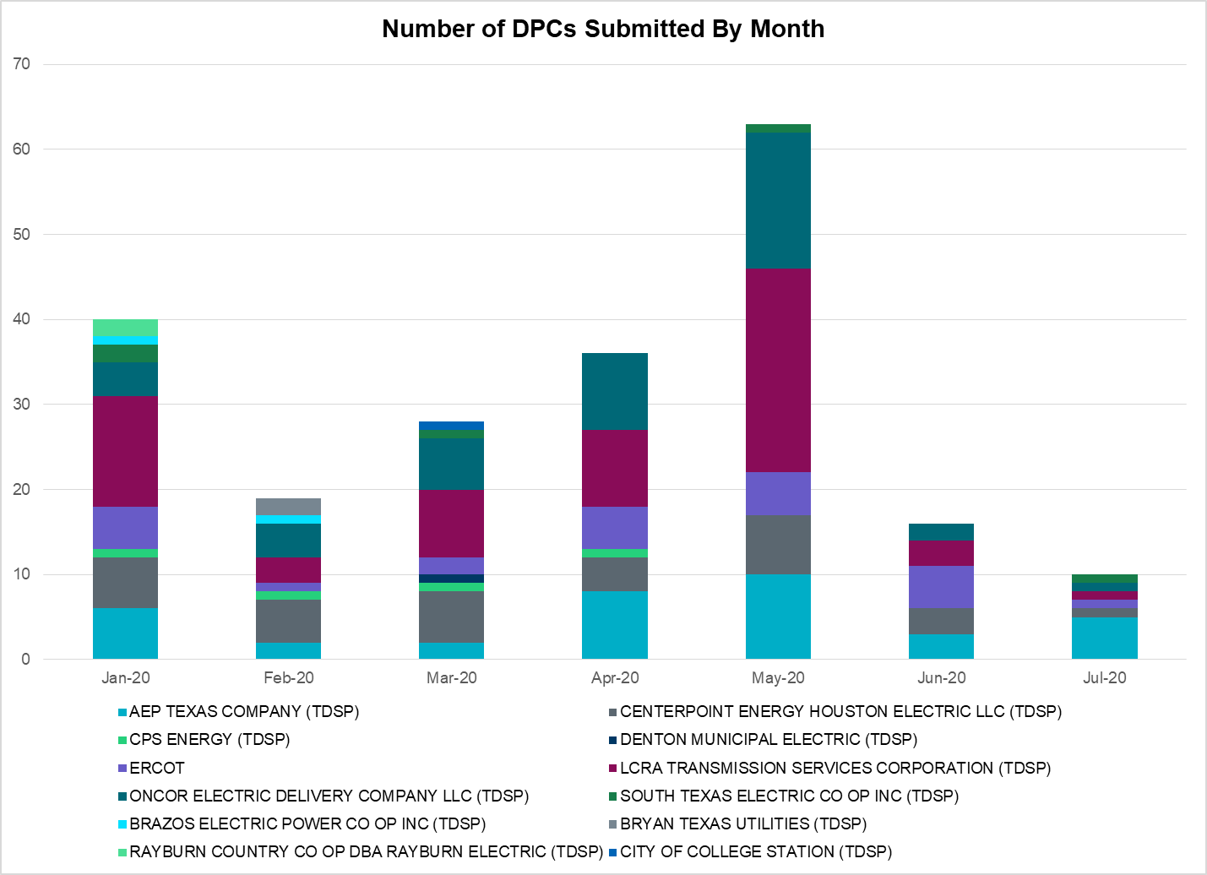

Transmission Operator | Number of DPCs
AEP TEXAS COMPANY (TDSP) | 5
BRAZOS ELECTRIC POWER CO OP INC (TDSP) | 0
BRYAN TEXAS UTILITIES (TDSP) | 0
CENTERPOINT ENERGY HOUSTON ELECTRIC LLC (TDSP) | 1
CITY OF AUSTIN DBA AUSTIN ENERGY (TDSP) | 0
CITY OF COLLEGE STATION (TDSP) | 0
CITY OF GARLAND (TDSP) | 0
CPS ENERGY (TDSP) | 0
DENTON MUNICIPAL ELECTRIC (TDSP) | 0
ELECTRIC TRANSMISSION TEXAS LLC (TDSP) | 0
ERCOT | 1
LCRA TRANSMISSION SERVICES CORPORATION (TDSP) | 1
ONCOR ELECTRIC DELIVERY COMPANY LLC (TDSP) | 1
RAYBURN COUNTRY CO OP DBA RAYBURN ELECTRIC (TDSP) | 0
SHARYLAND UTILITIES LP (TDSP) | 0
SOUTH TEXAS ELECTRIC CO OP INC (TDSP) | 1
TEXAS MUNICIPAL POWER AGENCY (TDSP) | 0
TEXAS-NEW MEXICO POWER CO (TDSP) | 2

Appendix A: Real-Time Constraints
The following is a complete list of constraints activated in SCED. Full contingency descriptions can be found in the Standard Contingencies List located on the MIS secure site at Grid Generation Reliability Unit Commitment.

Contingency Name | Overloaded Element | From Station | To Station | Count of Days
BASE CASE | MCCAMY | n/a | n/a | 27
BASE CASE | PNHNDL | n/a | n/a | 23
BASE CASE | NE_LOB | n/a | n/a | 21
SMV_PAR8 | RIOHND_ERIOHND_1 | MV_RIOHO | RIOHONDO | 20
DHCKSAG8 | 6265__A | EMSES | MRSDO | 19
SRAYRI28 | RAYMND2_69A1 | RAYMND2 | RAYMND2 | 18
BASE CASE | REROCK_TLINE_1 | REROCK | LINTERNA | 16
SW_BW_25 | CRTVLE_EINSTEN_1 | EINSTEIN | CRTRVLLE | 16
SBRAUVA8 | HAMILT_MAVERI1_1 | HAMILTON | MAVERICK | 16
DWAPHLJ5 | STPWAP39_1 | STP | WAP | 15
SLAQLOB8 | BRUNI_69_1 | BRUNI | BRUNI | 14
DCAGCO58 | 583T583_1 | BANDER | MASOCR | 14
DCAGCI58 | 255T279_1 | PIPECR | MEDILA | 11
SMELRIN8 | BONIVI_RINCON1_1 | RINCON | BONIVIEW | 11
DBIGKEN5 | BONDRO_SONR1_1 | SONR | BONDROAD | 10
XCAG158 | CAGNON_MR4H | CAGNON | CAGNON | 10
SLOBSA25 | LARDVN_LASCRU1_1 | LARDVNTH | LASCRUCE | 10
DWAP_JN5 | OB_WAP99_A | WAP | OB | 9
SBEVASH8 | BEVO_BRUNDAGE_1 | BRUNDGS | BEVO | 9
SLGEI_D8 | I_DUPS_LGE1_1 | LGE | I_DUPSW | 9
DFERSTA8 | 1318T313_1 | WIRTZ | JOHNCI | 8
SKINODE5 | FTST_SOLSTI1_1 | FTST | SOLSTICE | 8
DCAGCO58 | 584T584_1 | KENDAL | WELFAR | 8
SCMNCPS5 | 651__B | CMNSW | CMNTP | 7
SLOBSA25 | NLARSW_PILONC1_1 | NLARSW | PILONCIL | 7
SOXYIN28 | I_DUPP_I_DUPS1_1 | I_DUPP1 | I_DUPSW | 6
SHACPB38 | FTST_SOLSTI1_1 | FTST | SOLSTICE | 6
SBOSELM5 | 1030__B | BOSQUESW | RGH | 6
SSOLFTS8 | ALPINE_BRONCO1_1 | BRONCO | ALPINE | 6
SRICGRS8 | 6840__B | NVKSW | ANARN | 5
DVENLIG5 | 530__C | VENSW | BRTRD | 5
DNEDWED8 | AZTECA_HEC1_1 | HEC | AZTECA | 5
DMARPA_8 | 1318T313_1 | WIRTZ | JOHNCI | 5
SMELRIN8 | HEARDT_WOODSB1_1 | WOODSBOR | HEARDTAP | 5
DCHBJOR5 | CBYCD_84_A | CBY | CD | 5
SLOBSA25 | BRUNI_69_1 | BRUNI | BRUNI | 5
SAVMBSP8 | 6610__A | BUZSW | CHATP | 5
DBIGKEN5 | TREADW_YELWJC1_1 | TREADWEL | YELWJCKT | 5
XVIC89 | MAGRUD_VICTOR2_1 | VICTORIA | MAGRUDER | 5
MODEMOS5 | FTST_SOLSTI1_1 | FTST | SOLSTICE | 5
SSANFOW5 | COTULL_REVEIL1_1 | REVEILLE | COTULLA | 4
XBSP89 | 6610__A | BUZSW | CHATP | 4
SCENLOB5 | GODDAR_PAWNEE1_1 | GODDARD | PAWNEE | 4
SORLPAU8 | CHLC_V_VERN1_1 | VERN | CHLC_VER | 4
STOMLYN8 | 16TH_WRD2_1 | WOODWRD2 | 16TH_ST | 4
SPORNCA9 | NCARBI_PV_TAP1_1 | NCARBIDE | PV_TAP | 4
DAUSDUN8 | CKT_972_1 | HWRDLN | MCNEIL | 4
SCO2EUL8 | COLETO_ROSATA1_1 | COLETO | ROSATA | 4
DHUTGEA8 | 526T526_1 | WELLBR | RRSTH | 4
DMDBDCS5 | 651__B | CMNSW | CMNTP | 4
SMDOPHR5 | 138_ALV_MNL_1 | ALVIN | MAINLAND | 3
DSTEXP12 | BLESSI_LOLITA1_1 | LOLITA | BLESSING | 3
DCAGCO58 | 392T392_1 | MASOCR | PIPECR | 3
DCHBJOR5 | LANMB_86_A | MB | LAN | 3
SMCEESK8 | MKLT_TRNT1_1 | TRNT | MKLT | 3
DCAGCO58 | 122T122_1 | COMFOR | RAYBAR | 3
SMDOOAS5 | OB_WAP99_A | WAP | OB | 3
DCDHMCS8 | 3160__A | CDCSW | OKCLS | 3
BASE CASE | RANDAD_ZAPATA1_1 | RANDADO | ZAPATA | 3
MODEMOS5 | 6475__C | ODEHV | TROTP | 3
SILLFTL8 | HAMILT_MAXWEL1_1 | MAXWELL | HAMILTON | 3
DKENCA58 | 584T584_1 | KENDAL | WELFAR | 2
DAUSDUN8 | CKT_962_1 | GARFIELD | STONEY_R | 2
DDUPHE18 | I_DUPS_MCCAMP2_1 | I_DUPSW | MCCAMPBE | 2
XNED258 | NEDIN_138H | NEDIN | NEDIN | 2
SMV2NED8 | NEDIN_MVWED_1A_1 | NEDIN | MV_WEDN4 | 2
SSCUSU28 | SPUR_69_1 | SPUR | SPUR | 2
BASE CASE | BURNS_RIOHONDO_1 | RIOHONDO | MV_BURNS | 2
SMVRLA_8 | HAINE__LA_PAL1_1 | LA_PALMA | HAINE_DR | 2
SCOMKEN8 | 115T123_1 | KENDAL | KERRST | 2
DBIGKEN5 | HAMILT_MAXWEL1_1 | MAXWELL | HAMILTON | 2
DODEMOS5 | 6475__C | ODEHV | TROTP | 2
SLKAWFS8 | BOW_FMR1 | BOW | BOW | 2
DELMSAN5 | MAGRUD_VICTOR2_1 | VICTORIA | MAGRUDER | 2
SSCUSU28 | ROTN_WOLFGA1_1 | WOLFGANG | ROTN | 2
DHILMAR5 | 361T361_1 | SCHERT | PARKWA | 2
SSCUSU28 | ASPM_69T1 | ASPM | ASPM | 2
SOLNRIC8 | 6840__B | NVKSW | ANARN | 2
DLYTTUN8 | CKT_943_1 | LYTTON_S | PILOT | 2
BASE CASE | FTST_SOLSTI1_1 | FTST | SOLSTICE | 2
SLA_RI25 | RAYMND2_69A1 | RAYMND2 | RAYMND2 | 2
DKENCA58 | 460T460_1 | MEDILA | W1 | 2
BASE CASE | FWLR_SLR_TLINE_1 | FWLR_SLR | CASTMO | 2
DPHRAL58 | 138_ALV_MNL_1 | ALVIN | MAINLAND | 1
SMCEABS8 | MKLT_TRNT1_1 | TRNT | MKLT | 1
SBTECH25 | BTE_AT-2 | BTE | BTE | 1
SLA_RI25 | BURNS_RIOHONDO_1 | RIOHONDO | MV_BURNS | 1
SEULTUL8 | COLETO_ROSATA1_1 | COLETO | ROSATA | 1
SFTLMES8 | CROSSO_NORTMC1_1 | NORTMC | CROSSOVE | 1
SWRDYN8 | EL_CAM_LANCTY1_1 | LANCTYPM | EL_CAMPO | 1
DODEMOS5 | FTST_SOLSTI1_1 | FTST | SOLSTICE | 1
DNEDWED8 | HAINE__LA_PAL1_1 | LA_PALMA | HAINE_DR | 1
DVICEDN8 | LOOP_VICTORIA_1 | VICTORIA | L_463S | 1
SKLELOY8 | LOYOLA_69_1 | LOYOLA | LOYOLA | 1
DWAP_JN5 | OB_WAP98_A | WAP | OB | 1
SJNWA1P5 | OB_WAP99_A | WAP | OB | 1
DNAVWTR5 | 530__C | VENSW | BRTRD | 1
DCPSST58 | 651__B | CMNSW | CMNTP | 1
SLEABAN9 | BONDRO_SONR1_1 | SONR | BONDROAD | 1
SCOLPAW5 | COLETO_VICTOR2_1 | COLETO | VICTORIA | 1
SOXYING8 | I_DUPP_I_DUPS2_1 | I_DUPP1 | I_DUPSW | 1
XKE2N58 | KENDAL_AT3L | KENDAL | KENDAL | 1
SMDOOAS5 | OB_WAP98_A | WAP | OB | 1
SCISPUT8 | SOUTHA_VINSON1_1 | SOUTHABI | VINSON | 1
DAUSLOS5 | 608T608_1 | GIDEON | BASTCI | 1
XCAG158 | CAGNON_MR4L | CAGNON | CAGNON | 1
SI_DI_38 | I_DUPP_I_DUPS1_1 | I_DUPP1 | I_DUPSW | 1
DHWIND89 | MORRIS_NUECES1_1 | NUECES_B | MORRIS | 1
SCMNCPS5 | 651__C | CMNTP | SHILO | 1
SODLBRA8 | HAMILT_MAVERI1_1 | HAMILTON | MAVERICK | 1
DMCEBUT8 | MKLT_TRNT1_1 | TRNT | MKLT | 1
SOLNRIC8 | 6840__A | ANARN | CRDSW | 1
SLOBSA25 | ASHERT_CATARI1_1 | ASHERTON | CATARINA | 1
SHAMMAX8 | BONDRO_SONR1_1 | SONR | BONDROAD | 1
SCRDLOF9 | BOW_FMR1 | BOW | BOW | 1
SE_HLA_9 | HAINE__LA_PAL1_1 | LA_PALMA | HAINE_DR | 1
XRAY89 | HAINE__LA_PAL1_1 | LA_PALMA | HAINE_DR | 1
DEVRCRT5 | 530__C | VENSW | BRTRD | 1
DGRMGRS8 | 6830__B | CRDSW | OLNEY | 1
SVICCO28 | COLETO_VICTOR2_1 | COLETO | VICTORIA | 1
BASE CASE | MAGRUD_VICTOR2_1 | VICTORIA | MAGRUDER | 1
SREDMCC8 | 102T375_1 | MCCALA | RNRD12 | 1
DCDHVEN5 | 310__A | LIGSW | NORSW | 1
DGRSPKR5 | 6377__A | BRTSW | ORANS | 1
DWINDUN8 | 6485__B | RLKSW | PWPOD | 1
SHOLWES8 | ARCADI_SOUTH_1_1 | ARCADIA | SOUTH_SI | 1
MSPUSCK8 | ASPM_69T1 | ASPM | ASPM | 1
XHAM88 | BONDRO_SONR1_1 | SONR | BONDROAD | 1
SZEPCMN8 | HLD_FMR1 | HLD | HLD | 1
STNA16T8 | LYNX_TOMBST1_1 | LYNX | TOMBSTNE | 1
DELMSAN5 | PAWNEE_SPRUCE_1 | PAWNEE | CALAVERS | 1
SSANFOW5 | SANMIGL_ATAH | SANMIGL | SANMIGL | 1
DBIGKEN5 | SAPOWE_TREADW1_1 | SAPOWER | TREADWEL | 1
DWLV89N8 | 3410__A | ELVSW | REGST | 1
XKE2N58 | KENDAL_AT3H | KENDAL | KENDAL | 1
BASE CASE | LA_PALMA_XF1A | LA_PALMA | LA_PALMA | 1
XLME489 | LMESA_FMR1 | LMESA | LMESA | 1
SWOORI28 | LYNX_TOMBST1_1 | LYNX | TOMBSTNE | 1
SMV_ALT8 | 479T479_1 | WESLACO | N_ALAMO | 1
DBIGKEN5 | SAPOWE_TREADW1_1 | SAPOWER | TREADWEL | 1
DWLV89N8 | 3410__A | ELVSW | REGST | 1
XKE2N58 | KENDAL_AT3H | KENDAL | KENDAL | 1
BASE CASE | LA_PALMA_XF1A | LA_PALMA | LA_PALMA | 1
XLME489 | LMESA_FMR1 | LMESA | LMESA | 1
SWOORI28 | LYNX_TOMBST1_1 | LYNX | TOMBSTNE | 1
SMV_ALT8 | 479T479_1 | WESLACO | N_ALAMO | 1

This is the hourly integrated peak demand as published in the ERCOT D&E report.

