TDTMS
July 23rd, 2020
WebEx only
Attendee | Company | Attendee | Company | Attendee | Company
Diana Rehfeldt | TNMP | Jim Lee | AEP
Sam Pak | Oncor | Dave Michelson | ERCOT
Kathy Scott | CenterPoint | Eric Blakey | Just Energy
Sheri Wiegand | TXU | Steven Pliler | TXU
Jordan Troublefield | ERCOT | Shantel Wallace | Liberty Power
Kyle Patrick | NRG | Shermeka (?) | Liberty Power
Mick Hanna | ERCOT

Minutes & Antitrust
- Antitrust Admonition was read by Sheri
- Minutes from 6/18/20 were approved

ERCOT System Instances And MarkeTrak Monthly Performance Review
- Uneventful June – no incidences to report – Retail and Market Data Transparency – all SLAs met
- All MT API SLAs were met for June – graph was added to report to show historical performance – ERCOT will monitor up/down of API Query list
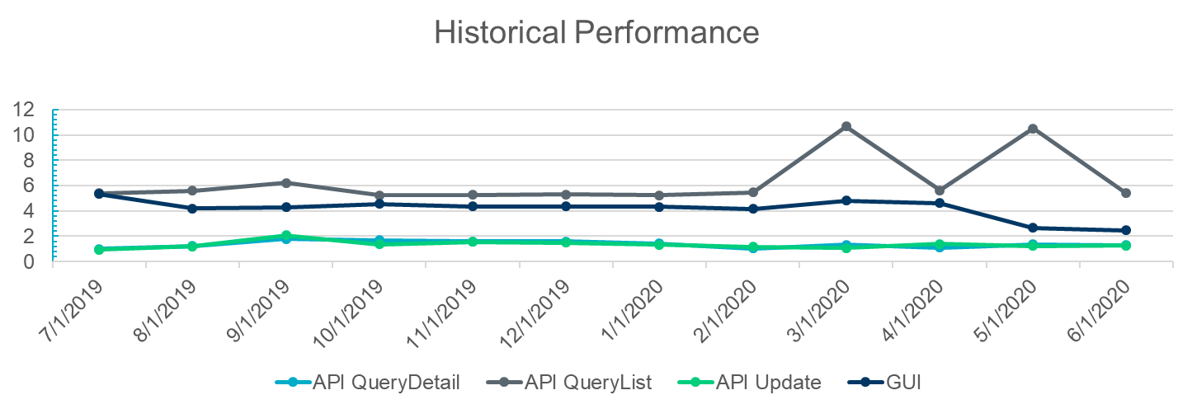

Transport Layer Security (TLS) Discussion/Timeline/ERCOT NAESB Upgrade
- Email sent to trading partners who had received script for testing, notifying of market call tomorrow to review Q&A about the test
- Requested trading partner to provide test transaction back to ERCOT to test TLS 1.2
- Dave Michelson reported if trading partner participated in mass transition testing, then transactions were already provided to ERCOT
- Validation of testing data will not occur

MarkeTrak Subtype Analysis – SCR – Data points
- Confirmed with Sam TDTMS has received necessary data points to perform analysis in support of MT enhancements business case
- After discussion of the IAG proposal, Sam suggested smaller group (Sheri, Kyle, Sam, etc) review the data and derive required analysis (i.e. IAG workflow timelines)
- Requested six-month high level MT subtype counts for Jan – Jun 2020 and will discuss at the next meeting

IAG Proposal/Solution
- Kyle provided an overview of the discussion at the 7/22 TXSET meeting regarding the options proposed
  - Option 1 – ERCOT to monitor MT for agreement and generate the 814_03 is not a viable option due to the regulatory hurdles and will not be pursued
  - Options 2 & 3 were reclassified as the ‘push and pull’ options with both having a Rescission alternative
    - The PUSH option: Gaining CR to ‘push’ or initiate a ‘drop’ transaction. Discussion is whether to utilize the 814_10 or create a new 814_30.
      - 814_10 : ERCOT cautioned the Siebel system still had logic for the old 814_10 (TXSET 3.0) transactions and could be challenging to untangle
      - 814_30 or 814_XX: a new transaction to accomplish the ‘drop’ and cleaner to create its own stacking logic
    - The PULL option: Losing CR to continue to ‘pull’ or initiate the BDMVI / BDSWI
- At a high level, the push and pull options utilize MT for the initial dialogue between CRs to arrive at an agreement: to regain and proposed regain date. Once the agreement is reached, a transactional solution will follow. The transactional solution will establish validations:
  - Agreement in MT
  - Regain Date –
    - matches proposed regain date in MT
    - Falls within 150 days of initiating transaction
    - For rescission = DOL+1
    - IAS => discussion around two options: DOL +1 or current dated as opposed to DOL+1 or MT +10
  - Other validations to occur such as safety net, switch hold, leap frog
- Both options will also carry “IA”, “MT#”, “RESC” indicators in 814_03 for identification allowing option to automate
- TDTMS will provide support for the MT piece of the solution as well as assist in developing the business case for the TX SET change controls. TDTMS goal will be to review how the process can be streamlined to arrive at an agreement:
  - Time frame from agree to ROR
  - ROR to submittal of BDMVI
  - Rescission window – 15 days??
- TDSPs expressed they do not need to play a role in the “agreement”. Once the agreement is reached, TDSPs will be involved in the validations (safety net, leap frog, switch hold), but that would be when the 814_03 is submitted to them.
- The original matrix was revised to outline the differences between the two viable options: the push and pull options with their associated Rescission piece. ACTION: Sheri to work with Kyle to develop updated matrix.

TXSET 5.0 and MT Enhancements SCR
- The WG agreed to ensure the IAG solution is thorough and not to rush to complete to meet TAC deadline as noted below.
- With a June 2021 target for Board approval, TXSET Change Controls would need to be written and approved by late 2020/early 2021 up for TAC approval February 2021.

MarkeTrak Enhancement Discussion
- WG reviewed all proposed MT enhancements and provided clarification where needed and prioritized as high/med/low.
- Highlights on the attached spreadsheet warrant further discussion. Market participants are asked to review the enhancements within their business processes to offer feedback at the next meeting.

AGENDA for 8/20/20 Meeting
- Further discussion of options for IAG Push and Pull Solutions
  - Review of MT Data Analysis for IAG Workflow
Inadvertent Situation Flow
Time elapsed
1 → 2 | original transaction to submittal of MT
2 → 4 | agreement between CRs
4 → 6 | Losing CR to send BDMVI
5 → 6 | Ready to Receive to submittal of BDMVI
2 → 8 | total resolution time
  - Proposed regain date vs Actual transaction date
  - Time difference on IALs vs IAGs for submittal of BDMVI for Losing CR
- Review other MT Enhancements list to confirm prioritization
  - Differentiate administrative vs Validation
  - Identify need for data analysis to support business case

