ERCOT
DC-TIE OPERATIONS

NERC Tagging, Interchange Scheduling, Normal and Emergency Operations, and Inadvertent Energy Accounting

Version 3.0 Rev 13
July 31, 2020

Document Control

Preparation
Prepared by | Role | Date Completed
M. Atanacio | Writer/Editor | June 6, 2001
T. Garza | Entered changes | June 26, 2001
V. Weldon | Entered Draft 2 changes into final | July 11, 2001
T. Garza | Entered Sheppard revisions | July 23, 2001
T. Garza | Entered Zotter’s revisions | August 15, 2001
T. Garza | Entered Ronnie Johnson’s revisions | September 11, 2001
E. Villanueva | Update writer | October 2002
C. Frosch | Update writer | January 2, 2002
D. See | Update writer | August 7, 2003
D. See | Update writer | May 3, 2004
D. See | Revision writer | August 25, 2004
D. See | Revision writer | October 18, 2004
T. Mortensen | Update writer | May 31, 2007
C. Frosch | Update writer | December 1, 2007
C. Frosch | Update writer | July 14, 2008
C. Frosch | Update writer | August 7, 2008
C. Frosch | Update writer | February 17, 2009
C. Frosch | Update writer | April 14, 2009
C. Frosch/Hartmann/  T. Mortensen/J. Stone | Update writer | October 21, 2010
C. Frosch/J. Hartmann | Update writer | December 16, 2011
C. Frosch/J. Hartmann/  P. Peters/B. Collard | Update writer and editors | January 20, 2014
C. Frosch/J. Hartmann/ P. Peters | Update writer and editors | February 26, 2014
C. Frosch | Update writer and editors | October 09, 2014
J. Hartmann | Update writer and editor | July 14, 2015
J. Hartmann | Update writer and editor | June 22, 2018
J. Hartmann / C. Frosch | Update writer and editor | May 13, 2019
J. Hartmann / J. Gaddy / C. Frosch | Update writer and editor | July 02, 2020

Distribution List
Name | Organization
C.J. Brown  Bryan Wood  Scott Aclin | SPP
Dennis Sauriol  Chris Shaffer  Dennis Kunkel  Dave Erickson | AEP
Daniel Paniagua  Luis Sergio Martínez  Eliseo Estrada | CENACE
Rickey FloydShiftSupervisors-TGM | Oncor

Change History
Issue | Reason for issue | Effective Date
Version 1 Draft 1 | Initial Draft for Review | June 6, 2001
Version 1.0 Rev 0 | Final Procedure Review | September 11, 2001
Version 1.0 Rev 0 | Reviewed. Updates procedure | October 25, 2002
Version 1.0 Rev 2 | Reviewed. Updates to section 3.3.2 and page 14 | January 3, 2003
Version 1.0 Rev 3 | Reviewed. Updates to section 3.3 and Appendix 1. Added Appendix 1.2. | October 1, 2003
Version 1.0 Rev 4 | Reviewed. Updates to sections 5.2, 5.3 and deleted the Appendices. | August 27, 2004
Version 1.0 Rev 5 | Reviewed. Updates to section 3.3.3. | October 29, 2004
Version 2.0 Rev 1 | Reviewed. Updates to include information on RAIL DC-Tie and Laredo VFT. | May 31, 2007
Version 3.0 Rev 0 | Reviewed. Updates to all sections. | December 1, 2007
Version 3.0 Rev 1 | Reviewed. Updates for CFE DC-Tie Commercial Operations | July 14, 2008
Version 3.0 Rev 2 | Reviewed. Updates to section 6 | August 7, 2008
Version 3.0 Rev 3 | Reviewed. Updates to sections 1.3, 1.3.3, 3.7 to reflect FERC exemption for Eagle Pass DC-Tie. Update section 5 to make clear that inadvertent energy payback is not tagged. | April 14, 2009
Version 3.0 Rev 4 | Reviewed. Updates to section 6 to incorporate EECP to EEA changes | June 2, 2009
Version 3.0 Rev 5 | Reviewed. Updates to sections 1.1, 1.3.4, 2.3, 3.1, 3.2, 3.5, 3.7, 4.1, 4.2, 5.0, 6.2 and deleted section 3.8 | November 30, 2010
Version 3.0 Rev 6 | Reviewed. Updates to sections 3.1, 6.0, 6.1 and 6.2 | February 03, 2012
Version 3.0 Rev 7 | Reviewed. Updated to include Sharyland as a DC-Tie Operator for Railroad | February 03, 2014
Version 3.0 Rev 8 | Reviewed. Updated to incorporate SPP becoming single BA | March 4, 2014
Version 3.0 Rev 9 | Reviewed. Updated for Railroad expansion | October 10, 2014
Version 3.0 Rev 10 | Reviewed. Updated for Railroad expansion | July 15, 2015
Version 3.0 Rev 11 | Deleted section 5, Renamed section 6 to section 5, New section 6 Incorporated the ERCOT Inadvertent Energy Procedure for DC-Ties into a common procedure to delete the standalone process. Increased South Ties Inadvertent payback to 250MWh. Changed CFE to CENACE | July 15, 2018
Verision 3.0 Rev 12 | Reviewed. Updated to include Oncor as a DC-Tie Operator for Railroad | May 16, 2019
Verision 3.0 Rev 13 | Reviewed. Updated contacts, corrected Section 2.2, 3.3 and removed Eagle Pass DC_S Tie due to the failed equipment and retirement | July 31, 2020

Contents

1. Introduction

1.1 Purpose
1.2 Scope
1.3 Description of the ERCOT DC-Ties
1.3.1 North DC-Tie (DC_N)
1.3.2 East DC-Tie (DC_E)
1.3.3 Railroad DC-Tie (DC_R)
1.3.4 Laredo DC-Tie (DC_L)

2. Transmission Reservations across the ERCOT DC-Ties

2.1 Eastern Interconnection Transmission Provider Requirements
2.2 CENACE Requirements
2.3 ERCOT Requirements

3. NERC Tagging and Scheduling Process across the ERCOT DC-Ties

3.1 NERC E-Tag
3.2 Non-ERCOT Interchange Schedules vs. ERCOT Schedules
3.3 NERC E-Tag and Scheduling Process across the ERCOT DC-Ties
3.4 Scheduling Process with SPP
3.4.1 Availability Transfer Capability on the North and East DC-Ties
3.5 ERCOT NERC E-Tag and Scheduling Process with SPP
3.6 Scheduling Process with CENACE
3.6.1 DC-Tie Limit Calculation
3.7 ERCOT Day-Ahead NERC E-Tag Process across the CENACE DC-Ties

4. Withdrawals, Cancellations and Termination of Schedules across the DC-Ties
4.1 Interchange Transaction Curtailment Process
4.2 Planned and Forced Outages on the DC-Ties

5. Emergency Energy across the ERCOT DC-Ties
5.1 Emergency Energy across the SPP DC-Ties
5.2 Emergency Energy across the CENACE DC-Ties

6. Inadvertent Energy

6.1 Introduction
6.2 Hourly and Daily Inadvertent Energy
6.3 Daily Settlement Meter Data
6.4 Monthly Settlement of Inadvertent Energy
6.5 Inadvertent Energy Pay Back

Introduction

Purpose

This document is an ERCOT (Electric Reliability Council of Texas, Inc.) Operating Procedure that describes the operating guidelines used by the following entities:

- ERCOT
- ERCOT Qualified Scheduling Entities (QSEs)
- Transmission Service Providers (TSPs)
- Purchasing-Selling Entities (PSEs)
- Non-ERCOT Balancing Authorities (BAs)
- Southwest Power Pool (SPP)
- Comision Federal de Electricidad (CFE)
- National Center for Energy Control (CENACE)
- The DC-Tie Operators

ERCOT is the NERC designated Reliability Coordinator for the ERCOT Region. The interactions between ERCOT, SPP, and CENACE for the purposes of NERC E-Tagging, scheduling, transmission reservations, and Inadvertent Energy accounting for transactions of energy across the DC-Ties, are covered within this document. This document shall be reviewed at least every three years.

This ERCOT procedure supports the ERCOT Protocols, Operating Guides and NERC Reliability Standards.

All verbal and written communications with ERCOT for commercial or emergency operations of the DC-Ties will be in English. For verbal communications between ERCOT and CENACE (and vice versa), the DC-Tie Operator will be the primary contact. The DC-Tie Operator will coordinate any operational issues between ERCOT and CENACE.

The communication among CENACE, the DC-Tie Operator and ERCOT will be according to the ERCOT Operating Procedures located at the following link, which include:
  - ERCOT DCTie Operations
  - Inadvertent Energy Procedure
  - Operating Procedure Manual: DC-Tie Desk

http://www.ercot.com/mktrules/guides/procedures/index.html

Scope

This document encompasses and describes the normal and emergency operations of the ERCOT DC-Ties.

Description of the ERCOT DC-Ties

There are two (2) commercially operational DC-Ties between ERCOT and the Eastern Interconnection:

- North (DC_N) located near Oklaunion
- East (DC_E) located near Monticello

There are two (2) commercially operational DC-Ties between ERCOT and CENACE:

- Railroad (DC_R) located near McAllen
- Laredo (DC_L) located near Laredo. This is a Variable Frequency Transformer (VFT)

The following sections describe these DC-Ties’ basic characteristics.

North DC-Tie (DC_N)

The ERCOT North DC-Tie is a back-to-back 220 MW HVDC converter located between the American Electric Power (AEP) ERCOT Oklaunion substation and the AEP Public Service of Oklahoma (PSO) Oklaunion substation.

The North DC-Tie may have an original rating of 220 MW but its actual operating limit is dynamic based on real time conditions. The operating limit can be reduced due to tripping. The DC-Tie Operator and SPP will be instructed to respect the new MW limit whenever it is de-rated. At times, especially during high temperatures, the North DC-Tie actual operational limit can be 200 MW or lower.

Due to limitations with the control system of the North DC-Tie, a deadband of about (+/-) 22 MW will be considered for normal operation. The deadband will be considered in place of shutting down the DC-Tie.

The AEP ERCOT Oklaunion substation is located in the ERCOT Region. ERCOT is the Transmission Provider, Reliability Coordinator, and Balancing Authority for the ERCOT side of the DC-Tie.

The AEP PSO Oklaunion substation is located in the SPP Reliability Coordinator Area. SPP is the Transmission Provider and Reliability Coordinator for AEP in SPP. AEP operates the North DC-Tie.

The metering point between ERCOT and AEP SPP for the North DC-Tie is located at the PSO Oklaunion 345KV substation between CB 5635 and 5630.

The characteristics of the ERCOT Polled Settlement (EPS) meter used for settlement and Inadvertent Energy accounting for this DC-Tie are as follows:

ERCOT EPS Meter Identification
DC-Tie Name | Model Name | Resource ID | Meter Serial Number
North DC-Tie | DC_N | AEPOKLUGPDC00 | 0109A064

Figure 1.3 shows a representation of the North DC-Tie.

East DC-Tie (DC_E)

The ERCOT East DC-Tie is a back-to-back 600 MW HVDC converter located between the Oncor ERCOT Monticello substation and the AEP Southwestern Electric Power (SWEP) Welsh substation.

The Oncor ERCOT Monticello substation is located in the ERCOT Region. The AEP SWEP Welsh substation is located in the SPP area. AEP SPP operates the East HVDC-Tie. The metering point between ERCOT and AEP SPP for the East DC-Tie is located at the Oncor Monticello 345KV substation on CB 4320.

The characteristics of the EPS meter used for settlement and Inadvertent Energy accounting for this DC-Tie are as follows:

ERCOT EPS Meter Identification
DC-Tie Name | Model Name | Resource ID | Meter Serial Number
East DC-Tie | DC_E | TXUMONTOPDC00 | 0604A076

Figure 1.3 shows a representation of the East DC-Tie.

1.3.3 Railroad DC-Tie (DC_R)

The Railroad DC-Tie is a 300 MW back-to-back HVDC converter located at the Sharyland Utilities’ Railroad substation and connects the ERCOT Region with CENACE in Mexico (Cumbres Frontera substation). The Railroad DC-Tie has a minimum flow requirement of 15 MW and ramp rate of 50 MW per minute.

This DC-Tie is used for commercial operations. Oncor Electric Delivery Company LLC (ONCOR)Transmission Operations in Dallas is the DC-Tie Operator.

The metering point between the ERCOT Region and CENACE is located at breaker 8372 at the Sharyland Utilities’ Railroad substation.

The characteristics of the EPS meter used for settlement and Inadvertent Energy accounting for this DC-Tie are as follows:

ERCOT EPS Meter Identification
DC-Tie Name | Model Name | Resource ID | Meter Serial Number
Railroad DC-Tie | DC_R | SLUSHRYGP0100 | 0612A011

Figure 1.3 shows a representation of the Railroad DC-Tie.
The Back to Back Converter Station and primary metering equipment is located at Sharyland Utilities’ Railroad Substation. CENACE’s secondary metering equipment is located at Sharyland Utilities’ Railroad Substation and will serve as backup to the ERCOT EPS meters and will be used only in the event data from the ERCOT EPS meters cannot be used.

The characteristics of the CENACE meter used for backup settlement and Inadvertent Energy accounting for this DC-Tie are as follows:

CFE Meter Identification
DC-Tie Name | Model Name | Resource ID | Meter Serial Number
CUF-83430 | KITRON-K6216 | NA | PT-0702A350-01

1.3.4 Laredo DC-Tie (DC_L)

The Laredo DC-Tie is a 100 MW Variable Frequency Transformer located at the AEP Laredo VFT station and connects the ERCOT Region with CENACE in Mexico (Ciudad Industrial substation), even though this interface is not a back-to-back HVDC converter, it is used as a DC-Tie.

This DC-Tie is used for commercial operations. AEP Transmission in Corpus Christi is the DC-Tie Operator.

The metering points between the ERCOT Region and CENACE are located at the Laredo DC-Tie station at circuit breakers 4265, 5240 and 8095. This covers both the 138kV and 230kV paths that the flow can take on the CENACE side of the DC-Tie.

The characteristics of the net ERCOT EPS meter that will be used for settlement and Inadvertent Energy accounting for this DC-Tie are as follows:

ERCOT EPS Meter Identification
DC-Tie Name | Model Name | Resource ID | Meter Serial Number
Laredo DC-Tie | DC_L | CPLLAREGP0400 | 701A603

Figure 1.3 shows a representation of the Laredo DC-Tie.
Primary metering equipment is located at AEP’s Texas Central Company (TCC) Laredo VFT South Substation. CENACE’s secondary metering equipment is located at TCC’s Laredo VFT South Substation, and will serve as backup to the ERCOT EPS meters and will be used only in the event data from the ERCOT EPS meters cannot be used.

The characteristics of the CENACE meter used for backup settlement and Inadvertent Energy accounting for this DC-Tie are as follows:

CFE Meter Identification
DC-Tie Name | Model Name | Resource ID | Meter Serial Number
CID-93300 | ION8600A | NA | PT-0610A062-01

Figure 1.3
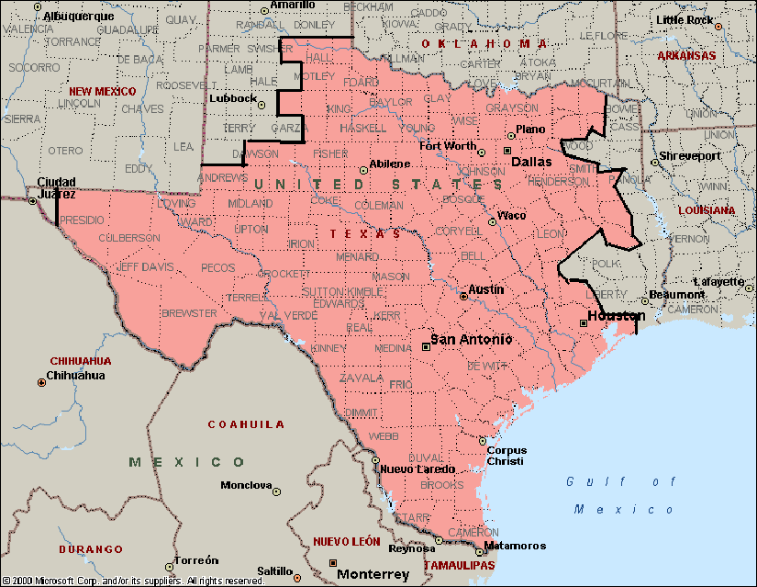
DC_R
300 MW
DC_L
100 MW
DC_E
600 MW
DC_N
220 MW

Transmission Reservations across the ERCOT DC-Ties

Eastern Interconnection Transmission Provider Requirements

Transmission reservations are necessary on the SPP side of the DC-Ties. Any NERC registered PSE wanting to schedule energy transactions across the ERCOT DC-Ties must have an approved Transmission Reservation for the portion or portions of the schedule paths located within the SPP transmission system and other applicable Transmission Providers (TPs). The SPP Open Access Same-Time Information System (OASIS) shall be used for these purposes and SPP Transmission Reservation procedures apply. These reservations also include all necessary Ancillary Services under the SPP Open Access Transmission Tariff (SPP OATT).

For more information on the SPP transmission reservation requirements, please go to the SPP OASIS Internet page located at http://sppoasis.spp.org/OASIS/SWPP.

CENACE Requirements

There is not a Transmission Reservations requirement for the DC-Tie portions of the CENACE system. A PSE wanting to schedule energy into or out of CENACE via the DC-Ties must have a contract or agreement with CENACE.

ERCOT Requirements

Transmission Reservations are not required for the DC-Tie portions of the proposed energy schedules located within the ERCOT Region, or within the ERCOT transmission system. A PSE wanting to schedule energy into or out of the ERCOT Region via the DC-Ties must be registered as an ERCOT Qualified Scheduling Entity (QSE) or enter into an agreement with an existing ERCOT QSE.

ERCOT Protocols allow QSEs to submit bilateral schedules that use the ERCOT DC-Ties by submitting energy schedules for the exports/imports with matching NERC E-Tags under ERCOT Protocols and Operating Guides.

NERC Tagging and Scheduling Process across the ERCOT DC-Ties

NERC E-Tag

NERC provides Interchange Transaction tagging and scheduling requirements for Balancing Authorities, Reliability Coordinators, Transmission Operators, Transmission Providers, and PSEs.

Appendix A of the North American Energy Standards Board (NAESB) Wholesale Electric Quadrant (WEQ) Coordinated Interchange Standards specifically applies to Interchange Transactions between the ERCOT Region and the Eastern Interconnection. ERCOT as the single Reliability Coordinator for the ERCOT Region is responsible for the NERC E-Tag duties assigned by NERC.

The sections below describe the NERC E-Tag and scheduling processes as they apply to ERCOT and all the entities involved in the scheduling of energy across the DC-Ties.
As required by the ERCOT Protocols, all energy flows across the DC-Ties, including those involving emergency energy, will be electronically tagged using the NERC E-Tags (excluding emergency energy from/to CENACE).

Non-ERCOT Interchange Schedules vs. ERCOT Schedules

There are fundamental differences between the Non-ERCOT Interchange Schedules and the ERCOT Schedules. It is important to recognize these differences when reviewing the NERC E-Tag specification and scheduling as they apply to ERCOT transactions across the DC-Ties.

The major differences are described in the following table:

Non-ERCOT Interchange Schedules | ERCOT Schedules
Need pre-approved Transmission Reservations in the Eastern Interconnection, or a contract with CENACE | Do not need pre-approved Transmission Reservations
Each interchange schedule reflects a single energy transaction. The PSE, CA/BA, Scheduling Coordinators (SC) and TP can see and identify each individual transaction. | Each interchange schedule reflects a single energy transaction. The PSE, CA/BA, Scheduling Coordinators (SC) and TP can see and identify each individual transaction.
OASIS business rules and the SPP OATT specify reservations and scheduling timeframes. If there are other Transmission Providers beyond SPP, the proper FERC approved Transmission Tariffs and rules shall apply | ERCOT protocols allow for Day-Ahead schedules and Adjustment Period schedule modification only.

NERC E-Tag and Scheduling Process across the ERCOT DC-Ties

ERCOT, as the Balancing Authority and a Transmission Service Provider for the ERCOT Region, has NERC E-Tag approval responsibilities for interchange transactions across the DC-Ties with SPP and CENACE.

SPP, CENACE and other Transmission Providers and source/sink E-Tag Balancing Authorities have similar approval rights as indicated in the E-Tag specification.

The actual flow across a DC-Tie, at any given time, should match the total aggregated energy profile of all the approved NERC E-tags scheduled across that DC-Tie. Any deviation will be considered Inadvertent Energy.

ERCOT will not allow energy schedules from CENACE to the Eastern Interconnection (or vice versa) in a single NERC-Tag. ERCOT will deny such NERC E-tags.

Scheduling Process with SPP

3.4.1 Availability Transfer Capacity on the North and East DC-Ties

SPP, ERCOT and the DC-Tie Operators will coordinate any de-ratings or transmission limitations across the DC-Ties that reduced the DC-Tie’s capacity. The available capacity will be maintained and considered in the scheduling and NERC E-Tag approval process detailed below.

ERCOT NERC E-Tag and Scheduling Process with SPP

A PSE that is seeking transmission arrangements to schedule energy between the ERCOT Region and the Eastern Interconnection (or vice versa) will coordinate with all the applicable transmission providers in the Eastern Interconnection, including SPP.

Requests for service must be made to SPP for service into, out of or through SPP, including service across either the North or East DC-Ties via the SPP OASIS. SPP will coordinate approval of transmission reservations and energy schedules involving the SPP portion of transmission service. Other TPs might be involved and reservations will need to be made accordingly depending upon the transmission path of the E-Tag.

ERCOT will review and approve or deny the NERC E-Tags for transactions across the DC-Ties.

The following process is followed when scheduling transmission service between SPP and the ERCOT Region across the North and East DC-Ties:

- The PSE must receive approval for transmission service in SPPs transmission system from SPP for the proposed transaction. The PSE must arrange any required ancillary services in SPP. The same applies to other applicable TPs, if any.

- For all transmission service requests, the PSE will create a NERC E-Tag and submit it to all the parties involved for processing, as per the NERC E-Tag rules.

- SPP approves the NERC E-tag if capacity is available in SPP and across the DC-Tie.

- ERCOT may approve the NERC E-Tag if the tag complies with the ERCOT scheduling requirements as described in section 3.2 of this document and if the tag complies with NERC E-Tag procedures.

- The DC-Tie Operator follows the NERC E-Tag energy profile when setting flows across the DC-Tie.

Scheduling Process with CENACE

DC-Tie Limit Calculation

Studies are required to set import/export limits between CENACE and ERCOT based on system conditions for commercial and emergency operations. ERCOT will conduct studies in different time horizons including but not limited to seasonal (winter and summer peaks), Day-Ahead and real-time as needed. ERCOT will calculate import/export transfer limits for each DC-Tie, on a daily basis, and as system conditions change.

CENACE will provide ERCOT with any limits due to its system conditions daily by 16:00.

The operating limits for the DC-Tie will be the lowest of the limits calculated by ERCOT and CENACE. During the limit calculations, any de-ratings provided by the DC-Tie Operator will be considered.

The limits will be posted on the MIS Secure. Updates to the limits based on current conditions will be made available to the Market Participants.

ERCOT Day Ahead NERC E-Tag across the CENACE DC-Ties

A PSE scheduling energy between the ERCOT Region and CENACE will use the following process for the CENACE DC-Ties:

- The PSE will create and submit a NERC E-Tag for approval. CENACE will verify that a valid contract is in place with the PSE, validate the information on the NERC E-tag and check available capacity on the DC-Tie.

- ERCOT will approve the NERC E-Tag if it complies with the ERCOT scheduling requirements as described in section 3.2 of this document, it complies with NERC E-Tag specification and there is enough capacity across the DC-Tie.

- The DC-Tie Operator will have infrastructure in place to receive a copy of all the NERC E-Tags across each DC-Tie.

- The DC-Tie Operator will have a mechanism or system to aggregate the current energy profile across each DC-Tie. The scheduled flow across the DC-Ties will match the aggregated energy profile.

Withdrawals, Cancellations and Termination of Schedules across the DC-Ties

The notification of schedule withdrawals, cancellations, and termination will follow the NERC E-Tag specification.

4.1 Interchange Transaction Curtailments Process

Whenever there is a need to curtail a NERC E-Tag, the NERC E-Tag specification will be followed. Potential reasons for curtailment can be: loss of generation or load, reduction of capacity due to system conditions, mitigation of a System Operating Limit (SOL) or Interconnection Reliability Operating Limit (IROL) violation, etc.

If ERCOT initiates a curtailment, ERCOT will be in an Emergency. This information will be published on the ERCOT Market Information System (MIS). ERCOT will curtail E-Tags as necessary to accommodate the new transfer limits. ERCOT will use Last In, First Out (LIFO) for prioritizing the curtailed E-Tags.

If CENACE initiates a curtailment, CENACE will contact the DC-Tie Operator, and initiate a NERC E-Tag curtailment on current energy schedules to reduce the flow across the DC-Tie to the required energy profile level. CENACE will use the LIFO methodology for prioritizing the curtailed E-Tags. ERCOT will acknowledge the curtailment and the DC-Tie Operator will proceed with the controls to reduce the flow across the DC-Tie.

Planned and Forced Outages on the DC-Ties

Outages on the DC-Ties are subject to the same requirements as any outages on other transmission elements in the ERCOT Region. Outages on the DC-Ties must be submitted to ERCOT in accordance with ERCOT Protocols.

The DC-Tie Operator for the DC_N and DC_E must coordinate planned outages on the respective DC-Ties with SPP and ERCOT, including entering the (both planned and forced) in the SPP CROW and the ERCOT Outage Scheduler. The ERCOT transmission provider assigned to the particular DC-Tie will enter outages in the ERCOT Outage Scheduler.

The DC-Tie Operators for the CENACE DC-Ties must coordinate planned outage on the respective DC-Ties with ERCOT and CENACE, including entering the outage (both planned and forced) in the ERCOT Outage Scheduler.

Reductions in capacity are subject to the provisions of the ERCOT Protocols and must be entered in the ERCOT Outage Scheduler as a de-rating. ERCOT will post all planned outages on the ERCOT MIS.

5. Emergency Energy across the ERCOT DC-Ties

5.1 Emergency Energy across the SPP DC-Ties

SPP, AEP and ERCOT have the designated authority and responsibility to make and carry out reciprocal emergency energy decisions required to operate the SPP, AEP and ERCOT Systems during emergencies or adverse conditions. Any emergency energy and any decisions made during these emergencies will be within the AEP HVDC DC-Tie Operator’s guidelines and available capacity limits for reliable operations of the North and East DC-Tie facilities. When an apparent emergency exists, SPP, AEP and ERCOT must initiate and coordinate the appropriate Energy Emergency Alert (EEA) Level with their respective systems in accordance with the NERC Reliability Standard Attachment 1-EOP-011-1 Energy Emergency Alerts.

The following summarizes the required coordination and implementation between the necessary involved/responsible parties with regard to scheduling Emergency Energy across the DC_N and DC_E Ties, as requested and/or agreed upon by AEP, ERCOT, and SPP:

ERCOT Requested Emergency Energy:

- When ERCOT declares an EEA, ERCOT will notify SPP of ERCOT’s EEA status. A message will be posted on the Reliability Coordinator Information System (RCIS).

- If there is available capacity on the DC-Ties, ERCOT will request AEP to submit a request for transmission service and a tag for the available capacity. SPP will approve if the availability exists, and the normal DC-Tie scheduling process will apply.

- ERCOT will provide AEP QSE a Verbal Dispatch Instruction (VDI) for use in settling the payment for emergency energy.

5.2 Emergency Energy across the CENACE DC-Ties

The following summarizes coordination between the DC-Tie Operators, CENACE and ERCOT with regard to scheduling Emergency Energy across the CENACE DC-Ties:

- ERCOT or CENACE declares an emergency condition.

- If ERCOT requests emergency energy from CENACE, ERCOT will coordinate with the DC-Tie Operators. If available capacity exists on any or all DC-Ties and if CENACE can supply the energy, emergency energy can start as soon as agreed. The appropriate DC-Tie Operator, CENACE and ERCOT will coordinate start time, duration MW amount and ramp time. A VDI will be issued to the appropriate QSE for settlements due to the scheduling limitations in ERCOT.

- If CENACE requests emergency energy from ERCOT, CENACE will coordinate with the appropriate DC-Tie Operator. If available capacity exists on any or all DC-Ties, ERCOT will supply CENACE energy from DC-Tie Settlement Point if available or CENACE can contact a QSE to provide the energy. The appropriate DC-Tie Operator, CENACE and ERCOT will coordinate start time, duration MW amount and ramp time. A VDI will be issued to the appropriate QSE for settlements due to the scheduling limitations in ERCOT.

Detailed emergency procedures can be found in the ERCOT Operating Procedure Manual: DC-Tie Desk at the following link:

http://www.ercot.com/mktrules/guides/procedures/

6. Inadvertent Energy

6.1 Introduction

This section outlines the process that the Electric Reliability Council of Texas (ERCOT), Southwest Power Pool (SPP), National Center for Energy Control (CENACE), American Electric Power (AEP) and Oncor Electric Delivery Company LLC (ONCOR) will follow for Inadvertent Energy accounting.

The EPS meters previously specified will be used by all parties involved to account for actual energy accounting.

The hourly difference between ERCOT’s actual interchange and ERCOT’s scheduled interchange across its DC-Ties is classified as Inadvertent Energy. Unscheduled energy flowing across each of the ERCOT DC-Ties is inadvertent energy. ERCOT tracks and maintains Inadvertent Energy accounting for all DC-Ties.

ERCOT, CENACE, and SPP will monitor the balance of the Inadvertent Energy account. Inadvertent Energy will be re-paid in kind.

Inadvertent Energy payback will be arranged between ERCOT, CENACE, and SPP, so that the Inadvertent Energy account balances remain as close to zero as possible. This will be accomplished by biasing the DC-Ties in the desired direction.

ERCOT will monitor in real-time the scheduled and actual flow across the DC-Ties. ERCOT will resolve with the DC-Tie Operator any SCADA integrated flow discrepancy.

Each day, after midnight, ERCOT will verify with the DC-Tie Operator and SPP all the schedules and real-time aggregated SCADA flows. An interim Inadvertent Energy account balance will be maintained. Any discrepancies will be escalated and resolved immediately.

At least, once per month, an accounting true-up will be conducted between ERCOT, SPP, and CENACE using the ERCOT EPS meters.

Energy payback will be arranged so the Inadvertent Energy account balance should not exceed 1000 MWh cumulative for the East and North DC-Ties and 250 MWh cumulative for the Laredo VFT, and Railroad DC-Ties. Energy payback maybe arranged if the above amounts have not been exceeded but agreed to between parties.

6.2 Hourly and Daily Inadvertent Energy

AEP TO in Columbus, Ohio is the DC-Tie Operator for the East and North DC-Ties, AEP TO in Corpus Christi is the DC-Tie Operator for the Laredo VFT DC-Tie, and ONCOR TO in Dallas is the DC-Tie Operator for the Railroad DC-Tie. ERCOT uses OATI webTrans to checkout with AEP TO Corpus, ONCOR TO and SPP.

National Center for Energy Control (CENACE) is the Security Coordinator for the Laredo VFT, and Railroad DC-Ties and SPP is the Balancing Authority for the East and North DC-Ties.

The ERCOT Control Room DC-Tie Procedure includes intraday monitoring of all hourly DC-Tie Inadvertent Energy flows on a periodic basis.

Before the start of each hour, the ERCOT Operator will confirm the next hour schedules for each DC-Tie with the appropriate entity which includes AEP TO Corpus, ONCOR TO, and SPP.

After each hour, the ERCOT Operator will check the actual SCADA data with the appropriate entity. The appropriate entity will monitor the same real-time telemetry points as ERCOT for each DC Tie. The ERCOT Operator will override any actual SCADA data as necessary to check out with the DC-Tie Operators. These are the Actual Flows on which Inadvertent Energy will be calculated initially, prior to the final upload of the ERCOT Polled Settlement (EPS) meter data in the OATI webTrans system.

Any discrepancies in Actuals 10 MWh or more will trigger investigation, in both ERCOT and the DC-Tie-Operator, and escalation to the SCADA/metering team. If ERCOT detects that there is a known SCADA related problem, then ERCOT will use the AEP or ONCORs value.

After midnight each day, the ERCOT Operator will check out with each appropriate entity, the total ‘In and Out Scheduled MWh’ and the total ‘In and Out Actual MWh’ flows, for the past day. If the totals do not match, the Operators will check each hour until the discrepancy is found. If needed, the ERCOT Operator will provide a summary of all the E-tags that were scheduled in the current day for further analysis until the discrepancy is solved. The ERCOT Operator will mark in the ERCOT OATI webTrans for each hour all of the agreed upon schedules.

After the midnight check out, the ERCOT Operator will send to each appropriate entity a snapshot of the agreed upon daily checkout (screen shot below).

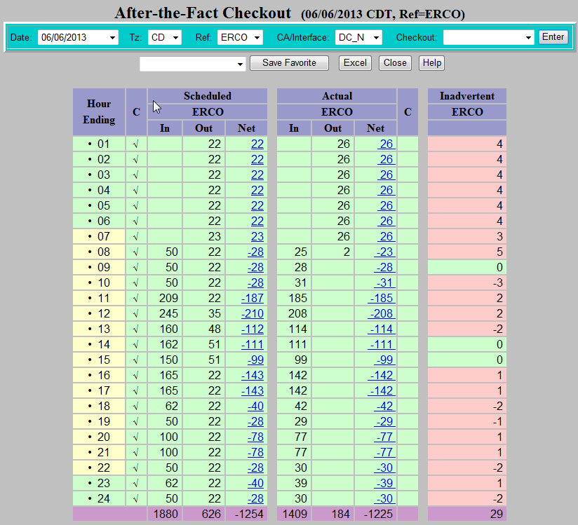

6.3 Daily Settlement Meter Data

ERCOT will use, for the final check out, ERCOT Settlement metering data from the EPS meters assigned to each DC-Tie. The meters have the following identifiers:

ERCOT EPS Meter Identification
DC-Tie Name | webTrans Name | Resource ID | Meter Serial Number
East DC-Tie | DC_E | TXUMONTOPDC00 | 0604A076
North DC-Tie | DC_N | AEPOKLUGPDC00 | 0109A064
Laredo VFT Tie | DC_L | CPLLAREGP0400 | 701A603
(Rail)road DC-Tie (Cumbres) | DC_R | CPLSHRYGP0100 | 0612A011

Seven days after the fact, EPS Settlement metering data is uploaded to the ERCOT OATI webTrans system, which supersedes the initial SCADA values checked out by the Operators. ERCOT will e-mail to CENACE and SPP the hourly meter data for each day once the EPS Settlement metering data has been populated in webTrans.

Example below:

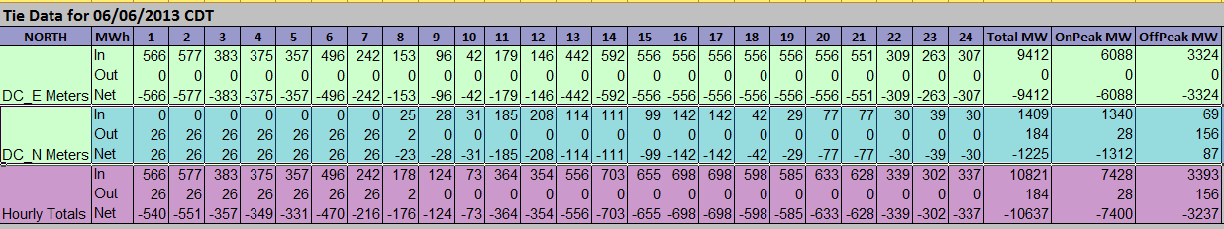

6.4 Monthly Settlement of Inadvertent Energy

The seventh day after the last operating day of the month or the next business day and no later than the 14th of the month, ERCOT will send to CENACE, SPP, and each appropriate DC-Tie Operator, the Monthly Inadvertent Energy Report for each DC-Tie. A Monthly Inadvertent Energy Report will also be provided that combines the ties so an accurate accumulative Inadvertent Energy total will be given (as shown below). The East and North DC-Tie will be combined, Laredo VFT, and the Railroad DC-Tie will be South ties will be combined.

CENACE and SPP will provide acknowledgement of agreement with the monthly settlement report via email within the next 5 business days. In case of disagreement they will provide clear explanation and supporting documentation of their observed discrepancies.

Any Outstanding discrepancies will be escalated to ERCOT System Operations Management immediately to facilitate the resolution.

If the discrepancy cannot be resolved, the issue will be referred to the ERCOT Legal Department for advice and arbitration.

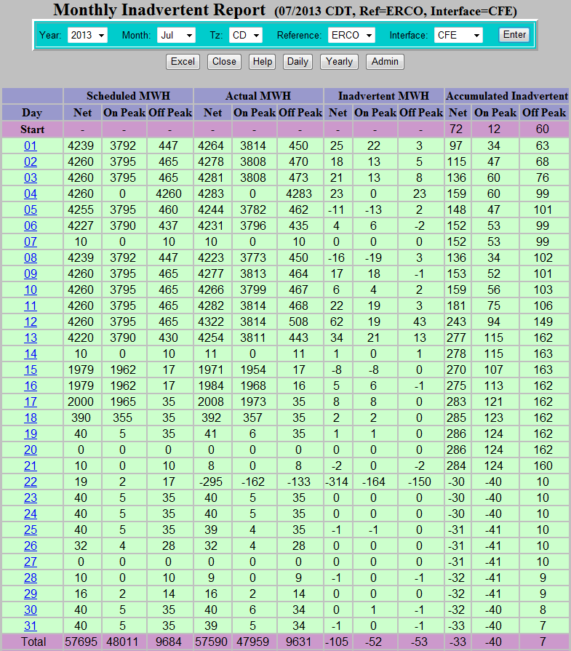

6.5 Inadvertent Energy Pay Back

Inadvertent Energy pay back on the North and East DC-Ties will be approved by ERCOT and SPP. Inadvertent Energy due will be paid back “in-kind”. Accumulated On-Peak Inadvertent Energy will be paid back On-Peak. On-Peak periods as defined by the NAESB Business Practice Standards are Monday through Saturday Hour-Ending 0700 – 2200. The accumulated Off-Peak Inadvertent Energy will be paid back Off-Peak. Off-Peak periods as defined by the NAESB Business Practice Standards are Monday through Saturday Hour-Ending 2300 – 0600 and Sundays and special holidays. The Inadvertent Energy account should be as close to zero as possible. In any case, the Inadvertent Energy balance should not go beyond 1,000 MWh for the North and East DC-Ties.

Inadvertent Energy pay back on the Laredo VFT, and Railroad DC-Ties will be approved by ERCOT and CENACE. Notification will be made to the appropriate DC-Tie Operator, and CENACE. Inadvertent Energy will be paid back “in-kind”. Accumulated On-Peak Inadvertent Energy will be paid back On-Peak. On-Peak periods as defined by the NAESB Business Practice Standards are Monday through Saturday Hour-Ending 0700 – 2200. The accumulated Off-Peak Inadvertent Energy will be paid back Off-Peak. Off-Peak periods as defined by the NAESB Business Practice Standards are Monday through Saturday Hour-Ending 2300 – 0600 and Sundays and special holidays. The Inadvertent Energy account should be as close to zero as possible every month. Inadverent Energy payback should not exceed 25 MWh for each hour. In any case, the balance should not go beyond 250 MWh total for the Laredo VFT, and Railroad DC-Tie. Any Inadvertent Energy on the South DC-Ties that is not scheduled 3 months after the settlement month will be considered as paid.

