June 2020 ERCOT Monthly Operations Report
Reliability and Operations Subcommittee Meeting
August 6, 2020

Table of Contents
1. Report Highlights 2
2. Frequency Control 3
2.1. Frequency Events 3
2.2. Responsive Reserve Events 4
2.3. Load Resource Events 4
3. Reliability Unit Commitment 4
4. Wind Generation as a Percent of Load 5
5. Largest Net-Load Ramp 5
6. COP Error Analysis 6
7. Congestion Analysis 8
7.1. Notable Constraints 8
7.2. Generic Transmission Constraint Congestion 12
7.3. Manual Overrides 12
7.4. Congestion Costs for Calendar Year 2020 12
8. System Events 14
8.1. ERCOT Peak Load 14
8.2. Load Shed Events 14
8.3. Stability Events 14
8.4. Notable PMU Events 14
8.5. DC Tie Curtailment 14
8.6. TRE/DOE Reportable Events 14
8.7. New/Modified/Removed RAS 14
8.8. New Procedures/Forms/Operating Bulletins 14
9. Emergency Conditions 15
9.1. OCNs 15
9.2. Advisories 15
9.3. Watches 15
9.4. Emergency Notices 15
10. Application Performance 15
10.1. TSAT/VSAT Performance Issues 15
10.2. Communication Issues 15
10.3. Market System Issues 16
11. Model Updates 16
Appendix A: Real-Time Constraints 18

Report Highlights
- The unofficial ERCOT peak was 68,043 MW.
- There were 5 frequency events.
- There were 4 instances where Responsive Reserves were deployed.
- There were 0 RUC commitments.
- Congestion in the Panhandle can be attributed to high wind generation as well as outages. Congestion in the North are can mostly be attributed to high generation output from Jack County and Keechi Wind. Congestion in the South can be attributed to high wind generation in the Laredo and Valley areas. There were 30 days of congestion on the Panhandle GTC, 23 days on the McCamey GTC, 17 days on the North Edinburg to Lobo GTC, 3 day on the North to Houston GTC, 1 day on the West to Central, and 1 day on the Bearkat. There was no activity on the remaining GTCs during the month.
- There was 1 DC Tie curtailment.

Frequency Control

Frequency Events
The ERCOT Interconnection experienced four frequency events, which resulted from units’ trip. The average event duration was 00:05:59.

A summary of the frequency events is provided below. The reported frequency events meet one of the following criteria: Delta Frequency is 60 mHz or greater; the MW loss is 350 MW or greater; resource trip event triggered RRS deployment. Frequency events that have been identified as Frequency Measurable Events (FME) for purposes of BAL-001-TRE-1 analysis are highlighted in blue. When analyzing frequency events, ERCOT evaluates PMU data according to industry standards. Events with an oscillating frequency of less than 1 Hz are considered to be inter-area, while higher frequencies indicate local events. Industry standards specify that damping ratio for inter-area oscillations should be 3.0% or greater. For the frequency events listed below, the ERCOT system met these standards and transitioned well after each disturbance.

Date and Time | Delta Frequency | Max/Min Frequency | Duration of Event | PMU Data |  | MW Loss | Load | Wind | Inertia
 | (Hz) | (Hz) |  | Oscillation Mode (Hz) | Damping Ratio |  | (MW) | % | (GW-s)
6/1/2020 9:48 | 0.068 | 59.910 | 0:03:01 | No PMU Data Available |  | 342 | 40,955 | 6% | 282,780
6/13/2020 12:00 | 0.118 | 59.892 | 0:05:44 | 0.66 | 14% | 679 | 50,102 | 20% | 290,825
6/15/2020 17:22 | 0.107 | 59.906 | 0:07:18 | 0.68 | 16% | 511 | 64,602 | 19% | 331,183
6/22/2020 14:22 | 0.072 | 59.909 | 0:07:53 | No PMU Data Available |  | 349 | 55,472 | 10% | 321,106
6/23/2020 16:53 | 0.114 | 59.897 | 0:04:57 | 0.65 | 11% | 502 | 54,891 | 12% | 299,412

(Note: All data on this graph encompasses frequency event analysis based on BAL-001-TRE-1.)
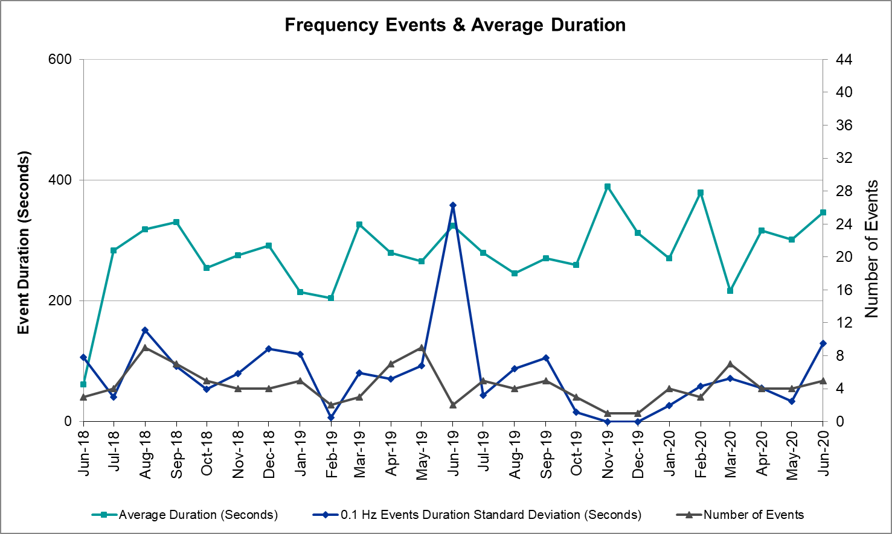

Note that the large standard deviation in June 2019 is due to coincidental extreme high and low durations for a small set of events (2).

Responsive Reserve Events
There were 4 events where Responsive Reserve MWs were released to SCED. The events highlighted in blue were related to frequency events reported in Section 2.1 above.

Date and Time Released to SCED | Date and Time Recalled | Duration of Event | Maximum MWs Released | Comments
6/1/2020 9:48 | 6/1/2020 9:51 | 0:03:00 | 214
6/13/2020 12:00 | 6/13/2020 12:05 | 0:04:44 | 396
6/15/2020 17:22 | 6/15/2020 17:29 | 0:06:52 | 529
6/23/2020 16:54 | 6/23/2020 16:58 | 0:04:44 | 665

Load Resource Events
No Load Resource Events.

Reliability Unit Commitment
ERCOT reports on Reliability Unit Commitments (RUC) on a monthly basis. Commitments are reported grouped by operating day and weather zone. The total number of hours committed is the sum of the hours for all the units in the specified region. Additional information on RUC commitments can be found on the MIS secure site at Grid Generation Reliability Unit Commitment.

There were no DRUC commitments.

There was no HRUC commitments.

Wind Generation as a Percent of Load
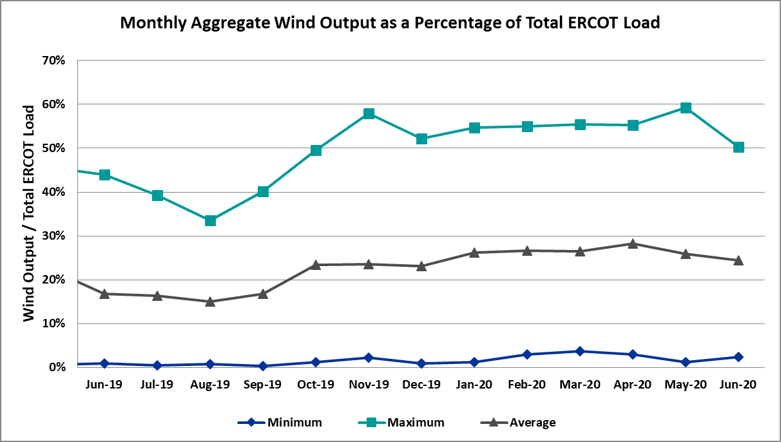

Wind Generation Record: 21,375 MW on 6/8/2020 at 23:22
Wind Penetration Record: 59.30% on 05/02/2020 at 02:10

Largest Net-Load Ramp
The net-load ramp is defined as the change in net-load (load minus wind and PVGR generation) during the defined time horizon. Such a variation in net-load needs to be accommodated in grid operations to ensure that the reliability of the grid is satisfactorily maintained. The largest net-load ramp during 5-min, 10-min, 15-min, 30-min and 60-min in June 2020 are 902 MW, 1615 MW, 2340 MW, 3726 MW, and 7015 MW, respectively. The comparison with respect to the historical values is given in the table below.

Month and Year | 5 min | 10 min | 15 min | 30 min | 60 min
June 2020 | 902 MW | 1615 MW | 2340 MW | 3726 MW | 7015 MW
June 2014 | 919 MW | 1329 MW | 1873 MW | 3516 MW | 5724 MW
June 2015 | 1038 MW | 1771 MW | 2489 MW | 3119 MW | 5360 MW
June 2016 | 1183 MW | 1716 MW | 2148 MW | 3131 MW | 5975 MW
June 2017 | 751 MW | 1287 MW | 1772 MW | 3106 MW | 5573 MW
June 2018 | 1029 MW | 1413 MW | 2035 MW | 3590 MW | 6320 MW
June 2019 | 824 MW | 1284 MW | 1706 MW | 2985 MW | 5684 MW
2014-2019 | 1494 MW | 1991 MW | 2780 MW | 4109 MW | 7786 MW

COP Error Analysis
COP Error is calculated as the capacity difference between the COP HSL and real-time HSL of the unit. Mean Absolute Error (MAE) stayed high over 8,000 MW until Day-Ahead at 12:00, then dropped significantly to 2,017 MW by Day-Ahead at 14:00. In the following chart, Under-Scheduling Error indicates that COP had less generation capacity than real-time and Over-Scheduling Error indicates that COP had more generation capacity than real-time. Under-Scheduling persisted from beginning of Day-Ahead to end of the Operating Day.
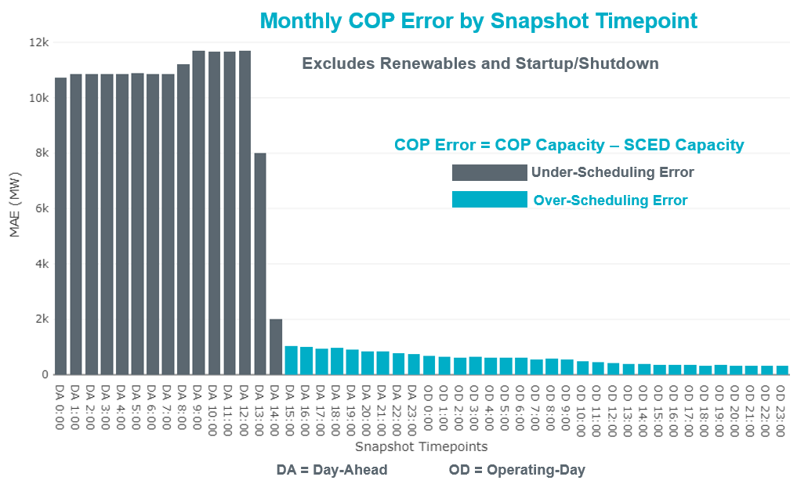
Monthly MAE for the Latest COP at the end of the Adjustment Period was 339 MW with median ranging from -197 MW for Hour-Ending (HE) 21 to 231 MW for HE 23. HE 24 on the 3rd had the largest Over-Scheduling Error (1,421 MW) and HE 15 on the 25th had the largest Under-Scheduling Error (-2,500 MW).
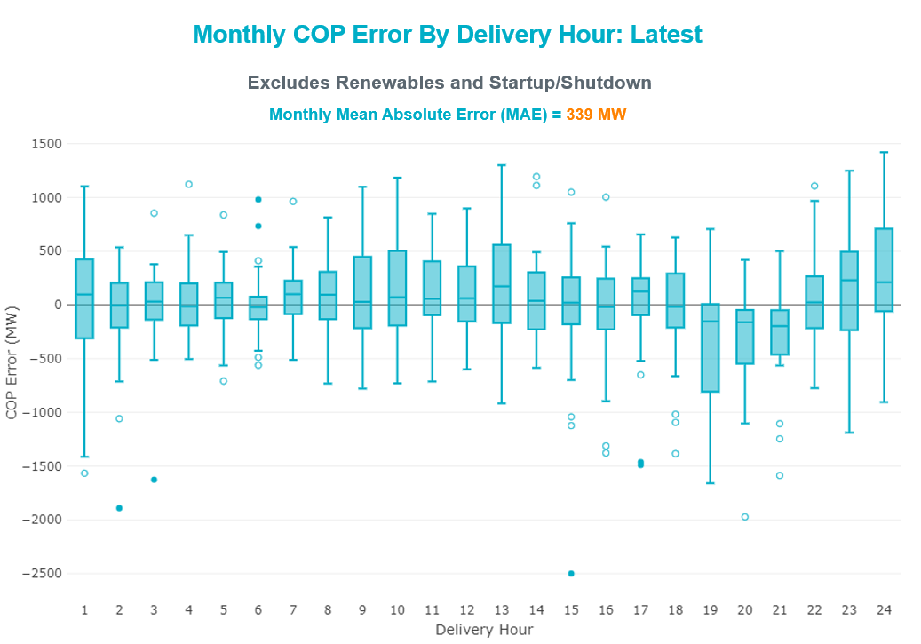

Monthly MAE for the Day-Ahead COP at 12:00 was 11,700 MW with median ranging from -17,380 MW for Hour-Ending (HE) 18 to -5,503 MW for HE 5. HE 13 on the 8th had the largest Under-Scheduling Error (-21,520 MW) and HE 8 on the 14th had the largest Over-Scheduling Error (+2,835 MW).

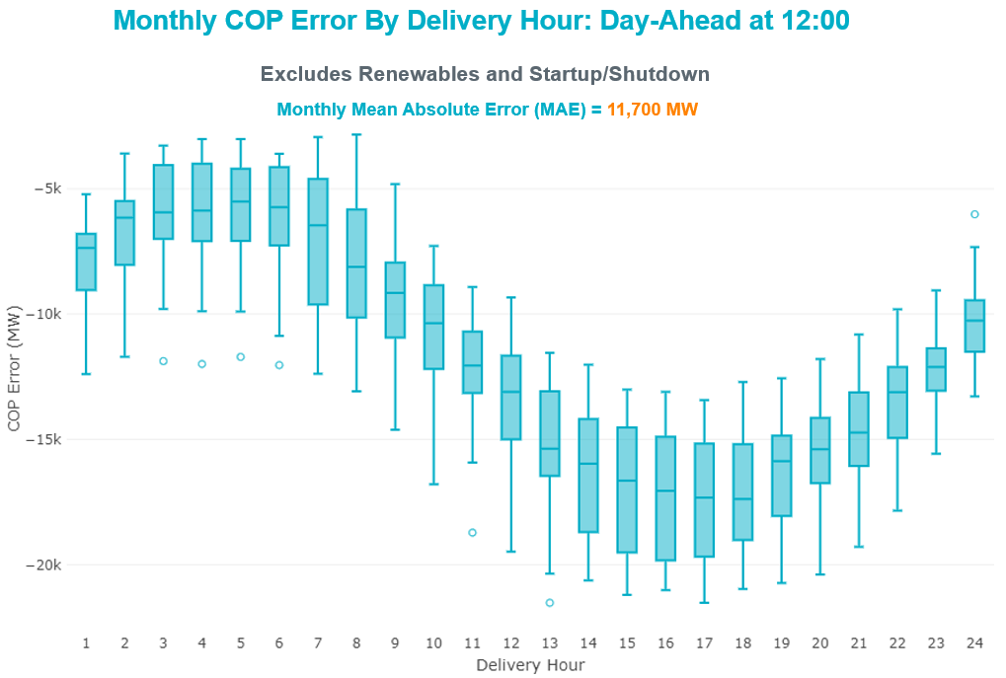

Congestion Analysis

Notable Constraints
Nodal protocol section 3.20 specifies that ERCOT shall identify transmission constraints that are active or binding three or more times within a calendar month. As part of this process, ERCOT reports congestion that meets this criterion to ROS. In addition ERCOT also highlights notable constraints that have an estimated congestion rent exceeding $1,000 for a calendar month. These constraints are detailed in the table below. Rows highlighted in blue indicate the congestion was affected by one or more outages. For a list of all constraints activated in SCED, please see Appendix A at the end of this report.

Contingency Name | Overloaded Element | # of Days Constraint Active | Congestion Rent | Transmission Project
Basecase | PNHNDL GTC | 28 | $24,142,326.88 | Panhandle GTC Exit Plan - "PANHANDLE RENEWABLE ENERGY ZONE (PREZ)  STUDY REPORT" on MIS, CONSTRUCT OGALLALA TO BLACKWATER DRAW 345 KV LINE (52245), CONSTRUCT BLACKWATER DRAW TO FOLSOM POINT345 KV LINE (52258), CONSTRUCT BLACKWATER DRAW TO DOUBLE MOUNTAIN (52299), CONSTRUCT DOUBLE MOUNTAIN TO FIDDLEWOOD TO FARMLAND 345 KV L (522307)
HCKSW TO SAGNA 138 DBLCKT | Eagle Mountain Ses - Morris Dido 138kV | 13 | $4,402,392.72 | Upgrade the Saginaw - Eagle Mountain 138 kV Double Circuit Line (6273)
TWR (345) HLJ-WAP64 & BLY-WAP72 | South Texas Project - Wa Parish 345kV | 11 | $2,609,755.17 | Freeport - Master Plan (6668B)
Basecase | MCCAMY GTC | 21 | $1,923,478.92 | McCamey GTC Exit Plan posted on the ERCOT MIS website
TOMBSTONE to Lynx LIN 1 | 16th Street Tnp - Woodward 2 138kV | 12 | $1,090,312.34 | Solstice: Build 345 kV station (5530) and Solstice to Bakersfield: Build 345 kV line (5539)
Basecase | NE_LOB GTC | 15 | $1,013,315.11 | GTC Exit plan in the North Edinburg - Lobo Stability Study Report posted in the ERCOT MIS website
SAN MIGUEL GEN to FOWLERTON LIN 1 | San Miguel Gen 345kV | 8 | $818,306.77 | San Miguel 345/138 kV autotransformer replacements (5218A, 5218B)
ODLAW SWITCHYARD to ASPHALT MINES LIN 1 | Hamilton Road - Maverick 138kV | 18 | $782,938.28 | Brackettville to Escondido: Construct 138 kV line (5206)
Berghe-Kendal 345kv & Welfar-Boerne 138kv | Kendall - Cagnon 345kV | 4 | $291,199.15 | Boerne Cico - Comfort - Kendall Transmission Line Upgrade (6982)
HCKSW TO SAGNA 138 DBLCKT | Eagle Mountain Ses - Rosen Heights Tap 1 138kV | 3 | $246,521.02 | Saginaw-Eagle Mountain 138 kV DCKT (6273)
MESA VIEW SWITCH to FORT LANCASTER LIN 1 | North Mccamey - Crossover 138kV | 5 | $243,264.10 | McCamey GTC Exit Plan posted on the ERCOT MIS website
COMANCHE SWITCH (Oncor) to COMANCHE PEAK SES LIN _A | Comanche Tap - Comanche Switch (Oncor) 138kV | 7 | $221,184.93
CRLNW TO LWSSW 345 DBLCKT | Ti Tnp - West Tnp 138kV | 4 | $206,815.24 | Lewisville - Lewisville Jones - Lakepointe 138 kV Line (45537)
Gibcrk-Toksw & Jk_Ck 345kV | Btu_Jack_Creek - Btu_Tabor 138kV | 3 | $167,562.20
Bighil-Kendal 345kV | Yellow Jacket - Treadwell 138kV | 13 | $160,205.56 | Treadwell GTC Exit Plan posted on the ERCOT MIS website
LAQUINTA to LOBO LIN 1 | Bruni Sub 138kV | 8 | $152,493.29
BOSQUE SWITCH to ELM MOTT LIN 1 | Bosque Switch - Rogers Hill Bepc 138kV | 22 | $125,928.70 | Upgrade Elm Mott - Bosque 138 kV Line (52149)
KING MOUNTAIN SWITCHYARD to ODESSA EHV SWITCH LIN 1 | Fort Stockton Plant - Solstice 138kV | 8 | $100,649.31 | Solstice: Build 345 kV station (5530)
RIO HONDO to LAS PULGAS LIN 1 | Raymondville 2 138kV | 9 | $97,369.59 | Harlingen SS - Raymondville #2: Convert to 138 kV (6167)
SAN MIGUEL 345_138 KV SWITCHYARDS to LOBO LIN 1 | Laredo Vft North - Las Cruces 138kV | 6 | $96,903.48 | Laredo - Del Mar: 138 kV Line Rebuild (45511)
SAN MIGUEL 345_138 KV SWITCHYARDS to LOBO LIN 1 | North Laredo Switch - Piloncillo 138kV | 11 | $78,851.76 | GTC Exit plan in the North Edinburg - Lobo Stability Study Report posted in the ERCOT MIS website
Solstice to FORT STOCKTON PLANT LIN 1 | Alpine - Bronco 69kV | 10 | $66,735.36
GAS PAD to FLAT TOP TNP LIN 1 | Fort Stockton Plant - Solstice 138kV | 11 | $66,440.29 | Solstice: Build 345 kV station (5530)
BAKERSFIELD SWITCHYARD to Big HiLL LIN 1 | North Mccamey - Crossover 138kV | 6 | $64,881.71 | McCamey GTC Exit Plan posted on the ERCOT MIS website
Pig Creek to Solstice LIN 1 | Lynx - Rio Pecos 138kV | 11 | $58,968.85 | Rebuild Rio Pecos-Lynx Ckt 2 (1926 ACSS) (54255)
Pig Creek to Solstice LIN 1 | Woodward 2 - Rio Pecos 138kV | 10 | $54,855.31 | Lynx: Expand 138 kV station (45503) and Solstice: Build 345 kV station (5530) and Solstice to Bakersfield: Build 345 kV line (5539)  Rebuild Rio Pecos-Lynx Ckt 2 (1926 ACSS) (54255)
wett_sand_bluff to wett_bearkat LIN 1 | Carterville - Einstein 138kV | 4 | $53,483.74 | Bearkat Loop - Bearkat to Longshore (45399)
WICHITA FALLS SOUTH SWITCH to NEWPORT BEPC LIN _E | Bowie 138kV | 4 | $50,742.92 | Bowie Autotransformer Replacement (52275)
Fergus-Granmo&Wirtz-Starck 138kV | Johnson City - Wirtz 138kV | 15 | $44,710.02 | Wirtz to Johnson City to Mountain Top Rebuild to 138kV (6789)
BRACKETTVILLE to HAMILTON ROAD LIN 1 | Hamilton Road - Maverick 138kV | 5 | $40,148.79 | Brackettville to Escondido: Construct 138 kV line (5206)
FIREROCK TO BRNWD 138 AND FIREROCK TO BANGS 69 DBLCKT | Cottonwood Road Switch - Olney Pod 69kV | 4 | $39,490.09
GRSES TO PKRSW 345 DBLCKT | Barton Chapel Wind Farm - Oran Sub 138kV | 4 | $34,856.11
Berghe-Kendal 345kv & Welfar 138kv | Kendall - Cagnon 345kV | 4 | $29,339.61 | Boerne Cico - Comfort - Kendall Transmission Line Upgrade (6982)
BENNETT ROAD SWITCH to WISE COUNTY LIN _B | Myra - Valley View Bepc 138kV | 3 | $27,834.07
DUPONT SWITCH - INGLESIDE to GREGORY POWER LIN 1 | Dupont Switch - Ingleside - Lge 138kV | 7 | $25,102.71
Basecase | Re Roserock Solar Plant - Linterna 138kV | 10 | $23,406.46
WINK to DUNE SWITCH and YUKON | Red Lakes Switch - Penwell Pod 138kV | 5 | $22,208.78
PAREDES SWITCHING STATION to CENTRAL AVENUE SUB LIN 1 | Rio Hondo - East Rio Hondo Sub 138kV | 16 | $21,888.04 | Rebuild Rio Hondo to East Rio Hondo (6687)
Basecase | Randado Aep - Zapata 138kV | 7 | $21,269.43
FORT LANCASTER to ILLINOIS #4 LIN 1 | Hamilton Road - Maxwell 138kV | 8 | $17,333.23 | Hamilton Road to Picacho ckt #2, rebuild 138 kV line (6373)
FLAT TOP TNP to Pig Creek LIN 2 | Woodward 2 - Rio Pecos 138kV | 4 | $16,856.86 | Lynx: Expand 138 kV station (45503) and Solstice: Build 345 kV station (5530) and Solstice to Bakersfield: Build 345 kV line (5539)  Rebuild Rio Pecos-Lynx Ckt 2 (1926 ACSS) (54255)
CAGNON TRX CAGNON_3_3 345/138 | Cagnon 345kV | 4 | $16,476.93
Bighil-Kendal 345kV | Hamilton Road - Maxwell 138kV | 5 | $16,138.74 | Hamilton Road to Picacho ckt #2, rebuild 138 kV line (6373)
ODESSA EHV SWITCH to MOSS SWITCH LIN _A | Odessa Ehv Switch - Yarbrough Sub 138kV | 3 | $15,942.94 | Riverton-Odessa EHV/Moss 345 kV Line (5445)
Basecase | Fort Stockton Plant - Solstice 138kV | 10 | $15,367.50 | Solstice: Build 345 kV station (5530)
PH ROBINSON to MEADOW LIN A | Mainland Tnp - Alvin Tnp 138kV | 4 | $12,732.28 | Rebuild Alvin-Mainland-Freeway Park (795 ACSS) (54118)
CAGNON TRX CAGNON_3_3 345/138 | Cagnon 138kV | 4 | $10,668.82
BRACKETTVILLE to ODLAW SWITCHYARD LIN 1 | Hamilton Road - Maverick 138kV | 5 | $9,874.22 | Brackettville to Escondido: Construct 138 kV line (5206)
BAKERSFIELD SWITCHYARD to Big HiLL LIN 1 | Fort Stockton Plant - Solstice 138kV | 5 | $4,204.46 | Solstice: Build 345 kV station (5530)
FLAT TOP TNP to Pig Creek LIN 2 | Lynx - Rio Pecos 138kV | 3 | $3,451.50 | Rebuild Rio Pecos-Lynx Ckt 2 (1926 ACSS) (54255)
GUNSIGHT SWITCH to GETTY VEALMOOR TAP LIN _A | Chevron Ackerly Tap - Buzzard Draw Switch 69kV | 4 | $3,444.12 | Big Spring - Buzzard Draw 69 kV Line Conversion (46259)
SUN SWITCH to SCURRY SWITCH LIN 1 | Wolfgang - Rotan 69kV | 6 | $2,090.66 | Wolfgang to Rotan 69 kV line: Rebuild 69 kV line (5970)

Generic Transmission Constraint Congestion
There were 30 days of congestion on the Panhandle GTC, 23 days on the McCamey GTC, 17 days on the North Edinburg to Lobo GTC, 3 day on the North to Houston GTC, 1 day on the West to Central, and 1 day on the Bearkat. There was no activity on the remaining GTCs during the month.

Note: This is how many times a constraint has been activated to avoid exceeding a GTC limit, it does not imply an exceedance of the GTC occurred or that the GTC was binding.

Manual Overrides
None.

Congestion Costs for Calendar Year 2020
The following table represents the top twenty active constraints for the calendar year based on the estimated congestion rent attributed to the congestion. ERCOT updates this list on a monthly basis.

Contingency | Overloaded Element | # of 5-min SCED | Estimated | Transmision
MOSS SWITCH to ECTOR COUNTY NORTH SWITCHING STATION LIN _A | Dollarhide - No Trees Switch 138kV | 12277 | 115237549.4 | Andrews County South Switch - No Trees Switch 138 kV Line (7171)
WINK to DUNE SWITCH and YUKON | Dollarhide - No Trees Switch 138kV | 10924 | 76533287.97 | Andrews County South Switch - No Trees Switch 138 kV Line (7171)
Basecase | PNHNDL GTC | 19856 | 56364487.98 | Panhandle GTC Exit Plan - "PANHANDLE RENEWABLE ENERGY ZONE (PREZ)  STUDY REPORT" on MIS
Manual MDSSW_TRX1_345/138 | Trigas Odessa Tap - Odessa Ehv Switch 138kV | 1787 | 38328997.67 | Riverton-Odessa EHV/Moss 345 kV Line (5445)
CRLNW TO LWSSW 345 DBLCKT | Ti Tnp - West Tnp 138kV | 8052 | 27713003.79 | Lewisville - Lewisville Jones - Lakepointe 138 kV Line (45537)
WINK to DUNE SWITCH and YUKON | Andrews County South - Amoco Three Bar Tap 138kV | 2002 | 23188211.21 | Andrews County South Switch - No Trees Switch 138 kV Line (7171)
MOSS SWITCH to ECTOR COUNTY NORTH SWITCHING STATION LIN _A | Andrews County South - Amoco Three Bar Tap 138kV | 1316 | 21247827.71 | Andrews County South Switch - No Trees Switch 138 kV Line (7171)
JEWET TO SNG 345 DBLCKT | Btu_Jack_Creek - Twin Oak Switch 345kV | 1193 | 17477432.7
HCKSW TO SAGNA 138 DBLCKT | Eagle Mountain Ses - Morris Dido 138kV | 1965 | 12495061.84 | Upgrade the Saginaw - Eagle Mountain 138 kV Double Circuit Line (6273)
POMELO to NORTH EDINBURG LIN 1 | Lobo - Freer 69kV | 7377 | 10626337.75 | GTC Exit plan in the North Edinburg - Lobo Stability Study Report posted in the ERCOT MIS website
CRLNW TO LWSSW 345 DBLCKT | Argyle - Highlands Tnp 138kV | 3922 | 10613392.34 | Lewisville - Lewisville Jones - Lakepointe 138 kV Line (45537)
ODLAW SWITCHYARD to ASPHALT MINES LIN 1 | Hamilton Road - Maverick 138kV | 13937 | 10139451.52 | Brackettville to Escondido: Construct 138 kV line (5206)
Loss of NEDIN train | North Edinburg 345kV | 90 | 9831038.841 | North Edinburg: 345 kV Reconfigure (50878)
NORTH EDINBURG TRX 1382 345/138 | North Edinburg 345kV | 503 | 9225085.274 | North Edinburg: 345 kV Reconfigure (50878)
ODESSA EHV SWITCH TRX ODEHV_3_1 345/138 | Odessa Ehv Switch 345kV | 558 | 8111745.697 | Riverton-Odessa EHV/Moss 345 kV Line (5445)
BIG SPRING SWITCH to CHALK_69kV and McDonald Road_138kV | Odessa Ehv Switch 345kV | 257 | 7736976.707 | Riverton-Odessa EHV/Moss 345 kV Line (5445)
MOSS SWITCH to ECTOR COUNTY NORTH SWITCHING STATION LIN _A | Odessa Ehv Switch - Yarbrough Sub 138kV | 371 | 7401498.444 | Riverton-Odessa EHV/Moss 345 kV Line (5445)
Basecase | NE_LOB GTC | 9789 | 7224267.085 | GTC Exit plan in the North Edinburg - Lobo Stability Study Report posted in the ERCOT MIS website
MIDESSA SOUTH SW TRX MDSSW_1_1 345/138 | Trigas Odessa Tap - Odessa Ehv Switch 138kV | 1045 | 7114333.098 | Riverton-Odessa EHV/Moss 345 kV Line (5445)
DCRMOD28 Odesa-Mdssw&Glnhv 138 kV | Big Three Odessa Tap - Odessa Ehv Switch 138kV | 435 | 6442561.354 | Riverton-Odessa EHV/Moss 345 kV Line (5445)

System Events

ERCOT Peak Load
The unofficial ERCOT peak load for the month was 68,043 MW and occurred on the 8th, during hour ending 18:00.

Load Shed Events
None.

Stability Events
None.

Notable PMU Events
ERCOT analyzes PMU data for any significant system disturbances that do not fall into the Frequency Events category reported in section 2.1. The results are summarized in this section once the analysis has been completed.

There were no PMU events outside of those reported in section 2.1.

DC Tie Curtailment

Date | DC Tie | Curtailing Period | # of Tags Curtailed | Initiating Event | Curtailment Reason
06/11/2020 | DC-L | HE 22:00 | 1 | Unplanned Outage | Unplanned Outage

TRE/DOE Reportable Events
- AEN submitted an OE-417 for 06/26/2020. Reportable Event Type: Complete Loss of Monitoring or Control Capability

New/Modified/Removed RAS
None.

New Procedures/Forms/Operating Bulletins
None.

Emergency Conditions

OCNs

Date and Time | Message
June 01 2020 19:00 CPT | ERCOT is modifying the Panhandle Generic Transmission Constraint due to the Coulomb - Gauss - Clear Crossing and Edith Clarke - Gauss - Smoky Hill 345 kV outage becoming a valid N-1 scenario.

Advisories

Date and Time | Message
June 08 2020 13:30 CPT | ERCOT has postponed the posting of the DAM solution for Operating Day June 09, 2020 due to a delay in clearing DAM.
June 25 2020 14:15 CPT | ERCOT issued an Advisory due to Physical Responsive Capability being below 3,000 MW.
June 27 2020 13:30 CPT | ERCOT has postponed the posting of the DAM solution for Operating Day June 28, 2020 due to a delay in clearing DAM.
June 28 2020 13:30 CPT | ERCOT has postponed the posting of the DAM solution for Operating Day June 29, 2020 due to a delay in clearing DAM.

Watches
None.

Emergency Notices
None.

Application Performance

TSAT/VSAT Performance Issues
None.

Communication Issues
None.

Market System Issues
None.

Model Updates
The Downstream Production Change (DPC) process allows ERCOT to make changes in the on-line Network Operations Model without loading a completely new model. The purpose of this process is to allow for reliable grid operations as system conditions change between designated Network Operations Model database loads. The DPC process is limited in scope to just those items listed below, with equipment ratings updates being the most common. ERCOT has seen a rise in the use of the DPC process to make on-line updates to the Network Operations Model in recent years, instead of through the standard Network Operations Model Change Request process.

- Static Line ratings (Interim Update)
- Dynamic Line ratings (non-Interim Update)
- Autotransformer ratings (non-Interim Update)
- Breaker and Switch Normal status (Interim Update)
- Contingency Definitions (Interim Update)
- RAP and RAS changes or additions (Interim Update)
- Net Dependable and Reactive Capability (NDCRC) values (Interim Update)
- Impedance Updates (non-Interim)

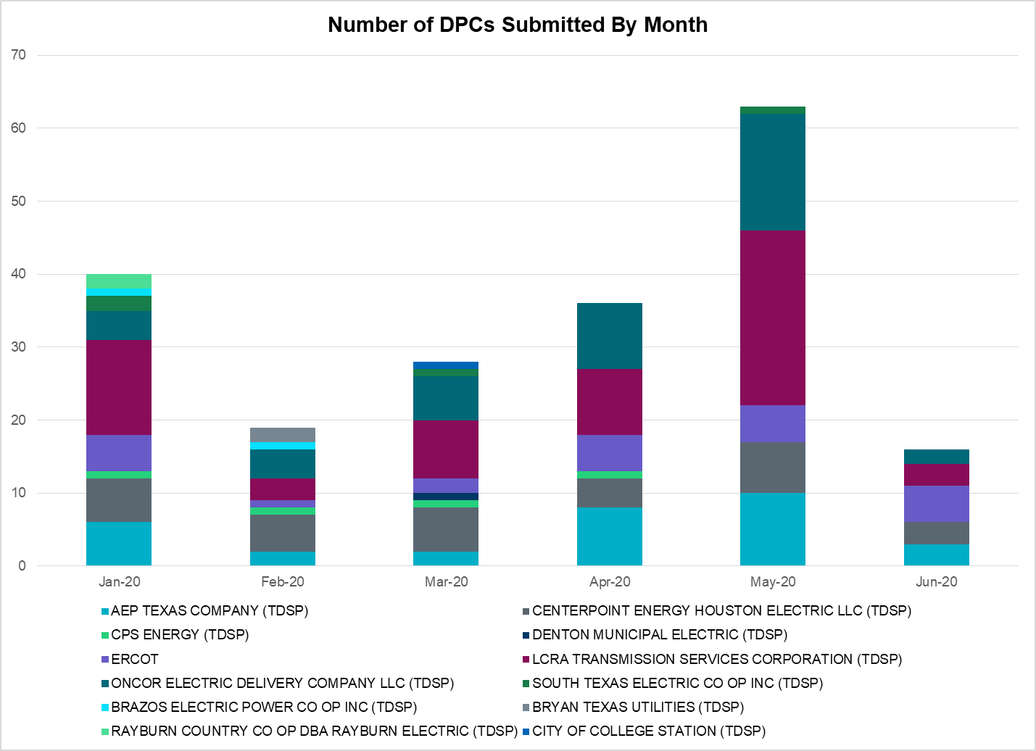

Transmission Operator | Number of DPCs
AEP TEXAS COMPANY (TDSP) | 3
BRAZOS ELECTRIC POWER CO OP INC (TDSP) | 0
BRYAN TEXAS UTILITIES (TDSP) | 0
CENTERPOINT ENERGY HOUSTON ELECTRIC LLC (TDSP) | 3
CITY OF AUSTIN DBA AUSTIN ENERGY (TDSP) | 0
CITY OF COLLEGE STATION (TDSP) | 0
CITY OF GARLAND (TDSP) | 0
CPS ENERGY (TDSP) | 0
DENTON MUNICIPAL ELECTRIC (TDSP) | 0
ELECTRIC TRANSMISSION TEXAS LLC (TDSP) | 0
ERCOT | 5
LCRA TRANSMISSION SERVICES CORPORATION (TDSP) | 3
ONCOR ELECTRIC DELIVERY COMPANY LLC (TDSP) | 2
RAYBURN COUNTRY CO OP DBA RAYBURN ELECTRIC (TDSP) | 0
SHARYLAND UTILITIES LP (TDSP) | 0
SOUTH TEXAS ELECTRIC CO OP INC (TDSP) | 0
TEXAS MUNICIPAL POWER AGENCY (TDSP) | 0
TEXAS-NEW MEXICO POWER CO (TDSP) | 0

Appendix A: Real-Time Constraints
The following is a complete list of constraints activated in SCED. Full contingency descriptions can be found in the Standard Contingencies List located on the MIS secure site at Grid Generation Reliability Unit Commitment.

Contingency Name | Overloaded Element | From Station | To Station | Count of Days
BASE CASE | PNHNDL | n/a | n/a | 28
SBOSELM5 | 1030__B | BOSQUESW | RGH | 22
BASE CASE | MCCAMY | n/a | n/a | 21
SBRAUVA8 | HAMILT_MAVERI1_1 | HAMILTON | MAVERICK | 18
SMV_PAR8 | RIOHND_ERIOHND_1 | MV_RIOHO | RIOHONDO | 16
DFERSTA8 | 1318T313_1 | WIRTZ | JOHNCI | 15
BASE CASE | NE_LOB | n/a | n/a | 15
DHCKSAG8 | 6265__A | EMSES | MRSDO | 13
DBIGKEN5 | TREADW_YELWJC1_1 | TREADWEL | YELWJCKT | 13
STOMLYN8 | 16TH_WRD2_1 | WOODWRD2 | 16TH_ST | 12
DWAPHLJ5 | STPWAP39_1 | STP | WAP | 11
SLOBSA25 | NLARSW_PILONC1_1 | NLARSW | PILONCIL | 11
SHACPB38 | FTST_SOLSTI1_1 | FTST | SOLSTICE | 11
SPIGSOL8 | LYNX_RIOPEC1_1 | LYNX | RIOPECOS | 11
SPIGSOL8 | RIOPEC_WOODW21_1 | WOODWRD2 | RIOPECOS | 10
BASE CASE | FTST_SOLSTI1_1 | FTST | SOLSTICE | 10
BASE CASE | REROCK_TLINE_1 | REROCK | LINTERNA | 10
SSOLFTS8 | ALPINE_BRONCO1_1 | BRONCO | ALPINE | 10
BASE CASE | REROCK_TLINE_1 | LINTERNA | REROCK | 10
SRAYRI28 | RAYMND2_69A1 | RAYMND2 | RAYMND2 | 9
SILLFTL8 | HAMILT_MAXWEL1_1 | MAXWELL | HAMILTON | 8
SSANFOW5 | SANMIGL_ATAH | SANMIGL | SANMIGL | 8
SKINODE5 | FTST_SOLSTI1_1 | FTST | SOLSTICE | 8
SLAQLOB8 | BRUNI_69_1 | BRUNI | BRUNI | 8
SLGEI_D8 | I_DUPS_LGE1_1 | LGE | I_DUPSW | 7
SCMNCPS5 | 651__B | CMNSW | CMNTP | 7
BASE CASE | RANDAD_ZAPATA1_1 | RANDADO | ZAPATA | 7
SBAKBIG5 | CROSSO_NORTMC1_1 | NORTMC | CROSSOVE | 6
SSCUSU28 | ROTN_WOLFGA1_1 | WOLFGANG | ROTN | 6
SLOBSA25 | LARDVN_LASCRU1_1 | LARDVNTH | LASCRUCE | 6
SODLBRA8 | HAMILT_MAVERI1_1 | HAMILTON | MAVERICK | 5
SBRAHAM8 | HAMILT_MAVERI1_1 | HAMILTON | MAVERICK | 5
DBIGKEN5 | HAMILT_MAXWEL1_1 | MAXWELL | HAMILTON | 5
SBAKBIG5 | FTST_SOLSTI1_1 | FTST | SOLSTICE | 5
SFTLMES8 | CROSSO_NORTMC1_1 | NORTMC | CROSSOVE | 5
DWINDUN8 | 6485__B | RLKSW | PWPOD | 5
DCRLLSW5 | 588_A_1 | LWSVW | LWVTI | 4
DBERBO58 | R5_KENDL_1 | KENDAL | CAGNON | 4
SFLAPIG8 | RIOPEC_WOODW21_1 | WOODWRD2 | RIOPECOS | 4
DGRSPKR5 | 6377__A | BRTSW | ORANS | 4
SLKAWFS8 | BOW_FMR1 | BOW | BOW | 4
DMARPA_8 | 1318T313_1 | WIRTZ | JOHNCI | 4
XCAG158 | CAGNON_MR4L | CAGNON | CAGNON | 4
SW_BW_25 | CRTVLE_EINSTEN_1 | EINSTEIN | CRTRVLLE | 4
DBERWE58 | R5_KENDL_1 | KENDAL | CAGNON | 4
DGRMGRS8 | 6830__B | CRDSW | OLNEY | 4
SAVMBSP8 | 6610__A | BUZSW | CHATP | 4
SMDOPHR5 | 138_ALV_MNL_1 | ALVIN | MAINLAND | 4
XCAG158 | CAGNON_MR4H | CAGNON | CAGNON | 4
SBTPBNT8 | MYRA_VAL_1 | MYRA | VALYVIEW | 3
DGIBTOK5 | JK_CK_TABOR_1 | JK_CK | TABOR | 3
SSPUASP8 | ROTN_WOLFGA1_1 | WOLFGANG | ROTN | 3
SFLAPIG8 | LYNX_RIOPEC1_1 | LYNX | RIOPECOS | 3
DHCKSAG8 | 6260__C | EMSES | RHTP1 | 3
SMDLODE5 | 6520__E | ODEHV | YARBR | 3
SLYNRIO8 | 16TH_WRD2_1 | WOODWRD2 | 16TH_ST | 2
SBEVASH8 | BEVO_BRUNDAGE_1 | BRUNDGS | BEVO | 2
SKLELOY8 | LOYOLA_69_1 | LOYOLA | LOYOLA | 2
STOMLYN8 | RIOPEC_WOODW21_1 | RIOPECOS | WOODWRD2 | 2
SCISPUT8 | ESTES_PECAN_1_1 | PECAN_BY | ESTES | 2
SWOORI28 | LYNX_TOMBST1_1 | LYNX | TOMBSTNE | 2
MSPUSCK8 | ROTN_WOLFGA1_1 | WOLFGANG | ROTN | 2
DCAGCO58 | 656T656_1 | KENDAL | BERGHE | 2
DSCOFAR5 | 6216__B | WLVSW | SHRNE | 2
DELMSAN5 | MAGRUD_VICTOR2_1 | VICTORIA | MAGRUDER | 2
DHUTGEA8 | 526T526_1 | WELLBR | RRSTH | 2
SCRDLOF9 | BOW_FMR1 | BOW | BOW | 2
SWCSBOO8 | FTST_SOLSTI1_1 | FTST | SOLSTICE | 2
SCISPUT8 | SOUTHA_VINSON1_1 | SOUTHABI | VINSON | 2
SHASTNN8 | 138_ALV_MNL_1 | ALVIN | MAINLAND | 1
SHACPB38 | 6710__A | YUCSW | WICKETT | 1
XDES258 | 932__B | CDHSW | EGFRD | 1
DZORSEG8 | 94T340_1 | MARION | SHERPO | 1
SBROALP9 | FTST_SOLSTI1_1 | FTST | SOLSTICE | 1
DDUPHE18 | I_DUPS_MCCAMP2_1 | I_DUPSW | MCCAMPBE | 1
SCO2EUL8 | COLETO_ROSATA1_1 | COLETO | ROSATA | 1
DHILMAR5 | 361T361_1 | SCHERT | PARKWA | 1
DRILBOW5 | 6011__B | RILEY | FSHSW | 1
SMELRIN8 | BONIVI_RINCON1_1 | RINCON | BONIVIEW | 1
BASE CASE | BR_HOC09_A | BR | HOC | 1
SMDLODE5 | FTST_SOLSTI1_1 | FTST | SOLSTICE | 1
XHI3L58 | HILLCTRY_MR4H | HILLCTRY | HILLCTRY | 1
SLYNRIO8 | RIOPEC_WOODW21_1 | RIOPECOS | WOODWRD2 | 1
SCOMKEN8 | 115T123_1 | KENDAL | KERRST | 1
DFERGRM8 | 1318T313_1 | WIRTZ | JOHNCI | 1
DLWSRNK5 | 587__A | ARGYL | LWSVH | 1
DSCOFAR5 | 6437__F | SCRCV | KNAPP | 1
SCOLBAL8 | BALLIN_HUMBLT1_1 | BALLINGE | HUMBLTAP | 1
SLOBSA25 | BRUNI_69_1 | BRUNI | BRUNI | 1
DCI_SA_8 | DH_WO_81_A | DH | WO | 1
DREAPWE8 | 1610__A | PWEST | RCHAT | 1
MACSRA18 | 6425__D | SHPOI | NTPOI | 1
SDUKNE28 | ADERHO_HEC1_1 | HEC | ADERHOLD | 1
SODLBRA8 | GANSO_MAVERI1_1 | MAVERICK | GANSO | 1
SCENLOB5 | GODDAR_PAWNEE1_1 | GODDARD | PAWNEE | 1
SCOMHA38 | HAMILT_MAXWEL1_1 | MAXWELL | HAMILTON | 1
SMCEABS8 | MKLT_TRNT1_1 | TRNT | MKLT | 1
DPHRCTR5 | 138_ALV_MNL_1 | ALVIN | MAINLAND | 1
DCDHVEN5 | 310__A | LIGSW | NORSW | 1
DCDHVEN5 | 3180__A | FCRSW | CDHSW | 1
BASE CASE | BEARKT | n/a | n/a | 1
DCHBJOR5 | CBY_AT2A | CBY | CBY | 1
DHUTHUT5 | HUTTO_MR1H | HUTTO | HUTTO | 1
SMCEESK8 | MKLT_TRNT1_1 | TRNT | MKLT | 1
DZORHAY5 | R5_KENDL_1 | KENDAL | CAGNON | 1
DSKYNAC8 | WEIDER_RAND_1 | WEIDER | W2 | 1
DENTSCS5 | 1350__E | NCSTP | LFKSW | 1
DNAVLEG5 | 50__A | BBSES | JEWET | 1
DRILKRW5 | BOW_FMR1 | BOW | BOW | 1
BASE CASE | LOCKETT_TLINE_1 | LOCKETT | DIGBY | 1
DFERWIR8 | SANDCR_AT1 | SANDCR | SANDCR | 1
BASE CASE | W_TO_C | n/a | n/a | 1
DZORSEG8 | 290T305_1 | CIBOLO | MCQUEE | 1
DBWNKLN5 | 651__B | CMNSW | CMNTP | 1
SHAYZO25 | 6T227_1 | HAYSEN | ZORN | 1
DZORHAY5 | BERGHE_AT1H | BERGHE | BERGHE | 1
BASE CASE | N_TO_H | n/a | n/a | 1

This is the hourly integrated peak demand as published in the ERCOT D&E report.

