System Planning
Monthly Status Report

Report Highlights

- ERCOT is currently reviewing proposed transmission improvements with a total estimated cost of $1,034.6 Million as of June 30, 2020.
- Transmission Projects endorsed in 2020 total $598.6 Million as of June 30, 2020.
- All projects (in engineering, routing, licensing and construction) total approximately $7.26 Billion as of June 1, 2020.
- Transmission Projects energized in 2020 total about $1.06 Billion as of June 1, 2020.

Regional Planning Group Reviews
- AEPSC has submitted the LRGV Import Project. This is a Tier 1 project that is estimated to cost $73.4 million. AEPSC has also requested that ERCOT provide a conditional endorsement for an additional $357.2 million project. The ERCOT Independent Review has been conducted in accordance with Protocol Section 3.11.4.9(3), and this project is currently placed on hold until the LNG loads are confirmed.
- STEC has submitted the Lower Rio Grande Valley Transmission Expansion Project. This is a Tier 1 project that is estimated to cost $511 million. The ERCOT Independent Review has been conducted in accordance with Protocol Section 3.11.4.9(3), and this project is currently placed on hold until the LNG loads are confirmed.
- AEPSC has submitted the Corpus North Shore Project. This is a Tier 1 project that is estimated to cost $259.57 million. ERCOT has completed the independent review on May 19, and an alternate project was recommended for ERCOT Board endorsement. TAC voted unanimously to endorse the project on May 27. The ERCOT Board endorsed the project on June 9.
- TNMP has submitted the Texas City Transmission Improvement Project. This is a Tier 2 project that is estimated to cost $29.3 million. This project is currently under ERCOT Independent Review.
- BEC has submitted the Moffat to Hasse Voltage Conversion Project. This is a Tier 2 project that is estimated to cost $55.2 million. This project is currently under ERCOT Independent Review.
- Oncor has submitted the Quarry Field 345-kV Switch Project. This is a Tier 3 project that is estimated to cost $29 million. This project completed the RPG review on June 12, and ERCOT has issued an acceptance letter.
- Oncor has submitted the Big Spring – Buzzard Draw 69-kV Line Conversion to 138-kV Project. This is a Tier 3 project that is estimated to cost $32 million. This project completed the RPG review on June 26, and ERCOT will issue an acceptance letter.
- Oncor has submitted the Carrollton Northwest 345/138-kV Autotransformer Upgrade Project. This is a Tier 3 project that is estimated to cost $8.5 million. This project is currently in the RPG comment period.

More information on current and past RPG projects can be found on the ERCOT MIS Secure (digital certificate required): https://mis.ercot.com/pps/tibco/mis/Pages/Grid+Information/RegionalPlanning
Past email communication on RPG projects can be found on the ERCOT listserve by signing up for the REGPLANGROUP list: http://lists.ercot.com/scripts/wa-ERCOT.exe?A0=REGPLANGROUP

Planning Model Activities
The short-term calendar of major planning model events is as follows:
- By Oct 15, 2020 20SSWG Update 1 cases and TPIT are posted
- By Oct 31, 2020 20SSWGU1 Contingency definitions and Planning Data Dictionary are posted
The following table shows interconnection projects that met Planning Guide section 6.9(1) and 6.9(2) and were modeled in the SSWG cases as a full model or as a simple model in accordance with Planning Guide section 6.9.
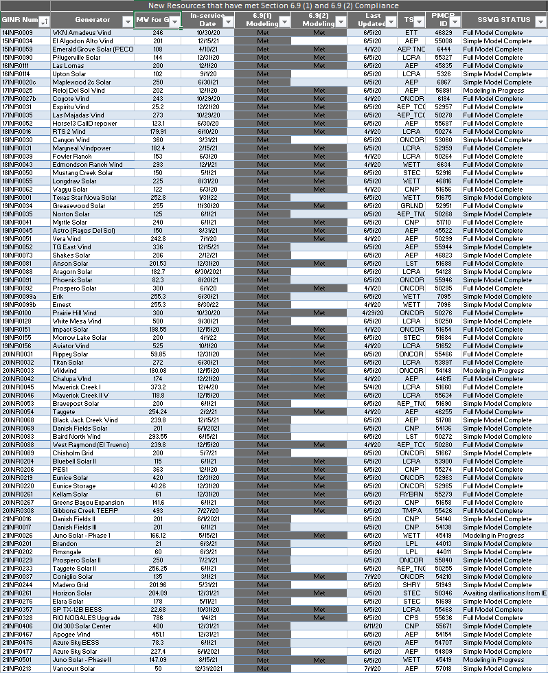

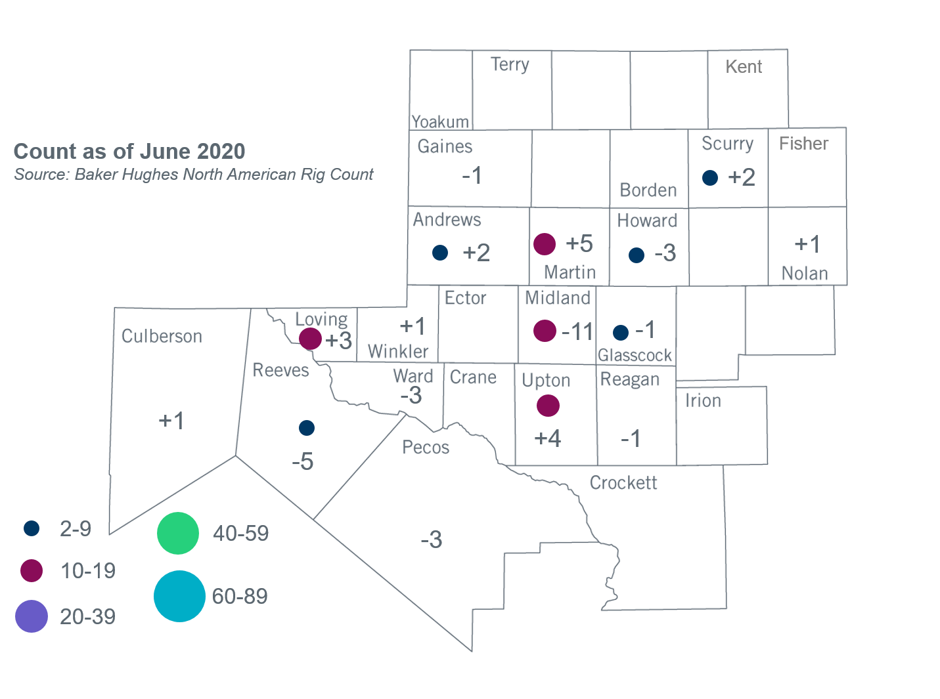
Permian Basin Oil Rig Count
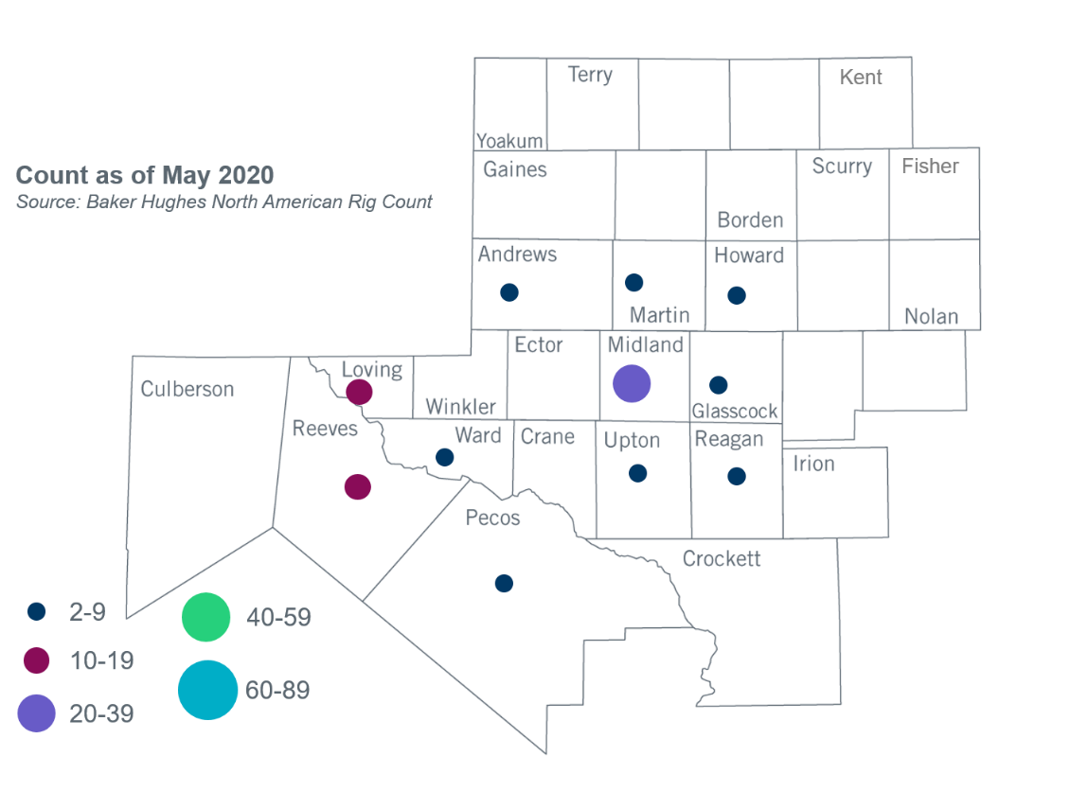

Other Notable Activities
- The SPWG completed and posted the 2020 CY base case on March 27, 2020.
- The SPWG has begun building the 2020 FY cases.
- ERCOT is performing stability analysis for Panhandle and West Texas exports and plans to finalize both reports in July. ERCOT plans to start Valley export stability analysis in August.
- ERCOT presented information and a proposal for assumptions for including Battery Energy Storage Systems (BESS) in transmission planning studies to PLWG in June. The assumptions included in the presentation are related to BESTF KTC 10, Item 5.

+/- symbol indicates the increase or decrease from the previous month in oil rigs present in each county. There are 78 rigs, including a total decrease of 9 oil rigs, in the Permian Basin from May to June 2020.

