May 2020 ERCOT Monthly Operations Report
Reliability and Operations Subcommittee Meeting
July 9, 2020

Table of Contents
1. Report Highlights 2
2. Frequency Control 3
2.1. Frequency Events 3
2.2. Responsive Reserve Events 4
2.3. Load Resource Events 4
3. Reliability Unit Commitment 4
4. Wind Generation as a Percent of Load 5
5. Largest Net-Load Ramp 5
6. COP Error Analysis 6
7. Congestion Analysis 8
7.1. Notable Constraints 8
7.2. Generic Transmission Constraint Congestion 12
7.3. Manual Overrides 12
7.4. Congestion Costs for Calendar Year 2020 12
8. System Events 14
8.1. ERCOT Peak Load 14
8.2. Load Shed Events 14
8.3. Stability Events 14
8.4. Notable PMU Events 14
8.5. DC Tie Curtailment 14
8.6. TRE/DOE Reportable Events 14
8.7. New/Modified/Removed RAS 14
8.8. New Procedures/Forms/Operating Bulletins 14
9. Emergency Conditions 15
9.1. OCNs 15
9.2. Advisories 15
9.3. Watches 15
9.4. Emergency Notices 15
10. Application Performance 15
10.1. TSAT/VSAT Performance Issues 15
10.2. Communication Issues 15
10.3. Market System Issues 16
11. Model Updates 16
Appendix A: Real-Time Constraints 18

Report Highlights
- The unofficial ERCOT peak was 64,396 MW.
- There were 4 frequency events.
- There were 4 instances where Responsive Reserves were deployed.
- There was 1 RUC commitment.
- Congestion in the Panhandle can be attributed to high wind generation. Congestion in the North are can mostly be attributed to planned outages and high generation output. Congestion in the South can be attributed to planned outages and the load pattern in the Valley. There were 24 days of congestion on the Panhandle GTC, 22 days on the North Edinburg to Lobo GTC, 18 days on the McCamey GTC, 3 days on the Nelson Sharpe to Rio Hondo GTC, and 1 day on the North to Houston GTC. There was no activity on the remaining GTCs during the month.
- There were 0 DC Tie curtailments.

Frequency Control

Frequency Events
The ERCOT Interconnection experienced four frequency events, which resulted from units’ trip. The average event duration was 00:05:02.

A summary of the frequency events is provided below. The reported frequency events meet one of the following criteria: Delta Frequency is 60 mHz or greater; the MW loss is 350 MW or greater; resource trip event triggered RRS deployment. Frequency events that have been identified as Frequency Measurable Events (FME) for purposes of BAL-001-TRE-1 analysis are highlighted in blue. When analyzing frequency events, ERCOT evaluates PMU data according to industry standards. Events with an oscillating frequency of less than 1 Hz are considered to be inter-area, while higher frequencies indicate local events. Industry standards specify that damping ratio for inter-area oscillations should be 3.0% or greater. For the frequency events listed below, the ERCOT system met these standards and transitioned well after each disturbance.

Date and Time | Delta Frequency | Max/Min Frequency | Duration of Event | PMU Data |  | MW Loss | Load | Wind | Inertia
 | (Hz) | (Hz) |  | Oscillation Mode (Hz) | Damping Ratio |  | (MW) | % | (GW-s)
5/6/2020 5:57 | 0.081 | 59.891 | 0:03:16 | 0.58 | 8% | 385 | 31,753 | 23% | 226,799
5/7/2020 23:29 | 0.102 | 59.901 | 0:03:54 | 2.15 | 5% | 406 | 40,975 | 49% | 175,063
5/26/2020 21:23 | 0.113 | 59.905 | 0:04:24 | 0.7 | 13% | 481 | 44,343 | 5% | 268,224
5/31/2020 10:45 | 0.174 | 59.819 | 0:08:34 | 1.86 | 15% | 820 | 40,765 | 7% | 263,918

(Note: All data on this graph encompasses frequency event analysis based on BAL-001-TRE-1.)

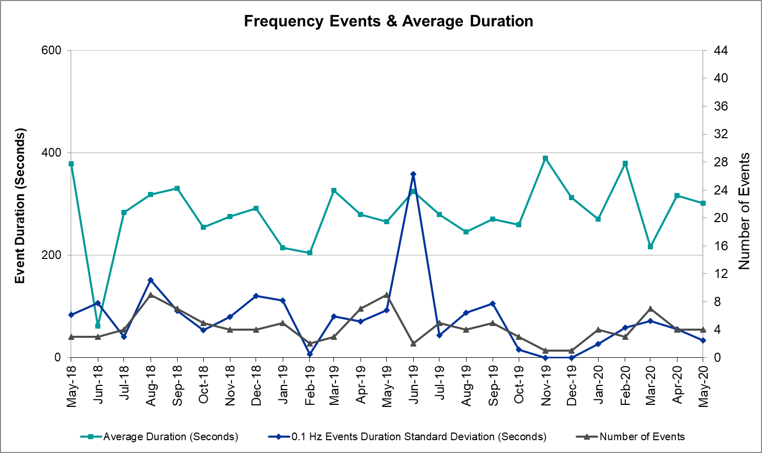

Note that the large standard deviation in June 2019 is due to coincidental extreme high and low durations for a small set of events (2).

Responsive Reserve Events
There were 4 events where Responsive Reserve MWs were released to SCED. The events highlighted in blue were related to frequency events reported in Section 2.1 above.

Date and Time Released to SCED | Date and Time Recalled | Duration of Event | Maximum MWs Released | Comments
5/6/2020 5:57 | 5/6/2020 6:01 | 0:03:32 | 423
5/7/2020 23:29 | 5/7/2020 23:33 | 0:03:32 | 595
5/12/2020 1:14 | 5/12/2020 1:20 | 0:06:12 | 707 | Large wind down ramp
5/31/2020 10:45 | 5/31/2020 10:53 | 0:07:52 | 1153

Load Resource Events
No Load Resource Events.

Reliability Unit Commitment
ERCOT reports on Reliability Unit Commitments (RUC) on a monthly basis. Commitments are reported grouped by operating day and weather zone. The total number of hours committed is the sum of the hours for all the units in the specified region. Additional information on RUC commitments can be found on the MIS secure site at Grid Generation Reliability Unit Commitment.

There were no DRUC commitments.

There was 1 HRUC commitment.

Resource Location | # of Resources | Operating Day | Total # of Hours Committed | Total MWhs | Reason for Commitment
Southern | 1 | 5/1/2020 | 6 | 1,409 | DCC3_NED

Wind Generation as a Percent of Load
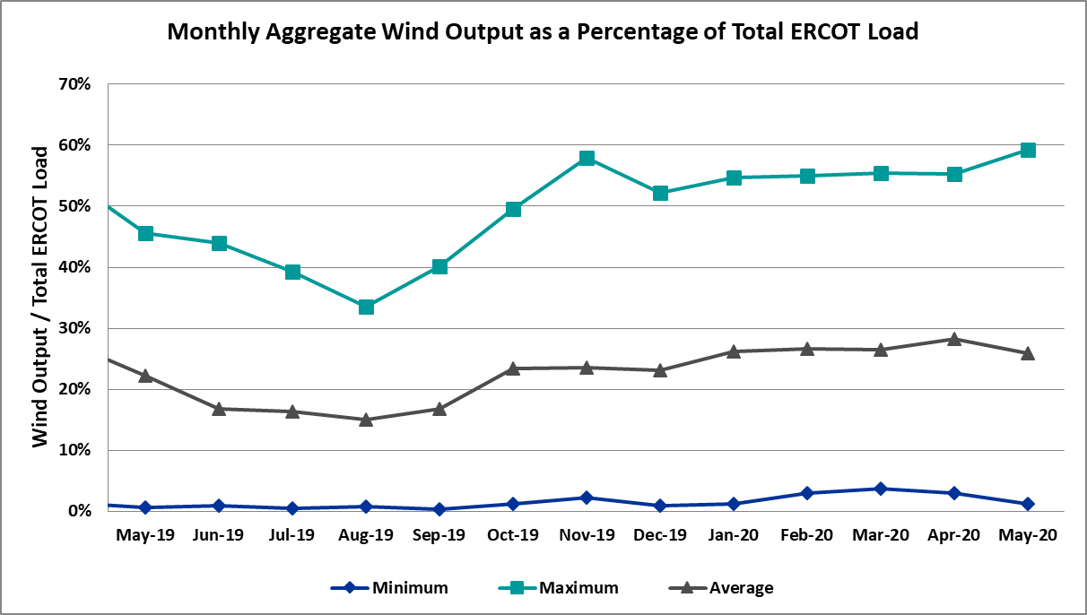

Wind Generation Record: 21,144 MW on 05/07/2020 at 20:43
Wind Penetration Record: 59.30% on 05/02/2020 at 02:10

Largest Net-Load Ramp
The net-load ramp is defined as the change in net-load (load minus wind and PVGR generation) during the defined time horizon. Such a variation in net-load needs to be accommodated in grid operations to ensure that the reliability of the grid is satisfactorily maintained. The largest net-load ramp during 5-min, 10-min, 15-min, 30-min and 60-min in May 2020 is 988 MW, 1529 MW, 1852 MW, 3104 MW, and 5757 MW, respectively. The comparison with respect to the historical values is given in the table below.

Month and Year | 5 min | 10 min | 15 min | 30 min | 60 min
May 2020 | 988 MW | 1529 MW | 1852 MW | 3104 MW | 5757 MW
May 2014 | 914 MW | 1468 MW | 2264 MW | 3123 MW | 4331 MW
May 2015 | 1156 MW | 1770 MW | 2088 MW | 3242 MW | 5318 MW
May 2016 | 871 MW | 1324 MW | 1804 MW | 2945 MW | 4897 MW
May 2017 | 1109 MW | 1422 MW | 1883 MW | 3149 MW | 5348 MW
May 2018 | 1173 MW | 1330 MW | 1845 MW | 3382 MW | 6508 MW
May 2019 | 1066 MW | 1767 MW | 2483 MW | 4227 MW | 5146 MW
2014-2019 | 1494 MW | 1991 MW | 2780 MW | 4109 MW | 7786 MW

COP Error Analysis
COP Error is calculated as the capacity difference between the COP HSL and real-time HSL of the unit. Mean Absolute Error (MAE) stayed high over 9,000 MW until Day-Ahead at 12:00, then dropped significantly to 2,381 MW by Day-Ahead at 14:00. In the following chart, Under-Scheduling Error indicates that COP had less generation capacity than real-time and Over-Scheduling Error indicates that COP had more generation capacity than real-time. Under-Scheduling persisted from beginning of Day-Ahead to end of the Operating Day.

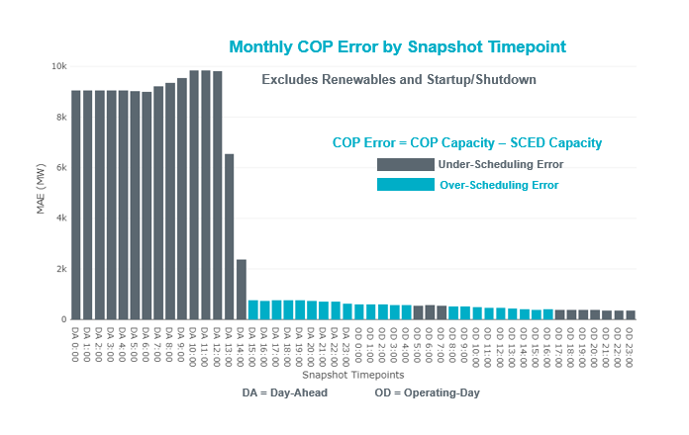
Monthly MAE for the Latest COP at the end of the Adjustment Period was 365 MW with median ranging from -209 MW for Hour-Ending (HE) 18 to 183 MW for HE 12. HE 2 on the 30th had the largest Over-Scheduling Error (1,318 MW) and HE 21 on the 22nd had the largest Under-Scheduling Error (-3,049 MW).
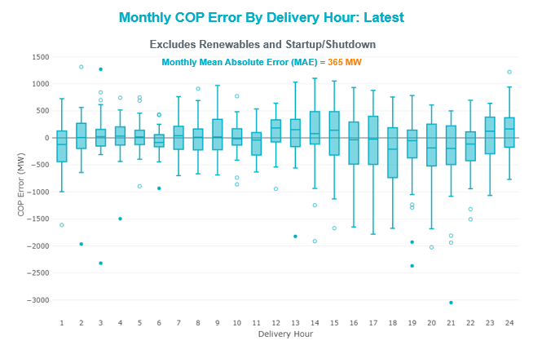

Monthly MAE for the Day-Ahead COP at 12:00 was 9,817 MW with median ranging from -14,845 MW for Hour-Ending (HE) 18 to -4,797 MW for HE 5. HE 17 on the 22nd had the largest Under-Scheduling Error (-22,666 MW) and HE 2 on the 1st had the largest Over-Scheduling Error (+1,702 MW).

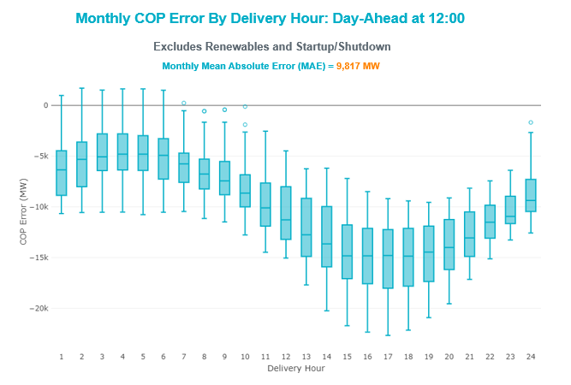

Congestion Analysis

Notable Constraints
Nodal protocol section 3.20 specifies that ERCOT shall identify transmission constraints that are active or binding three or more times within a calendar month. As part of this process, ERCOT reports congestion that meets this criterion to ROS. In addition ERCOT also highlights notable constraints that have an estimated congestion rent exceeding $1,000 for a calendar month. These constraints are detailed in the table below. Rows highlighted in blue indicate the congestion was affected by one or more outages. For a list of all constraints activated in SCED, please see Appendix A at the end of this report.

Contingency Name | Overloaded Element | # of Days Constraint Active | Congestion Rent | Transmission Project
JEWET TO SNG 345 DBLCKT | Btu_Jack_Creek - Twin Oak Switch 345kV | 9 | $17,072,907.31
Loss of NEDIN train | North Edinburg 345kV | 1 | $9,831,038.84
NORTH EDINBURG TRX 1382 345/138 | North Edinburg 345kV | 7 | $9,225,085.27
HCKSW TO SAGNA 138 DBLCKT | Eagle Mountain Ses - Morris Dido 138kV | 8 | $5,961,790.60 | Upgrade the Saginaw - Eagle Mountain 138 kV Double Circuit Line (6273)
Berghe-Kendal 345kv & Welfar-Boerne 138kv | Kendall - Cagnon 345kV | 13 | $5,306,414.56 | Boerne Cico - Comfort - Kendall Transmission Line Upgrade (6982)
Basecase | PNHNDL GTC | 24 | $3,959,785.22 | Panhandle GTC Exit Plan - "PANHANDLE RENEWABLE ENERGY ZONE (PREZ)  STUDY REPORT" on MIS, CONSTRUCT OGALLALA TO BLACKWATER DRAW 345 KV LINE (52245), CONSTRUCT BLACKWATER DRAW TO FOLSOM POINT345 KV LINE (52258), CONSTRUCT BLACKWATER DRAW TO DOUBLE MOUNTAIN (52299), CONSTRUCT DOUBLE MOUNTAIN TO FIDDLEWOOD TO FARMLAND 345 KV L (522307)
CRLNW TO LWSSW 345 DBLCKT | Ti Tnp - West Tnp 138kV | 13 | $3,038,095.25 | Lewisville - Lewisville Jones - Lakepointe 138 kV Line (45537)
ODLAW SWITCHYARD to ASPHALT MINES LIN 1 | Hamilton Road - Maverick 138kV | 24 | $2,405,673.78 | Brackettville to Escondido: Construct 138 kV line (5206)
Basecase | NE_LOB GTC | 22 | $1,938,416.02 | GTC Exit plan in the North Edinburg - Lobo Stability Study Report posted in the ERCOT MIS website
Gila - Highway 9 138KV | Mayo - Gila 138kV | 5 | $1,717,497.85
TWR (345) HLJ-WAP64 & BLY-WAP72 | South Texas Project - Wa Parish 345kV | 5 | $1,500,638.98 | Freeport - Master Plan (6668B)
SALSW TO KLNSW 345 DBLCKT | Killeen Switch 345kV | 4 | $1,057,651.36 | Killeen Sw. Sta. 345/138 kV Autotransformer Replacement (5624)
PAREDES SWITCHING STATION to CENTRAL AVENUE SUB LIN 1 | Rio Hondo - East Rio Hondo Sub 138kV | 24 | $1,054,378.67 | Rebuild Rio Hondo to East Rio Hondo (6687)
GILA to MAYO LIN 1 | Nueces Bay - Whitepoint 138kV | 2 | $1,031,620.55
RIO HONDO to LAS PULGAS LIN 1 | Raymondville 2 138kV | 16 | $961,790.22 | Harlingen SS - Raymondville #2: Convert to 138 kV (6167)
COMANCHE SWITCH (Oncor) to COMANCHE PEAK SES LIN _A | Comanche Tap - Comanche Switch (Oncor) 138kV | 11 | $922,169.43
wett_sand_bluff to wett_bearkat LIN 1 | Carterville - Einstein 138kV | 7 | $787,468.71 | Bearkat Loop - Bearkat to Longshore (45399)
SAN MIGUEL 345_138 KV SWITCHYARDS to LOBO LIN 1 | North Laredo Switch - Piloncillo 138kV | 16 | $616,485.72 | GTC Exit plan in the North Edinburg - Lobo Stability Study Report posted in the ERCOT MIS website
WICHITA FALLS SOUTH SWITCH to NEWPORT BEPC LIN _E | Bowie 138kV | 12 | $449,765.34 | Bowie Autotransformer Replacement (52275)
Basecase | MCCAMY GTC | 18 | $430,135.24 | McCamey GTC Exit Plan posted on the ERCOT MIS website
Basecase | NELRIO GTC | 3 | $307,273.35 | GTC Exit plan in the Nelson Sharpe - Rio Hondo Stability Study Report posted in the ERCOT MIS website
BOSQUE SWITCH to ELM MOTT LIN 1 | Bosque Switch - Rogers Hill Bepc 138kV | 29 | $255,683.34 | Upgrade Elm Mott - Bosque 138 kV Line (52149)
Berghe-Kendal 345kv & Welfar 138kv | Kendall - Cagnon 345kV | 6 | $232,991.30 | Boerne Cico - Comfort - Kendall Transmission Line Upgrade (6982)
LON HILL to NELSON SHARPE LIN 1 | Celanese Bishop - Kleberg Aep 138kV | 7 | $217,620.14
SAN MIGUEL GEN to FOWLERTON LIN 1 | San Miguel Gen 345kV | 5 | $213,362.37 | San Miguel 345/138 kV autotransformer replacements (5218A, 5218B)
TOMBSTONE to Lynx LIN 1 | 16th Street Tnp - Woodward 2 138kV | 8 | $174,752.38 | Solstice: Build 345 kV station (5530) and Solstice to Bakersfield: Build 345 kV line (5539)
GRSES TO PKRSW 345 DBLCKT | Barton Chapel Wind Farm - Oran Sub 138kV | 9 | $113,404.70
Cagnon-Kendal 345 &Cico-Mengcr 138 | Bergheim - Kendall 345kV | 3 | $107,147.76 | Boerne Cico - Comfort - Kendall Transmission Line Upgrade (51953)
AJO to NELSON SHARPE LIN 1 | Las Pulgas - Raymondville 2 138kV | 3 | $105,700.51 | GTC Exit plan in the Raymondville - Rio Hondo Stability Study Report posted in the ERCOT MIS website
Melon Creek to RINCON LIN 1 | Bonnieview - Rincon 69kV | 9 | $79,803.25 | Refugio - Rincon: Upgrade 69 kV Line (6427)
LAQUINTA to LOBO LIN 1 | Bruni Sub 138kV | 6 | $74,516.38
ASHERTON to Bevo Substation LIN 1 | Bevo - Brundage Sub 69kV | 3 | $61,769.23 | Rebuild BEVO to Brundage to Big Wells 69 kV lines. (6255B)
WESTSIDE AEP to HOLLY LIN 1 | Holly - Southside 138kV | 3 | $60,519.66 | Holly - Southside: 138 kV Line Rating Increase (45566)
CISCO to PUTNAM 138kv LIN 1 | Estes - Pecan Bayou 138kV | 7 | $55,402.52
PRICE ROAD SUBSTATION to POWER PLANT SUBSTATION LIN 1 | Silas Ray Power Plant 138kV | 3 | $53,980.41
VICTORIA TRX 69A1 138/69 | Magruder - Victoria 138kV | 5 | $52,458.79 | Port Lavaca - Victoria: Line Rebuild (50876)
FORT MASON to YELLOW JACKET LIN 1 | Yellow Jacket - Hext Lcra 69kV | 12 | $50,470.63 | Heartland to Yellowjacket: Build 69 kV line (3754)
Bighil-Kendal 345kV | Yellow Jacket - Treadwell 138kV | 8 | $45,551.03 | Treadwell GTC Exit Plan posted on the ERCOT MIS website
Elmcreek-Sanmigl 345kV | Pawnee Switching Station - Calaveras 345kV | 3 | $44,062.26
FORT MASON to YELLOW JACKET LIN 1 | Yellow Jacket - Hext Lcra 69kV | 12 | $43,462.78 | Heartland to Yellowjacket: Build 69 kV line (3754)
Basecase | Omega - Horse Hollow Generation Tie 345kV | 3 | $38,449.32
KING MOUNTAIN SWITCHYARD to ODESSA EHV SWITCH LIN 1 | Fort Stockton Plant - Solstice 138kV | 6 | $37,436.57 | Solstice: Build 345 kV station (5530)
CISCO to PUTNAM 138kv LIN 1 | Abilene South - Vinson 138kV | 4 | $36,267.00
Solstice to FORT STOCKTON PLANT LIN 1 | Alpine - Bronco 69kV | 9 | $35,548.60
BRACKETTVILLE to HAMILTON ROAD LIN 1 | Hamilton Road - Maverick 138kV | 12 | $34,526.90 | Brackettville to Escondido: Construct 138 kV line (5206)
FORT MASON to YELLOW JACKET LIN 1 | Mason Switching Station - Hext Lcra 69kV | 9 | $32,702.59 | Mason to North Brady: Rebuild 69 kV line (50900)
LOFTIN to COTTONWOOD ROAD SWITCH LIN 1 | Bowie 138kV | 9 | $32,149.46 | Bowie Autotransformer Replacement (52275)
FORT MASON to YELLOW JACKET LIN 1 | Mason Switching Station - Hext Lcra 69kV | 9 | $29,562.79 | Mason to North Brady: Rebuild 69 kV line (50900)
ALPINE REA to BARRILLA LIN 1 | Alpine - Paisano 69kV | 3 | $26,403.65
BOWIE (Oncor) to BENNETT ROAD SWITCH LIN _A | Bowie 138kV | 4 | $25,072.48 | Bowie Autotransformer Replacement (52275)
COLETO CREEK to VICTORIA LIN 1 | Coleto Creek - Victoria 138kV | 3 | $23,505.66 | Coleto Creek - Rosata: Line Rebuild (50870)
CAGNON to KENDALL LIN 1 | Comfort - Kendall 138kV | 3 | $22,277.15 | Boerne Cico - Comfort - Kendall Transmission Line Upgrade (51953)
LON HILL to NELSON SHARPE LIN 1 | Celanese Bishop - Nelson Sharpe 138kV | 3 | $21,407.37 | GTC Exit plan in the Nelson Sharpe - Rio Hondo Stability Study Report posted in the ERCOT MIS website
Basecase | Randado Aep - Zapata 138kV | 15 | $18,041.82 | Zapata: Add 138 kV Reactor (44393)
FORT LANCASTER to ILLINOIS #4 LIN 1 | Hamilton Road - Maxwell 138kV | 14 | $17,583.18
GILA to HIWAY 9 LIN 1 | Gila - Hiway 9 138kV | 6 | $15,918.23
Cagnon-Kendal 345 & Cico-Comfor 138 | Mason Creek - Bandera 138kV | 3 | $13,017.14
Ferguson-Sherwood Shores & Ferguson-Granite Mountain 138kV | Johnson City - Wirtz 138kV | 3 | $12,966.53 | Wirtz to Johnson City to Mountain Top Rebuild to 138kV (6789)
SAN MIGUEL 345_138 KV SWITCHYARDS to LOBO LIN 1 | Laredo Vft North - Las Cruces 138kV | 4 | $9,022.65 | Laredo - Del Mar: 138 kV Line Rebuild (45511)
MCELMURRAY to ESKOTA SWITCH LIN 1 | Eskota Switch - Longworth 69kV | 5 | $8,129.28 | Scott REA Tap to Eskota 69 kV line: Rebuild 69 kV line (6042)  Wolfgang to Rotan 69 kV line: Rebuild 69 kV line (5970)
CALF CREEK POI to NATURAL DAM LIN _A | Big Spring West - Stanton East 138kV | 6 | $7,130.66
SUN SWITCH to SCURRY SWITCH LIN 1 | Wolfgang - Rotan 69kV | 8 | $4,951.98 | Wolfgang to Rotan 69 kV line: Rebuild 69 kV line (5970)
ODESSA EHV SWITCH to MOSS SWITCH LIN _Z | Trigas Odessa Tap - Odessa Ehv Switch 138kV | 3 | $4,264.14 | Riverton-Odessa EHV/Moss 345 kV Line (5445)
Bighil-Kendal 345kV | Hamilton Road - Maxwell 138kV | 8 | $2,426.37
ASPERMONT AEP to SPUR LIN 1 | Wolfgang - Rotan 69kV | 9 | $2,376.61 | Wolfgang to Rotan 69 kV line: Rebuild 69 kV line (5970)
BENNETT ROAD SWITCH to WISE COUNTY LIN _B | Myra - Valley View Bepc 138kV | 3 | $1,794.95
Pig Creek to Solstice LIN 1 | Fort Stockton Plant - Airport Tnp 138kV | 7 | $1,667.16

Generic Transmission Constraint Congestion
There were 24 days of congestion on the Panhandle GTC, 22 days on the North Edinburg to Lobo GTC, 18 days on the McCamey GTC, 3 days on the Nelson Sharpe to Rio Hondo GTC, and 1 day on the North to Houston GTC. There was no activity on the remaining GTCs during the month.

Note: This is how many times a constraint has been activated to avoid exceeding a GTC limit, it does not imply an exceedance of the GTC occurred or that the GTC was binding.

Manual Overrides
None.

Congestion Costs for Calendar Year 2020
The following table represents the top twenty active constraints for the calendar year based on the estimated congestion rent attributed to the congestion. ERCOT updates this list on a monthly basis.

Contingency | Binding Element | # of 5-min SCED | Estimated | Transmission Project
MOSS SWITCH to ECTOR COUNTY NORTH SWITCHING STATION LIN _A | Dollarhide - No Trees Switch 138kV | 12,277 | 115,237,549.35 | Andrews County South Switch - No Trees Switch 138 kV Line (7171)
WINK to DUNE SWITCH and YUKON | Dollarhide - No Trees Switch 138kV | 10,924 | 76,533,287.97 | Andrews County South Switch - No Trees Switch 138 kV Line (7171)
Manual MDSSW_TRX1_345/138 | Trigas Odessa Tap - Odessa Ehv Switch 138kV | 1,787 | 38,328,997.67 | Riverton-Odessa EHV/Moss 345 kV Line (5445)
Basecase | PNHNDL GTC | 14,455 | 32,222,161.10 | Panhandle GTC Exit Plan - "PANHANDLE RENEWABLE ENERGY ZONE (PREZ)  STUDY REPORT" on MIS
CRLNW TO LWSSW 345 DBLCKT | Ti Tnp - West Tnp 138kV | 7,512 | 27,506,188.55 | Congestion Management Plan # 4 and Stewart Road: Construct 345 kV cut-in (5604)
WINK to DUNE SWITCH and YUKON | Andrews County South - Amoco Three Bar Tap 138kV | 2,002 | 23,188,211.21 | Andrews County South Switch - No Trees Switch 138 kV Line (7171)
MOSS SWITCH to ECTOR COUNTY NORTH SWITCHING STATION LIN _A | Andrews County South - Amoco Three Bar Tap 138kV | 1,316 | 21,247,827.71 | Andrews County South Switch - No Trees Switch 138 kV Line (7171)
JEWET TO SNG 345 DBLCKT | Btu_Jack_Creek - Twin Oak Switch 345kV | 1,193 | 17,477,432.70
POMELO to NORTH EDINBURG LIN 1 | Lobo - Freer 69kV | 7,377 | 10,626,337.75 | GTC Exit plan in the North Edinburg - Lobo Stability Study Report posted in the ERCOT MIS website
CRLNW TO LWSSW 345 DBLCKT | Argyle - Highlands Tnp 138kV | 3,922 | 10,613,392.34 | Lewisville - Lewisville Jones - Lakepointe 138 kV Line (45537)
Loss of NEDIN train | North Edinburg 345kV | 90 | 9,831,038.84
ODLAW SWITCHYARD to ASPHALT MINES LIN 1 | Hamilton Road - Maverick 138kV | 12,209 | 9,356,513.24 | Brackettville to Escondido: Construct 138 kV line (5206)
NORTH EDINBURG TRX 1382 345/138 | North Edinburg 345kV | 503 | 9,225,085.27
ODESSA EHV SWITCH TRX ODEHV_3_1 345/138 | Odessa Ehv Switch 345kV | 558 | 8,111,745.70 | Riverton-Odessa EHV/Moss 345 kV Line (5445)
HCKSW TO SAGNA 138 DBLCKT | Eagle Mountain Ses - Morris Dido 138kV | 821 | 8,092,669.11 | Upgrade the Saginaw - Eagle Mountain 138 kV Double Circuit Line (6273)
BIG SPRING SWITCH to CHALK_69kV and McDonald Road_138kV | Odessa Ehv Switch 345kV | 257 | 7,736,976.71 | Riverton-Odessa EHV/Moss 345 kV Line (5445)
MOSS SWITCH to ECTOR COUNTY NORTH SWITCHING STATION LIN _A | Odessa Ehv Switch - Yarbrough Sub 138kV | 371 | 7,401,498.44 | Riverton-Odessa EHV/Moss 345 kV Line (5445)
MIDESSA SOUTH SW TRX MDSSW_1_1 345/138 | Trigas Odessa Tap - Odessa Ehv Switch 138kV | 1,045 | 7,114,333.10 | Riverton-Odessa EHV/Moss 345 kV Line (5445)
DCRMOD28 Odesa-Mdssw&Glnhv 138 kV | Big Three Odessa Tap - Odessa Ehv Switch 138kV | 435 | 6,442,561.35 | Riverton-Odessa EHV/Moss 345 kV Line (5445)
Basecase | NE_LOB GTC | 8,530 | 6,210,951.97 | GTC Exit plan in the North Edinburg - Lobo Stability Study Report posted in the ERCOT MIS website

System Events

ERCOT Peak Load
The unofficial ERCOT peak load for the month was 64,396 MW and occurred on the 19th, during hour ending 18:00.

Load Shed Events
None.

Stability Events
None.

Notable PMU Events
ERCOT analyzes PMU data for any significant system disturbances that do not fall into the Frequency Events category reported in section 2.1. The results are summarized in this section once the analysis has been completed.

There were no PMU events outside of those reported in section 2.1.

DC Tie Curtailment
There were no DC Tie curtailments.

TRE/DOE Reportable Events
- BPUB submitted an OE-417 for 05/16/2020. Reportable Event Type: Suspicious Activity
- LCRA TO submitted an OE-417 for 05/25/2020. Reportable Event Type: Transmission Loss
- CNP submitted an OE-417 for 05/27/2020. Reportable Event Type: Loss of Electric Service to more than 50,000 customers
- CPS QSE submitted an OE-417 for 05/30/2020. Reportable Event Type: Unplanned Evacuation

New/Modified/Removed RAS
None.

New Procedures/Forms/Operating Bulletins

Procedure Title | POB
Reliability Unit Commitment Desk | 938
Scripts | 939

Emergency Conditions

OCNs
None.

Advisories
Date and Time | Message
May 06 2020 13:30 CPT | ERCOT has postponed the posting of the DAM solution for Operating Day May 07, 2020 due to a delay in clearing DAM.
May 07 2020 13:30 CPT | ERCOT has postponed the posting of the DAM solution for Operating Day May 08, 2020 due to a delay in clearing DAM.
May 13 2020 13:30 CPT | ERCOT has postponed the posting of the DAM solution for Operating Day May 14, 2020 due to a delay in clearing DAM.
May 18 2020 13:30 CPT | ERCOT has postponed the posting of the DAM solution for Operating Day May 19, 2020 due to a delay in clearing DAM.
May 20 2020 13:30 CPT | ERCOT has postponed the posting of the DAM solution for Operating Day May 21, 2020 due to a delay in clearing DAM.

Watches
None.

Emergency Notices
None.

Application Performance

TSAT/VSAT Performance Issues
None.

Communication Issues
None.

Market System Issues
None.

Model Updates
The Downstream Production Change (DPC) process allows ERCOT to make changes in the on-line Network Operations Model without loading a completely new model. The purpose of this process is to allow for reliable grid operations as system conditions change between designated Network Operations Model database loads. The DPC process is limited in scope to just those items listed below, with equipment ratings updates being the most common. ERCOT has seen a rise in the use of the DPC process to make on-line updates to the Network Operations Model in recent years, instead of through the standard Network Operations Model Change Request process.

- Static Line ratings (Interim Update)
- Dynamic Line ratings (non-Interim Update)
- Autotransformer ratings (non-Interim Update)
- Breaker and Switch Normal status (Interim Update)
- Contingency Definitions (Interim Update)
- RAP and RAS changes or additions (Interim Update)
- Net Dependable and Reactive Capability (NDCRC) values (Interim Update)
- Impedance Updates (non-Interim)

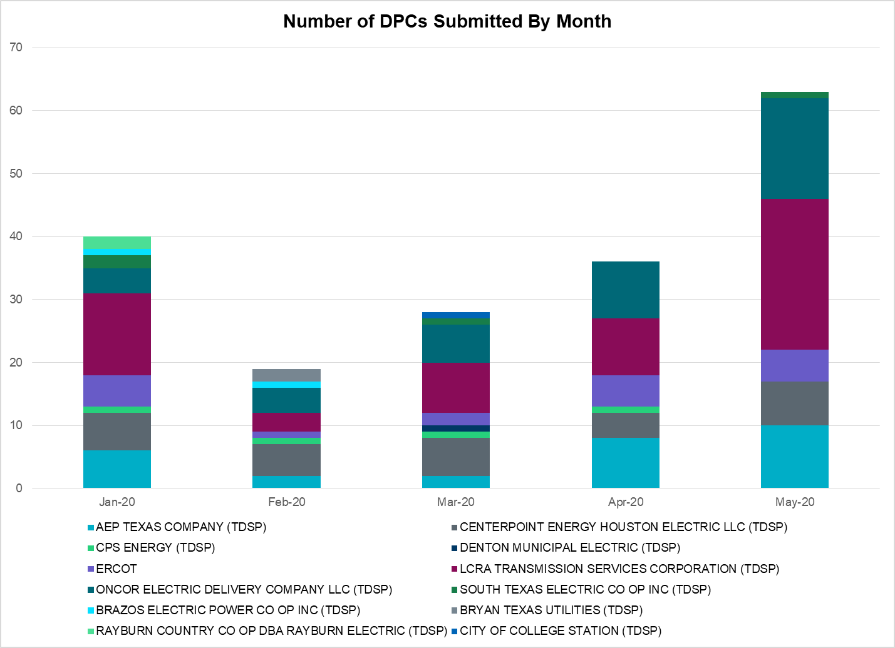

Transmission Operator | Number of DPCs
AEP TEXAS COMPANY (TDSP) | 10
BRAZOS ELECTRIC POWER CO OP INC (TDSP) | 0
BRYAN TEXAS UTILITIES (TDSP) | 0
CENTERPOINT ENERGY HOUSTON ELECTRIC LLC (TDSP) | 7
CITY OF AUSTIN DBA AUSTIN ENERGY (TDSP) | 1
CITY OF COLLEGE STATION (TDSP) | 0
CITY OF GARLAND (TDSP) | 0
CPS ENERGY (TDSP) | 0
DENTON MUNICIPAL ELECTRIC (TDSP) | 0
ELECTRIC TRANSMISSION TEXAS LLC (TDSP) | 0
ERCOT | 5
LCRA TRANSMISSION SERVICES CORPORATION (TDSP) | 24
ONCOR ELECTRIC DELIVERY COMPANY LLC (TDSP) | 16
RAYBURN COUNTRY CO OP DBA RAYBURN ELECTRIC (TDSP) | 0
SHARYLAND UTILITIES LP (TDSP) | 0
SOUTH TEXAS ELECTRIC CO OP INC (TDSP) | 1
TEXAS MUNICIPAL POWER AGENCY (TDSP) | 0
TEXAS-NEW MEXICO POWER CO (TDSP) | 3

Appendix A: Real-Time Constraints
The following is a complete list of constraints activated in SCED. Full contingency descriptions can be found in the Standard Contingencies List located on the MIS secure site at Grid Generation Reliability Unit Commitment.

Contingency Name | Overloaded Element | From Station | To Station | Count of Days
SBOSELM5 | 1030__B | BOSQUESW | RGH | 29
SMV_PAR8 | RIOHND_ERIOHND_1 | MV_RIOHO | RIOHONDO | 25
SMV_PAR8 | RIOHND_ERIOHND_1 | RIOHONDO | MV_RIOHO | 25
SBRAUVA8 | HAMILT_MAVERI1_1 | HAMILTON | MAVERICK | 24
BASE CASE | PNHNDL | n/a | n/a | 24
BASE CASE | NE_LOB | n/a | n/a | 22
BASE CASE | MCCAMY | n/a | n/a | 18
SRAYRI28 | RAYMND2_69A1 | RAYMND2 | RAYMND2 | 16
SLOBSA25 | NLARSW_PILONC1_1 | NLARSW | PILONCIL | 16
BASE CASE | RANDAD_ZAPATA1_1 | ZAPATA | RANDADO | 15
BASE CASE | RANDAD_ZAPATA1_1 | RANDADO | ZAPATA | 15
SILLFTL8 | HAMILT_MAXWEL1_1 | MAXWELL | HAMILTON | 14
DBERBO58 | R5_KENDL_1 | KENDAL | CAGNON | 13
DCRLLSW5 | 588_A_1 | LWSVW | LWVTI | 13
SFORYEL8 | HEXT_YELWJC1_1 | YELWJCKT | HEXT | 12
SBRAHAM8 | HAMILT_MAVERI1_1 | HAMILTON | MAVERICK | 12
SLKAWFS8 | BOW_FMR1 | BOW | BOW | 12
SFORYEL8 | HEXT_YELWJC1_1 | HEXT | YELWJCKT | 12
SCMNCPS5 | 651__B | CMNSW | CMNTP | 11
SMELRIN8 | BONIVI_RINCON1_1 | RINCON | BONIVIEW | 9
SFORYEL8 | HEXT_MASONS1_1 | MASONSW | HEXT | 9
SSPUASP8 | ROTN_WOLFGA1_1 | WOLFGANG | ROTN | 9
DJEWSNG5 | JK_TOKSW_1 | TOKSW | JK_CK | 9
SCRDLOF9 | BOW_FMR1 | BOW | BOW | 9
SSOLFTS8 | ALPINE_BRONCO1_1 | BRONCO | ALPINE | 9
DGRSPKR5 | 6377__A | BRTSW | ORANS | 9
SFORYEL8 | HEXT_MASONS1_1 | HEXT | MASONSW | 9
DBIGKEN5 | HAMILT_MAXWEL1_1 | MAXWELL | HAMILTON | 8
STOMLYN8 | 16TH_WRD2_1 | WOODWRD2 | 16TH_ST | 8
DHCKSAG8 | 6265__A | EMSES | MRSDO | 8
SSCUSU28 | ROTN_WOLFGA1_1 | WOLFGANG | ROTN | 8
SSCUSU28 | ROTN_WOLFGA1_1 | ROTN | WOLFGANG | 8
DBIGKEN5 | TREADW_YELWJC1_1 | TREADWEL | YELWJCKT | 8
SCISPUT8 | ESTES_PECAN_1_1 | PECAN_BY | ESTES | 7
SPIGSOL8 | TNAF_FTS_1 | TNAF | FTST | 7
XNED258 | NEDIN_138H | NEDIN | NEDIN | 7
SN_SLON5 | CELANE_KLEBER1_1 | CELANEBI | KLEBERG | 7
SPIGSOL8 | TNAF_FTS_1 | FTST | TNAF | 7
SW_BW_25 | CRTVLE_EINSTEN_1 | EINSTEIN | CRTRVLLE | 7
SSTABS18 | 6144__A | BSPRW | STASW | 6
SGILNU78 | GILA_HIWAY_1_1 | GILA | HIWAY_9 | 6
SLAQLOB8 | BRUNI_69_1 | BRUNI | BRUNI | 6
DBERWE58 | R5_KENDL_1 | KENDAL | CAGNON | 6
SKINODE5 | FTST_SOLSTI1_1 | FTST | SOLSTICE | 6
MGILHIW8 | GILA_MAYO1_1 | MAYO | GILA | 5
SMCEESK8 | 6780__A | ESKSW | LONGWRTH | 5
MGILHIW8 | GILA_MAYO1_1 | GILA | MAYO | 5
SODLBRA8 | HAMILT_MAVERI1_1 | HAMILTON | MAVERICK | 5
SSANFOW5 | SANMIGL_ATAH | SANMIGL | SANMIGL | 5
DWAPHLJ5 | STPWAP39_1 | STP | WAP | 5
XVI2C89 | MAGRUD_VICTOR2_1 | VICTORIA | MAGRUDER | 5
SALPBAR9 | ALPINE_PAIS1_1 | ALPINE | PAIS | 4
SALPBAR9 | ALPINE_PAIS1_1 | PAIS | ALPINE | 4
SCISPUT8 | SOUTHA_VINSON1_1 | SOUTHABI | VINSON | 4
BASE CASE | FTST_SOLSTI1_1 | FTST | SOLSTICE | 4
DSALKLN5 | KLNSW_MR2H | KLNSW | KLNSW | 4
SBOWBNT9 | BOW_FMR1 | BOW | BOW | 4
SLOBSA25 | LARDVN_LASCRU1_1 | LARDVNTH | LASCRUCE | 4
DCAGCO58 | 583T583_1 | BANDER | MASOCR | 3
MSPUSCK8 | ROTN_WOLFGA1_1 | ROTN | WOLFGANG | 3
BASE CASE | NELRIO | n/a | n/a | 3
DELMSAN5 | PAWNEE_SPRUCE_1 | PAWNEE | CALAVERS | 3
SSILPRI8 | SILASRAY_T1 | SILASRAY | SILASRAY | 3
SBEVASH8 | BEVO_BRUNDAGE_1 | BRUNDGS | BEVO | 3
SBRAUVA8 | GANSO_MAVERI1_1 | MAVERICK | GANSO | 3
BASE CASE | HHGTOM_1 | HHGT | OMEGA | 3
DZORHAY5 | R5_KENDL_1 | KENDAL | CAGNON | 3
SODEMOS5 | 6475__C | ODEHV | TROTP | 3
DCAGCI58 | 656T656_1 | KENDAL | BERGHE | 3
SHOLWES8 | HOLLY4_SOUTH_1_1 | HOLLY4 | SOUTH_SI | 3
SCMNCPS5 | 651__C | CMNTP | SHILO | 3
SCAGKEN5 | 75T243_1 | KENDAL | COMFOR | 3
SN_SLON5 | CELANE_N_SHAR1_1 | N_SHARPE | CELANEBI | 3
SVICCO28 | COLETO_VICTOR2_1 | COLETO | VICTORIA | 3
SBAKBIG5 | FTST_SOLSTI1_1 | FTST | SOLSTICE | 3
SN_SAJO5 | LASPUL_RAYMND1_1 | LASPULGA | RAYMND2 | 3
DFERGRM8 | 1318T313_1 | WIRTZ | JOHNCI | 3
SBTPBNT8 | MYRA_VAL_1 | MYRA | VALYVIEW | 3
MSPUSCK8 | ROTN_WOLFGA1_1 | WOLFGANG | ROTN | 3
XMDS58 | 6475__C | ODEHV | TROTP | 2
XMDL58 | TALLCITY_TELPR_1 | TELPH_RD | TALLCITY | 2
DGIBLIM5 | JK_TOKSW_1 | TOKSW | JK_CK | 2
SPIGSOL8 | LYNX_RIOPEC1_1 | LYNX | RIOPECOS | 2
SMAYWHI8 | NUECES_WHITE_2_1 | WHITE_PT | NUECES_B | 2
SMDOPHR5 | 138_ALV_MNL_1 | ALVIN | MAINLAND | 2
SAVMBSP8 | 6095__D | LMESA | JPPOI | 2
DGRMGRS8 | 6830__B | CRDSW | OLNEY | 2
SN_SLON5 | LOYOLA_69_1 | LOYOLA | LOYOLA | 2
SPIGSOL8 | RIOPEC_WOODW21_1 | WOODWRD2 | RIOPECOS | 2
SMELRIN8 | HEARDT_WOODSB1_1 | WOODSBOR | HEARDTAP | 2
SMDLODE5 | 6475__F | ODESA | ODNTH | 2
SKINFAL8 | FALFUR_PREMON1_1 | FALFUR | PREMONT | 2
SCISPUT8 | POTOSI_VINSON1_1 | VINSON | POTOSI_T | 2
XVLS58 | 565__A | ANASW | MLISA | 2
SWLFMON8 | FTST_SOLSTI1_1 | FTST | SOLSTICE | 2
DWLDSCO5 | LUTHER_VEALMOR_1 | VEALMOOR | LUTHER | 2
SSTAMDL8 | TALLCITY_TELPR_1 | TELPH_RD | TALLCITY | 2
DCAGCO58 | 656T656_1 | KENDAL | BERGHE | 2
SLOBSA25 | ASHERT_CATARI1_1 | ASHERTON | CATARINA | 2
DBONNED5 | BURNS_RIOHONDO_1 | RIOHONDO | MV_BURNS | 2
DB_DAIR8 | B_DAVI_VALADE3_1 | B_DAVIS | VALADEZ | 2
SKLELOY8 | LOYOLA_69_1 | LOYOLA | LOYOLA | 2
DDUPHE18 | I_DUPS_MCCAMP2_1 | I_DUPSW | MCCAMPBE | 2
MWHI58 | NUECES_WHITE_2_1 | WHITE_PT | NUECES_B | 1
SCOLLON5 | VICTO_WARBU_1A_1 | VICTORIA | WARBURTN | 1
DMGSQAL5 | 6095__D | LMESA | JPPOI | 1
SPLDLME8 | 6135__A | GUNSW | GYVLM | 1
DMTSCOS5 | 6437__F | SCRCV | KNAPP | 1
SHAYZO25 | 6T227_1 | HAYSEN | ZORN | 1
SHOLWES8 | ARCADI_SOUTH_1_1 | ARCADIA | SOUTH_SI | 1
DSWECBF5 | BLUF_C_MULBER1_1 | MULBERRY | BLUF_CRK | 1
SNORODE5 | FTST_SOLSTI1_1 | FTST | SOLSTICE | 1
XHHG58 | HHGT_T2H | HHGT | HHGT | 1
SN_SLON5 | HOLLY4_SOUTH_1_1 | HOLLY4 | SOUTH_SI | 1
DSTPRED5 | MRK_VNVL_1 | MRKHMSW | VNVLKSW | 1
DPRSVLS5 | PRSSW_MR1H | PRSSW | PRSSW | 1
SGRICOL5 | VICTO_WARBU_1A_1 | VICTORIA | WARBURTN | 1
XNED358 | WES_MV_W_1 | MV_WESL4 | WESLACO | 1
DJCKWCS5 | 6041__A | GRSES | PKRSW | 1
SDOWMOO8 | DOWNIES_AX1H | DOWNIES | DOWNIES | 1
SREAUVA8 | DOWNIES_AX1H | DOWNIES | DOWNIES | 1
SPOMNED5 | FREER_LOBO1_1 | LOBO | FREER | 1
DMCEBUT8 | LONGWR_ROBY1_1 | LONGWRTH | ROBY | 1
STNWRIO8 | M_69_N1_1 | TNPINION | TNFS | 1
DCC3_NED | NEDIN_138H | NEDIN | NEDIN | 1
BASE CASE | N_TO_H | n/a | n/a | 1
BASE CASE | PAP1LINE_1 | PAP1 | PELICAN | 1
DSCOFAR5 | 6216__B | WLVSW | SHRNE | 1
DGRSLNC5 | 6380__D | PAINTCRE | MURRAY | 1
DMGSMDS5 | 6475__C | ODEHV | TROTP | 1
SKEYWLV8 | 6610__D | BSPSW | BSCTP | 1
SLOBSA25 | BRUNI_69_1 | BRUNI | BRUNI | 1
BASE CASE | CAMWINDTL_1 | CAMWIND | PAREDES | 1
DCBYQNM8 | CBYDKR83_A | CBY | DKR | 1
DLB_GBY8 | HR_NS_91_A | HR | NS | 1
SFLAPIG8 | LYNX_RIOPEC1_1 | LYNX | RIOPECOS | 1
DCAGBRA5 | N5_P4_2_1 | CALAVERS | SKYLINE | 1
SSCLWF28 | NVKSW_FMR1 | NVKSW | NVKSW | 1
DFLCMGS5 | 6095__D | LMESA | JPPOI | 1
DHCKSAG8 | 6260__C | EMSES | RHTP1 | 1
SSCLWF18 | 6840__B | NVKSW | ANARN | 1
SSCLWF28 | 6840__B | NVKSW | ANARN | 1
SRDODES8 | 940__C | ENWSW | WXHCH | 1
DFLAPLU8 | BELLSO_AT2 | BELLSO | BELLSO | 1
DZORHAY5 | BERGHE_AT1L | BERGHE | BERGHE | 1
DBONRIO5 | BURNS_RIOHONDO_1 | RIOHONDO | MV_BURNS | 1
XNED258 | NEDIN_138L | NEDIN | NEDIN | 1
DSTEDES8 | STERT_FMR1 | STERT | STERT | 1
BASE CASE | SWEETWN3_XF31 | SWEETWN3 | SWEETWN3 | 1
DJCKHND5 | 6041__A | GRSES | PKRSW | 1
DJCKHND5 | 6377__A | BRTSW | ORANS | 1
XMOS258 | 6475__C | ODEHV | TROTP | 1
DCPSST58 | 651__C | CMNTP | SHILO | 1
SMOLLOB8 | DEL_MA_LAREDO1_1 | LAREDO | DEL_MAR | 1
SPEAX28 | DOWNIES_AX1H | DOWNIES | DOWNIES | 1
SMELRIN8 | HEARDT_REFUGI1_1 | REFUGIO | HEARDTAP | 1
DHUTHUT5 | HUTTO_MR1H | HUTTO | HUTTO | 1
SKINODE5 | PIGCRE_SOLSTI1_1 | SOLSTICE | PIGCREEK | 1
SMV_MV78 | RIOHND_ERIOHND_1 | MV_RIOHO | RIOHONDO | 1
DCPSJON5 | 152__A | MBDSW | RKCRK | 1
DRILKRW5 | 6085__E | WFSSW | NSTAR | 1
DCPSST58 | 651__B | CMNSW | CMNTP | 1
SSCLWF28 | BBTIE1_1 | BCATWIND | WNDSW | 1
SPOMNED5 | DEL_MA_LAREDO1_1 | LAREDO | DEL_MAR | 1
SN_SLON5 | N_SHARPE_PS3 | N_SHARPE | N_SHARPE | 1
SGRILON5 | VICTO_WARBU_1A_1 | VICTORIA | WARBURTN | 1
SFLCMGS5 | 6095__D | LMESA | JPPOI | 1
DRILBOW5 | 6380__D | PAINTCRE | MURRAY | 1
SRICGRS8 | 6840__B | NVKSW | ANARN | 1
DRILKRW5 | BOW_FMR1 | BOW | BOW | 1
SSIEMOL8 | DEL_MA_LAREDO1_1 | LAREDO | DEL_MAR | 1
UAM2AMI1 | DEL_RI_HAMILT1_1 | HAMILTON | DEL_RIO | 1
SODLBRA8 | GANSO_MAVERI1_1 | MAVERICK | GANSO | 1
SCENLOB5 | GODDAR_PAWNEE1_1 | GODDARD | PAWNEE | 1
BASE CASE | HHGT_400MVAR_1 | HHGT | HHGT | 1
STNWRIO8 | M_69_N1_1 | TNFS | TNPINION | 1
DAUSDUN8 | 211T147_1 | GILLCR | MCNEIL_ | 1
DHILMAR5 | 361T361_1 | SCHERT | PARKWA | 1
SAVMBSP8 | 6610__A | BUZSW | CHATP | 1
DBWNKLN5 | COLETA_COLE_I1_1 | COLE_IVI | COLETAP | 1
SHACPB38 | FTST_SOLSTI1_1 | FTST | SOLSTICE | 1
DLONWAR5 | NCARBI_SEADRF1_1 | SEADRFTC | NCARBIDE | 1

This is the hourly integrated peak demand as published in the ERCOT D&E report.

