PWG Meeting Notes – May 15, 2020
ERCOT Met Center
9:30 AM

Attendees:

Sam Pak – Oncor | Bill Boswell - ERCOT | Karen Malkey - CNP
Sheri Wiegand – TXU | Calvin Opheim - ERCOT | Jim Lee – AEP
Kathy Scott – CNP | Randy Roberts - ERCOT | Carolyn Reed - CNP
Diana Rehfeldt – TNMP | Jordan Troublefield – ERCOT | Eric Blakey – Just
Andrea Couch - TNMP | Mark Ruane - ERCOT | Bill Barnes - NRG
Chris Rowley - Oncor | Ivan Velasquez - Oncor

- Sam Pak read Antitrust Admonition and reviewed the agenda
- PWG meeting minutes from March 2nd were reviewed and approved

- Business Annual Validation Update
  - ERCOT provided an update to the 2020 Business AV Task List Progress
    - TDSPs have until 9/30/20 to submit their 814_20 updates
  - CNP had concerns there may be higher volume of AV counts due to potential conflicts of ERCOT Decision Tree logic and TDSP tariffs in Load Profile assignment
    - It was suggested a follow up on this issue to be discussed at the next PWG meeting

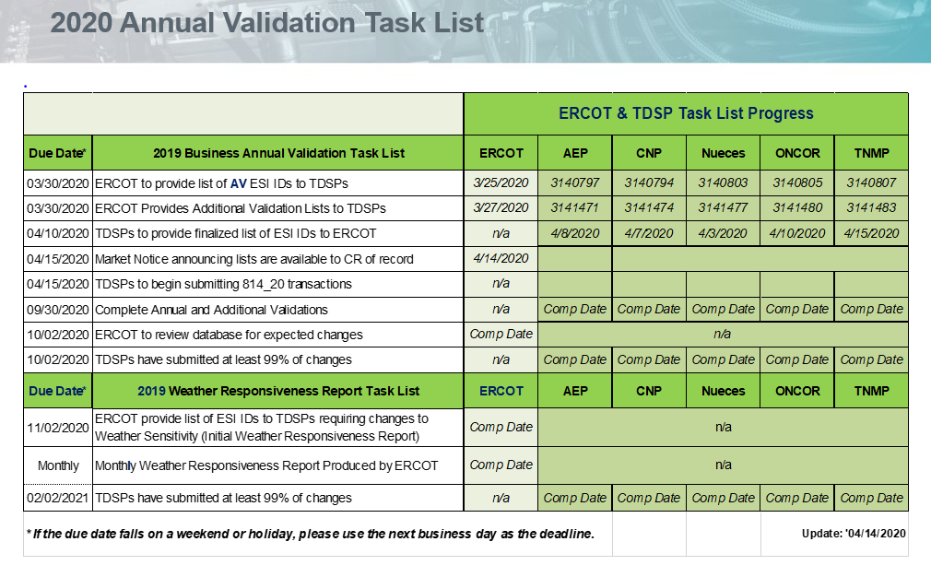

- Status and Implementation of LPGRR067: Profile Decision Tree Revisions
  - ERCOT proposed adding additional inputs of information on the Profile Decision Tree DG Template worksheet
  - ERCOT would also like to propose creating a new “DG Removal” worksheet for TDSPs to utilize when reporting the removal of an Electric Service Identifier (ESI ID) from a DG Profile Type

- Reviewed IDR vs AMS meter matrix
  - In preparation of the June 1st IDR/AMS Workshop, the IDR/AMS Meter Matrix was reviewed and updated
  - Below is the latest version based on June 1st IDR/AMS Workshop:
IDR/AMS Meter Matrix
As of AMS/IDR Workshop June 1, 2020
 |  | Oncor | CNP | AEP | TNMP
Current number of BUSIDRRQ profiles in ERCOT (2/4/20) |  | 7,058 | 4,611 | 1,104 | 352
1 | For premises with demand >700kW/kVa, does the Tariff allow AMS metering in place of IDR metering? | Yes | No | Yes | Yes
2 | Where permissible by Tariff, what meter type is used for premises >700kW/kVa? | Most currently AMS metered | CNP is currently replacing IDR with AMS IDR capable meter. Expected to be completed by year end 2020 with exceptions noted in Question #4 below | AMS | AMS
3 | Where permissible by Tariff, will the TDSP replace traditional IDR Meters with AMS meters? | Yes. Deployment of remaining BUSIDRRQ customers to AMS meters w/in 2yrs | Yes, see above #2 response | Yes | Yes  fully deployed
4 | Example situations where a traditional IDR Meter will remain as the metering asset for premises >700kW/kVA: | Subtractive and EPS meters probably not until 2021; ESIs with RIDs | 4CP Billing; Transmission level, EPS and those with Direct Dedicated Telephone connections | Transmission level; EPS meters; ESIs with RIDs | EPS; Customer Owned Transformer Sites, Billing on Secondary Side of Transformer Sites
5 | Are pulse outputs available with AMS meters? | Yes | Yes | Yes | No; Pulses require IDR
For NEW premises where demand is >700kW/kVa and an AMS meter may be installed:
6 | What determines 4CP billing for NEW premises once historical data is available? | Demand of 700kW or greater | Demand of 700kVa or greater | Demand of 700kW or greater | Demand of  700kW or greater
7 | Will the TDSPs install an IDR or AMS meter at a new premise where demand is >700kW/kVa? | AMS | IDR capable meter | AMS | AMS
8 | What will the TDSP assign as the default load profile? | Currently will assign BUSIDRRQ, but is agreeable to assign other profile if Protocols are revised | BUSIDRRQ | BUSIDRRQ (Assigns Load Profile according to Profile Decision Tree) | BUSIDRRQ
9 | Does the customer have the option to establish an AMS meter with a BUS profile, other than BUSIDRRQ, if expected to exceed 700 kW/kVa? | Yes | Yes | Yes | Yes
For EXISTING premises where demand is >700kW/kVa and an AMS meter may be installed:
10 | What determines 4CP billing for EXISTING premises? | 700kW or greater; Or billed on 4CP prior to 11/27/17 | 700kVa or greater in any previous billing month | 700kW or greater in any previous billing month | 700kW or greater; Or billed on 4CP prior to 1/1/19
11 | For premises grandfathered on the BUSIDRRQ profile w/ demand less than 700 kW/kVa: Does the Customer have the option to establish an AMS meter with a BUS profile, other than BUSIDRRQ, and remain on 4CP billing? | Yes | No | Yes | No
12 | If the profile changes from BUSIDRRQ to another BUS profile, does the TDSP Rate change? | Profiles are independent of TDSP rate code | Profiles are independent of TDSP rate code | Profiles are independent of TDSP rate code | Profiles are independent of TDSP rate code
13 | If the demand is >700kW/kVa, with an assigned BUSHI/MED/LO profile, and a MVO is completed: Will the load profile change upon completion of a MVI from another CR/Customer?  If a premise has exceeded the 700kW/kVa threshold and requested to remain on a BUSHI/MED/LO profile and a MVO is issued, will the premise return to a BUSIDRRQ profile upon the MVI of another customer? | Will remain the same Load Profile that was previously assigned to the MVO Customer of either BUSHI/MED/LO until Annual Validation | Will remain the same Load Profile that was previously assigned to the MVO Customer of either BUSHI/MED/LO until Annual Validation | Will remain the same Load Profile that was previously assigned to the MVO Customer of either BUSHI/MED/LO until Annual Validation | Will remain the same Load Profile that was previously assigned to the MVO Customer of either BUSHI/MED/LO until Annual Validation

- ERCOT Proposal for BUSIDRRQ to AMS Process
  - ERCOT proposed adding a new PROFILETYPECODE (BUSLRG) to be used for > 700 kW/kVA premises where the TDSP can support a 4CP billing rate with an AMS profile

- Changes to TDSP Read Generation Metering Registration Form per NPRR866
  - For efficiency purposes, AEP suggested among the TDSPs to add additional Transmission level information on the TDSP Read Generation Registration Form.
    - Gained support from Oncor and TNMP. Jim Lee will follow up with CNP.

- PWG leadership will be following up with a June meeting date.

