System Planning
Monthly Status Report

Report Highlights

- ERCOT is currently reviewing proposed transmission improvements with a total estimated cost of $1,314.67 Million as of May 31, 2020.
- Transmission Projects endorsed in 2020 total $319.10 Million as of May 31, 2020.
- All projects (in engineering, routing, licensing and construction) total approximately $7.45 Billion as of February 1, 2020.
- Transmission Projects energized in 2020 total about $122 Million as of February 1, 2020.

Regional Planning Group Reviews
- AEPSC has submitted the LRGV Import Project. This is a Tier 1 project that is estimated to cost $73.4 million. AEPSC has also requested that ERCOT provide a conditional endorsement for an additional $357.2 million project. The ERCOT Independent Review has been conducted in accordance with Protocol Section 3.11.4.9(3), and this project is currently placed on hold until the LNG loads are confirmed.
- STEC has submitted the Lower Rio Grande Valley Transmission Expansion Project. This is a Tier 1 project that is estimated to cost $511 million. The ERCOT Independent Review has been conducted in accordance with Protocol Section 3.11.4.9(3), and this project is currently placed on hold until the LNG loads are confirmed.
- AEPSC has submitted the Corpus North Shore Project. This is a Tier 1 project that is estimated to cost $259.57 million. ERCOT has completed the independent review on May 19, and an alternate project was recommended for BOD endorsement. TAC voted unanimously to endorse the project on May 27. ERCOT will present the recommendation for BOD endorsement on June 9.
- 7x Energy has submitted the Frio County Transmission Project. This is a Tier 2 project that is estimated to cost $23 million. ERCOT has completed the independent review on May 21, and an alternate project was recommended. ERCOT will issue an ERCOT endorsement letter.
- GP&L has submitted the Farmersville Area Reliability Project. This is a Tier 2 project that is estimated to cost $24.37 million. ERCOT has completed the independent review on May 21. In accordance with Protocol Section 3.11.4.9(4), ERCOT will not endorse this project as it is needed solely to meet a TSP’s criteria.
- GP&L has submitted the Lookout Substation SVC Project. This is a Tier 3 project that is estimated to cost $25 million. This project completed the RPG review on May 11, and ERCOT has issued the acceptance letter.
- TNMP has submitted the Texas City Transmission Improvement Project. This is a Tier 2 project that is estimated to cost $29.3 million. This project is currently under ERCOT Independent Review.
- Oncor has submitted the DeCordova Switching Station Rebuild Project. This is a Tier 3 project that is estimated to cost $37.5 million. This project completed the RPG review on May 29, and ERCOT will issue an acceptance letter.
- BEC has submitted the Moffat to Hasse Voltage Conversion Project. This is a Tier 2 project that is estimated to cost $55.2 million. This project is currently in the RPG comment period.
- Oncor has submitted the Quarry Field 345-kV Switch Project. This is a Tier 3 project that is estimated to cost $29 million. This project is currently in the RPG comment period.
More information on current and past RPG projects can be found on the ERCOT MIS Secure (digital certificate required): https://mis.ercot.com/pps/tibco/mis/Pages/Grid+Information/RegionalPlanning
Past email communication on RPG projects can be found on the ERCOT listserve by signing up for the REGPLANGROUP list: http://lists.ercot.com/scripts/wa-ERCOT.exe?A0=REGPLANGROUP

Planning Model Activities
The short-term calendar of major planning model events is as follows:
- By July 1, 2020 20SSWG cases and TPIT are posted
- By July 20, 2020 Post 20SSWG Contingency definitions and Planning Data Dictionary
The following table shows interconnection projects that met Planning Guide section 6.9(1) and 6.9(2) and were modeled in the SSWG cases as a full model or as a simple model in accordance with Planning Guide section 6.9.
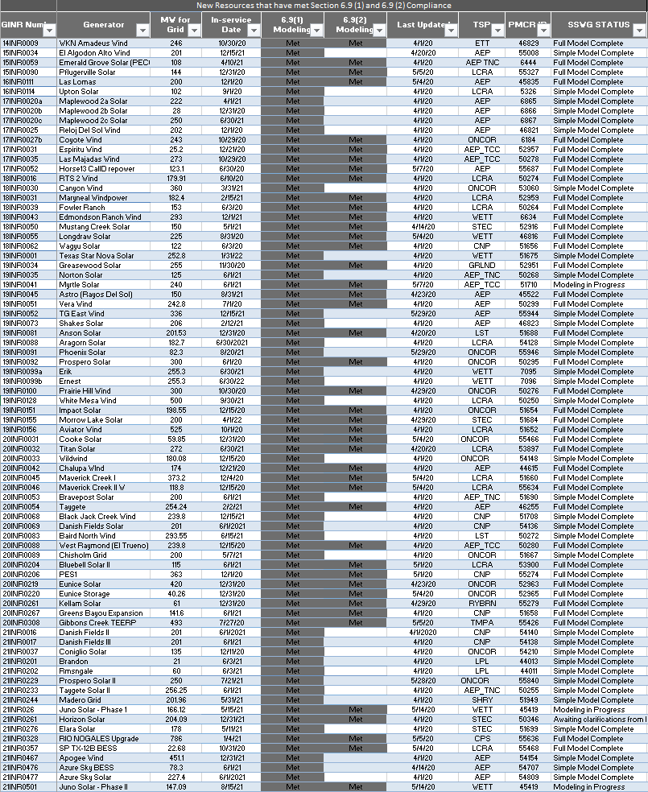

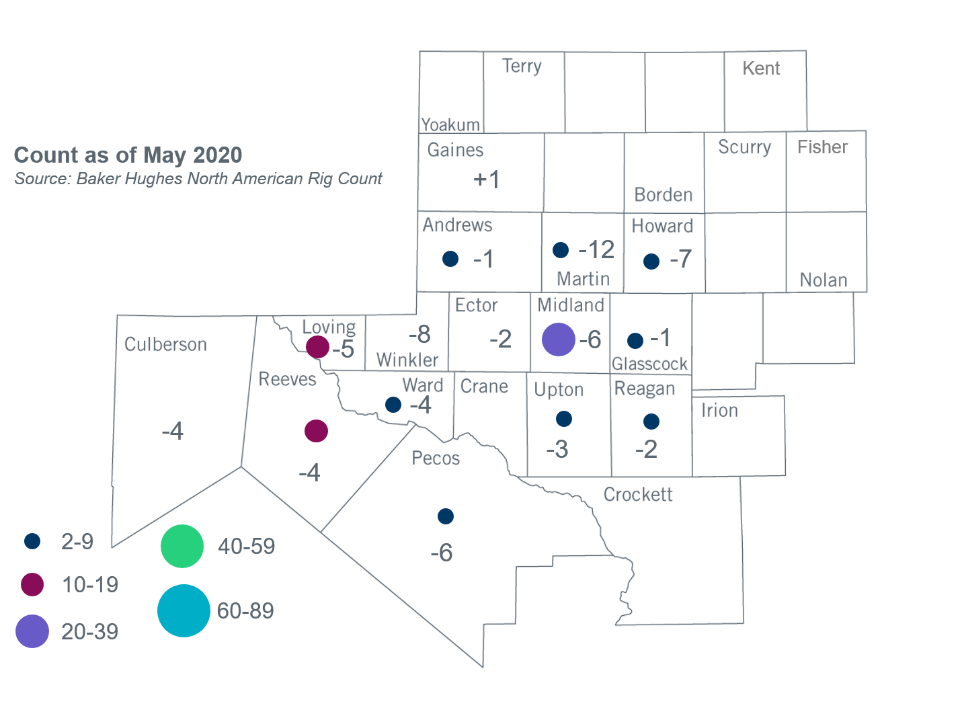
Permian Basin Oil Rig Count
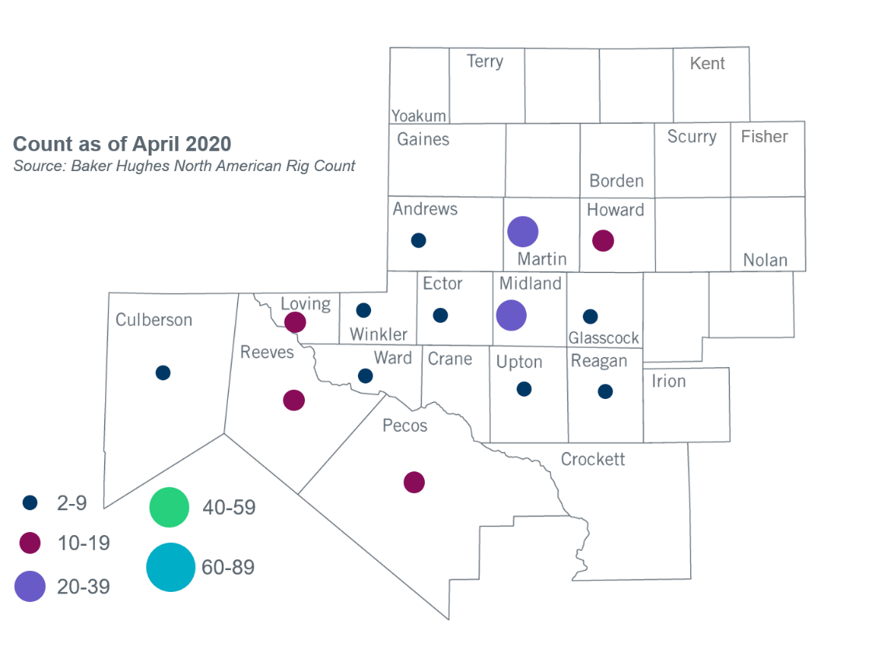

Other Notable Activities
- The SPWG completed and posted the 2020 CY base case on March 27, 2020.
- The SPWG has begun building the 2020 FY cases.
- ERCOT is performing stability analysis for Panhandle and West Texas exports and plans to finalize the analysis in June.
- Initial reliability cases and N-1 results for the 2020 Regional Transmission Plan (RTP) were posted to MIS Secure on May 13, 2020.
- ERCOT presented an update on the 2020 Long-Term System Assessment (LTSA) to the Regional Planning Group (RPG) in May.
- ERCOT presented preliminary analysis of steady-state voltage performance for the benchmark Geomagnetic Disturbance Vulnerability Assessment (GMDVA) to the RPG in May.
- ERCOT presented information and a proposal for assumptions for including Battery Energy Storage Systems (BESS) in transmission planning studies to the RPG in May. The assumptions included in the presentation are related to BEST KTC 10, Item 5. The presentation will be provided again at the June PLWG meeting.
- The DWG completed and posted the 2020 Flat Start cases on May 15, 2020.
- ERCOT completed and posted the 2020 Subsynchronous Resonance (SSR) Annual Report on May 27, 2020.

+/- symbol indicates the increase or decrease from the previous month in oil rigs present in each county. There are 87 rigs, including a total decrease of 65 oil rigs, in the Permian Basin from April to May 2020.

