April 2020 ERCOT Monthly Operations Report
Reliability and Operations Subcommittee Meeting
June 4, 2020

Table of Contents
1. Report Highlights 2
2. Frequency Control 3
2.1. Frequency Events 3
2.2. Responsive Reserve Events 4
2.3. Load Resource Events 4
3. Reliability Unit Commitment 4
4. Wind Generation as a Percent of Load 5
5. Largest Net-Load Ramp 5
6. COP Error Analysis 6
7. Congestion Analysis 8
7.1. Notable Constraints 8
7.2. Generic Transmission Constraint Congestion 12
7.3. Manual Overrides 12
7.4. Congestion Costs for Calendar Year 2020 12
8. System Events 14
8.1. ERCOT Peak Load 14
8.2. Load Shed Events 14
8.3. Stability Events 14
8.4. Notable PMU Events 14
8.5. DC Tie Curtailment 14
8.6. TRE/DOE Reportable Events 14
8.7. New/Modified/Removed RAS 14
8.8. New Procedures/Forms/Operating Bulletins 14
9. Emergency Conditions 15
9.1. OCNs 15
9.2. Advisories 15
9.3. Watches 15
9.4. Emergency Notices 15
10. Application Performance 15
10.1. TSAT/VSAT Performance Issues 15
10.2. Communication Issues 15
10.3. Market System Issues 16
11. Model Updates 16
Appendix A: Real-Time Constraints 18

Report Highlights
- The unofficial ERCOT peak was 55,247 MW.
- There were 4 frequency events.
- There were 2 instances where Responsive Reserves were deployed.
- There were 0 RUC commitments.
- Congestion in the Panhandle Area can mostly be attributed to high wind generation. Congestion in the Far West Area can mostly be attributed to low conventional and renewable generation while experiencing high loads and planned outages. Congestion in the South, North, and Houston LZs were mostly due to planned outages. There were 25 days of congestion on the Panhandle GTC, 14 days on the North Edinburg to Lobo GTC, 11 days on the McCamey GTC, 11 days on the Tredwell GTC, 4 days on Raymondville to Rio Hondo, 2 days on the North to Houston, 2 days on the Nelson Sharpe to Rio Hondo GTC, and 1 day on the East Texas GTC. There was no activity on the remaining GTCs during the month.
- There were 0 DC Tie curtailments.

Frequency Control

Frequency Events
The ERCOT Interconnection experienced four frequency events, which resulted from units’ trip. The average event duration was 00:05:17.

A summary of the frequency events is provided below. The reported frequency events meet one of the following criteria: Delta Frequency is 60 mHz or greater; the MW loss is 350 MW or greater; resource trip event triggered RRS deployment. Frequency events that have been identified as Frequency Measurable Events (FME) for purposes of BAL-001-TRE-1 analysis are highlighted in blue. When analyzing frequency events, ERCOT evaluates PMU data according to industry standards. Events with an oscillating frequency of less than 1 Hz are considered to be inter-area, while higher frequencies indicate local events. Industry standards specify that damping ratio for inter-area oscillations should be 3.0% or greater. For the frequency events listed below, the ERCOT system met these standards and transitioned well after each disturbance.

Date and Time | Delta Frequency | Max/Min Frequency | Duration of Event | PMU Data |  | MW Loss | Load | Wind | Inertia
 | (Hz) | (Hz) |  | Oscillation Mode (Hz) | Damping Ratio |  | (MW) | % | (GW-s)
4/8/2020 15:37 | 0.059 | 59.909 | 0:05:39 | 0.66 | 7% | 352.65 | 54,216 | 11% | 283,884
4/22/2020 12:44 | 0.073 | 59.902 | 0:05:29 | 0.99 | 13% | 320.85 | 42,810 | 33% | 206,475
4/28/2020 17:48 | 0.083 | 59.932 | 0:07:10 | 0.68 | 10% | 331.93 | 53,059 | 20% | 253,320
4/30/2020 21:56 | 0.078 | 59.911 | 0:02:48 | 0.73 | 9% | 396.82 | 41,159 | 46% | 204,387
(Note: All data on this graph encompasses frequency event analysis based on BAL-001-TRE-1.)

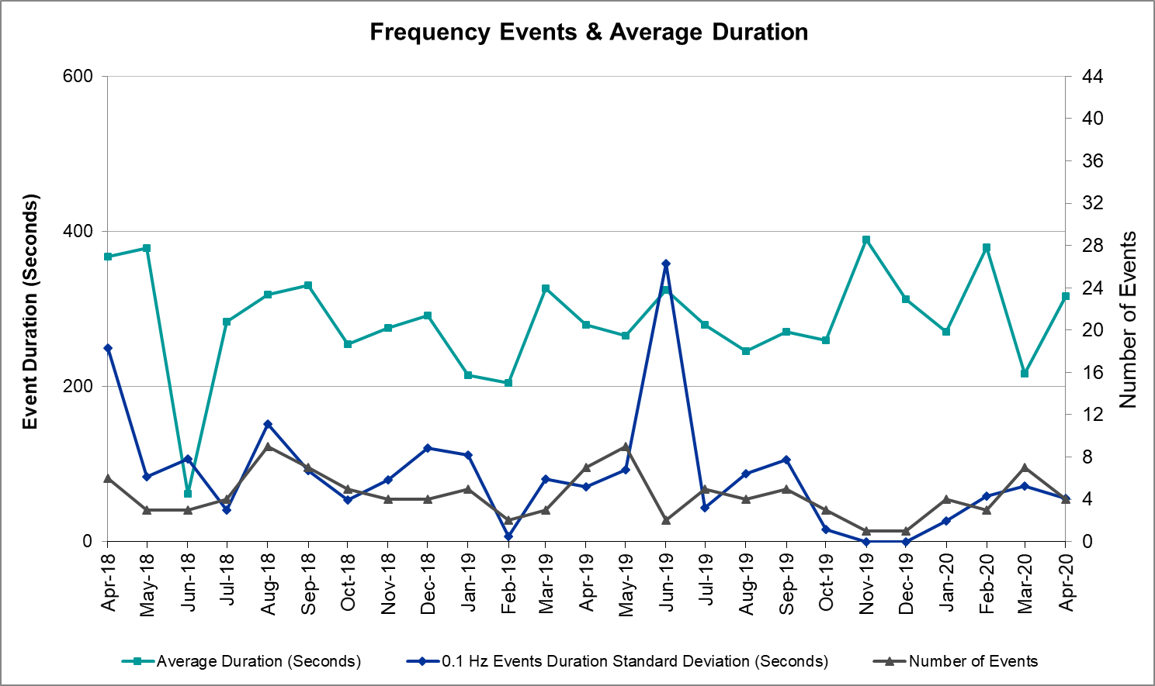
Note that the large standard deviation in June 2019 is due to coincidental extreme high and low durations for a small set of events (2).

Responsive Reserve Events
There were 2 events where Responsive Reserve MWs were released to SCED. The events highlighted in blue were related to frequency events reported in Section 2.1 above.

Date and Time Released to SCED | Date and Time Recalled | Duration of Event | Maximum MWs Released | Comments
4/8/2020 15:37 | 4/8/2020 15:42 | 0:05:39 | 635
4/22/2020 12:44 | 4/22/2020 12:49 | 0:05:29 | 679

Load Resource Events
No Load Resource Events.

Reliability Unit Commitment
ERCOT reports on Reliability Unit Commitments (RUC) on a monthly basis. Commitments are reported grouped by operating day and weather zone. The total number of hours committed is the sum of the hours for all the units in the specified region. Additional information on RUC commitments can be found on the MIS secure site at Grid Generation Reliability Unit Commitment.

There were no DRUC commitments.

There were no HRUC commitments.

Wind Generation as a Percent of Load

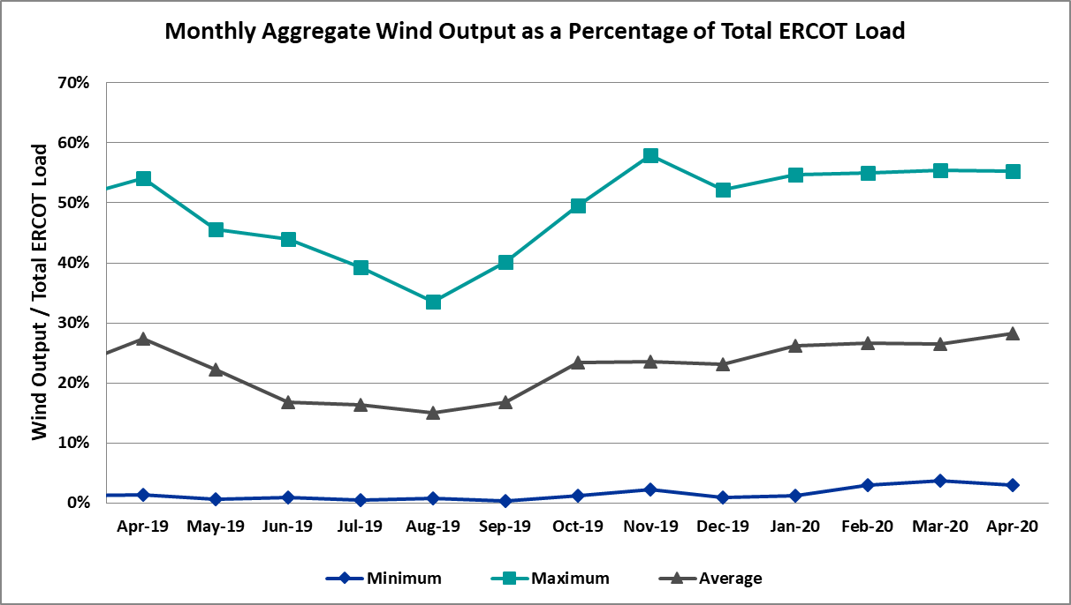

Wind Generation Record: 20,066 MW on 01/08/2020 at 22:18
Wind Penetration Record: 57.88% on 11/26/2019 03:52

Largest Net-Load Ramp
The net-load ramp is defined as the change in net-load (load minus wind and PVGR generation) during the defined time horizon. Such a variation in net-load needs to be accommodated in grid operations to ensure that the reliability of the grid is satisfactorily maintained. The largest net-load ramp during 5-min, 10-min, 15-min, 30-min and 60-min in Apr 2020 is 1189 MW, 1655 MW, 1578 MW, 2773 MW, and 4948 MW, respectively. The comparison with respect to the historical values is given in the table below.

Month and Year | 5 min | 10 min | 15 min | 30 min | 60 min
Apr 2020 | 1189 MW | 1655 MW | 1578 MW | 2773 MW | 4948 MW
Apr 2014 | 796 MW | 1358 MW | 1868 MW | 3445 MW | 6274 MW
Apr 2015 | 835 MW | 1482 MW | 1985 MW | 3216 MW | 5330 MW
Apr 2016 | 1183 MW | 1666 MW | 2394 MW | 3804 MW | 5101 MW
Apr 2017 | 914 MW | 1492 MW | 2315 MW | 3779 MW | 6385 MW
Apr 2018 | 947 MW | 1366 MW | 1710 MW | 3303 MW | 5030 MW
Apr 2019 | 1147 MW | 1778 MW | 1866 MW | 2866 MW | 4856 MW
2014-2019 | 1494 MW | 1991 MW | 2780 MW | 4109 MW | 7786 MW

COP Error Analysis
COP Error is calculated as the capacity difference between the COP HSL and real-time HSL of the unit. Mean Absolute Error (MAE) stayed high over 7,000 MW until Day-Ahead at 13:00, then dropped significantly to 1,760 MW by Day-Ahead at 14:00. In the following chart, Under-Scheduling Error indicates that COP had less generation capacity than real-time and Over-Scheduling Error indicates that COP had more generation capacity than real-time. Under-Scheduling persisted from beginning of Day-Ahead to end of the Operating Day.

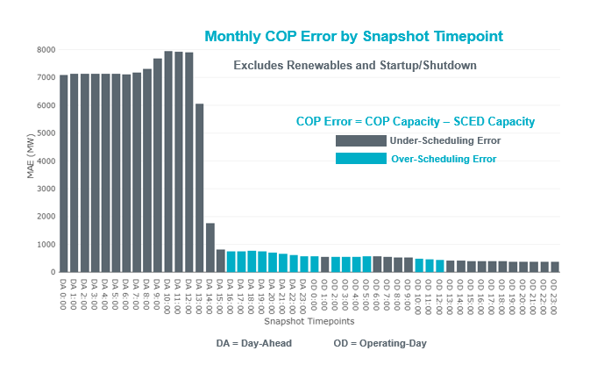

Monthly MAE for the Latest COP at the end of the Adjustment Period was 368 MW with median ranging from -246 MW for Hour-Ending (HE) 21 to 104 MW for HE 13. HE 13 on the 24th had the largest Over-Scheduling Error (1,735 MW) and HE 17 on the 27th had the largest Under-Scheduling Error (-2,936 MW).
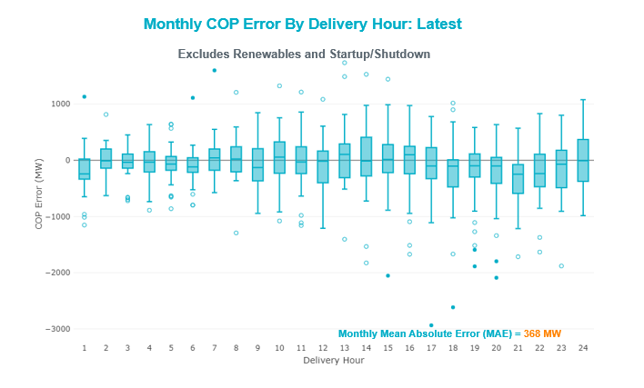

Monthly MAE for the Day-Ahead COP at 12:00 was 7,895 MW with median ranging from -10,822 MW for Hour-Ending (HE) 18 to -5,063 MW for HE 3. HE 15 on the 9th had the largest Under-Scheduling Error (-19,114 MW) and HE 5 on the 19th had the largest Over-Scheduling Error (+2,135 MW).

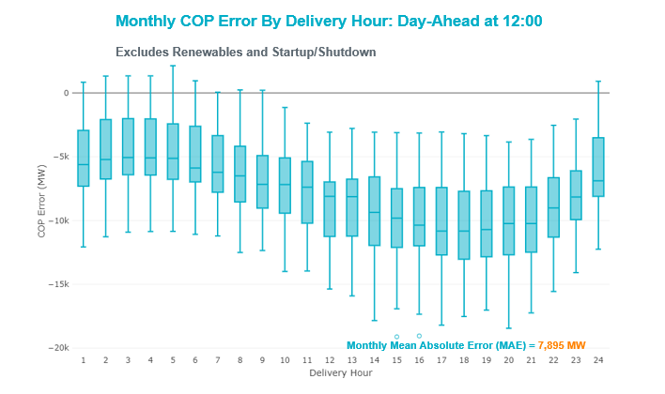

Congestion Analysis

Notable Constraints
Nodal protocol section 3.20 specifies that ERCOT shall identify transmission constraints that are active or binding three or more times within a calendar month. As part of this process, ERCOT reports congestion that meets this criterion to ROS. In addition ERCOT also highlights notable constraints that have an estimated congestion rent exceeding $1,000 for a calendar month. These constraints are detailed in the table below. Rows highlighted in blue indicate the congestion was affected by one or more outages. For a list of all constraints activated in SCED, please see Appendix A at the end of this report.

Contingency Name | Overloaded Element | # of Days Constraint Active | Congestion Rent | Transmission Project
CRLNW TO LWSSW 345 DBLCKT | Ti Tnp - West Tnp 138kV | 19 | $8,413,409.78 | Lewisville - Lewisville Jones - Lakepointe 138 kV Line (45537)
Basecase | PNHNDL GTC | 25 | $4,531,729.31 | Panhandle GTC Exit Plan - "PANHANDLE RENEWABLE ENERGY ZONE (PREZ)  STUDY REPORT" on MIS, CONSTRUCT OGALLALA TO BLACKWATER DRAW 345 KV LINE (52245), CONSTRUCT BLACKWATER DRAW TO FOLSOM POINT345 KV LINE (52258), CONSTRUCT BLACKWATER DRAW TO DOUBLE MOUNTAIN (52299), CONSTRUCT DOUBLE MOUNTAIN TO FIDDLEWOOD TO FARMLAND 345 KV L (522307)
Hillctry-Marion 345kV | Cibolo - Schertz 138kV | 2 | $2,182,615.68 | Cibolo Substation, T3 transformer addition (3505)  Cibolo to McQueeney Transmission Line (51736)
Basecase | EASTEX GTC | 1 | $1,839,604.88 | East Texas GTC Exit Plan posted on the ERCOT MIS website
ODLAW SWITCHYARD to ASPHALT MINES LIN 1 | Hamilton Road - Maverick 138kV | 24 | $1,834,456.41 | Brackettville to Escondido: Construct 138 kV line (5206)
Hutto-Zorn & Gillcr 345kV | Hutto Switch 345kV | 9 | $1,615,462.90 | Hutto Switch second 345/138 kV autotransformer (4829)
SAN MIGUEL 345_138 KV SWITCHYARDS to LOBO LIN 1 | Laredo Vft North - Las Cruces 138kV | 6 | $1,435,564.36 | Laredo - Del Mar: 138 kV Line Rebuild (45511)
VICTORIA TRX 69A2 138/69 | Magruder - Victoria 138kV | 2 | $1,385,399.78
GAS PAD to FLAT TOP TNP LIN 1 | Fort Stockton Plant - Solstice 138kV | 2 | $1,351,621.74 | Solstice: Build 345 kV station (5530)
SAN MIGUEL 345_138 KV SWITCHYARDS to LOBO LIN 1 | North Laredo Switch - Piloncillo 138kV | 13 | $1,270,214.39 | GTC Exit plan in the North Edinburg - Lobo Stability Study Report posted in the ERCOT MIS website
HCKSW TO SAGNA 138 DBLCKT | Eagle Mountain Ses - Rosen Heights Tap 1 138kV | 1 | $1,258,300.23
SALSW TO KLNSW 345 DBLCKT | Killeen Switch 345kV | 7 | $1,226,389.87 | Killeen Sw. Sta. 345/138 kV Autotransformer Replacement (5624)
Rns-Rtw & Sng-Tb 345kV | Th Wharton - Zenith 345kV | 2 | $1,143,173.79
MOSS SWITCH to ECTOR COUNTY NORTH SWITCHING STATION LIN _A | Dollarhide - No Trees Switch 138kV | 2 | $1,099,868.66 | Andrews County South Switch - No Trees Switch 138 kV Line (7171)
WINK to DUNE SWITCH and YUKON | Dollarhide - No Trees Switch 138kV | 2 | $1,034,593.05 | Andrews County South Switch - No Trees Switch 138 kV Line (7171)
BOSQUE SWITCH to ELM MOTT LIN 1 | Bosque Switch - Rogers Hill Bepc 138kV | 25 | $1,033,804.21
KING MOUNTAIN SWITCHYARD to ODESSA EHV SWITCH LIN 1 | Fort Stockton Plant - Solstice 138kV | 16 | $971,298.53 | Solstice: Build 345 kV station (5530)
LCRANE TO KINGMO AND CASTIL 138 KV | Rio Pecos - Crane Lcra 138kV | 14 | $893,044.62
ODESSA EHV SWITCH to MOSS SWITCH LIN _A | Odessa Ehv Switch - Yarbrough Sub 138kV | 5 | $865,198.13 | Riverton-Odessa EHV/Moss 345 kV Line (5445)
HAYS ENERGY to KENDALL LIN 1 | Kendall - Cagnon 345kV | 6 | $815,136.80 | Boerne Cico - Comfort - Kendall Transmission Line Upgrade (6982)
EVERMAN SWITCH to VENUS SWITCH LIN _A | Everman Switch - Venus Switch 345kV | 10 | $654,431.47 | Everman - Venus 345 kV Double-circuit line (5310)
DMTSW TO SCOSW 345 DBLCKT | Knapp - Scurry Chevron 138kV | 9 | $617,527.89 | Ennis Creek - Cogdell 69 kV Line (4554) & Ennis Creek 138 kV Switching Station (6269)
SALSW TO KLNSW 345 DBLCKT | Harker Heights South - Killeen Switch 138kV | 4 | $561,059.85
COMANCHE SWITCH (Oncor) to COMANCHE PEAK SES LIN _A | Comanche Tap - Comanche Switch (Oncor) 138kV | 11 | $496,261.96
ZORN - HAYSEN 345KV | Kendall - Cagnon 345kV | 10 | $462,657.61 | Boerne Cico - Comfort - Kendall Transmission Line Upgrade (6982)
WICHITA FALLS SOUTH SWITCH to NEWPORT BEPC LIN _E | Bowie 138kV | 15 | $461,439.37 | Bowie Autotransformer Replacement (52275)
ASHERTON to Bevo Substation LIN 1 | Bevo - Brundage Sub 69kV | 6 | $433,802.83 | Rebuild BEVO to Brundage to Big Wells 69 kV lines. (6255B)
Basecase | NE_LOB GTC | 14 | $414,951.37 | GTC Exit plan in the North Edinburg - Lobo Stability Study Report posted in the ERCOT MIS website
Gideon-Bastwe&Redroc 138kV | Butler Lcra - Sim Gideon 138kV | 5 | $408,853.85
JEWET TO SNG 345 DBLCKT | Btu_Jack_Creek - Twin Oak Switch 345kV | 4 | $398,619.17
SAN MIGUEL 345_138 KV SWITCHYARDS to PAWNEE SWITCHING STATION LIN 1 | Pawnee Switching Station 345kV | 8 | $394,927.47
PAREDES SWITCHING STATION to CENTRAL AVENUE SUB LIN 1 | Rio Hondo - East Rio Hondo Sub 138kV | 21 | $366,152.37 | Rebuild Rio Hondo to East Rio Hondo (6687)
Gila - Highway 9 138KV | Mayo - Gila 138kV | 4 | $302,406.64
Austro-Daffin&Dunlap-Decker 138kV | Gilleland Creek - Mcneil 138kV | 4 | $293,088.10
Melon Creek to RINCON LIN 1 | Bonnieview - Rincon 69kV | 11 | $245,715.42 | Refugio - Rincon: Upgrade 69 kV Line (6427)
Berghe-Kendal 345kv & Welfar-Boerne 138kv | Kendall - Cagnon 345kV | 6 | $207,497.81 | Boerne Cico - Comfort - Kendall Transmission Line Upgrade (6982)
RIO HONDO to LAS PULGAS LIN 1 | Raymondville 2 138kV | 11 | $204,210.80 | Harlingen SS - Raymondville #2: Convert to 138 kV (6167)
Bighil-Kendal 345kV | Yellow Jacket - Treadwell 138kV | 9 | $186,952.62 | Treadwell GTC Exit Plan posted on the ERCOT MIS website
Solstice to FORT STOCKTON PLANT LIN 1 | Alpine - Bronco 69kV | 23 | $184,156.77
Basecase | MCCAMY GTC | 11 | $179,332.35 | McCamey GTC Exit Plan posted on the ERCOT MIS website
FORT MASON to YELLOW JACKET LIN 1 | Yellow Jacket - Hext Lcra 69kV | 14 | $158,242.96 | Heartland to Yellowjacket: Build 69 kV line (3754)
KING MOUNTAIN SWITCHYARD to ODESSA EHV SWITCH LIN 1 | Pig Creek - Solstice 138kV | 12 | $140,284.76 | Solstice: Build 345 kV station (5530)
POMELO to NORTH EDINBURG LIN 1 | Lobo - Freer 69kV | 3 | $135,077.91 | GTC Exit plan in the North Edinburg - Lobo Stability Study Report posted on the ERCOT MIS website
Elmcreek-Sanmigl 345kV | Pettus - Normanna 69kV | 3 | $131,055.81
Berghe-Kendal 345kv & Welfar-Boerne 138kv | Kerrville Stadium - Verde Creek 138kV | 3 | $112,847.15
Ferguson-Sherwood Shores & Ferguson-Granite Mountain 138kV | Johnson City - Wirtz 138kV | 8 | $96,940.13 | Wirtz to Johnson City to Mountain Top Rebuild to 138kV (6789)
TOMBSTONE to Lynx LIN 1 | 16th Street Tnp - Woodward 2 138kV | 10 | $90,999.97 | Solstice: Build 345 kV station (5530) and Solstice to Bakersfield: Build 345 kV line (5539)
Elmcreek-Sanmigl 345kV | Poteet Sub - Oaks Sub 69kV | 3 | $88,061.23
W_CW_345-DMTSW 345kV | Liberty Rea - Lake Pauline 69kV | 3 | $83,444.27 | Goodlett to Quanah: Build a new portion of 69 kV line (49572)
CENIZO to LOBO LIN 1 | Pawnee Switching Station - Goddard 345kV | 3 | $72,772.98
COLETO CREEK to VICTORIA LIN 1 | Coleto Creek - Victoria 138kV | 5 | $66,985.23 | Coleto Creek - Rosata: Line Rebuild (50870)
Bighil-Kendal 345kV | San Angelo Power Station - Treadwell 138kV | 7 | $64,672.83
LOFTIN to COTTONWOOD ROAD SWITCH LIN 1 | Bowie 138kV | 15 | $53,640.60 | Bowie Autotransformer Replacement (52275)
CISCO to PUTNAM 138kv LIN 1 | Estes - Pecan Bayou 138kV | 3 | $50,633.95
DIVIDE SWITCHYARD to GASCONADES CREEK LIN 1 | Carterville - Einstein 138kV | 5 | $50,080.01 | Bearkat Loop - Bearkat to Longshore (45399)
LAQUINTA to LOBO LIN 1 | Bruni Sub 138kV | 9 | $48,680.69
ODLAW SWITCHYARD to ASPHALT MINES LIN 1 | Escondido - Ganso 138kV | 7 | $48,019.62 | Brackettville to Escondido: Construct 138 kV line (5206)
BRACKETTVILLE to HAMILTON ROAD LIN 1 | Hamilton Road - Maverick 138kV | 15 | $42,633.23 | Brackettville to Escondido: Construct 138 kV line (5206)
Elmcreek-Sanmigl 345kV | San Miguel Gen 345kV | 3 | $38,977.42 | San Miguel 345/138 kV autotransformer replacements (5218A, 5218B)
FORT MASON to YELLOW JACKET LIN 1 | Mason Switching Station - Hext Lcra 69kV | 9 | $36,978.75 | Mason to North Brady: Rebuild 69 kV line (50900)
LNGSW TO MDSSW 345 AND MGSES TO QALSW 345 DBLCKT | Lamesa - Jim Payne Poi 138kV | 4 | $32,115.67
SAN MIGUEL GEN to FOWLERTON LIN 1 | North Laredo Switch - Piloncillo 138kV | 3 | $28,714.44 | GTC Exit plan in the North Edinburg - Lobo Stability Study Report posted in the ERCOT MIS website
wett_sand_bluff to wett_bearkat LIN 1 | Carterville - Einstein 138kV | 5 | $28,681.80 | Bearkat Loop - Bearkat to Longshore (45399)
ASPERMONT AEP to SPUR LIN 1 | Girard Tap - Spur 69kV | 11 | $21,242.03
BOWIE (Oncor) to BENNETT ROAD SWITCH LIN _A | Bowie 138kV | 4 | $21,162.85 | Bowie Autotransformer Replacement (52275)
Bighil-Kendal 345kV | Coleman Lake Ivie Tap - East Coleman Tap 138kV | 3 | $20,022.25
Bighil-Kendal 345kV | Yellow Jacket - Fort Mason 138kV | 4 | $19,827.06 | Heartland to Yellowjacket: Build 69 kV line (3754)
ASPERMONT AEP to SPUR LIN 1 | Spur 138kV | 8 | $17,838.53
Basecase | TRDWEL GTC | 11 | $17,235.46 | Treadwell GTC Exit Plan posted on the ERCOT MIS website
Basecase | Randado Aep - Zapata 138kV | 15 | $15,083.39 | Zapata: Add 138 kV Reactor (44393)
GRSES TO PKRSW 345 DBLCKT | Barton Chapel Wind Farm - Oran Sub 138kV | 5 | $14,399.28
FORT MASON to YELLOW JACKET LIN 1 | Mason Switching Station - Hext Lcra 69kV | 9 | $6,772.49 | Mason to North Brady: Rebuild 69 kV line (50900)
Hutto-Zorn & Gillcr 345kV | Hutto Switch 138kV | 3 | $5,718.18 | Hutto Switch second 345/138 kV autotransformer (4829)
Pig Creek to Solstice LIN 1 | Woodward 2 - Rio Pecos 138kV | 6 | $3,823.15 | Lynx: Expand 138 kV station (45503) and Solstice: Build 345 kV station (5530) and Solstice to Bakersfield: Build 345 kV line (5539)
LCRANE TO KINGMO AND CASTIL TO NORTMC 138 KV | Rio Pecos - Crane Lcra 138kV | 4 | $3,078.88
ASPERMONT AEP to SPUR LIN 1 | Wolfgang - Rotan 69kV | 3 | $2,847.35 | Wolfgang to Rotan 69 kV line: Rebuild 69 kV line (5970)
BWNSW TO KLNSW 345 DBLCKT | Coleman Lake Ivie Tap - East Coleman Tap 138kV | 3 | $2,398.56
SUN SWITCH to SCURRY SWITCH LIN 1 | Aspermont Aep 138kV | 5 | $2,040.82 | Aspermont: Replace the 138/69 kV autotransformer (6569)
BRACKETTVILLE to ODLAW SWITCHYARD LIN 1 | Hamilton Road - Maverick 138kV | 7 | $1,798.28 | Brackettville to Escondido: Construct 138 kV line (5206)
GILA to HIWAY 9 LIN 1 | Gila - Hiway 9 138kV | 3 | $1,403.41
FORT MASON to YELLOW JACKET LIN 1 | Yellow Jacket - Hext Lcra 69kV | 14 | $1,107.51 | Heartland to Yellowjacket: Build 69 kV line (3754)

Generic Transmission Constraint Congestion
There were 25 days of congestion on the Panhandle GTC, 14 days on the North Edinburg to Lobo GTC, 11 days on the McCamey GTC, 11 days on the Tredwell GTC, 4 days on Raymondville to Rio Hondo, 2 days on the North to Houston, 2 days on the Nelson Sharpe to Rio Hondo GTC, and 1 day on the East Texas GTC. There was no activity on the remaining GTCs during the month.

Note: This is how many times a constraint has been activated to avoid exceeding a GTC limit, it does not imply an exceedance of the GTC occurred or that the GTC was binding.

Manual Overrides
None.

Congestion Costs for Calendar Year 2020
The following table represents the top twenty active constraints for the calendar year based on the estimated congestion rent attributed to the congestion. ERCOT updates this list on a monthly basis.

Contingency | Binding Element | # of 5-min SCED Intervals | Estimated Congestion Rent | Transmission Project
MOSS SWITCH to ECTOR COUNTY NORTH SWITCHING STATION LIN _A | Dollarhide - No Trees Switch 138kV | 12,277 | 115,237,549.35 | Andrews County South Switch - No Trees Switch 138 kV Line (7171)
WINK to DUNE SWITCH and YUKON | Dollarhide - No Trees Switch 138kV | 10,924 | 76,533,287.97 | Andrews County South Switch - No Trees Switch 138 kV Line (7171)
Manual MDSSW_TRX1_345/138 | Trigas Odessa Tap - Odessa Ehv Switch 138kV | 1,787 | 38,328,997.67 | Riverton-Odessa EHV/Moss 345 kV Line (5445)
Basecase | PNHNDL GTC | 11,885 | 28,262,375.88 | Panhandle GTC Exit Plan - "PANHANDLE RENEWABLE ENERGY ZONE (PREZ)  STUDY REPORT" on MIS
CRLNW TO LWSSW 345 DBLCKT | Ti Tnp - West Tnp 138kV | 6,088 | 24,468,093.30 | Congestion Management Plan # 4 and Stewart Road: Construct 345 kV cut-in (5604)
WINK to DUNE SWITCH and YUKON | Andrews County South - Amoco Three Bar Tap 138kV | 2,002 | 23,188,211.21 | Andrews County South Switch - No Trees Switch 138 kV Line (7171)
MOSS SWITCH to ECTOR COUNTY NORTH SWITCHING STATION LIN _A | Andrews County South - Amoco Three Bar Tap 138kV | 1,316 | 21,247,827.71 | Andrews County South Switch - No Trees Switch 138 kV Line (7171)
POMELO to NORTH EDINBURG LIN 1 | Lobo - Freer 69kV | 7,319 | 10,616,962.07 | GTC Exit plan in the North Edinburg - Lobo Stability Study Report posted in the ERCOT MIS website
CRLNW TO LWSSW 345 DBLCKT | Argyle - Highlands Tnp 138kV | 3,922 | 10,613,392.34 | Lewisville - Lewisville Jones - Lakepointe 138 kV Line (45537)
ODESSA EHV SWITCH TRX ODEHV_3_1 345/138 | Odessa Ehv Switch 345kV | 558 | 8,111,745.70 | Riverton-Odessa EHV/Moss 345 kV Line (5445)
BIG SPRING SWITCH to CHALK_69kV and McDonald Road_138kV | Odessa Ehv Switch 345kV | 257 | 7,736,976.71 | Riverton-Odessa EHV/Moss 345 kV Line (5445)
MOSS SWITCH to ECTOR COUNTY NORTH SWITCHING STATION LIN _A | Odessa Ehv Switch - Yarbrough Sub 138kV | 371 | 7,401,498.44 | Riverton-Odessa EHV/Moss 345 kV Line (5445)
ODLAW SWITCHYARD to ASPHALT MINES LIN 1 | Hamilton Road - Maverick 138kV | 9,175 | 6,950,839.46 | Brackettville to Escondido: Construct 138 kV line (5206)
MIDESSA SOUTH SW TRX MDSSW_1_1 345/138 | Trigas Odessa Tap - Odessa Ehv Switch 138kV | 891 | 6,705,558.70 | Riverton-Odessa EHV/Moss 345 kV Line (5445)
DCRMOD28 Odesa-Mdssw&Glnhv 138 kV | Big Three Odessa Tap - Odessa Ehv Switch 138kV | 435 | 6,442,561.35 | Riverton-Odessa EHV/Moss 345 kV Line (5445)
CALF CREEK POI to NATURAL DAM LIN _A | Big Spring West - Stanton East 138kV | 1,616 | 6,065,289.57
MANUAL TWR(345) HLJ-WAP64 & BLY-WAP72 | Jones Creek - Refuge 345kV | 873 | 5,286,436.70 | Freeport - Bridge the Gap (6673)  Freeport Master Plan (6668A)
DMTSW TO SCOSW 345 DBLCKT | Knapp - Scurry Chevron 138kV | 3,928 | 5,181,488.50 | Ennis Creek - Cogdell 69 kV Line (4554) & Ennis Creek 138 kV Switching Station (6269)
ODESSA EHV SWITCH TRX ODEHV_3_3 345/138 | Odessa Ehv Switch 345kV | 411 | 5,058,983.07 | Riverton-Odessa EHV/Moss 345 kV Line (5445)
SAN MIGUEL 345_138 KV SWITCHYARDS to PAWNEE SWITCHING STATION LIN 1 | Pawnee Switching Station 345kV | 2,718 | 4,385,712.69

System Events

ERCOT Peak Load
The unofficial ERCOT peak load for the month was 55,247 MW and occurred on the 8th, during hour ending 17:00.

Load Shed Events
None.

Stability Events
None.

Notable PMU Events
ERCOT analyzes PMU data for any significant system disturbances that do not fall into the Frequency Events category reported in section 2.1. The results are summarized in this section once the analysis has been completed.

There were no PMU events outside of those reported in section 2.1.

DC Tie Curtailment
There were no DC Tie curtailments.

TRE/DOE Reportable Events
- BPUB submitted an OE-417 for 04/05/2020. Reportable Event Type: Suspicious Activity
- CNP submitted an OE-417 for 04/09/2020. Reportable Event Type: Loss of Electric Service to more than 50,000 customers
- CNP submitted an OE-417 for 04/29/2020. Reportable Event Type: Loss of Electric Service to more than 50,000 customers

New/Modified/Removed RAS
None.

New Procedures/Forms/Operating Bulletins

None.

Emergency Conditions

OCNs
None.

Advisories
Date and Time | Message
Apr 15 2020 13:30 CPT | ERCOT has postponed the deadline for the posting of the DAM solution for Operating Day April 16, 2020 due to long running solution.
Apr 21 2020 13:30 CPT | ERCOT has postponed the deadline for the posting of the DAM Solution for Operating Day April 22, 2020 due to long solution time.
Apr 23 2020 13:30 CPT | ERCOT has postponed the deadline for the posting of the DAM Solution for Operating Day April 24, 2020 due to long solution time.
Apr 26 2020 13:30 CPT | ERCOT has postponed the deadline for the posting of the DAM solution for Operating Day April 27, 2020 due to long solution time.

Watches
None.

Emergency Notices
None.

Application Performance

TSAT/VSAT Performance Issues
None.

Communication Issues
None.

Market System Issues
None.

Model Updates
The Downstream Production Change (DPC) process allows ERCOT to make changes in the on-line Network Operations Model without loading a completely new model. The purpose of this process is to allow for reliable grid operations as system conditions change between designated Network Operations Model database loads. The DPC process is limited in scope to just those items listed below, with equipment ratings updates being the most common. ERCOT has seen a rise in the use of the DPC process to make on-line updates to the Network Operations Model in recent years, instead of through the standard Network Operations Model Change Request process.

- Static Line ratings (Interim Update)
- Dynamic Line ratings (non-Interim Update)
- Autotransformer ratings (non-Interim Update)
- Breaker and Switch Normal status (Interim Update)
- Contingency Definitions (Interim Update)
- RAP and RAS changes or additions (Interim Update)
- Net Dependable and Reactive Capability (NDCRC) values (Interim Update)
- Impedance Updates (non-Interim)

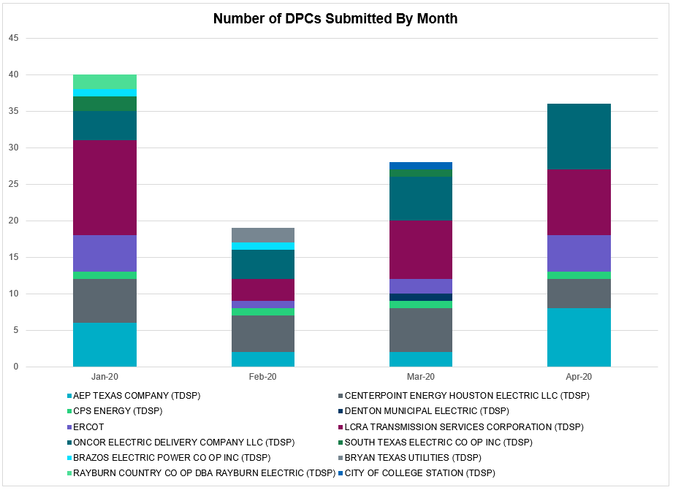

Transmission Operator | Number of DPCs
AEP TEXAS COMPANY (TDSP) | 8
BRAZOS ELECTRIC POWER CO OP INC (TDSP)
BRYAN TEXAS UTILITIES (TDSP)
CENTERPOINT ENERGY HOUSTON ELECTRIC LLC (TDSP) | 4
CITY OF AUSTIN DBA AUSTIN ENERGY (TDSP) | 1
CITY OF COLLEGE STATION (TDSP)
CITY OF GARLAND (TDSP)
CPS ENERGY (TDSP) | 1
DENTON MUNICIPAL ELECTRIC (TDSP)
ELECTRIC TRANSMISSION TEXAS LLC (TDSP) | 2
ERCOT | 5
LCRA TRANSMISSION SERVICES CORPORATION (TDSP) | 9
ONCOR ELECTRIC DELIVERY COMPANY LLC (TDSP) | 9
RAYBURN COUNTRY CO OP DBA RAYBURN ELECTRIC (TDSP)
SHARYLAND UTILITIES LP (TDSP)
SOUTH TEXAS ELECTRIC CO OP INC (TDSP)
TEXAS MUNICIPAL POWER AGENCY (TDSP)
TEXAS-NEW MEXICO POWER CO (TDSP) | 2

Appendix A: Real-Time Constraints
The following is a complete list of constraints activated in SCED. Full contingency descriptions can be found in the Standard Contingencies List located on the MIS secure site at Grid Generation Reliability Unit Commitment.

Contingency Name | Overloaded Element | From Station | To Station | Count of Days
SBOSELM5 | 1030__B | BOSQUESW | RGH | 25
BASE CASE | PNHNDL | n/a | n/a | 25
SBRAUVA8 | HAMILT_MAVERI1_1 | HAMILTON | MAVERICK | 24
SSOLFTS8 | ALPINE_BRONCO1_1 | BRONCO | ALPINE | 23
SMV_PAR8 | RIOHND_ERIOHND_1 | MV_RIOHO | RIOHONDO | 21
DCRLLSW5 | 588_A_1 | LWSVW | LWVTI | 19
SKINODE5 | FTST_SOLSTI1_1 | FTST | SOLSTICE | 16
BASE CASE | RANDAD_ZAPATA1_1 | RANDADO | ZAPATA | 15
SBRAHAM8 | HAMILT_MAVERI1_1 | HAMILTON | MAVERICK | 15
SCRDLOF9 | BOW_FMR1 | BOW | BOW | 15
SLKAWFS8 | BOW_FMR1 | BOW | BOW | 15
BASE CASE | RANDAD_ZAPATA1_1 | ZAPATA | RANDADO | 15
SFORYEL8 | HEXT_YELWJC1_1 | YELWJCKT | HEXT | 14
BASE CASE | NE_LOB | n/a | n/a | 14
SFORYEL8 | HEXT_YELWJC1_1 | HEXT | YELWJCKT | 14
DLCRKIN8 | LCRANE_RIOPEC1_1 | RIOPECOS | LCRANE | 14
SLOBSA25 | NLARSW_PILONC1_1 | NLARSW | PILONCIL | 13
SKINODE5 | PIGCRE_SOLSTI1_1 | SOLSTICE | PIGCREEK | 12
SCMNCPS5 | 651__B | CMNSW | CMNTP | 11
SMELRIN8 | BONIVI_RINCON1_1 | RINCON | BONIVIEW | 11
BASE CASE | MCCAMY | n/a | n/a | 11
SRAYRI28 | RAYMND2_69A1 | RAYMND2 | RAYMND2 | 11
SSPUASP8 | GIRA_T_SPUR1_1 | SPUR | GIRA_TAP | 11
SSPUASP8 | GIRA_T_SPUR1_1 | GIRA_TAP | SPUR | 11
BASE CASE | TRDWEL | n/a | n/a | 11
DZORHAY5 | R5_KENDL_1 | KENDAL | CAGNON | 10
SEVRVEN5 | 495__A | EVRSW | VENSW | 10
STOMLYN8 | 16TH_WRD2_1 | WOODWRD2 | 16TH_ST | 10
SFORYEL8 | HEXT_MASONS1_1 | HEXT | MASONSW | 9
SFORYEL8 | HEXT_MASONS1_1 | MASONSW | HEXT | 9
SLAQLOB8 | BRUNI_69_1 | BRUNI | BRUNI | 9
DBIGKEN5 | TREADW_YELWJC1_1 | TREADWEL | YELWJCKT | 9
DHUTHUT5 | HUTTO_MR1H | HUTTO | HUTTO | 9
DMTSCOS5 | 6437__F | SCRCV | KNAPP | 9
DFERGRM8 | 1318T313_1 | JOHNCI | WIRTZ | 8
SSPUASP8 | SPUR_69_1 | SPUR | SPUR | 8
DFERGRM8 | 1318T313_1 | WIRTZ | JOHNCI | 8
SPAWSAN5 | PAWNEE_XF1 | PAWNEE | PAWNEE | 8
SODLBRA8 | HAMILT_MAVERI1_1 | HAMILTON | MAVERICK | 7
DBIGKEN5 | SAPOWE_TREADW1_1 | SAPOWER | TREADWEL | 7
DSALKLN5 | KLNSW_MR2H | KLNSW | KLNSW | 7
SBRAUVA8 | ESCOND_GANSO1_1 | GANSO | ESCONDID | 7
SBEVASH8 | BEVO_BRUNDAGE_1 | BRUNDGS | BEVO | 6
SLOBSA25 | LARDVN_LASCRU1_1 | LARDVNTH | LASCRUCE | 6
DBERBO58 | R5_KENDL_1 | KENDAL | CAGNON | 6
SHAYKE25 | R5_KENDL_1 | KENDAL | CAGNON | 6
SPIGSOL8 | RIOPEC_WOODW21_1 | WOODWRD2 | RIOPECOS | 6
SSCUSU28 | ASPM_69T1 | ASPM | ASPM | 5
SGASDIV5 | CRTVLE_EINSTEN_1 | EINSTEIN | CRTRVLLE | 5
SVICCO28 | COLETO_VICTOR2_1 | COLETO | VICTORIA | 5
SW_BW_25 | CRTVLE_EINSTEN_1 | EINSTEIN | CRTRVLLE | 5
SNORODE5 | FTST_SOLSTI1_1 | FTST | SOLSTICE | 5
DGRSPKR5 | 6377__A | BRTSW | ORANS | 5
SMDLODE5 | 6520__E | ODEHV | YARBR | 5
DGIDTAH8 | 670T670_1 | GIDEON | BUTLER | 5
DBIGKEN5 | FORTMA_YELWJC1_1 | YELWJCKT | FORTMA | 4
MGILHIW8 | GILA_MAYO1_1 | GILA | MAYO | 4
DJEWSNG5 | JK_TOKSW_1 | TOKSW | JK_CK | 4
DSALKLN5 | 630__B | KLNSW | HHSTH | 4
MGILHIW8 | GILA_MAYO1_1 | MAYO | GILA | 4
SBOWBNT9 | BOW_FMR1 | BOW | BOW | 4
DLCRCAS8 | LCRANE_RIOPEC1_1 | RIOPECOS | LCRANE | 4
BASE CASE | RV_RH | n/a | n/a | 4
DMGSQAL5 | 6095__D | LMESA | JPPOI | 4
DAUSDUN8 | 211T147_1 | GILLCR | MCNEIL_ | 4
DCPSST58 | 651__B | CMNSW | CMNTP | 3
SPOMNED5 | FREER_LOBO1_1 | LOBO | FREER | 3
DELMSAN5 | NORMAN_PETTUS1_1 | PETTUS | NORMANNA | 3
DBWNKLN5 | COLETA_COLE_I1_1 | COLE_IVI | COLETAP | 3
SCENLOB5 | GODDAR_PAWNEE1_1 | GODDARD | PAWNEE | 3
DELMSAN5 | POT_OAKS_1 | OAKS9 | POTEETS | 3
DBIGKEN5 | COLETA_COLE_I1_1 | COLE_IVI | COLETAP | 3
DBERBO58 | 60T225_1 | KERRST | VERDCR | 3
SPIGSOL8 | LYNX_RIOPEC1_1 | LYNX | RIOPECOS | 3
SSPUASP8 | ROTN_WOLFGA1_1 | WOLFGANG | ROTN | 3
SCISPUT8 | ESTES_PECAN_1_1 | PECAN_BY | ESTES | 3
SSANFOW5 | NLARSW_PILONC1_1 | NLARSW | PILONCIL | 3
DBERWE58 | R5_KENDL_1 | KENDAL | CAGNON | 3
DELMSAN5 | SANMIGL_ATAH | SANMIGL | SANMIGL | 3
SGILNU78 | GILA_HIWAY_1_1 | GILA | HIWAY_9 | 3
DHUTHUT5 | HUTTO_MR1L | HUTTO | HUTTO | 3
DCOTDMT5 | LIBR_PAUL1_1 | PAUL | LIBR | 3
SECNMO28 | 6100__F | DHIDE | NOTSW | 2
DRNS_TB5 | THWZEN71_A | ZEN | THW | 2
SHOLWES8 | ARCADI_SOUTH_1_1 | ARCADIA | SOUTH_SI | 2
SHACPB38 | FTST_SOLSTI1_1 | FTST | SOLSTICE | 2
SHOLWES8 | HOLLY4_SOUTH_1_1 | SOUTH_SI | HOLLY4 | 2
XVIC89 | MAGRUD_VICTOR2_1 | VICTORIA | MAGRUDER | 2
DHILMAR5 | 292T303_1 | CIBOLO | SCHERT | 2
DCRLLSW5 | 495__A | EVRSW | VENSW | 2
DMGSQAL5 | 6144__A | BSPRW | STASW | 2
SAVMBSP8 | 6610__A | BUZSW | CHATP | 2
MSPUSCK8 | ASPM_69T1 | ASPM | ASPM | 2
SFLAPIG8 | IH20_IHT1 | IH20 | IH20 | 2
BASE CASE | RIOHND_ERIOHND_1 | MV_RIOHO | RIOHONDO | 2
DCPSJON5 | 151__A | CPSES | WOFHO | 2
SHOLWES8 | HOLLY4_SOUTH_1_1 | HOLLY4 | SOUTH_SI | 2
SBAKBIG5 | MCCAMY_BAKRFLD_1 | BAKESW | NORTMC | 2
SPIGSOL8 | TNAF_FTS_1 | FTST | TNAF | 2
DFERSTA8 | 1318T313_1 | WIRTZ | JOHNCI | 2
DMGSQAL5 | 14040__A | PCTSW | RBPOI | 2
DWINDUN8 | 6100__F | DHIDE | NOTSW | 2
DHCKSAG8 | 6265__A | EMSES | MRSDO | 2
SENSEN28 | 941__B | ENNIS | ENSSW | 2
DZORHAY5 | BERGHE_AT1H | BERGHE | BERGHE | 2
SBRAHAM8 | ESCOND_GANSO1_1 | GANSO | ESCONDID | 2
SFREGIL8 | FREDER_AT2 | FREDER | FREDER | 2
BASE CASE | FTST_SOLSTI1_1 | FTST | SOLSTICE | 2
DWINDUN8 | M_69_F3_1 | WICKETT | WNKLRCO6 | 2
DMARPA_8 | 1318T313_1 | WIRTZ | JOHNCI | 2
DWINDUN8 | 6100__F | NOTSW | DHIDE | 2
DHCKRNK5 | 6265__A | EMSES | MRSDO | 2
SENSEN28 | 941__C | ENWSW | ENSSO | 2
SKLELOY8 | LOYOLA_69_1 | LOYOLA | LOYOLA | 2
DBWNKLN5 | SOUTHA_VINSON1_1 | SOUTHABI | VINSON | 2
SILLFTL8 | HAMILT_MAXWEL1_1 | MAXWELL | HAMILTON | 2
SFTLMES8 | MIDW_OZONA1_1 | MIDW | OZONA | 2
BASE CASE | NELRIO | n/a | n/a | 2
BASE CASE | N_TO_H | n/a | n/a | 2
SWCSBOO8 | FTST_SOLSTI1_1 | FTST | SOLSTICE | 2
DSALHUT5 | 1710__C | BELCNTY | SALSW | 2
SECNMO28 | 6100__F | NOTSW | DHIDE | 2
SBIGOR55 | HAMILT_MAVERI1_1 | HAMILTON | MAVERICK | 2
SFLAPIG8 | M_69_F3_1 | WICKETT | WNKLRCO6 | 2
SSTABS18 | 6144__A | BSPRW | STASW | 2
DBERWE58 | 497T497_1 | MARBFA | LAKEWY | 1
SFLCMGS5 | 6095__D | LMESA | JPPOI | 1
XMDS58 | 6475__C | ODEHV | TROTP | 1
S127STA8 | 6620__A | STASW | MRCAP | 1
DRILKRW5 | 6626__F | BTTSW | HENWE | 1
DGRMGRS8 | 6830__B | CRDSW | OLNEY | 1
SHAYZO25 | 6T227_1 | HAYSEN | ZORN | 1
DTRSENT5 | 970__F | LLPOI | ATHNS | 1
SLOLFOR8 | BIGTRE_V_DUPS1_1 | V_DUPSW | BIGTRE | 1
DELMSAN5 | BLESSI_LOLITA1_1 | BLESSING | LOLITA | 1
DRILKRW5 | BOW_FMR1 | BOW | BOW | 1
SFAICOR8 | CORONA_AT4 | CORONA | CORONA | 1
SSACSUN8 | ECRSW_FMR1 | ECRSW | ECRSW | 1
SCT2CAR8 | HAMILT_MAXWEL1_1 | MAXWELL | HAMILTON | 1
DDUPHE18 | I_DUPS_MCCAMP2_1 | I_DUPSW | MCCAMPBE | 1
DSTPRED5 | OASWAP18_A | WAP | OAS | 1
DELMSAN5 | PAWNEE_SPRUCE_1 | PAWNEE | CALAVERS | 1
SSKYSB28 | PRONGHRN_SMIDL_1 | SMIDLAND | PRONGHRN | 1
DFLCMGS5 | 6095__D | LMESA | JPPOI | 1
DZORHAY5 | 60T225_1 | KERRST | VERDCR | 1
DCAGCI58 | 656T656_1 | KENDAL | BERGHE | 1
DKENCA58 | 656T656_1 | KENDAL | BERGHE | 1
SGODPAW5 | CALLIC_LON_HI1_1 | LON_HILL | CALLICOA | 1
SN_SLON5 | CELANE_KLEBER1_1 | CELANEBI | KLEBERG | 1
DTRSENT5 | ELKTN_MR3L | ELKTN | ELKTN | 1
DTGFLC_8 | EL_CAM_LANCTY1_1 | LANCTYPM | EL_CAMPO | 1
SMDLODE5 | FTST_SOLSTI1_1 | FTST | SOLSTICE | 1
SCISPUT8 | LENSW_PUTN2_1 | PUTN | LENSW | 1
SFTPFTP8 | OILMIT_SAWGRA1_1 | SAWGRASS | OILMITAP | 1
SFAICOR8 | 1318T313_1 | WIRTZ | JOHNCI | 1
DHUTGIL5 | 211T147_1 | GILLCR | MCNEIL_ | 1
DHILMAR5 | 361T361_1 | SCHERT | PARKWA | 1
SFAICOR8 | 38T365_1 | WIRTZ | FLATRO | 1
DCRLLSW5 | 590__A | LWSSW | LWVJS | 1
DWINDUN8 | 6520__E | ODEHV | YARBR | 1
DBUZLME8 | 6610__A | BUZSW | CHATP | 1
SSCLWF18 | 6840__A | ANARN | CRDSW | 1
DCOTDMT5 | 6855__E | SMRTP | SMOUR | 1
SREVDIL8 | CATARI_PILONC1_1 | PILONCIL | CATARINA | 1
DBONNED5 | HAINE__LA_PAL1_1 | LA_PALMA | HAINE_DR | 1
DBIGKEN5 | HAMILT_MAXWEL1_1 | MAXWELL | HAMILTON | 1
SMELRIN8 | HEARDT_WOODSB1_1 | WOODSBOR | HEARDTAP | 1
DELMSAN5 | PLESNTN_TORDLO_1 | TORDILLO | PLSNTOS | 1
DSNG_TB5 | THWZEN71_A | ZEN | THW | 1
DGILFR89 | 1318T313_1 | WIRTZ | JOHNCI | 1
SPHIMIL8 | 1318T313_1 | WIRTZ | JOHNCI | 1
DLWSRNK5 | 587__A | ARGYL | LWSVH | 1
SPIGSOL8 | 6520__E | ODEHV | YARBR | 1
DNLSCRL8 | 715__A | CRLNW | CRLJL | 1
SENSENW8 | 943__A | ENWSW | ENSSW | 1
SFTLMES8 | CROSSO_NORTMC1_1 | NORTMC | CROSSOVE | 1
DENTSCS5 | ELKTN_MR3L | ELKTN | ELKTN | 1
DELMSAN5 | NLARSW_PILONC1_1 | NLARSW | PILONCIL | 1
SREVDIL8 | NLARSW_PILONC1_1 | NLARSW | PILONCIL | 1
DWH_STP5 | NORMAN_PETTUS1_1 | PETTUS | NORMANNA | 1
SSCLWF18 | NVKSW_FMR1 | NVKSW | NVKSW | 1
DFPPHOL5 | 155T217_1 | BELLSO | PT | 1
SRICGRS8 | 6840__A | ANARN | CRDSW | 1
DPAIMUR8 | 6855__E | SMRTP | SMOUR | 1
DFPPFAY5 | CKT_3131_1 | FPPYD1 | LOSTPINE | 1
DCLEZOR5 | CLEASP_AT2L | CLEASP | CLEASP | 1
SLCDYN8 | GEBWA_65_A | WA | GEB | 1
DBONRIO5 | HAINE__LA_PAL1_1 | LA_PALMA | HAINE_DR | 1
DMGSMDS5 | MDSSW_MR1H | MDSSW | MDSSW | 1
BASE CASE | SONR_69-1 | SONR | SONR | 1
SCISPUT8 | SOUTHA_VINSON1_1 | SOUTHABI | VINSON | 1
DRNS_TB5 | THWZEN98_A | ZEN | THW | 1
SSCLWF18 | 6840__B | NVKSW | ANARN | 1
SSWDMGS8 | 6940__C | SWTWR | PLOWB | 1
DZORHAY5 | BERGHE_AT1L | BERGHE | BERGHE | 1
DCLEZOR5 | CLEASP_AT2H | CLEASP | CLEASP | 1
DBWNKLN5 | ESTES_PECAN_1_1 | PECAN_BY | ESTES | 1
DCMNCMN8 | HLD_FMR1 | HLD | HLD | 1
DZORHAY5 | KENDAL_AT4H | KENDAL | KENDAL | 1
DSALKLN5 | KLNSW_MR2L | KLNSW | KLNSW | 1
BASE CASE | MXWL_FERMI_1 | FERMI | MAXWELL | 1
BASE CASE | NEDIN_138H | NEDIN | NEDIN | 1
SNORODE5 | PIGCRE_SOLSTI1_1 | SOLSTICE | PIGCREEK | 1
SPRILOM8 | SCARBI_TITAN_1_1 | SCARBIDE | TITAN_SU | 1
DYKNWIN8 | 6100__F | DHIDE | NOTSW | 1
SPLDLME8 | 6610__A | BUZSW | CHATP | 1
XNED358 | BURNS_RIOHONDO_1 | RIOHONDO | MV_BURNS | 1
SGLDSUN8 | ECRSW_FMR1 | ECRSW | ECRSW | 1
SBROALP9 | FTST_SOLSTI1_1 | FTST | SOLSTICE | 1
SSANELM5 | NORMAN_PETTUS1_1 | PETTUS | NORMANNA | 1
DHECWHI8 | RINCON_WHITE_2_1 | WHITE_PT | RINCON | 1
SLWVLWS8 | 588_A_1 | LWSVW | LWVTI | 1
DBERWE58 | 60T225_1 | KERRST | VERDCR | 1
DHCKSAG8 | 6260__C | EMSES | RHTP1 | 1
SSWDMGS8 | 6940__C | PLOWB | SWTWR | 1
BASE CASE | EASTEX | n/a | n/a | 1
DGRSLNC5 | ESTES_PUTN1_1 | ESTES | PUTN | 1
DDELGA58 | FREER_LOBO1_1 | LOBO | FREER | 1
SCT2CAR8 | HAMILT_MAVERI1_1 | HAMILTON | MAVERICK | 1
SN_SAJO5 | LASPUL_RAYMND1_1 | LASPULGA | RAYMND2 | 1
MGILHIW8 | MAYO_WHITE_1_1 | MAYO | WHITE_PT | 1
DCAGBRA5 | N5_P4_1_1 | CALAVERS | SKYLINE | 1
SFMCSON9 | SONR_69-1 | SONR | SONR | 1
SBEVASH8 | TURTLECK_WCRYS_1 | TURTLCRK | WCRYSTS | 1
SOKLRI25 | VERN_69T1 | VERN | VERN | 1

This is the hourly integrated peak demand as published in the ERCOT D&E report.

