System Planning
Monthly Status Report

Report Highlights

- ERCOT is currently reviewing proposed transmission improvements with a total estimated cost of $1,302.84 Million as of April 30, 2020.
- Transmission Projects endorsed in 2020 total $218.27 Million as of April 30, 2020.
- All projects (in engineering, routing, licensing and construction) total approximately $7.45 Billion as of February 1, 2020.
- Transmission Projects energized in 2020 total about $122 Million as of February 1, 2020.

Regional Planning Group Reviews
- AEPSC has submitted the LRGV Import Project. This is a Tier 1 project that is estimated to cost $73.4 million. AEPSC has also requested that ERCOT provide a conditional endorsement for an additional $357.2 million project. The ERCOT Independent Review has been conducted in accordance with Protocol Section 3.11.4.9(3), and this project is currently placed on hold until the LNG loads are confirmed.
- STEC has submitted the Lower Rio Grande Valley Transmission Expansion Project. This is a Tier 1 project that is estimated to cost $511 million. The ERCOT Independent Review has been conducted in accordance with Protocol Section 3.11.4.9(3), and this project is currently placed on hold until the LNG loads are confirmed.
- AEPSC has submitted the Corpus North Shore Project. This is a Tier 1 project that is estimated to cost $259.57 million. This project is currently under ERCOT Independent Review.
- 7x Energy has submitted the Frio County Transmission Project. This is a Tier 2 project that is estimated to cost $23 million. This project is currently under ERCOT Independent Review.
- GP&L has submitted the Farmersville Area Reliability Project. This is a Tier 2 project that is estimated to cost $24.37 million. This project is currently under ERCOT Independent Review.
- Oncor has submitted the Anna Switch - Royse Switch 138-kV Line Upgrade Project. This is a Tier 3 project that is estimated to cost $91.2 million. This project completed the RPG review on April 13, and ERCOT has issued the acceptance letter.
- GP&L has submitted the Lookout Substation SVC Project. This is a Tier 3 project that is estimated to cost $25 million. This project is currently in the RPG study mode.
- AEPSC has submitted the Ballinger to San Angelo Concho 69 kV Line Rebuild Project. This is a Tier 3 project that is estimated to cost $27 million. This project completed the RPG review on April 30, and ERCOT will issue an acceptance letter.
- TNMP has submitted the Texas City Transmission Improvement Project. This is a Tier 2 project that is estimated to cost $29.3 million. This project is currently in the RPG comment period.
More information on current and past RPG projects can be found on the ERCOT MIS Secure (digital certificate required): https://mis.ercot.com/pps/tibco/mis/Pages/Grid+Information/RegionalPlanning
Past email communication on RPG projects can be found on the ERCOT listserve by signing up for the REGPLANGROUP list: http://lists.ercot.com/scripts/wa-ERCOT.exe?A0=REGPLANGROUP

Planning Model Activities
The short-term calendar of major planning model events is as follows:
- July 1, 2020 20SSWG cases and TPIT are posted
- By July 20, 2020 Post 20SSWG Contingency definitions and Planning Data Dictionary
The following table shows interconnection projects that met Planning Guide section 6.9(1) and 6.9(2) and were modeled in the SSWG cases as a full model or as a simple model in accordance with Planning Guide section 6.9.
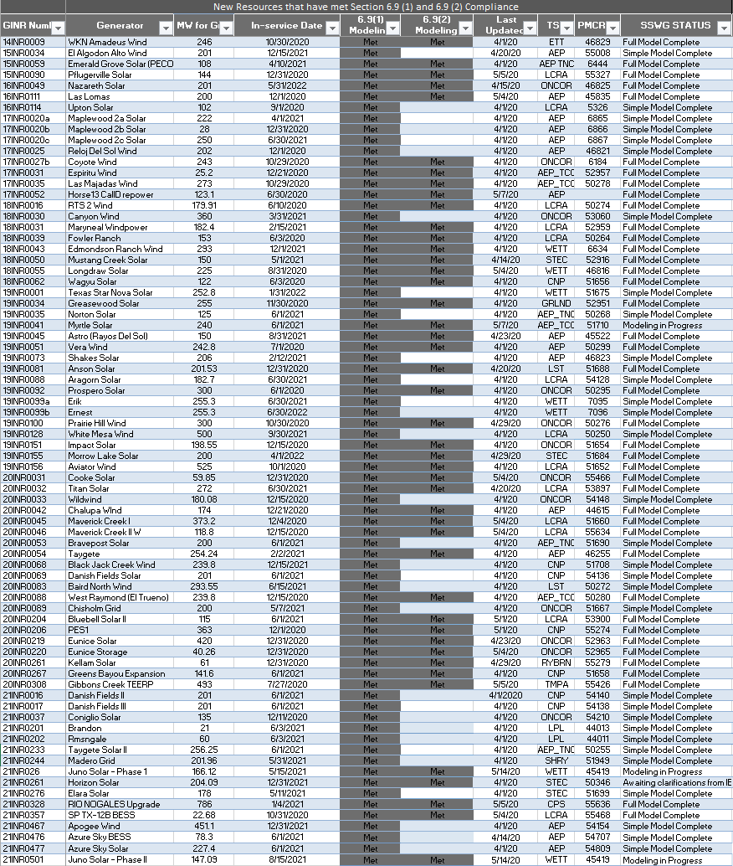

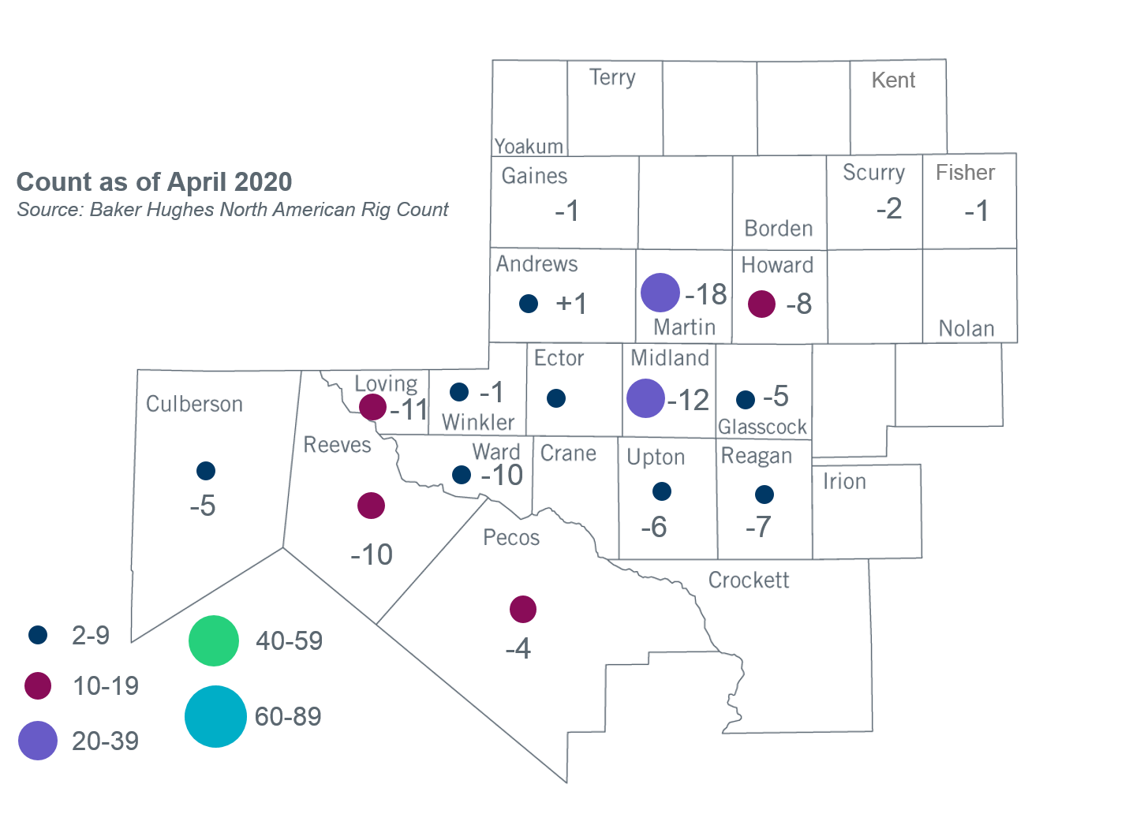
Permian Basin Oil Rig Count
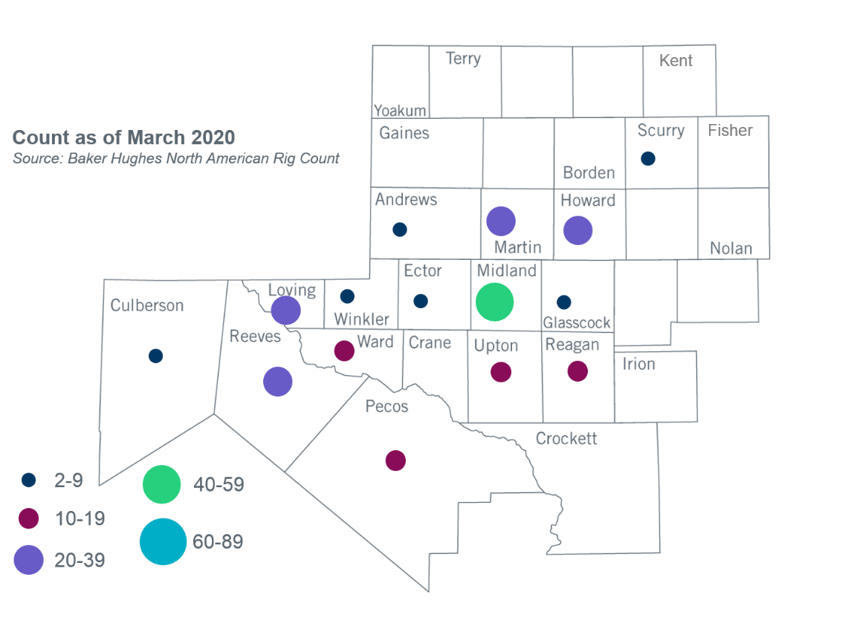

Other Notable Activities
- The SPWG completed and posted the 2020 CY base case on March 27, 2020.
- The SPWG has begun building the 2020 FY cases.
- ERCOT is performing stability analysis for Panhandle and West Texas exports and plans to present preliminary results to ROS in May.

+/- symbol indicates the increase or decrease from the previous month in oil rigs present in each county. There are 152 rigs, including a total decrease of 99 oil rigs, in the Permian Basin from March to April 2020.

