ERCOT Market Information System (MIS) Sandbox Release Notes
Release Date: May 28, 2020
ERCOT will be releasing a new sandbox version of the Market Information System (MIS) on Thursday, May 28, 2020. Here is a quick list of item availability. Continue reading for more details on each of these items.

Quick View
What’s available? | What’s not yet available? | Enhancements since previous release
Home page | Digital certificates | No enhancements as this is the first release
Data product search | Roles | No enhancements as this is the first release
Topics | Access to data  (Public, Secure or Certified) | No enhancements as this is the first release
Data export | Ability to display reports based upon role or availability of data | No enhancements as this is the first release
Data detail pages | Notices | No enhancements as this is the first release
Category pages | Applications | No enhancements as this is the first release
Links to ERCOT.com |  | No enhancements as this is the first release

What will be available in this sandbox release of MIS?
Home page – A temporary home page providing information needed to explore the MIS sandbox as well as available methods for submitting feedback.
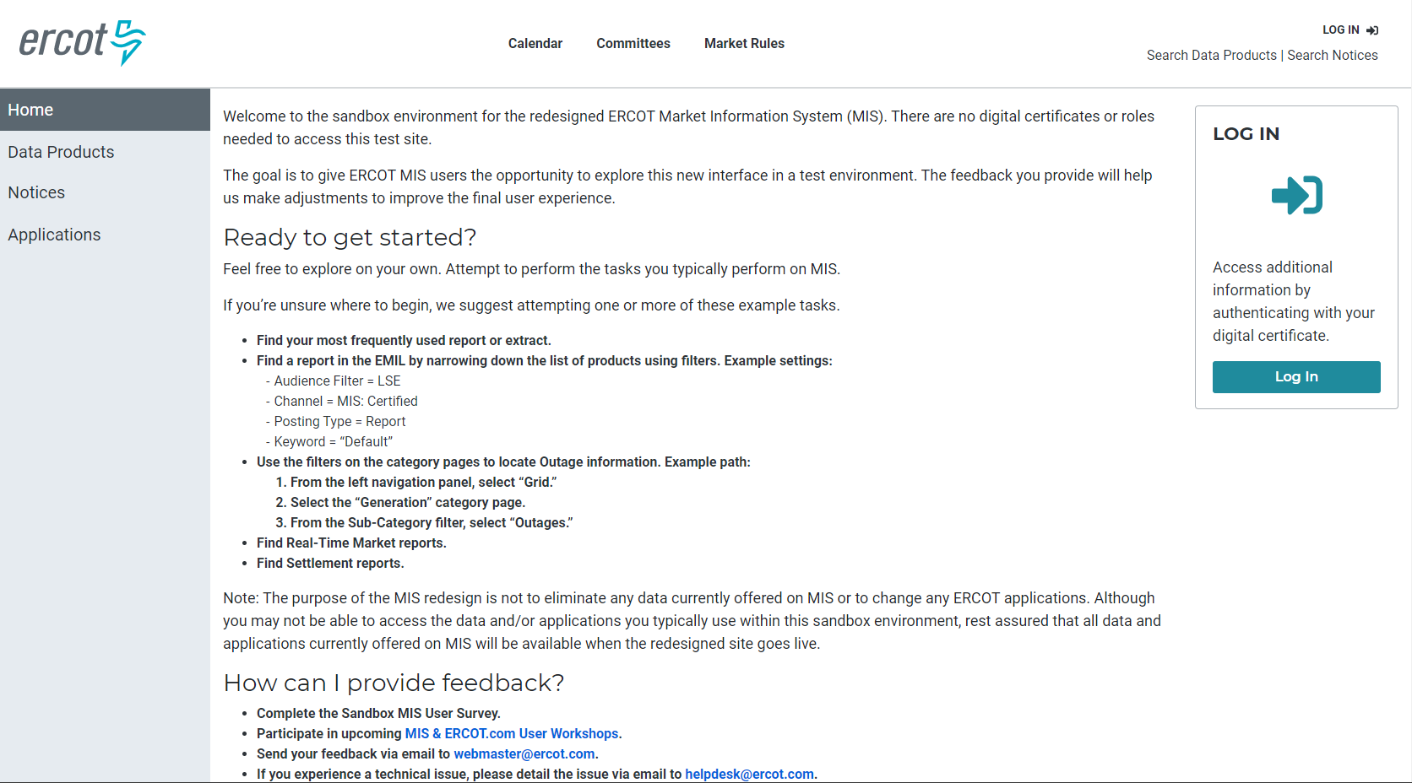
MIS badge – Visual cue letting you know when you are authenticated to MIS and are able to see Secure and Certified data (although this functionality is not yet active within the sandbox environment).

Desktop
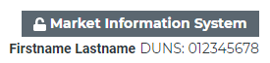
Mobile


Data product search – Search for all reports, extracts, notices, and applications ERCOT is required to provide. Narrow a search using filters or keywords.
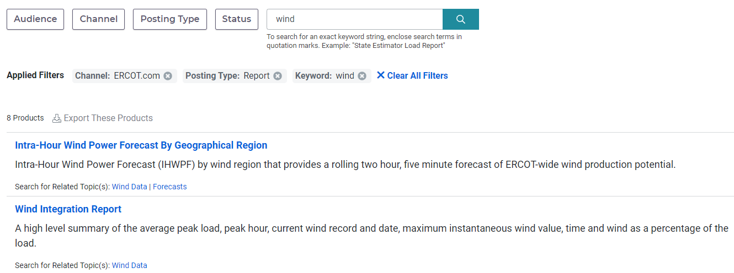

Topics – Tags on data products that, when clicked, allows the user to see similar reports or information.
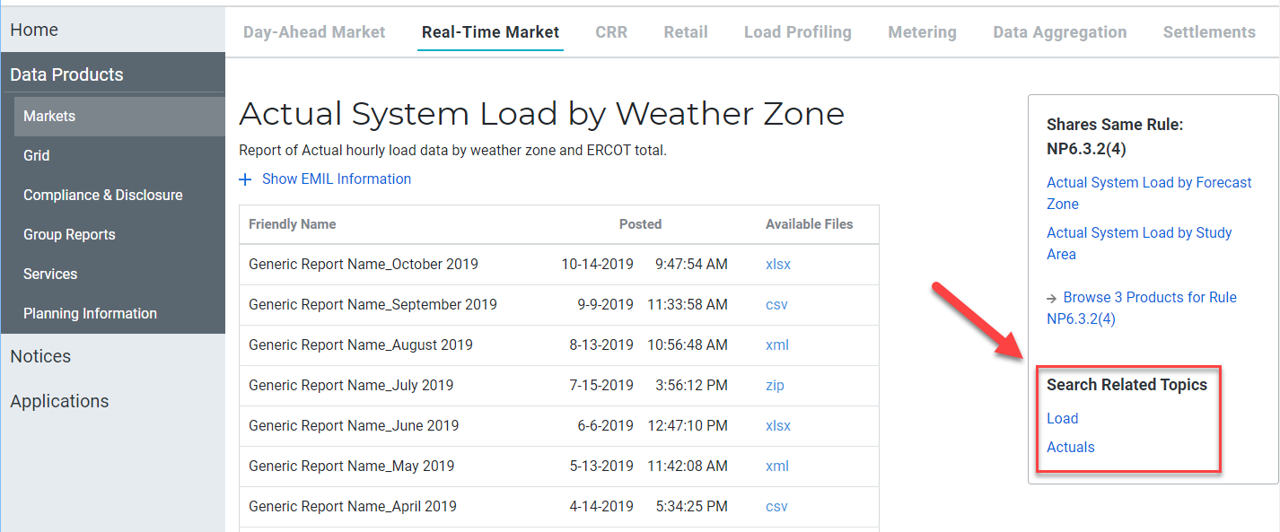
Data export – Export the full EMIL or a subset of products in an Excel file.
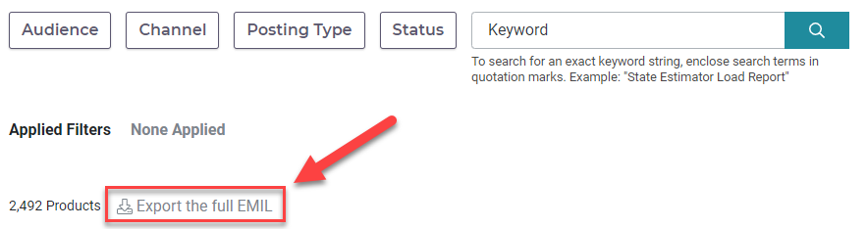
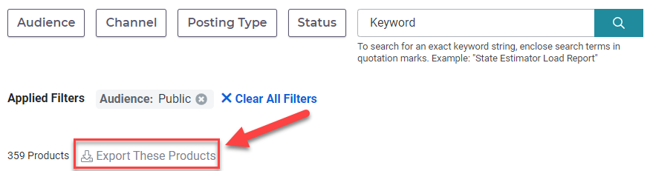

Data detail pages – Dive deeper into the details of a specific data product.
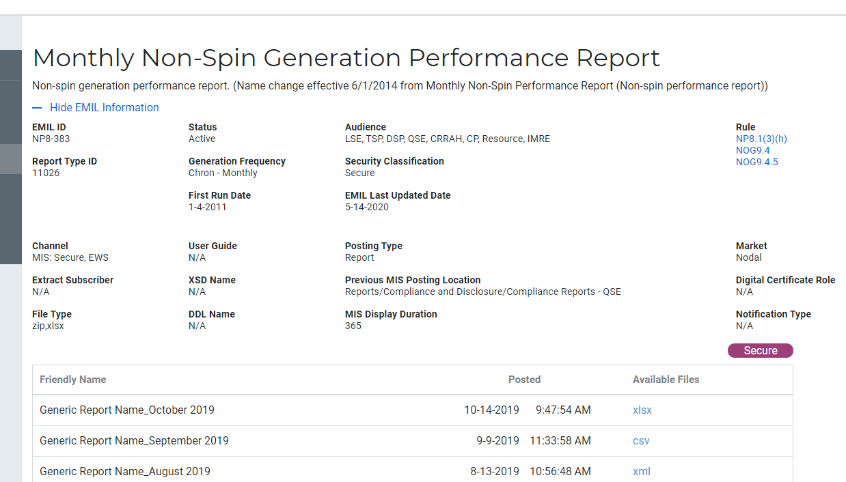

Category pages – Navigate directly to collections of reports and extracts.
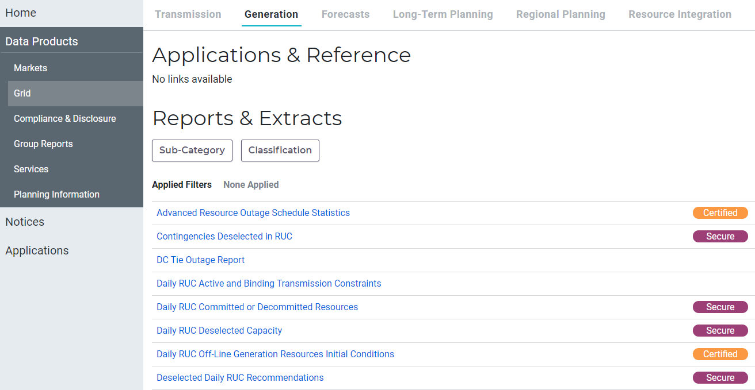

Links to ERCOT.com - Jump to related sections of ERCOT.com.
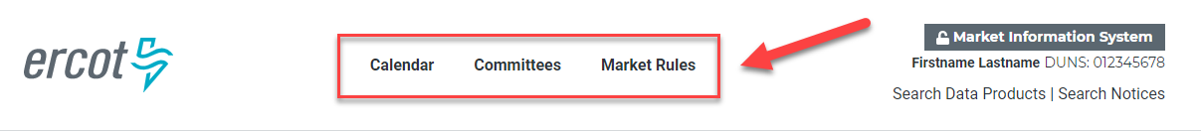

What isn't available in this sandbox release of MIS?
The focus of the sandbox release is to get early feedback from stakeholders on the user interface. The Production Preview Release planned for September 2020 will provide an opportunity to test out the fully functional redesigned MIS.
Currently, the MIS sandbox does not contain:
- Digital certificates
- Roles
- Public, secure or certified data
- Ability to display reports based upon role or availability of data
- Notices
- Access to applications (only placeholder links are available at this time)
Note: Some planning studies, such as INRs, are not available in the sandbox release. The team is working on display options. If you are a user of planning information, please email userexperience@ercot.com so that your input can be considered.

What about MIS isn’t changing?
- Digital certificate access
- No reports or extracts will be removed
- No changes to applications accessed through MIS
- API access will still be available

