PWG Meeting Notes – March 2, 2020
ERCOT Met Center
1:00 PM

Attendees:

Sam Pak – Oncor | Bill Boswell - ERCOT | Carl Raisch - ERCOT
Sheri Wiegand – TXU | Calvin Opheim - ERCOT | Jim Lee – AEP
Kathy Scott – CNP | Randy Roberts - ERCOT | John Schatz - TXU
Diana Rehfeldt – TNMP | Jordan Troublefield – ERCOT | Eric Blakey – Just
Andrea Couch - TNMP | Mark Ruane - ERCOT | Bill Barnes - NRG
Chris Rowley - Oncor | Kevin Tamson – ERCOT | Malcolm Ainspan - ???

- Sam Pak read Antitrust Admonition and reviewed the agenda
- PWG meeting minutes from February 4th were reviewed and approved

- Weather Sensitivity Report
  - Randy Roberts presented the WS Report as of 3/2/20
  - All TDSPs are considered complete
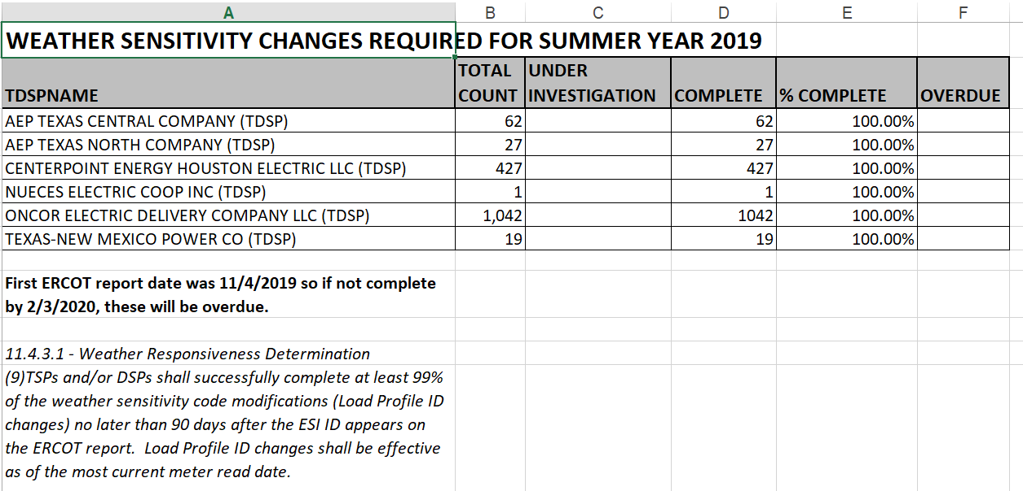

- Jurisdiction of UFE Report
  - Protocol language section 11.6, Unaccounted For Energy Analysis allows for “The appropriate TAC Subcommittee” to reassigned and reside with WMS on a go forward basis for review and formal presentation. Although, it was agreed that PWG would have interest in a less formal review of the UFE report when available. It was also agreed that the UFE will not be presented at RMS.
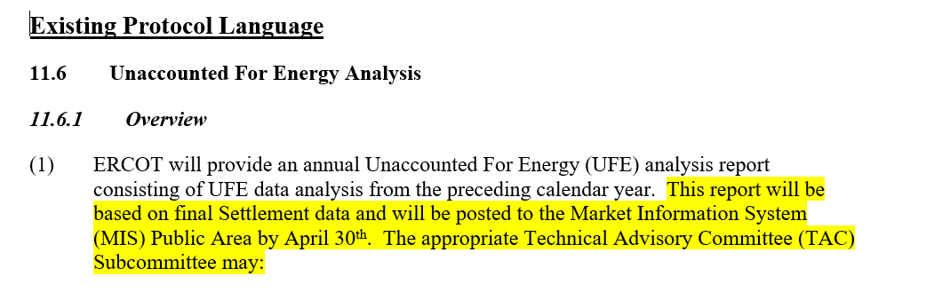

- IDR vs AMS meters
  - Jim Lee assisted in revising the TDSP response matrix for the utilization of AMS vs IDR meters

 |  | Oncor | CNP | AEP | TNMP
Current number of BUSIDRRQ profiles in ERCOT (2/4/20) |  | 7,058 | 4,611 | 1,104 | 352
(To be updated upon approval/effectuation of CNP & AEP rate cases - #49421 (CNP); #49494 (AEP))
As of 2/4/2020, TDSP application of AMS or IDR meters:
1 | For premises with demand >700kW/kVa, does the Tariff allow AMS metering in place of IDR metering? | Yes | Yes | No | Yes
2 | Where permissible by Tariff, what meter type is used for premises >700kW/kVa? | Most currently AMS metered | CNP is currently replacing IDR with AMS meters. Expected to be completed by year end 2020 with exceptions noted in Question #4 below | IDR | AMS
3 | Where permissible by Tariff, will the TDSP replace traditional IDR Meters with AMS meters? | Yes. Deployment of remaining BUSIDRRQ customers to AMS meters w/in 2yrs | Yes, see above #2 response | Yes | Yes  fully deployed
4 | Example situations where a traditional IDR Meter will remain as the metering asset for premises >700kW/kVA: | Subtractive and EPS meters; ESIs with RIDs | Transmission level, EPS and those with Direct Dedicated Telephone connections | Transmission level; EPS meters; ESIs with RIDs | EPS; Customer Owned Transformer Sites, Billing on Secondary Side of Transformer Sites
For NEW premises where demand is >700kW/kVa and an AMS meter may be installed:
(To be updated upon approval/effectuation of CNP & AEP rate cases - #49421 (CNP); #49494 (AEP))
5 | What determines 4CP billing for NEW premises once historical data is available? | Demand of 700kW or greater | Demand of 700kVa or greater | Demand of 700kW or greater | Demand of  700kW or greater
6 | Will the TDSPs install an IDR or AMS meter at a new premise where demand is >700kW/kVa? | AMS | AMS | AMS | AMS
7 | What will the TDSP assign as the default load profile? | Currently will assign BUSIDRRQ, but is agreeable to assign other profile if Protocols are revised | BUSIDRRQ | BUSIDRRQ (Assigns Load Profile according to Profile Decision Tree) | BUSIDRRQ
8 | Does the customer have the option to establish an AMS meter with a BUS profile, other than BUSIDRRQ, if expected to exceed 700 kW/kVa? | Yes | Yes | Yes | Yes
For EXISTING premises where demand is >700kW/kVa and an AMS meter may be installed:
(To be updated upon approval/effectuation of CNP & AEP rate cases - #49421 (CNP); #49494 (AEP))
9 | What determines 4CP billing for EXISTING premises? | 700kW or greater; Or billed on 4CP prior to 11/27/17 | 700kVa or greater in any previous billing month | 700kW or greater in any previous billing month | 700kW or greater; Or billed on 4CP prior to 1/1/19
10 | For premises grandfathered on the BUSIDRRQ profile w/ demand less than 700 kW/kVa: Does the Customer have the option to establish an AMS meter with a BUS profile, other than BUSIDRRQ, and remain on 4CP billing? | Yes | Yes | Yes | No
11 | If the profile changes from BUSIDRRQ to another BUS profile, does the TDSP Rate change? | No | No | No | No
12 | If the demand is >700kW/kVa, with an assigned BUSHI/MED/LO profile, and a MVO is completed: Will the load profile change upon completion of a MVI from another CR/Customer?  If a premise has exceeded the 700kW/kVa threshold and requested to remain on a BUSHI/MED/LO profile and a MVO is issued, will the premise return to a BUSIDRRQ profile upon the MVI of another customer? | Will remain the same Load Profile that was previously assigned to the MVO Customer of either BUSHI/MED/LO until Annual Validation | Will remain the same Load Profile that was previously assigned to the MVO Customer of either BUSHI/MED/LO until Annual Validation | Will remain the same Load Profile that was previously assigned to the MVO Customer of either BUSHI/MED/LO until Annual Validation | Will remain the same Load Profile that was previously assigned to the MVO Customer of either BUSHI/MED/LO until Annual Validation

  - Discussion revolved around the possibility to repurpose a unique combination of existing load profile segments (eg BUS with a unique TOU segment) to help identify the condition of an AMS metered BUSIDRRQ premise and 4CP billing with daily settlement interval data.
  - While not ideal due to system changes, a new load profile was suggested instead of the unique combination of existing load profile as discussed above.
  - Two process paths were discussed if new profile is not needed:
    - Existing customer on BUSIDDRQ (> 700 kW) transitioning to BUSHI/MED/LO
      - Send MT to ERCOT notifying of change
      - Send MT to CR notifying of change
      - Send 814_20
    - Existing customer on BUSHI/MED/LO exceeds 700 kW
      - Leave profile
      - Change rate to 4CP rate classification
      - Submit MT to ERCOT notifying of change
      - Send 814_20
  - ERCOT and market participants will evaluate within their respective shops on the impacts the unique combo solution OR possibly creating a new load profile for AMS metered BUSIDRRQ customer.
  - With the transition from IDR Meter to AMS meters for premises exceeding 700 kW/kVA, Randy and Calvin presented proposed revisions to Protocol 18.6.1 and RMG 7.13

- DRAFT LPGRR Profile Decision Tree Revisions
  - With the advancement of AMS meters, Calvin presented a draft LPGRR to:
    - Streamline the process to change the DG profile segment assignment whereby TDSP assigns the DG Profile Segment for residential and business profiles and reports the assignment to ERCOT
    - ERCOT will only validate weather sensitivity for NIDR ESIs that request the Oil & Gas Flat (OGFLT) Profile
    - Administrative clean up to remove the “TOU Schedules” and “Non-ERCOT Profile IDs” worksheets

- Next Meeting is April 8th, Wednesday 9:30 AM at ERCOT Met Center
- PROPOSED AGENDA for April 8th, 2020
  - Review Business Annual Validation Matrix timeline
  - IDR/AMS Meter discussions
    - Review TDSP response matrix with additional questions:
      - Can the TDSP support a 4CP rate where the premise has an AMS profile type?
      - If not, is the TDSP working toward that capability? Proposed timeframe?
      - What are the issues the TDSP must overcome in order to have that capability?
    - AMS/IDR Meter Workshop May 4th, 1pm at MET Center room 206
  - Review DRAFT NPRR: ERCOT Proposal for BUSIDRRQ to AMS Process
    - Do we need to create a new load profile?
      - Consideration of DG segment
      - Cost and resource consideration to market

