March 2020 ERCOT Monthly Operations Report
Reliability and Operations Subcommittee Meeting
May 7, 2020

Table of Contents
1. Report Highlights 2
2. Frequency Control 3
2.1. Frequency Events 3
2.2. Responsive Reserve Events 4
2.3. Load Resource Events 4
3. Reliability Unit Commitment 4
4. Wind Generation as a Percent of Load 5
5. Largest Net-Load Ramp 5
6. COP Error Analysis 6
7. Congestion Analysis 8
7.1. Notable Constraints 8
7.2. Generic Transmission Constraint Congestion 12
7.3. Manual Overrides 12
7.4. Congestion Costs for Calendar Year 2020 12
8. System Events 14
8.1. ERCOT Peak Load 14
8.2. Load Shed Events 14
8.3. Stability Events 14
8.4. Notable PMU Events 14
8.5. DC Tie Curtailment 14
8.6. TRE/DOE Reportable Events 14
8.7. New/Modified/Removed RAS 14
8.8. New Procedures/Forms/Operating Bulletins 14
9. Emergency Conditions 15
9.1. OCNs 15
9.2. Advisories 15
9.3. Watches 15
9.4. Emergency Notices 15
10. Application Performance 15
10.1. TSAT/VSAT Performance Issues 15
10.2. Communication Issues 15
10.3. Market System Issues 16
11. Model Updates 16
Appendix A: Real-Time Constraints 18

Report Highlights
- The unofficial ERCOT peak was 52,819 MW.
- There were 6 frequency events.
- There were 5 instances where Responsive Reserves were deployed.
- There was 1 RUC commitment.
- Congestion in the Panhandle Area can mostly be attributed to high wind generation. Congestion in the Far West Area can mostly be attributed to low conventional and renewable generation while experiencing high loads and planned outages. Congestion in the South, North, and Houston LZs were mostly due to planned outages. There were 19 days of congestion on the Panhandle GTC, 25 days on the North Edinburg to Lobo GTC, 9 days on the North to Houston, 4 days on the McCamey GTC, and 16 days on Raymondville to Rio Hondo. There was no activity on the remaining GTCs during the month.
- There were 3 DC Tie curtailments.

Frequency Control

Frequency Events
The ERCOT Interconnection experienced six frequency events, which resulted from units’ trip. The average event duration was 00:04:25.

A summary of the frequency events is provided below. The reported frequency events meet one of the following criteria: Delta Frequency is 60 mHz or greater; the MW loss is 350 MW or greater; resource trip event triggered RRS deployment. Frequency events that have been identified as Frequency Measurable Events (FME) for purposes of BAL-001-TRE-1 analysis are highlighted in blue. When analyzing frequency events, ERCOT evaluates PMU data according to industry standards. Events with an oscillating frequency of less than 1 Hz are considered to be inter-area, while higher frequencies indicate local events. Industry standards specify that damping ratio for inter-area oscillations should be 3.0% or greater. For the frequency events listed below, the ERCOT system met these standards and transitioned well after each disturbance.

Date and Time | Delta Frequency | Max/Min Frequency | Duration of Event | PMU Data |  | MW Loss | Load | Wind | Inertia
 | (Hz) | (Hz) |  | Oscillation Mode (Hz) | Damping Ratio |  | (MW) | % | (GW-s)
3/1/2020 17:43 | 0.106 | 59.893 | 0:04:14 | 1.78 | 16% | 440.52 | 37,071 | 32% | 193,820
3/2/2020 13:13 | 0.095 | 59.896 | 0:05:31 | 0.06 | 14% | 396 | 39,418 | 4% | 238,739
3/16/2020 6:02 | -0.133 | 60.108 | 0:00:00 | 0.73 | 9% | 543 | 34,314 | 8% | 223,637
3/18/2020 19:15 | 0.113 | 59.854 | 0:04:35 | 0.78 | 12% | 691 | 44,814 | 30% | 236,351
3/22/2020 8:10 | 0.167 | 59.855 | 0:04:38 | 0.07 | 11% | 699 | 33,030 | 9% | 227,793
3/26/2020 13:05 | 0.059 | 59.905 | 0:03:12 | No PMU Data Available |  | 277 | 47,397 | 23% | 242,436

(Note: All data on this graph encompasses frequency event analysis based on BAL-001-TRE-1.)

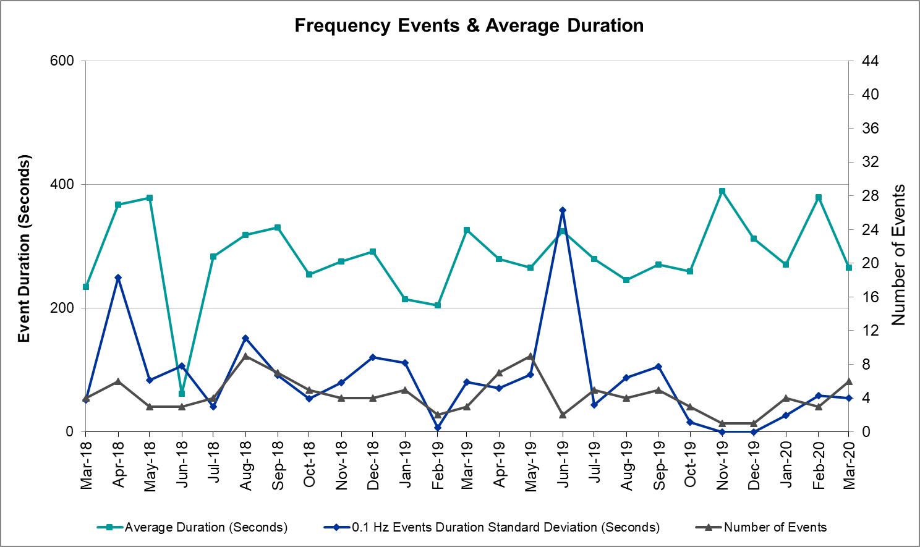

Note that the large standard deviation in June 2019 is due to coincidental extreme high and low durations for a small set of events (2).

Responsive Reserve Events
There were 5 events where Responsive Reserve MWs were released to SCED. The events highlighted in blue were related to frequency events reported in Section 2.1 above.

Date and Time Released to SCED | Date and Time Recalled | Duration of Event | Maximum MWs Released | Comments
3/1/2020 17:43 | 3/1/2020 17:47 | 0:03:52 | 520
3/2/2020 13:13 | 3/2/2020 13:18 | 0:05:08 | 506
3/18/2020 19:15 | 3/18/2020 19:20 | 0:04:32 | 958
3/22/2020 8:10 | 3/22/2020 8:14 | 0:04:12 | 852
3/26/2020 13:05 | 3/26/2020 13:10 | 0:05:16 | 671

Load Resource Events
No Load Resource Events.

Reliability Unit Commitment
ERCOT reports on Reliability Unit Commitments (RUC) on a monthly basis. Commitments are reported grouped by operating day and weather zone. The total number of hours committed is the sum of the hours for all the units in the specified region. Additional information on RUC commitments can be found on the MIS secure site at Grid Generation Reliability Unit Commitment.

There were no DRUC commitments.

There was 1 HRUC commitment.

Resource Location | # of Resources | Operating Day | Total # of Hours Committed | Total MWhs | Reason for Commitment
Far West | 1 | 3/1/2020 | 1 | 70 | SECNMO25

Wind Generation as a Percent of Load

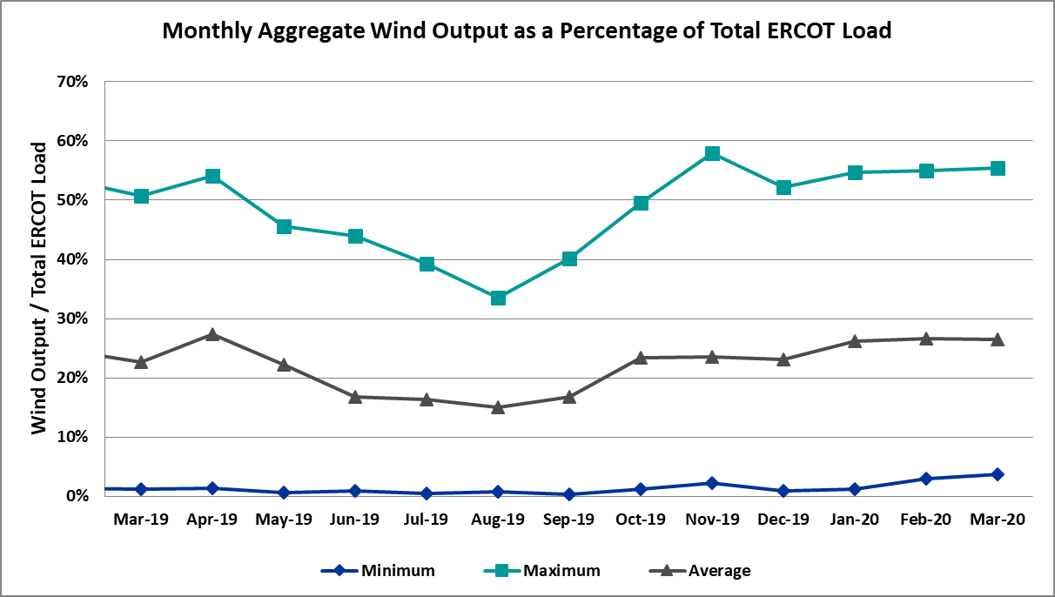

Wind Generation Record: 20,066 MW on 01/08/2020 at 22:18
Wind Penetration Record: 57.88% on 11/26/2019 03:52

Largest Net-Load Ramp
The net-load ramp is defined as the change in net-load (load minus wind and PVGR generation) during the defined time horizon. Such a variation in net-load needs to be accommodated in grid operations to ensure that the reliability of the grid is satisfactorily maintained. The largest net-load ramp during 5-min, 10-min, 15-min, 30-min and 60-min in Mar 2020 is 979 MW, 1406 MW, 1650 MW, 2642 MW, and 4660 MW, respectively. The comparison with respect to the historical values is given in the table below.

Month and Year | 5 min | 10 min | 15 min | 30 min | 60 min
Mar 2020 | 979 MW | 1406 MW | 1650 MW | 2642 MW | 4660 MW
Mar 2014 | 822 MW | 1381 MW | 1895 MW | 3237 MW | 5257 MW
Mar 2015 | 956 MW | 1615 MW | 2146 MW | 3341 MW | 5661 MW
Mar 2016 | 979 MW | 1635 MW | 2149 MW | 2967 MW | 5070 MW
Mar 2017 | 888 MW | 1522 MW | 1838 MW | 3321 MW | 5395 MW
Mar 2018 | 1375 MW | 1688 MW | 2069 MW | 3576 MW | 5957 MW
Mar 2019 | 919 MW | 1511 MW | 1932 MW | 3194 MW | 5596 MW
2014-2019 | 1494 MW | 1991 MW | 2780 MW | 4109 MW | 7786 MW

COP Error Analysis
COP Error is calculated as the capacity difference between the COP HSL and real-time HSL of the unit. Mean Absolute Error (MAE) stayed high over 9,300 MW until Day-Ahead at 11:00, then dropped significantly to 1,250 MW by Day-Ahead at 14:00. In the following chart, Under-Scheduling Error indicates that COP had less generation capacity than real-time and Over-Scheduling Error indicates that COP had more generation capacity than real-time. Under-Scheduling persisted from beginning of Day-Ahead to end of the Operating Day.
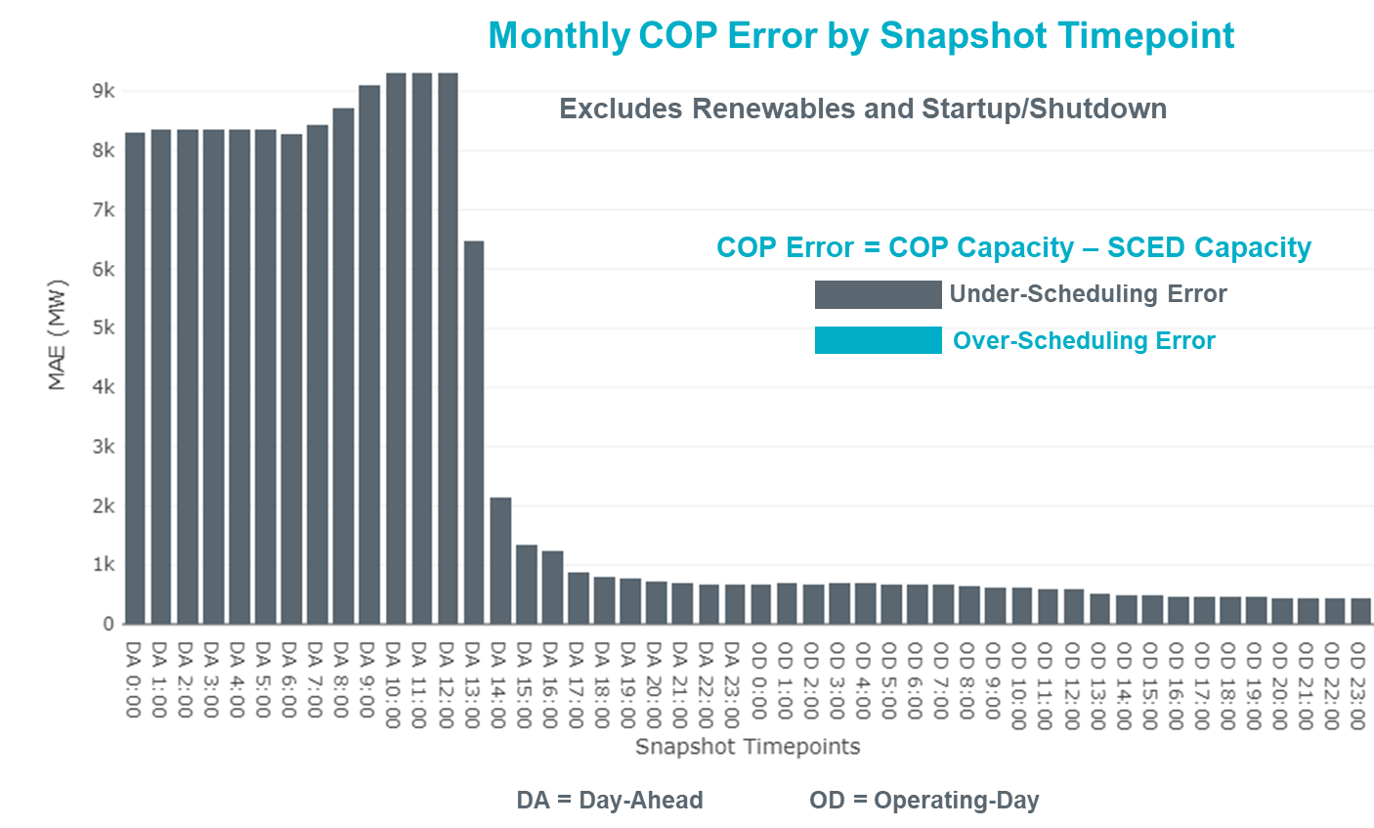

Monthly MAE for the Latest COP at the end of the Adjustment Period was 448 MW with median ranging from -319 MW for Hour-Ending (HE) 21 to 153 MW for HE 8. HE 9 on the 30th had the largest Over-Scheduling Error (1,667 MW) and HE 22 on the 24th had the largest Under-Scheduling Error (-3,050 MW).

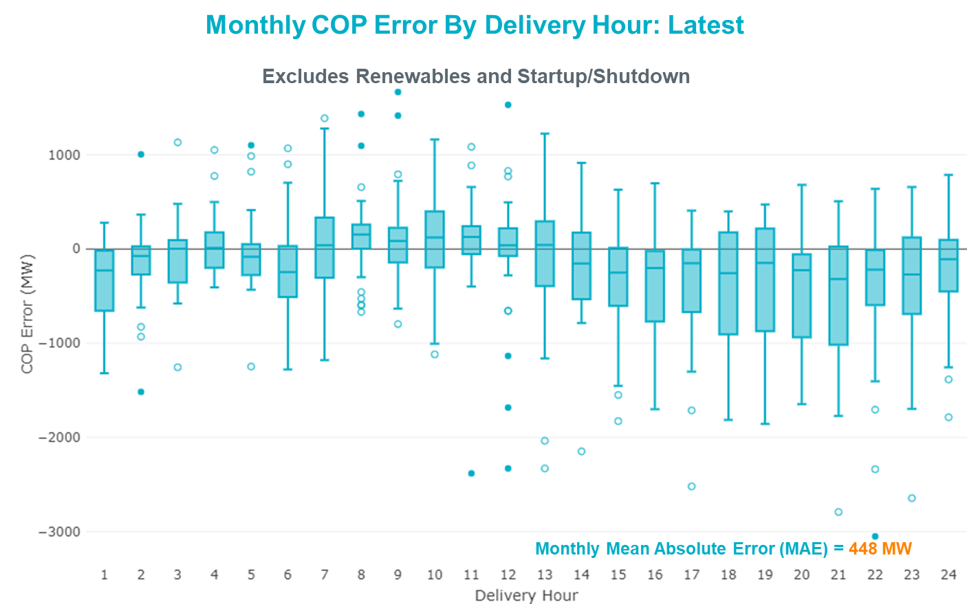

Monthly MAE for the Day-Ahead COP at 12:00 was 9,286 MW with median ranging from -12,514 MW for Hour-Ending (HE) 20 to -6,246 MW for HE 4. HE 18 on the 12th had the largest Under-Scheduling Error (-19,348 MW) and HE 3 on the 4th had the largest Over-Scheduling Error (-162 MW).

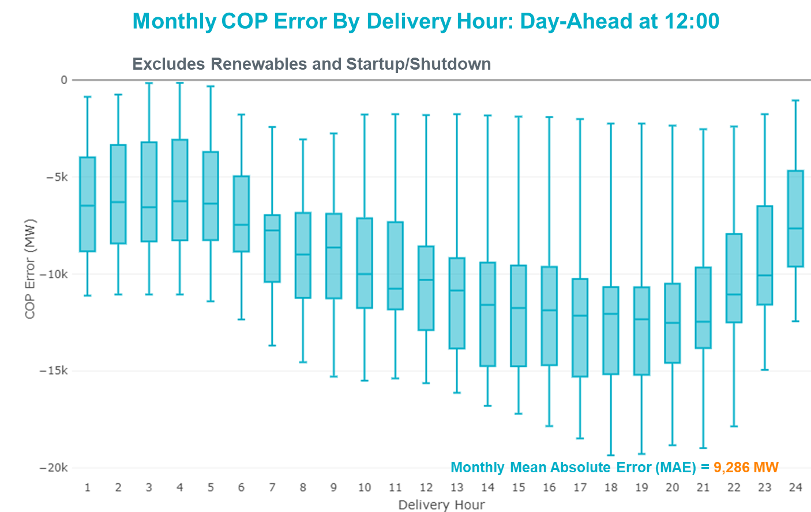

Congestion Analysis

Notable Constraints
Nodal protocol section 3.20 specifies that ERCOT shall identify transmission constraints that are active or binding three or more times within a calendar month. As part of this process, ERCOT reports congestion that meets this criterion to ROS. In addition ERCOT also highlights notable constraints that have an estimated congestion rent exceeding $1,000,000 for a calendar month. These constraints are detailed in the table below. Rows highlighted in blue indicate the congestion was affected by one or more outages. For a list of all constraints activated in SCED, please see Appendix A at the end of this report.

Contingency Name | Overloaded Element | # of Days Constraint Active | Congestion Rent | Transmission Project
MOSS SWITCH to ECTOR COUNTY NORTH SWITCHING STATION LIN _A | Dollarhide - No Trees Switch 138kV | 30 | $49,744,117.82 | Andrews County South Switch - No Trees Switch 138 kV Line (7171)
WINK to DUNE SWITCH and YUKON | Dollarhide - No Trees Switch 138kV | 28 | $38,895,791.82 | Andrews County South Switch - No Trees Switch 138 kV Line (7171)
MOSS SWITCH to ECTOR COUNTY NORTH SWITCHING STATION LIN _A | Andrews County South - Amoco Three Bar Tap 138kV | 17 | $19,623,505.47 | Andrews County South Switch - No Trees Switch 138 kV Line (7171)
WINK to DUNE SWITCH and YUKON | Andrews County South - Amoco Three Bar Tap 138kV | 15 | $19,009,728.61 | Andrews County South Switch - No Trees Switch 138 kV Line (7171)
CRLNW TO LWSSW 345 DBLCKT | Ti Tnp - West Tnp 138kV | 12 | $12,404,210.33
CRLNW TO LWSSW 345 DBLCKT | Argyle - Highlands Tnp 138kV | 12 | $5,595,498.69 | Lewisville - Lewisville Jones - Lakepointe 138 kV Line (45537)
MANUAL TWR(345) HLJ-WAP64 & BLY-WAP72 | Jones Creek - Refuge 345kV | 6 | $5,286,436.70 | Freeport - Bridge the Gap (6673)  Freeport Master Plan (6668A)
POMELO to NORTH EDINBURG LIN 1 | Lobo - Freer 69kV | 22 | $5,153,674.87 | GTC Exit plan in the North Edinburg - Lobo Stability Study Report posted in the ERCOT MIS website
MIDESSA SOUTH SW TRX MDSSW_1_1 345/138 | Trigas Odessa Tap - Odessa Ehv Switch 138kV | 6 | $4,647,781.85 | Riverton-Odessa EHV/Moss 345 kV Line (5445)
SAN MIGUEL 345_138 KV SWITCHYARDS to PAWNEE SWITCHING STATION LIN 1 | Pawnee Switching Station 345kV | 16 | $3,990,785.22
ODESSA EHV SWITCH TRX ODEHV_3_3 345/138 | Odessa Ehv Switch 345kV | 6 | $3,624,522.96 | Riverton-Odessa EHV/Moss 345 kV Line (5445)
GAS PAD to FLAT TOP TNP LIN 1 | 16th Street Tnp - Woodward 2 138kV | 2 | $2,976,982.06 | Solstice: Build 345 kV station (5530) and Solstice to Bakersfield: Build 345 kV line (5539)
DMTSW TO SCOSW 345 DBLCKT | Knapp - Scurry Chevron 138kV | 20 | $2,617,604.00 | Ennis Creek - Cogdell 69 kV Line (4554) & Ennis Creek 138 kV Switching Station (6269)
ODESSA EHV SWITCH to MOSS SWITCH LIN _A | Odessa Ehv Switch - Yarbrough Sub 138kV | 4 | $2,460,184.46 | Riverton-Odessa EHV/Moss 345 kV Line (5445)
Basecase | PNHNDL GTC | 19 | $2,074,003.68 | Panhandle GTC Exit Plan - "PANHANDLE RENEWABLE ENERGY ZONE (PREZ)  STUDY REPORT" on MIS, CONSTRUCT OGALLALA TO BLACKWATER DRAW 345 KV LINE (52245), CONSTRUCT BLACKWATER DRAW TO FOLSOM POINT345 KV LINE (52258), CONSTRUCT BLACKWATER DRAW TO DOUBLE MOUNTAIN (52299), CONSTRUCT DOUBLE MOUNTAIN TO FIDDLEWOOD TO FARMLAND 345 KV L (522307)
WESTSIDE AEP to HOLLY LIN 1 | Arcadia - Southside 138kV | 3 | $1,924,761.40 | Holly - Southside: 138 kV Line Rating Increase (45566)
Goddard to PAWNEE SWITCHING STATION LIN 1 | Lon Hill - Callicoatte 138kV | 9 | $1,846,712.22 | Angstrom - Grissom: Build New Line (50948); North Shore: 345 kV (Chienere LNG) RPG (50966)
ODLAW SWITCHYARD to ASPHALT MINES LIN 1 | Hamilton Road - Maverick 138kV | 22 | $1,796,523.49 | Brackettville to Escondido: Construct 138 kV line (5206)
BOSQUE SWITCH to ELM MOTT LIN 1 | Bosque Switch - Rogers Hill Bepc 138kV | 20 | $1,460,027.69
CPSES TO JONSW 345 AND CPSES TO EVRSW 345 DBLCKT | Wolf Hollow 345 Switch - Mitchell Bend Switch 345kV | 10 | $1,388,185.49 | Mitchell Bend - Rocky Creek 345 kV line (5312)
ODESSA EHV SWITCH to MOSS SWITCH LIN _A | Odessa Ehv Switch 345kV | 4 | $1,387,123.59 | Riverton-Odessa EHV/Moss 345 kV Line (5445)
PAREDES SWITCHING STATION to CENTRAL AVENUE SUB LIN 1 | Rio Hondo - East Rio Hondo Sub 138kV | 25 | $1,334,218.14 | Rebuild Rio Hondo to East Rio Hondo (6687)
SAN MIGUEL 345_138 KV SWITCHYARDS to PAWNEE SWITCHING STATION LIN 1 | San Miguel Gen 345kV | 6 | $1,300,089.39 | San Miguel 345/138 kV autotransformer replacements (5218A, 5218B)
Basecase | NE_LOB GTC | 25 | $1,249,905.44 | GTC Exit plan in the North Edinburg - Lobo Stability Study Report posted in the ERCOT MIS website
YUKON SWITCH to Wink and Dune Sw | Dollarhide - No Trees Switch 138kV | 6 | $1,156,853.76 | Andrews County South Switch - No Trees Switch 138 kV Line (7171)
CPSES TO JONSW 345 AND CPSES TO EVRSW 345 DBLCKT | Wolf Hollow 345 Switch - Comanche Peak Ses 345kV | 5 | $1,105,442.31 | Mitchell Bend - Rocky Creek 345 kV line (5312)
NORTH EDINBURG TRX 1382 345/138 | Burns Sub - Rio Hondo 138kV | 5 | $1,035,882.19 | Rebuild Rio Hondo to East Rio Hondo (6687)
REFUGE to Jones Creek LIN A | Hillje - South Texas Project 345kV | 4 | $966,053.59 | Freeport - Bridge the Gap (6673)  Freeport Master Plan (6668A)
MANUAL TWR(345) HLJ-WAP64 & BLY-WAP72 | Refuge - South Texas Project 345kV | 6 | $917,497.86 | Freeport - Bridge the Gap (6673)  Freeport Master Plan (6668A)
POMELO to NORTH EDINBURG LIN 1 | Laredo Vft North - Las Cruces 138kV | 11 | $910,691.12 | Laredo - Del Mar: 138 kV Line Rebuild (45511)
ARMSTRONG AEP to YTURRIA SUB LIN 1 | Raymondville 2 138kV | 17 | $900,283.88 | Harlingen SS - Raymondville #2: Convert to 138 kV (6167)
WINK to DUNE SWITCH and YUKON | Odessa Ehv Switch - Yarbrough Sub 138kV | 3 | $899,410.56 | Riverton-Odessa EHV/Moss 345 kV Line (5445)
wett_sand_bluff to wett_bearkat LIN 1 | Carterville - Einstein 138kV | 21 | $837,986.72 | Bearkat Loop - Bearkat to Longshore (45399)
Fergus-Gilles & Horsba 138kV | Flat Rock Lcra - Wirtz 138kV | 16 | $790,552.98 | Wirtz to FlatRock to Paleface Transmission Line Upgrade (4465)
ODESSA EHV SWITCH TRX ODEHV_3_1 345/138 | Odessa Ehv Switch 345kV | 6 | $669,958.41 | Riverton-Odessa EHV/Moss 345 kV Line (5445)
POMELO to NORTH EDINBURG LIN 1 | North Laredo Switch - Piloncillo 138kV | 8 | $657,728.96 | GTC Exit plan in the North Edinburg - Lobo Stability Study Report posted in the ERCOT MIS website
ODESSA to odehv &sbysw 138 | Midessa South Sw 345kV | 8 | $578,995.43 | Riverton-Odessa EHV/Moss 345 kV Line (5445)
Delsol-Pomelo (345) & Garza-Liston (138) | Lobo - Freer 69kV | 19 | $543,714.17 | GTC Exit plan in the North Edinburg - Lobo Stability Study Report posted in the ERCOT MIS website
ZORN - HAYSEN 345KV | Kendall - Cagnon 345kV | 3 | $520,504.04 | Boerne Cico - Comfort - Kendall Transmission Line Upgrade (6982)
SAN MIGUEL GEN to FOWLERTON LIN 1 | Laredo Vft North - Las Cruces 138kV | 8 | $506,402.47 | Laredo - Del Mar: 138 kV Line Rebuild (45511)
Mgses-Qalsw&Odehv-Mdssw 345kV | Trigas Odessa Tap - Odessa Ehv Switch 138kV | 5 | $447,902.91 | Riverton-Odessa EHV/Moss 345 kV Line (5445)
Elmcreek-Sanmigl 345kV | Poteet Sub - Oaks Sub 69kV | 6 | $444,611.84
RIO HONDO to LAS PULGAS LIN 1 | Raymondville 2 138kV | 10 | $444,222.71 | Harlingen SS - Raymondville #2: Convert to 138 kV (6167)
SAN MIGUEL GEN to FOWLERTON LIN 1 | North Laredo Switch - Piloncillo 138kV | 3 | $418,482.49 | Brackettville to Escondido: Construct 138 kV line (5206)
Berghe-Kendal 345kv & Welfar-Boerne 138kv | Kerrville Stadium - Verde Creek 138kV | 3 | $343,099.18
Goddard to PAWNEE SWITCHING STATION LIN 1 | Rincon - Melon Creek 138kV | 5 | $327,905.10 | Angstrom - Grissom: Build New Line (50948); North Shore: 345 kV (Chienere LNG) RPG (50966)
Solstice to FORT STOCKTON PLANT LIN 1 | Alpine - Bronco 69kV | 27 | $327,432.86
SALSW TO KLNSW 345 DBLCKT | Harker Heights South - Killeen Switch 138kV | 5 | $325,040.39
Bighil-Kendal 345kV | Yellow Jacket - Treadwell 138kV | 14 | $316,967.12
LAQUINTA to LOBO LIN 1 | Bruni Sub 138kV | 20 | $300,063.90
BLUFF CREEK TRX BLUF_CRK_3_2 345/138 | Tennyson - Nicole 138kV | 4 | $279,398.08
Pig Creek to Solstice LIN 1 | Odessa Ehv Switch - Yarbrough Sub 138kV | 4 | $250,691.51 | Riverton-Odessa EHV/Moss 345 kV Line (5445)
WICHITA FALLS SOUTH SWITCH to NEWPORT BEPC LIN _E | Bowie 138kV | 9 | $236,287.87 | Bowie Autotransformer Replacement (52275)
LCRANE TO KINGMO AND CASTIL 138 KV | Rio Pecos - Crane Lcra 138kV | 5 | $226,067.82
WESTSIDE AEP to HOLLY LIN 1 | Holly - Southside 138kV | 6 | $222,135.83
ZORN - HAYSEN 345KV | Kerrville Stadium - Verde Creek 138kV | 3 | $219,443.58
BRACKETTVILLE to HAMILTON ROAD LIN 1 | Hamilton Road - Maverick 138kV | 15 | $214,928.18 | Brackettville to Escondido: Construct 138 kV line (5206)
HAYS ENERGY to ZORN LIN 1 | Zorn - Hays Energy 345kV | 4 | $211,576.13
Basecase | N_TO_H GTC | 9 | $160,760.67
HIWAY_9 - CITGO_NO & INDUSTRI 69kV & 138 kV | Morris Street - Nueces Bay 138kV | 3 | $145,115.38
TOMBSTONE to Lynx LIN 1 | 16th Street Tnp - Woodward 2 138kV | 6 | $140,875.55 | Solstice: Build 345 kV station (5530) and Solstice to Bakersfield: Build 345 kV line (5539)
Delsol-Pomelo (345) & Garza-Liston (138) | North Laredo Switch - Piloncillo 138kV | 7 | $122,239.93 | Brackettville to Escondido: Construct 138 kV line (5206)
SAN MIGUEL 345_138 KV SWITCHYARDS to PAWNEE SWITCHING STATION LIN 1 | San Miguel Gen 138kV | 3 | $120,194.06 | San Miguel 345/138 kV autotransformer replacements (5218A, 5218B)
FAIRLAND to CORONADO LIN 1 | Flat Rock Lcra - Wirtz 138kV | 6 | $109,038.99 | Wirtz to FlatRock to Paleface Transmission Line Upgrade (4465)
FAIRLAND to CORONADO LIN 1 | Coronado 138kV | 14 | $107,565.73
COMANCHE SWITCH (Oncor) to COMANCHE PEAK SES LIN _A | Holder 138kV | 4 | $105,193.90
COMANCHE SWITCH (Oncor) TRX CMNSW_3_1 345/138 | Holder 138kV | 4 | $103,179.89
MESA VIEW SWITCH to FORT LANCASTER LIN 1 | North Mccamey - Crossover 138kV | 3 | $100,112.23
BLUFF CREEK TRX BLUF_CRK_3_1 345/138 | Bluff Creek 345kV | 5 | $85,044.20
Loss of NEDIN train | Asherton - Catarina 138kV | 3 | $77,371.65 | Brackettville to Escondido: Construct 138 kV line (5206)
ODLAW SWITCHYARD to ASPHALT MINES LIN 1 | Maxwell - Whiting 138kV | 4 | $69,309.91 | Brackettville to Escondido: Construct 138 kV line (5206)
POMELO to DEL SOL LIN 1 | Laredo Vft North - Las Cruces 138kV | 5 | $57,029.84 | Laredo - Del Mar: 138 kV Line Rebuild (45511)
FORT MASON to YELLOW JACKET LIN 1 | Yellow Jacket - Hext Lcra 69kV | 10 | $48,159.56 | Heartland to Yellowjacket: Build 69 kV line (3754)
CHB-KG & JOR-NB 345kV | Bigvue - Power Systems Arco Cogen 138kV | 4 | $45,316.77
Cbfsw-Bwnsw&Bluf_Crk 345kV | Tennyson - Nicole 138kV | 4 | $38,727.04
Basecase | Randado Aep - Zapata 138kV | 16 | $35,810.43 | Zapata: Add 138 kV Reactor (44393)
ODLAW SWITCHYARD to ASPHALT MINES LIN 1 | Escondido - Ganso 138kV | 5 | $27,954.36 | Brackettville to Escondido: Construct 138 kV line (5206)
KLEBERG AEP to LOYOLA SUB LIN 1 | Loyola Sub 138kV | 6 | $26,749.25
SUN SWITCH to SCURRY SWITCH LIN 1 | Aspermont Aep 138kV | 13 | $23,413.06 | Aspermont: Replace the 138/69 kV autotransformer (6569)
Delsol-Pomelo (345) & Garza-Liston (138) | Laredo Vft North - Las Cruces 138kV | 7 | $22,756.17 | Laredo - Del Mar: 138 kV Line Rebuild (45511)
Solstice to LINTERNA LIN 1 | Fort Stockton Plant - Solstice 138kV | 3 | $19,296.96 | Solstice: Build 345 kV station (5530)
LOFTIN to COTTONWOOD ROAD SWITCH LIN 1 | Bowie 138kV | 7 | $19,150.62 | Bowie Autotransformer Replacement (52275)
CPSES TO CMNSW 345 AND CPSES TO STNVL 138 DBLCKT | Holder 138kV | 3 | $18,372.83
Fergus-Gilles & Horsba 138kV | Coronado 138kV | 4 | $15,555.92
REVEILLE to NORTH LAREDO Switch LIN 1 | Bruni Sub 138kV | 3 | $14,563.59
KING MOUNTAIN SWITCHYARD to ODESSA EHV SWITCH LIN 1 | Fort Stockton Plant - Solstice 138kV | 7 | $13,019.78 | Solstice: Build 345 kV station (5530)
PORTLAND to Gibbs LIN 1 | Whitepoint - Rincon 138kV | 4 | $12,561.73 | Whitepoint Area Improvements (50950)
BAKERSFIELD SWITCHYARD to Big HiLL LIN 1 | Fort Stockton Plant - Solstice 138kV | 3 | $10,131.81 | Solstice: Build 345 kV station (5530)
FORT MASON to YELLOW JACKET LIN 1 | Yellow Jacket - Hext Lcra 69kV | 10 | $9,962.08 | Heartland to Yellowjacket: Build 69 kV line (3754)
Basecase | MCCAMY GTC | 4 | $9,645.42
Berghe-Kendal 345kv & Welfar 138kv | Kendall - Cagnon 345kV | 3 | $8,234.57 | Boerne Cico - Comfort - Kendall Transmission Line Upgrade (6982)
Cenizo-Delsol(345)&Falcnsw-Zapata(13) | Lobo - Freer 69kV | 8 | $7,626.85
SPRING to MYRA LIN 1 | Bowie 138kV | 3 | $7,607.22 | Bowie Autotransformer Replacement (52275)
BRACKETTVILLE to ODLAW SWITCHYARD LIN 1 | Hamilton Road - Maverick 138kV | 8 | $7,523.30 | Brackettville to Escondido: Construct 138 kV line (5206)
FORT MASON to YELLOW JACKET LIN 1 | Mason Switching Station - Hext Lcra 69kV | 2 | $7,115.98 | Mason to North Brady: Rebuild 69 kV line (50900)
MCELMURRAY to ESKOTA SWITCH LIN 1 | Eskota Switch - Longworth 69kV | 7 | $4,848.48 | Scott REA Tap to Eskota 69 kV line: Rebuild 69 kV line (6042)  Wolfgang to Rotan 69 kV line: Rebuild 69 kV line (5970)
Manual from SPUR to SCK including SLTCRKSS 138 kV | Aspermont Aep 138kV | 3 | $3,135.02 | Aspermont: Replace the 138/69 kV autotransformer (6569)
GAS PAD to FLAT TOP TNP LIN 1 | Fort Stockton Plant - Solstice 138kV | 4 | $2,989.04 | Solstice: Build 345 kV station (5530)
SUN SWITCH to SCURRY SWITCH LIN 1 | Wolfgang - Rotan 69kV | 4 | $2,119.61 | Wolfgang to Rotan 69 kV line: Rebuild 69 kV line (5970)
LON HILL to NELSON SHARPE LIN 1 | Celanese Bishop - Nelson Sharpe 138kV | 3 | $1,783.15

Generic Transmission Constraint Congestion
There were 19 days of congestion on the Panhandle GTC, 25 days on the North Edinburg to Lobo GTC, 9 days on the North to Houston, 4 days on the McCamey GTC, and 16 days on Raymondville to Rio Hondo. There was no activity on the remaining GTCs during the month.

Note: This is how many times a constraint has been activated to avoid exceeding a GTC limit, it does not imply an exceedance of the GTC occurred or that the GTC was binding.

Manual Overrides
None.

Congestion Costs for Calendar Year 2020
The following table represents the top twenty active constraints for the calendar year based on the estimated congestion rent attributed to the congestion. ERCOT updates this list on a monthly basis.

Contingency | Binding Element | # of 5-min SCED Intervals | Estimated Congestion Rent | Transmission Project
MOSS SWITCH to ECTOR COUNTY NORTH SWITCHING STATION LIN _A | Dollarhide - No Trees Switch 138kV | 11,906 | 114,137,680.69 | Andrews County South Switch - No Trees Switch 138 kV Line (7171)
WINK to DUNE SWITCH and YUKON | Dollarhide - No Trees Switch 138kV | 10,589 | 75,498,694.92 | Andrews County South Switch - No Trees Switch 138 kV Line (7171)
Manual MDSSW_TRX1_345/138 | Trigas Odessa Tap - Odessa Ehv Switch 138kV | 1,787 | 38,328,997.67 | Riverton-Odessa EHV/Moss 345 kV Line (5445)
Basecase | PNHNDL GTC | 8,773 | 23,730,646.57 | Panhandle GTC Exit Plan - "PANHANDLE RENEWABLE ENERGY ZONE (PREZ)  STUDY REPORT" on MIS
WINK to DUNE SWITCH and YUKON | Andrews County South - Amoco Three Bar Tap 138kV | 2,002 | 23,188,211.21 | Andrews County South Switch - No Trees Switch 138 kV Line (7171)
MOSS SWITCH to ECTOR COUNTY NORTH SWITCHING STATION LIN _A | Andrews County South - Amoco Three Bar Tap 138kV | 1,316 | 21,247,827.71 | Andrews County South Switch - No Trees Switch 138 kV Line (7171)
CRLNW TO LWSSW 345 DBLCKT | Ti Tnp - West Tnp 138kV | 4,079 | 16,054,683.52 | Congestion Management Plan # 4 and Stewart Road: Construct 345 kV cut-in (5604)
CRLNW TO LWSSW 345 DBLCKT | Argyle - Highlands Tnp 138kV | 3,922 | 10,613,392.34 | Lewisville - Lewisville Jones - Lakepointe 138 kV Line (45537)
POMELO to NORTH EDINBURG LIN 1 | Lobo - Freer 69kV | 7,152 | 10,481,884.15 | GTC Exit plan in the North Edinburg - Lobo Stability Study Report posted in the ERCOT MIS website
ODESSA EHV SWITCH TRX ODEHV_3_1 345/138 | Odessa Ehv Switch 345kV | 558 | 8,111,745.70 | Riverton-Odessa EHV/Moss 345 kV Line (5445)
BIG SPRING SWITCH to CHALK_69kV and McDonald Road_138kV | Odessa Ehv Switch 345kV | 257 | 7,736,976.71 | Riverton-Odessa EHV/Moss 345 kV Line (5445)
MOSS SWITCH to ECTOR COUNTY NORTH SWITCHING STATION LIN _A | Odessa Ehv Switch - Yarbrough Sub 138kV | 371 | 7,401,498.44 | Riverton-Odessa EHV/Moss 345 kV Line (5445)
MIDESSA SOUTH SW TRX MDSSW_1_1 345/138 | Trigas Odessa Tap - Odessa Ehv Switch 138kV | 867 | 6,704,480.91 | Riverton-Odessa EHV/Moss 345 kV Line (5445)
DCRMOD28 Odesa-Mdssw&Glnhv 138 kV | Big Three Odessa Tap - Odessa Ehv Switch 138kV | 435 | 6,442,561.35 | Riverton-Odessa EHV/Moss 345 kV Line (5445)
CALF CREEK POI to NATURAL DAM LIN _A | Big Spring West - Stanton East 138kV | 1,440 | 6,065,289.57
MANUAL TWR(345) HLJ-WAP64 & BLY-WAP72 | Jones Creek - Refuge 345kV | 873 | 5,286,436.70 | Freeport - Bridge the Gap (6673)  Freeport Master Plan (6668A)
ODLAW SWITCHYARD to ASPHALT MINES LIN 1 | Hamilton Road - Maverick 138kV | 6,245 | 5,116,383.05 | Brackettville to Escondido: Construct 138 kV line (5206)
ODESSA EHV SWITCH TRX ODEHV_3_3 345/138 | Odessa Ehv Switch 345kV | 411 | 5,058,983.07 | Riverton-Odessa EHV/Moss 345 kV Line (5445)
DMTSW TO SCOSW 345 DBLCKT | Knapp - Scurry Chevron 138kV | 3,509 | 4,563,960.61 | Ennis Creek - Cogdell 69 kV Line (4554) & Ennis Creek 138 kV Switching Station (6269)
HCKSW TO ALLNC 345 AND HCKSW TO RNKSW 345 DBLCKT | Blue Mound - Saginaw Switch 138kV | 440 | 4,325,045.48 | Saginaw 345/138 kV autotransformer (6273)

System Events

ERCOT Peak Load
The unofficial ERCOT peak load for the month was 52,819 MW and occurred on the 26th, during hour ending 17:00.

Load Shed Events
None.

Stability Events
None.

Notable PMU Events
ERCOT analyzes PMU data for any significant system disturbances that do not fall into the Frequency Events category reported in section 2.1. The results are summarized in this section once the analysis has been completed.

There were no PMU events outside of those reported in section 2.1.

DC Tie Curtailment
Date | DC Tie | Curtailing Period | # of Tags Curtailed | Initiating Event | Curtailment Reason
03/04/2020 | DC-L | HE 05:00-07:00 | 3 | Unplanned Outage | Unplanned Outage
03/20/2020 | DC-S | HE 19:00-24:00 | 2 | Unplanned Outage | Unplanned Outage
03/23/2020 | DC-S | HE 20:00-21:00 | 1 | Unplanned Outage | Unplanned Outage

TRE/DOE Reportable Events
- LCRA QSE submitted an OE-417 for 03/08/2020. Reportable Event Type: Physical threat to its facilities

New/Modified/Removed RAS
None.

New Procedures/Forms/Operating Bulletins

None.

Emergency Conditions

OCNs
None.

Advisories
Date and Time | Message
Mar 23 2020 13:30 CPT | ERCOT has postponed the deadline for the posting of the DAM Solution for Operating Day March 24, 2020 due to long solution time.
Mar 26 2020 13:30 CPT | ERCOT has postponed the deadline for the posting of the DAM Solution for Operating Day March 27, 2020 due to long solution time.

Watches
None.

Emergency Notices
Date and Time | Message
Mar 01 2020 04:56 CPT | Transmission Emergency Notice has been issued for the Far West Texas area due to contingency SECNMO28.

Application Performance

TSAT/VSAT Performance Issues
None.

Communication Issues
None.

Market System Issues
None.

Model Updates
The Downstream Production Change (DPC) process allows ERCOT to make changes in the on-line Network Operations Model without loading a completely new model. The purpose of this process is to allow for reliable grid operations as system conditions change between designated Network Operations Model database loads. The DPC process is limited in scope to just those items listed below, with equipment ratings updates being the most common. ERCOT has seen a rise in the use of the DPC process to make on-line updates to the Network Operations Model in recent years, instead of through the standard Network Operations Model Change Request process.

- Static Line ratings (Interim Update)
- Dynamic Line ratings (non-Interim Update)
- Autotransformer ratings (non-Interim Update)
- Breaker and Switch Normal status (Interim Update)
- Contingency Definitions (Interim Update)
- RAP and RAS changes or additions (Interim Update)
- Net Dependable and Reactive Capability (NDCRC) values (Interim Update)
- Impedance Updates (non-Interim)

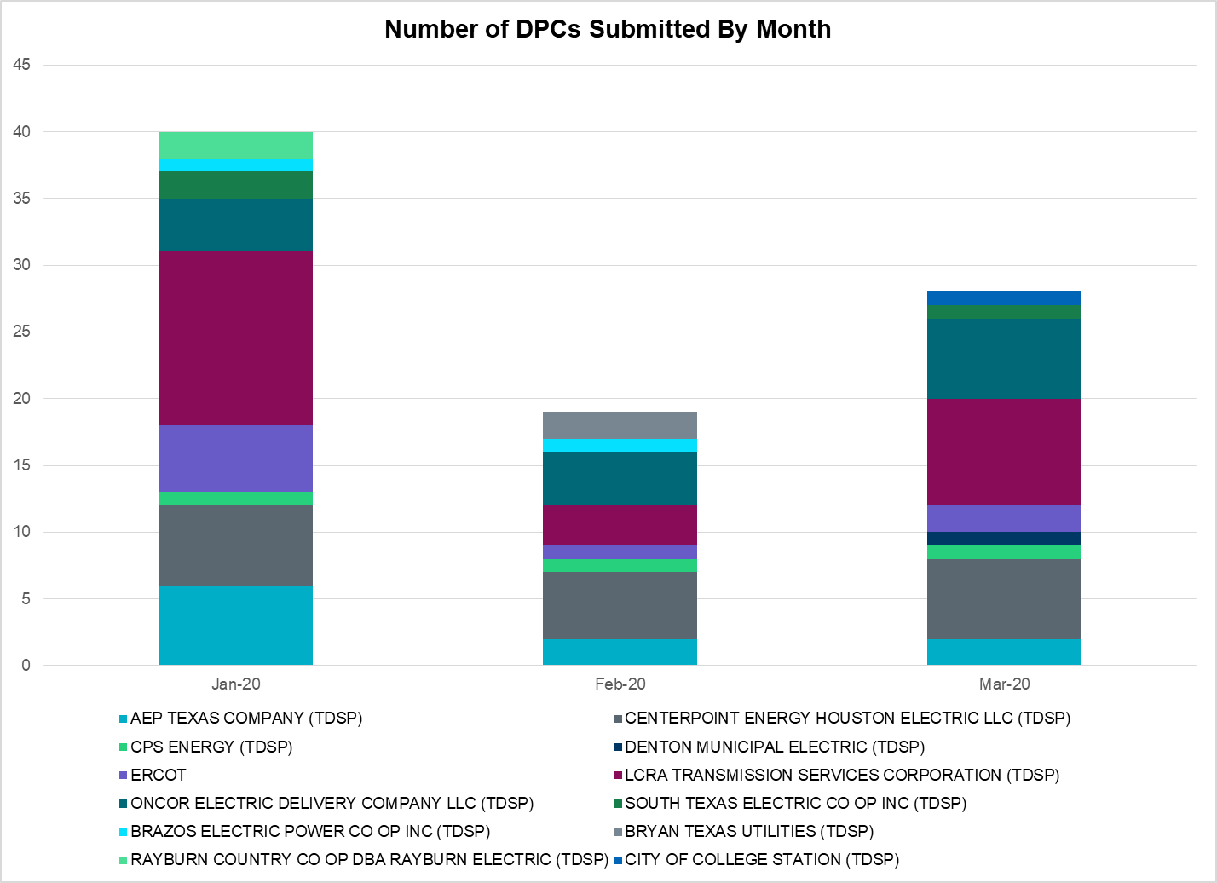

Transmission Operator | Number of DPCs
AEP TEXAS COMPANY (TDSP) | 2
BRAZOS ELECTRIC POWER CO OP INC (TDSP)
BRYAN TEXAS UTILITIES (TDSP)
CENTERPOINT ENERGY HOUSTON ELECTRIC LLC (TDSP) | 6
CITY OF AUSTIN DBA AUSTIN ENERGY (TDSP)
CITY OF COLLEGE STATION (TDSP) | 1
CITY OF GARLAND (TDSP)
CPS ENERGY (TDSP) | 1
DENTON MUNICIPAL ELECTRIC (TDSP) | 1
ELECTRIC TRANSMISSION TEXAS LLC (TDSP)
ERCOT | 2
LCRA TRANSMISSION SERVICES CORPORATION (TDSP) | 8
ONCOR ELECTRIC DELIVERY COMPANY LLC (TDSP) | 6
RAYBURN COUNTRY CO OP DBA RAYBURN ELECTRIC (TDSP)
SHARYLAND UTILITIES LP (TDSP) | 2
SOUTH TEXAS ELECTRIC CO OP INC (TDSP) | 1
TEXAS MUNICIPAL POWER AGENCY (TDSP)
TEXAS-NEW MEXICO POWER CO (TDSP) | 2

Appendix A: Real-Time Constraints
The following is a complete list of constraints activated in SCED. Full contingency descriptions can be found in the Standard Contingencies List located on the MIS secure site at Grid Generation Reliability Unit Commitment.

Contingency | Constrained Element | From Station | To Station | # of Days Constraint Active
SECNMO28 | 6100__F | DHIDE | NOTSW | 30
DWINDUN8 | 6100__F | DHIDE | NOTSW | 28
SSOLFTS8 | ALPINE_BRONCO1_1 | BRONCO | ALPINE | 27
BASE CASE | NE_LOB | n/a | n/a | 25
SMV_PAR8 | RIOHND_ERIOHND_1 | MV_RIOHO | RIOHONDO | 25
SBRAUVA8 | HAMILT_MAVERI1_1 | HAMILTON | MAVERICK | 22
SPOMNED5 | FREER_LOBO1_1 | LOBO | FREER | 22
SW_BW_25 | CRTVLE_EINSTEN_1 | EINSTEIN | CRTRVLLE | 21
SLAQLOB8 | BRUNI_69_1 | BRUNI | BRUNI | 20
SBOSELM5 | 1030__B | BOSQUESW | RGH | 20
DMTSCOS5 | 6437__F | SCRCV | KNAPP | 20
BASE CASE | PNHNDL | n/a | n/a | 19
DDELGA58 | FREER_LOBO1_1 | LOBO | FREER | 19
SECNMO28 | 6100__G | ACSSW | AMTBT | 17
SARMRA38 | RAYMND2_69A1 | RAYMND2 | RAYMND2 | 17
BASE CASE | RV_RH | n/a | n/a | 16
BASE CASE | RANDAD_ZAPATA1_1 | ZAPATA | RANDADO | 16
DFERHOR8 | 38T365_1 | WIRTZ | FLATRO | 16
BASE CASE | RANDAD_ZAPATA1_1 | RANDADO | ZAPATA | 16
SPAWSAN5 | PAWNEE_XF1 | PAWNEE | PAWNEE | 16
SBRAHAM8 | HAMILT_MAVERI1_1 | HAMILTON | MAVERICK | 15
DWINDUN8 | 6100__G | ACSSW | AMTBT | 15
DBIGKEN5 | TREADW_YELWJC1_1 | TREADWEL | YELWJCKT | 14
SFAICOR8 | CORONA_AT4 | CORONA | CORONA | 14
SSCUSU28 | ASPM_69T1 | ASPM | ASPM | 13
DCRLLSW5 | 588_A_1 | LWSVW | LWVTI | 12
DCRLLSW5 | 588_A_1 | LWVTI | LWSVW | 12
DCRLLSW5 | 587__A | ARGYL | LWSVH | 12
SPOMNED5 | LARDVN_LASCRU1_1 | LARDVNTH | LASCRUCE | 11
SFORYEL8 | HEXT_YELWJC1_1 | HEXT | YELWJCKT | 10
SRAYRI28 | RAYMND2_69A1 | RAYMND2 | RAYMND2 | 10
SFORYEL8 | HEXT_YELWJC1_1 | YELWJCKT | HEXT | 10
DCPSJON5 | 6034__A | WOFHO | MBDSW | 10
BASE CASE | N_TO_H | n/a | n/a | 9
SGODPAW5 | CALLIC_LON_HI1_1 | LON_HILL | CALLICOA | 9
SLKAWFS8 | BOW_FMR1 | BOW | BOW | 9
DCE_LO58 | FREER_LOBO1_1 | LOBO | FREER | 8
SODLBRA8 | HAMILT_MAVERI1_1 | HAMILTON | MAVERICK | 8
SPOMNED5 | NLARSW_PILONC1_1 | NLARSW | PILONCIL | 8
DODESBY8 | MDSSW_MR1H | MDSSW | MDSSW | 8
SSANFOW5 | LARDVN_LASCRU1_1 | LARDVNTH | LASCRUCE | 8
DDELGA58 | LARDVN_LASCRU1_1 | LARDVNTH | LASCRUCE | 7
SMCEESK8 | 6780__A | ESKSW | LONGWRTH | 7
SKINODE5 | FTST_SOLSTI1_1 | FTST | SOLSTICE | 7
DDELGA58 | NLARSW_PILONC1_1 | NLARSW | PILONCIL | 7
SCRDLOF9 | BOW_FMR1 | BOW | BOW | 7
SHOLWES8 | HOLLY4_SOUTH_1_1 | HOLLY4 | SOUTH_SI | 6
XOD2E58 | ODEHV_MR2H | ODEHV | ODEHV | 6
DELMSAN5 | POT_OAKS_1 | OAKS9 | POTEETS | 6
XMDS58 | 6475__C | ODEHV | TROTP | 6
SPAWSAN5 | SANMIGL_ATBH | SANMIGL | SANMIGL | 6
MHLJBLY5 | REFSTP27_A | STP | REF | 6
SFAICOR8 | 38T365_1 | WIRTZ | FLATRO | 6
SKLELOY8 | LOYOLA_69_1 | LOYOLA | LOYOLA | 6
XOD3E58 | ODEHV_MR2H | ODEHV | ODEHV | 6
DYKNWIN8 | 6100__F | DHIDE | NOTSW | 6
MHLJBLY5 | JCKREF27_A | REF | JCK | 6
STOMLYN8 | 16TH_WRD2_1 | WOODWRD2 | 16TH_ST | 6
DCPSJON5 | 151__A | CPSES | WOFHO | 5
DSALKLN5 | 630__B | KLNSW | HHSTH | 5
XBL2U58 | BLUF_CRK_T1_H | BLUF_CRK | BLUF_CRK | 5
XNED258 | BURNS_RIOHONDO_1 | RIOHONDO | MV_BURNS | 5
SBRAUVA8 | ESCOND_GANSO1_1 | GANSO | ESCONDID | 5
BASE CASE | FTST_SOLSTI1_1 | FTST | SOLSTICE | 5
DMGSMDS5 | 6475__C | ODEHV | TROTP | 5
DLCRKIN8 | LCRANE_RIOPEC1_1 | RIOPECOS | LCRANE | 5
SGODPAW5 | MELONC_RINCON1_1 | RINCON | MELONCRE | 5
SPOMDEL5 | LARDVN_LASCRU1_1 | LARDVNTH | LASCRUCE | 5
DCHB_NB5 | BCVPSA03_A | PSA | BCV | 4
DCBFBLU5 | NICOLE_TENNYS1_1 | NICOLE | TENNYSON | 4
DCRMO218 | 6500__B | ODEHV | BTHOT | 4
DFERHOR8 | CORONA_AT4 | CORONA | CORONA | 4
BASE CASE | MCCAMY | n/a | n/a | 4
SPIGSOL8 | 6520__E | ODEHV | YARBR | 4
XBLU58 | NICOLE_TENNYS1_1 | NICOLE | TENNYSON | 4
SMDLODE5 | ODEHV_MR2H | ODEHV | ODEHV | 4
SHAYZO25 | 6T227_1 | HAYSEN | ZORN | 4
SHACPB38 | FTST_SOLSTI1_1 | FTST | SOLSTICE | 4
SSCUSU28 | ROTN_WOLFGA1_1 | WOLFGANG | ROTN | 4
SPORGIB8 | RINCON_WHITE_2_1 | WHITE_PT | RINCON | 4
BASE CASE | RIOHND_ERIOHND_1 | MV_RIOHO | RIOHONDO | 4
SMDLODE5 | 6520__E | ODEHV | YARBR | 4
SREFJCK5 | CKT_3124_1 | STP | HLJ | 4
SCMNCPS5 | HLD_FMR1 | HLD | HLD | 4
XCMN58 | HLD_FMR1 | HLD | HLD | 4
SBRAUVA8 | MAXWEL_WHITIN1_1 | MAXWELL | WHITING | 4
XBLU58 | NICOLE_TENNYS1_1 | TENNYSON | NICOLE | 4
MSPUSCK8 | ASPM_69T1 | ASPM | ASPM | 3
SFORYEL8 | HEXT_MASONS1_1 | HEXT | MASONSW | 3
SFORYEL8 | HEXT_MASONS1_1 | MASONSW | HEXT | 3
SHOLWES8 | ARCADI_SOUTH_1_1 | ARCADIA | SOUTH_SI | 3
SHOLNLA8 | BRUNI_69_1 | BRUNI | BRUNI | 3
SPOMDEL5 | FREER_LOBO1_1 | LOBO | FREER | 3
SBAKBIG5 | FTST_SOLSTI1_1 | FTST | SOLSTICE | 3
SWCSBOO8 | FTST_SOLSTI1_1 | FTST | SOLSTICE | 3
SSANFOW5 | NLARSW_PILONC1_1 | NLARSW | PILONCIL | 3
SPAWSAN5 | SANMIGL_ATBL | SANMIGL | SANMIGL | 3
DZORHAY5 | 60T225_1 | KERRST | VERDCR | 3
DBERWE58 | R5_KENDL_1 | KENDAL | CAGNON | 3
SCENDEL5 | FREER_LOBO1_1 | LOBO | FREER | 3
DCE_LO58 | NLARSW_PILONC1_1 | NLARSW | PILONCIL | 3
SCOLPAW5 | CALLIC_LON_HI1_1 | LON_HILL | CALLICOA | 3
DCPSST58 | HLD_FMR1 | HLD | HLD | 3
DHWIND89 | MORRIS_NUECES1_1 | NUECES_B | MORRIS | 3
DZORHAY5 | R5_KENDL_1 | KENDAL | CAGNON | 3
DBERBO58 | 60T225_1 | KERRST | VERDCR | 3
DCC3_NED | ASHERT_CATARI1_1 | ASHERTON | CATARINA | 3
SSTPREF5 | CKT_3124_1 | STP | HLJ | 3
SFTLMES8 | CROSSO_NORTMC1_1 | NORTMC | CROSSOVE | 3
DWINDUN8 | 6520__E | ODEHV | YARBR | 3
SN_SLON5 | CELANE_N_SHAR1_1 | N_SHARPE | CELANEBI | 3
SMYRSPR8 | BOW_FMR1 | BOW | BOW | 3
SSOLFTS8 | 6520__E | ODEHV | YARBR | 2
SMGIENW8 | TRU_UAT1 | TRU | TRU | 2
DBIGKEN5 | SAPOWE_TREADW1_1 | SAPOWER | TREADWEL | 2
SECNMO28 | 6480__D | ECTHP | RLKSW | 2
DCRMO218 | 6520__E | ODEHV | YARBR | 2
SECNMO28 | 6520__E | ODEHV | YARBR | 2
MHLJBLY5 | STPWAP39_1 | STP | WAP | 2
XBLU58 | BALLIN_FTCHAD1_1 | FTCHADBT | BALLINGE | 2
SCISPUT8 | ESTES_PECAN_1_1 | PECAN_BY | ESTES | 2
DCE_RI58 | FREER_LOBO1_1 | LOBO | FREER | 2
DLONWAR5 | MELONC_RINCON1_1 | RINCON | MELONCRE | 2
BASE CASE | VFTNORTH_LEC4_1 | LARDVFTN | LARDVNTH | 2
DCBFBLU5 | BALLIN_FTCHAD1_1 | FTCHADBT | BALLINGE | 2
SSANFOW5 | CATARI_PILONC1_1 | CATARINA | PILONCIL | 2
SSANFOW5 | CATARI_PILONC1_1 | PILONCIL | CATARINA | 2
DDELPOM5 | FREER_LOBO1_1 | LOBO | FREER | 2
SWLFMON8 | FTST_SOLSTI1_1 | FTST | SOLSTICE | 2
SCMNCMN8 | HLD_FMR1 | HLD | HLD | 2
SLOBSA25 | LARDVN_LASCRU1_1 | LARDVNTH | LASCRUCE | 2
SGIBGCG8 | RINCON_WHITE_2_1 | WHITE_PT | RINCON | 2
DRENCRL5 | 588_A_1 | LWSVW | LWVTI | 2
SMDLODE5 | 6475__F | ODESA | ODNTH | 2
DREFSTP5 | CKT_3124_1 | STP | HLJ | 2
SMDLODE5 | FTST_SOLSTI1_1 | FTST | SOLSTICE | 2
SCT2CAR8 | HAMILT_MAXWEL1_1 | MAXWELL | HAMILTON | 2
SWHILON5 | LON_HILL_382H | LON_HILL | LON_HILL | 2
SHACPB38 | RIOPEC_WOODW21_1 | RIOPECOS | WOODWRD2 | 2
SHACPB38 | 16TH_WRD2_1 | WOODWRD2 | 16TH_ST | 2
SSANFOW5 | BRUNI_69_1 | BRUNI | BRUNI | 2
SBRAHAM8 | ESCOND_GANSO1_1 | GANSO | ESCONDID | 2
DGBY_KG5 | GBY_AT2 | GBY | GBY | 2
DELMSAN5 | NORMAN_PETTUS1_1 | PETTUS | NORMANNA | 2
SNWFNOT8 | 6100__G | ACSSW | AMTBT | 2
XBOM358 | 6558__B | FSHSW | WFALS | 2
XBLU58 | ABNTHW_CALLAH1_1 | CALLAHAN | ABNTHWST | 2
DELMSAN5 | BLESSI_LOLITA1_1 | BLESSING | LOLITA | 2
DZORHAY5 | R0_FAIR_1 | R0 | FAIROA | 2
MHLJBLY5 | JCKSTP18_A | STP | JCK | 2
DSALHUT5 | 270__A | KNBSW | TMPSW | 1
SHAYZOR5 | 388T388_1 | HAYSEN | ZORN | 1
DBERWE58 | 415T415_1 | MILLER | HENLY | 1
DMTSCOS5 | 6474__A | SUNSW | MGSES | 1
SMDLODE5 | 6475__C | ODEHV | TROTP | 1
SFLCMDL5 | 6475__F | ODESA | ODNTH | 1
SMOSRLK8 | 6520__E | ODEHV | YARBR | 1
DSTPWHI5 | BLESSI_LOLITA1_1 | BLESSING | LOLITA | 1
SSPRVAL8 | BOW_FMR1 | BOW | BOW | 1
DELMSTP5 | CKT_3124_1 | STP | HLJ | 1
SFT_BAL8 | CLIM_STMBOA1_1 | CLIM | STMBOAT | 1
SWIRJOH8 | CORONA_AT4 | CORONA | CORONA | 1
SFORYEL8 | MASNPH_MASN1_1 | MASN | MASNPHT | 1
DTWIDIV5 | NICOLE_TENNYS1_1 | NICOLE | TENNYSON | 1
SLOBSA25 | NLARSW_PILONC1_1 | NLARSW | PILONCIL | 1
SMEMANA8 | 1580__B | PAYNE | PNKHL | 1
XREN58 | 3750__A | MSLSW | MSHLN | 1
DBERWE58 | 583T583_1 | BANDER | MASOCR | 1
DVENEVR5 | 6300__I | OAKT2 | TATTP | 1
SBKWNVK9 | 6855_D_1 | SMR | SMRTP | 1
DCBFBLU5 | BLUF_C_SOUTHA1_1 | BLUF_CRK | SOUTHABI | 1
DBIGKEN5 | HAMILT_MAXWEL1_1 | MAXWELL | HAMILTON | 1
SPIGSOL8 | TNAF_FTS_1 | FTST | TNAF | 1
SMDLODE5 | 6095__D | LMESA | JPPOI | 1
DBWNKLN5 | CORONA_AT4 | CORONA | CORONA | 1
DSALKLN5 | CORONA_AT4 | CORONA | CORONA | 1
SMELRIN8 | HEARDT_WOODSB1_1 | WOODSBOR | HEARDTAP | 1
DJEWSNG5 | JK_TOKSW_1 | TOKSW | JK_CK | 1
SWOORI28 | LYNX_TOMBST1_1 | LYNX | TOMBSTNE | 1
SCISPUT8 | SOUTHA_VINSON1_1 | SOUTHABI | VINSON | 1
SLWSCRL5 | 588_A_1 | LWSVW | LWVTI | 1
DBERWE58 | 60T225_1 | KERRST | VERDCR | 1
SECNMO28 | 6100__B | AMTBT | DHIDE | 1
XBLU58 | BLUF_C_SOUTHA1_1 | BLUF_CRK | SOUTHABI | 1
SBOWBNT9 | BOW_FMR1 | BOW | BOW | 1
DHARRIO5 | BURNS_RIOHONDO_1 | RIOHONDO | MV_BURNS | 1
SHOLNLA8 | CATARI_PILONC1_1 | PILONCIL | CATARINA | 1
SCENLOB5 | GODDAR_PAWNEE1_1 | GODDARD | PAWNEE | 1
DZORHAY5 | KENDAL_AT4H | KENDAL | KENDAL | 1
DDELPOM5 | LARDVN_LASCRU1_1 | LARDVNTH | LASCRUCE | 1
SSIEMOL8 | LARDVN_LASCRU1_1 | LARDVNTH | LASCRUCE | 1
SCOLPAW5 | MELONC_RINCON1_1 | RINCON | MELONCRE | 1
SFTLMES8 | MIDW_OZONA1_1 | MIDW | OZONA | 1
DSTPRED5 | MRK_VNVL_1 | MRKHMSW | VNVLKSW | 1
SFLCMDL5 | ODEHV_MR2H | ODEHV | ODEHV | 1
DCBFBLU5 | ORNT_REDCRE1_1 | ORNT | REDCREEK | 1
XSA2N58 | PAWNEE_XF1 | PAWNEE | PAWNEE | 1
SPAWSAN5 | SANMIGL_ATAH | SANMIGL | SANMIGL | 1
DCBFBLU5 | SOUTHA_VINSON1_1 | SOUTHABI | VINSON | 1
SENSENS8 | TRU_UAT1 | TRU | TRU | 1
SSALFPP5 | 174T177_1 | FAYETT | SALEM | 1
SDENN_D8 | 588_A_1 | LWSVW | LWVTI | 1
SENSENS8 | 940__C | ENWSW | WXHCH | 1
SABSBLU8 | ABNTHW_CALLAH1_1 | CALLAHAN | ABNTHWST | 1
SLOBSA25 | ASHERT_CATARI1_1 | ASHERTON | CATARINA | 1
DCBFBLU5 | COLETA_COLE_I1_1 | COLE_IVI | COLETAP | 1
DBERAN58 | CORONA_AT4 | CORONA | CORONA | 1
DRENCRL5 | CRLNW_MR1H | CRLNW | CRLNW | 1
SODLBRA8 | ESCOND_GANSO1_1 | GANSO | ESCONDID | 1
SPOMNED5 | LASCRU_MILO1_1 | LASCRUCE | MILO | 1
BASE CASE | LENSW_PUTN2_1 | LENSW | PUTN | 1
STNA16T8 | LYNX_TOMBST1_1 | LYNX | TOMBSTNE | 1
SNEDLON5 | NLARSW_PILONC1_1 | NLARSW | PILONCIL | 1
XNED258 | WES_MV_W_1 | WESLACO | MV_WESL4 | 1
DZORHAY5 | 28T110_1 | CORONA | FAIRLA | 1
DGILHOR8 | 43T365_1 | FLATRO | PALEPE | 1
DVENEVR5 | 6020__A | CRTLD | CDHSW | 1
SCMNCPS5 | 651__B | CMNSW | CMNTP | 1
SAVMBSP8 | 6610__A | BUZSW | CHATP | 1
DSTPRED5 | BAY_SARG_1 | BAYCTYS | SARGNTS | 1
DSTPRED5 | CKT_3124_1 | STP | HLJ | 1
SPIGSOL8 | RIOPEC_WOODW21_1 | WOODWRD2 | RIOPECOS | 1
DGIBZEN5 | SNGZEN99_A | SNG | ZEN | 1
SBOSELM5 | WHTNY_HT1H | WHTNY | WHTNY | 1
SKENKEN8 | 38T365_1 | WIRTZ | FLATRO | 1
DVENLIG5 | 530__C | VENSW | BRTRD | 1
DMGSQAL5 | 6095__D | LMESA | JPPOI | 1
DFLCMGS5 | 6475__F | ODESA | ODNTH | 1
XGRS58 | 6635__G | ESTLD | MRVLY | 1
DCBFBLU5 | ABNTHW_CALLAH1_1 | CALLAHAN | ABNTHWST | 1
DBONRIO5 | BURNS_RIOHONDO_1 | RIOHONDO | MV_BURNS | 1
DDELPOM5 | CATARI_PILONC1_1 | PILONCIL | CATARINA | 1
DBIGKEN5 | COLETA_COLE_I1_1 | COLE_IVI | COLETAP | 1
XNED258 | HAINE__LA_PAL1_1 | LA_PALMA | HAINE_DR | 1
DDELPOM5 | NLARSW_PILONC1_1 | NLARSW | PILONCIL | 1
DELMSAN5 | PLESNTN_TORDLO_1 | TORDILLO | PLSNTOS | 1
SBREHIG8 | 367T347_1 | MAXZUE | GAYHIL | 1
DGILHOR8 | 38T365_1 | WIRTZ | FLATRO | 1
DWINDUN8 | 6100__B | AMTBT | DHIDE | 1
MMDS58 | 6475__C | ODEHV | TROTP | 1
SPOMNED5 | ASHERT_CATARI1_1 | CATARINA | ASHERTON | 1
SGODPAW5 | CALLIC_HAISLE1_1 | CALLICOA | HAISLEY | 1
DDELGA58 | CATARI_PILONC1_1 | PILONCIL | CATARINA | 1
SN_SLON5 | CELANE_KLEBER1_1 | CELANEBI | KLEBERG | 1
SBRAHAM8 | GANSO_MAVERI1_1 | MAVERICK | GANSO | 1
SOXYIN28 | I_DUPP_I_DUPS1_1 | I_DUPP1 | I_DUPSW | 1
SHAYBER5 | KENDAL_AT4H | KENDAL | KENDAL | 1
SDELLAR8 | LARDVN_LASCRU1_1 | LARDVNTH | LASCRUCE | 1
DWH_STP5 | MELONC_RINCON1_1 | RINCON | MELONCRE | 1
SCENDEL5 | NLARSW_PILONC1_1 | NLARSW | PILONCIL | 1
SPOMDEL5 | NLARSW_PILONC1_1 | NLARSW | PILONCIL | 1
BASE CASE | NWF_NOTSW_1 | NWF | NOTSW | 1
BASE CASE | SWEETWN3_XF31 | SWEETWN3 | SWEETWN3 | 1
SFLAPIG8 | TNAF_TNFS_1 | TNAF | 16TH_ST | 1
SNCRELM8 | WEAST_XF1H | WEAST | WEAST | 1

This is the hourly integrated peak demand as published in the ERCOT D&E report.

