February 2020 ERCOT Monthly Operations Report
Reliability and Operations Subcommittee Meeting
April 2, 2020

Table of Contents
1. Report Highlights 2
2. Frequency Control 3
2.1. Frequency Events 3
2.2. Responsive Reserve Events 4
2.3. Load Resource Events 4
3. Reliability Unit Commitment 4
4. Wind Generation as a Percent of Load 5
5. Largest Net-Load Ramp 5
6. COP Error Analysis 6
7. Congestion Analysis 8
7.1. Notable Constraints 8
7.2. Generic Transmission Constraint Congestion 12
7.3. Manual Overrides 12
7.4. Congestion Costs for Calendar Year 2020 12
8. System Events 14
8.1. ERCOT Peak Load 14
8.2. Load Shed Events 14
8.3. Stability Events 14
8.4. Notable PMU Events 14
8.5. DC Tie Curtailment 14
8.6. TRE/DOE Reportable Events 14
8.7. New/Modified/Removed RAS 14
8.8. New Procedures/Forms/Operating Bulletins 14
9. Emergency Conditions 15
9.1. OCNs 15
9.2. Advisories 15
9.3. Watches 15
9.4. Emergency Notices 15
10. Application Performance 15
10.1. TSAT/VSAT Performance Issues 15
10.2. Communication Issues 15
10.3. Market System Issues 16
11. Model Updates 16
Appendix A: Real-Time Constraints 18

Report Highlights
- The unofficial ERCOT peak was 56,116 MW.
- There were 3 frequency events.
- There were 3 instances where Responsive Reserves were deployed.
- There were 5 RUC commitments.
- Congestion in Panhandle Area can mostly attribute to high wind generation. Congestion in the Far West Area can mostly be attributed to low conventional, renewable generation with high loads, and planned outages. Congestion in the South, North, and Houston LZs were mostly due to planned outages. There were 21 days of congestion on the Panhandle GTC, 26 days on the North Edinburg to Lobo GTC, 7 day on the McCamey GTC, and Raymondville to Rio Hondo. There was no activity on the remaining GTCs during the month.
- There were 2 DC Tie curtailments.

Frequency Control

Frequency Events
The ERCOT Interconnection experienced one frequency event, which resulted from units’ trip. The average event duration was 00:06:20.

A summary of the frequency events is provided below. The reported frequency events meet one of the following criteria: Delta Frequency is 60 mHz or greater; the MW loss is 350 MW or greater; resource trip event triggered RRS deployment. Frequency events that have been identified as Frequency Measurable Events (FME) for purposes of BAL-001-TRE-1 analysis are highlighted in blue. When analyzing frequency events, ERCOT evaluates PMU data according to industry standards. Events with an oscillating frequency of less than 1 Hz are considered to be inter-area, while higher frequencies indicate local events. Industry standards specify that damping ratio for inter-area oscillations should be 3.0% or greater. For the frequency events listed below, the ERCOT system met these standards and transitioned well after each disturbance.

Date and Time | Delta Frequency | Max/Min Frequency | Duration of Event | PMU Data |  | MW Loss | Load | Wind | Inertia
 | (Hz) | (Hz) |  | Oscillation Mode (Hz) | Damping Ratio |  | (MW) | % | (GW-s)
2/6/2020 1:16 | 0.102 | 59.904 | 0:05:12 | N/A | N/A | 595.56 | 45,134 | 13% | 280,980
2/6/2020 21:22 | 0.153 | 59.863 | 0:06:49 | 0.03 | 12% | 622.643 | 48,300 | 17% | 258,881
2/10/2020 16:07 | 0.151 | 59.860 | 0:06:58 | 0.67 | 4% | 510.026 | 43,864 | 10% | 253,543

(Note: All data on this graph encompasses frequency event analysis based on BAL-001-TRE-1.)

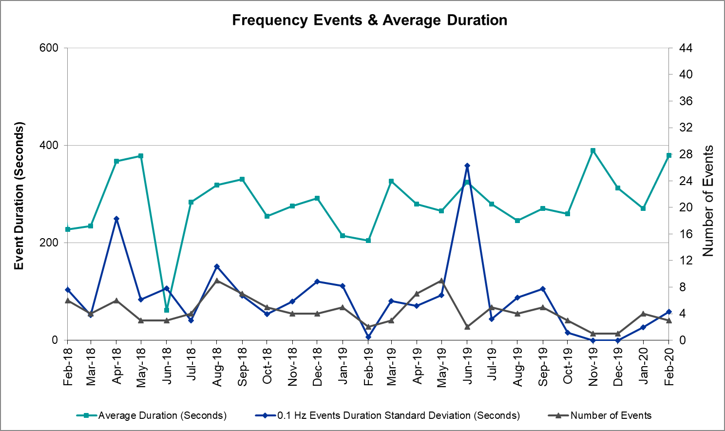

Note that the large standard deviation in June 2019 is due to coincidental extreme high and low durations for a small set of events (2).

Responsive Reserve Events
There were 3 events where Responsive Reserve MWs were released to SCED. The events highlighted in blue were related to frequency events reported in Section 2.1 above.

Date and Time Released to SCED | Date and Time Recalled | Duration of Event | Maximum MWs Released | Comments
2/6/2020 1:16 | 2/6/2020 1:20 | 0:03:52 | 429
2/6/2020 21:22 | 2/6/2020 21:29 | 0:06:32 | 845
2/10/2020 16:07 | 2/10/2020 16:13 | 0:06:32 | 854

Load Resource Events
No Load Resource Events.

Reliability Unit Commitment
ERCOT reports on Reliability Unit Commitments (RUC) on a monthly basis. Commitments are reported grouped by operating day and weather zone. The total number of hours committed is the sum of the hours for all the units in the specified region. Additional information on RUC commitments can be found on the MIS secure site at Grid Generation Reliability Unit Commitment.

There were no DRUC commitments.

There was 5 HRUC commitment.

Resource Location | # of Resources | Operating Day | Total # of Hours Committed | Total MWhs | Reason for Commitment
Far West | 1 | 2/4/2020 | 2 | 146 | SECNM028
Far West | 1 | 2/19/2020 | 1 | 171 | DFLCMGS5
Far West | 1 | 2/20/2020 | 8 | 1,368 | DFLCMGS5, MMDS58
Far West | 1 | 2/26/2020 | 2 | 145 | SECNMO28
Far West | 1 | 2/27/2020 | 1 | 78 | SECNMO28

Wind Generation as a Percent of Load
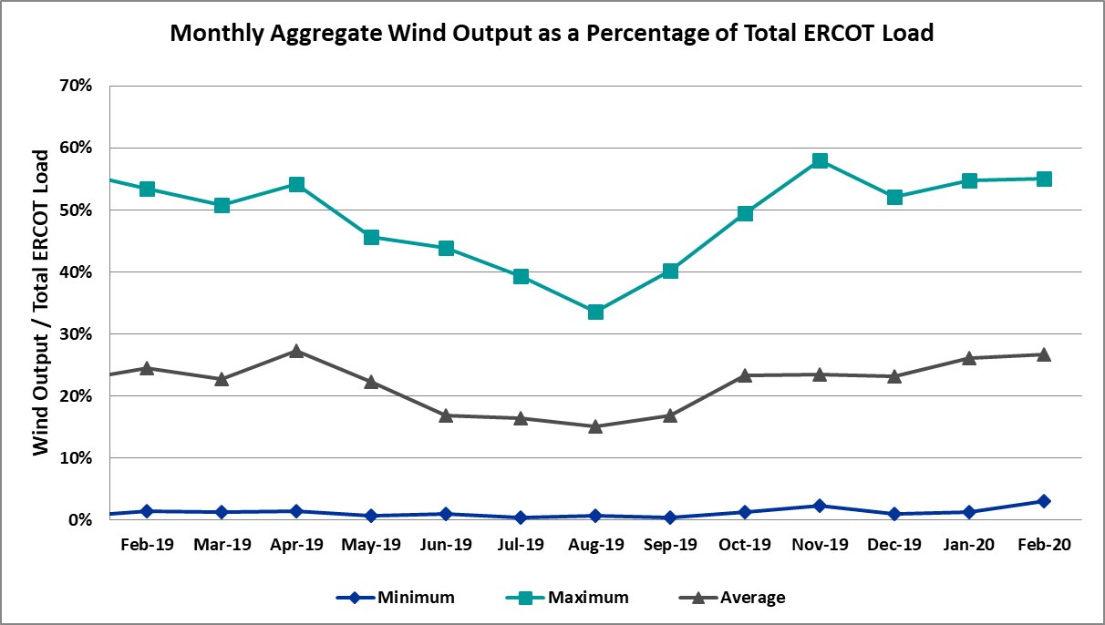

Wind Generation Record: 20,066 MW on 01/08/2020 at 22:18
Wind Penetration Record: 57.88% on 11/26/2019 03:52

Largest Net-Load Ramp
The net-load ramp is defined as the change in net-load (load minus wind and PVGR generation) during the defined time horizon. Such a variation in net-load needs to be accommodated in grid operations to ensure that the reliability of the grid is satisfactorily maintained. The largest net-load ramp during 5-min, 10-min, 15-min, 30-min and 60-min in Feb 2020 is 1173 MW, 1777 MW, 2198 MW, 4107 MW, and 7430 MW, respectively. The comparison with respect to the historical values is given in the table below.

Month and Year | 5 min | 10 min | 15 min | 30 min | 60 min
Feb 2020 | 1173 MW | 1777 MW | 2198 MW | 4107 MW | 7430 MW
Feb 2014 | 971 MW | 1610 MW | 2164 MW | 3516 MW | 5960 MW
Feb 2015 | 1131 MW | 1763 MW | 2469 MW | 4031 MW | 6910 MW
Feb 2016 | 999 MW | 1658 MW | 2144 MW | 3504 MW | 5923 MW
Feb 2017 | 1051 MW | 1744 MW | 2268 MW | 3228 MW | 5346 MW
Feb 2018 | 1494 MW | 1706 MW | 2003 MW | 3419 MW | 5628 MW
Feb 2019 | 1094 MW | 1793 MW | 2388 MW | 3718 MW | 6540 MW

COP Error Analysis
COP Error is calculated as the capacity difference between the COP HSL and real-time HSL of the unit. Mean Absolute Error (MAE) stayed high over 8,700 MW until Day-Ahead at 8:00, then dropped significantly to 1,251 MW by Day-Ahead at 15:00. In the following chart, Under-Scheduling Error indicates that COP had less generation capacity than real-time and Over-Scheduling Error indicates that COP had more generation capacity than real-time. Under-Scheduling persisted from beginning of Day-Ahead to end of the Operating Day with the exception of eight hours. However, COP error for the Operating Hour freezes after the Adjustment Period.

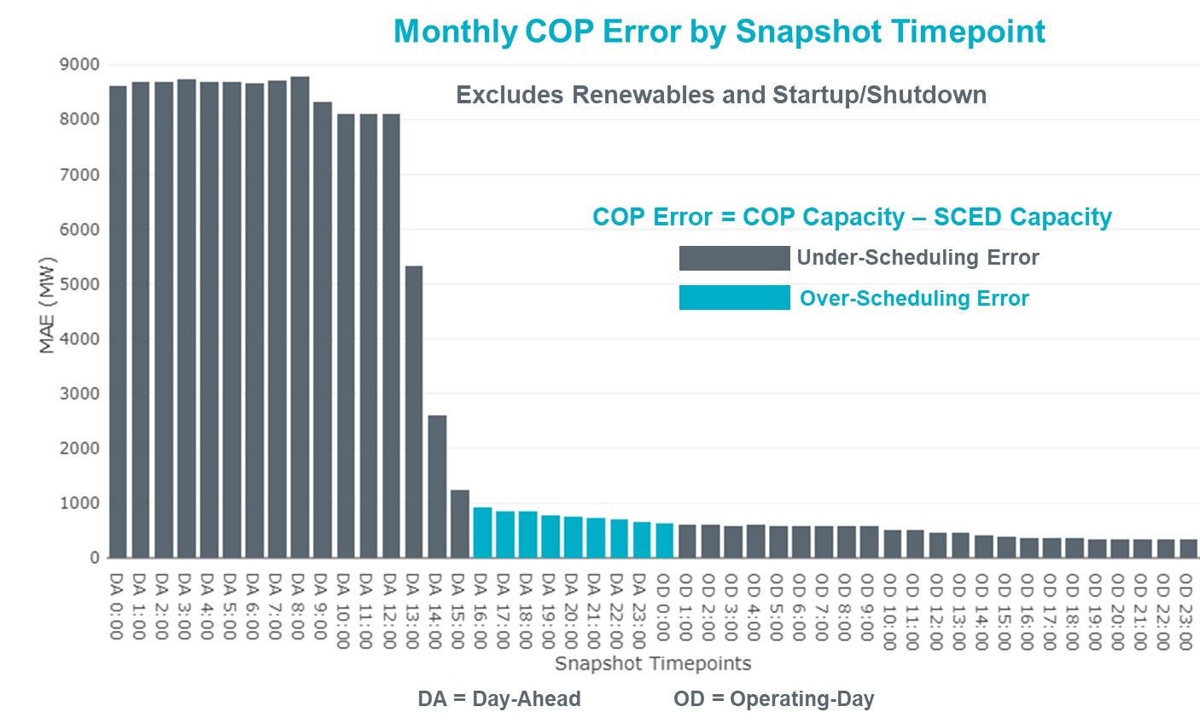

Monthly MAE for the Latest COP at the end of the Adjustment Period was 344 MW with median ranging from -196 MW for Hour-Ending (HE) 9 to 76 MW for HE 14. HE 1 on the 9th had the largest Over-Scheduling Error (1,875 MW) and HE 11 on the 12th had the largest Under-Scheduling Error (-2,897 MW).

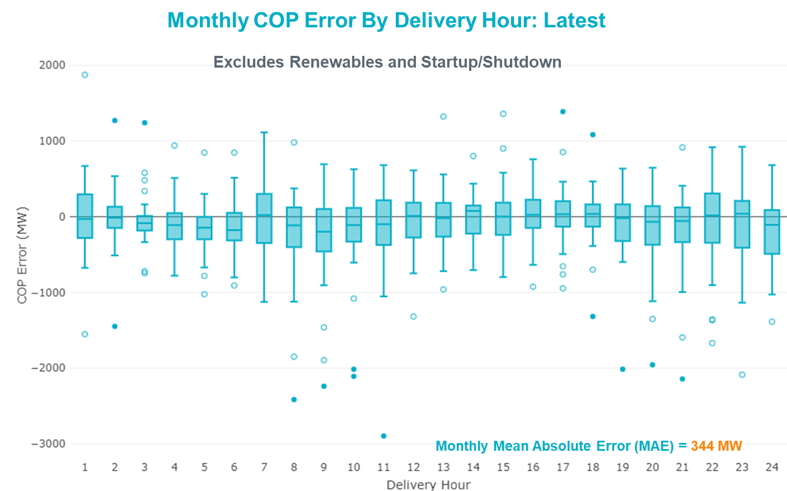

Monthly MAE for the Day-Ahead COP at 12:00 was 8,103 MW with median ranging from -8,538 MW for Hour-Ending (HE) 9 to -4,549 MW for HE 24. HE 8 on the 14th had the largest Under-Scheduling Error (-20,922 MW) and HE 4 on the 3rd had the largest Over-Scheduling Error (1,114 MW).

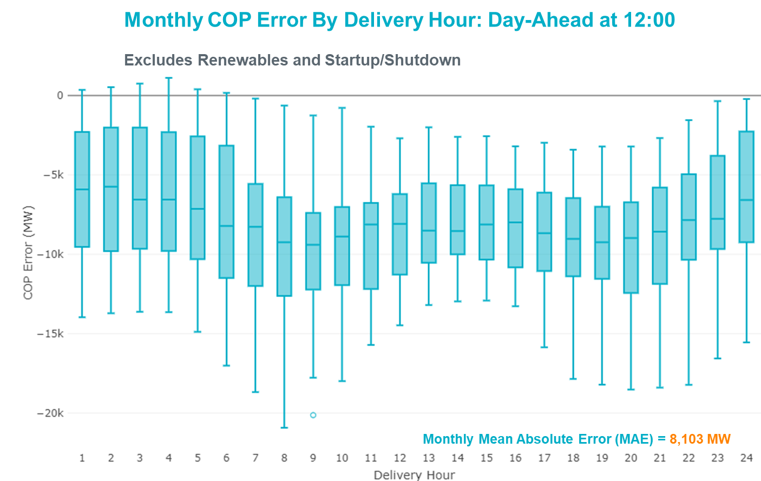

Congestion Analysis

Notable Constraints
Nodal protocol section 3.20 specifies that ERCOT shall identify transmission constraints that are active or binding three or more times within a calendar month. As part of this process, ERCOT reports congestion that meets this criterion to ROS. In addition ERCOT also highlights notable constraints that have an estimated congestion rent exceeding $1,000,000 for a calendar month. These constraints are detailed in the table below. Rows highlighted in blue indicate the congestion was affected by one or more outages. For a list of all constraints activated in SCED, please see Appendix A at the end of this report.

Contingency Name | Overloaded Element | # of Days Constraint Active | Congestion Rent | Transmission Project
MOSS SWITCH to ECTOR COUNTY NORTH SWITCHING STATION LIN _A | Dollarhide - No Trees Switch 138kV | 29 | $47,019,673.96 | Andrews County South Switch - No Trees Switch 138 kV Line (7171)
Manual MDSSW_TRX1_345/138 | Trigas Odessa Tap - Odessa Ehv Switch 138kV | 14 | $38,328,997.67 | Riverton-Odessa EHV/Moss 345 kV Line (5445)
WINK to DUNE SWITCH and YUKON | Dollarhide - No Trees Switch 138kV | 28 | $29,459,821.93 | Andrews County South Switch - No Trees Switch 138 kV Line (7171)
BIG SPRING SWITCH to CHALK_69kV and McDonald Road_138kV | Odessa Ehv Switch 345kV | 5 | $7,736,976.71 | Riverton-Odessa EHV/Moss 345 kV Line (5445)
ODESSA EHV SWITCH TRX ODEHV_3_1 345/138 | Odessa Ehv Switch 345kV | 6 | $7,441,787.29 | Riverton-Odessa EHV/Moss 345 kV Line (5445)
DCRMOD28 Odesa-Mdssw&Glnhv 138 kV | Big Three Odessa Tap - Odessa Ehv Switch 138kV | 7 | $6,442,561.35 | Riverton-Odessa EHV/Moss 345 kV Line (5445)
MOSS SWITCH to ECTOR COUNTY NORTH SWITCHING STATION LIN _A | Odessa Ehv Switch - Yarbrough Sub 138kV | 9 | $6,405,044.18 | Riverton-Odessa EHV/Moss 345 kV Line (5445)
CALF CREEK POI to NATURAL DAM LIN _A | Big Spring West - Stanton East 138kV | 14 | $6,064,797.99
POMELO to NORTH EDINBURG LIN 1 | Lobo - Freer 69kV | 23 | $5,291,462.58 | Lobo to Freer: Rebuild 69 kV line (3901)
CRLNW-LWSSW 345kV | Argyle - Highlands Tnp 138kV | 19 | $3,983,469.53 | Highlands TNP (1974) - Argyle (1984) 138-kV line upgrade (2017-NC 17)
ODESSA EHV SWITCH to ODESSA LIN _D | Midessa South Sw 345kV | 12 | $3,897,516.25 | Riverton-Odessa EHV/Moss 345 kV Line (5445)
WINK to DUNE SWITCH and YUKON | Andrews County South - Amoco Three Bar Tap 138kV | 7 | $3,851,067.55 | Andrews County South Switch - No Trees Switch 138 kV Line (7171)
CRLNW-LWSSW 345kV | Ti Tnp - West Tnp 138kV | 14 | $3,522,580.54 | Congestion Management Plan # 4 and Stewart Road: Construct 345 kV cut-in (5604)
MOSS SWITCH TRX MOSSW_3_2 345/138 | Moss Switch 345kV | 2 | $3,208,650.13 | Riverton-Odessa EHV/Moss 345 kV Line (5445)
Bbses-Rchbr 345kV | Seagoville - Kleberg Tap 138kV | 5 | $2,505,599.64
Falcon Seaboard to MIDLAND EAST LIN _A | Odessa North - Odessa 138kV | 2 | $2,152,704.75 | Riverton-Odessa EHV/Moss 345 kV Line (5445)
WINK to DUNE SWITCH and YUKON | Odessa Ehv Switch - Yarbrough Sub 138kV | 5 | $2,148,340.13 | Riverton-Odessa EHV/Moss 345 kV Line (5445)
MIDESSA SOUTH SW TRX MDSSW_1_1 345/138 | Trigas Odessa Tap - Odessa Ehv Switch 138kV | 7 | $2,056,699.06 | Riverton-Odessa EHV/Moss 345 kV Line (5445)
DMTSW-SCOSW 345KV | Knapp - Scurry Chevron 138kV | 10 | $1,946,356.61 | Ennis Creek - Cogdell 69 kV Line (4554) & Ennis Creek 138 kV Switching Station (6269)
Basecase | PNHNDL GTC | 21 | $1,940,960.56 | LP&L Integration Tie Lines (43367 A,B,C) and Panhandle Loop
YUKON SWITCH to Wink and Dune Sw | Andrews County South - Amoco Three Bar Tap 138kV | 4 | $1,862,075.61 | Andrews County South Switch - No Trees Switch 138 kV Line (7171)
ODESSA EHV SWITCH TRX ODEHV_3_2 345/138 | Odessa Ehv Switch 345kV | 1 | $1,663,376.25 | Riverton-Odessa EHV/Moss 345 kV Line (5445)
ODLAW SWITCHYARD to ASPHALT MINES LIN 1 | Hamilton Road - Maverick 138kV | 20 | $1,600,429.82 | Brackettville to Escondido: Construct 138 kV line (5206)
ZORN - HAYSEN 345KV | Kendall 345kV | 5 | $1,445,657.91
MOSS SWITCH to ECTOR COUNTY NORTH SWITCHING STATION LIN _A | Andrews County South - Amoco Three Bar Tap 138kV | 6 | $1,442,135.33 | Andrews County South Switch - No Trees Switch 138 kV Line (7171)
ODESSA EHV SWITCH TRX ODEHV_3_3 345/138 | Odessa Ehv Switch 345kV | 5 | $1,434,460.12 | Riverton-Odessa EHV/Moss 345 kV Line (5445)
DCRMOD28 Odesa-Mdssw&Glnhv 138 kV | Odessa Ehv Switch - Yarbrough Sub 138kV | 6 | $1,117,534.74 | Riverton-Odessa EHV/Moss 345 kV Line (5445)
MGSES-BITTCR&CCRSW 345kV | Tonkawa Switch - Morgan Creek Ses 345kV | 1 | $1,036,008.20 | Highlands TNP (1974) - Argyle (1984) 138-kV line upgrade (2017-NC 17)
Berghe-Kendal 345kv & Welfar 138kv | Kerrville Stadium - Verde Creek 138kV | 6 | $973,262.24
ODESSA EHV SWITCH to MOSS SWITCH LIN _A | Odessa Ehv Switch 345kV | 3 | $780,900.90 | Riverton-Odessa EHV/Moss 345 kV Line (5445)
Manual LOBO TO SAN MIGUEL 345 kV | North Laredo Switch - Piloncillo 138kV | 6 | $778,411.54 | Brackettville to Escondido: Construct 138 kV line (5206)
GAS PAD to FLAT TOP TNP LIN 1 | Fort Stockton Plant - Solstice 138kV | 13 | $742,605.19 | Solstice: Build 345 kV station (5530)
Lon_Hill-Coleto 345kV&Warburtn 138kV | Pawnee Switching Station - Goddard 345kV | 10 | $700,797.48
SKYWEST to SPRABERRY SWITCH LIN 1 | East Stiles - St. Lawrence 138kV | 4 | $667,909.95
PAREDES SWITCHING STATION to CENTRAL AVENUE SUB LIN 1 | Rio Hondo - East Rio Hondo Sub 138kV | 11 | $637,727.02 | Rebuild Rio Hondo to East Rio Hondo (6687)
WOODWARD 2 to RIO PECOS LIN 1 | Lynx - Tombstone 138kV | 9 | $636,384.85 | Lynx: Expand 138 kV station (45503)
PKRSW-CPSES 345 kV | Mitchell Bend Switch - Decordova Ses 345kV | 5 | $617,853.75 | Mitchell Bend - Rocky Creek 345 kV line (5312)
mdssw TO SBYSW AND ODESA 138 | Big Three Odessa Tap - Odessa Ehv Switch 138kV | 4 | $563,814.10 | Riverton-Odessa EHV/Moss 345 kV Line (5445)
RIOHONDO-BONILLA 345kV & HARLNSW 138kV | Burns Sub - Rio Hondo 138kV | 4 | $554,105.42 | Rebuild Rio Hondo to East Rio Hondo (6687)
ARMSTRONG AEP to YTURRIA SUB LIN 1 | Raymondville 2 138kV | 12 | $459,907.86 | Harlingen SS - Raymondville #2: Convert to 138 kV (6167)
POMELO to NORTH EDINBURG LIN 1 | Laredo Vft North - Las Cruces 138kV | 3 | $386,726.54
Basecase | Rio Hondo - East Rio Hondo Sub 138kV | 11 | $360,922.47 | Rebuild Rio Hondo to East Rio Hondo (6687)
Berghe-Kendal 345kv & Boerne-Espera 138kv | Kerrville Stadium - Verde Creek 138kV | 3 | $335,497.55
Solstice to FORT STOCKTON PLANT LIN 1 | Alpine - Bronco 69kV | 24 | $326,934.18 | "Rehab Alpine to Alpine REA 69 kV line (5968)
Pig Creek to Solstice LIN 1 | Odessa Ehv Switch - Yarbrough Sub 138kV | 4 | $324,646.07 | Riverton-Odessa EHV/Moss 345 kV Line (5445)
Delsol-Pomelo (345) & Garza-Liston (138) | Lobo - Freer 69kV | 22 | $320,895.58 | Lobo to Freer: Rebuild 69 kV line (3901)
Basecase | NE_LOB GTC | 26 | $310,941.93 | GTC Exit plan in the North Edinburg - Lobo Stability Study Report posted in the ERCOT MIS website
REVEILLE to NORTH LAREDO Switch LIN 1 | Bruni Sub 138kV | 8 | $304,905.81
FAIRLAND to CORONADO LIN 1 | Coronado 138kV | 19 | $256,975.72
CPSES-JONSW&EVRSW 345kV | Mitchell Bend Switch - Decordova Ses 345kV | 7 | $255,245.25 | Mitchell Bend - Rocky Creek 345 kV line (5312)
Berghe-Kendal 345kv & Welfar 138kv | Miller Creek - Henly 138kV | 4 | $225,319.13 | Bowie Autotransformer Replacement (52275)
Stp-Hlj&&White_Pt 345kV | Blessing - Lolita 138kV | 7 | $220,919.26 | Tidehaven: Construct New Distribution Station (48776)
WICHITA FALLS SOUTH SWITCH to NEWPORT BEPC LIN _E | Bowie 138kV | 12 | $220,904.75 | Bowie Autotransformer Replacement (52275)
ZORN - HAYSEN 345KV | Kendall - Cagnon 345kV | 7 | $214,473.69 | Boerne Cico - Comfort - Kendall Transmission Line Upgrade (6982)
Bighil-Kendal 345kV | Yellow Jacket - Treadwell 138kV | 8 | $207,680.96 | Treadwell: Build new 138 kV station (6397)
Berghe-Kendal 345kv & Welfar 138kv | Kendall - Cagnon 345kV | 8 | $206,047.42 | Boerne Cico - Comfort - Kendall Transmission Line Upgrade (6982)
Solstice to FORT STOCKTON PLANT LIN 1 | Odessa Ehv Switch - Yarbrough Sub 138kV | 4 | $203,406.49 | Riverton-Odessa EHV/Moss 345 kV Line (5445)
JARDIN to DILLEY SWITCH AEP LIN 1 | Dilley Switch Aep - Cotulla Sub 69kV | 3 | $130,362.56 | Rebuild Dilley to Cotulla 69 kV line (5222)
KING MOUNTAIN SWITCHYARD to ODESSA EHV SWITCH LIN 1 | Fort Stockton Plant - Solstice 138kV | 8 | $115,133.17 | Solstice: Build 345 kV station (5530)
Mgses-Qalsw&Odehv-Mdssw 345kV | Trigas Odessa Tap - Odessa Ehv Switch 138kV | 5 | $112,476.74 | Riverton-Odessa EHV/Moss 345 kV Line (5445)
BLUFF CREEK TRX BLUF_CRK_3_1 345/138 | Tennyson - Nicole 138kV | 3 | $112,212.98
FORT MASON to YELLOW JACKET LIN 1 | Mason Switching Station - Hext Lcra 69kV | 15 | $99,486.90 | Mason to North Brady: Rebuild 69 kV line (50900)
POMELO to NORTH EDINBURG LIN 1 | North Laredo Switch - Piloncillo 138kV | 4 | $98,705.26 | Brackettville to Escondido: Construct 138 kV line (5206)
TWR (345) WHITE_PT-LON_HILL & STP | Blessing - Lolita 138kV | 5 | $85,377.05 | Tidehaven: Construct New Distribution Station (48776)
FORT MASON to YELLOW JACKET LIN 1 | Yellow Jacket - Hext Lcra 69kV | 19 | $81,130.15 | Heartland to Yellowjacket: Build 69 kV line (3754)
LAQUINTA to LOBO LIN 1 | Bruni Sub 138kV | 11 | $77,977.63
BRACKETTVILLE to HAMILTON ROAD LIN 1 | Hamilton Road - Maverick 138kV | 14 | $76,251.29 | Brackettville to Escondido: Construct 138 kV line (5206)
SCOSW-LONG DRAW&FARADAY 345kV | Bluff Creek Switch - Exxon Sharon Ridge 138kV | 6 | $68,925.29
TOMBSTONE to Lynx LIN 1 | 16th Street Tnp - Woodward 2 138kV | 5 | $67,828.37 | Solstice: Build 345 kV station (5530) and Solstice to Bakersfield: Build 345 kV line (5539)
SCOSW-LONG DRAW&FARADAY 345kV | Bluff Creek Switch - Exxon Sharon Ridge 138kV | 6 | $62,199.72
Goddard to PAWNEE SWITCHING STATION LIN 1 | Rincon - Melon Creek 138kV | 4 | $59,482.37 | Angstrom - Grissom: Build New Line (50948); North Shore: 345 kV (Chienere LNG) RPG (50966)
Basecase | MCCAMY GTC | 7 | $51,774.88
LOFTIN to COTTONWOOD ROAD SWITCH LIN 1 | Bowie 138kV | 11 | $50,012.51 | Bowie Autotransformer Replacement (52275)
NEDIN-BONILLA 345kV & HARLNSW 138kV | Burns Sub - Rio Hondo 138kV | 3 | $48,058.63 | Rebuild Rio Hondo to East Rio Hondo (6687)
SUN SWITCH to SCURRY SWITCH LIN 1 | Aspermont Aep 138kV | 15 | $46,637.46 | Aspermont: Replace the 138/69 kV autotransformer (6569)
ENNIS WEST SWITCH to WAXAHACHIE PUMP 1 LIN _C | Trumbull - Ennis Switch 138kV | 5 | $41,842.02
AJO to RIO HONDO LIN 1 | Raymondville 2 138kV | 4 | $41,512.65 | Harlingen SS - Raymondville #2: Convert to 138 kV (6167)
POMELO to NORTH EDINBURG LIN 1 | Bruni Sub 138kV | 3 | $34,263.12
Basecase | RV_RH GTC | 14 | $32,662.73
FORT MASON to YELLOW JACKET LIN 1 | Mason Switching Station - Hext Lcra 69kV | 15 | $32,430.48 | Mason to North Brady: Rebuild 69 kV line (50900)
Goddard to PAWNEE SWITCHING STATION LIN 1 | Lon Hill - Callicoatte 138kV | 3 | $31,404.65 | Angstrom - Grissom: Build New Line (50948); North Shore: 345 kV (Chienere LNG) RPG (50966)
FAIRLAND to CORONADO LIN 1 | Buchanan - Burnet 69kV | 3 | $24,670.10
RIO HONDO to LAS PULGAS LIN 1 | Raymondville 2 138kV | 3 | $24,031.21 | Harlingen SS - Raymondville #2: Convert to 138 kV (6167)
ODLAW SWITCHYARD to ASPHALT MINES LIN 1 | Escondido - Ganso 138kV | 3 | $18,162.70 | Brackettville to Escondido: Construct 138 kV line (5206)
BOSQUE SWITCH to ELM MOTT LIN 1 | Bosque Switch - Rogers Hill Bepc 138kV | 9 | $10,368.24 | Bosque Switch (252) -Olsen TNP (37460) 138-kV line terminal upgrade
Delsol-Pomelo (345) & Garza-Liston (138) | Bruni Sub 138kV | 4 | $10,290.92
MCELMURRAY to ESKOTA SWITCH LIN 1 | Eskota Switch - Longworth 69kV | 12 | $9,741.01 | "Scott REA Tap to Eskota 69 kV line: Rebuild 69 kV line (6042)
Basecase | Fort Stockton Plant - Solstice 138kV | 4 | $7,553.04 | Solstice: Build 345 kV station (5530)
Basecase | Randado Aep - Zapata 138kV | 9 | $7,542.73 | Zapata: Add 138 kV Reactor (44393)
FORT MASON to YELLOW JACKET LIN 1 | Yellow Jacket - Hext Lcra 69kV | 19 | $6,563.60 | Heartland to Yellowjacket: Build 69 kV line (3754)
BRACKETTVILLE to ODLAW SWITCHYARD LIN 1 | Hamilton Road - Maverick 138kV | 7 | $6,132.73 | Brackettville to Escondido: Construct 138 kV line (5206)
FORT LANCASTER to ILLINOIS #4 LIN 1 | Hamilton Road - Maxwell 138kV | 9 | $5,801.50 | Brackettville to Escondido: Construct 138 kV line (5206)
SUN SWITCH to SCURRY SWITCH LIN 1 | Wolfgang - Rotan 69kV | 5 | $2,760.36 | Wolfgang to Rotan 69 kV line: Rebuild 69 kV line (5970)
Delsol-Pomelo (345) & Garza-Liston (138) | Laredo Vft North - Las Cruces 138kV | 4 | $2,644.37
Fergus-Gilles & Horsba 138kV | Flat Rock Lcra - Wirtz 138kV | 4 | $1,800.34 | Wirtz to FlatRock to Paleface Transmission Line Upgrade (4465)
KLEBERG AEP to LOYOLA SUB LIN 1 | Loyola Sub 138kV | 3 | $1,016.38 | Lon Hill: Replace 345/138 kV autotransformers (6101)

Generic Transmission Constraint Congestion
There were 21 days of congestion on the Panhandle GTC, 26 days on the North Edinburg to Lobo GTC, 7 day on the McCamey GTC, and Raymondville to Rio Hondo. There was no activity on the remaining GTCs during the month.

Note: This is how many times a constraint has been activated to avoid exceeding a GTC limit, it does not imply an exceedance of the GTC occurred or that the GTC was binding.

Manual Overrides
None.

Congestion Costs for Calendar Year 2020
The following table represents the top twenty active constraints for the calendar year based on the estimated congestion rent attributed to the congestion. ERCOT updates this list on a monthly basis.

Contingency | Binding Element | # of 5-min SCED Intervals | Estimated Congestion Rent | Transmission Project
MOSS SWITCH to ECTOR COUNTY NORTH SWITCHING STATION LIN _A | Dollarhide - No Trees Switch 138kV | 7,591 | 64,393,562.87 | Andrews County South Switch - No Trees Switch 138 kV Line (7171)
Manual MDSSW_TRX1_345/138 | Trigas Odessa Tap - Odessa Ehv Switch 138kV | 1,715 | 38,328,997.67 | Riverton-Odessa EHV/Moss 345 kV Line (5445)
WINK to DUNE SWITCH and YUKON | Dollarhide - No Trees Switch 138kV | 6,300 | 36,602,903.10 | Andrews County South Switch - No Trees Switch 138 kV Line (7171)
Basecase | PNHNDL GTC | 6,552 | 21,656,642.89 | LP&L Integration Tie Lines (43367 A,B,C) and Panhandle Loop
BIG SPRING SWITCH to CHALK_69kV and McDonald Road_138kV | Odessa Ehv Switch 345kV | 257 | 7,736,976.71 | Riverton-Odessa EHV/Moss 345 kV Line (5445)
ODESSA EHV SWITCH TRX ODEHV_3_1 345/138 | Odessa Ehv Switch 345kV | 291 | 7,441,787.29 | Riverton-Odessa EHV/Moss 345 kV Line (5445)
DCRMOD28 Odesa-Mdssw&Glnhv 138 kV | Big Three Odessa Tap - Odessa Ehv Switch 138kV | 288 | 6,442,561.35 | Riverton-Odessa EHV/Moss 345 kV Line (5445)
MOSS SWITCH to ECTOR COUNTY NORTH SWITCHING STATION LIN _A | Odessa Ehv Switch - Yarbrough Sub 138kV | 285 | 6,405,044.18 | Riverton-Odessa EHV/Moss 345 kV Line (5445)
CALF CREEK POI to NATURAL DAM LIN _A | Big Spring West - Stanton East 138kV | 1,440 | 6,065,289.57
POMELO to NORTH EDINBURG LIN 1 | Lobo - Freer 69kV | 3,503 | 5,328,209.28 | Lobo to Freer: Rebuild 69 kV line (3901)
CRLNW-LWSSW 345kV | Argyle - Highlands Tnp 138kV | 2,497 | 5,017,893.66 | Highlands TNP (1974) - Argyle (1984) 138-kV line upgrade (2017-NC 17)
HCKSW-ALLNC&RNKSW 345kV | Blue Mound - Saginaw Switch 138kV | 440 | 4,325,045.48 | Saginaw 345/138 kV autotransformer (6273)
WINK to DUNE SWITCH and YUKON | Andrews County South - Amoco Three Bar Tap 138kV | 361 | 4,178,482.59 | Andrews County South Switch - No Trees Switch 138 kV Line (7171)
ODESSA EHV SWITCH to ODESSA LIN _D | Midessa South Sw 345kV | 1,324 | 3,897,516.25 | Riverton-Odessa EHV/Moss 345 kV Line (5445)
CPSES-JONSW&EVRSW 345kV | Mitchell Bend Switch - Decordova Ses 345kV | 658 | 3,706,530.78 | Mitchell Bend - Rocky Creek 345 kV line (5312)
CRLNW-LWSSW 345kV | Ti Tnp - West Tnp 138kV | 2,194 | 3,650,473.19 | Congestion Management Plan # 4 and Stewart Road: Construct 345 kV cut-in (5604)
Manual LOBO TO SAN MIGUEL 345 kV | North Laredo Switch - Piloncillo 138kV | 2,218 | 3,441,908.96 | Brackettville to Escondido: Construct 138 kV line (5206)
ODLAW SWITCHYARD to ASPHALT MINES LIN 1 | Hamilton Road - Maverick 138kV | 4,060 | 3,319,859.56 | Brackettville to Escondido: Construct 138 kV line (5206)
MOSS SWITCH TRX MOSSW_3_2 345/138 | Moss Switch 345kV | 158 | 3,208,650.13
MILITARY HIGHWAY AEP to VILLA CAVAZOS LIN 1 | Laureles - La Palma 138kV | 82 | 2,879,779.90

System Events

ERCOT Peak Load
The unofficial ERCOT peak load for the month was 56,116 MW and occurred on the 6th, during hour ending 8:00.

Load Shed Events
None.

Stability Events
None.

Notable PMU Events
ERCOT analyzes PMU data for any significant system disturbances that do not fall into the Frequency Events category reported in section 2.1. The results are summarized in this section once the analysis has been completed.

There were no PMU events outside of those reported in section 2.1.

DC Tie Curtailment
Date | DC Tie | Curtailing Period | # of Tags Curtailed | Initiating Event | Curtailment Reason
02/06/2020 | DC-S | HE8 – 9 | 1 | SBEVSHA8, loss of the Bevo to Asherton 138 kV loads the Bigwells to Brundage Sub 69 kV. | Local Congestion
02/25/2020 | DC-S | HE7 - 12 | 1 | Unplanned Outage | Unplanned Outage

TRE/DOE Reportable Events
A Resource Entity (RE) submitted an OE-417 for 02/11/2020. Reportable Event Type: Cyber Event

New/Modified/Removed RAS
None.

New Procedures/Forms/Operating Bulletins

Procedure Title | POB
Real-Time Desk | 932
Reliability Risk Desk | 933
Reliability Unit Commitment Desk | 934
Resource Desk | 935
Shift Supervisor Desk | 936
Transmission & Security Desk | 937

Emergency Conditions

OCNs
None.

Advisories
Date and Time | Message
Feb 04 2020 13:30 CPT | ERCOT has postponed the deadline for the posting of the DAM Solution for Operating Day February 5, 2020 due to a long solution time.

Watches
None.

Emergency Notices
Date and Time | Message
Feb 04 2020 07:05 CPT | Transmission Emergency Notice has been issued for the Far West Texas area due to contingency SECNMO28.
Feb 26 2020 18:50 CPT | Transmission Emergency Notice has been issued for the Far West Texas area due to contingency SECNMO28.

Application Performance

TSAT/VSAT Performance Issues
None.

Communication Issues
None.

Market System Issues
None.

Model Updates
The Downstream Production Change (DPC) process allows ERCOT to make changes in the on-line Network Operations Model without loading a completely new model. The purpose of this process is to allow for reliable grid operations as system conditions change between designated Network Operations Model database loads. The DPC process is limited in scope to just those items listed below, with equipment ratings updates being the most common. ERCOT has seen a rise in the use of the DPC process to make on-line updates to the Network Operations Model in recent years, instead of through the standard Network Operations Model Change Request process.

- Static Line ratings (Interim Update)
- Dynamic Line ratings (non-Interim Update)
- Autotransformer ratings (non-Interim Update)
- Breaker and Switch Normal status (Interim Update)
- Contingency Definitions (Interim Update)
- RAP and RAS changes or additions (Interim Update)
- Net Dependable and Reactive Capability (NDCRC) values (Interim Update)
- Impedance Updates (non-Interim)

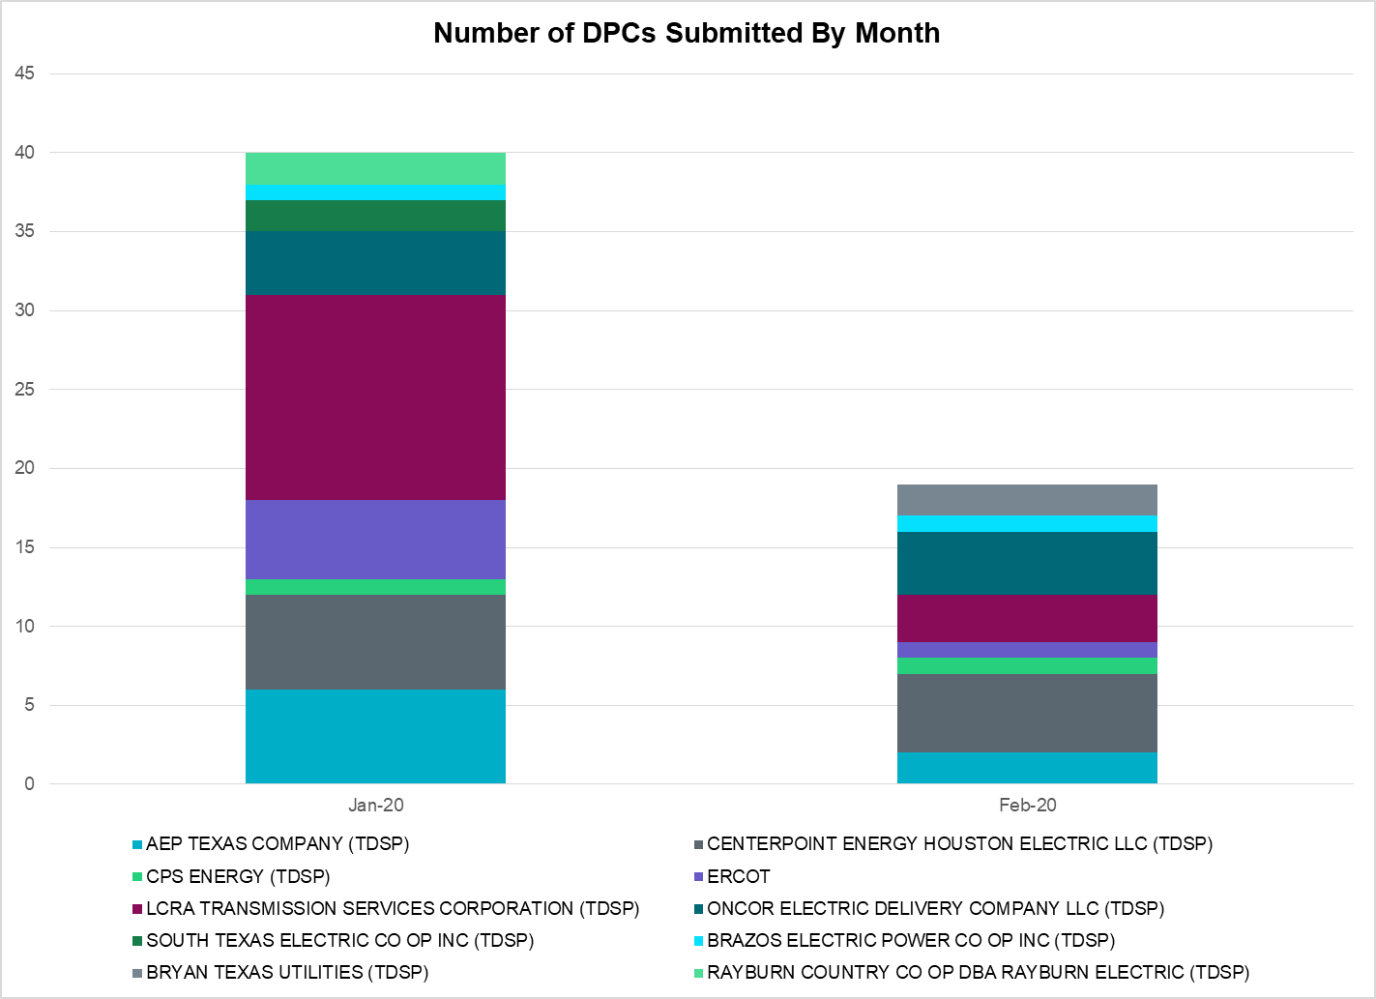

Transmission Operator | Number of DPCs
AEP TEXAS COMPANY (TDSP) | 2
BRAZOS ELECTRIC POWER CO OP INC (TDSP) | 1
BRYAN TEXAS UTILITIES (TDSP) | 2
CENTERPOINT ENERGY HOUSTON ELECTRIC LLC (TDSP) | 5
CITY OF AUSTIN DBA AUSTIN ENERGY (TDSP)
CITY OF GARLAND (TDSP)
CPS ENERGY (TDSP) | 1
DENTON MUNICIPAL ELECTRIC (TDSP)
ELECTRIC TRANSMISSION TEXAS LLC (TDSP)
ERCOT | 1
LCRA TRANSMISSION SERVICES CORPORATION (TDSP) | 3
ONCOR ELECTRIC DELIVERY COMPANY LLC (TDSP) | 4
RAYBURN COUNTRY CO OP DBA RAYBURN ELECTRIC (TDSP)
SHARYLAND UTILITIES LP (TDSP)
SOUTH TEXAS ELECTRIC CO OP INC (TDSP)
TEXAS MUNICIPAL POWER AGENCY (TDSP)
TEXAS-NEW MEXICO POWER CO (TDSP)

Appendix A: Real-Time Constraints
The following is a complete list of constraints activated in SCED. Full contingency descriptions can be found in the Standard Contingencies List located on the MIS secure site at Grid Generation Reliability Unit Commitment.

Contingency | Constrained Element | From Station | To Station | # of Days Constraint Active
SECNMO28 | 6100__F | DHIDE | NOTSW | 29
SECNMO28 | 6100__F | NOTSW | DHIDE | 29
DWINDUN8 | 6100__F | NOTSW | DHIDE | 28
DWINDUN8 | 6100__F | DHIDE | NOTSW | 28
BASE CASE | NE_LOB | n/a | n/a | 26
SSOLFTS8 | ALPINE_BRONCO1_1 | BRONCO | ALPINE | 24
SPOMNED5 | FREER_LOBO1_1 | LOBO | FREER | 23
DDELGA58 | FREER_LOBO1_1 | LOBO | FREER | 22
BASE CASE | PNHNDL | n/a | n/a | 21
SBRAUVA8 | HAMILT_MAVERI1_1 | HAMILTON | MAVERICK | 20
SBRAUVA8 | HAMILT_MAVERI1_1 | MAVERICK | HAMILTON | 20
SFAICOR8 | CORONA_AT4 | CORONA | CORONA | 19
DCRLLSW5 | 587__A | ARGYL | LWSVH | 19
SSCUSU28 | ASPM_69T1 | ASPM | ASPM | 15
SFORYEL8 | HEXT_MASONS1_1 | MASONSW | HEXT | 15
SFORYEL8 | HEXT_MASONS1_1 | HEXT | MASONSW | 15
SSTABS18 | 6144__A | BSPRW | STASW | 14
MMDS58 | 6475__C | ODEHV | TROTP | 14
SBRAHAM8 | HAMILT_MAVERI1_1 | HAMILTON | MAVERICK | 14
DCRLLSW5 | 588_A_1 | LWSVW | LWVTI | 14
BASE CASE | RV_RH | n/a | n/a | 14
SHACPB38 | FTST_SOLSTI1_1 | FTST | SOLSTICE | 13
SARMRA38 | RAYMND2_69A1 | RAYMND2 | RAYMND2 | 12
SLKAWFS8 | BOW_FMR1 | BOW | BOW | 12
SLIQOD18 | MDSSW_MR1H | MDSSW | MDSSW | 12
SMCEESK8 | 6780__A | ESKSW | LONGWRTH | 12
SCRDLOF9 | BOW_FMR1 | BOW | BOW | 11
SMV_PAR8 | RIOHND_ERIOHND_1 | MV_RIOHO | RIOHONDO | 11
SLAQLOB8 | BRUNI_69_1 | BRUNI | BRUNI | 11
BASE CASE | RIOHND_ERIOHND_1 | MV_RIOHO | RIOHONDO | 11
DLONWAR5 | GODDAR_PAWNEE1_1 | GODDARD | PAWNEE | 10
DMTSCOS5 | 6437__F | SCRCV | KNAPP | 10
SWOORI28 | LYNX_TOMBST1_1 | LYNX | TOMBSTNE | 9
SBOSELM5 | 1030__B | BOSQUESW | RGH | 9
SILLFTL8 | HAMILT_MAXWEL1_1 | MAXWELL | HAMILTON | 9
SECNMO28 | 6520__E | ODEHV | YARBR | 9
BASE CASE | RANDAD_ZAPATA1_1 | ZAPATA | RANDADO | 9
BASE CASE | RANDAD_ZAPATA1_1 | RANDADO | ZAPATA | 9
SHOLNLA8 | BRUNI_69_1 | BRUNI | BRUNI | 8
DBERWE58 | R5_KENDL_1 | KENDAL | CAGNON | 8
DBIGKEN5 | TREADW_YELWJC1_1 | TREADWEL | YELWJCKT | 8
SKINODE5 | FTST_SOLSTI1_1 | FTST | SOLSTICE | 8
DCPSJON5 | 6017__A | MBDSW | DCSES | 7
DCRMO218 | 6500__B | ODEHV | BTHOT | 7
SODLBRA8 | HAMILT_MAVERI1_1 | HAMILTON | MAVERICK | 7
DBIGKEN5 | HAMILT_MAXWEL1_1 | MAXWELL | HAMILTON | 7
DZORHAY5 | R5_KENDL_1 | KENDAL | CAGNON | 7
DWINDUN8 | 6100__G | ACSSW | AMTBT | 7
XMDS58 | 6475__C | ODEHV | TROTP | 7
BASE CASE | MCCAMY | n/a | n/a | 7
DSTPWHI5 | BLESSI_LOLITA1_1 | BLESSING | LOLITA | 7
MLOBSA_5 | NLARSW_PILONC1_1 | NLARSW | PILONCIL | 6
XOD2E58 | ODEHV_MR2H | ODEHV | ODEHV | 6
DSCOFAR5 | 6216__A | BCKSW | SHRNE | 6
DCRMO218 | 6520__E | ODEHV | YARBR | 6
DBERWE58 | 60T225_1 | KERRST | VERDCR | 6
DSCOFAR5 | 6216__A | SHRNE | BCKSW | 6
SECNMO28 | 6100__G | ACSSW | AMTBT | 6
SSCUSU28 | ROTN_WOLFGA1_1 | WOLFGANG | ROTN | 5
DPKRCPS5 | 6017__A | MBDSW | DCSES | 5
SMGIENW8 | 921__D | ENSSW | TRU | 5
MLOBSA_5 | NLARSW_PILONC1_1 | NLARSW | PILONCIL | 6
XOD2E58 | ODEHV_MR2H | ODEHV | ODEHV | 6
DSCOFAR5 | 6216__A | BCKSW | SHRNE | 6
DCRMO218 | 6520__E | ODEHV | YARBR | 6
DBERWE58 | 60T225_1 | KERRST | VERDCR | 6
DSCOFAR5 | 6216__A | SHRNE | BCKSW | 6
SECNMO28 | 6100__G | ACSSW | AMTBT | 6
SSCUSU28 | ROTN_WOLFGA1_1 | WOLFGANG | ROTN | 5
DPKRCPS5 | 6017__A | MBDSW | DCSES | 5
SMGIENW8 | 921__D | ENSSW | TRU | 5
XOD3E58 | ODEHV_MR2H | ODEHV | ODEHV | 5
DWH_STP5 | BLESSI_LOLITA1_1 | BLESSING | LOLITA | 5
SCENDEL5 | FREER_LOBO1_1 | LOBO | FREER | 5
DBBSRCH5 | 1750__B | SGOVL | KLBTP | 5
DMGSMDS5 | 6475__C | ODEHV | TROTP | 5
STOMLYN8 | 16TH_WRD2_1 | WOODWRD2 | 16TH_ST | 5
DFLCMGS5 | ODEHV_MR2H | ODEHV | ODEHV | 5
DWINDUN8 | 6520__E | ODEHV | YARBR | 5
DZORHAY5 | KENDAL_AT4H | KENDAL | KENDAL | 5
DYKNWIN8 | 6100__G | ACSSW | AMTBT | 4
BASE CASE | FTST_SOLSTI1_1 | FTST | SOLSTICE | 4
SSOLFTS8 | 6520__E | ODEHV | YARBR | 4
SSKYSB28 | ESTILE_STLWRNC_1 | STLWRNCE | ESTILES | 4
DDELGA58 | LARDVN_LASCRU1_1 | LARDVNTH | LASCRUCE | 4
MSPUSCK8 | ASPM_69T1 | ASPM | ASPM | 4
DDELGA58 | BRUNI_69_1 | BRUNI | BRUNI | 4
DHARRIO5 | BURNS_RIOHONDO_1 | RIOHONDO | MV_BURNS | 4
SPOMNED5 | NLARSW_PILONC1_1 | NLARSW | PILONCIL | 4
SAJORI25 | RAYMND2_69A1 | RAYMND2 | RAYMND2 | 4
MCARMAX8 | HAMILT_MAXWEL1_1 | MAXWELL | HAMILTON | 4
DBERWE58 | 415T415_1 | MILLER | HENLY | 4
SGODPAW5 | MELONC_RINCON1_1 | RINCON | MELONCRE | 4
DFERHOR8 | 38T365_1 | WIRTZ | FLATRO | 4
DSBYMDS8 | 6500__B | ODEHV | BTHOT | 4
SPIGSOL8 | 6520__E | ODEHV | YARBR | 4
DBERES58 | 60T225_1 | KERRST | VERDCR | 3
SPOMNED5 | BRUNI_69_1 | BRUNI | BRUNI | 3
SKLELOY8 | LOYOLA_69_1 | LOYOLA | LOYOLA | 3
SBRAUVA8 | ESCOND_GANSO1_1 | GANSO | ESCONDID | 3
SFAICOR8 | 30T108_1 | BUCHAN | BURNET | 3
SPOMNED5 | LARDVN_LASCRU1_1 | LARDVNTH | LASCRUCE | 3
SGODPAW5 | CALLIC_LON_HI1_1 | LON_HILL | CALLICOA | 3
DHARNED5 | BURNS_RIOHONDO_1 | RIOHONDO | MV_BURNS | 3
XBL2U58 | NICOLE_TENNYS1_1 | NICOLE | TENNYSON | 3
SJARDIL8 | DIL_COTU_1 | DILLEYSW | COTULAS | 3
SRAYRI28 | RAYMND2_69A1 | RAYMND2 | RAYMND2 | 3
XBL2U58 | ABNTHW_CALLAH1_1 | CALLAHAN | ABNTHWST | 3
SMDLODE5 | ODEHV_MR2H | ODEHV | ODEHV | 3
XMOS58 | MOSSW_MR1H | MOSSW | MOSSW | 2
DRIOHAR5 | HAINE__LA_PAL1_1 | LA_PALMA | HAINE_DR | 2
SFLCMDL5 | 6475__F | ODESA | ODNTH | 2
DAUSLOS5 | CKT_3121_1 | HOLMAN | LYTTON_S | 2
DLOCRED8 | DEERCR_AT1 | DEERCR | DEERCR | 2
SFLCMDL5 | ODEHV_MR2H | ODEHV | ODEHV | 2
SPOMDEL5 | FREER_LOBO1_1 | LOBO | FREER | 2
SCENLOB5 | GODDAR_PAWNEE1_1 | GODDARD | PAWNEE | 2
DBERBO58 | 583T583_1 | BANDER | MASOCR | 2
SFLCMDL5 | 6095__D | LMESA | JPPOI | 2
DZORHAY5 | 60T225_1 | KERRST | VERDCR | 2
DFLCMGS5 | 6475__F | ODESA | ODNTH | 2
SBONRIO5 | BURNS_RIOHONDO_1 | RIOHONDO | MV_BURNS | 2
DDELPOM5 | FREER_LOBO1_1 | LOBO | FREER | 2
SWHISTP5 | GODDAR_PAWNEE1_1 | PAWNEE | GODDARD | 2
SWOORI28 | LYNX_RIOPEC1_1 | RIOPECOS | LYNX | 2
BASE CASE | VFTNORTH_LEC4_1 | LARDVNTH | LARDVFTN | 2
DSBYMDS8 | 6520__E | ODEHV | YARBR | 2
SMDLODE5 | 6520__E | ODEHV | YARBR | 2
XBOM58 | 6558__B | FSHSW | WFALS | 2
DRIOHAR5 | BURNS_RIOHONDO_1 | RIOHONDO | MV_BURNS | 2
SN_SLON5 | CELANE_KLEBER1_1 | CELANEBI | KLEBERG | 2
MBONNED5 | FREER_LOBO1_1 | LOBO | FREER | 2
DFLCMGS5 | MGSES_MR1H | MGSES | MGSES | 2
SFLCMGS5 | MGSES_MR1H | MGSES | MGSES | 2
BASE CASE | VFTNORTH_LEC4_1 | LARDVFTN | LARDVNTH | 2
MSPUSCK8 | ASPM_CONA1_1 | ASPM | CONA | 2
SBRAHAM8 | ESCOND_GANSO1_1 | GANSO | ESCONDID | 2
SPIGSOL8 | TNAF_FTS_1 | FTST | TNAF | 2
DCRMO218 | 6500__C | BTHOT | ODESW | 2
SSCUSU28 | ASPM_CONA1_1 | ASPM | CONA | 2
DFLAPLU8 | BELLSO_AT2 | BELLSO | BELLSO | 2
SGUACUE8 | CUERO_AT3 | CUERO | CUERO | 2
DDILCOT8 | DIL_COTU_1 | DILLEYSW | COTULAS | 2
SWCSBOO8 | FTST_SOLSTI1_1 | FTST | SOLSTICE | 2
SFAICOR8 | 38T365_1 | WIRTZ | FLATRO | 2
DSTPWHI5 | SAR_FRAN_1 | FRANKC | SARGNTS | 2
SHACPB38 | 16TH_WRD2_1 | WOODWRD2 | 16TH_ST | 1
DAUSDUN8 | 197T171_1 | AUSTRO | GIDEON | 1
DYKNWIN8 | 6100__F | DHIDE | NOTSW | 1
XCED289 | BALLIN_ROWE1_1 | BALLINGE | ROWE | 1
DRENCRL5 | CRLNW_MR1H | CRLNW | CRLNW | 1
DTWIDIV5 | EILAND_CRTVLLE_1 | CRTRVLLE | EILAND | 1
SODLBRA8 | ESCOND_GANSO1_1 | GANSO | ESCONDID | 1
SNORODE5 | FTST_SOLSTI1_1 | FTST | SOLSTICE | 1
SBAKBIG5 | MCCAMY_BAKRFLD_1 | BAKESW | NORTMC | 1
XODE58 | ODEHV_MR1H | ODEHV | ODEHV | 1
DBEFAI58 | 392T392_1 | MASOCR | PIPECR | 1
DFLCMGS5 | 6500__B | ODEHV | BTHOT | 1
SGRMGRS8 | 6825__A | GRAHM | GRMSW | 1
XBL2U58 | BALLIN_FTCHAD1_1 | FTCHADBT | BALLINGE | 1
DWAP_JN5 | BI_SMR98_A | SMITHERS | BI | 1
SPOMDEL5 | BRUNI_69_1 | BRUNI | BRUNI | 1
DTWIDIV5 | CRTVLE_EINSTEN_1 | EINSTEIN | CRTRVLLE | 1
SLCDYN8 | EB_WA_65_A | EB | WA | 1
SCNRFOR5 | FORSW_MR3H | FORSW | FORSW | 1
SBAKBIG5 | FTST_SOLSTI1_1 | FTST | SOLSTICE | 1
BASE CASE | ODEHV_MR2H | ODEHV | ODEHV | 1
SE3S18 | PLESNTN_TORDLO_1 | TORDILLO | PLSNTOS | 1
SHACPB38 | TNAF_FTS_1 | TNAF | FTST | 1
SKINODE5 | 16TH_WRD2_1 | WOODWRD2 | 16TH_ST | 1
DBERHE58 | 254T331_1 | SATTLE | CRANMI | 1
DBERBO58 | 415T415_1 | MILLER | HENLY | 1
DBTHOD58 | 6475__F | ODESA | ODNTH | 1
DBWNKLN5 | 651__B | CMNSW | CMNTP | 1
SDANBLE8 | BLESSING_69A1 | BLESSING | BLESSING | 1
SCOLLON5 | GODDAR_PAWNEE1_1 | GODDARD | PAWNEE | 1
DHICEMS5 | HCKSW_MR2L | HCKSW | HCKSW | 1
DCMNCMN8 | HLD_FMR1 | HLD | HLD | 1
SPOMNED5 | LOBO_A1 | LOBO | LOBO | 1
SLYNRIO8 | RIOPEC_WOODW21_1 | RIOPECOS | WOODWRD2 | 1
BASE CASE | VFTNORTH_LEC5_1 | LARDVFTN | LARDVNTH | 1
DSWECCR5 | 6036__A | TKWSW | MGSES | 1
DCC1DUKE | ASHERT_CATARI1_1 | ASHERTON | CATARINA | 1
XDCS58 | BNBSW_MR1H | BNBSW | BNBSW | 1
BASE CASE | CP_MVCNT_1 | MV_CNTRA | COFFPORT | 1
SCRDJON5 | HOOD_DECRDVA_1 | DCDAM | HOD | 1
SPOMNED5 | LASCRU_MILO1_1 | LASCRUCE | MILO | 1
SHAMMAX8 | MAXWEL_WHITIN1_1 | MAXWELL | WHITING | 1
DWH_STP5 | NORMAN_PETTUS1_1 | PETTUS | NORMANNA | 1
DSALTM58 | SEA_AAT1 | SEA | SEA | 1
SCISPUT8 | SOUTHA_VINSON1_1 | SOUTHABI | VINSON | 1
DMGSBTR5 | 6036__A | TKWSW | MGSES | 1
DBERBO58 | 60T225_1 | KERRST | VERDCR | 1
SHAYZO25 | 6T227_1 | HAYSEN | ZORN | 1
SOAKOAK8 | BALLIN_ROWE1_1 | BALLINGE | ROWE | 1
SFORYEL8 | MASNPH_MASN1_1 | MASN | MASNPHT | 1
DDELPOM5 | NLARSW_PILONC1_1 | NLARSW | PILONCIL | 1
BASE CASE | ODEHV_MR2L | ODEHV | ODEHV | 1
DBERWE58 | 115T123_1 | KENDAL | KERRST | 1
DMGSBIT5 | 6036__A | TKWSW | MGSES | 1
SFLCMDL5 | 6500__B | ODEHV | BTHOT | 1
DGBY_KG5 | GBY_AT1L | GBY | GBY | 1
DGRMGRS8 | GRMSW_FMR1 | GRMSW | GRMSW | 1
SABMAB38 | OILMIT_SAWGRA1_1 | SAWGRASS | OILMITAP | 1
XBL2U58 | ORNT_TENNYS1_1 | TENNYSON | ORNT | 1
STOMLYN8 | RIOPEC_WOODW21_1 | RIOPECOS | WOODWRD2 | 1
DBIGKEN5 | SAPOWE_TREADW1_1 | SAPOWER | TREADWEL | 1
SHACPB38 | TNAF_TNFS_1 | 16TH_ST | TNAF | 1
DBEFAI58 | 60T225_1 | KERRST | VERDCR | 1
DMTSCOS5 | 6474__A | SUNSW | MGSES | 1
DSBYMDS8 | 6500__C | BTHOT | ODESW | 1
SNEDLON5 | ALICE_N_ELLA1_1 | ALICE | N_ELLA | 1
DWAP_JN5 | BI_WAP50_A | WAP | BI | 1
SVLYPRS5 | PRSSW_MR1H | PRSSW | PRSSW | 1
SFLAPIG8 | RIOPEC_WOODW21_1 | WOODWRD2 | RIOPECOS | 1
SHACPB38 | RIOPEC_WOODW21_1 | RIOPECOS | WOODWRD2 | 1
SMCEESK8 | ROBY_RONDTP1_1 | ROBY | RONDTPT | 1
DWINDUN8 | 6100__B | AMTBT | DHIDE | 1
SSNDPB48 | 6520__E | ODEHV | YARBR | 1
SGRMGRS8 | 6825__A | GRMSW | GRAHM | 1
SCOLBAL8 | BALLIN_HUMBLT1_1 | BALLINGE | HUMBLTAP | 1
SJNWA3P5 | BI_WAP50_A | WAP | BI | 1
SWHISTP5 | BLESSI_LOLITA1_1 | BLESSING | LOLITA | 1
DCC1DUKE | CATARI_PILONC1_1 | CATARINA | PILONCIL | 1
SDENN_D8 | COOPERCK_ARCO_1 | COOPERCK | ARCO | 1
XCRD58 | CRD_CRD2 | CRD | CRD | 1
SN_SAJO5 | FALFUR_PREMON1_1 | FALFUR | PREMONT | 1
XLOB258 | GODDAR_PAWNEE1_1 | GODDARD | PAWNEE | 1
MLOBSA_5 | LARDVN_LASCRU1_1 | LARDVNTH | LASCRUCE | 1
SOAKNIC8 | NICOLE_TENNYS1_1 | NICOLE | TENNYSON | 1
XBLE58 | SAR_FRAN_1 | FRANKC | SARGNTS | 1

The Duration of Event is defined as the time it takes for the frequency to recover to pre-disturbance frequency or 60 Hz as applicable.
PMU reports are typically generated when frequency drops below 59.9, but PMU data is available for other events.
Delta Frequency is defined as the difference between the starting point of the frequency event (t(0) or “A-point”) and minimum/maximum frequency (“C-Point”).
Currently, the Critical Inertia Level for ERCOT is approximately 100,000 MW-s
This is the hourly integrated peak demand as published in the ERCOT D&E report.

