System Planning
Monthly Status Report

Report Highlights

- ERCOT is currently reviewing proposed transmission improvements with a total estimated cost of $1,296.54 Million as of February 29, 2020.
- Transmission Projects endorsed in 2020 total $50.77 Million as of February 29, 2020.
- All projects (in engineering, routing, licensing and construction) total approximately $7.45 Billion as of February 1, 2020.
- Transmission Projects energized in 2020 total about $122 Million as of February 1, 2020.

Regional Planning Group Reviews
- AEPSC has submitted the LRGV Import Project. This is a Tier 1 project that is estimated to cost $73.4 million. AEPSC has also requested that ERCOT provide a conditional endorsement for an additional $357.2 million project. The ERCOT Independent Review has been conducted in accordance with Protocol Section 3.11.4.9(3), and this project is currently placed on hold until the LNG loads are confirmed.
- STEC has submitted the Lower Rio Grande Valley Transmission Expansion Project. This is a Tier 1 project that is estimated to cost $511 million. The ERCOT Independent Review has been conducted in accordance with Protocol Section 3.11.4.9(3), and this project is currently placed on hold until the LNG loads are confirmed.
- AEPSC has submitted the Corpus North Shore Project. This is a Tier 1 project that is estimated to cost $259.57 million. This project is currently under ERCOT Independent Review.
- 7x Energy has submitted the Frio County Transmission Project. This is a Tier 2 project that is estimated to cost $23 million. This project is currently under ERCOT Independent Review.
- AEPSC has submitted the Quanah Area Improvement Transmission Project. This is a Tier 2 project that is estimated to cost $10 million. This project is currently under ERCOT Independent Review.
- GP&L has submitted the Farmersville Area Reliability Project. This is a Tier 2 project that is estimated to cost $24.37 million. This project is currently under ERCOT Independent Review.
- AEPSC has submitted the Smith to Mathis 69-kV Line Rebuild Project. This is a Tier 3 project that is estimated to cost $38 million. This project is currently in the RPG comment period.
More information on current and past RPG projects can be found on the ERCOT MIS Secure (digital certificate required): https://mis.ercot.com/pps/tibco/mis/Pages/Grid+Information/RegionalPlanning
Past email communication on RPG projects can be found on the ERCOT listserve by signing up for the REGPLANGROUP list: http://lists.ercot.com/scripts/wa-ERCOT.exe?A0=REGPLANGROUP

Planning Model Activities
The short-term calendar of major planning model events is as follows:
- March 2, 2020 19SSWG Update 2 cases and TPIT are posted
- By March 20, 2020 Post 19SSWG Update 2 Contingency definitions and Planning Data Dictionary
The following table shows interconnection projects that met Planning Guide section 6.9(1) and 6.9(2) and were modeled in the SSWG cases as a full model or as a simple model in accordance with Planning Guide section 6.9.
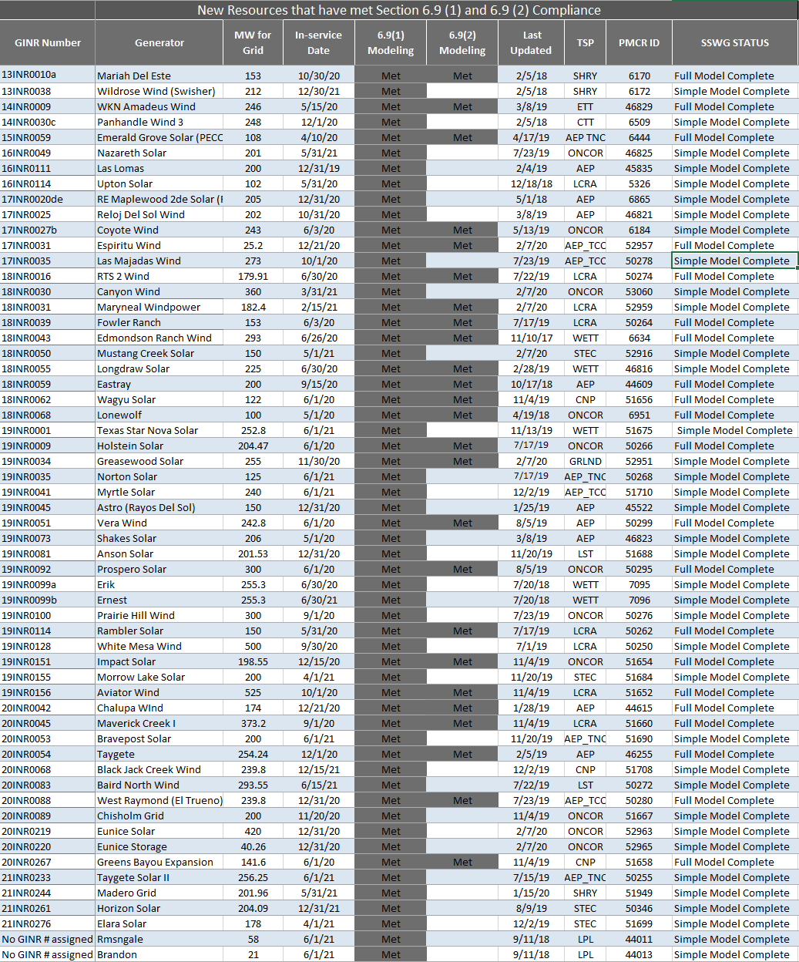

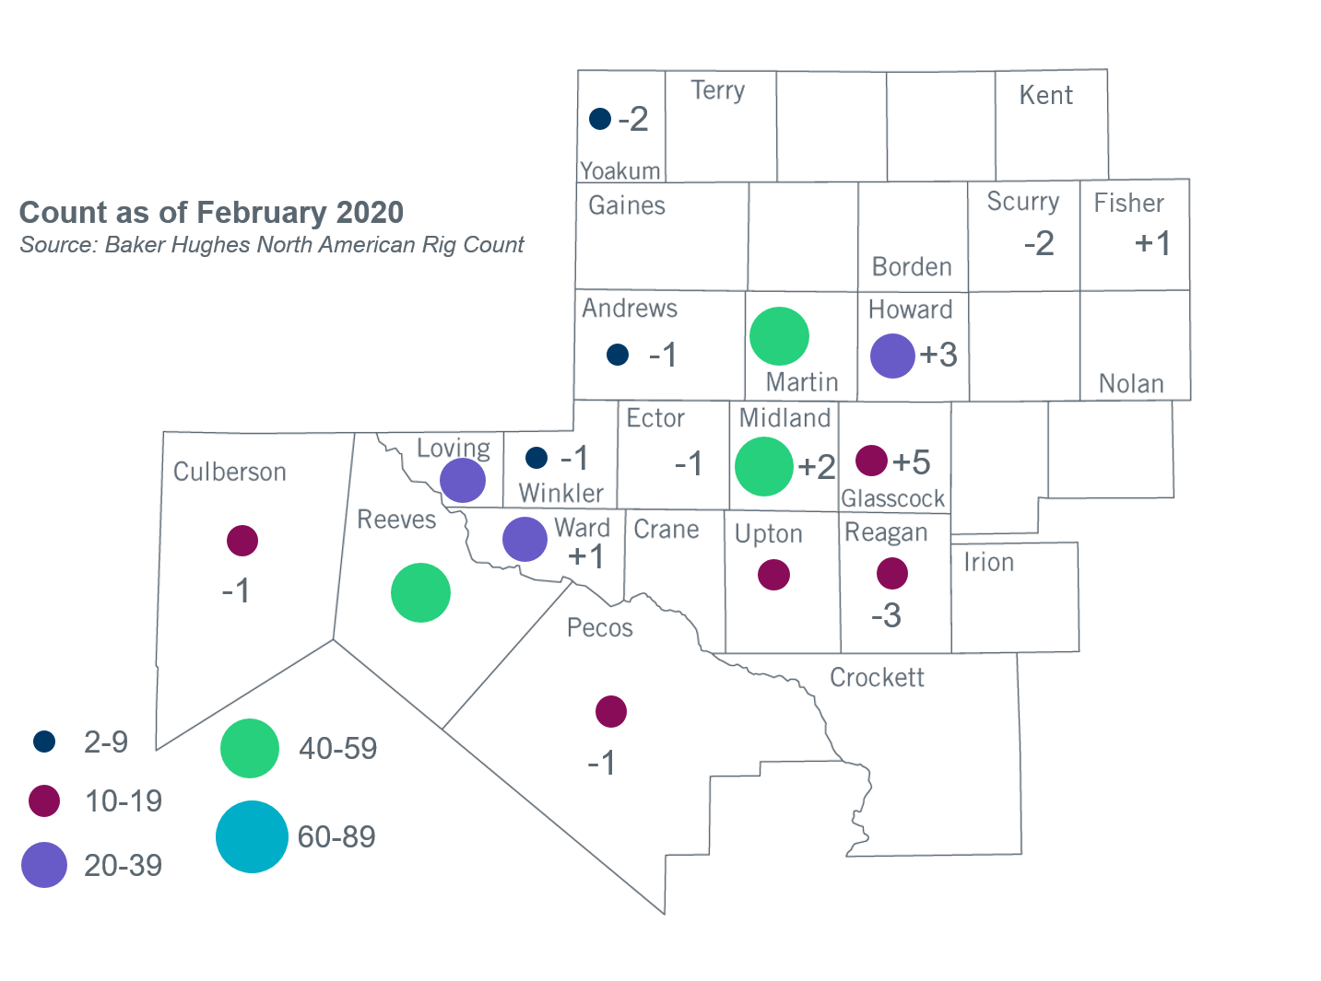
Permian Basin Oil Rig Count
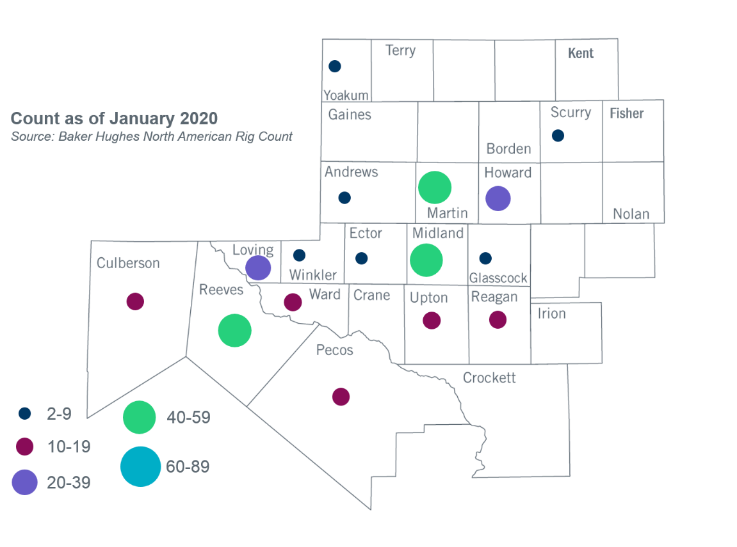

Other Notable Activities
- ERCOT presented an update on economic assumptions for the 2020 Regional Transmission Plan (RTP) to the Regional Planning Group (RPG) in February.
- The SPWG is currently building the 2020 CY base case.

+/- symbol indicates the increase or decrease from the previous month in oil rigs present in each county. There are 295 rigs, including a total decrease of 1 oil rig, in the Permian Basin from January to February 2020.

