TDTMS
February 20, 2020
ERCOT MET CENTER #168
Attendee | Company | Attendee | Company | Attendee | Company
*Diana Rehfeldt | TNMP | *Jim Lee | AEP
*Sam Pak | Oncor | Darilyn Mueller | ?
*Kathy Scott | CenterPoint | Dave Michelsen | ERCOT
*Sheri Wiegand | TXU | Mark Ruane | ERCOT
*Jordan Troublefield | ERCOT | *Eric Blakey | Just Energy
*Kyle Patrick | NRG
*Dave Paglaia | ERCOT
*In Person

Minutes & Antitrust
- Antitrust Admonition was read by Sheri
- Minutes from 1/23/20 were approved

ERCOT System Instances And MarkeTrak Monthly Performance Review
- All SLAs were met for January’s report (same report presented at RMS)
- MT response and availability were good
- 1/24 high volume of transactions “slowed down” ERCOT processing
  - ~150,000 to 200,000 814_20s were dropped overnight
  - Took ~7 hours to recover to normal processing times

Market Data Transparency SLA
- annual review does not have a home – makes sense for this to fall under purview of Dave Paglaia’s team and TDTMS
  - Dave will draft an email to RMS and TDTMS leadership requesting this SLA move to the purview of TDTMS
  - Eric will forward email to WMS leadership for consent
  - Scope may be revised as necessary
- Current SLA was reviewed and consent was granted

Transport Layer Security (TLS) Discussion/Timeline
- Cybersecurity team developed roadmap and how it impacts NAESB operation
- Machine to machine access, not browser based, APIs are secure
- Moved from SSL to TLS and now upgrading to version 1.2
- Testing to occur in RMTE in Q3/Q4
- Expected to conclude 1.0 in Feb 2021 around the first flight test in 2021
- MIS and MT API now support TLS 1.2 and market participants can make the change at any time now
- Dave plans to bring presentation to RMS and will host a market call if needed

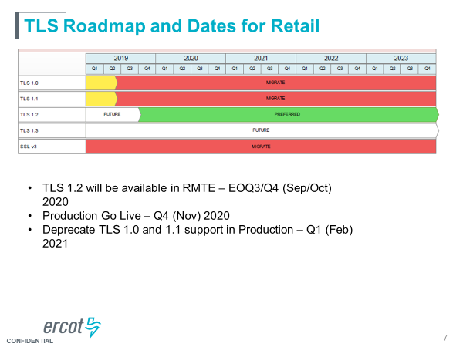

ERCOT NAESB Upgrade
- Targeting combined implementation with EDI
- ERCOT testing in Sept/Oct timeframe for RMTE
- May or may not coordinate with October flight
- Large and small file testing available for a few weeks in RMTE
- November GO LIVE

2019 Accomplishments/ 2020 Goals
- Reviewed summaries prepared by Kyle, Sam, and Sheri
- Will present at next RMS
TDTMS
2020 Goals
- Support Texas data transport improvement initiatives and continue joint efforts with other retail market working groups.
- Establish data/reporting requirements for ERCOT to assist TDTMS in ongoing MarkeTrak sub-type analysis. (Possible SCR)
- Support initiatives related to MarkeTrak system:
  - Identify process improvements based on MarkeTrak sub-type analysis
  - Prioritize enhancements utilizing supporting data from MarkeTrak sub-type analysis
  - Development of SCR for future upgrade
  - Update documentation
- IAG/IAL
  - Continue review of IAG/IAL market statistics
  - Review Retail Market Guide 7.3
- Perform annual review of the Retail Market Services Service Level Agreement (SLA) and work with ERCOT to evaluate and implement any potential changes, as needed.
- Review the quarterly ERCOT Retail Market Performance Measures.
- Support ERCOT resolution efforts in addressing each outage and/or degradation of service
- Review of Market Data Transparency Service Level Agreement (SLA)

2019 Accomplishments
- Performed MarkeTrak Sub type Analysis:
    - Established a biannual review of overall MarkeTrak SubTypes
    - Detailed monthly market analysis:
      - IAG/IAL
      - Rescission
      - Usage and Billing Missing
      - Usage and Billing Disputes
      - Switch Holds
      - Missing Enrollment Transactions
      - AMS LSE Dispute
- Based on MarkeTrak sub-type analysis collaborated with RMTTF:
  - Recommended IAS/IAL Training
  - Identified areas of improvement for training possibilities/gaps
- Created a MarkeTrak system enhancement matrix
- Supported ERCOT projects:
  - SSL Update
  - NAESB 1.2 Upgrade
  - EDI Gateway Upgrade
- Completed the annual review of the 2020 Retail Market Services SLA for endorsement to RMS
- Reviewed quarterly Performance Measures for 2019
- Reviewed and monitored monthly IT retail incident and service availability
- Reviewed all MarkeTrak supporting documentation on MarkeTrak Information landing page on ERCOT.com:
  - Began versioning documents
Recommended removal of old outdated materials

TDTMS landing page review
- reviewed and suggested TDTMS Scope RMS from 2015 be archived
- Procedures may be updated if move Market Data Transparency SLA
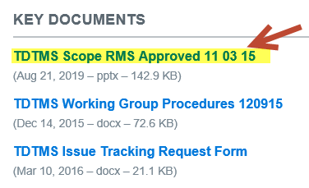
MarkeTrak Information Page
- Reviewed and the following actions recommended:
  - MarkeTrak Bulk Insert Tips and Tricks – to post updated “version stamped”
  - MarkeTrak Tips and Tricks – to post updated “version stamped”
  - Background Report – leave as posted
  - Bulk Insert Templates – leave as posted
  - MarkeTrak IAG Training Final 20150605 v2 – suggest archiving
  - MarkeTrak API Technical Files – leave as posted
  - MarkeTrak Administrator Form – leave as posted
  - MarkeTrak Bulk Insert Appendix A – leave as posted
  - MarkeTrak States Transitions – TO BE REVIEWED
  - MarkeTrak SubTypes Quick Reference Guide – Kathy to provide ‘cleaned up’ version for posting
  - MarkeTrak User’s Guide – leave current version posted – TDTMS has postpones updating
  - MarkeTrak Workflows – delete
- ACTION: Sheri will send email to Market Support Services for any new posting/revisions/archiving/deletions

MarkeTrak Subtype Analysis – SCR – Data points
- the following subtypes were reviewed for necessary data points to perform analysis requested – see separate spreadsheet
  - Switch hold removal
  - Missing Enrollment Transactions
  - U/B Missing / U/B Disputes / AMS LSE Disputes
  - Rescissions / IAGs / IALs

Next Meeting – Tuesday, March 24th ERCOT Met Center
- Review Subtype Analysis data points request
- Review States and Transitions posting on MT Information landing page
- Review MT Enhancement list and add any new suggestions
- Review TDTMS calendar for any additional Friday meetings and possibly move

Action Items | Due Date
Dave Paglai to send email to RMS and TDTMS leadership on Market Data Transparency SLA | 3/24/20
Sheri to send email to Market Support Services on revisions to landing pages | Pending
Sheri to send email requesting updated meeting date – moving from 3/27 to 3/24 | 2/25/20
Sam to provide updated MarkeTrak Bulk Insert Tips and Tricks , MarkeTrak Tips and Tricks to Sheri | 2/20/20
Kathy Scott to provide updated version of MarkeTrak SubTypes Quick Reference Guide | 2/20/20
Sheri and Sam to have a conversation with Dave M regarding MT upgrade – complete in 2021 with possible Serena upgrade | 3/24/20

