

January 2020 ERCOT Monthly Operations Report

Reliability and Operations Subcommittee Meeting

March 5, 2020

Table of Contents

1. Report Highlights 2

2. Frequency Control 3

2.1. Frequency Events 3

2.2. Responsive Reserve Events 4

2.3. Load Resource Events 4

3. Reliability Unit Commitment 4

4. Wind Generation as a Percent of Load 5

5. Largest Net-Load Ramp 5

6. COP Error Analysis 6

7. Congestion Analysis 8

7.1. Notable Constraints 8

7.2. Generic Transmission Constraint Congestion 12

7.3. Manual Overrides 12

7.4. Congestion Costs for Calendar Year 2020 12

8. System Events 14

8.1. ERCOT Peak Load 14

8.2. Load Shed Events 14

8.3. Stability Events 14

8.4. Notable PMU Events 14

8.5. DC Tie Curtailment 14

8.6. TRE/DOE Reportable Events 14

8.7. New/Modified/Removed RAS 14

8.8. New Procedures/Forms/Operating Bulletins 14

9. Emergency Conditions 15

9.1. OCNs 15

9.2. Advisories 15

9.3. Watches 15

9.4. Emergency Notices 15

10. Application Performance 15

10.1. TSAT/VSAT Performance Issues 15

10.2. Communication Issues 15

10.3. Market System Issues 16

11. Model Updates 16

Appendix A: Real-Time Constraints 18

# Report Highlights

* The unofficial ERCOT peak was 49,057 MW.
* There was 4 frequency events.
* There was 4 instances where Responsive Reserves were deployed.
* There was 1 RUC commitment.
* Congestion in Panhandle Area can mostly attribute to high wind generation. Congestion in the Far West Area can mostly be attributed to low conventional and renewable generation with high loads. Congestion in the South, North, and Houston LZs were mostly due to planned outages. East Texas Interface experienced congestion attributed to high generation combined with a forced outage of 345kV line. There were 27 days of congestion on the Panhandle GTC, 5 days on the East Texas GTC, 16 days on the North Edinburg to Lobo GTC, and 5 day on the McCamey GTC. There was no activity on the remaining GTCs during the month.
* There were 0 DC Tie curtailments.

# Frequency Control

## Frequency Events

The ERCOT Interconnection experienced four frequency events, which resulted from units’ trip. The average event duration was 00:04:31.

A summary of the frequency events is provided below. The reported frequency events meet one of the following criteria: Delta Frequency is 60 mHz or greater; the MW loss is 350 MW or greater; resource trip event triggered RRS deployment. Frequency events that have been identified as Frequency Measurable Events (FME) for purposes of BAL-001-TRE-1 analysis are highlighted in blue. When analyzing frequency events, ERCOT evaluates PMU data according to industry standards. Events with an oscillating frequency of less than 1 Hz are considered to be inter-area, while higher frequencies indicate local events. Industry standards specify that damping ratio for inter-area oscillations should be 3.0% or greater. For the frequency events listed below, the ERCOT system met these standards and transitioned well after each disturbance.

|  |  |  |  |  |  |  |  |  |  |
| --- | --- | --- | --- | --- | --- | --- | --- | --- | --- |
| **Date and Time** | **Delta Frequency** | **Max/Min Frequency** | **Duration of Event[1]** | **PMU Data[2]** | | **MW Loss** | **Load** | **Wind** | **Inertia** |
| **(Hz)[3]** | **(Hz)** | **Oscillation Mode (Hz)** | **Damping Ratio** | **(MW)** | **%** | **(GW-s)[4]** |
| 1/1/2020 12:53 | 0.256 | 59.745 | 0:05:01 | 0.05 | 16% | 1209.6 | 39,991 | 35% | 208,454 |
| 1/10/2020 20:54 | 0.132 | 59.846 | 0:04:12 | 0.06 | 9% | 773.1 | 38,960 | 46% | 207,115 |
| 1/16/2020 18:04 | 0.138 | 59.864 | 0:04:55 | 0.72 | 16% | 543.05 | 43,989 | 12% | 251,022 |
| 1/17/2020 10:01 | 0.182 | 59.827 | 0:03:54 | 0.68 | 13% | 663.25 | 41,416 | 13% | 234,344 |

(Note: All data on this graph encompasses frequency event analysis based on BAL-001-TRE-1.)

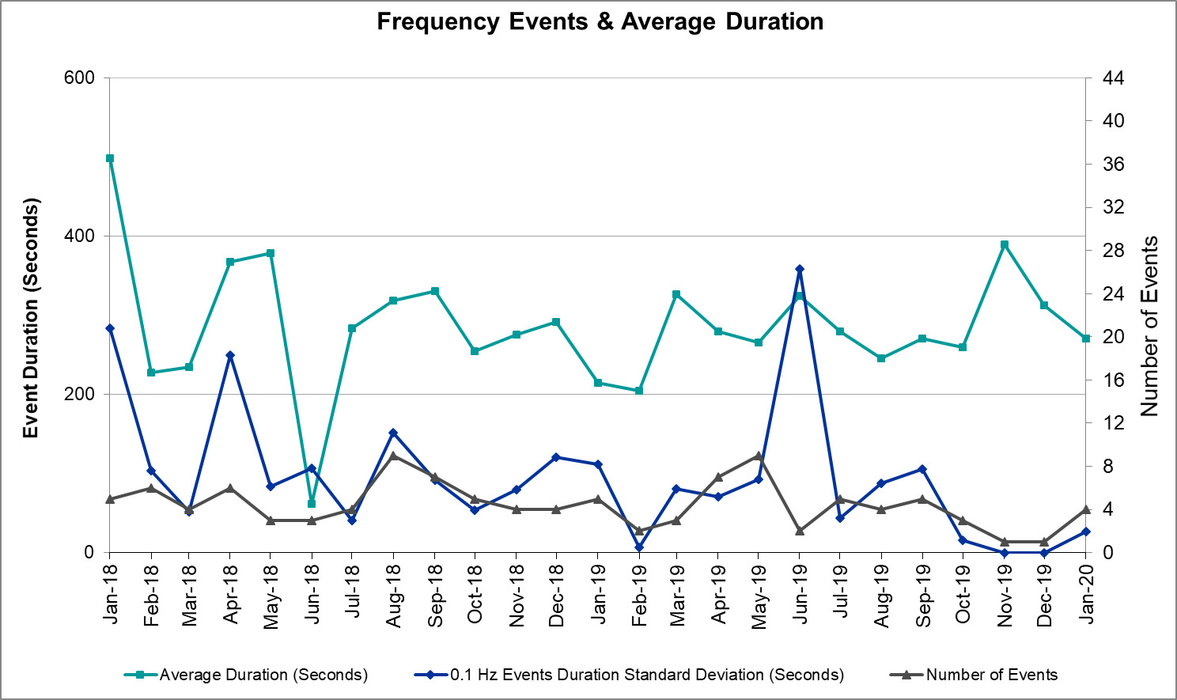

Note that the large standard deviation in June 2019 is due to coincidental extreme high and low durations for a small set of events (2).

## Responsive Reserve Events

There were 4 events where Responsive Reserve MWs were released to SCED. The events highlighted in blue were related to frequency events reported in Section 2.1 above.

|  |  |  |  |  |
| --- | --- | --- | --- | --- |
| **Date and Time Released to SCED** | **Date and Time Recalled** | **Duration of Event** | **Maximum MWs Released** | **Comments** |
| 1/1/2020 12:53 | 1/1/2020 12:58 | 0:05:01 | 1150 | 1/1/2020 12:53 |
| 1/10/2020 20:54 | 1/10/2020 20:58 | 0:04:12 | 1002 | 1/10/2020 20:54 |
| 1/16/2020 18:04 | 1/16/2020 18:09 | 0:04:55 | 600 | 1/16/2020 18:04 |
| 1/17/2020 10:01 | 1/17/2020 10:05 | 0:03:54 | 1099 | 1/17/2020 10:01 |

## Load Resource Events

One Load Resource deployed 10.38 MW as a result of the under-frequency event on January 1st at 15:53.

# Reliability Unit Commitment

ERCOT reports on Reliability Unit Commitments (RUC) on a monthly basis. Commitments are reported grouped by operating day and weather zone. The total number of hours committed is the sum of the hours for all the units in the specified region. Additional information on RUC commitments can be found on the MIS secure site at Grid 🡪 Generation 🡪 Reliability Unit Commitment.

There were no DRUC commitments.

There was 1 HRUC commitment.

|  |  |  |  |  |  |
| --- | --- | --- | --- | --- | --- |
| **Resource Location** | **# of Resources** | **Operating Day** | **Total # of Hours Committed** | **Total MWhs** | **Reason for Commitment** |
| Southern | 1 | 1/28/2020 | 4 | 157 | SVCAMIL8 |

# Wind Generation as a Percent of Load



Wind Generation Record: 20,066 MW on 01/08/2020 at 22:18

Wind Penetration Record: 57.88% on 11/26/2019 03:52

# Largest Net-Load Ramp

The net-load ramp is defined as the change in net-load (load minus wind and PVGR generation) during the defined time horizon. Such a variation in net-load needs to be accommodated in grid operations to ensure that the reliability of the grid is satisfactorily maintained. The largest net-load ramp during 5-min, 10-min, 15-min, 30-min and 60-min in Jan 2020 is 1009 MW, 1610 MW, 2124 MW, 3700 MW, and 6100 MW, respectively. The comparison with respect to the historical values is given in the table below.

|  |  |  |  |  |  |
| --- | --- | --- | --- | --- | --- |
| **Month and Year** | **5 min** | **10 min** | **15 min** | **30 min** | **60 min** |
| Jan 2020 | 1009 MW | 1610 MW | 2124 MW | 3700 MW | 6100 MW |
| Jan 2014 | 891 MW | 1603 MW | 2082 MW | 3607 MW | 6340 MW |
| Jan 2015 | 1025 MW | 1609 MW | 2150 MW | 3737 MW | 6496 MW |
| Jan 2016 | 950 MW | 1547 MW | 2076 MW | 3736 MW | 6213 MW |
| Jan 2017 | 959 MW | 1680 MW | 2160 MW | 3511 MW | 6181 MW |
| Jan 2018 | 1091 MW | 1824 MW | 2497 MW | 3901 MW | 6824 MW |
| Jan 2019 | 1087 MW | 1718 MW | 2308 MW | 4033 MW | 7786 MW |

# COP Error Analysis

COP Error is calculated as the capacity difference between the COP HSL and real-time HSL of the unit. Mean Absolute Error (MAE) stayed high over 6,500 MW until Day-Ahead at 12:00, then dropped significantly to 1,304 MW by Day-Ahead at 14:00. In the following chart, Under-Scheduling Error indicates that COP had less generation capacity than real-time and Over-Scheduling Error indicates that COP had more generation capacity than real-time. Under-Scheduling persisted from beginning of Day-Ahead to end of the Operating Day with the exception of eight hours. However, COP error for the Operating Hour freezes after the Adjustment Period.

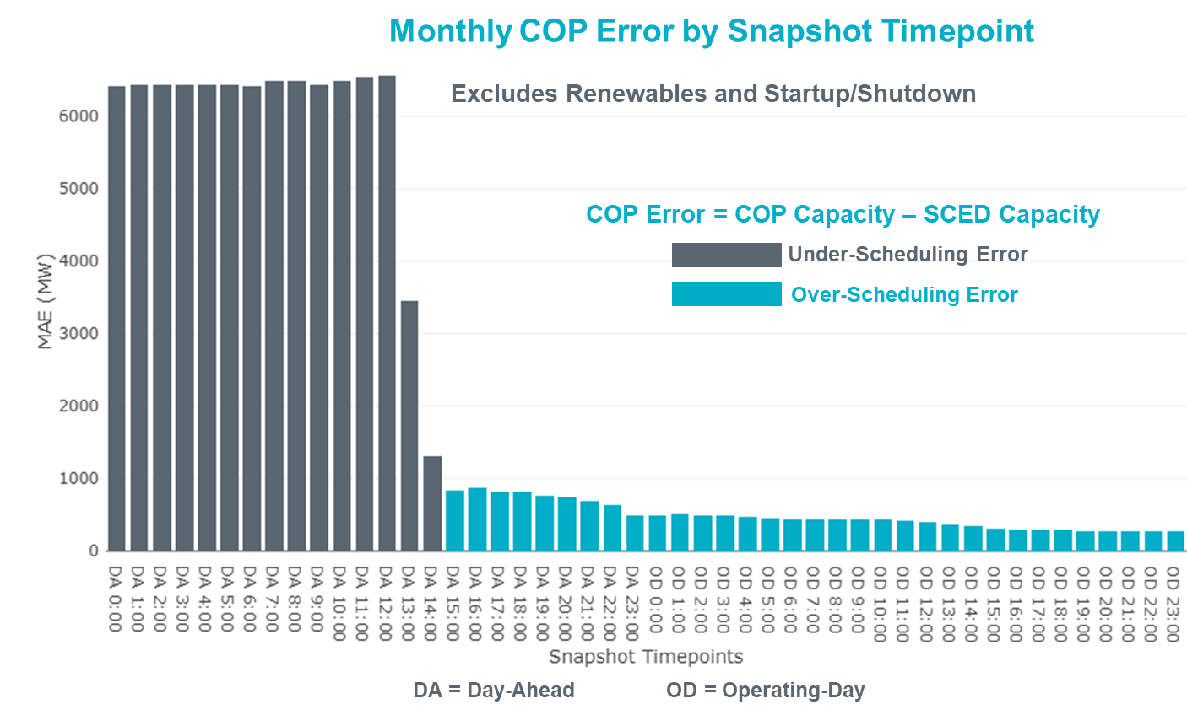

Monthly MAE for the Latest COP at the end of the Adjustment Period was 264 MW with median ranging from -36 MW for Hour-Ending (HE) 6 to 191 MW for HE 22. HE 22 on the 10th had the largest Over-Scheduling Error (1,561 MW) and HE 21 on the 17th had the largest Under-Scheduling Error (-1,873 MW).

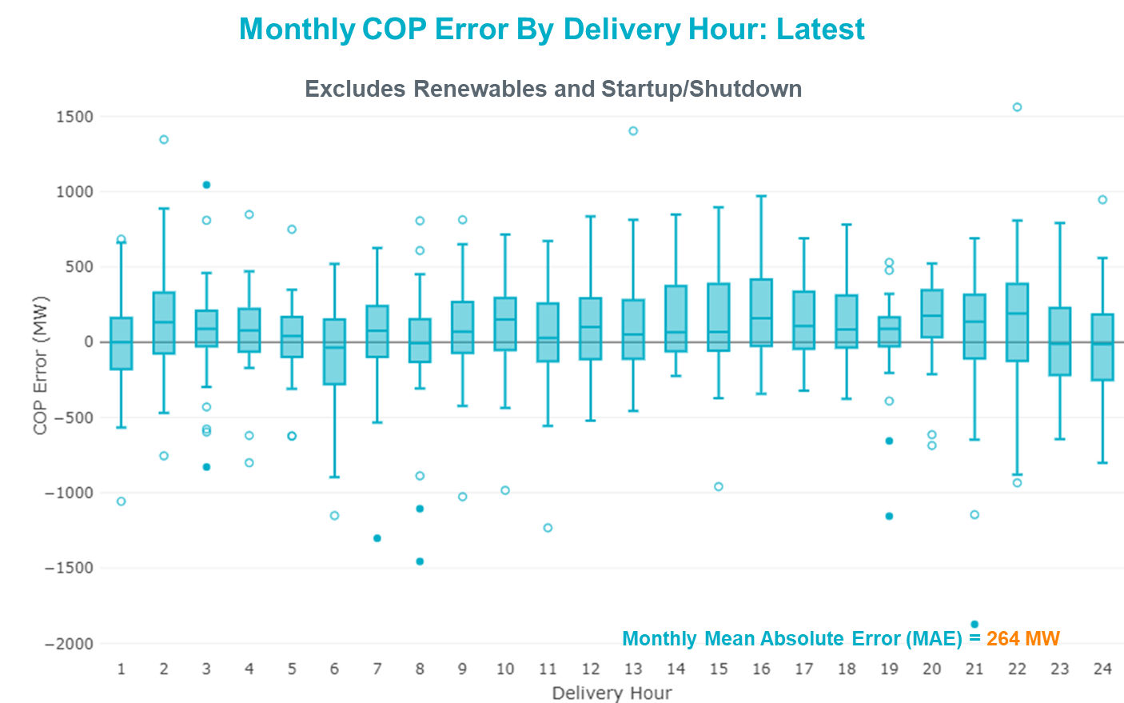

Monthly MAE for the Day-Ahead COP at 12:00 was 6,560 MW with median ranging from -8,153 MW for Hour-Ending (HE) 8 to -4,549 MW for HE 24. HE 19 on the 30th had the largest Under-Scheduling Error (-15,022 MW) and HE 24 on the 8th had the largest Over-Scheduling Error (1,694 MW).

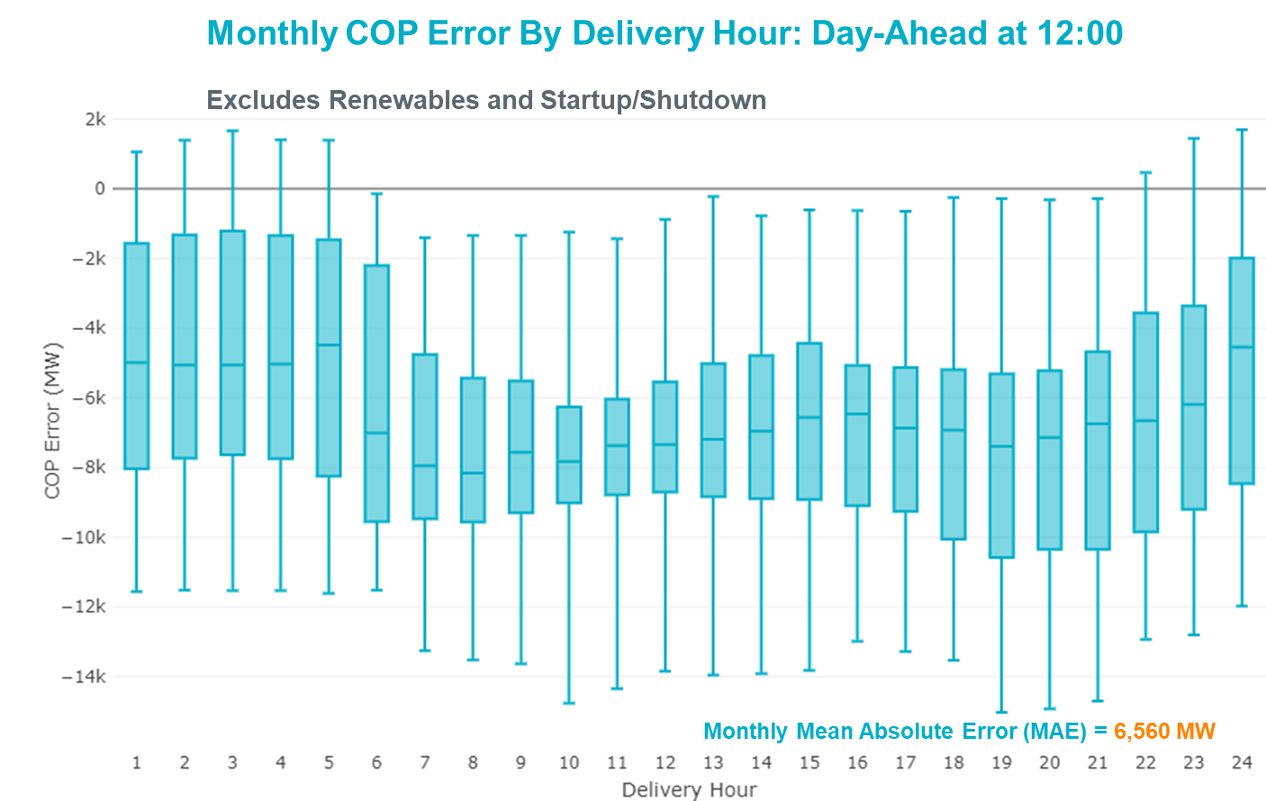

# Congestion Analysis

## Notable Constraints

Nodal protocol section 3.20 specifies that ERCOT shall identify transmission constraints that are active or binding three or more times within a calendar month. As part of this process, ERCOT reports congestion that meets this criterion to ROS. In addition ERCOT also highlights notable constraints that have an estimated congestion rent exceeding $1,000,000 for a calendar month. These constraints are detailed in the table below. Rows highlighted in blue indicate the congestion was affected by one or more outages. For a list of all constraints activated in SCED, please see Appendix A at the end of this report.

|  |  |  |  |  |
| --- | --- | --- | --- | --- |
| **Contingency Name** | **Overloaded Element** | **# of Days Constraint Active** | **Congestion Rent** | **Transmission Project** |
| Basecase | PNHNDL GTC | 27 | $19,715,682.33 | LP&L Integration Tie Lines (43367 A,B,C) and Panhandle Loop |
| MOSS SWITCH to ECTOR COUNTY NORTH SWITCHING STATION LIN _A | Dollarhide - No Trees Switch 138kV | 29 | $17,373,888.92 | Andrews County South Switch - No Trees Switch 138 kV Line (7171) |
| WINK to DUNE SWITCH and YUKON | Dollarhide - No Trees Switch 138kV | 21 | $7,143,081.16 | Andrews County South Switch - No Trees Switch 138 kV Line (7171) |
| HCKSW-ALLNC&RNKSW 345kV | Blue Mound - Saginaw Switch 138kV | 3 | $4,325,045.48 | Saginaw 345/138 kV autotransformer (6273) |
| CPSES-JONSW&EVRSW 345kV | Mitchell Bend Switch - Decordova Ses 345kV | 4 | $3,451,285.53 | Mitchell Bend - Rocky Creek 345 kV line (5312) |
| MILITARY HIGHWAY AEP to VILLA CAVAZOS LIN 1 | Laureles - La Palma 138kV | 1 | $2,879,779.90 |  |
| AJO to NELSON SHARPE LIN 1 | Burns Sub - Rio Hondo 138kV | 16 | $2,779,558.48 | Rebuild Rio Hondo to East Rio Hondo (6687) |
| Manual LOBO TO SAN MIGUEL 345 kV | North Laredo Switch - Piloncillo 138kV | 19 | $2,663,497.41 |  |
| CRLNW-LWSSW 345kV | Jones Street Tnp - Lakepointe Tnp 138kV | 17 | $2,407,398.62 | Lewisville - Lewisville Jones - Lakepointe 138 kV Line (45537) |
| Basecase | EASTEX GTC | 5 | $2,326,858.27 |  |
| Basecase | NE_LOB GTC | 16 | $2,296,737.22 |  |
| TOMBSTONE to Lynx LIN 1 | Woodward 2 - Rio Pecos 138kV | 18 | $2,218,800.08 | Lynx: Expand 138 kV station (45503) and Solstice: Build 345 kV station (5530) and Solstice to Bakersfield: Build 345 kV line (5539) |
| Basecase | Center - Cedar Bayou Plant 345kV | 3 | $1,815,120.08 | Baytown Area Upgrades (43284B, 43284E, 43284D, 43284F, 43284G) |
| ODLAW SWITCHYARD to ASPHALT MINES LIN 1 | Hamilton Road - Maverick 138kV | 19 | $1,719,429.75 | Brackettville to Escondido: Construct 138 kV line (5206) |
| GAS PAD to FLAT TOP TNP LIN 1 | Lynx - Tombstone 138kV | 3 | $1,312,185.66 | Lynx: Expand 138 kV station (45503) |
| Lynx to RIO PECOS LIN 1 | Woodward 2 - Rio Pecos 138kV | 9 | $1,136,773.01 | Lynx: Expand 138 kV station (45503) and Solstice: Build 345 kV station (5530) and Solstice to Bakersfield: Build 345 kV line (5539) |
| Hcksw-Sagna-138kv | Eagle Mountain Ses - Morris Dido 138kV | 1 | $1,135,298.09 | Eagle Mountain-Calmont 138 kV Line (4253) |
| CRLNW-LWSSW 345kV | Argyle - Highlands Tnp 138kV | 3 | $1,034,424.13 |  |
| YUKON SWITCH to Wink and Dune Sw | Andrews County South - Amoco Three Bar Tap 138kV | 3 | $804,690.89 | Andrews County South Switch - No Trees Switch 138 kV Line (7171) |
| GAS PAD to FLAT TOP TNP LIN 1 | Fort Stockton Plant - Solstice 138kV | 7 | $712,096.05 | Solstice: Build 345 kV station (5530) |
| Berghe-Kendal 345kv & Welfar 138kv | Mason Creek - Bandera 138kV | 6 | $674,932.98 |  |
| Berghe-Kendal 345kv & Welfar 138kv | Miller Creek - Henly 138kV | 7 | $542,254.35 |  |
| Berghe-Kendal 345kv & Welfar 138kv | Granite Mountain - Marble Falls 138kV | 3 | $496,489.86 | T195 Granite Mountain - Marble Falls MLSE Upgrade (7164) |
| Manual LOBO TO SAN MIGUEL 345 kV | Bruni Sub 138kV | 3 | $483,590.82 |  |
| Bighil-Kendal 345kV | Yellow Jacket - Treadwell 138kV | 6 | $413,443.72 |  |
| LAQUINTA to LOBO LIN 1 | Falfurrias - Premont 69kV | 7 | $379,538.80 | Premont - Falfurrias 69 kV Line (6203) |
| FORT MASON to YELLOW JACKET LIN 1 | Yellow Jacket - Hext Lcra 69kV | 15 | $374,163.19 |  |
| ABILENE MAPLE STREET to ABILENE SOUTH LIN 1 | Sawgrass - Abilene Oil Mill Tap 69kV | 4 | $373,195.03 |  |
| WINK to DUNE SWITCH and YUKON | Andrews County South - Amoco Three Bar Tap 138kV | 4 | $327,415.04 | Andrews County South Switch - No Trees Switch 138 kV Line (7171) |
| Stp-Hlj&&White_Pt 345kV | Blessing - Lolita 138kV | 7 | $276,515.42 | Tidehaven: Construct New Distribution Station (48776) |
| Bighil-Kendal 345kV | San Angelo Power Station - Treadwell 138kV | 5 | $238,239.98 |  |
| LAQUINTA to LOBO LIN 1 | Bruni Sub 138kV | 13 | $226,551.22 |  |
| Austro-Garfie&Zorn 345kV | Garfield Aen - Stoney Ridge 138kV | 3 | $225,450.62 |  |
| KLEBERG AEP to LOYOLA SUB LIN 1 | Loyola Sub 138kV | 3 | $198,700.86 |  |
| WICHITA FALLS SOUTH SWITCH to NEWPORT BEPC LIN _E | Bowie 138kV | 11 | $185,787.61 |  |
| MOSS SWITCH to ECTOR COUNTY NORTH SWITCHING STATION LIN _A | Andrews County South - Amoco Three Bar Tap 138kV | 5 | $182,186.91 | Andrews County South Switch - No Trees Switch 138 kV Line (7171) |
| TWR (345) WHITE_PT-LON_HILL & STP | Blessing - Lolita 138kV | 10 | $140,586.87 | Tidehaven: Construct New Distribution Station (48776) |
| BAILEY to WA PARISH LIN A | Jones Creek - South Texas Project 345kV | 6 | $136,355.46 | Freeport Master Plan (6688A, 6688B) |
| CRLNW-LWSSW 345kV | Ti Tnp - West Tnp 138kV | 10 | $127,892.64 |  |
| BRACKETTVILLE to HAMILTON ROAD LIN 1 | Hamilton Road - Maverick 138kV | 13 | $119,799.24 | Brackettville to Escondido: Construct 138 kV line (5206) |
| Fergus-Granmo&Wirtz-Starck 138kV | Bertram - Burnet 69kV | 5 | $115,000.33 | PEC_Burnet_Bertram_Andice_138kV_Conversion (44944) |
| SCOSW-LONG DRAW&FARADAY 345kV | Bluff Creek Switch - Exxon Sharon Ridge 138kV | 6 | $96,000.61 |  |
| Basecase | Burns Sub - Rio Hondo 138kV | 4 | $94,755.08 | Rebuild Rio Hondo to East Rio Hondo (6687) |
| Basecase | Randado Aep - Zapata 138kV | 19 | $79,618.36 | Zapata: Add 138 kV Reactor (44393) |
| FAIRLAND to CORONADO LIN 1 | Coronado 138kV | 10 | $72,689.14 |  |
| Fergus-Gilles & Horsba 138kV | Flat Rock Lcra - Wirtz 138kV | 3 | $68,845.89 | Wirtz to FlatRock to Paleface Transmission Line Upgrade (4465) |
| BOSQUE SWITCH to ELM MOTT LIN 1 | Bosque Switch - Rogers Hill Bepc 138kV | 14 | $56,442.07 |  |
| Basecase | Farmland - Tahoka Wind 345kV | 9 | $55,346.54 |  |
| BLUFF CREEK to ABILENE SOUTH LIN 1 | Callahan Windfarm Fpl - Abilene Northwest 138kV | 3 | $50,258.79 |  |
| NORTH ALVIN TNP to HASTINGS TNP LIN 1 | Mainland Tnp - Alvin Tnp 138kV | 3 | $47,360.93 |  |
| ODLAW SWITCHYARD to ASPHALT MINES LIN 1 | Escondido - Ganso 138kV | 3 | $46,378.06 | Brackettville to Escondido: Construct 138 kV line (5206) |
| ENNIS WEST SWITCH to WAXAHACHIE PUMP 1 LIN _C | Trumbull - Ennis Switch 138kV | 7 | $45,708.38 |  |
| Manual LOBO TO SAN MIGUEL 345 kV | Falfurrias - Premont 69kV | 4 | $43,812.49 | Premont - Falfurrias 69 kV Line (6203) |
| MCELMURRAY to ESKOTA SWITCH LIN 1 | Eskota Switch - Longworth 69kV | 6 | $43,619.84 | "Scott REA Tap to Eskota 69 kV line: Rebuild 69 kV line (6042) |
| LOFTIN to COTTONWOOD ROAD SWITCH LIN 1 | Bowie 138kV | 15 | $36,906.28 |  |
| POMELO to NORTH EDINBURG LIN 1 | Lobo - Freer 69kV | 5 | $36,746.70 | Lobo to Freer: Rebuild 69 kV line (3901) |
| SUN SWITCH to SCURRY SWITCH LIN 1 | Aspermont Aep 138kV | 13 | $34,718.01 | Aspermont: Replace the 138/69 kV autotransformer (6569) |
| Pig Creek to Solstice LIN 1 | Woodward 2 - Rio Pecos 138kV | 5 | $27,719.65 | Lynx: Expand 138 kV station (45503) and Solstice: Build 345 kV station (5530) and Solstice to Bakersfield: Build 345 kV line (5539) |
| RIO HONDO to LAS PULGAS LIN 1 | Raymondville 2 138kV | 9 | $24,356.59 | Harlingen SS - Raymondville #2: Convert to 138 kV (6167) |
| KING MOUNTAIN SWITCHYARD to ODESSA EHV SWITCH LIN 1 | Fort Stockton Plant - Solstice 138kV | 3 | $23,260.40 | Solstice: Build 345 kV station (5530) |
| BRACKETTVILLE to HAMILTON ROAD LIN 1 | Escondido - Ganso 138kV | 3 | $22,076.19 | Brackettville to Escondido: Construct 138 kV line (5206) |
| Ferguson-Sherwood Shores & Ferguson-Granite Mountain 138kV | Sandy Creek 138kV | 3 | $21,084.65 |  |
| DANEVANG SWITCHING STATION to BLESSING LIN 1 | Blessing 138kV | 4 | $19,869.41 |  |
| Basecase | MCCAMY GTC | 5 | $18,860.85 |  |
| Solstice to FORT STOCKTON PLANT LIN 1 | Alpine - Bronco 69kV | 13 | $18,528.59 |  |
| Basecase | Rio Hondo - East Rio Hondo Sub 138kV | 9 | $13,955.25 | Rebuild Rio Hondo to East Rio Hondo (6687) |
| BLESSING TRX 1382 345/138 | Sargent Sub - Franklins Camp Sub 69kV | 5 | $9,714.11 |  |
| FORT MASON to YELLOW JACKET LIN 1 | Mason Switching Station - Hext Lcra 69kV | 7 | $6,816.04 | Mason to North Brady: Rebuild 69 kV line (50900) |
| DESOTO SWITCH to ENNIS SWITCH LIN _D | Ennis West Switch - Waxahachie 138kV | 9 | $5,449.81 |  |
| GBY-DAV& TNK-CRN138KV | Bigvue - Power Systems Arco Cogen 138kV | 3 | $4,863.88 |  |
| FORT LANCASTER to ILLINOIS #4 LIN 1 | Hamilton Road - Maxwell 138kV | 8 | $3,970.73 | Brackettville to Escondido: Construct 138 kV line (5206) |
| Elmcreek-Sanmigl 345kV | Pawnee Switching Station - Calaveras 345kV | 3 | $3,727.14 |  |
| Basecase | Camp Springs Energy Center - Golden Switch 138kV | 4 | $2,067.11 |  |
| Berghe-Kendal 345kv & Welfar 138kv | Kendall - Cagnon 345kV | 4 | $1,906.56 | Boerne Cico - Comfort - Kendall Transmission Line Upgrade (6982) |
| FORT MASON to YELLOW JACKET LIN 1 | Mason Switching Station - Hext Lcra 69kV | 7 | $1,319.51 | Mason to North Brady: Rebuild 69 kV line (50900) |

## Generic Transmission Constraint Congestion

There were 27 days of congestion on the Panhandle GTC, 5 days on the East Texas GTC, 16 days on the North Edinburg to Lobo GTC, and 5 day on the McCamey GTC. There was no activity on the remaining GTCs during the month.

Note: This is how many times a constraint has been activated to avoid exceeding a GTC limit, it does not imply an exceedance of the GTC occurred or that the GTC was binding.

## Manual Overrides

None.

## Congestion Costs for Calendar Year 2020

The following table represents the top twenty active constraints for the calendar year based on the estimated congestion rent attributed to the congestion. ERCOT updates this list on a monthly basis.

|  |  |  |  |  |
| --- | --- | --- | --- | --- |
| **Contingency** | **Binding Element** | **# of 5-min SCED Intervals** | **Estimated Congestion Rent** | **Transmission Project** |
| Basecase | PNHNDL GTC | 4,016 | 19,715,682.33 | LP&L Integration Tie Lines (43367 A,B,C) and Panhandle Loop |
| MOSS SWITCH to ECTOR COUNTY NORTH SWITCHING STATION LIN _A | Dollarhide - No Trees Switch 138kV | 2,891 | 17,373,888.92 | Andrews County South Switch - No Trees Switch 138 kV Line (7171) |
| WINK to DUNE SWITCH and YUKON | Dollarhide - No Trees Switch 138kV | 2,027 | 7,143,081.16 | Andrews County South Switch - No Trees Switch 138 kV Line (7171) |
| HCKSW-ALLNC&RNKSW 345kV | Blue Mound - Saginaw Switch 138kV | 440 | 4,325,045.48 | Saginaw 345/138 kV autotransformer (6273) |
| CPSES-JONSW&EVRSW 345kV | Mitchell Bend Switch - Decordova Ses 345kV | 275 | 3,451,285.53 | Mitchell Bend - Rocky Creek 345 kV line (5312) |
| MILITARY HIGHWAY AEP to VILLA CAVAZOS LIN 1 | Laureles - La Palma 138kV | 82 | 2,879,779.90 |  |
| AJO to NELSON SHARPE LIN 1 | Burns Sub - Rio Hondo 138kV | 2,280 | 2,779,558.48 | Rebuild Rio Hondo to East Rio Hondo (6687) |
| Manual LOBO TO SAN MIGUEL 345 kV | North Laredo Switch - Piloncillo 138kV | 1,714 | 2,663,497.41 | Brackettville to Escondido: Construct 138 kV line (5206) |
| CRLNW-LWSSW 345kV | Jones Street Tnp - Lakepointe Tnp 138kV | 1,369 | 2,407,398.62 | Lewisville - Lewisville Jones - Lakepointe 138 kV Line (45537) |
| Basecase | EASTEX GTC | 124 | 2,326,858.27 |  |
| Basecase | NE_LOB GTC | 1,692 | 2,296,737.22 |  |
| TOMBSTONE to Lynx LIN 1 | Woodward 2 - Rio Pecos 138kV | 1,138 | 2,218,800.08 | Solstice: Build 345 kV station (5530)  Solstice to Bakersfield: Build 345 kV line (5539) |
| Basecase | Center - Cedar Bayou Plant 345kV | 67 | 1,815,120.08 | Baytown Area Upgrades (43284B, 43284E, 43284D, 43284F, 43284G) |
| ODLAW SWITCHYARD to ASPHALT MINES LIN 1 | Hamilton Road - Maverick 138kV | 1,920 | 1,719,429.75 | Brackettville to Escondido: Construct 138 kV line (5206) |
| GAS PAD to FLAT TOP TNP LIN 1 | Lynx - Tombstone 138kV | 314 | 1,312,185.66 | Lynx: Expand 138 kV station (45503) |
| Lynx to RIO PECOS LIN 1 | Woodward 2 - Rio Pecos 138kV | 557 | 1,136,773.01 | Solstice: Build 345 kV station (5530)  Solstice to Bakersfield: Build 345 kV line (5539) |
| Hcksw-Sagna-138kv | Eagle Mountain Ses - Morris Dido 138kV | 98 | 1,135,298.09 | Eagle Mountain-Calmont 138 kV Line (4253) |
| CRLNW-LWSSW 345kV | Argyle - Highlands Tnp 138kV | 235 | 1,034,424.13 |  |
| YUKON SWITCH to Wink and Dune Sw | Andrews County South - Amoco Three Bar Tap 138kV | 147 | 804,690.89 | Andrews County South Switch - No Trees Switch 138 kV Line (7171) |
| GAS PAD to FLAT TOP TNP LIN 1 | Fort Stockton Plant - Solstice 138kV | 565 | 712,096.05 | Solstice: Build 345 kV station (5530) |

# System Events

## ERCOT Peak Load

The unofficial ERCOT peak load[5] for the month was 49,057 MW and occurred on the 8th, during hour ending 8:00.

## Load Shed Events

None.

## Stability Events

None.

## Notable PMU Events

ERCOT analyzes PMU data for any significant system disturbances that do not fall into the Frequency Events category reported in section 2.1. The results are summarized in this section once the analysis has been completed.

There were no PMU events outside of those reported in section 2.1.

## DC Tie Curtailment

None.

## TRE/DOE Reportable Events

* LCRA TO submitted an EOP-004 for 01/11/2020. Reportable Event Type: Physical threat to its facilities
* BTU submitted an OE-417 for 01/12/2020. Reportable Event Type: Suspicious activity
* LCRA QSE submitted an EOP-004 for 01/14/2020. Reportable Event Type: Physical threat to its facilities
* CenterPoint submitted an OE-417 for 01/16/2020. Reportable Event Type: Unplanned evacuation
* LCRA TO submitted an EOP-004 for 01/24/2020. Reportable Event Type: Physical threat to its facilities

## New/Modified/Removed RAS

None.

## New Procedures/Forms/Operating Bulletins

|  |  |
| --- | --- |
| **Procedure Title** | **POB** |
| Real-Time Desk | 925 |
| Reliability Risk Desk | 926 |
| Reliability Unit Commitment Desk | 927 |
| Resource Desk | 928 |
| Scripts | 929 |
| Shift Supervisor Desk | 930 |
| Transmission & Security Desk | 931 |

# Emergency Conditions

## OCNs

None.

## Advisories

|  |  |
| --- | --- |
| **Date and Time** | **Message** |
| Jan 27 2020 13:30 CPT | ERCOT has postponed the deadline for the posting of the DAM Solution for Operating Day Jan 28, 2020 due to long running solution. |

## Watches

None.

## Emergency Notices

None.

# Application Performance

## TSAT/VSAT Performance Issues

None.

## Communication Issues

None.

## Market System Issues

None.

# Model Updates

The Downstream Production Change (DPC) process allows ERCOT to make changes in the on-line Network Operations Model without loading a completely new model. The purpose of this process is to allow for reliable grid operations as system conditions change between designated Network Operations Model database loads. The DPC process is limited in scope to just those items listed below, with equipment ratings updates being the most common. ERCOT has seen a rise in the use of the DPC process to make on-line updates to the Network Operations Model in recent years, instead of through the standard Network Operations Model Change Request process.

* Static Line ratings (Interim Update)
* Dynamic Line ratings (non-Interim Update)
* Autotransformer ratings (non-Interim Update)
* Breaker and Switch Normal status (Interim Update)
* Contingency Definitions (Interim Update)
* RAP and RAS changes or additions (Interim Update)
* Net Dependable and Reactive Capability (NDCRC) values (Interim Update)
* Impedance Updates (non-Interim)

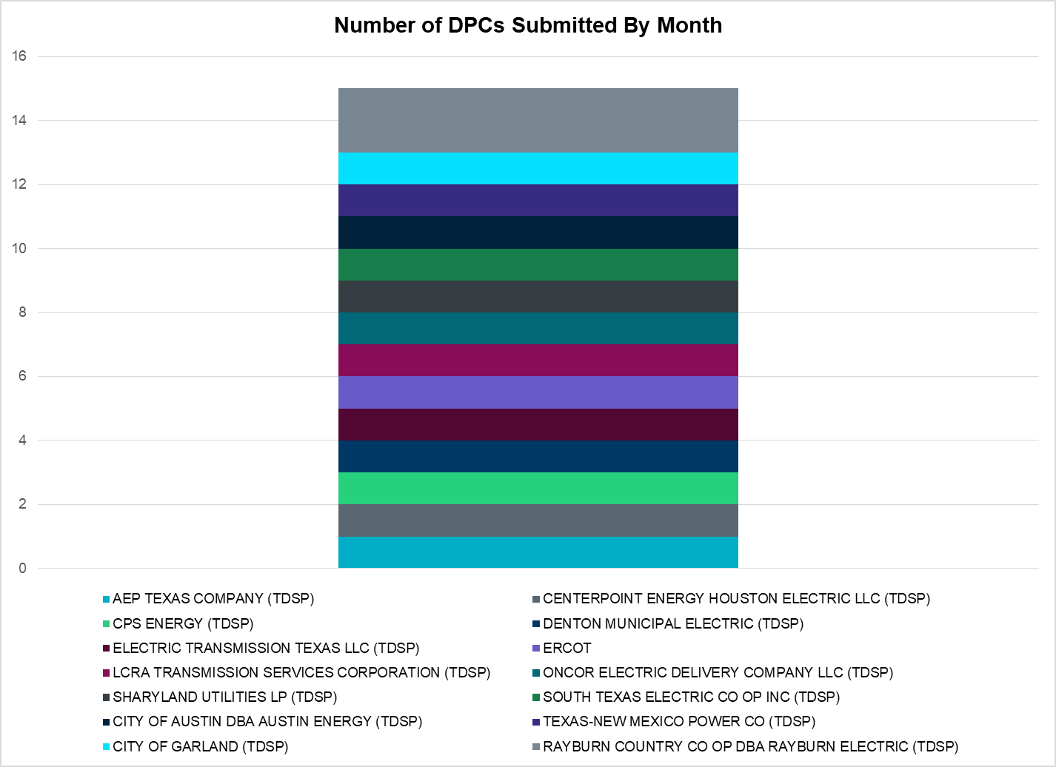

|  |  |
| --- | --- |
| **Transmission Operator** | **Number of DPCs** |
| AEP TEXAS COMPANY (TDSP) | 6 |
| BRAZOS ELECTRIC POWER CO OP INC (TDSP) | 1 |
| CENTERPOINT ENERGY HOUSTON ELECTRIC LLC (TDSP) | 6 |
| CITY OF AUSTIN DBA AUSTIN ENERGY (TDSP) | 0 |
| CITY OF GARLAND (TDSP) | 0 |
| CPS ENERGY (TDSP) | 1 |
| DENTON MUNICIPAL ELECTRIC (TDSP) | 0 |
| ELECTRIC TRANSMISSION TEXAS LLC (TDSP) | 0 |
| ERCOT | 5 |
| LCRA TRANSMISSION SERVICES CORPORATION (TDSP) | 13 |
| ONCOR ELECTRIC DELIVERY COMPANY LLC (TDSP) | 4 |
| RAYBURN COUNTRY CO OP DBA RAYBURN ELECTRIC (TDSP) | 2 |
| SHARYLAND UTILITIES LP (TDSP) | 0 |
| SOUTH TEXAS ELECTRIC CO OP INC (TDSP) | 2 |
| TEXAS MUNICIPAL POWER AGENCY (TDSP) | 0 |
| TEXAS-NEW MEXICO POWER CO (TDSP) | 0 |

# Appendix A: Real-Time Constraints

The following is a complete list of constraints activated in SCED. Full contingency descriptions can be found in the Standard Contingencies List located on the MIS secure site at Grid 🡪 Generation 🡪 Reliability Unit Commitment.

|  |  |  |  |  |
| --- | --- | --- | --- | --- |
| **Contingency** | **Constrained Element** | **From Station** | **To Station** | **# of Days Constraint Active** |
| SECNMO28 | 6100__F | DHIDE | NOTSW | 29 |
| BASE CASE | PNHNDL | n/a | n/a | 27 |
| DWINDUN8 | 6100__F | DHIDE | NOTSW | 21 |
| MLOBSA_5 | NLARSW_PILONC1_1 | NLARSW | PILONCIL | 19 |
| BASE CASE | RANDAD_ZAPATA1_1 | RANDADO | ZAPATA | 19 |
| SBRAUVA8 | HAMILT_MAVERI1_1 | HAMILTON | MAVERICK | 19 |
| BASE CASE | RANDAD_ZAPATA1_1 | ZAPATA | RANDADO | 19 |
| STOMLYN8 | RIOPEC_WOODW21_1 | RIOPECOS | WOODWRD2 | 18 |
| DCRLLSW5 | 590__B | LWVJS | LKPNT | 17 |
| SN_SAJO5 | BURNS_RIOHONDO_1 | RIOHONDO | MV_BURNS | 16 |
| BASE CASE | NE_LOB | n/a | n/a | 16 |
| SCRDLOF9 | BOW_FMR1 | BOW | BOW | 15 |
| SFORYEL8 | HEXT_YELWJC1_1 | YELWJCKT | HEXT | 15 |
| SBOSELM5 | 1030__B | BOSQUESW | RGH | 14 |
| SSOLFTS8 | ALPINE_BRONCO1_1 | BRONCO | ALPINE | 13 |
| SBRAHAM8 | HAMILT_MAVERI1_1 | HAMILTON | MAVERICK | 13 |
| SLAQLOB8 | BRUNI_69_1 | BRUNI | BRUNI | 13 |
| SSCUSU28 | ASPM_69T1 | ASPM | ASPM | 13 |
| SLKAWFS8 | BOW_FMR1 | BOW | BOW | 11 |
| SFAICOR8 | CORONA_AT4 | CORONA | CORONA | 10 |
| DWH_STP5 | BLESSI_LOLITA1_1 | BLESSING | LOLITA | 10 |
| DCRLLSW5 | 588_A_1 | LWSVW | LWVTI | 10 |
| BASE CASE | RIOHND_ERIOHND_1 | MV_RIOHO | RIOHONDO | 9 |
| SRDODES8 | 940__C | ENWSW | WXHCH | 9 |
| SRAYRI28 | RAYMND2_69A1 | RAYMND2 | RAYMND2 | 9 |
| BASE CASE | TAHOKA_TLINE_1 | TAHOKA | FARMLAND | 9 |
| SLYNRIO8 | RIOPEC_WOODW21_1 | RIOPECOS | WOODWRD2 | 9 |
| SILLFTL8 | HAMILT_MAXWEL1_1 | MAXWELL | HAMILTON | 8 |
| SLAQLOB8 | FALFUR_PREMON1_1 | FALFUR | PREMONT | 7 |
| SMGIENW8 | 921__D | ENSSW | TRU | 7 |
| SHACPB38 | FTST_SOLSTI1_1 | FTST | SOLSTICE | 7 |
| DBERWE58 | 415T415_1 | MILLER | HENLY | 7 |
| DSTPWHI5 | BLESSI_LOLITA1_1 | BLESSING | LOLITA | 7 |
| SFORYEL8 | HEXT_MASONS1_1 | MASONSW | HEXT | 7 |
| SFORYEL8 | HEXT_MASONS1_1 | HEXT | MASONSW | 7 |
| DBERWE58 | 583T583_1 | BANDER | MASOCR | 6 |
| DSCOFAR5 | 6216__A | SHRNE | BCKSW | 6 |
| SMCEESK8 | 6780__A | ESKSW | LONGWRTH | 6 |
| SBLYWA25 | JCKSTP18_A | STP | JCK | 6 |
| DBIGKEN5 | TREADW_YELWJC1_1 | TREADWEL | YELWJCKT | 6 |
| SECNMO28 | 6100__G | ACSSW | AMTBT | 5 |
| SPIGSOL8 | RIOPEC_WOODW21_1 | WOODWRD2 | RIOPECOS | 5 |
| DBIGKEN5 | SAPOWE_TREADW1_1 | SAPOWER | TREADWEL | 5 |
| BASE CASE | EASTEX | n/a | n/a | 5 |
| BASE CASE | MCCAMY | n/a | n/a | 5 |
| SPOMNED5 | FREER_LOBO1_1 | LOBO | FREER | 5 |
| XBLE58 | SAR_FRAN_1 | FRANKC | SARGNTS | 5 |
| DFERSTA8 | 32T311_1 | BURNET | BERTRA | 5 |
| DCPSJON5 | 6017__A | MBDSW | DCSES | 4 |
| MLOBSA_5 | FALFUR_PREMON1_1 | FALFUR | PREMONT | 4 |
| BASE CASE | CAMP_SPRINGS_1 | CSEC | GLDSW | 4 |
| SDANBLE8 | BLESSING_69A1 | BLESSING | BLESSING | 4 |
| BASE CASE | BURNS_HEIDLBRG_1 | MV_BURNS | MV_HBRG4 | 4 |
| SABMAB38 | OILMIT_SAWGRA1_1 | SAWGRASS | OILMITAP | 4 |
| DMARPA_8 | 32T311_1 | BURNET | BERTRA | 4 |
| BASE CASE | BURNS_RIOHONDO_1 | RIOHONDO | MV_BURNS | 4 |
| SN_SLON5 | BURNS_RIOHONDO_1 | RIOHONDO | MV_BURNS | 4 |
| DWINDUN8 | 6100__G | ACSSW | AMTBT | 4 |
| DBERWE58 | R5_KENDL_1 | KENDAL | CAGNON | 4 |
| DLONOR58 | FALFUR_PREMON1_1 | FALFUR | PREMONT | 3 |
| MCARMAX8 | HAMILT_MAXWEL1_1 | MAXWELL | HAMILTON | 3 |
| BASE CASE | CBYCTR97_A | CTR | CBY | 3 |
| DFERHOR8 | 38T365_1 | WIRTZ | FLATRO | 3 |
| DHCKRNK5 | 6270__B | BLMND | SAGNA | 3 |
| SBRAUVA8 | ESCOND_GANSO1_1 | GANSO | ESCONDID | 3 |
| SKINODE5 | FTST_SOLSTI1_1 | FTST | SOLSTICE | 3 |
| DFERGRM8 | SANDCR_AT1 | SANDCR | SANDCR | 3 |
| SHASTNN8 | 138_ALV_MNL_1 | ALVIN | MAINLAND | 3 |
| SHACPB38 | LYNX_TOMBST1_1 | LYNX | TOMBSTNE | 3 |
| DBERWE58 | 342T195_1 | GRANMO | MARBFA | 3 |
| SKLELOY8 | LOYOLA_69_1 | LOYOLA | LOYOLA | 3 |
| DYKNWIN8 | 6100__G | ACSSW | AMTBT | 3 |
| DGBYCRN8 | BCVPSA03_A | PSA | BCV | 3 |
| DELMSAN5 | PAWNEE_SPRUCE_1 | PAWNEE | CALAVERS | 3 |
| DCRLLSW5 | 587__A | ARGYL | LWSVH | 3 |
| SABSBLU8 | ABNTHW_CALLAH1_1 | CALLAHAN | ABNTHWST | 3 |
| DAUSGAR5 | CKT_962_1 | GARFIELD | STONEY_R | 3 |
| SBRAHAM8 | ESCOND_GANSO1_1 | GANSO | ESCONDID | 3 |
| MLOBSA_5 | BRUNI_69_1 | BRUNI | BRUNI | 3 |
| SODLBRA8 | HAMILT_MAVERI1_1 | HAMILTON | MAVERICK | 2 |
| MLOBSA_5 | LARDVN_LASCRU1_1 | LARDVNTH | LASCRUCE | 2 |
| SFTLMES8 | MIDW_OZONA1_1 | MIDW | OZONA | 2 |
| DBERBO58 | 583T583_1 | BANDER | MASOCR | 2 |
| DENWSTE8 | 921__D | ENSSW | TRU | 2 |
| SBOSELM5 | WHTNY_MR2L | WHTNY | WHTNY | 2 |
| SSTABS18 | 6144__A | BSPRW | STASW | 2 |
| MLOBSA_5 | CATARI_PILONC1_1 | PILONCIL | CATARINA | 2 |
| SHACPB38 | LYNX_RIOPEC1_1 | RIOPECOS | LYNX | 2 |
| DFERHOR8 | CORONA_AT4 | CORONA | CORONA | 2 |
| SFTLMES8 | CROSSO_NORTMC1_1 | NORTMC | CROSSOVE | 2 |
| SN_SLON5 | KINGSV_KLEBER1_1 | KLEBERG | KINGSVIL | 2 |
| DCRLLSW5 | 590__A | LWSSW | LWVJS | 2 |
| DNB_JOR5 | BCVPSA03_A | PSA | BCV | 2 |
| DSHREVR5 | 6125__C | MSTLT | HMPHL | 2 |
| SPIGSOL8 | LYNX_RIOPEC1_1 | LYNX | RIOPECOS | 2 |
| STOMLYN8 | RIOPECOS_69_2 | RIOPECOS | RIOPECOS | 2 |
| SCISPUT8 | SOUTHA_VINSON1_1 | SOUTHABI | VINSON | 2 |
| DBERBO58 | 415T415_1 | MILLER | HENLY | 1 |
| DLONWAR5 | MELONC_RINCON1_1 | RINCON | MELONCRE | 1 |
| SGASDIV5 | CRTVLE_EINSTEN_1 | EINSTEIN | CRTRVLLE | 1 |
| SFLAPIG8 | FTST_TOMBST1_1 | FTST | TOMBSTNE | 1 |
| SSPJFS8 | JFSSC_06_A | JFS | SC | 1 |
| BASE CASE | VFTNORTH_LEC4_1 | LARDVFTN | LARDVNTH | 1 |
| BASE CASE | WESLCO_HIDLBRG_1 | MV_HBRG4 | MV_WESL4 | 1 |
| DSGVFOR5 | 30__A | RCHBR | BBSES | 1 |
| XSA4N89 | BALLIN_HUMBLT1_1 | BALLINGE | HUMBLTAP | 1 |
| SWINPIN8 | BELLSO_AT2 | BELLSO | BELLSO | 1 |
| MLOBSA_5 | GODDAR_PAWNEE1_1 | GODDARD | PAWNEE | 1 |
| DBIGKEN5 | HAMILT_MAXWEL1_1 | MAXWELL | HAMILTON | 1 |
| XNOR358 | HARGRO_TWINBU1_1 | TWINBU | HARGROVE | 1 |
| SDOWMOO8 | UVALDE_W_BATE1_1 | UVALDE | W_BATESV | 1 |
| BASE CASE | VFTNORTH_LEC4_1 | LARDVNTH | LARDVFTN | 1 |
| DDMTGLD8 | 6474__A | SUNSW | MGSES | 1 |
| SSPUMW18 | 6780__A | ESKSW | LONGWRTH | 1 |
| MLOBSA_5 | ASHERT_CATARI1_1 | CATARINA | ASHERTON | 1 |
| BASE CASE | ASPM_69T1 | ASPM | ASPM | 1 |
| DELMSTP5 | JCKSTP18_A | STP | JCK | 1 |
| DBEFAI58 | 450T450_1 | HENLY | DRIPSP | 1 |
| DPKRCPS5 | 6017__A | MBDSW | DCSES | 1 |
| DHCKSAG8 | 6265__A | EMSES | MRSDO | 1 |
| SGASMGS5 | CRTVLE_EINSTEN_1 | EINSTEIN | CRTRVLLE | 1 |
| SSCUSU28 | ROTN_WOLFGA1_1 | WOLFGANG | ROTN | 1 |
| MLOBSA_5 | UVALDE_W_BATE1_1 | UVALDE | W_BATESV | 1 |
| SMUNPAI8 | 6855__E | SMRTP | SMOUR | 1 |
| MLOBSA_5 | ASHERT_CATARI1_1 | ASHERTON | CATARINA | 1 |
| SFLAPIG8 | FTST_TOMBST1_1 | TOMBSTNE | FTST | 1 |
| SCOMHA38 | HAMILT_MAXWEL1_1 | MAXWELL | HAMILTON | 1 |
| DNB_JOR5 | JFSSC_06_A | JFS | SC | 1 |
| DBEFAI58 | 415T415_1 | MILLER | HENLY | 1 |
| SPIGSOL8 | FTST_TOMBST1_1 | FTST | TOMBSTNE | 1 |
| SBRAUVA8 | MAXWEL_WHITIN1_1 | MAXWELL | WHITING | 1 |
| DRILTES5 | WHIT_RV_W_CW1_1 | WHIT_RVR | W_CW_345 | 1 |
| SFAICOR8 | 30T108_1 | BUCHAN | BURNET | 1 |
| DBERWE58 | 73T120_1 | HOLLMI | FREDER | 1 |
| DENWSTE8 | 921__B | TRU | RDOAK | 1 |
| DSWECBF5 | BLUF_C_MULBER1_1 | MULBERRY | BLUF_CRK | 1 |
| SPOMNED5 | CATARI_PILONC1_1 | PILONCIL | CATARINA | 1 |
| SCBYNB5 | G138_10B_1 | SEMINOLE | MAGNO_TN | 1 |
| SMDOPHR5 | G138_10B_1 | SEMINOLE | MAGNO_TN | 1 |
| SN_SAJO5 | HAINE__LA_PAL1_1 | LA_PALMA | HAINE_DR | 1 |
| DZORHAY5 | KENDAL_AT4H | KENDAL | KENDAL | 1 |
| SVCAMIL8 | LAUREL_LA_PAL1_1 | LA_PALMA | LAURELES | 1 |
| DFERWIR8 | SANDCR_AT1 | SANDCR | SANDCR | 1 |
| BASE CASE | SWEETWN3_XF31 | SWEETWN3 | SWEETWN3 | 1 |
| SREAUVA8 | UVALDE_W_BATE1_1 | UVALDE | W_BATESV | 1 |
| DBBSRCH5 | 1750__B | SGOVL | KLBTP | 1 |
| DBERWE58 | 450T450_1 | HENLY | DRIPSP | 1 |
| SSPUMW18 | CLAT_JATN1_1 | CLAT | JATN | 1 |
| SHAYKE25 | KENDAL_AT4H | KENDAL | KENDAL | 1 |
| SPALWIR8 | CORONA_AT4 | CORONA | CORONA | 1 |

1. The Duration of Event is defined as the time it takes for the frequency to recover to pre-disturbance frequency or 60 Hz as applicable.
2. PMU reports are typically generated when frequency drops below 59.9, but PMU data is available for other events.
3. Delta Frequency is defined as the difference between the starting point of the frequency event (t(0) or “A-point”) and minimum/maximum frequency (“C-Point”).
4. Currently, the Critical Inertia Level for ERCOT is approximately 100,000 MW-s
5. This is the hourly integrated peak demand as published in the ERCOT D&E report.