Mass Transition Testing Preparation

Scope:

- Test no more than 3,500 ESI IDs Drop to POLR (See TDSP allotment below)
- Test no more than 3 ESI IDs per selected CR by sending non-POLR switches
- Test VREP (Volunteer) and POLR (LSP-Large Service Provider) allocation of Drop to POLR transactions
- Recommendation is to hold a workshop in March 2020

Allocation:

No more than 3500 ESI IDs still to be determined by ERCOT
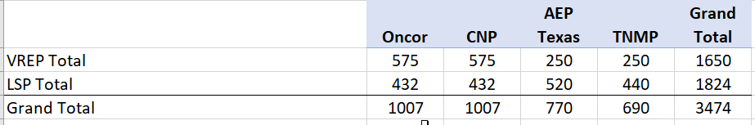

Setup Requirements
In order to minimize risks to the testing the following recommendations are suggested
Avoid:
- ERCOT release dates
- Spring Break dates
- May 6 and 7 due to Retail training in Dallas.
- April 10, 2020 due to conflict with Easter weekend including Good Friday
- It is recommended that Mass Transition Test should be initiated after Flight 0220 is concluded prior to Flight 0620

- TDSPs to identify and send list of ESI IDs to be used to ERCOT.
- ERCOT will verify all ESI IDs are available in the RMTE.
- For ESI IDs that are unavailable in the RMTE, TDSPs will send 814_20s.
- TDSPs may set up the Default CR DUNS in test systems, or coordinate with ERCOT to receive MVIs for any ESI IDs requiring their assistance.
- CRs will need 2 weeks to prepare for the competitive switches.
  - ERCOT to identify the Non-POLR ESI IDs and send those to the Non-POLR CRs.
  - Non-POLR CRs to send Non-POLR Switches to ERCOT at one time.
  - ERCOT to hold Non-POLR Switches as received; then release at various times of the day to TDSPs

ERCOT Communication of Mass Transition Activities to Market Participants

- Unless otherwise noted, ERCOT will follow the established market processes for communications during a Mass Transition as outlined in Retail Market Guide Section 7.11

Success Criteria:

- TDSPs to transition the Drop to POLR ESI IDs with the Mass Transition Date.
- Exceptions will be completed with the Mass Transition Date or the scheduled date of the non-POLR transaction.
- TDSPs to send ERCOT 867_04 or 867_03F no later than day 5 of the Mass Transition event.

Mass Transition Timeline

RMG Section 9 Appendix F2 Timeline for Initiation of a Mass Transition

Calendar
Day -1

Notification Date
Default confirmed by ERCOT legal
Initial Notification sent
Initial Project Coordination Call scheduled
If default is on a Business Day before a weekend or ERCOT holiday, initial project coordination call to occur on same Business Day
Project Coordination Call
Mass Transition process:
- ESI ID allocations & lists are generated and sent to POLR and/or Designated CR and affected TDSPs by ERCOT
- 814_03s sent by ERCOT requesting Mass Transition Date.
- ERCOT requests Customer Billing Contact Information from Defaulting CR.
Project Coordination Call
- 867_02s from TDSP to ERCOT.
- 814_04s from TDSP to ERCOT.
- 814_11s from ERCOT to Losing CR.
- 814_14s from ERCOT to POLR and/or Designated CRs.
- Customer billing information sent by ERCOT to POLR and/or Designated CRs and affected TDSP(s).
- ERCOT sends PUCT mandated notifications to Customers
Project Coordination Call
- TDSP sends to ERCOT Final 867_03s and ERCOT forwards to Losing CR.
- TDSP sends 867_04s to ERCOT and ERCOT forwards to POLR and/or Designated CRs.
- Mass Transition completes at ERCOT.

Calendar
Day 0

Mass Transition Date
Project Coordination Call
- TDSP performs meter reads (actuals or estimates) for Mass Transition Date.
Calendar
Day 1
Calendar
Day 2
Calendar
Day 3 & 4
Calendar
Day 5

Document Revision History
Date | Description | Author(s)
1/22/2020 | Approved for 2020 | TXSET (Patrick)

