PWG Meeting Notes – November 8th, 2019
WebEx only
9:30 am

Attendees:

Sam Pak – Oncor
Sheri Wiegand – TXU
Kathy Scott – CNP
Diana Rehfeldt – TNMP
Bill Boswell - ERCOT
Jim Lee – AEP
Calvin Opheim - ERCOT
Randy Roberts - ERCOT
Mike Pickens – IHS Market
Jordan Troublefield – ERCOT
Karen Malkey - CNP

- Sheri Wiegand, Chair 2019, read Antitrust Admonition and reviewed the agenda
- Meeting minutes from May 10th were reviewed and approved

- NPRR 923 Revision to Weather Responsiveness Determination Process - Approved – language has been unboxed/implemented as of 10/18 protocol update

- Business Annual Validation Update
- 2019 Business AV is complete
- Jim Lee noted relief for resources this year with the market changes only including Business AV each year and Residential AV every three years

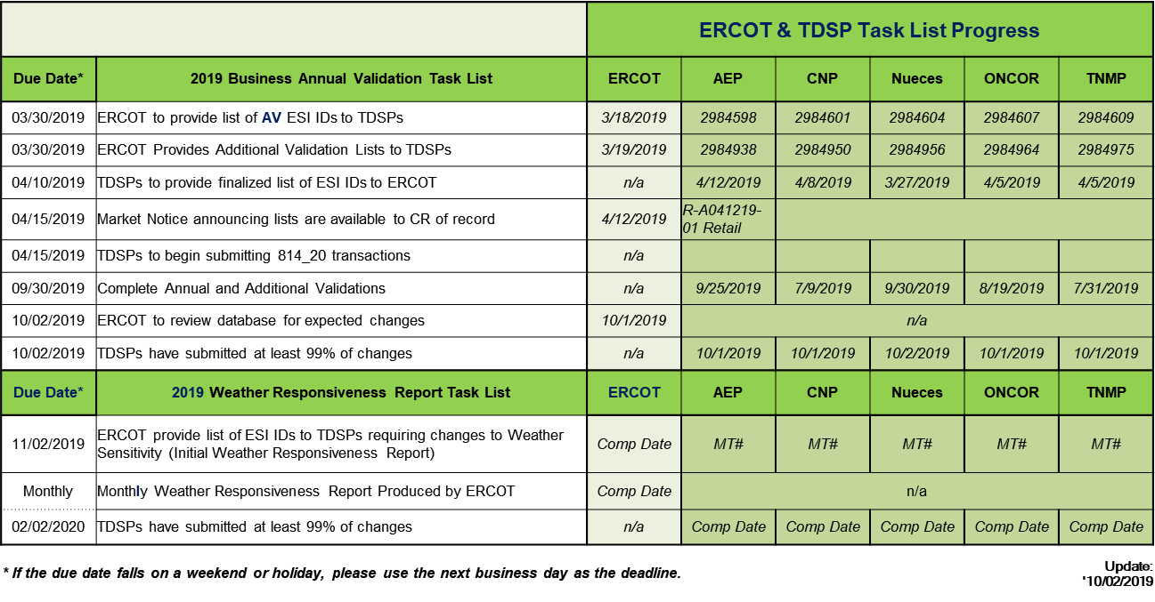

- Weather Sensitivity Report
  - Format of matrix will be revised to reflect the following columns:
    - Total count
    - Under Investigation
    - Complete
    - % Complete
    - Overdue
  - Randy will update the incorrect dates on the below matrix
  - Confirmed separate ERCOT Initiated MarkeTraks are submitted for the general population and those under investigation (likely missing data to be able to perform analysis)

- Jurisdiction of UFE Report – Randy reported this annual report should be presented to WMS. Randy agreed to notify the PWG exploder when the report is to be presented. ACTION: Sheri and Jim will review procedures and scope of PWG to see if revisions are necessary to move the jurisdiction of this report to WMS.

- Grey box language 18.6.1 Interval Data Recorder Meter Mandatory Installation Requirements
  - Sheri summarized the grey box language impacts noting the current language allows for “CR and TSDP approval, upon a Customer’s request” to allow for an AMS meter to be installed at a premise that would normally qualify for an IDR Meter (over 700 kW/kVA), whereby…
    - the appropriate load profile is assigned (not BUSIDRRQ)
    - LSE files are set to be received
    - MT to ERCOT noting no longer BUSIDRRQ
    - MT to CR noting profile will change
Would change to “at a TDSP’s discretion, or upon Customer’s request and TDSP’s approval”. The language is scheduled to be unboxed 1/1/20.
  - Working Group agreed language is applicable after 1/1/20.
  - Currently, only Oncor and TNMP have base rates that align with language allowing a customer to receive the benefits of 4CP while maintaining an AMS meter
  - It was also noted other factors impact TDSP approval such as customer requirements (integration with energy management systems), measurement of applicable billing determinants, or preparation of TDSP systems impact meter asset selection
  - Currently Oncor and TNMP will utilize an AMS meter asset for eligible customers, yet assign the BUSIDRRQ profile
  - Sheri noted the load profile determines delivery of interval and monthly data
  - CNP and AEP currently have base rate cases pending approval which will divest the meter asset from 4CP eligibility.
  - Working Group agreed options should be ‘charted out’ for new and existing IDR applications. ACTION: Sheri agreed to draft some structure to the options and will be reviewed at the next meeting.
  - Randy noted TAC’s holistic goal of moving current IDR Metered interval data to initial settlement after the Operating Day

- Improvements to Oil and Gas Profile assignments
  - Calvin explained with AMS meters being used and settled for oil and gas premises, scrutiny is no longer needed to review historical data to apply the profile.
  - Calvin is proposing the simply instruct the TDSPs to perform the revision once appropriate documentation (an noted in the LPG) has been provided
  - ACTION: ERCOT plans to submit an “administrative” LPGRR for above proposed revisions and plans to include the additional revisions:
    - Removal of TOU tab
    - Removal of non-ERCOT profile tab – should not impact Lubbock addition
    - Cleaning up Annual Validation tab for Residential

- Goals 2020/ Accomplishments 2019
Drafts were presented and the following was added

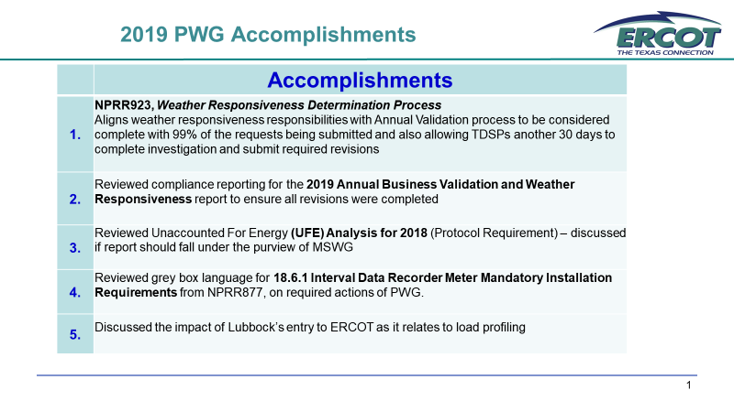

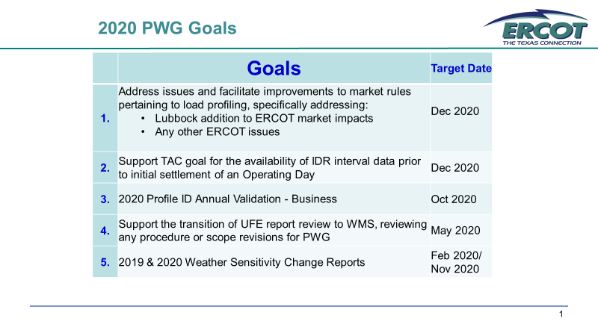
- Proposed Meeting Dates for 2020
  - February 4th - 1:30 PM (after RMS) – Face to Face meeting
  - April 3rd – 9:30 AM – WebEx only
  - May 15th – 9:30 AM – WebEx only
  - November 6th – 9:30 AM – WebEx only
ACTION: Sheri will send a note to ERCOT requesting dates be placed on the 2020 calendar.

- Meeting adjourned at 11:09
- PROPOSED AGENDA for February 4th , 2020
  - Review of Weather Sensitivity Report
  - Review of PWG procedures and scope pertaining to UFE report
  - 18.6.1 Interval Data Recorder Meter Mandatory Installation Requirements – chart of options and TDSP processes
  - DRAFT LPGRR – Oil and Gas Profile Assignment and Administrative Clean Up

