December 2019 ERCOT Monthly Operations Report
Reliability and Operations Subcommittee Meeting
Feb 6, 2020

Table of Contents
1. Report Highlights 2
2. Frequency Control 3
2.1. Frequency Events 3
2.2. Responsive Reserve Events 4
2.3. Load Resource Events 4
3. Reliability Unit Commitment 4
4. Wind Generation as a Percent of Load 5
5. Largest Net-Load Ramp 5
6. COP Error Analysis 6
7. Congestion Analysis 8
7.1. Notable Constraints 8
7.2. Generic Transmission Constraint Congestion 12
7.3. Manual Overrides 12
7.4. Congestion Costs for Calendar Year 2019 12
8. System Events 13
8.1. ERCOT Peak Load 13
8.2. Load Shed Events 14
8.3. Stability Events 14
8.4. Notable PMU Events 14
8.5. DC Tie Curtailment 14
8.6. TRE/DOE Reportable Events 14
8.7. New/Updated Constraint Management Plans. 14
8.8. New/Modified/Removed RAS 14
8.9. New Procedures/Forms/Operating Bulletins 14
9. Emergency Conditions 15
9.1. OCNs 15
9.2. Advisories 15
9.3. Watches 15
9.4. Emergency Notices 15
10. Application Performance 15
10.1. TSAT/VSAT Performance Issues 15
10.2. Communication Issues 15
10.3. Market System Issues 15
11. Model Updates 16
Appendix A: Real-Time Constraints 18

Report Highlights
- The unofficial ERCOT peak was 56,066 MW.
- There was 1 frequency event.
- There was 1 instance where Responsive Reserves were deployed.
- There was 1 RUC commitment.
- Congestion in the West Load Zone (LZ) can mostly be attributed to low conventional and renewable generation with high loads. Congestion in the South, North, and Houston LZs were mostly due to planned outages. There were 17 days of congestion on the Panhandle GTC and 2 on the Red Tap GTC.
- There were 3 DC Tie curtailments.

Frequency Control

Frequency Events
The ERCOT Interconnection experienced one frequency event, which resulted from a unit trip. The average event duration was 00:05:13.

A summary of the frequency events is provided below. The reported frequency events meet one of the following criteria: Delta Frequency is 60 mHz or greater; the MW loss is 350 MW or greater; resource trip event triggered RRS deployment. Frequency events that have been identified as Frequency Measurable Events (FME) for purposes of BAL-001-TRE-1 analysis are highlighted in blue. When analyzing frequency events, ERCOT evaluates PMU data according to industry standards. Events with an oscillating frequency of less than 1 Hz are considered to be inter-area, while higher frequencies indicate local events. Industry standards specify that damping ratio for inter-area oscillations should be 3.0% or greater. For the frequency events listed below, the ERCOT system met these standards and transitioned well after each disturbance.

Date and Time | Delta Frequency | Max/Min Frequency | Duration of Event | PMU Data |  | MW Loss | Load | Wind | Inertia
 | (Hz) | (Hz) |  | Oscillation Mode (Hz) | Damping Ratio |  | (MW) | % | (GW-s)
12/29/2019 22:27 | 0.093 | 59.892 | 0:05:13 | No PMU Data Available |  | 458.75 | 38,993 | 14% | 237,436

(Note: All data on this graph encompasses frequency event analysis based on BAL-001-TRE-1.)

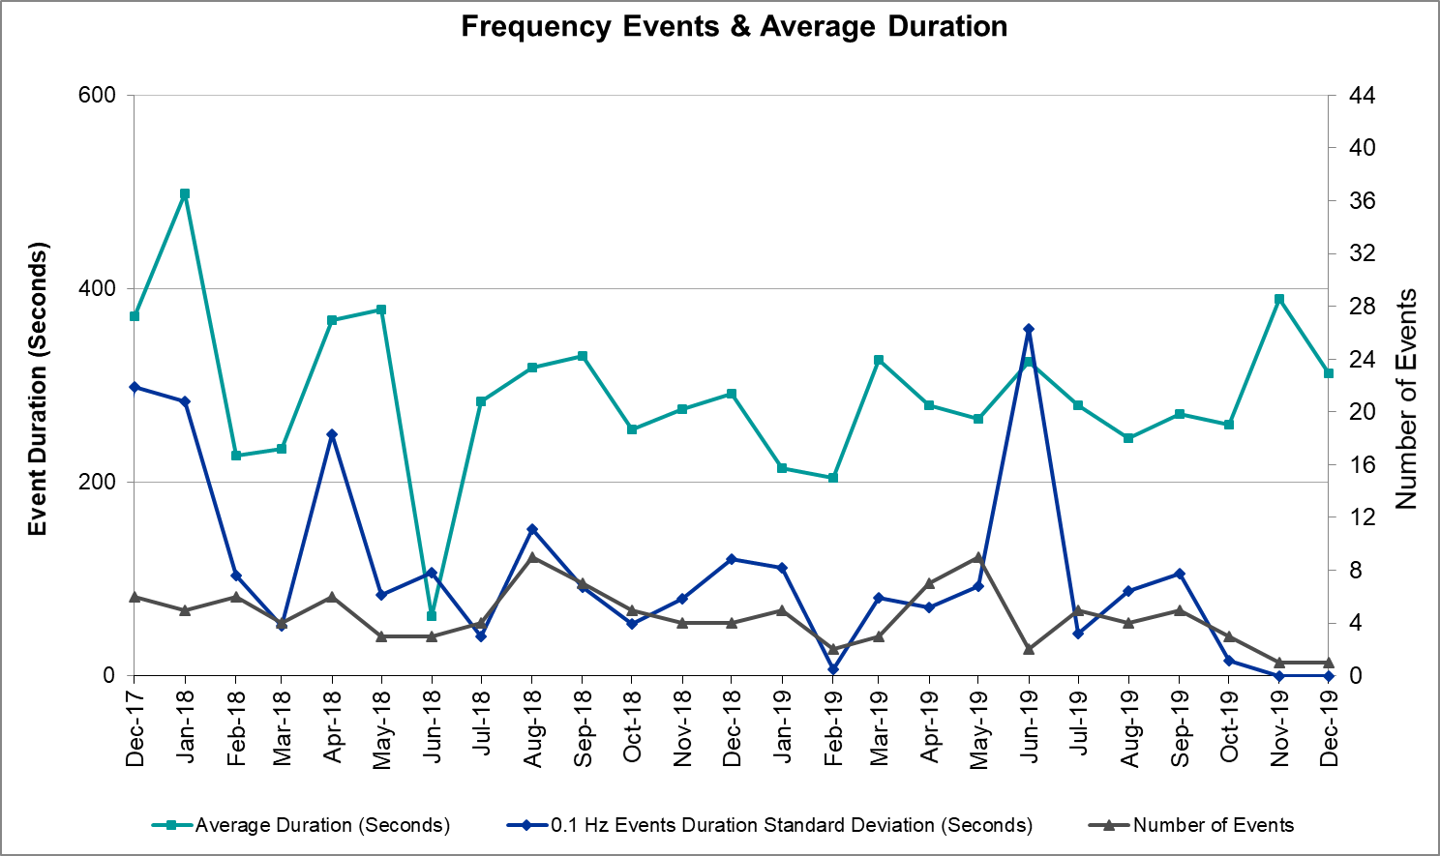
Note that the large standard deviation in June 2019 is due to coincidental extreme high and low durations for a small set of events (2).

Responsive Reserve Events
There was 1 event where Responsive Reserve MWs were released to SCED. The events highlighted in blue were related to frequency events reported in Section 2.1 above.

Date and Time Released to SCED | Date and Time Recalled | Duration of Event | Maximum MWs Released | Comments
12/29/2019 22:27 | 12/29/2019 22:31 | 00:04:12 | 689

Load Resource Events
None.

Reliability Unit Commitment
ERCOT reports on Reliability Unit Commitments (RUC) on a monthly basis. Commitments are reported grouped by operating day and weather zone. The total number of hours committed is the sum of the hours for all the units in the specified region. Additional information on RUC commitments can be found on the MIS secure site at Grid Generation Reliability Unit Commitment.

There were no DRUC commitments.

There was 1 HRUC commitment.

Resource Location | # of Resources | Operating Day | Total # of Hours Committed | Total MWhs | Reason for Commitment
Far West | 1 | 12/4/2019 | 1 | 70 | VDI / SECNMO28

Wind Generation as a Percent of Load

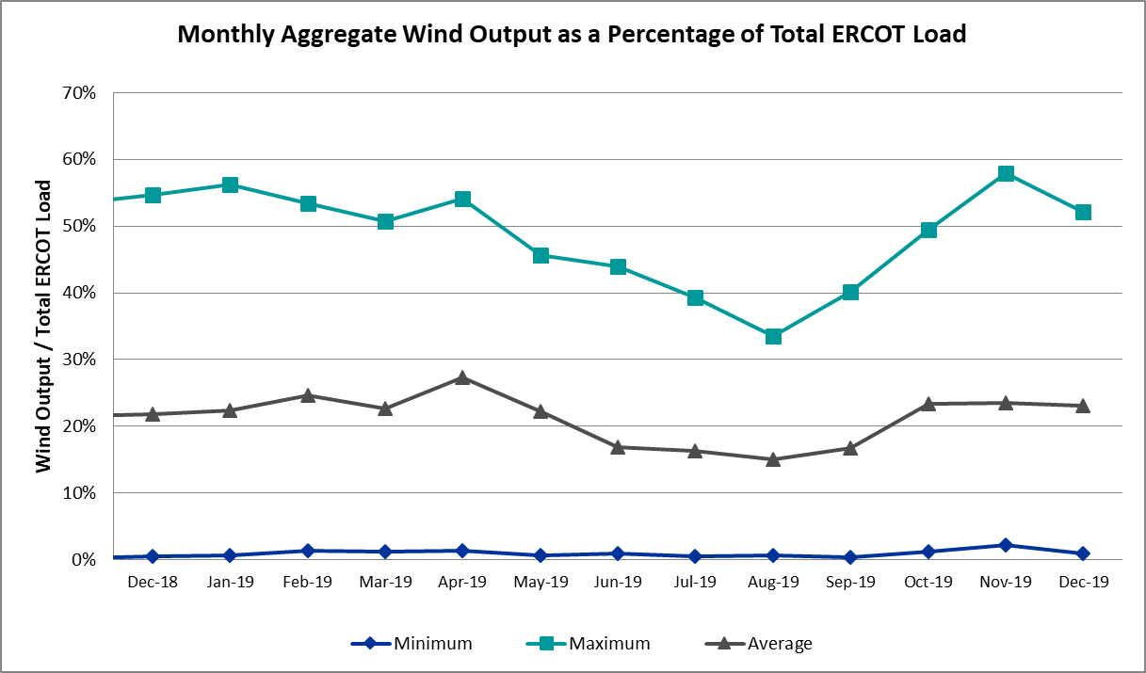

Wind Generation Record: 19,672 MW on 01/21/2019 at 19:19
Wind Penetration Record: 57.88% on 11/26/2019 03:52

Largest Net-Load Ramp
The net-load ramp is defined as the change in net-load (load minus wind and PVGR generation) during the defined time horizon. Such a variation in net-load needs to be accommodated in grid operations to ensure that the reliability of the grid is satisfactorily maintained. The largest net-load ramp during 5-min, 10-min, 15-min, 30-min and 60-min in December 2019 is 1186 MW, 1681 MW, 2462 MW, 4083 MW, and 6890 MW, respectively. The comparison with respect to the historical values is given in the table below.

Month and Year | 5 min | 10 min | 15 min | 30 min | 60 min
Dec 2019 | 1186 MW | 1681 MW | 2462 MW | 4083 MW | 6890 MW
Dec 2014 | 1014 MW | 1689 MW | 2112 MW | 3034 MW | 5296 MW
Dec 2015 | 962 MW | 1637 MW | 1995 MW | 3241 MW | 5516 MW
Dec 2016 | 857 MW | 1404 MW | 1827 MW | 3166 MW | 5866 MW
Dec 2017 | 964 MW | 1581 MW | 2078 MW | 3393 MW | 5708 MW
Dec 2018 | 923 MW | 1553 MW | 2148 MW | 4109 MW | 7218 MW
2014-2018 | 1494 MW | 1991 MW | 2780 MW | 4109 MW | 7218 MW

COP Error Analysis
COP Error is calculated as the capacity difference between the COP HSL and real-time HSL of the unit. Mean Absolute Error (MAE) stayed high over 6,900 MW until Day-Ahead at 12:00, then dropped significantly to 1,204 MW by Day-Ahead at 14:00. In the following chart, Under-Scheduling Error indicates that COP had less generation capacity than real-time and Over-Scheduling Error indicates that COP had more generation capacity than real-time. Under-Scheduling persisted from beginning of Day-Ahead to end of the Operating Day with the exception of eight hours. However, COP error for the Operating Hour freezes after the Adjustment Period.

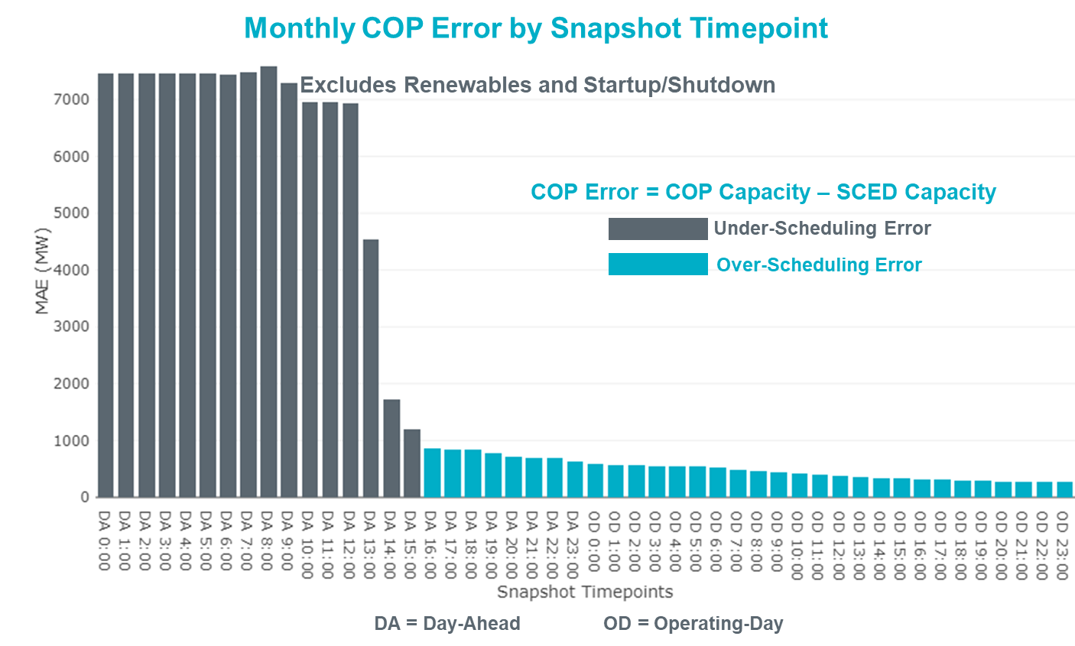

Monthly MAE for the Latest COP at the end of the Adjustment Period was 275 MW with median ranging from -71 MW for Hour-Ending (HE) 6 to 220 MW for HE 10. HE 20 on the 24th had the largest Over-Scheduling Error (1,252 MW) and HE 9 on the 18th had the largest Under-Scheduling Error (-1,323 MW).

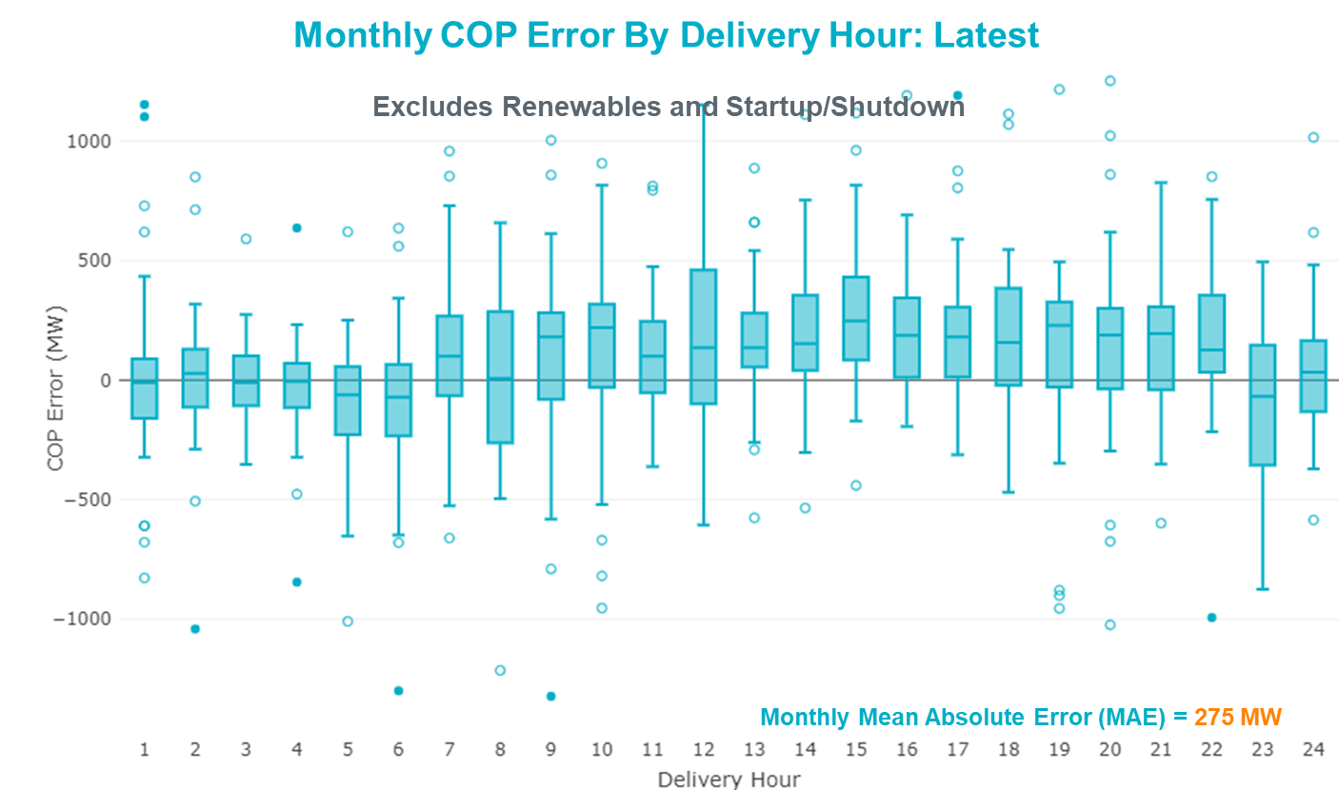

Monthly MAE for the Day-Ahead COP at 12:00 was 6,940 MW with median ranging from -8,978 MW for Hour-Ending (HE) 11 to -4,097 MW for HE 1. HE 8 on the 2nd had the largest Under-Scheduling Error (-15,918 MW) and HE 2 on the 25th had the largest Over-Scheduling Error (2,367 MW).

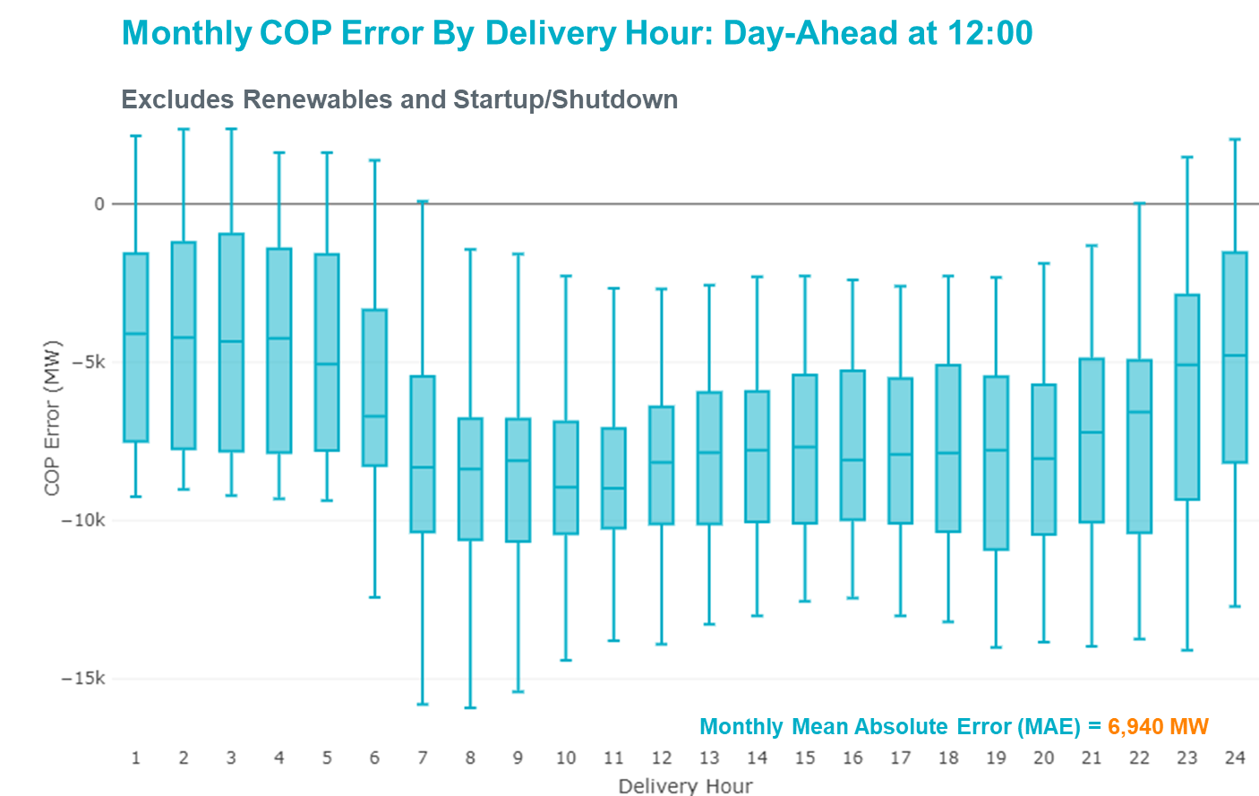

Congestion Analysis

Notable Constraints
Nodal protocol section 3.20 specifies that ERCOT shall identify transmission constraints that are active or binding three or more times within a calendar month. As part of this process, ERCOT reports congestion that meets this criterion to ROS. In addition ERCOT also highlights notable constraints that have an estimated congestion rent exceeding $1,000,000 for a calendar month. These constraints are detailed in the table below. Rows highlighted in blue indicate the congestion was affected by one or more outages. For a list of all constraints activated in SCED, please see Appendix A at the end of this report.

Contingency Name | Overloaded Element | # of Days Constraint Active | Congestion Rent | Transmission Project
MOSS SWITCH to ECTOR COUNTY NORTH SWITCHING STATION LIN _A | Dollarhide - No Trees Switch 138kV | 28 | $38,701,105.25 | Andrews County South Switch - No Trees Switch 138 kV Line (7171)
WINK to DUNE SWITCH and YUKON | Dollarhide - No Trees Switch 138kV | 26 | $23,757,613.88 | Andrews County South Switch - No Trees Switch 138 kV Line (7171)
Basecase | PNHNDL GTC | 25 | $18,209,225.26 | LP&L Integration Tie Lines (43367 A,B,C) and Panhandle Loop
Basecase | Center - Cedar Bayou Plant 345kV | 8 | $6,375,893.45 | Baytown Area Upgrades (43284B, 43284E, 43284D, 43284F, 43284G)
Lynx to RIO PECOS LIN 1 | Woodward 2 - Rio Pecos 138kV | 21 | $6,034,910.24 | Lynx: Expand 138 kV station (45503) and Solstice: Build 345 kV station (5530) and Solstice to Bakersfield: Build 345 kV line (5539)
TOMBSTONE to Lynx LIN 1 | Woodward 2 - Rio Pecos 138kV | 26 | $5,056,775.41 | Lynx: Expand 138 kV station (45503) and Solstice: Build 345 kV station (5530) and Solstice to Bakersfield: Build 345 kV line (5539)
Basecase | EASTEX GTC | 4 | $4,111,811.93
CRLNW-LWSSW 345kV | Jones Street Tnp - Lakepointe Tnp 138kV | 15 | $1,021,782.76 | Lewisville - Lewisville Jones - Lakepointe 138 kV Line (45537)
ODLAW SWITCHYARD to ASPHALT MINES LIN 1 | Hamilton Road - Maverick 138kV | 20 | $977,021.99 | Brackettville to Escondido: Construct 138 kV line (5206)
BLESSING TRX 1382 345/138 | Sargent Sub - Franklins Camp Sub 69kV | 6 | $800,994.98
Manual LOBO TO SAN MIGUEL 345 kV | Bruni Sub 138kV | 5 | $761,950.12
Bbses-Rchbr 345kV | Seagoville - Kleberg Tap 138kV | 4 | $695,762.01
Berghe-Kendal 345kv & Welfar 138kv | Kendall - Cagnon 345kV | 8 | $561,321.67 | Boerne Cico - Comfort - Kendall Transmission Line Upgrade (6982)
Riohondo-Nedin 345kV&Harlnsw 138kV | Burns Sub - Rio Hondo 138kV | 4 | $512,738.14 | Rebuild Rio Hondo to East Rio Hondo (6687)
FORT MASON to YELLOW JACKET LIN 1 | Yellow Jacket - Hext Lcra 69kV | 16 | $490,898.56
MOSS SWITCH to ECTOR COUNTY NORTH SWITCHING STATION LIN _A | Moss Switch - Shin Oak Pod 138kV | 3 | $476,844.59
KLEBERG AEP to LOYOLA SUB LIN 1 | Loyola Sub 138kV | 6 | $436,239.88
Stp-Hlj&&White_Pt 345kV | Blessing - Lolita 138kV | 13 | $306,814.76 | Tidehaven: Construct New Distribution Station (48776)
CPSES-JONSW&EVRSW 345kV | Mitchell Bend Switch - Decordova Ses 345kV | 5 | $278,447.68 | Mitchell Bend - Rocky Creek 345 kV line (5312)
ZORN - HAYSEN 345KV | Fairra - Esperanza 138kV | 4 | $204,283.81 | Boerne Cico - Comfort - Kendall Transmission Line Upgrade (6982)
Lon_Hill-Coleto 345kV&Warburtn 138kV | Rincon - Melon Creek 138kV | 3 | $204,260.78
TWR (345) JN-WAP64 & JN-WAP72 | Bellaire - Smithers 345kV | 7 | $184,735.63
DANEVANG SWITCHING STATION to BLESSING LIN 1 | Blessing 138kV | 6 | $176,355.01
LAQUINTA to LOBO LIN 1 | Bruni Sub 138kV | 6 | $169,607.33
PH ROBINSON to MEADOW LIN A | Mainland Tnp - Alvin Tnp 138kV | 3 | $166,656.86
ZORN - HAYSEN 345KV | Kendall - Cagnon 345kV | 6 | $162,381.21 | Boerne Cico - Comfort - Kendall Transmission Line Upgrade (6982)
LAQUINTA to LOBO LIN 1 | Falfurrias - Premont 69kV | 6 | $143,791.93 | Premont - Falfurrias 69 kV Line (6203)
Manual LOBO TO SAN MIGUEL 345 kV | North Laredo Switch - Piloncillo 138kV | 5 | $140,404.05
LON HILL to NELSON SHARPE LIN 1 | Kingsville - Kleberg Aep 138kV | 3 | $115,292.48
LOFTIN to COTTONWOOD ROAD SWITCH LIN 1 | Bowie 138kV | 17 | $108,671.95
MANUAL MANUAL RIOPECOS to LYNX 138 kV | Woodward 2 - Rio Pecos 138kV | 3 | $101,670.01 | Lynx: Expand 138 kV station (45503) and Solstice: Build 345 kV station (5530) and Solstice to Bakersfield: Build 345 kV line (5539)
RIO HONDO to LAS PULGAS LIN 1 | Raymondville 2 138kV | 6 | $96,137.86 | Harlingen SS - Raymondville #2: Convert to 138 kV (6167)
WXHCH-WXOCF_69kV & ENWSW-STERT_138kV | Trumbull - Ennis Switch 138kV | 5 | $61,734.54
WICHITA FALLS SOUTH SWITCH to NEWPORT BEPC LIN _E | Bowie 138kV | 8 | $59,417.50
ODLAW SWITCHYARD to ASPHALT MINES LIN 1 | Escondido - Ganso 138kV | 10 | $51,954.19 | Brackettville to Escondido: Construct 138 kV line (5206)
CRLNW-LWSSW 345kV | Ti Tnp - West Tnp 138kV | 3 | $47,839.24
BOSQUE SWITCH to ELM MOTT LIN 1 | Bosque Switch - Rogers Hill Bepc 138kV | 11 | $45,698.29
MOSS SWITCH to ECTOR COUNTY NORTH SWITCHING STATION LIN _A | Cheyenne Tap - Wink Sub 138kV | 8 | $44,191.52 | Rebuild Wink Sw. Sta. - No Trees Sw. Sta. 138 kV Line (7101). Andrews County South Switch - No Trees Switch 138 kV Line (7171). Add Wink to Andrews County South 138 kV Second Circuit (51236)
FORT LANCASTER to ILLINOIS #4 LIN 1 | Hamilton Road - Maxwell 138kV | 14 | $39,598.86 | Brackettville to Escondido: Construct 138 kV line (5206)
BRACKETTVILLE to HAMILTON ROAD LIN 1 | Hamilton Road - Maverick 138kV | 8 | $36,428.71 | Brackettville to Escondido: Construct 138 kV line (5206)
Pig Creek to Solstice LIN 1 | Woodward 2 - Rio Pecos 138kV | 8 | $26,508.23 | Lynx: Expand 138 kV station (45503) and Solstice: Build 345 kV station (5530) and Solstice to Bakersfield: Build 345 kV line (5539)
Basecase | NE_LOB GTC | 10 | $20,829.24
Basecase | Randado Aep - Zapata 138kV | 10 | $20,296.36 | Zapata: Add 138 kV Reactor (44393)
KING MOUNTAIN SWITCHYARD to ODESSA EHV SWITCH LIN 1 | Fort Stockton Plant - Solstice 138kV | 3 | $18,658.88 | Solstice: Build 345 kV station (5530)
Solstice to FORT STOCKTON PLANT LIN 1 | Alpine - Bronco 69kV | 4 | $16,188.69
COLEMAN LAKE IVIE TAP to EAST COLEMAN TAP LIN 1 | Ballinger - Ballinger Humble Tap 69kV | 3 | $5,013.51 | Ballinger to Paint Rock 69 kV line: Rebuild 69 kV line (6347). Ballinger: Replace the 138/69 kV autotransformer (48818). Ballinger to Eden 69 kV line: Rebuild taps (6572)
TWR(345) JCK-STP18 & DOW-REF27 | Hillje - South Texas Project 345kV | 3 | $4,288.19
GLEN HEIGHTS to DESOTO SWITCH LIN _A | Waxahachie Ocf - Waxahachie 69kV | 3 | $3,252.27

Generic Transmission Constraint Congestion
There were 17 days of congestion on the Panhandle GTC and 2 days on the Red Tap GTC. There was no activity on the remaining GTCs during the month.

Note: This is how many times a constraint has been activated to avoid exceeding a GTC limit, it does not imply an exceedance of the GTC occurred or that the GTC was binding.

Manual Overrides
None.

Congestion Costs for Calendar Year 2019
The following table represents the top twenty active constraints for the calendar year based on the estimated congestion rent attributed to the congestion. ERCOT updates this list on a monthly basis.

Contingency | Binding Element | # of 5-min SCED Intervals | Estimated Congestion Rent | Transmission Project
MOSS SWITCH to ECTOR COUNTY NORTH SWITCHING STATION LIN _A | Dollarhide - No Trees Switch 138kV | 9,813 | 124,222,369.15 | Andrews County South Switch - No Trees Switch 138 kV Line (7171)
Basecase | PNHNDL GTC | 36,285 | 97,120,897.62
WINK to DUNE SWITCH and YUKON | Dollarhide - No Trees Switch 138kV | 5,685 | 61,522,791.11 | Andrews County South Switch - No Trees Switch 138 kV Line (7171)
MOSS SWITCH to ECTOR COUNTY NORTH SWITCHING STATION LIN _A | Andrews County South - Amoco Three Bar Tap 138kV | 3,509 | 36,990,892.12 | Andrews County South Switch - No Trees Switch 138 kV Line (7171)
GAS PAD to FLAT TOP TNP LIN 1 | Woodward 2 - Rio Pecos 138kV | 2,032 | 31,254,543.67 | "Solstice: Build 345 kV station (5530)
Hcksw-Sagna-138kv | Eagle Mountain Ses - Morris Dido 138kV | 3,036 | 28,140,366.16 | Solstice to Bakersfield: Build 345 kV line (5539)"
CAGNON to KENDALL LIN 1 | Cico - Comfort 138kV | 8,246 | 27,467,121.10 | Eagle Mountain-Calmont 138 kV Line (4253)
Elmcreek-Skyline 345kV | Hill Country - Marion 345kV | 961 | 26,958,430.36 | Boerne Cico - Comfort - Kendall Transmission Line Upgrade (6982)
TWR (345) HLJ-WAP64 & BLY-WAP72 | Jones Creek - South Texas Project 345kV | 6,554 | 25,411,174.07 | Zorn to Marion 2nd 345-kV Transmission Line Addition (4473)
MIDESSA SOUTH SW TRX MDSSW_1_1 345/138 | Trigas Odessa Tap - Odessa Ehv Switch 138kV | 1,490 | 23,618,361.58 | Freeport Master Plan (6668A)
Solstice to FORT STOCKTON PLANT LIN 1 | Barrilla - Fort Stockton Switch 69kV | 15,075 | 23,366,135.59 | Riverton-Odessa EHV/Moss 345 kV Line (5445)
CRLNW-LWSSW 345kV | Jones Street Tnp - Lakepointe Tnp 138kV | 8,048 | 21,845,320.86 | "Solstice: Build 345 kV station (5530) and Solstice to Bakersfield: Build 345 kV line (5539)
CRLNW-LWSSW 345kV | Ti Tnp - West Tnp 138kV | 2,878 | 19,209,874.61 | Pecos County Modification Project (7028, 44359)"
FRIEND RANCH TRX FMR1 138/69 | Sonora 138kV | 4,982 | 18,574,808.81 | Lewisville - Lewisville Jones - Lakepointe 138 kV Line (45537)
WINK to DUNE SWITCH and YUKON | Andrews County South - Amoco Three Bar Tap 138kV | 2,374 | 18,556,925.85
TWR (345) HLJ-WAP64 & BLY-WAP72 | South Texas Project - Wa Parish 345kV | 902 | 15,903,156.70 | "Carver: Build new 138 kV station (5979)
Hcksw-Sagna-138kv | #N/A | 1,171 | 14,755,180.28 | Friess Ranch to Sonora: Rebuild 69 kV line (51001)
Manual LOTEBUSH toYUCSW 138 kV | Woodward 2 - Rio Pecos 138kV | 2,888 | 14,726,601.84 | Rocksprings to Friess Ranch: Rebuild 69 kV line (51005)"
Manual LOTEBUSH toYUCSW 138 kV | 16th Street Tnp - Woodward 2 138kV | 4,906 | 14,675,595.13 | Andrews County South Switch - No Trees Switch 138 kV Line (7171)
DMTSW-SCOSW 345KV | Knapp - Scurry Chevron 138kV | 4,760 | 14,601,372.86 | Freeport Master Plan (6668A)

System Events

ERCOT Peak Load
The unofficial ERCOT peak load for the month was 56,066 MW and occurred on the 18th, during hour ending 8:00.

Load Shed Events
None.

Stability Events
None.

Notable PMU Events
ERCOT analyzes PMU data for any significant system disturbances that do not fall into the Frequency Events category reported in section 2.1. The results are summarized in this section once the analysis has been completed.

There were no PMU events outside of those reported in section 2.1.

DC Tie Curtailment
Date | DC Tie | Curtailing Period | # of Tags Curtailed | Initiating Event | Curtailment Reason
12/5/2019 | DC-L | HE19 | 1 | VFT issue | Unplanned outage
12/13/2019-12/14/2019 | DC-S | 12/13 HE22 - 12/14 HE24 | 5 | RTU failure | Unplanned outage
12/22/2019 | DC-L | HE18 - 19 | 1 | Unplanned outage | Unplanned outage

TRE/DOE Reportable Events
- AEP submitted an OE-417 for 12/16/2019. Reportable Event Type: Loss of 3 or more BES Elements
- AEP submitted an OE-417 for 12/31/2019. Reportable Event Type: Electrical System Separation
(Islanding) where part or parts of a power grid remain(s) operational in an otherwise blacked out
area or within the partial failure of an integrated electrical system

New/Updated Constraint Management Plans.
None.

New/Modified/Removed RAS
- One RAS added.

New Procedures/Forms/Operating Bulletins

Procedure Title | POB
DC Tie Desk | 917
Real-Time Desk | 918
Reliability Risk Desk | 919
Reliability Unit Commitment Desk | 920
Resource Desk | 921
Scripts | 922
Shift Supervisor Desk | 923
Transmission & Security Desk | 924

Emergency Conditions

OCNs
None.

Advisories
Date and Time | Message
Dec 12 2019 13:29 CPT | ERCOT has postponed the deadline for the posting of the DAM Solution for Operating Day December 13, 2019 due to an internal issue that is being investigated.
Dec 12 2019 13:48 CPT | ERCOT is issuing an Advisory for the timeline deviation of the Day Ahead Market the start of DRUC will be delayed.
Dec 12 2019 13:30CPT | ERCOT has postponed the deadline for the posting of the DAM Solution for Operating Day December 13, 2019 due to an internal issue that is being investigated.
Dec 16 2019 13:30 CPT | ERCOT has postponed the deadline for the posting of the DAM Solution for Operating Day December 17, 2019 due to long solution run time. Please wait for further instruction.

Watches
None.

Emergency Notices
Date and Time | Message
Dec 04 2019 17:18 CPT | Transmission Emergency Notice has been issued for the Far West area.

Application Performance

TSAT/VSAT Performance Issues
None.

Communication Issues
None.

Market System Issues
None.

Model Updates
The Downstream Production Change (DPC) process allows ERCOT to make changes in the on-line Network Operations Model without loading a completely new model. The purpose of this process is to allow for reliable grid operations as system conditions change between designated Network Operations Model database loads. The DPC process is limited in scope to just those items listed below, with equipment ratings updates being the most common. ERCOT has seen a rise in the use of the DPC process to make on-line updates to the Network Operations Model in recent years, instead of through the standard Network Operations Model Change Request process.

- Static Line ratings (Interim Update)
- Dynamic Line ratings (non-Interim Update)
- Autotransformer ratings (non-Interim Update)
- Breaker and Switch Normal status (Interim Update)
- Contingency Definitions (Interim Update)
- RAP and RAS changes or additions (Interim Update)
- Net Dependable and Reactive Capability (NDCRC) values (Interim Update)
- Impedance Updates (non-Interim)

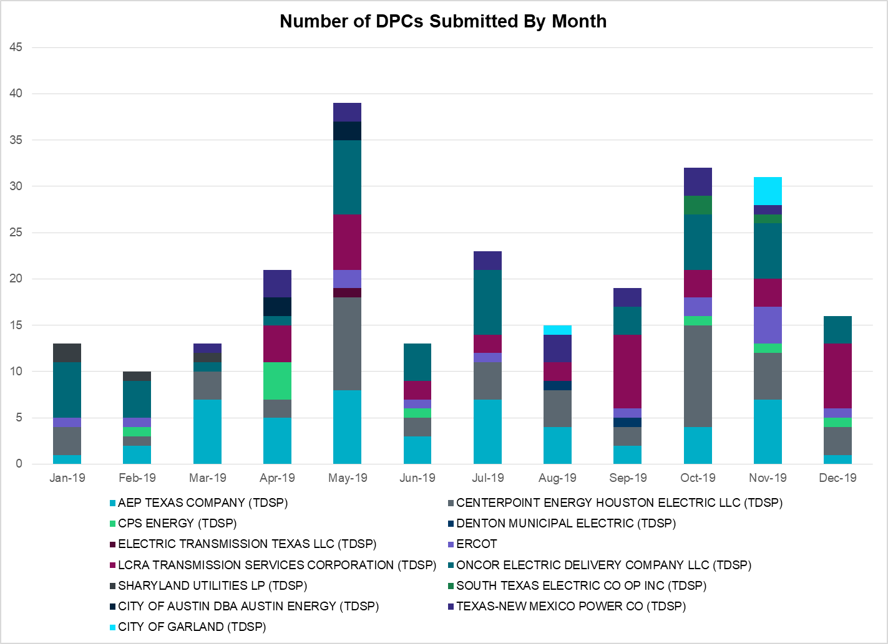

Transmission Operator | Number of DPCs
AEP TEXAS COMPANY (TDSP) | 1
BRAZOS ELECTRIC POWER CO OP INC (TDSP) | 0
CENTERPOINT ENERGY HOUSTON ELECTRIC LLC (TDSP) | 3
CITY OF AUSTIN DBA AUSTIN ENERGY (TDSP) | 0
CITY OF GARLAND (TDSP) | 0
CPS ENERGY (TDSP) | 1
DENTON MUNICIPAL ELECTRIC (TDSP) | 0
ELECTRIC TRANSMISSION TEXAS LLC (TDSP) | 0
ERCOT | 1
LCRA TRANSMISSION SERVICES CORPORATION (TDSP) | 7
ONCOR ELECTRIC DELIVERY COMPANY LLC (TDSP) | 3
SHARYLAND UTILITIES LP (TDSP) | 0
SOUTH TEXAS ELECTRIC CO OP INC (TDSP) | 0
TEXAS MUNICIPAL POWER AGENCY (TDSP) | 0
TEXAS-NEW MEXICO POWER CO (TDSP) | 0

Appendix A: Real-Time Constraints
The following is a complete list of constraints activated in SCED. Full contingency descriptions can be found in the Standard Contingencies List located on the MIS secure site at Grid Generation Reliability Unit Commitment.

Contingency | Constrained Element | From Station | To Station | # of Days Constraint Active
SECNMO28 | 6100__F | DHIDE | NOTSW | 28
DWINDUN8 | 6100__F | DHIDE | NOTSW | 26
STOMLYN8 | RIOPEC_WOODW21_1 | RIOPECOS | WOODWRD2 | 26
BASE CASE | PNHNDL | n/a | n/a | 25
SLYNRIO8 | RIOPEC_WOODW21_1 | RIOPECOS | WOODWRD2 | 21
SBRAUVA8 | HAMILT_MAVERI1_1 | HAMILTON | MAVERICK | 20
SCRDLOF9 | BOW_FMR1 | BOW | BOW | 17
SFORYEL8 | HEXT_YELWJC1_1 | YELWJCKT | HEXT | 16
DCRLLSW5 | 590__B | LWVJS | LKPNT | 15
SILLFTL8 | HAMILT_MAXWEL1_1 | MAXWELL | HAMILTON | 14
DSTPWHI5 | BLESSI_LOLITA1_1 | BLESSING | LOLITA | 13
SBOSELM5 | 1030__B | BOSQUESW | RGH | 11
BASE CASE | NE_LOB | n/a | n/a | 10
BASE CASE | RANDAD_ZAPATA1_1 | RANDADO | ZAPATA | 10
SBRAUVA8 | ESCOND_GANSO1_1 | GANSO | ESCONDID | 10
SBRAHAM8 | HAMILT_MAVERI1_1 | HAMILTON | MAVERICK | 8
SLKAWFS8 | BOW_FMR1 | BOW | BOW | 8
SPIGSOL8 | RIOPEC_WOODW21_1 | WOODWRD2 | RIOPECOS | 8
BASE CASE | CBYCTR97_A | CTR | CBY | 8
DBERWE58 | R5_KENDL_1 | KENDAL | CAGNON | 8
SECNMO28 | 6101__B | CHEYT | WINKS | 8
DWAP_JN5 | BI_SMR98_A | SMITHERS | BI | 7
SLAQLOB8 | FALFUR_PREMON1_1 | FALFUR | PREMONT | 6
SRAYRI28 | RAYMND2_69A1 | RAYMND2 | RAYMND2 | 6
SLAQLOB8 | BRUNI_69_1 | BRUNI | BRUNI | 6
XBLE58 | SAR_FRAN_1 | FRANKC | SARGNTS | 6
SDANBLE8 | BLESSING_69A1 | BLESSING | BLESSING | 6
DZORHAY5 | R5_KENDL_1 | KENDAL | CAGNON | 6
SKLELOY8 | LOYOLA_69_1 | LOYOLA | LOYOLA | 6
DCPSJON5 | 6017__A | MBDSW | DCSES | 5
MLOBSA_5 | BRUNI_69_1 | BRUNI | BRUNI | 5
DENWSTE8 | 921__D | ENSSW | TRU | 5
MLOBSA_5 | NLARSW_PILONC1_1 | NLARSW | PILONCIL | 5
SSOLFTS8 | ALPINE_BRONCO1_1 | BRONCO | ALPINE | 4
DBBSRCH5 | 1750__B | SGOVL | KLBTP | 4
DRIOHAR5 | BURNS_RIOHONDO_1 | RIOHONDO | MV_BURNS | 4
BASE CASE | EASTEX | n/a | n/a | 4
DZORHAY5 | 503T503_1 | ESPERA | R0 | 4
SCOLBAL8 | BALLIN_HUMBLT1_1 | BALLINGE | HUMBLTAP | 3
SKINODE5 | FTST_SOLSTI1_1 | FTST | SOLSTICE | 3
DWAPHLJ5 | JCKSTP18_A | STP | JCK | 3
SN_SLON5 | KINGSV_KLEBER1_1 | KLEBERG | KINGSVIL | 3
SECNMO28 | 6518__A | MOSSW | SOPOD | 3
MRIOLYN8 | RIOPEC_WOODW21_1 | RIOPECOS | WOODWRD2 | 3
DJCKREF5 | CKT_3124_1 | STP | HLJ | 3
SMDOPHR5 | 138_ALV_MNL_1 | ALVIN | MAINLAND | 3
SGLNDES8 | 2450__A | WXHCH | WXOCF | 3
DWH_STP5 | BLESSI_LOLITA1_1 | BLESSING | LOLITA | 3
DLONWAR5 | MELONC_RINCON1_1 | RINCON | MELONCRE | 3
DCRLLSW5 | 588_A_1 | LWSVW | LWVTI | 3
SBNDRYS5 | 568__A | RYSSW | NEVADA | 3
DBERWE58 | 73T120_1 | HOLLMI | FREDER | 2
SORE2B8 | EB_WA_65_A | EB | WA | 2
DREFSTP5 | CKT_3124_1 | STP | HLJ | 2
SFORYEL8 | HEXT_MASONS1_1 | MASONSW | HEXT | 2
SPOMNED5 | NLARSW_PILONC1_1 | NLARSW | PILONCIL | 2
DELMSAN5 | PAWNEE_SPRUCE_1 | PAWNEE | CALAVERS | 2
BASE CASE | RV_RH | n/a | n/a | 2
DBIGKEN5 | SAPOWE_TREADW1_1 | SAPOWER | TREADWEL | 2
DBIGKEN5 | TREADW_YELWJC1_1 | TREADWEL | YELWJCKT | 2
DWINDUN8 | 6101__B | CHEYT | WINKS | 2
SPLUPIN8 | BELLSO_AT2 | BELLSO | BELLSO | 2
DBIGKEN5 | HAMILT_MAXWEL1_1 | MAXWELL | HAMILTON | 2
SFORYEL8 | MASNPH_MASN1_1 | MASN | MASNPHT | 2
MFTSLYN8 | RIOPEC_WOODW21_1 | RIOPECOS | WOODWRD2 | 2
DRYSFOR5 | FORSW_MR3H | FORSW | FORSW | 2
SMDLODE5 | ODEHV_MR2H | ODEHV | ODEHV | 2
DHILMAR5 | 361T361_1 | SCHERT | PARKWA | 2
DELMSAN5 | PAWNEE_SPRUCE_1 | CALAVERS | PAWNEE | 2
DSCOFAR5 | 6216__A | SHRNE | BCKSW | 2
SMCEABS8 | MKLT_TRNT1_1 | TRNT | MKLT | 2
BASE CASE | N_TO_H | n/a | n/a | 2
SMGIENW8 | 921__D | ENSSW | TRU | 2
XMOS58 | MOSSW_MR1H | MOSSW | MOSSW | 2
BASE CASE | MCCAMY | n/a | n/a | 2
DFLAPLU8 | BELLSO_AT2 | BELLSO | BELLSO | 2
SJNWA3P5 | BI_SMR98_A | SMITHERS | BI | 2
SGLNDES8 | 940__C | ENWSW | WXHCH | 2
XCBY58 | CBY_AT3 | CBY | CBY | 1
SSCUSU28 | ROTN_WOLFGA1_1 | WOLFGANG | ROTN | 1
MLOBSA_5 | FALFUR_PREMON1_1 | FALFUR | PREMONT | 1
SN_SLON5 | LOYOLA_69_1 | LOYOLA | LOYOLA | 1
DZORHAY5 | R0_FAIR_1 | R0 | FAIROA | 1
BASE CASE | THOMASTN_PS1 | THOMASTN | THOMASTN | 1
DRYSFOR5 | 1750__B | SGOVL | KLBTP | 1
SDOBCOR8 | 670__A | BRNWD | BRNSO | 1
SHAYZO25 | 6T227_1 | HAYSEN | ZORN | 1
SMARALM9 | ALPINE_PAIS1_1 | ALPINE | PAIS | 1
BASE CASE | BEARKT | n/a | n/a | 1
DJCKREF5 | BLESSI_LAN_CT1_1 | BLESSING | LAN_CTY | 1
SGEOORN8 | CSA_SAN_1 | CASA_BLA | SANDIAS | 1
SMCEESK8 | ESKSW_TRNT1_1 | ESKSW | TRNT | 1
BASE CASE | JFSSC_06_A | JFS | SC | 1
SRAYRI28 | RAYMND_RAYMON1_1 | RAYMND2 | RAYMOND1 | 1
SBNDRYS5 | 1390__F | MESFR | BCKHM | 1
DYKNWIN8 | 6100__G | ACSSW | AMTBT | 1
DWINDUN8 | 6518__A | MOSSW | SOPOD | 1
XCB3Y58 | BCVPSA03_A | PSA | BCV | 1
DREFSTP5 | BLESSI_LAN_CT1_1 | BLESSING | LAN_CTY | 1
DAUSDUN8 | CKT_962_1 | GARFIELD | STONEY_R | 1
DGABGEA8 | GABRIE_AT1 | GABRIE | GABRIE | 1
SGARGA35 | GARFIELD_AT1 | GARFIELD | GARFIELD | 1
DZORHAY5 | 115T123_1 | KENDAL | KERRST | 1
DPHRAL58 | 138_FWP_MNL_1 | MAINLAND | FRWYPARK | 1
DBERWE58 | 415T415_1 | MILLER | HENLY | 1
DYKNWIN8 | 6100__F | DHIDE | NOTSW | 1
DYKNWIN8 | 6485__A | PWPOD | WLFSW | 1
DWINDUN8 | 6485__B | RLKSW | PWPOD | 1
SENSEN28 | 941__B | ENSSW | ENNIS | 1
SBLESTP5 | BELLSO_AT2 | BELLSO | BELLSO | 1
DRILKRW5 | BOW_FMR1 | BOW | BOW | 1
SSTLEIN8 | CRTVLE_EINSTEN_1 | EINSTEIN | CRTRVLLE | 1
SKINKLE8 | LOYOLA_69_1 | LOYOLA | LOYOLA | 1
DYKNWIN8 | 6101__B | CHEYT | WINKS | 1
SECNMO28 | 6485__B | RLKSW | PWPOD | 1
SDOBCOR8 | 650__A | CMNSW | BRNWD | 1
XCAG158 | CAGNON_MR4H | CAGNON | CAGNON | 1
SSCJFS8 | CRNJFS94_A | JFS | CRN | 1
SN_SLON5 | HOLLY4_SOUTH_1_1 | HOLLY4 | SOUTH_SI | 1
DWH_STP5 | NORMAN_PETTUS1_1 | PETTUS | NORMANNA | 1
SECNMO28 | 6100__G | ACSSW | AMTBT | 1
DBERBO58 | 73T120_1 | HOLLMI | FREDER | 1
SPATBOW8 | BOW_FMR1 | BOW | BOW | 1
SN_SLON5 | CELANE_N_SHAR1_1 | N_SHARPE | CELANEBI | 1
SPOMNED5 | FREER_LOBO1_1 | LOBO | FREER | 1
DGARLYT5 | GARFIELD_AT1 | GARFIELD | GARFIELD | 1
SCOLLON5 | MELONC_RINCON1_1 | RINCON | MELONCRE | 1
SSCLWF18 | NVKSW_FMR1 | NVKSW | NVKSW | 1
DBERWE58 | 55T207_1 | GILLES | WOLFCR | 1
SMDOOAS5 | BCVPSA03_A | PSA | BCV | 1
BASE CASE | TRDWEL | n/a | n/a | 1
DWINDUN8 | 6100__G | ACSSW | AMTBT | 1
DGRMGRS8 | 6635__G | ESTLD | MRVLY | 1
SSCLWF18 | 6840__B | NVKSW | ANARN | 1
DAUSLOS5 | BELLSO_AT2 | BELLSO | BELLSO | 1
MSMIPIN8 | BELLSO_AT2 | BELLSO | BELLSO | 1
SCISPUT8 | ESTES_PECAN_1_1 | PECAN_BY | ESTES | 1
DBERAN58 | R5_KENDL_1 | KENDAL | CAGNON | 1
BASE CASE | RIOHND_ERIOHND_1 | MV_RIOHO | RIOHONDO | 1
DTYGFOR5 | ELKTN_MR3L | ELKTN | ELKTN | 1

The Duration of Event is defined as the time it takes for the frequency to recover to pre-disturbance frequency or 60 Hz as applicable.
PMU reports are typically generated when frequency drops below 59.9, but PMU data is available for other events.
Delta Frequency is defined as the difference between the starting point of the frequency event (t(0) or “A-point”) and minimum/maximum frequency (“C-Point”).
Currently, the Critical Inertia Level for ERCOT is approximately 100,000 MW-s
This is the hourly integrated peak demand as published in the ERCOT D&E report.

