System Planning
Monthly Status Report

Report Highlights

- ERCOT is currently reviewing proposed transmission improvements with a total estimated cost of $1,309.31 Million as of December 31, 2019.
- Transmission Projects endorsed in 2019 total $628.8 Million as of December 31, 2019.
- All projects (in engineering, routing, licensing and construction) total approximately $3.41 Billion as of October 1, 2019.
- Transmission Projects energized in 2019 total about $1.30 Billion as of October 1, 2019.

Regional Planning Group Reviews
- AEPSC has submitted the LRGV Import Project. This is a Tier 1 project that is estimated to cost $73.4 million. AEPSC has also requested that ERCOT provide a conditional endorsement for an additional $357.2 million project. The ERCOT Independent Review has been conducted in accordance with Protocol Section 3.11.4.9(3), and this project is currently placed on hold until the LNG loads are confirmed.
- STEC has submitted the Lower Rio Grande Valley Transmission Expansion Project. This is a Tier 1 project that is estimated to cost $511 million. The ERCOT Independent Review has been conducted in accordance with Protocol Section 3.11.4.9(3), and this project is currently placed on hold until the LNG loads are confirmed.
- AEPSC has submitted the Corpus North Shore Project. This is a Tier 1 project that is estimated to cost $259.57 million. This project is currently under ERCOT Independent Review.
- 7x Energy has submitted the Frio County Transmission Project. This is a Tier 2 project that is estimated to cost $23 million. This project is currently under ERCOT Independent Review.
- AEPSC has submitted the Quanah Area Improvement Transmission Project. This is a Tier 2 project that is estimated to cost $10 million. This project is currently under ERCOT Independent Review.
- GP&L has submitted the McCree Substation Reliability Upgrades Project. This is a Tier 3 project that is estimated to cost $18.2 million. This project completed the RPG review on December 17, and ERCOT has issued the acceptance letter.
- GP&L has submitted the Farmersville Area Reliability Project. This is a Tier 2 project that is estimated to cost $24.37 million. This project is currently in the RPG comment period.
- CNP has submitted the W.A. Parish to Westpark Tollway Ckt 09 Rebuild Project. This is a Tier 3 project that is estimated to cost $50.77 million. This project is currently in the RPG comment period.
More information on current and past RPG projects can be found on the ERCOT MIS Secure (digital certificate required): https://mis.ercot.com/pps/tibco/mis/Pages/Grid+Information/RegionalPlanning
Past email communication on RPG projects can be found on the ERCOT listserve by signing up for the REGPLANGROUP list: http://lists.ercot.com/scripts/wa-ERCOT.exe?A0=REGPLANGROUP

Planning Model Activities
The short-term calendar of major planning model events is as follows:
- March 1, 2020 19SSWG Update 2 cases are posted
- By March 20, 2020 Post 19SSWG Update 2 Contingency definitions and Planning Data Dictionary
The following table shows interconnection projects that met Planning Guide section 6.9(1) and 6.9(2) and were modeled in the SSWG cases as a full model or as a simple model in accordance with Planning Guide section 6.9.
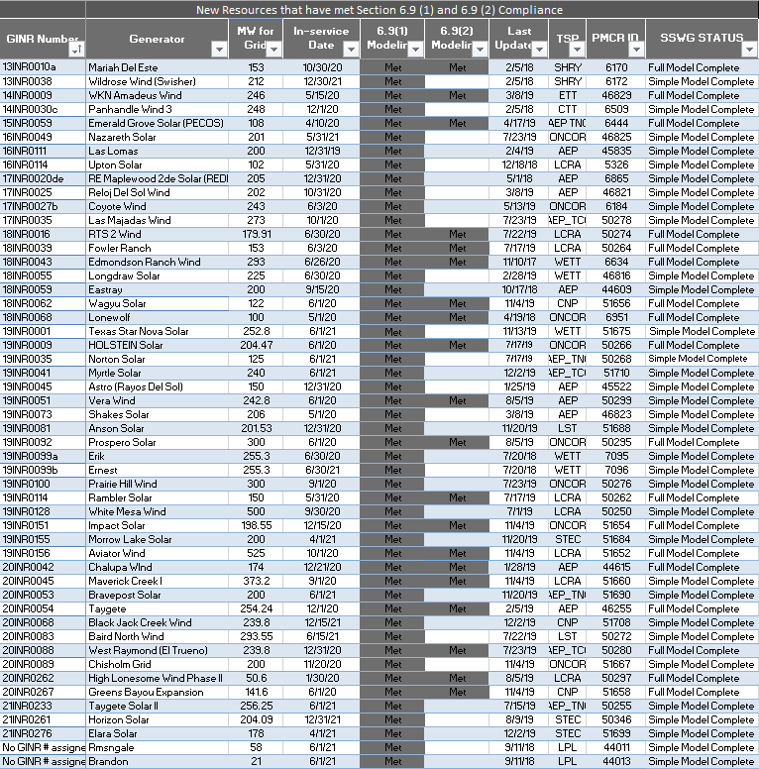

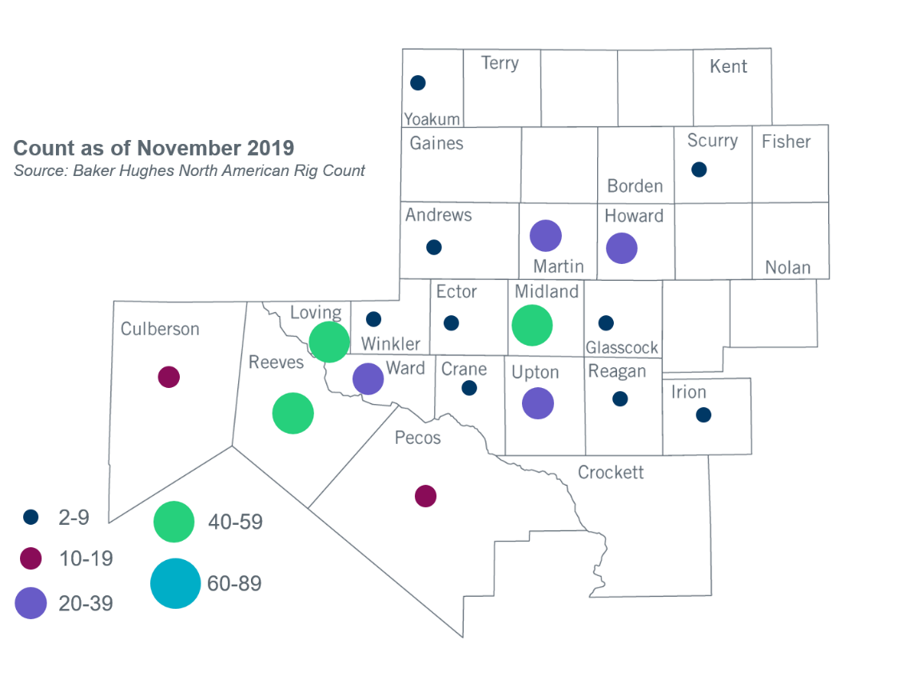
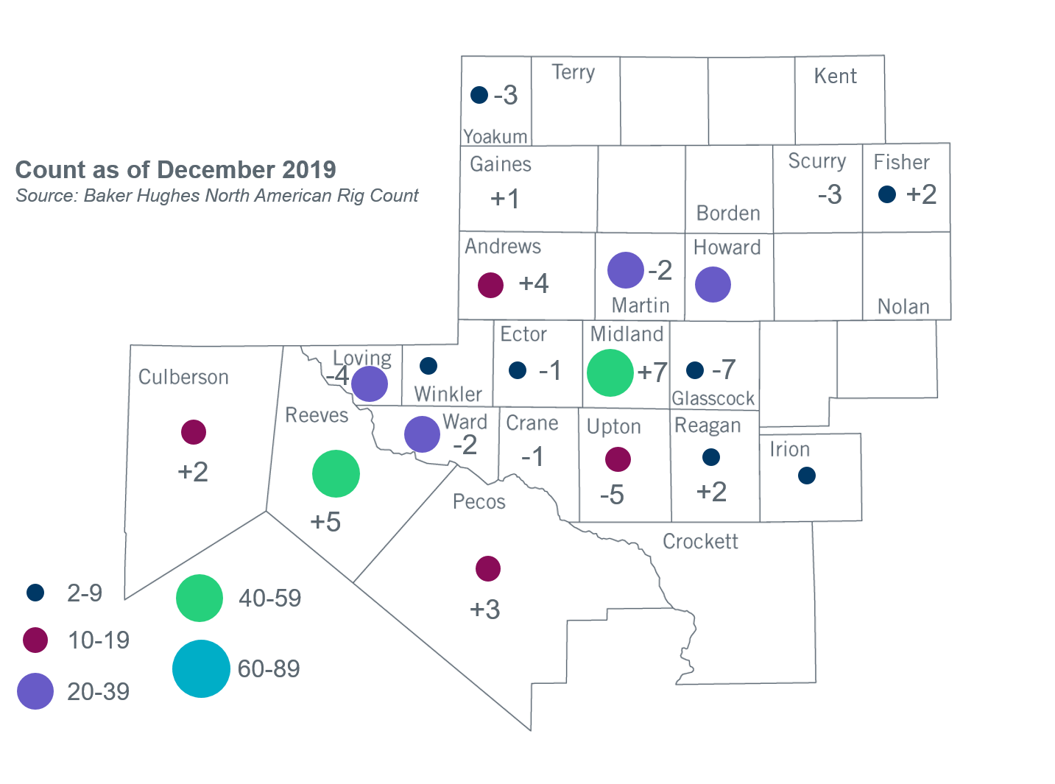
Permian Basin Oil Rig Count

Other Notable Activities
- ERCOT posted the 2019 Regional Transmission Plan (RTP) report to the MIS Secure Area on December 23. A public version is also available at http://www.ercot.com/news/presentations.
- ERCOT presented draft assumptions for the 2020 RTP to the Regional Planning Group (RPG) in December. The draft 2020 Regional Transmission Plan Scope and Process document was also posted to the December RPG meeting page.
- ERCOT presented the Delaware Basin Load Integration Study result to the Regional Planning Group (RPG) in December. The report is also available at http://www.ercot.com/news/presentations.
- The ERCOT 2019 Constraints and Needs report is available at http://www.ercot.com/news/presentations.
- ERCOT presented descriptions of proposed scenarios for the 2020 Long-Term System Assessment (LTSA) to the Regional Planning Group (RPG) in November. ERCOT is working on detailed assumptions for the proposed scenarios, other than Current Trends, as well as transmission expansion analysis for the Current Trends scenario.
- The SPWG will begin building the 2020 CY base case in January 2020.

+/- symbol indicates the increase or decrease from the previous month in oil rigs present in each county. There are 297 rigs, including a total decrease of 3 oil rigs, in the Permian Basin from November to December 2019.

