MarkeTrak User Application Training

1. Inadvertent Gaining

1.1 Title
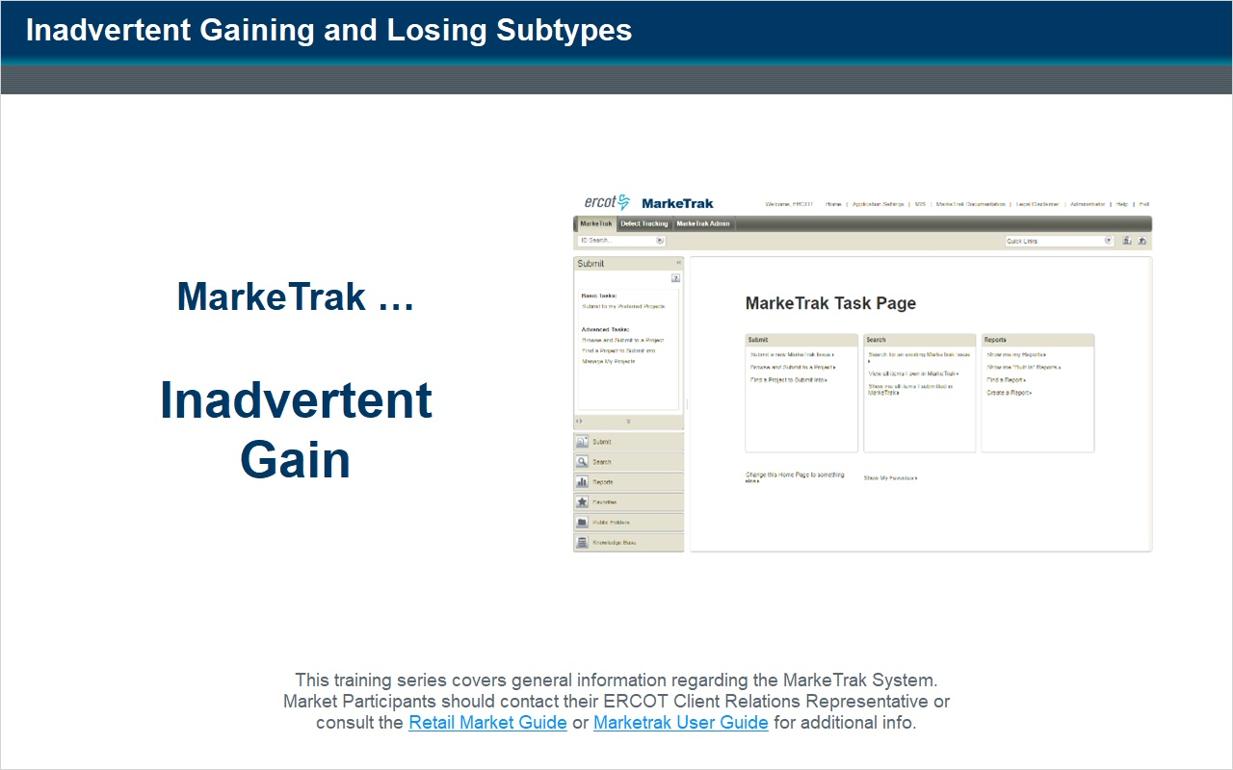
Notes:
Thank you for participating in ERCOT's Market Training Program.

This course discusses the Inadvertent Gain and Inadvertent Loss subtypes within the MarkeTrak system application.

1.2 Introduction
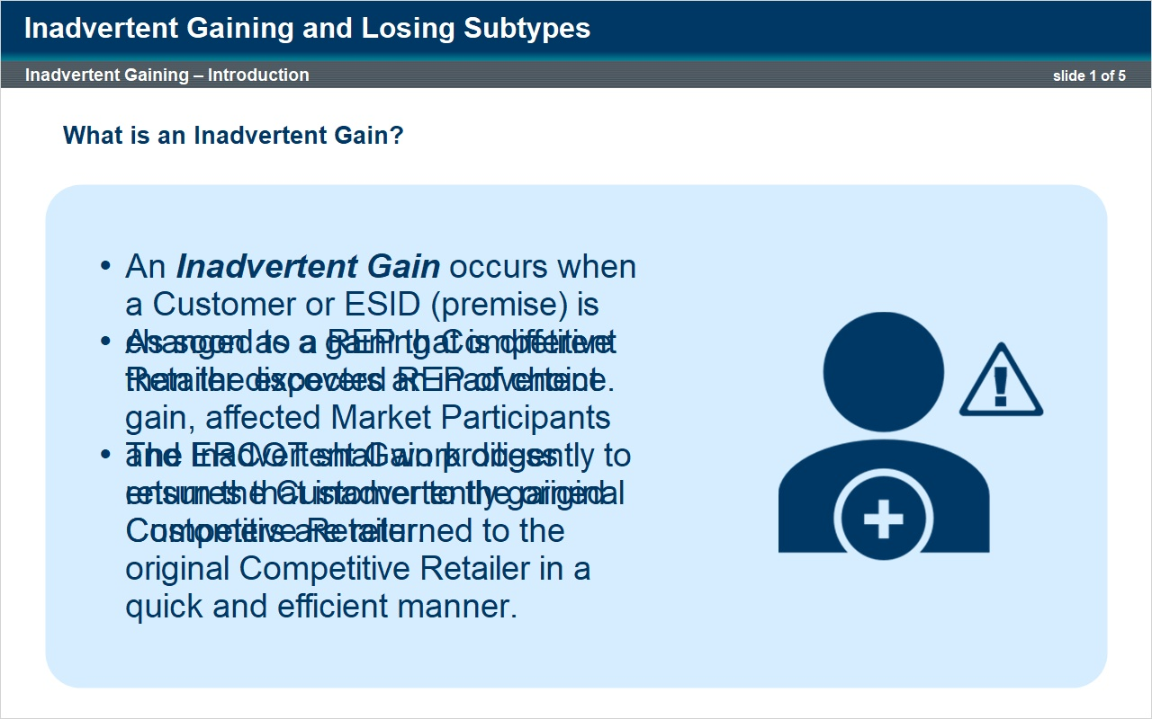
Notes:
An inadvertent gain occurs when a customer or ESID is changed to a REP that is different than the expected REP of choice.

The Inadvertent Gain process was designed to ensure that inadvertently gained Customers are returned to the original Competitive Retailer in a quick and efficient manner with minimal inconvenience to the Customer as per PUC rules regarding Unauthorized Change of Electric Provider.

As soon as a gaining Competitive Retailer discovers or is notified of an inadvertent gain, affected Market Participants and ERCOT shall work diligently to return the Customer to the original Competitive Retailer.

MarkeTrak is the tool used by the Market to facilitate resolution of Inadvertent Gain occurrences.

1.3 Losing CR agrees
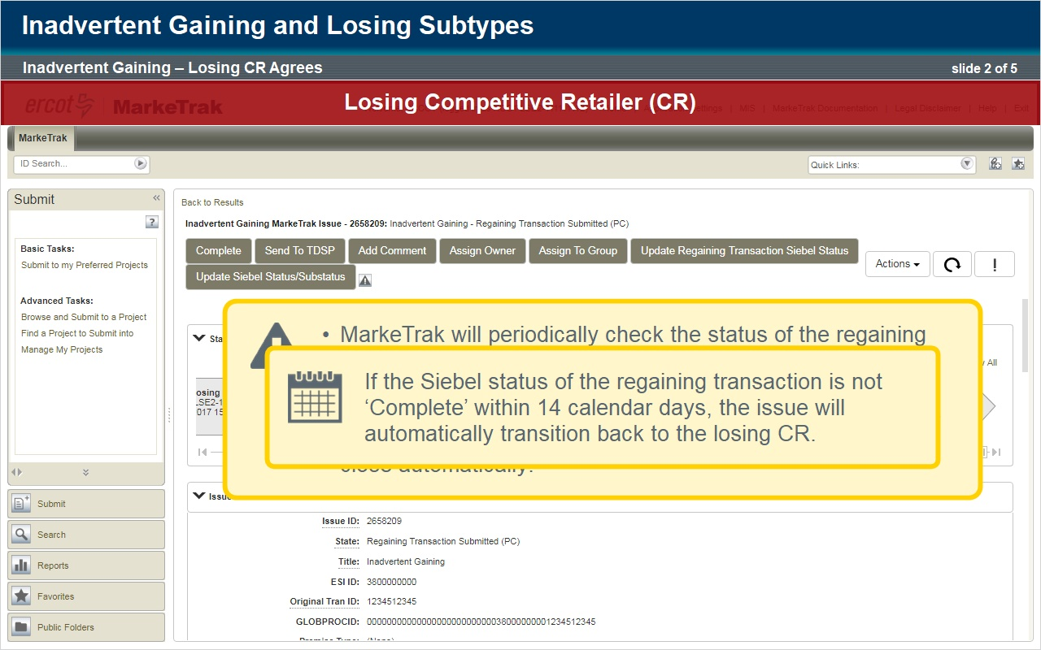
Notes:
Here is the process for filing an inadvertent gain.
The gaining Competitive Retailer begins the process by selecting “Inadvertent Gain” from the submit tree.
The gaining Competitive Retailer enters the ESI ID and Original Tran ID which is the Original Tran ID of the gaining Competitive Retailer’s enrollment.
The comments field is technically optional; however, not providing the Customer name, Service address, and Meter number (as referenced in the Retail Market Guide) could result in a delay of issue resolution.
Any additional information that could help to resolve the issue should also be included.
Click OK to submit.
A series of validations are performed on the ESI ID and the Original Tran ID to verify the data matches the information in ERCOT’s registration system.
Once these validations are complete and the issue is successfully created, it is transitioned to ERCOT.
ERCOT will update the issue with the losing Competitive Retailer and the TDSP.
ERCOT will also indicate if the gaining Competitive Retailer is still the Rep of Record and will provide the gaining Competitive Retailer start date.
The issue will then be transitioned to the losing Competitive Retailer.
The losing Competitive Retailer will receive the issue in a state of ‘New (Losing CR)’.
The losing Competitive Retailer selects ‘Begin Working’ and the issue transitions to a state of ‘In Progress (Losing CR)’.
For issues that remain in states of New (Losing CR), New (Gaining CR), New (TDSP), and New (Losing CR Submit) for more than three calendar days, an escalation email will be generated to the primary and secondary responsible contact.
It is now upon the losing Competitive Retailer to decide if they agree with the Inadvertent Gain and would like their customer back.
The simplest case (known to some as a “happy path”) is for the losing Competitive Retailer to agree to the Inadvertent Gain and transition the issue to the TDSP.
In this scenario, we are going to say that the losing Competitive Retailer agrees with the Inadvertent Gain and would like their customer returned.
We will look at an alternate scenario shortly.
In this case, the losing Competitive Retailer would select ‘Send To TDSP’ and will then be prompted to enter the Proposed Regain Date.
The proposed regain date shall be at least one day beyond the date of loss, but no greater than 10 days from the date the MarkeTrak was submitted.
The losing Competitive Retailer will enter the Proposed Regain Date and select OK.
The issue will then transition to the TDSP.
Now the Inadvertent Gain is in the hands of the TDSP.
The TDSP selects “Begin Working” and investigates the details of the issue.
For the “happy path”, the TDSP selects ‘Ready To Receive’ and the issue is sent back to the losing Competitive Retailer.
The Inadvertent Gain is received by the losing Competitive Retailer and they select ‘Begin Working’.
The losing Competitive Retailer sends the EDI transaction to regain the customer.
The losing Competitive Retailer then selects ‘Provide Regaining BGN02’ where they will be prompted to enter the Regaining BGN02 from that EDI transaction.
The issue then transitions to a state of ‘Regaining Transaction Submitted (Pending Complete)’.
At this point, all parties on the issue should monitor MIS and their internal systems for the successful completion of the EDI transaction.
Completion of the transaction is also monitored within MarkeTrak.
Once the issue is in the ‘Regaining Transaction Submitted (Pending Complete)’ state, MarkeTrak will periodically check the status of the regaining transaction in ERCOT’s Siebel Registration System.
The current Siebel status is returned to MarkeTrak and populated to the issue.
When the transaction has completed in Siebel and the status of ‘Complete’ has been returned to MarkeTrak, the issue will close automatically.
If the Siebel status of the regaining transaction is not ‘Complete’ within 14 calendar days, the issue will automatically transition back to the losing Competitive Retailer.
This is an indication that the regaining transaction should be reviewed and re-submitted if necessary.

1.4 Losing CR Disagrees
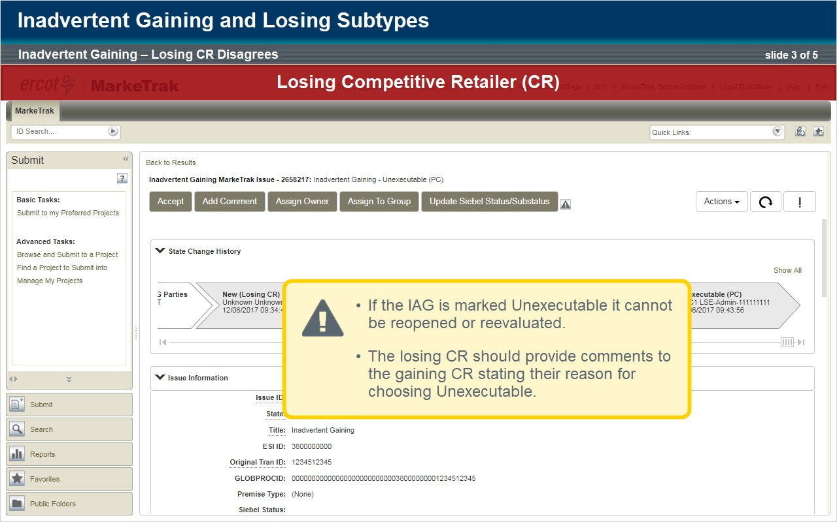
Notes:
Now let’s look at a scenario where a Competitive Retailer thinks they inadvertently gained a customer, but the losing Competitive Retailer disagrees that the customer should be taken back.
Things begin the same as in our previous example.
The gaining Competitive Retailer begins the process by selecting “Inadvertent Gain” from the submit tree.
Again, the ESI ID and Original Tran ID are required.
As noted before, comments are optional but critical to the resolution of the issue. Click OK to submit.
The issue is received by ERCOT, updated with the required information pertaining to the Inadvertent Gain parties, and transitioned to the losing Competitive Retailer.
The Losing Competitive Retailer clicks “Begin Working” … in this scenario, the losing Competitive Retailer disagrees with the Inadvertent Gain.
They select ‘Unexecutable’ to stop the Inadvertent Gain process.
There are market approved reasons why a losing Competitive Retailer can say a customer will not be taken back.
Valid reject reasons are outlined in Section 7.3.2.4 of the Retail Market Guide.
These values will display in a drop down field for selection.
Once the selection is made, the losing Competitive Retailer will select ‘OK’ and the issue will be sent back to the gaining Competitive Retailer in a state of ‘Unexecutable (PC)’.
If the Inadvertent Gain is marked Unexecutable it cannot be reopened or reevaluated.
For this reason, the losing Competitive Retailer should provide comments to the gaining Competitive Retailer stating their reason for choosing Unexecutable.
The gaining Competitive Retailer can close the issue by selecting ‘Accept’ or, if untouched for 14 calendar days, the issue will automatically close.

1.5 More Info Needed
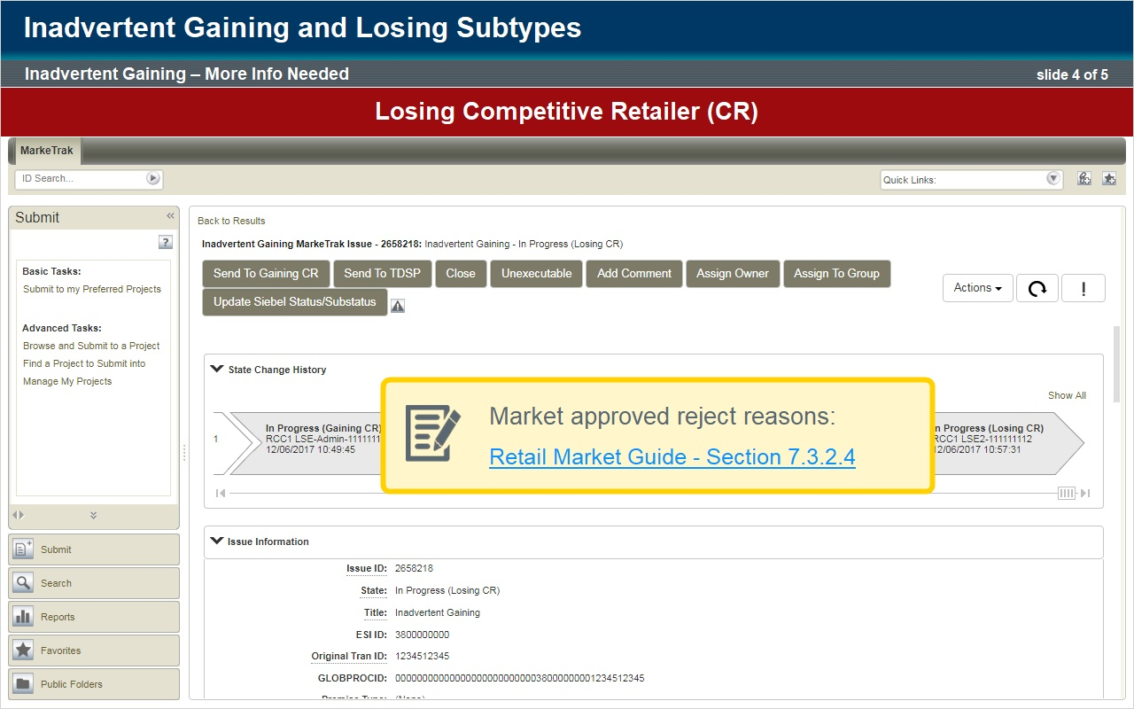
Notes:
At times, the Losing Competitive Retailer may want additional information before they decide to pass the issue to the TDSP or mark it as Unexecutable.
If this were the case … then, after the issue had been submitted and the ERCOT validations performed, the Losing Competitive Retailer would select “Begin Working” … and then select the ‘Send to Gaining CR’ transition.
Since they would like additional information, they are prompted for comments which are required for this transition.
It is imperative that as much pertinent information as possible be entered into the comments field.
The Inadvertent Gain is now returned to the gaining Competitive Retailer.
The gaining Competitive Retailer sees that the Inadvertent Gain has been sent back.
The gaining Competitive Retailer selects “Begin Working” … reviews the comments … provides the requested information … and selects ‘Send to Losing CR’.
The losing Competitive Retailer will now review the comments and determine if they accept the Inadvertent Gain.
If they agree, then the Inadvertent Gain is sent to the TDSP. If they disagree, they will select Unexecutable and provide a valid market approved reason.

1.6 Checkpoint Question
(Multiple Choice, 10 points, 1 attempt permitted)
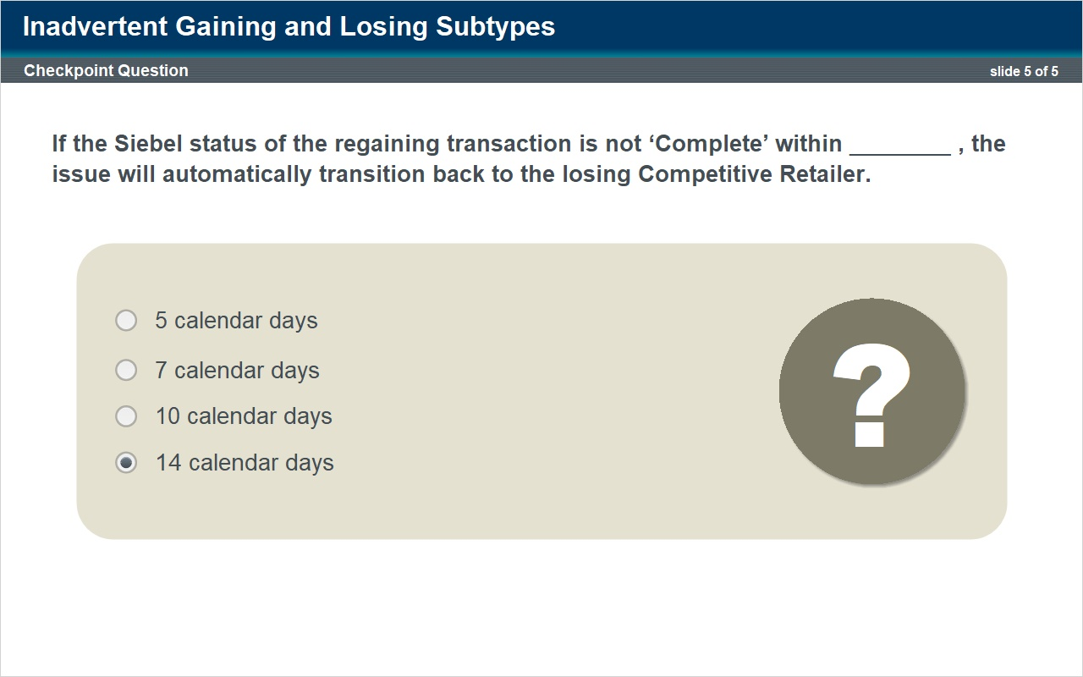
Correct | Choice
 | 5 calendar days
 | 7 calendar days
 | 10 calendar days
X | 14 calendar days

Notes:
Let's take a moment to review.

Can you answer the following question?

If the Siebel status of the regaining transaction is not ‘Complete’ within ________ , the issue will automatically transition back to the losing Competitive Retailer.

2. Inadvertent Losing

2.1 Title
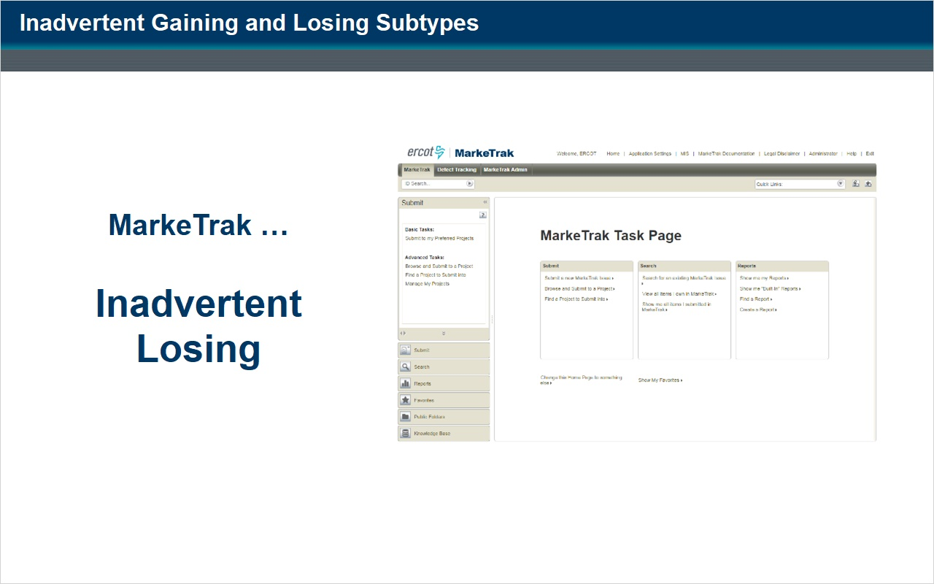
Notes:
Now let’s review the inadvertent loss subtype.

2.2 Introduction
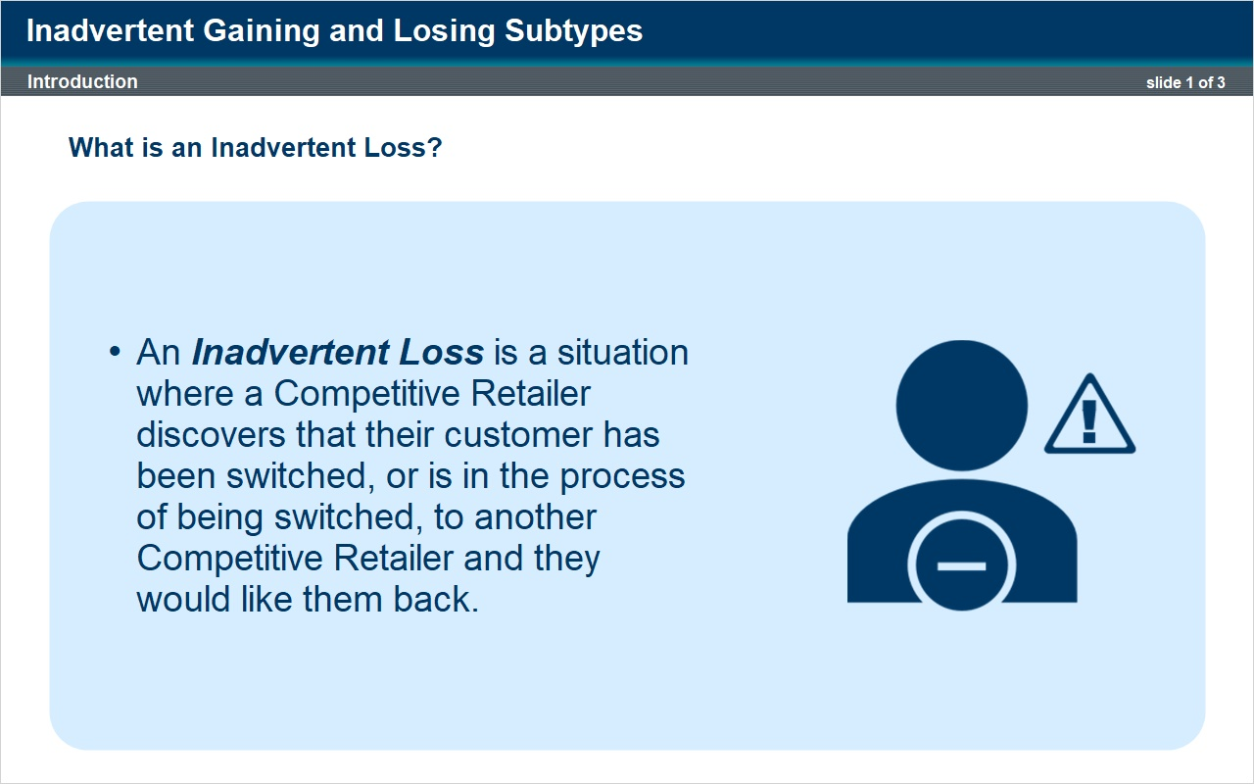
Notes:
An Inadvertent Loss is a situation where a CR Competitive Retailer discovers or is notified that their customer has been switched, or is in the process of being switched, to another Competitive Retailer and they would like them back.

As with the Inadvertent Gain process, MarkeTrak is the tool used by the Market to facilitate resolution of Inadvertent Loss occurrences.

This process is very similar to the Inadvertent Gain, except in this case, the Inadvertent Loss is initiated by the losing Competitive Retailer.

2.3 Gaining CR Agrees
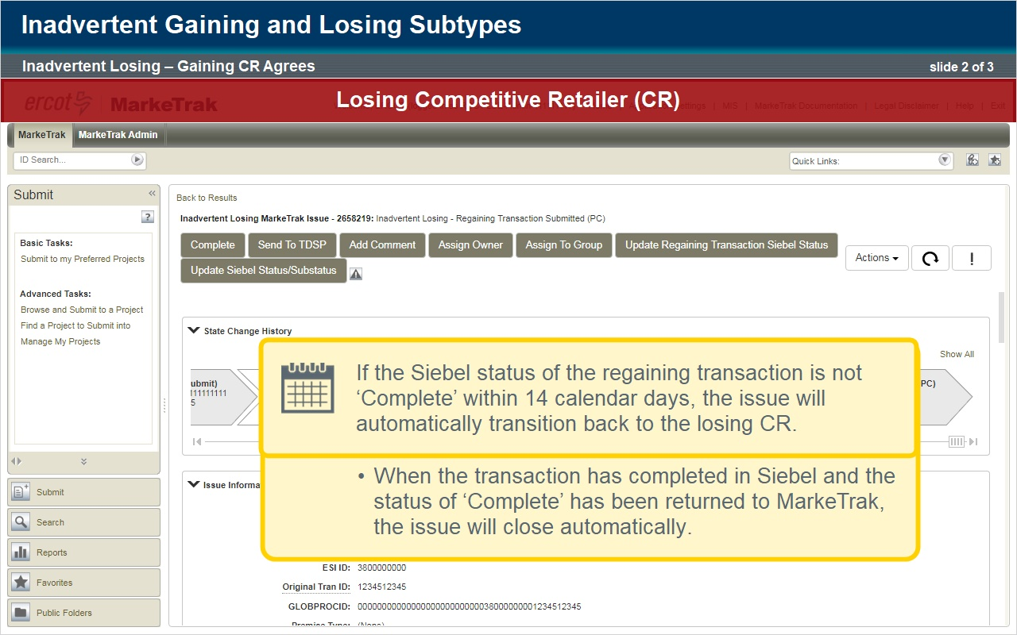
Notes:
The losing Competitive Retailer begins by selecting ‘Inadvertent Losing’ from the submit tree.

As with an Inadvertent Gain, the ESID and Original Tran ID fields are required.

For an Inadvertent Loss issue, the Original Tran ID is the Original Tran ID of the other Competitive Retailer’s enrollment transaction.

This is the BGN06 from the 814_06 EDI transaction sent to the losing Competitive Retailer by ERCOT.

Again, while not required, comments are critical so add any pertinent information to the comments field and hit OK.

Validations are performed on the data provided and the issue transitions to ERCOT.

The required information pertaining to the Inadvertent Gain parties is provided and the issue is transitioned to the gaining Competitive Retailer.

The gaining Competitive Retailer clicks “Begin Working” and the issue is now in a state of ‘In Progress (Gaining CR).

In this scenario, The gaining Competitive Retailer agrees with the Inadvertent Loss: they should not have taken the customer.

So, the gaining Competitive Retailer selects ‘Agree’.

The issue will then be sent back to the losing Competitive Retailer.

No comments are necessary if the gaining Competitive Retailer agrees with the Inadvertent Loss.

The losing Competitive Retailer sees that the Inadvertent Loss has come back from the Gaining Competitive Retailer, and that it has been agreed to.

The losing Competitive Retailer clicks “Begin working” then “send to TDSP”.

They provide the Proposed Regain Date when prompted and select ‘OK’.

The issue now goes to the TDSP. The TDSP clicks “Begin working”, reviews the issue details and acknowledges ready to receive by clicking the “ready to receive button”.

The Inadvertent Loss is then returned back to the losing Competitive Retailer.

The losing Competitive Retailer clicks “begin working”, then selects ‘Provide Regaining BGN02’.

The losing Competitive Retailer is prompted to enter the Regaining BGN02 which is the Original Tran ID of the regaining transaction from the EDI that was sent.

Upon entering this data, the losing Competitive Retailer selects ‘OK’ and the issue transitions to a state of ‘Regaining Transaction Submitted (Pending Complete)’ and remains with the losing Competitive Retailer as the responsible Market Participant.

As with the Inadvertent Gain subtype, all parties on the issue should monitor MIS and their internal systems for the successful completion of the EDI transaction.

Completion of the transaction is also monitored within MarkeTrak.

Once the issue is in the ‘Regaining Transaction Submitted (Pending Complete)’ state, MarkeTrak will periodically check the status of the regaining transaction in ERCOT’s Siebel Registration System.

The current Siebel status is returned to MarkeTrak and populated to the issue.

When the transaction has completed in Siebel and the status of ‘Complete’ has been returned to MarkeTrak, the issue will close automatically.

If the Siebel status of the regaining transaction is not ‘Complete’ within 14 calendar days, the issue will automatically transition back to the losing Competitive Retailer.

This is an indication that the regaining transaction should be reviewed and re-submitted if necessary.

2.4 Checkpoint Question
(Multiple Choice, 10 points, 1 attempt permitted)
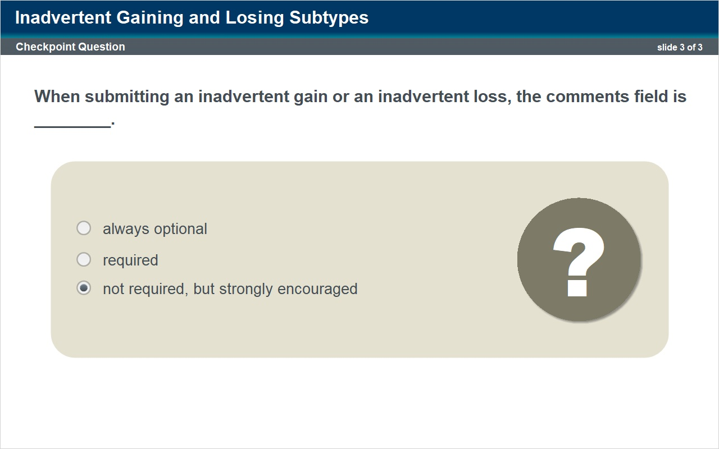
Correct | Choice
 | always optional
 | required
X | not required, but strongly encouraged

Notes:
Let's take a moment to review.

Can you answer the following question?

When submitting an inadvertent gain or an inadvertent loss, the comments field is ________.

3. Customer Rescission

3.1 Title
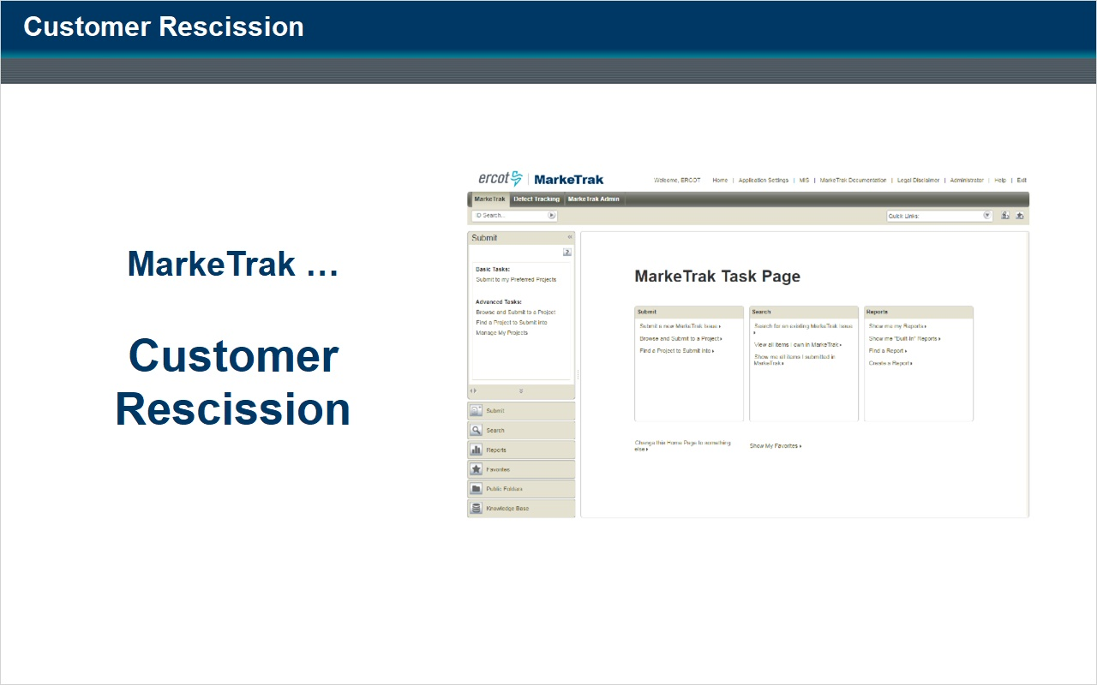
Notes:
Now let's review the Customer Rescission subtype.

3.2 Introduction
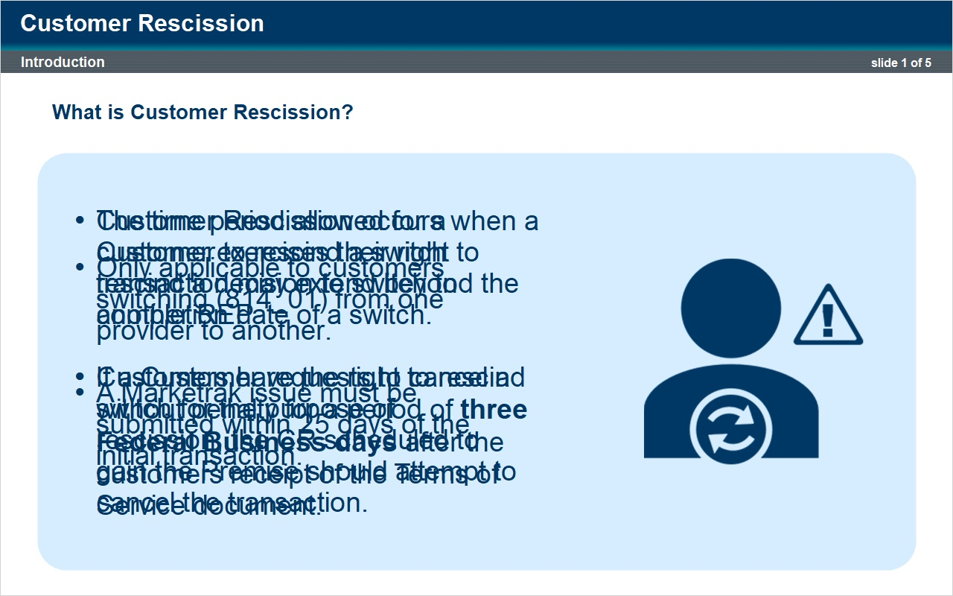
Notes:
A Customer Rescission situation occurs when a customer exercises their right to rescind a decision to switch to another REP.

Customers who wish to switch providers are guaranteed the right of rescission.

Customers have the right to rescind without penalty for a period of 3 Federal Business days after the customers receipt of the Terms of Service document.

The right of rescission does not apply to a customer requesting a move in.

It is only applicable to customer’s switching from one provider to another.

A Marketrak issue must be submitted within 25 days of the initial transaction.

The time period allowed for a Customer to rescind a switch transaction may extend beyond the completion date of a switch.

If a Customer requests to cancel a switch for the purpose of rescission, the CR scheduled to gain the Premise should attempt to cancel the transaction.

If the TDSP is unable to cancel the switch, or the Customer waits until after the switch is complete to exercise the rescission, but is still rescinding within the allowed timeline, the gaining CR should file a MarkeTrak issue, subtype Customer Rescission, to initiate reinstatement of the Customer to the previous CR.

3.3 Losing CR Agrees
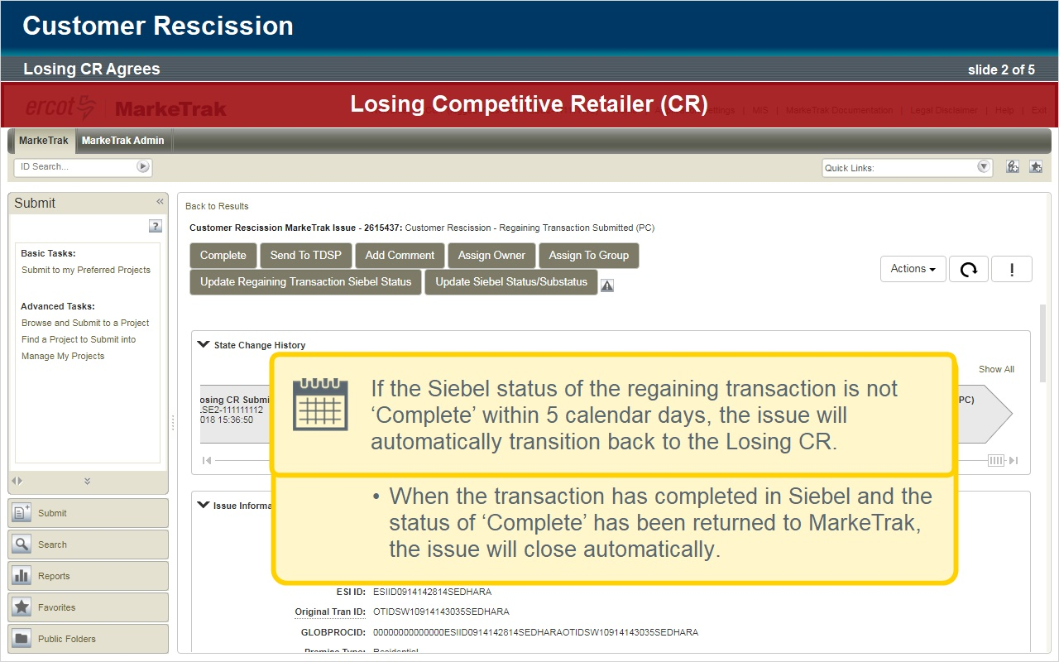
Notes:
Here is the process for filing a Customer Rescission issue.

The Gaining Competitive Retailer who has signed a customer that is now requesting rescission begins the process of returning that customer to their previous provider by selecting “Customer Rescission” from the submit tree.

The Gaining Competitive Retailer enters the ESI ID and the Original Tan ID which is the BGN02 of the 814_01.

Comments are not required on the submit transition but it is strongly recommended that the submitting Competitive Retailer include any details such as customer name in the comments section to expedite resolution of the issue.

Click OK to submit.

A series of validations are performed which include the following:

A validation is performed to verify that the ESIID and Global ID are valid in ERCOT’s registration system.

A validation is performed to verify that the Tran type for the ESIID/Original Tran ID provided is an 814_01 switch transaction.

If the Tran type is an 814_16 move-in transaction, the validation will fail.

Another validation is performed to determine if the MarkeTrak issue is being submitted within 25 calendar days from the effective date of the switch.

Customer Rescission issues submitted outside the 25 calendar day window will fail the validation and will need to be submitted as an Inadvertent Gain issue.

For example, a customer who wishes to switch service from REP A to REP B enters a service contract with REP B effective September 1 and they decide to rescind within the 3 business days.

REP B must file a Customer Rescission issue within 25 days from the September 1 effective date or the issue will be deemed invalid as a Customer Rescission.

Once these validations are complete and the issue is successfully created, it is transitioned to ERCOT.

ERCOT will update the issue with the following information:

The Losing Competitive Retailer Name and DUNS

The TDSP Name and DUNS

The Gaining Competitive Retailer REP of Record

The Gaining Competitive Retailer Start Date

The Regain Date - which is auto populated by ERCOT as the Gaining Competitive Retailer Start Date plus 1 calendar day.

The issue is then transitioned to the Losing Competitive Retailer in the state of ‘New (Losing CR)’.

The Losing Competitive Retailer selects ‘Begin Working’ and the issue transitions to a state of ‘In Progress (Losing CR)’.

The Losing Competitive Retailer has a period of two business days to agree to the Customer Rescission MarkeTrak issue unless a valid reason for rejecting the issue is met.

Valid reject reasons are outlined under Section 7.3.5 of the Retail Market Guide.

The simplest case (known to some as a “happy path”) is for the Losing Competitive Retailer to transition the issue noting that they agree with the Customer Rescission which is the scenario we will now review. We will look at an alternate scenario shortly.

The Losing Competitive Retailer reviews the information provided on the MarkeTrak issue and agrees to the Customer Rescission.

The Losing Competitive Retailer selects the ‘Send to TDSP’ button.

Now the Customer Rescission issue is in the hands of the TDSP in a state of ‘New (TDSP)’.

The TDSP selects “Begin Working” and investigates the details of the issue.

For this scenario, the TDSP selects ‘Ready To Receive’ and the issue is sent back to the Losing CR.

The Customer Rescission issue is received by the Losing Competitive Retailer and they select ‘Begin Working’.

The Losing Competitive Retailer sends the EDI transaction to regain the customer.

The Losing Competitive Retailer then selects ‘Provide Regaining BGN02’ where they will be prompted to enter the Regaining BGN02 from that EDI transaction.

The issue then transitions to a state of ‘Regaining Transaction Submitted (Pending Complete)’.

At this point, all parties on the issue should monitor MIS and their internal systems for the successful completion of the EDI transaction.

Completion of the transaction is also monitored within MarkeTrak.

Once the issue is in the ‘Regaining Transaction Submitted (Pending Complete)’ state, MarkeTrak will periodically check the status of the regaining transaction in ERCOT’s Siebel Registration System.

The current Siebel status is returned to MarkeTrak and populated to the issue.

When the transaction has completed in Siebel and the status of ‘Complete’ has been returned to MarkeTrak, the issue will close automatically.

If the Siebel status of the regaining transaction is not ‘Complete’ within 5 calendar days, the issue will automatically transition back to the Losing CR.

This is an indication that the regaining transaction should be reviewed and re-submitted if necessary.

3.4 Losing CR Disagrees
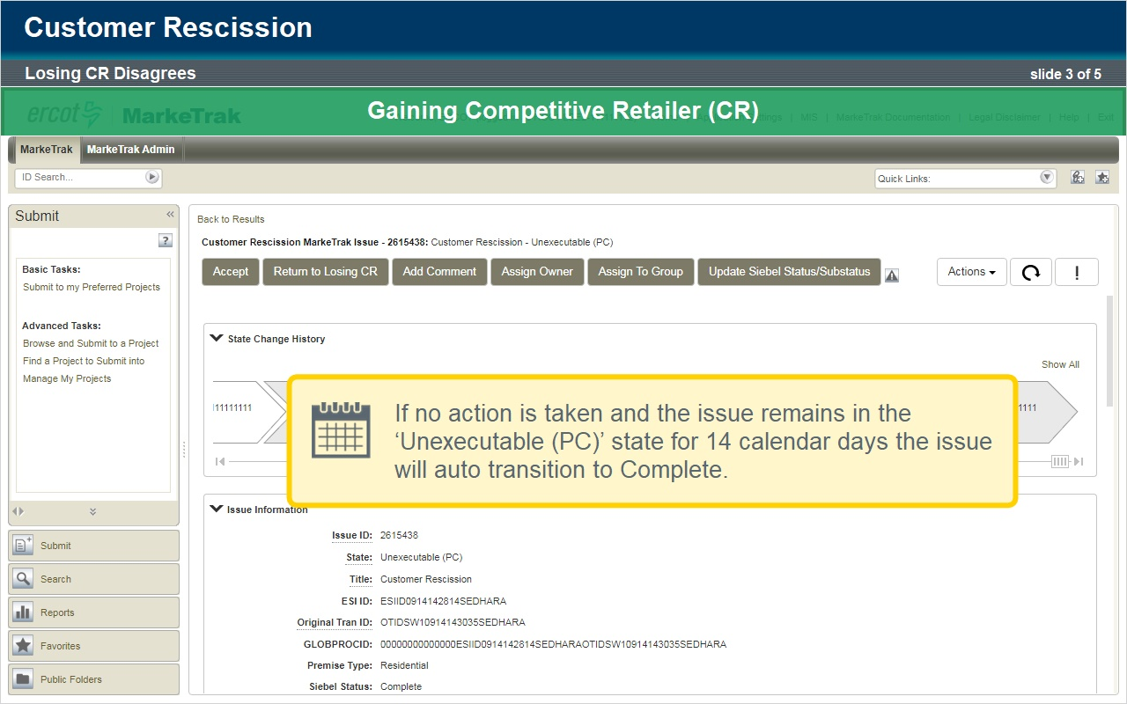
Notes:
Now lets look at an alternate scenario where the Losing Competitive Retailer does not agree to the Customer Rescission.

The Gaining Competitive Retailer who has signed a customer that is now requesting rescission begins the process of returning that customer to their previous provider by selecting “Customer Rescission” from the submit tree.

The Gaining Competitive Retailer enters the ESI ID and the Original Tan ID which is the BGN02 of the 814_01.

Comments are not required on the submit transition but it is strongly recommended that the submitting Competitive Retailer include any details such as customer name in the comments section to expedite resolution of the issue.

Click OK to submit.

A series of validations are performed which include the following:

A validation is performed to verify that the ESIID and Global ID are valid in ERCOT’s registration system.

A validation is performed to verify that the Tran type for the ESIID/Original Tran ID provided is an 814_01 switch transaction.

If the Tran type is an 814_16 move-in transaction, the validation will fail.

Another validation is performed to determine if the MarkeTrak issue is being submitted within 25 calendar days from the effective date of the switch.

Customer Rescission issues submitted outside the 25 calendar day window will fail the validation and will need to be submitted as an Inadvertent Gain issue.

Once these validations are complete and the issue is successfully created, it is transitioned to ERCOT.

ERCOT will update the issue with the following information:

The Losing Competitive Retailer Name and DUNS.

The TDSP Name and DUNS.

The Gaining Competitive Retailer REP of Record.

The Gaining Competitive Retailer Start Date.

The Regain Date - which is auto populated by ERCOT as the Gaining Competitive Retailer Start Date plus 1 calendar day.

The issue is then transitioned to the Losing Competitive Retailerin the state of ‘New (Losing CR)’.

The Losing Competitive Retailer selects ‘Begin Working’ and the issue transitions to a state of ‘In Progress (Losing CR)’.

The Losing Competitive Retailer has a period of two business days to agree to the Customer Rescission MarkeTrak issue unless a valid reason for rejecting the issue is met.

The Losing Competitive Retailer reviews the information provided on the MarkeTrak issue and does not agree to the Customer Rescission.

They select the ‘Unexecutable’ button and provide a Market approved reject reason.

The issue is transitioned back to the Gaining Competitive Retailer in a state of ‘Unexecutable (Pending Complete)’.

In the state of ‘Unexecutable (Pending Complete)’, the Gaining Competitive Retailer has the option to select ‘Accept’ and close the issue or they can select ‘Return to Losing CR’ to send the issue back to the Losing Competitive Retailer for additional discussion.

If no action is taken and the issue remains in the ‘Unexecutable (Pending Complete)’ state for 14 calendar days the issue will auto transition to Complete.

3.5 Checkpoint Question
(Multiple Choice, 10 points, 1 attempt permitted)
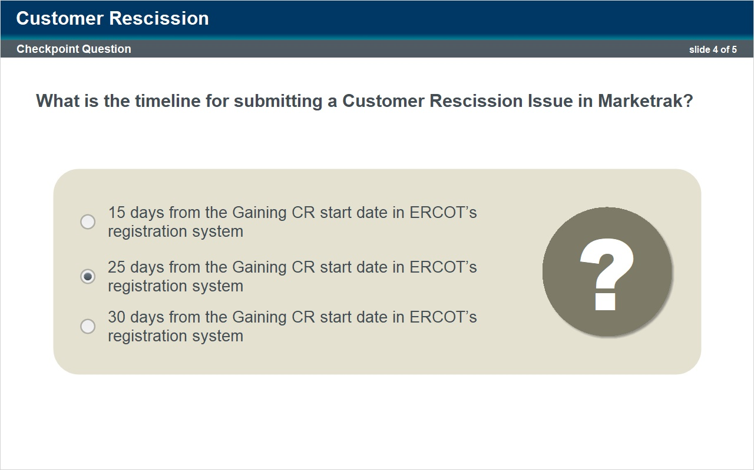
Correct | Choice
 | 15 days from the Gaining CR start date in ERCOT’s registration system
X | 25 days from the Gaining CR start date in ERCOT’s registration system
 | 30 days from the Gaining CR start date in ERCOT’s registration system

Notes:
Let's take a moment to review.

Can you answer the following questions?

What is the timeline for submitting a Customer Rescission Issue in Marketrak?

3.6 Checkpoint Question
(Multiple Choice, 10 points, 1 attempt permitted)
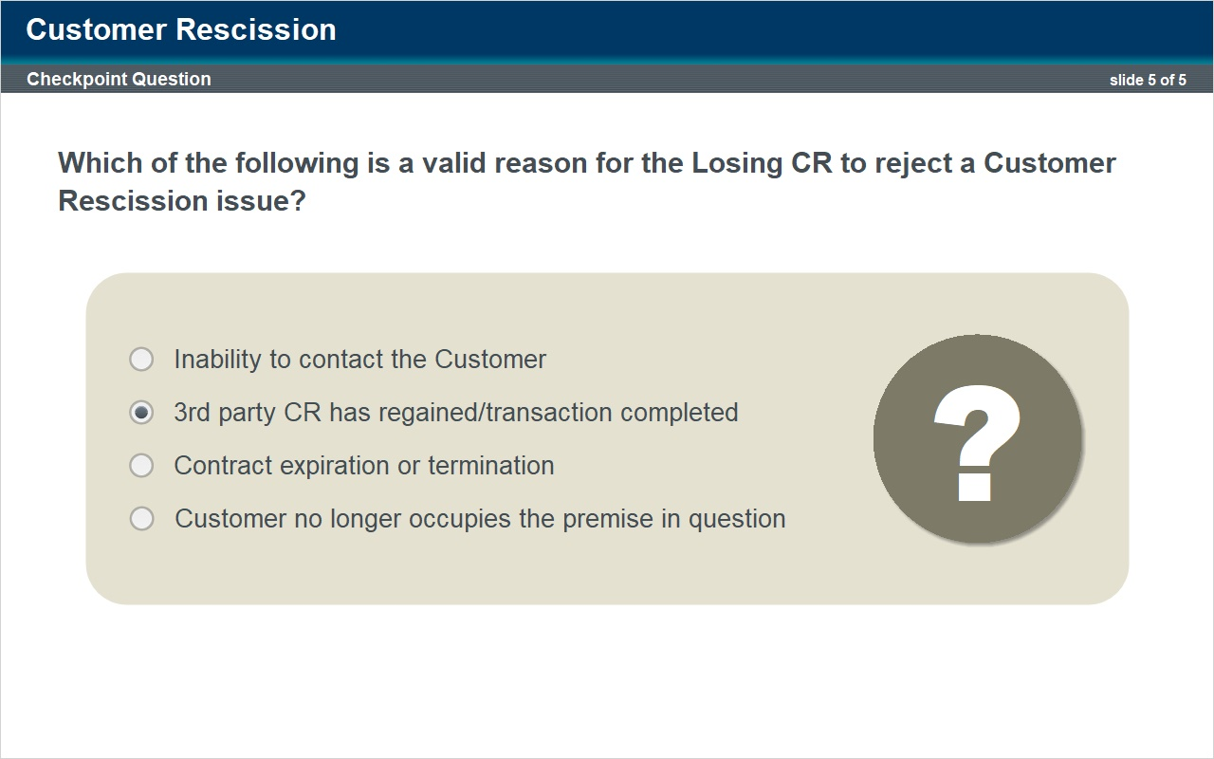
Correct | Choice
 | Inability to contact the Customer
X | 3rd party CR has regained/transaction completed
 | Contract expiration or termination
 | Customer no longer occupies the premise in question

Notes:
Which of the following is a valid reason for the Losing CR to reject a Customer Rescission issue?

4. Redirect Fees

4.1 Title
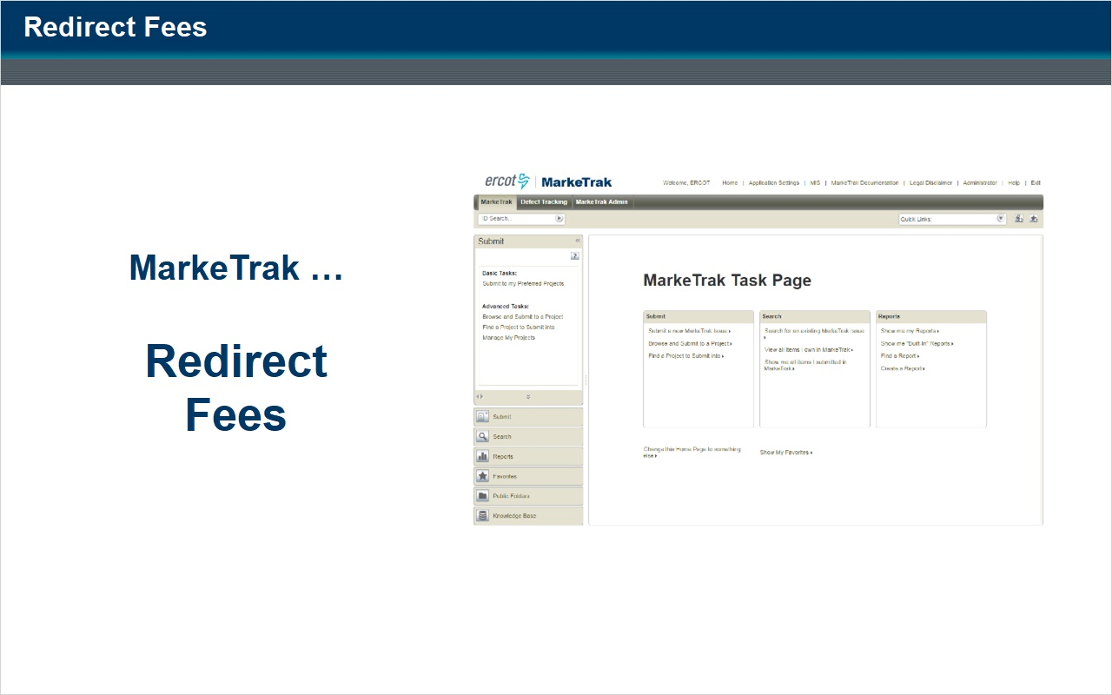
Notes:
Now let's review the Redirect Fees subtype.

4.2 Introduction
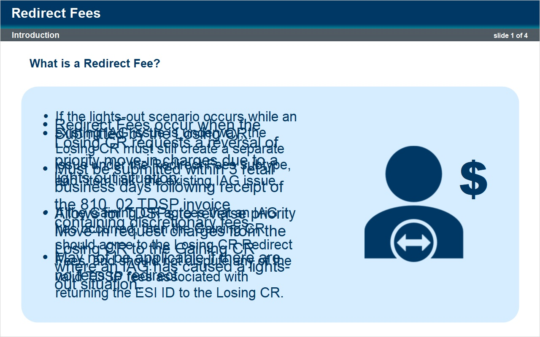
Notes:
Redirect Fees occurs when the losing Competitive Retailer requests a reversal of priority move-in charges due to a lights out situation.
The Redirect Fees subtype allows for TDSPs to reverse priority Move-In request charges from the losing Competitive Retailer to the gaining Competitive Retailer where an inadvertent gain has caused a lights-out situation.
Redirect Fee issues are submitted by the Losing Competitive Retailer and must be submitted within 3 retail business days following receipt of the 810_02 TDSP invoice containing discretionary fees as a result of the Inadvertent Gain.
Keep in mind, Redirect Fees may not be applicable if there are no fees to redirect.
If the lights-out scenario occurs while an existing Inadvertent Gain issue is underway, the Losing Competitive Retailer must still create a separate issue under the Redirect Fees subtype, and “item link” the existing Inadvertent Gain issue.
If the gaining Competitive Retailer agrees that an inadvertent gain has occurred, possibly including agreement within a related inadvertent gain issue, then the gaining Competitive Retailer should agree to the losing Competitive Retailer’s Redirect Fees MarkeTrak issue and should not dispute any of the valid TDSP fees associated with returning the ESI ID to the losing Competitive Retailer.

4.3 Gaining CR Agrees
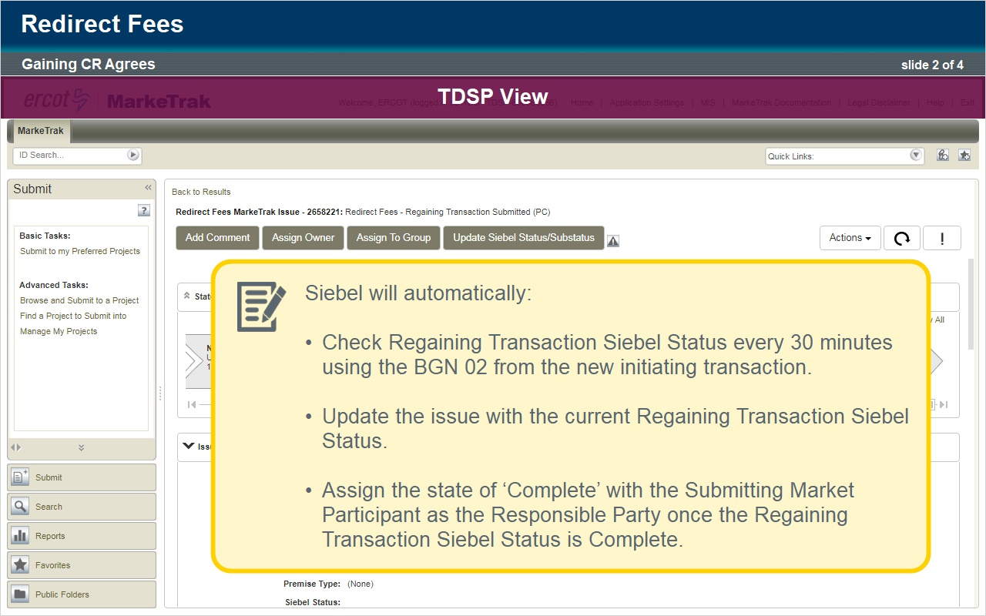
Notes:
Here is the process for filing a Redirect Fees issue.

The Losing Competitive Retailer who is requesting a reversal of fees begins the process by selecting “Redirect Fees” from the submit tree.

The following fields are required:

- ESIID
- Original Tran ID
- Priority BGN02 and
- PMVI Requested Date

The Losing Competitive Retailer selects ‘Ok’ to create the issue.

Once the issue has been submitted, ERCOT provides the following information:

- The Gaining Competitive Retailer Name and Duns
- The TDSP Name and DUNS
- The Gaining Competitive Retailer REP of Record
- The Gaining Competitive Retailer Start Date

Next, the MarkeTrak issue is assigned to the state of ‘New (Gaining CR)’ with the Gaining Competitive Retailer as the Responsible Party.

The Gaining Competitive Retailer selects ‘Begin Working’

The MarkeTrak issue is assigned to the state of ‘In Progress (Gaining CR)’.

The simplest case (known to some as a “happy path”) is for the Gaining Competitive Retailer to transition the issue noting that they agree which is the scenario we will now review. We will look at an alternate scenario shortly.

The Gaining Competitive Retailer reviews the information provided on the issue and is in agreement with the request.

The Gaining Competitive Retailer selects the ‘Agree’ button.

The issue is now in a state of ‘New (TDSP)’ with the TDSP as the Responsible Market Participant.

The TDSP selects ‘Begin Working’.

The issue is now in a state of ‘In Progress (TDSP)’ with the TDSP as the Responsible Market Participant.

After reviewing the issue details, the TDSP selects ‘Redirect Fees’.

The issue transitions to a state of ‘Regaining Transaction Submitted (Pending Complete)’ with the Losing Competitive Retailer as the Responsible Market Participant.

At this point Siebel will automatically:

Check Regaining Transaction Siebel Status every 30 minutes using the BGN 02 from the new initiating transaction.

Update the issue with the current Regaining Transaction Siebel Status.

Assign the state of ‘Complete’ with the Submitting Market Participant as the Responsible Party once the Regaining Transaction Siebel Status is Complete.

4.4 Gaining CR Disgrees
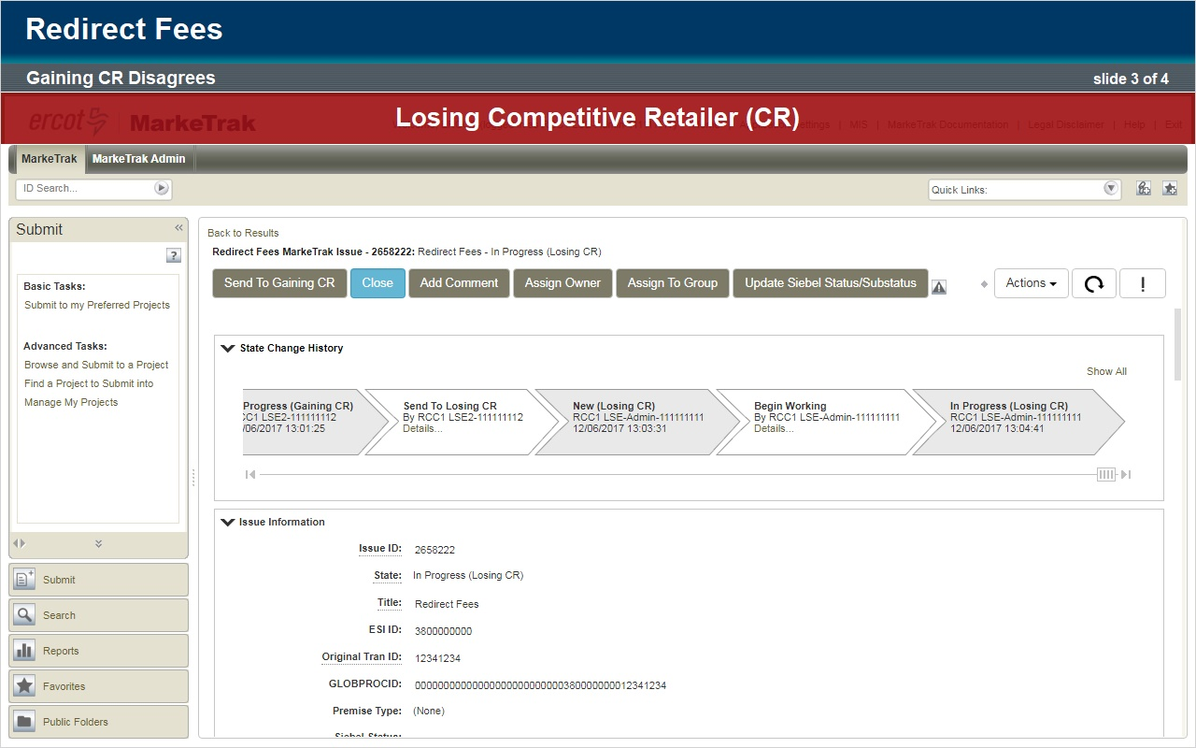
Notes:
Now let’s look at an alternative scenario where the Gaining Competitive Retailer does not agree with the submitted redirect fees issue.

The Losing Competitive Retailer who is requesting a reversal of fees begins the process by selecting “Redirect Fees” from the submit tree.
The following fields are required:
ESIID
Original Tran ID
Priority BGN02 and
PMVI Requested Date
The Losing Competitive Retailer selects ‘Ok’ to create the issue.
Once the issue is submitted, ERCOT provides the following information:
The Gaining Competitive Retailer Name and Duns
The TDSP Name and DUNS
The Gaining Competitive Retailer REP of Record
The Gaining Competitive Retailer Start Date
Next, the MarkeTrak issue is assigned to the state of ‘New (Gaining CR)’ with the Gaining Competitive Retailer as the Responsible Party.
The Gaining Competitive Retailer selects ‘Begin Working’.
The MarkeTrak issue is assigned to the state of ‘In Progress (Gaining CR)’ .
For this scenario, the Gaining Competitive Retailer reviews the information provided on the issue and does not agree with the Inadvertent Gain or the request to reverse fees.
The Gaining Competitive Retailer selects the ‘Send to Losing CR’ button and enters required comments noting their reason for disagreement.
The issue transitions to a state of ‘New (Losing CR)’.
The Losing Competitive Retailer, after selecting 'Begin Working', now has the option to return the issue to the Gaining Competitive Retailer by selecting ‘Send To Gaining CR’ or they can close the issue by selecting ‘Close’.
For this scenario, the Losing Competitive Retailer selects the ‘Close’ button and the issue transitions to a state of ‘Closed By Submitter’.

4.5 Checkpoint Question
(Multiple Choice, 10 points, 1 attempt permitted)
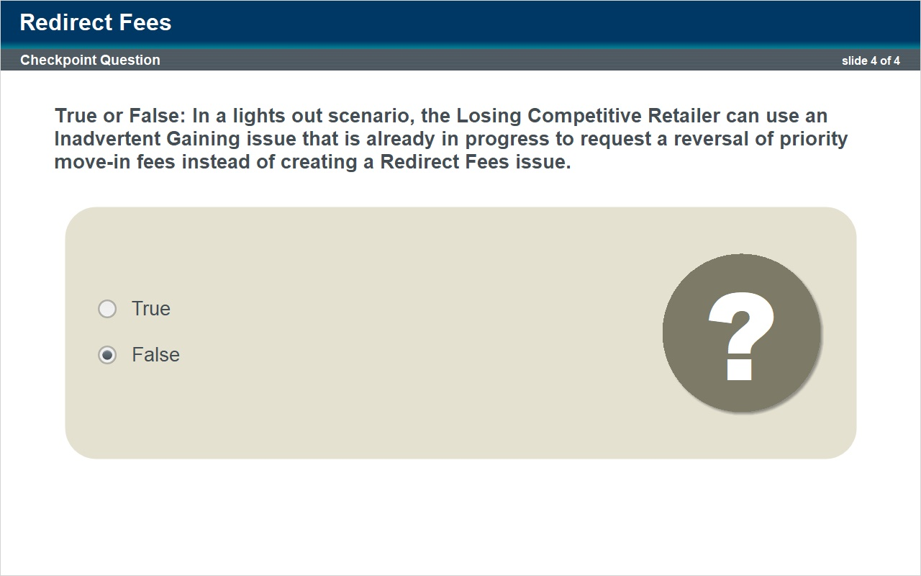
Correct | Choice
 | True
X | False

Notes:
Let's take a moment to review.

Can you answer the following question?

True or False: In a lights out scenario, the Losing Competitive Retailer can use an Inadvertent Gaining issue that is already in progress to request a reversal of priority move-in fees instead of creating a Redirect Fees issue.

5. Conclusion

5.1 End
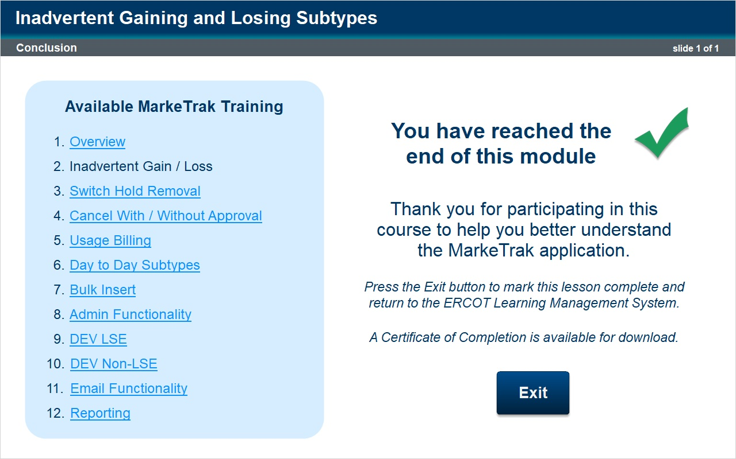
Notes:
This concludes our lesson.

Thank you for participating in ERCOT’s Market Training Program.

