November 2019 ERCOT Monthly Operations Report
Reliability and Operations Subcommittee Meeting
Jan 9, 2020

Table of Contents
1. Report Highlights 2
2. Frequency Control 3
2.1. Frequency Events 3
2.2. Responsive Reserve Events 4
2.3. Load Resource Events 4
3. Reliability Unit Commitment 4
4. Wind Generation as a Percent of Load 5
5. Largest Net-Load Ramp 5
6. COP Error Analysis 6
7. Congestion Analysis 8
7.1. Notable Constraints 8
7.2. Generic Transmission Constraint Congestion 14
7.3. Manual Overrides 14
7.4. Congestion Costs for Calendar Year 2019 14
8. System Events 15
8.1. ERCOT Peak Load 15
8.2. Load Shed Events 15
8.3. Stability Events 15
8.4. Notable PMU Events 15
8.5. DC Tie Curtailment 16
8.6. TRE/DOE Reportable Events 16
8.7. New/Updated Constraint Management Plans 16
8.8. New/Modified/Removed RAS 16
8.9. New Procedures/Forms/Operating Bulletins 16
9. Emergency Conditions 16
9.1. OCNs 16
9.2. Advisories 16
9.3. Watches 16
9.4. Emergency Notices 17
10. Application Performance 17
10.1. TSAT/VSAT Performance Issues 17
10.2. Communication Issues 17
10.3. Market System Issues 17
11. Model Updates 17
Appendix A: Real-Time Constraints 20

Report Highlights
- The unofficial ERCOT peak was 56,427 MW, which is a new November record.
- There was 1 frequency event.
- There was 1 instance where Responsive Reserves were deployed.
- There were 2 RUC commitments.
- Congestion in the West Load Zone (LZ) can be mostly attributed to planned outages and high renewable generation. Congestion in the South LZ was mostly due to planned outages and high wind generation in the area. Congestion in the North and Houston LZs was mostly due to planned outages. There were 25 days of congestion on the Panhandle GTC, 3 days on the East Texas GTC, 3 days on the Raymondivlle – Rio Hondo GTC ,1 day on the Tredwell GTC, 5 days on the North Edinburg to Lobo GTC and 1 day on the McCamey GTC.
- There was 0 DC Tie curtailment.
- ERCOT set a new wind penetration record of 57.88% at 03:52 on 11/26/2019.

Frequency Control

Frequency Events
The ERCOT Interconnection experienced four frequency events, all of which resulted from a unit trip. The average event duration was approximately 00:06:29.

A summary of the frequency events is provided below. The reported frequency events meet one of the following criteria: Delta Frequency is 60 mHz or greater; the MW loss is 350 MW or greater; resource trip event triggered RRS deployment. Frequency events that have been identified as Frequency Measurable Events (FME) for purposes of BAL-001-TRE-1 analysis are highlighted in blue. When analyzing frequency events, ERCOT evaluates PMU data according to industry standards. Events with an oscillating frequency of less than 1 Hz are considered to be inter-area, while higher frequencies indicate local events. Industry standards specify that damping ratio for inter-area oscillations should be 3.0% or greater. For the frequency events listed below, the ERCOT system met these standards and transitioned well after each disturbance.

Date and Time | Delta Frequency | Max/Min Frequency | Duration of Event | PMU Data |  | MW Loss | Load | Wind | Inertia
 | (Hz) | (Hz) |  | Oscillation Mode (Hz) | Damping Ratio |  | (MW) | % | (GW-s)
11/18/2019 16:20 | 0.114 | 59.891 | 0:06:29 | No PMU Data Available |  | 466.25 | 37,479 | 3% | 242,551

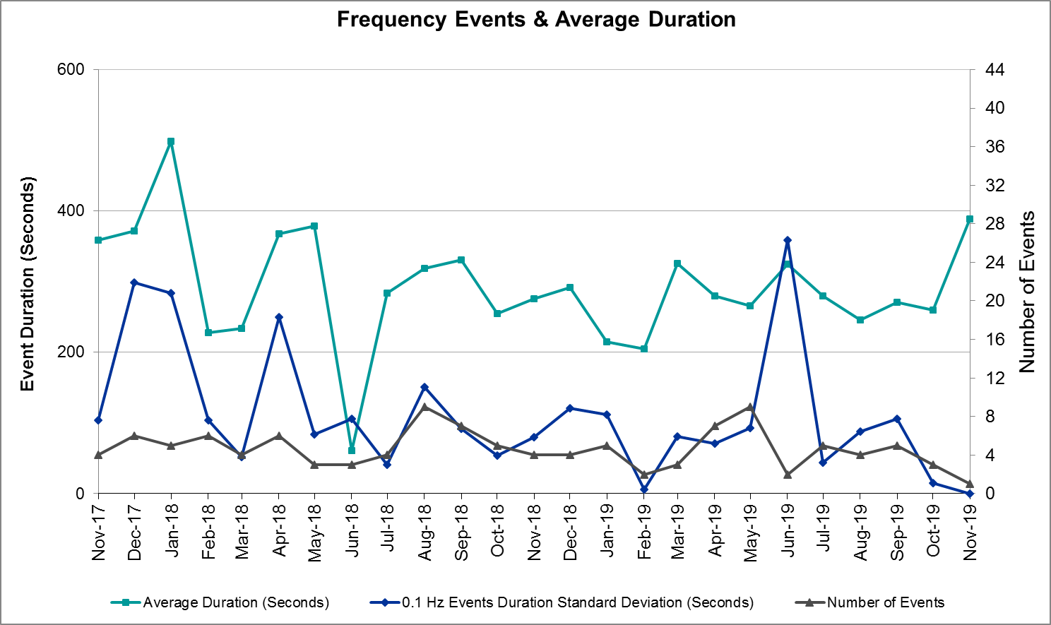 (Note: All data on this graph encompasses frequency event analysis based on BAL-001-TRE-1.)

Note that the large standard deviation in June 2019 is due to coincidental extreme high and low durations for a small set of events (2).

Responsive Reserve Events
There was one event where Responsive Reserve MWs were released to SCED. The events highlighted in blue were related to frequency events reported in Section 2.1 above.

Date and Time Released to SCED | Date and Time Recalled | Duration of Event | Maximum MWs Released | Comments
11/18/2019 16:20 | 11/18/2019 16:26 | 00:06:08 | 486

Load Resource Events
None.

Reliability Unit Commitment
ERCOT reports on Reliability Unit Commitments (RUC) on a monthly basis. Commitments are reported grouped by operating day and weather zone. The total number of hours committed is the sum of the hours for all the units in the specified region. Additional information on RUC commitments can be found on the MIS secure site at Grid Generation Reliability Unit Commitment.

There were no DRUC commitments.

There were 2 HRUC commitments.

Resource Location | # of Resources | Operating Day | Total # of Hours Committed | Total MWhs | Reason for Commitment
Far West | 1 | 11/13/2019 | 1 | 74 | SECNMO28
Far West | 1 | 11/14/2019 | 3 | 222 | SECNMO28

Wind Generation as a Percent of Load
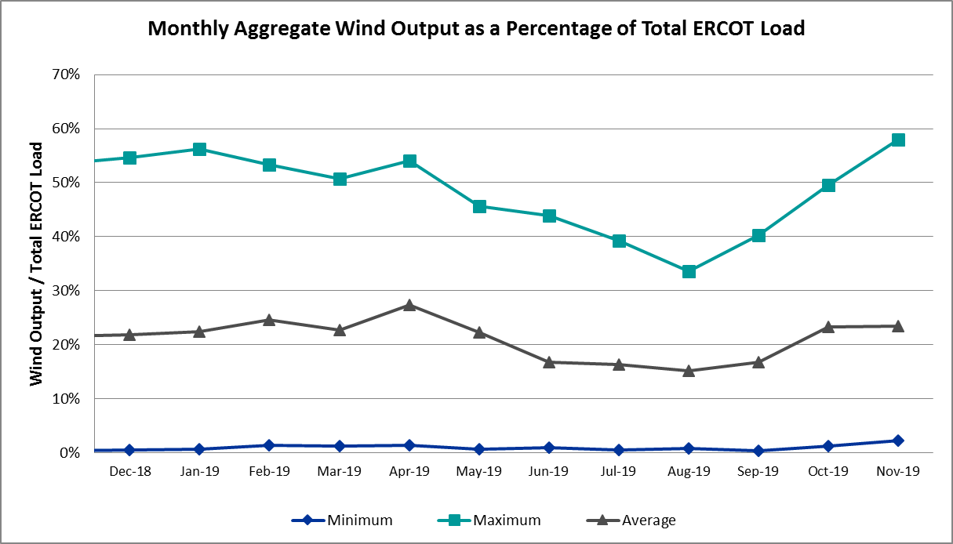

Wind Generation Record: 19,672 MW on 01/21/2019 at 19:19
Wind Penetration Record: 57.88% on 11/26/2019 03:52

Largest Net-Load Ramp
The net-load ramp is defined as the change in net-load (load minus wind and PVGR generation) during the defined time horizon. Such a variation in net-load needs to be accommodated in grid operations to ensure that the reliability of the grid is satisfactorily maintained. The largest net-load ramp during 5-min, 10-min, 15-min, 30-min and 60-min in Nov 2019 is 940 MW, 1606 MW, 2269 MW, 3934 MW, and 6317 MW, respectively. The comparison with respect to the historical values is given in the table below.

Month and Year | 5 min | 10 min | 15 min | 30 min | 60 min
Nov 2019 | 940 MW | 1606 MW | 2269 MW | 3934 MW | 6317 MW
Nov 2014 | 991 MW | 1689 MW | 2112 MW | 3289 MW | 5392 MW
Nov 2015 | 915 MW | 1637 MW | 1995 MW | 3241 MW | 5516 MW
Nov 2016 | 821 MW | 1404 MW | 1827 MW | 3166 MW | 5866 MW
Nov 2017 | 877 MW | 1581 MW | 2078 MW | 3393 MW | 5708 MW
Nov 2018 | 814 MW | 1553 MW | 2148 MW | 4109 MW | 7218 MW
2014-2018 | 1494 MW | 1991 MW | 2780 MW | 4109 MW | 7218 MW

COP Error Analysis
COP Error is calculated as the capacity difference between the COP HSL and real-time HSL of the unit. Mean Absolute Error (MAE) stayed high over 6,900 MW until Day-Ahead at 12:00, then dropped significantly to 1,039 MW by Day-Ahead at 14:00. In the following chart, Under-Scheduling Error indicates that COP had less generation capacity than real-time and Over-Scheduling Error indicates that COP had more generation capacity than real-time. Under-Scheduling persisted from beginning of Day-Ahead to end of the Operating Day with the exception of eight hours. However, COP error for the Operating Hour freezes after the Adjustment Period.

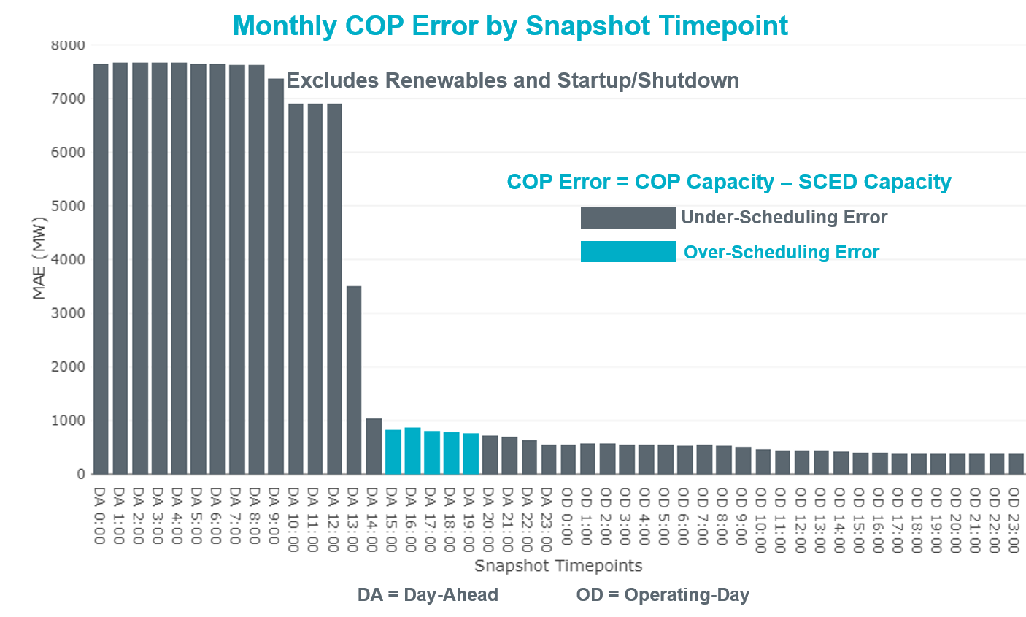

Monthly MAE for the Latest COP at the end of the Adjustment Period was 377 MW with median ranging from -233 MW for Hour-Ending (HE) 23 to 122 MW for HE 17. HE 11 on the 23rd had the largest Over-Scheduling Error (1,469 MW) and HE 11 on the 29th had the largest Under-Scheduling Error (-3,321MW).

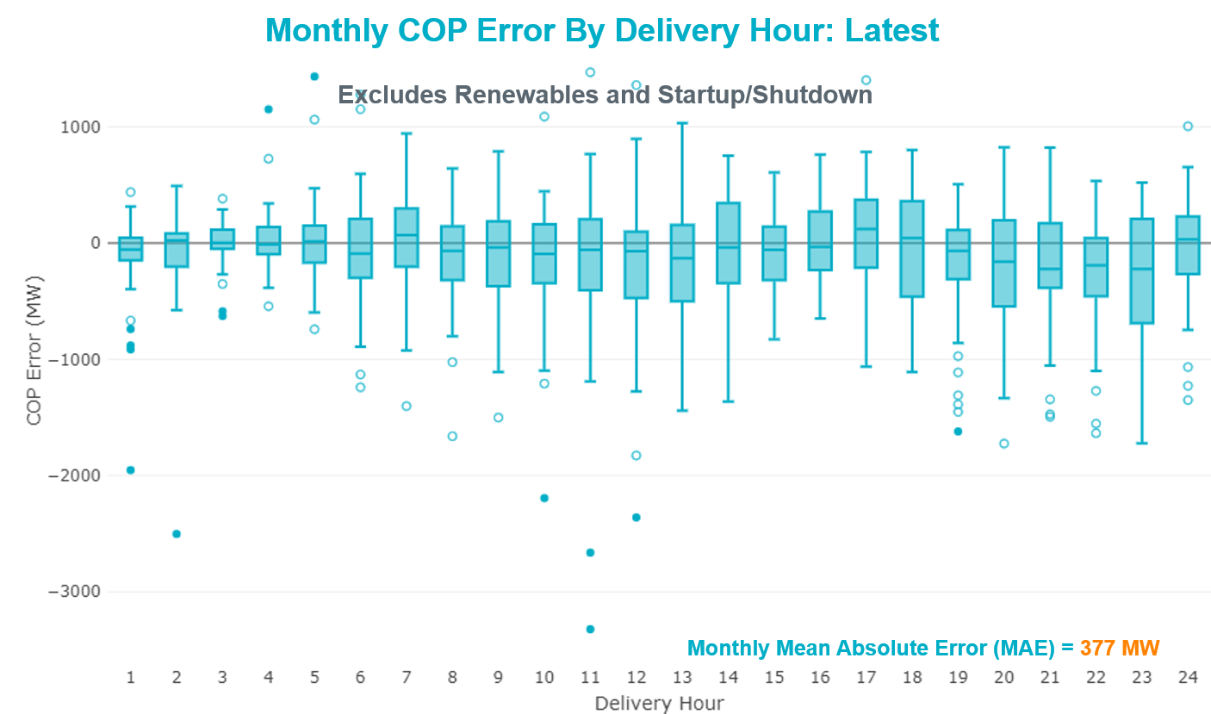

Monthly MAE for the Day-Ahead COP at 12:00 was 6,913 MW with median ranging from -9,250 MW for Hour-Ending (HE) 19 to -2,861 MW for HE 3. HE 17 on the 4th had the largest Under-Scheduling Error (-15,366 MW) and HE 24 on the 19th had the largest Over-Scheduling Error (1092 MW).

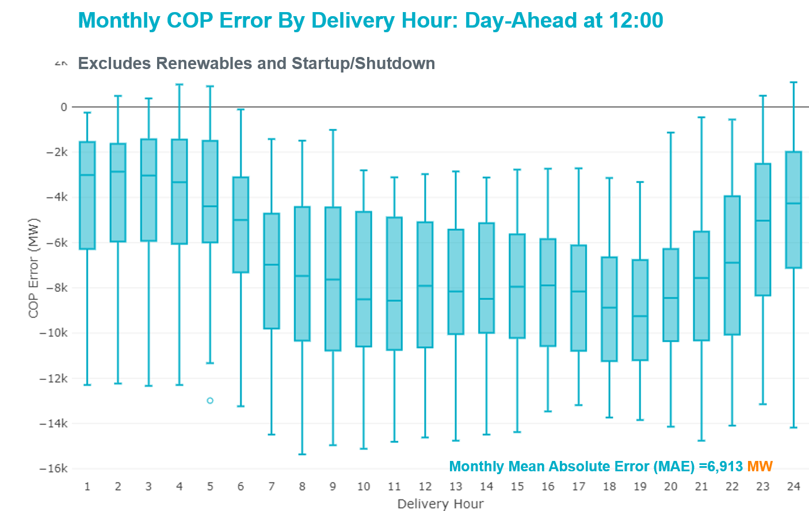

Congestion Analysis

Notable Constraints
Nodal protocol section 3.20 specifies that ERCOT shall identify transmission constraints that are active or binding three or more times within a calendar month. As part of this process, ERCOT reports congestion that meets this criterion to ROS. In addition ERCOT also highlights notable constraints that have an estimated congestion rent exceeding $1,000,000 for a calendar month. These constraints are detailed in the table below. Rows highlighted in blue indicate the congestion was affected by one or more outages. For a list of all constraints activated in SCED, please see Appendix A at the end of this report.

Contingency Name | Overloaded Element | # of Days Constraint Active | Congestion Rent | Transmission Project
MOSS SWITCH to ECTOR COUNTY NORTH SWITCHING STATION LIN _A | Dollarhide - No Trees Switch 138kV | 29 | $49,568,679.79 | Andrews County South Switch - No Trees Switch 138 kV Line (7171)
WINK to DUNE SWITCH and YUKON | Dollarhide - No Trees Switch 138kV | 23 | $24,598,404.14 | Andrews County South Switch - No Trees Switch 138 kV Line (7171)
Basecase | PNHNDL GTC | 25 | $19,209,731.65 | LP&L Integration Tie Lines (43367 A,B,C) and Panhandle Loop
Lynx to RIO PECOS LIN 1 | Woodward 2 - Rio Pecos 138kV | 16 | $7,625,383.43 | Lynx: Expand 138 kV station (45503) and Solstice: Build 345 kV station (5530) and Solstice to Bakersfield: Build 345 kV line (5539)
YUKON SWITCH to Wink and Dune Sw | Dollarhide - No Trees Switch 138kV | 7 | $7,546,525.52 | Andrews County South Switch - No Trees Switch 138 kV Line (7171)
DESOTO SWITCH TRX DESSW_3_1 345/138 | Eagle Ford - Cedar Hill Switch 138kV | 3 | $6,196,505.41 | Cedar Hill - Camp Wisdom 138 kV Line (7020)
TOMBSTONE to Lynx LIN 1 | Woodward 2 - Rio Pecos 138kV | 16 | $6,026,312.69 | Lynx: Expand 138 kV station (45503) and Solstice: Build 345 kV station (5530) and Solstice to Bakersfield: Build 345 kV line (5539)
MOSS SWITCH to ECTOR COUNTY NORTH SWITCHING STATION LIN _A | Andrews County South - Amoco Three Bar Tap 138kV | 8 | $4,577,145.47 | Andrews County South Switch - No Trees Switch 138 kV Line (7171)
VENUS SWITCH TRX VENSW_3_1 345/138 | Britton Road - Venus Switch 345kV | 2 | $2,234,950.20 | Everman - Venus 345 kV Double-circuit line (5310)  Venus - Webb/Cedar Hill Sw. Sta. 345 kV DCKT Line (5492)  Norwood Sw. Sta. - Cedar Hill Sw. Sta. 345 kV Line (7024)
CONCORD TRX CRD1 345/138 | Concord 345kV | 8 | $2,216,633.96
FORT LANCASTER to ILLINOIS #4 LIN 1 | Ozona - Ozona Rea 69kV | 21 | $2,180,322.98 | Ozona: Rebuild 69 kV station (49556)
WINK to DUNE SWITCH and YUKON | Andrews County South - Amoco Three Bar Tap 138kV | 6 | $2,143,096.11 | Andrews County South Switch - No Trees Switch 138 kV Line (7171)
CHB-KG & CBY-JOR 345kV | Chev - Cedar Bayou Plant 138kV | 2 | $1,952,624.12 | Baytown Area Upgrades (43284F & 43284G)
YUKON SWITCH to Wink and Dune Sw | Amoco Three Bar Tap - Dollarhide 138kV | 1 | $1,892,248.46 | Permian Basin Area Upgrade (51245)
Fergus-Gilles & Horsba 138kV | Flat Rock Lcra - Wirtz 138kV | 5 | $1,699,208.26 | Wirtz to FlatRock to Paleface Transmission Line Upgrade (4465)
CRLNW-LWSSW 345kV | Jones Street Tnp - Lakepointe Tnp 138kV | 10 | $1,544,501.87 | Lewisville - Lewisville Jones - Lakepointe 138 kV Line (45537)
Pig Creek to Solstice LIN 1 | Odessa Ehv Switch - Yarbrough Sub 138kV | 2 | $1,467,994.90 | Riverton-Odessa EHV/Moss 345 kV Line (5445)
FERGUSON to SANDY CREEK SWITCHYARD LIN 1 | Gillespie 138kV | 2 | $1,460,292.70
MIDESSA SOUTH SW TRX MDSSW_1_1 345/138 | Trigas Odessa Tap - Odessa Ehv Switch 138kV | 2 | $1,321,089.64 | Riverton-Odessa EHV/Moss 345 kV Line (5445)
TWR (138) QAB-SRB06 & DOL-SRB84 | South Channel 138kV | 1 | $1,196,457.40
EVRSW-CPSES & DCSES 345 KV | Mistletoe Heights - Hemphill 138kV | 5 | $1,026,007.42 | Handley - Hemphill 138 kV Line (4270)
Basecase | EASTEX GTC | 3 | $998,748.37
ODLAW SWITCHYARD to ASPHALT MINES LIN 1 | Hamilton Road - Maverick 138kV | 18 | $971,614.53 | Brackettville to Escondido: Construct 138 kV line (5206)
Basecase | Wolf Hollow Gen - Wolf Hollow 345 Switch 345kV | 3 | $753,569.91
EVRSW-CPSES & DCSES 345 KV | Benbrook Switch - Benbrook 138kV | 8 | $746,898.15 | Everman - Benbrook 345 kv line (6282)
Riohondo-Nedin 345kV&Harlnsw 138kV | Burns Sub - Rio Hondo 138kV | 4 | $738,916.44 | Rebuild Rio Hondo to East Rio Hondo (6687)
YUKON SWITCH to Wink and Dune Sw | Andrews County South - Amoco Three Bar Tap 138kV | 5 | $678,760.00 | Andrews County South Switch - No Trees Switch 138 kV Line (7171)
Manual LOBO TO SAN MIGUEL 345 kV | North Laredo Switch - Piloncillo 138kV | 8 | $672,968.81
ASHERTON to Bevo Substation LIN 1 | Turtle Creek Switching Station - West Crystal City Sub 69kV | 3 | $599,044.89 | Carrizo Springs-Crystal City: 69 kV Line Rebuild (5205)  Turtle Creek - La Pryor 69 kV Line (6123)
ZORN - HAYSEN 345KV | Fairra - Esperanza 138kV | 8 | $589,692.61 | Boerne Cico - Comfort - Kendall Transmission Line Upgrade (6982)
WA PARISH to OBRIEN LIN A | Wa Parish - Obrien 345kV | 3 | $452,303.41
LOFTIN to COTTONWOOD ROAD SWITCH LIN 1 | Bowie 138kV | 23 | $441,028.04
RIO HONDO to LAS PULGAS LIN 1 | Raymondville 2 138kV | 13 | $432,522.57 | Harlingen SS - Raymondville #2: Convert to 138 kV (6167)
Fppyd1-Lostpine 345kV | Fayetteville - Fayette Plant 138 138kV | 12 | $414,200.64 | Fayette Area Upgrades (5286)
FORT MASON to YELLOW JACKET LIN 1 | Yellow Jacket - Hext Lcra 69kV | 21 | $409,097.08
HAMILTON ROAD TRX PS2 138/138 | Sonora 138kV | 10 | $373,936.71 | Carver: Build new 138 kV station (5979)  Friess Ranch to Sonora: Rebuild 69 kV line (51001)  Rocksprings to Friess Ranch: Rebuild 69 kV line (51005)
LAQUINTA to LOBO LIN 1 | Bruni Sub 138kV | 9 | $363,683.42
Fppyd1-Lostpine 345kV | Fayette Plant 138 - La Grange 138kV | 6 | $331,208.16
BAKERSFIELD SWITCHYARD to Big HiLL LIN 1 | Fort Stockton Plant - Solstice 138kV | 8 | $331,133.00 | Solstice: Build 345 kV station (5530)
COMANCHE SWITCH (Oncor) to COMANCHE PEAK SES LIN _A | Comanche Tap - Comanche Switch (Oncor) 138kV | 3 | $295,035.27
WICHITA FALLS SOUTH SWITCH to NEWPORT BEPC LIN _E | Bowie 138kV | 11 | $276,500.73
DUKE / HEC to NORTH EDINBURG LIN 1 | North Edinburg - Hidalgo Energy Center 138kV | 18 | $209,180.68 | South McAllen-Bentsen and North Edinburg-West Edinburg (5621)  North Edinburg: 345 kV Reconfigure (50878)
Berghe-Kendal 345kv & Welfar 138kv | Fredericksburg - Hollmig 138kV | 3 | $205,864.18
Bbses-Rchbr 345kV | Seagoville - Kleberg Tap 138kV | 3 | $194,557.08
BAKERSFIELD SWITCHYARD to NORTH McCAMEY LIN 1 | Sonora 138kV | 4 | $191,220.38 | Carver: Build new 138 kV station (5979)  Friess Ranch to Sonora: Rebuild 69 kV line (51001)  Rocksprings to Friess Ranch: Rebuild 69 kV line (51005)
Lostpi-Austro&Dunlap 345kV | Fayetteville - Fayette Plant 138 138kV | 10 | $152,858.11 | Fayette Area Upgrades (5286)
Ryssw-Forsw 345kV | Forney Switch 345kV | 4 | $141,217.82 | Forney Sw. Sta. Second 600 MVA, 345/138 kV Autotransformer (12TPIT0080)
SANTIAGO to LANGFORD WIND POWER LLC LIN 1 | Friend Ranch - Crockett Heights 69kV | 3 | $139,558.78 | Crckett Hghts to Sonora Atlntic 69 kV line: Rbld 69 kV line (6352)
ODLAW SWITCHYARD to ASPHALT MINES LIN 1 | Escondido - Ganso 138kV | 9 | $126,946.84 | Brackettville to Escondido: Construct 138 kV line (5206)
PH ROBINSON to MEADOW LIN A | Mainland Tnp - Alvin Tnp 138kV | 3 | $111,240.24
MCELMURRAY to ESKOTA SWITCH LIN 1 | Eskota Switch - Longworth 69kV | 4 | $108,465.92 | Scott REA Tap to Eskota 69 kV line: Rebuild 69 kV line (6042)  Wolfgang to Rotan 69 kV line: Rebuild 69 kV line (5970)
HAMILTON ROAD to Maxwell LIN 1 | Sonora 138kV | 5 | $103,683.87 | Carver: Build new 138 kV station (5979)  Friess Ranch to Sonora: Rebuild 69 kV line (51001)  Rocksprings to Friess Ranch: Rebuild 69 kV line (51005)
FORT MASON to YELLOW JACKET LIN 1 | Mason Switching Station - Hext Lcra 69kV | 3 | $95,812.88 | Mason to North Brady: Rebuild 69 kV line (50900)
Basecase | RV_RH GTC | 3 | $93,526.77
WINDTHORST SWITCH to RICE SWITCH LIN _C | Navy Kickapoo Switch 138kV | 8 | $89,160.08
Berghe-Kendal 345kv & Welfar 138kv | Kendall - Cagnon 345kV | 3 | $82,258.91 | Boerne Cico - Comfort - Kendall Transmission Line Upgrade (6982)
Berghe-Kendal 345kv & Welfar 138kv | Hollmig - Kendall 138kV | 4 | $77,495.34
EVERMAN SWITCH to ELMONT_RC SUB LIN _A | Pink Hills Pod (Gcec) - Payne Sub 138kV | 3 | $75,234.42
Berghe-Kendal 345kv & Welfar 138kv | Miller Creek - Henly 138kV | 3 | $74,635.25
Berghe-Kendal 345kv & Welfar 138kv | Mountain Top 138kV | 3 | $66,403.72 | Wirtz to Johnson City to Mountain Top Rebuild to 138kV (6789)
Solstice to FORT STOCKTON PLANT LIN 1 | Alpine - Bronco 69kV | 12 | $64,555.37
Basecase | Randado Aep - Zapata 138kV | 6 | $52,361.60
HAMILTON ROAD to CORRAL LIN 1 | Hamilton Road - Maxwell 138kV | 5 | $47,808.55 | Brackettville to Escondido: Construct 138 kV line (5206)
Cdhsw-Vensw & Evrsw 345kV | Fish Creek Switch - Cedar Hill Switch 138kV | 3 | $41,520.45
MESA VIEW SWITCH to FORT LANCASTER LIN 1 | Sonora 138kV | 5 | $40,303.98 | Carver: Build new 138 kV station (5979)  Friess Ranch to Sonora: Rebuild 69 kV line (51001)  Rocksprings to Friess Ranch: Rebuild 69 kV line (51005)
NOELKE to CEDAR CAYON LIN 1 | Sonora 138kV | 6 | $34,946.61 | Carver: Build new 138 kV station (5979)  Friess Ranch to Sonora: Rebuild 69 kV line (51001)  Rocksprings to Friess Ranch: Rebuild 69 kV line (51005)
WINDTHORST SWITCH to RICE SWITCH LIN _C | Anarene - Navy Kickapoo Switch 69kV | 8 | $27,191.41
BRACKETTVILLE to HAMILTON ROAD LIN 1 | Hamilton Road - Maverick 138kV | 4 | $23,073.29 | Brackettville to Escondido: Construct 138 kV line (5206)
GRAHAM SES to RICE SWITCH LIN _A | Anarene - Navy Kickapoo Switch 69kV | 4 | $20,281.16
BAKERSFIELD SWITCHYARD to SCHNEEMAN DRAW LIN 1 | Hargrove - Twin Buttes 138kV | 3 | $18,556.07
Pig Creek to Solstice LIN 1 | Woodward 2 - Rio Pecos 138kV | 6 | $17,621.36 | Lynx: Expand 138 kV station (45503) and Solstice: Build 345 kV station (5530) and Solstice to Bakersfield: Build 345 kV line (5539)
Bighil-Kendal 345kV | Hamilton Road - Maxwell 138kV | 7 | $17,008.12 | Brackettville to Escondido: Construct 138 kV line (5206)
FORT LANCASTER to ILLINOIS #4 LIN 1 | Pandale - Illinois #4 69kV | 3 | $15,568.14
MOSS SWITCH to ECTOR COUNTY NORTH SWITCHING STATION LIN _A | Cheyenne Tap - Wink Sub 138kV | 6 | $14,976.19 | Rebuild Wink Sw. Sta. - No Trees Sw. Sta. 138 kV Line (7101)  Andrews County South Switch - No Trees Switch 138 kV Line (7171)  Add Wink to Andrews County South 138 kV Second Circuit (51236)
Ferguson-Sherwood Shores & Ferguson-Granite Mountain 138kV | Paleface - Phillips Johnson City 138kV | 4 | $6,744.93 | Wirtz to FlatRock to Paleface Transmission Line Upgrade (4465)
CHB-KG & JOR-NB 345kV | Jefferson - South Channel 138kV | 3 | $4,073.07
GRAHAM SES to RICE SWITCH LIN _A | Navy Kickapoo Switch 138kV | 4 | $2,968.45
Manual Carver to Maxwell 138kV | Hamilton Road - Maxwell 138kV | 3 | $1,922.56 | Brackettville to Escondido: Construct 138 kV line (5206)
Basecase | NE_LOB GTC | 5 | $1,367.45

Generic Transmission Constraint Congestion
There were 25 days of congestion on the Panhandle GTC, 3 days on the East Texas GTC, 3 days on the Raymondivlle – Rio Hondo GTC ,1 day on the Tredwell GTC, 5 days on the North Edinburg to Lobo GTC and 1 day on the McCamey GTC. There was no activity on the remaining GTCs during the month.

Note: This is how many times a constraint has been activated to avoid exceeding a GTC limit, it does not imply an exceedance of the GTC occurred or that the GTC was binding.

Manual Overrides
None.

Congestion Costs for Calendar Year 2019
The following table represents the top twenty active constraints for the calendar year based on the estimated congestion rent attributed to the congestion. ERCOT updates this list on a monthly basis.

Contingency | Binding Element | # of 5-min SCED Intervals | Estimated Congestion Rent | Transmission Project
MOSS SWITCH to ECTOR COUNTY NORTH SWITCHING STATION LIN _A | Dollarhide - No Trees Switch 138kV | 7,339 | 88,977,262.58 | Andrews County South Switch - No Trees Switch 138 kV Line (7171)
Basecase | PNHNDL GTC | 33,216 | 82,257,964.77 | LP&L Integration Tie Lines (43367 A,B,C) and Panhandle Loop
WINK to DUNE SWITCH and YUKON | Dollarhide - No Trees Switch 138kV | 3,478 | 39,722,928.67 | Andrews County South Switch - No Trees Switch 138 kV Line (7171)
MOSS SWITCH to ECTOR COUNTY NORTH SWITCHING STATION LIN _A | Andrews County South - Amoco Three Bar Tap 138kV | 3,503 | 36,784,977.18 | Andrews County South Switch - No Trees Switch 138 kV Line (7171)
GAS PAD to FLAT TOP TNP LIN 1 | Woodward 2 - Rio Pecos 138kV | 2,032 | 31,254,543.67 | Solstice: Build 345 kV station (5530) and Solstice to Bakersfield: Build 345 kV line (5539)
Hcksw-Sagna-138kv | Eagle Mountain Ses - Morris Dido 138kV | 3,036 | 28,140,366.16 | Eagle Mountain-Calmont 138 kV Line (4253)
CAGNON to KENDALL LIN 1 | Cico - Comfort 138kV | 8,246 | 27,467,121.10 | Boerne Cico - Comfort - Kendall Transmission Line Upgrade (6982)
Elmcreek-Skyline 345kV | Hill Country - Marion 345kV | 961 | 26,958,430.36 | Zorn to Marion 2nd 345-kV Transmission Line Addition (4473)
TWR (345) HLJ-WAP64 & BLY-WAP72 | Jones Creek - South Texas Project 345kV | 6,446 | 25,411,174.07 | Freeport Master Plan (6668A)
MIDESSA SOUTH SW TRX MDSSW_1_1 345/138 | Trigas Odessa Tap - Odessa Ehv Switch 138kV | 1,490 | 23,618,361.58 | Riverton-Odessa EHV/Moss 345 kV Line (5445)
Solstice to FORT STOCKTON PLANT LIN 1 | Barrilla - Fort Stockton Switch 69kV | 15,075 | 23,366,135.59 | Solstice: Build 345 kV station (5530) and Solstice to Bakersfield: Build 345 kV line (5539)  Pecos County Modification Project (7028, 44359)
CRLNW-LWSSW 345kV | Jones Street Tnp - Lakepointe Tnp 138kV | 7,298 | 20,823,538.11 | Lewisville - Lewisville Jones - Lakepointe 138 kV Line (45537)
CRLNW-LWSSW 345kV | Ti Tnp - West Tnp 138kV | 2,668 | 19,162,035.36
FRIEND RANCH TRX FMR1 138/69 | Sonora 138kV | 4,982 | 18,574,808.81 | Carver: Build new 138 kV station (5979)  Friess Ranch to Sonora: Rebuild 69 kV line (51001)  Rocksprings to Friess Ranch: Rebuild 69 kV line (51005)
WINK to DUNE SWITCH and YUKON | Andrews County South - Amoco Three Bar Tap 138kV | 2,368 | 18,389,298.51 | Andrews County South Switch - No Trees Switch 138 kV Line (7171)
TWR (345) HLJ-WAP64 & BLY-WAP72 | South Texas Project - Wa Parish 345kV | 902 | 15,903,156.70 | Freeport Master Plan (6668A)
Hcksw-Sagna-138kv | #N/A | 1,171 | 14,755,180.28
Manual LOTEBUSH toYUCSW 138 kV | Woodward 2 - Rio Pecos 138kV | 2,888 | 14,726,601.84 | Solstice: Build 345 kV station (5530) and Solstice to Bakersfield: Build 345 kV line (5539)
Manual LOTEBUSH toYUCSW 138 kV | 16th Street Tnp - Woodward 2 138kV | 4,906 | 14,675,595.13 | Solstice: Build 345 kV station (5530) and Solstice to Bakersfield: Build 345 kV line (5539)
DMTSW-SCOSW 345KV | Knapp - Scurry Chevron 138kV | 4,760 | 14,601,372.86 | Ennis Creek - Cogdell 69 kV Line (4554) & Ennis Creek 138 kV Switching Station (6269)

System Events

ERCOT Peak Load
The unofficial ERCOT peak load for the month was 56,427 MW and occurred on the 12th, during hour ending 8:00.

Load Shed Events
None.

Stability Events
None.

Notable PMU Events
ERCOT analyzes PMU data for any significant system disturbances that do not fall into the Frequency Events category reported in section 2.1. The results are summarized in this section once the analysis has been completed.

There were no PMU events outside of those reported in section 2.1.

DC Tie Curtailment
None.

TRE/DOE Reportable Events
None.

New/Updated Constraint Management Plans
None.

New/Modified/Removed RAS
None.

New Procedures/Forms/Operating Bulletins
Procedure Title | POB
DC Tie Desk | 908
Real-Time Desk | 909
Reliability Risk Desk | 910
Reliability Unit Commitment Desk | 911
Resource Desk | 912
Scripts | 913
Shift Supervisor Desk | 914
Transmission & Security Desk | 915
Communication Protocols | 916

Emergency Conditions

OCNs
None.

Advisories
Date and Time | Message
Nov 06 2019 13:30 CPT | ERCOT postponed the deadline for the posting of the DAM Solution for Operating Day Nov 7, 2019.

Watches
Date and Time | Message
Nov 08 2019 04:02 CPT | ERCOT issued a Watch for failure of SCED.

Emergency Notices
Date and Time | Message
Nov 13 2019 22:25 CPT | ERCOT issued a Transmission Emergency Notice for Far West Texas

Application Performance

TSAT/VSAT Performance Issues
None.

Communication Issues
None.

Market System Issues
None.

Model Updates
The Downstream Production Change (DPC) process allows ERCOT to make changes in the on-line Network Operations Model without loading a completely new model. The purpose of this process is to allow for reliable grid operations as system conditions change between designated Network Operations Model database loads. The DPC process is limited in scope to just those items listed below, with equipment ratings updates being the most common. ERCOT has seen a rise in the use of the DPC process to make on-line updates to the Network Operations Model in recent years, instead of through the standard Network Operations Model Change Request process.

- Static Line ratings (Interim Update)
- Dynamic Line ratings (non-Interim Update)
- Autotransformer ratings (non-Interim Update)
- Breaker and Switch Normal status (Interim Update)
- Contingency Definitions (Interim Update)
- RAP and RAS changes or additions (Interim Update)
- Net Dependable and Reactive Capability (NDCRC) values (Interim Update)
- Impedance Updates (non-Interim)

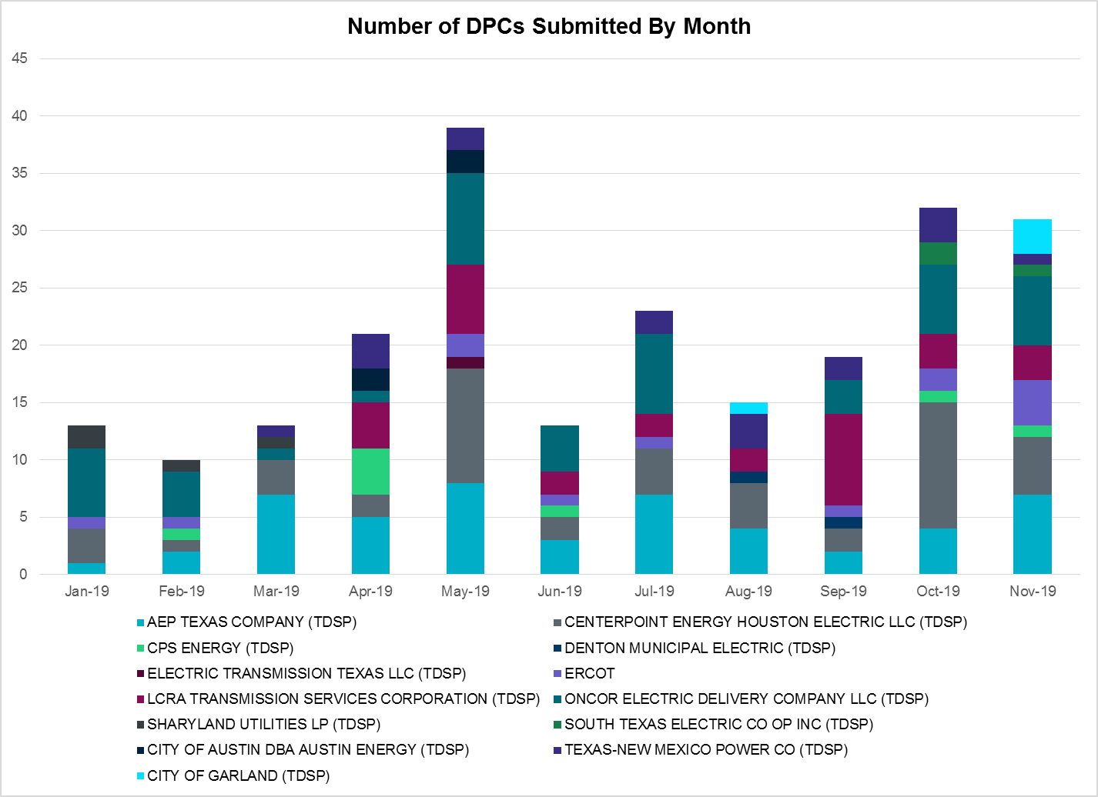

Transmission Operator | Number of DPCs
AEP TEXAS COMPANY (TDSP) | 7
BRAZOS ELECTRIC POWER CO OP INC (TDSP) | 0
CENTERPOINT ENERGY HOUSTON ELECTRIC LLC (TDSP) | 5
CITY OF AUSTIN DBA AUSTIN ENERGY (TDSP) | 0
CITY OF GARLAND (TDSP) | 3
CPS ENERGY (TDSP) | 1
DENTON MUNICIPAL ELECTRIC (TDSP) | 0
ELECTRIC TRANSMISSION TEXAS LLC (TDSP) | 0
ERCOT | 4
LCRA TRANSMISSION SERVICES CORPORATION (TDSP) | 3
ONCOR ELECTRIC DELIVERY COMPANY LLC (TDSP) | 6
SHARYLAND UTILITIES LP (TDSP) | 0
SOUTH TEXAS ELECTRIC CO OP INC (TDSP) | 1
TEXAS MUNICIPAL POWER AGENCY (TDSP) | 0
TEXAS-NEW MEXICO POWER CO (TDSP) | 1

Appendix A: Real-Time Constraints
The following is a complete list of constraints activated in SCED. Full contingency descriptions can be found in the Standard Contingencies List located on the MIS secure site at Grid Generation Reliability Unit Commitment.

Contingency | Constrained Element | From Station | To Station | # of Days Constraint Active
SECNMO28 | 6100__F | DHIDE | NOTSW | 29
BASE CASE | PNHNDL | n/a | n/a | 25
SCRDLOF9 | BOW_FMR1 | BOW | BOW | 23
DWINDUN8 | 6100__F | DHIDE | NOTSW | 23
SFORYEL8 | HEXT_YELWJC1_1 | YELWJCKT | HEXT | 21
SILLFTL8 | OZNR_OZONA1_1 | OZONA | OZNR | 21
SBRAUVA8 | HAMILT_MAVERI1_1 | HAMILTON | MAVERICK | 18
SDUKNED8 | HEC_NEDIN2_1 | HEC | NEDIN | 18
SLYNRIO8 | RIOPEC_WOODW21_1 | RIOPECOS | WOODWRD2 | 16
STOMLYN8 | RIOPEC_WOODW21_1 | RIOPECOS | WOODWRD2 | 16
SRAYRI28 | RAYMND2_69A1 | RAYMND2 | RAYMND2 | 13
SSOLFTS8 | ALPINE_BRONCO1_1 | BRONCO | ALPINE | 12
DFPPLOS5 | 171T253_1 | FAYETT | FPP138 | 12
SLKAWFS8 | BOW_FMR1 | BOW | BOW | 11
DCRLLSW5 | 590__B | LWVJS | LKPNT | 10
DAUSLOS5 | 171T253_1 | FAYETT | FPP138 | 10
XHAM88 | SONR_69-1 | SONR | SONR | 10
SBRAUVA8 | ESCOND_GANSO1_1 | GANSO | ESCONDID | 9
SLAQLOB8 | BRUNI_69_1 | BRUNI | BRUNI | 9
SSCLWF18 | 6840__B | ANARN | NVKSW | 8
SSCLWF18 | NVKSW_FMR1 | NVKSW | NVKSW | 8
MLOBSA_5 | NLARSW_PILONC1_1 | NLARSW | PILONCIL | 8
SBAKBIG5 | FTST_SOLSTI1_1 | FTST | SOLSTICE | 8
DEVRCPS5 | 6120__A | BNBSW | BNBRK | 8
DZORHAY5 | 503T503_1 | ESPERA | R0 | 8
XCRD58 | CRD_CRD2 | CRD | CRD | 8
SECNMO28 | 6100__G | ACSSW | AMTBT | 8
SSCLWF18 | 6840__B | NVKSW | ANARN | 8
DBIGKEN5 | HAMILT_MAXWEL1_1 | MAXWELL | HAMILTON | 7
DYKNWIN8 | 6100__F | DHIDE | NOTSW | 7
DFPPLOS5 | 169T263_1 | FPP138 | LAGRAN | 6
SPIGSOL8 | RIOPEC_WOODW21_1 | RIOPECOS | WOODWRD2 | 6
SNOECED5 | SONR_69-1 | SONR | SONR | 6
SECNMO28 | 6101__B | CHEYT | WINKS | 6
SPIGSOL8 | RIOPEC_WOODW21_1 | WOODWRD2 | RIOPECOS | 6
DWINDUN8 | 6100__G | ACSSW | AMTBT | 6
BASE CASE | RANDAD_ZAPATA1_1 | RANDADO | ZAPATA | 6
SCOMHA38 | HAMILT_MAXWEL1_1 | MAXWELL | HAMILTON | 5
DYKNWIN8 | 6100__G | ACSSW | AMTBT | 5
DEVRCPS5 | 6125__C | MSTLT | HMPHL | 5
SHAMMAX8 | SONR_69-1 | SONR | SONR | 5
BASE CASE | NE_LOB | n/a | n/a | 5
DAUSLOS5 | 169T263_1 | FPP138 | LAGRAN | 5
DFERHOR8 | 38T365_1 | WIRTZ | FLATRO | 5
SFTLMES8 | SONR_69-1 | SONR | SONR | 5
SMCEESK8 | 6780__A | LONGWRTH | ESKSW | 4
DRIOHAR5 | BURNS_RIOHONDO_1 | RIOHONDO | MV_BURNS | 4
DRYSFOR5 | FORSW_MR3H | FORSW | FORSW | 4
DFERGRM8 | 247T124_1 | PALEFA | PHILJC | 4
SMCEESK8 | 6780__A | ESKSW | LONGWRTH | 4
SSCUSU28 | ROTN_WOLFGA1_1 | WOLFGANG | ROTN | 4
SBRAHAM8 | HAMILT_MAVERI1_1 | HAMILTON | MAVERICK | 4
SRICGRS8 | NVKSW_FMR1 | NVKSW | NVKSW | 4
SBAKNOR5 | SONR_69-1 | SONR | SONR | 4
SRICGRS8 | 6840__B | ANARN | NVKSW | 4
DBERWE58 | 72T120_1 | KENDAL | HOLLMI | 4
SRICGRS8 | 6840__B | NVKSW | ANARN | 4
DBBSRCH5 | 1750__B | SGOVL | KLBTP | 3
DBERWE58 | MOUNTO_AT1 | MOUNTO | MOUNTO | 3
SCMNCPS5 | 651__B | CMNSW | CMNTP | 3
SILLFTL8 | ILLN_PANDAL1_1 | ILLN | PANDALE | 3
SOBWAP5 | OB_WAP98_A | WAP | OB | 3
SBAKSCH5 | HARGRO_TWINBU1_1 | TWINBU | HARGROVE | 3
DCHB_NB5 | JFSSC_06_A | JFS | SC | 3
DBERWE58 | R5_KENDL_1 | KENDAL | CAGNON | 3
SMEMANA8 | 1580__B | PAYNE | PNKHL | 3
DBERWE58 | 73T120_1 | HOLLMI | FREDER | 3
XDES258 | 932__B | CDHSW | EGFRD | 3
SBEVASH8 | TURTLECK_WCRYS_1 | TURTLCRK | WCRYSTS | 3
MCARMAX8 | HAMILT_MAXWEL1_1 | MAXWELL | HAMILTON | 3
BASE CASE | RV_RH | n/a | n/a | 3
BASE CASE | WHILP_EAST_1 | WHCCS | WOFHO | 3
SMDOPHR5 | 138_ALV_MNL_1 | ALVIN | MAINLAND | 3
BASE CASE | EASTEX | n/a | n/a | 3
SLGDSAP8 | FDR_OZNC_1 | FRIEND_R | OZNC | 3
SFORYEL8 | HEXT_MASONS1_1 | MASONSW | HEXT | 3
DMGSQAL5 | 14040__A | PCTSW | RBPOI | 3
DCDHVEN5 | 3180__A | FCRSW | CDHSW | 3
DBERWE58 | 415T415_1 | MILLER | HENLY | 3
DFPPLOS5 | 192T175_1 | WINCHE | SMITHV | 2
SCAGKEN5 | 72T120_1 | KENDAL | HOLLMI | 2
SN_SLON5 | CELANE_KLEBER1_1 | CELANEBI | KLEBERG | 2
SBAKSCH5 | SONR_69-1 | SONR | SONR | 2
SPIGSOL8 | 6520__E | ODEHV | YARBR | 2
DCHBJOR5 | CBYCVN86_A | CBY | CVN | 2
DAUSDUN8 | CKT_1004_1 | TRIDGE | HWRDLN | 2
SRICGRS8 | 6840__A | ANARN | CRDSW | 2
SBIWAP5 | BI_SMR98_A | SMITHERS | BI | 2
SNOECED5 | HARGRO_TWINBU1_1 | TWINBU | HARGROVE | 2
DCPSST58 | 651__B | CMNSW | CMNTP | 2
SWAPSMI5 | BI_WAP50_A | WAP | BI | 2
SODLBRA8 | HAMILT_MAVERI1_1 | HAMILTON | MAVERICK | 2
SNCRELM8 | WEAST_XF1H | WEAST | WEAST | 2
XVE3N58 | 530__C | VENSW | BRTRD | 2
DWINDUN8 | 6101__B | CHEYT | WINKS | 2
XMDS58 | 6475__C | ODEHV | TROTP | 2
DWINDUN8 | 6480__A | MOSSW | ECTHP | 2
SECNMO28 | 6480__A | MOSSW | ECTHP | 2
DMCEBUT8 | 6790__A | ESKSW | SWTWR | 2
BASE CASE | LGD_SANTIA1_1 | LGD | SANTIAGO | 2
DCPSES12 | MAGRUD_VICTOR2_1 | VICTORIA | MAGRUDER | 2
SCOMHA38 | SONR_69-1 | SONR | SONR | 2
SBOSELM5 | 1030__B | BOSQUESW | RGH | 2
XDUN58 | AUSTRO_AT2H | AUSTRO | AUSTRO | 2
SVICCO28 | COLETO_VICTOR2_1 | COLETO | VICTORIA | 2
SGEOORN8 | CSA_SAN_1 | CASA_BLA | SANDIAS | 2
MXNOR158 | WLVEE_MR2L | WLVEE | WLVEE | 2
DAUSLOS5 | 192T175_1 | WINCHE | SMITHV | 2
MLOBSA_5 | BRUNI_69_1 | BRUNI | BRUNI | 2
SSANFER8 | GILLES_AT1 | GILLES | GILLES | 2
DLONWAR5 | GRETA_REFUGI1_1 | REFUGIO | GRETA | 2
SFORYEL8 | MASNPH_MASN1_1 | MASN | MASNPHT | 2
MLOBSA_5 | ASHERT_CATARI1_1 | ASHERTON | CATARINA | 2
DSTPWHI5 | BLESSI_LOLITA1_1 | BLESSING | LOLITA | 2
DZORHAY5 | R5_KENDL_1 | KENDAL | CAGNON | 2
XBLE58 | SAR_FRAN_1 | FRANKC | SARGNTS | 2
SBOSELM5 | WHTNY_MR2L | WHTNY | WHTNY | 2
DBOMPLV8 | 6558__B | FSHSW | WFALS | 1
SBLESTP5 | COLETO_VICTOR2_1 | COLETO | VICTORIA | 1
SW_BW_25 | ESTILE_STLWRNC_1 | STLWRNCE | ESTILES | 1
MKINODE5 | FTST_SOLSTI1_1 | FTST | SOLSTICE | 1
SHACPB38 | FTST_SOLSTI1_1 | FTST | SOLSTICE | 1
SN_SLON5 | HOLLY4_SOUTH_1_1 | HOLLY4 | SOUTH_SI | 1
BASE CASE | JO-3_1 | FERGCC | FERGUS | 1
DLONWAR5 | REFUG_VICTO_1C_1 | VICTORIA | OCONNOR | 1
DMGSQAL5 | SONR_69-1 | SONR | SONR | 1
DCI_SA_8 | THWTHW81_1 | THW | THW | 1
DNAVLEG5 | 40__A | JEWET | BBSES | 1
DBERWE58 | 450T450_1 | HENLY | DRIPSP | 1
SHAYBER5 | 503T503_1 | ESPERA | R0 | 1
DMTSCOS5 | 6437__F | SCRCV | KNAPP | 1
DMCEBUT8 | 6780__A | ESKSW | LONGWRTH | 1
XDES258 | 932__A | EGFRD | SORCY | 1
SCOLPAW5 | COLETO_VICTOR2_1 | COLETO | VICTORIA | 1
DLONWAR5 | FANNIN_GOLIAD1_1 | FANNINS | GOLIAD | 1
SKLELOY8 | LOYOLA_69_1 | LOYOLA | LOYOLA | 1
SPOMNED5 | NLARSW_PILONC1_1 | NLARSW | PILONCIL | 1
MFTSLYN8 | RIOPEC_WOODW21_1 | RIOPECOS | WOODWRD2 | 1
SBOSWHT5 | 1030__A | ELMOT | RGH | 1
DCPSES12 | 35050__A | SAMSW | VENSW | 1
DCRMO218 | 6500__B | ODEHV | BTHOT | 1
DMCEBUT8 | 6940__C | SWTWR | PLOWB | 1
DCAGCO58 | 73T120_1 | HOLLMI | FREDER | 1
SLVOSON8 | FDR_OZNC_1 | FRIEND_R | OZNC | 1
MLOTYUC8 | FTST_SOLSTI1_1 | FTST | SOLSTICE | 1
DCE_GA58 | GARZA_69A1 | GARZA | GARZA | 1
BASE CASE | HAMILT_MAXWEL1_1 | MAXWELL | HAMILTON | 1
DSAMTHS5 | MEXIA_AT1 | MEXIA | MEXIA | 1
MLOTYUC8 | RIOPEC_WOODW21_1 | RIOPECOS | WOODWRD2 | 1
UWO2WOO1 | RIOPEC_WOODW21_1 | RIOPECOS | WOODWRD2 | 1
SSCHNOE5 | SONR_69-1 | SONR | SONR | 1
DCAGCI58 | 584T584_1 | KENDAL | WELFAR | 1
BASE CASE | 6064__A | TRENT | ESKSW | 1
DCAGCO58 | 72T120_1 | KENDAL | HOLLMI | 1
SBURCRD8 | 945__A | DESSW | GLNHT | 1
DCC1_VIC | COLETO_VICTOR2_1 | COLETO | VICTORIA | 1
SBOSWHT5 | ELMOT_MR2L | ELMOT | ELMOT | 1
SVICCOL8 | GRETA_REFUGI1_1 | REFUGIO | GRETA | 1
SBAKBIG5 | HARGRO_TWINBU1_1 | TWINBU | HARGROVE | 1
SFORJOS8 | LOLITA_VICTOR1_1 | LOLITA | VICTORIA | 1
BASE CASE | MCCAMY | n/a | n/a | 1
SSANPIT8 | SANDCR_AT1 | SANDCR | SANDCR | 1
DWLVWTR5 | 3070__C | MDLTM | ENTOH | 1
DCAGCI58 | 503T503_1 | ESPERA | R0 | 1
DFPPFAY5 | AUSTRO_AT2H | AUSTRO | AUSTRO | 1
XCAG158 | CAGNON_MR4H | CAGNON | CAGNON | 1
SBEVASH8 | CARRIZ_CRYSTA1_1 | CARRIZO | CRYSTAL | 1
SILLFTL8 | CTHR_DOLAN1_1 | CTHR | DOLAN | 1
BASE CASE | ESKSW_STRENT_1 | ESKSW | STWF | 1
SBRAUVA8 | GANSO_MAVERI1_1 | MAVERICK | GANSO | 1
SSANFOW5 | NLARSW_PILONC1_1 | NLARSW | PILONCIL | 1
DTKWGRS5 | ONYXRE_QUAINT1_1 | ONYXREA | QUAINT | 1
DWH_STP5 | REFUG_VICTO_1C_1 | VICTORIA | OCONNOR | 1
DQABSRB8 | SC_AT1 | SC | SC | 1
DENTSCS5 | 1350__E | NCSTP | LFKSW | 1
DCPSJON5 | 6017__A | MBDSW | DCSES | 1
DYKNWIN8 | 6100__B | AMTBT | DHIDE | 1
SSCLWF28 | 6840__B | NVKSW | ANARN | 1
DCAGTA58 | 73T120_1 | HOLLMI | FREDER | 1
DZORHAY5 | BERGHE_AT1H | BERGHE | BERGHE | 1
SBISMI5 | BI_WAP50_A | WAP | BI | 1
SCO2EUL8 | COLETO_ROSATA1_1 | COLETO | ROSATA | 1
SNOECED5 | CONCHO_SAMATH1_1 | CONCHO | SAMATHIS | 1
SWRDYN8 | EL_CAM_LANCTY1_1 | LANCTYPM | EL_CAMPO | 1
BASE CASE | FTST_SOLSTI1_1 | FTST | SOLSTICE | 1
SNORODE5 | FTST_SOLSTI1_1 | FTST | SOLSTICE | 1
MRIOLYN8 | RIOPEC_WOODW21_1 | RIOPECOS | WOODWRD2 | 1
SCOLLON5 | VICTO_WARBU_1A_1 | VICTORIA | WARBURTN | 1
DCAGTA58 | 56T379_1 | FREDER | GILLES | 1
SRICGRS8 | 6830__B | CRDSW | OLNEY | 1
SLGDSAP8 | ATSO_OZNC1_1 | OZNC | ATSO | 1
SMEMANA8 | BNMSW_FMR1 | BNMSW | BNMSW | 1
BASE CASE | BOW_FMR1 | BOW | BOW | 1
SJARDIL8 | DIL_COTU_1 | DILLEYSW | COTULAS | 1
SPOMNED5 | FREER_LOBO1_1 | LOBO | FREER | 1
MKINNOR5 | FTST_SOLSTI1_1 | FTST | SOLSTICE | 1
SWCSBOO8 | FTST_SOLSTI1_1 | FTST | SOLSTICE | 1
XTRS258 | MEXIA_AT1 | MEXIA | MEXIA | 1
SOBWA2P5 | OB_WAP99_A | WAP | OB | 1
SILLFTL8 | OZNR_PANDAL1_1 | OZNR | PANDALE | 1
SMCEESK8 | ROBY_RONDTP1_1 | ROBY | RONDTPT | 1
BASE CASE | TRDWEL | n/a | n/a | 1
DBERWE58 | 342T195_1 | GRANMO | MARBFA | 1
DDMTGLD8 | 6240__C | SACRC | DPCRK | 1
SCOLBAL8 | BALLIN_HUMBLT1_1 | BALLINGE | HUMBLTAP | 1
DGARHIC8 | CKT_943_1 | LYTTON_S | PILOT | 1
BASE CASE | ESKSW_STRENT_1 | STWF | ESKSW | 1
SBLARVS8 | HLSBR_MR1L | HLSBR | HLSBR | 1
DELMSAN5 | MAGRUD_VICTOR2_1 | VICTORIA | MAGRUDER | 1
SFLCMGS5 | ODEHV_MR2H | ODEHV | ODEHV | 1
DELMSAN5 | PAWNEE_SPRUCE_1 | PAWNEE | CALAVERS | 1
DFERGRM8 | SANDCR_AT1 | SANDCR | SANDCR | 1
SFAILAG8 | 427T427_1 | ANDICE | BERTRA | 1
DGILHOR8 | 43T365_1 | FLATRO | PALEPE | 1
DFLCMGS5 | 6500__B | ODEHV | BTHOT | 1

The Duration of Event is defined as the time it takes for the frequency to recover to pre-disturbance frequency or 60 Hz as applicable.
PMU reports are typically generated when frequency drops below 59.9, but PMU data is available for other events.
Delta Frequency is defined as the difference between the starting point of the frequency event (t(0) or “A-point”) and minimum/maximum frequency (“C-Point”).
Currently, the Critical Inertia Level for ERCOT is approximately 100,000 MW-s
This is the hourly integrated peak demand as published in the ERCOT D&E report.

