MarkeTrak Users Guide
Section 2: Inadvertent Gain

Table of Contents

MarkeTrak Users Guide 1
2.1 Day to Day Issues – Inadvertent Gain 3
2.1.1 Required Fields for Inadvertent Gain 3
2.1.2 Definition of Inadvertent Gain 3
2.1.3 Submitting an Inadvertent Gain 4
2.1.4 Submitting a Customer Rescission Issue 22
2.1.5 Redirect Fees Subtype 30

- Day to Day Issues – Inadvertent Gain

Required Fields for Inadvertent Gain
Refer to Section 10 – Bulk Insert Appendix – D2D Issues

2.1.2 Definition of Inadvertent Gain
For purposes of this section of the MarkeTrak Users Guide, CR2 is defined as the non-submitting CR. For example, if the submitting rep indicates they are the Gaining CR then CR2 is the Losing CR and vice versa.

An inadvertent issue begins upon the discovery of an Inadvertent Gain or Move-In transaction submission. Upon identification of an Inadvertent Gain or Move-in, the CR will check the transaction status via the ERCOT MIS.

- If transaction Status is pending, and the Inadvertent CR is the submitting CR, then the CR will cancel their submitting transaction either by submitting an EDI cancel transaction or following the procedures outlined in Section 3 of the MarkeTrak User’s Guide entitled Cancel With Approvals.

- For other Status types or if the CR was not the submitter of the transaction, the CR will log a MarkeTrak Inadvertent issue.
  - Only one ESI ID is allowed per MarkeTrak issue.
  - CR’s should refer to and follow additional steps that are outlined in the Retail Market Guide under “TDSP’s Inadvertent Gain Process”.

- CR’s will work together in a manner outlined in Section 7.2 of the Retail Market Guide (RMG) to determine appropriate resolution. The Retail Market Guide is available in the Market Guides section of www.ercot.com. See Section 1 of the MarkeTrak User’s Guide for response timelines required. If responses are not received in an adequate timeframe, the CR should escalate to the CR Inadvertent MarkeTrak contact.

- If the CR/TDSP resolution requires a backdated move-in being generated by the Original CR, then the date should be at least the Gaining CR start date plus 1 day to avoid creating transaction business process exceptions at ERCOT and the TDSP.

- The submitter should include any details, (ex. Customer name), which may expedite resolution of the issue.

NOTE: Move-Out or Disconnect for Non Payment transactions should NOT be used to resolve an inadvertent issue on an energized ESI ID. Per the Retail Market Guide, Section 7.2.2.3: “The gaining CR shall not send in a Move-Out Request or a Disconnect for Non-Pay on an ESI ID that was gained in error.”

- ERCOT’s Receipt of Inadvertent Gain Issue

- Confirm the pending or actual change of CR relationship.
- Assign CR2 and the TDSP to the MarkeTrak issue.
- ERCOT will transition the MarkeTrak issue to the parties involved with CR2 as the Responsible MP.
- CR2 is responsible for selecting Begin Working to transition the item into a State of In Progress.
- The Original CR must wait for the TDSP to select Ready to Receive prior to sending the EDI to regain the account.

- Examples of Invalid Inadvertent Gain Issue

There are instances where ERCOT will immediately return the issue to the submitter by selecting Invalid IAG and populating the Invalid IAG Reason field with the reason the issue could not be worked.

Possible reasons include:
  - Invalid ESI ID
  - Wrong or Invalid Tran ID
  - Invalid Order Type (order something other than MVI or Switch)
  - Submitter selected Gaining and is not the Gaining CR
  - Submitter selected Losing and is not the Losing CR
  - ESI ID was De-Energized prior to completion of MVI
  - The Losing and Gaining CR are the same
  - Losing CR has left the Market
  - Gaining CR has left the Market
  - Order was Cancelled – No IAG
  - Other

NOTE: ERCOT will monitor the volume of Inadvertent MarkeTrak Issues and provide reporting on an as-needed basis to RMS or the PUC. Reports will identify the submitting and resolving/monitoring party as logged in the MarkeTrak issue and will not attempt to identify the party responsible for the inadvertent issue

2.1.3 Submitting an Inadvertent Gain

- Example: CR Submits Inadvertent Gain as the Losing CR

- Select “Submit to my Preferred Projects” under Basic Tasks under the Submit Icon. (for this example, the Submitter is the CR1 (Losing/Original CR)) (Fig 2.1.3.1a)
- From the Submit Tree, select IAG – Inadvertent Losing

Fig 2.1.3.1a
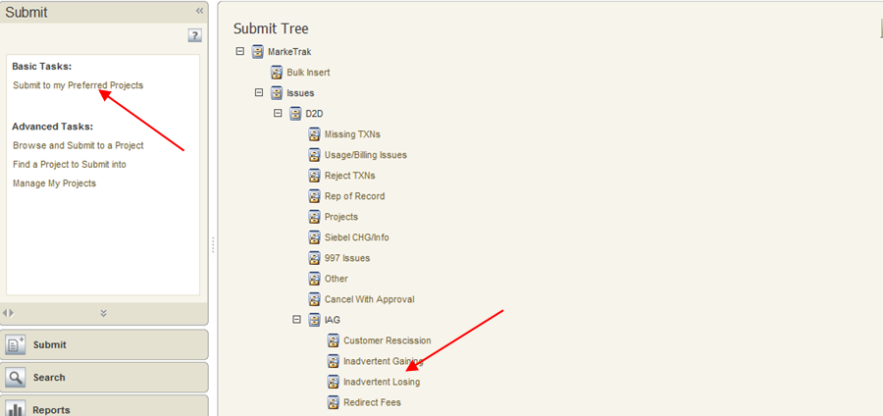

- CR1 (Losing/Original CR) will enter all required information. (Fig 2.1.3.1b)
ESIID
Original Tran ID – The original tran id of the other CR’s enrollment. (BGN06 of the 814_06).

CRITICAL: The Comments field is technically optional; however, not providing the required information referenced in RMG Section 7.3.2(1) could result in a delay of issue resolution.. Please include any additional information in this box.

- Select OK to create the IAG – Inadvertent Losing MarkeTrak Issue. (Fig 2.1.3.1b)

Fig 2.1.3.1b
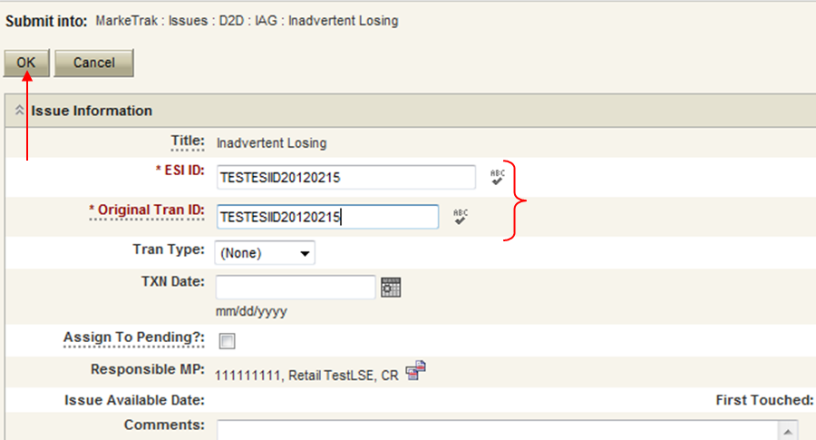

- The Premise Type and Siebel Status/Sub-status are now populated on the issue and it enters ERCOT’s queue in a state of New and is visible only by the Submitting CR and ERCOT. (Fig 2.1.3.1c)

Fig 2.1.3.1c
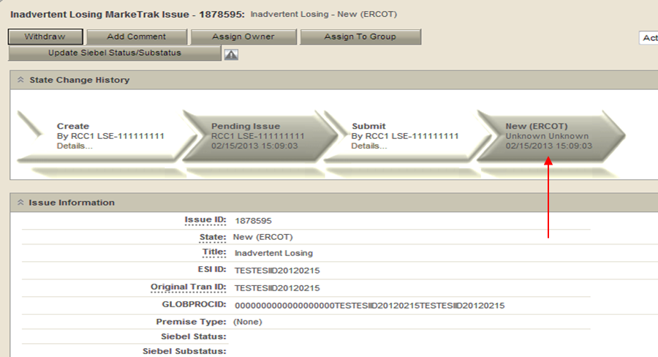

- The Submitting CR has the option to Withdraw the issue at this point. (Fig 2.1.3.1d)

Fig 2.1.3.1d
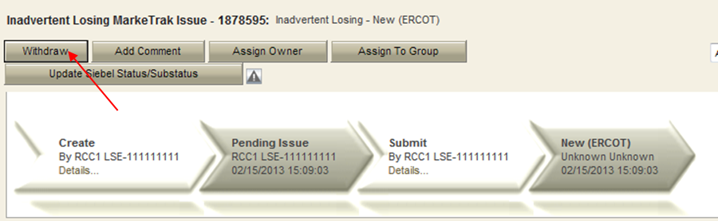

- ERCOT will select Begin Working to provide the Gaining CR Start Date, if the Gaining CR is still the rep of record (Gaining CR ROR), assign CR2 (Gaining CR) and TDSP. ERCOT will then select “OK” to move the issue to CR2 (Gaining CR).

NOTE: If the Gaining CR ROR field is NO then the Gaining CR is not the current rep of record at the time the IAG was submitted. The service order is still pending and the date provided in the Gaining CR Start Date field is the requested MVI date or the Scheduled meter read date. ERCOT will indicate in comments when this scenario happens and that the order may not complete for this date. The Losing CR and Gaining CR should take this into consideration when proposing the regain date.

- At this point, the Submitting CR can no longer Withdraw the issue.

NOTE: After the initial Begin Working is selected and Withdraw is not available or the issue is not in a Regaining Transaction Submitted (PC), Unexecutable (PC), or Complete state, if the submitting MP feels a resolution is no longer needed, the “Close button can be selected (Fig 2.1.3.1e). Comments will be required with this transition. All work will stop on the issue at this point.

Fig 2.1.3.1e
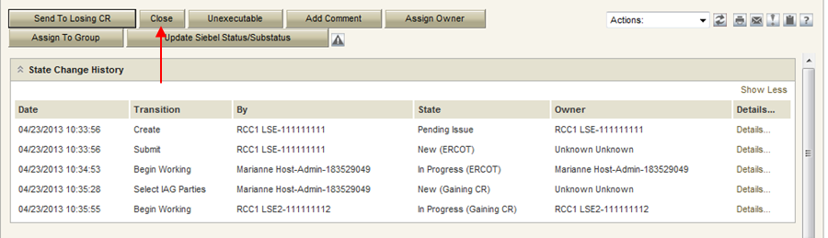

- CR2 (Gaining CR) will select Begin Working and investigate the Inadvertent Gain issue details to determine if CR1 (Losing/Original CR) should regain ESI ID as of their date of loss. (Fig 2.1.3.1f)

Fig 2.1.3.1f
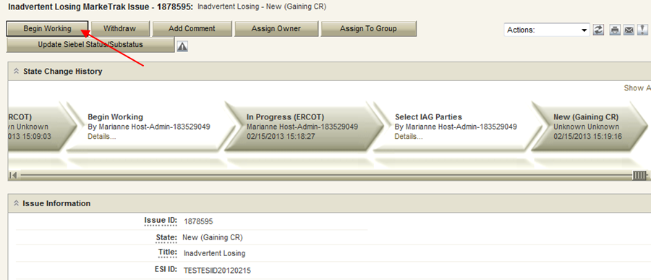

- If CR2 (Gaining CR) determines that an Inadvertent Gain has NOT taken place, they have the option to select “Unexecutable” to stop the Inadvertent Gain process. Invalid IAG Reason is required, enter one of the following: (Fig 2.1.3.1g)
Valid Reject Reasons are described in the RMG Section 7.3.2.4(2) and are as follows:
3rd party CR involved
Authorized Enrollment Confirmed
Duplicate Issue
Other (should require comments)

NOTE: Unexecutable ends the ability to do any other work on the issue.

Fig 2.1.3.1g
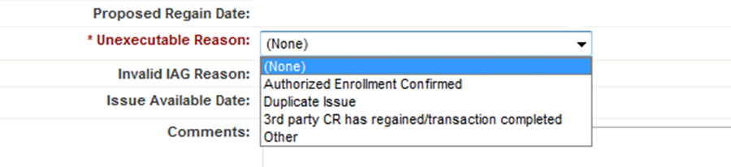

- If CR2 (Gaining CR) determines that an Inadvertent Gain has taken place, they will select Agree, enter comments and select “OK” to move issue to CR1 (Losing/Original CR). (Fig 2.1.3.1h)

Fig 2.1.3.1h
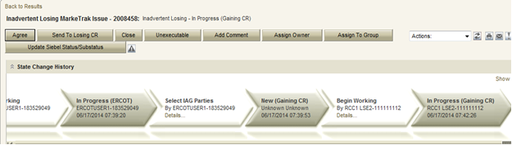

NOTE: Selecting Agree, the Gaining CR is agreeing to all fees associated with transitioning the premise back to the Losing CR.

- CR1 (Losing/Original CR) will select Begin Working and Investigate Market Conditions to determine the appropriate regain date.
- CR1 (Losing/Original CR) will select Send to TDSP, enter the proposed regain date, add comments and select “OK” to move the issue to the TDSP. (Fig 2.1.3.1i)

NOTE: The Reinstatement date shall be a day beyond the date of loss or any subsequent date chosen by the Losing/Original CR but no greater than 10 days past the date the MarkeTrak issue was logged.

- If CR1 (Losing/Original CR) determines that an Inadvertent Gain has NOT taken place, they have the option to select Unexecutable. (Fig 2.1.3.1i)

NOTE: Before selecting the Unexecutable Transition, as a courtesy please contact the CR to state reason for choosing Unexecutable. Once selected this stops the Inadvertent Gain process if any of the Valid Reject Reasons per the RMG Section 7.3.2.4 are present.

- If CR1 (Losing/Original CR) determines they will need more information from CR2 (Gaining CR), then they will need to select Send to Gaining CR. This transition allows both CRs to talk back and forth while transitioning the issue back and forth before a resolution is made. (Fig 2.1.3.1i)

Fig 2.1.3.1i
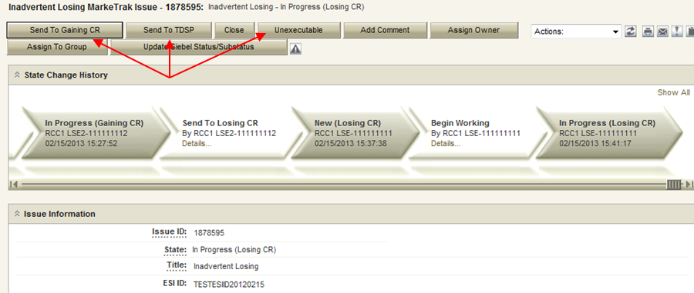

NOTE: The following validation will occur on the Proposed Regain Date: Validate that the date is less than “Submit Date” + 15 days. If not the following error message will be displayed “Proposed Regain Date is greater than 15 Calendar days from the submittal of MarkeTrak Issue, please update with valid Proposed Regain date.”

- The TDSP will select Begin Working, investigate the issue details, then select one of the following: (Fig 2.1.3.1j)
- Ready to Receive – The TDSP would select this transition to send the issue back to CR1 (Losing/Original CR).

NOTE: It is extremely important that CR1 (Losing/Original CR) wait for the TDSP to select Ready to Receive indicating TDSP’s systems have been prepared to receive the Original MP’s transaction before the EDI is actually sent. If not, the EDI will be rejected at the TDSP.
- Send To Submitting CR – The TDSP would select this transition if they needed further information from CR1 (Losing/Original CR).
- Request Updated Proposed Regain Date – The TDSP would select this transition if they do not agree with the proposed regain date that was provided. They would suggest a new date and send the issue back to CR1 (Losing/Original CR).

Fig 2.1.3.1j
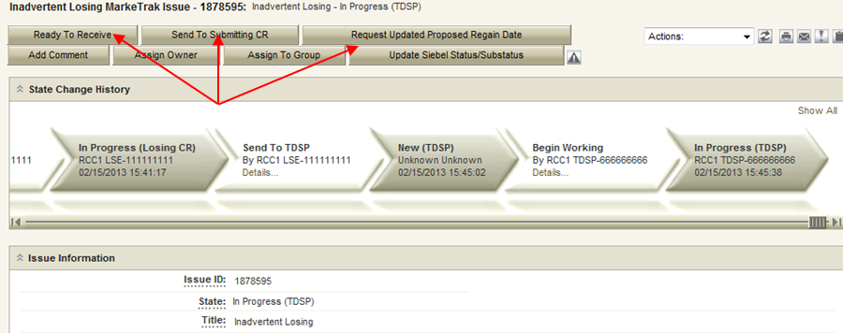

- CR1 (Losing/Original CR) will select Begin Working then select Provide Regaining BGN 02. CR1 (Losing/Original CR) will provide the Regaining BGN02 and then select “OK”. (Fig 2.1.3.1k) When the regaining transactions process into ERCOT’s registration system, the Regaining Transaction Submit Date, Regaining BGN Requested Date and Regaining BGN Priority Code will be auto-populated on the MarkeTrak issue.

NOTE: Once the Regaining BGN02 field is populated, the issue will appear to be in the Regaining Transaction Submitted (PC) state. At this point in the process, the Losing CR should NOT click the Send to TDSP transition with the intent of the TDSP closing the issue. This will prevent the issue from Auto-completion.

Fig 2.1.3.1k

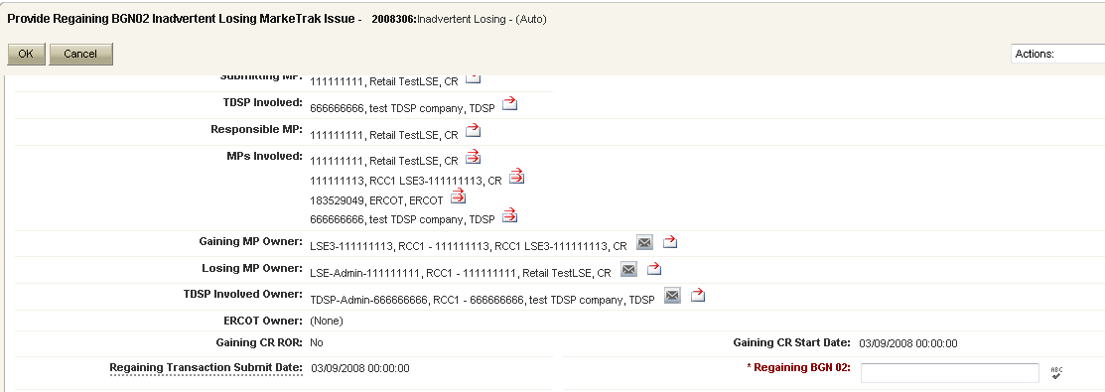
- All parties should continue to monitor MIS and internal systems for the successful delivery and completion of the EDI transaction being sent by CR1 (Losing/Original CR) to the Market to regain a premise and resolve the associated Inadvertent Gain MarkeTrak issue.

- Once the regaining transaction has been successfully sent to the Market by CR1 (Losing/Original CR), Siebel will automatically:
- Check Regaining Transaction Siebel Status every 30 minutes using the BGN 02 from the new initiating transaction
- Update the issue with the current Regaining Transaction Siebel Status
- Assign the state of Complete with the Submitting MP as the Responsible Party once the Regaining Transaction Siebel Status is Complete.
- Issues remaining in a state of ‘Regaining Transaction Submitted (PC)’ for 14 calendar days will be transitioned by MarkeTrak to a state of ‘New (Losing CR Re-Submit)’ with the following comment: “Regaining Transaction has been idle for too long. Please review and re-submit transaction.”

NOTE: Auto Close Transition If an IAG issue (either type) is in “New (Losing CR submit)” or “In Progress (Submit Regaining)” and remains unmodified for 20 days the issue will Auto Close and transition to a state of “Closed – Inactive”

- Example: CR Submits Inadvertent Losing Issue to Regain ESIID Released from Switch Hold

The Retail Market Guide, Section 7.16.4.3.3 provides additional reasons the Inadvertent Losing sub-type may be used to regain a location. The following section outlines a scenario where a location may be regained based on the criteria set forth in RMG 7.16.4.3.3.

- Select “Submit to my Preferred Projects” under Basic Tasks under the Submit Icon. (for this example, the Submitter is the CR1 (Losing/Original CR))
- From the Submit Tree select the “IAG – Inadvertent Losing sub-type
- CR1 (Losing/Original CR) will enter all required information
ESIID
Original Tran ID – The original tran id of the other CR’s enrollment. (BGN06 of the 814_06).
Comment - “TDSP return ESI ID per RMG Section 7.16.4.3.3 and restore switch hold upon reinstatement.” This comment is required at the time of submission in order for the issue to be considered valid. Also, for reporting purposes, it is important that this comment be entered exactly as shown above.

- Select "OK" to create the IAG – Inadvertent Losing MarkeTrak Issue.
- By selecting OK, the Premise Type and Siebel Status/Sub-status will be populated on the issue and it enters ERCOT’s queue in a state of New. The issue is visible only by the Submitting CR and ERCOT. The Submitting CR has the option to Withdraw the issue at this point.
- The Submitting CR will create an item link to the original Switch Hold Removal MarkeTrak issue which led to the release of the ESIID in question. (Fig 2.1.3.2a and Fig 2.1.3.2b)
  - Visit the “Actions” dropdown at the top right of the page
  - Choose “Add Item Link”
  - Enter the Issue ID of the original Switch Hold Removal MarkeTrak issue
  - Select “Create Link”

Fig 2.1.3.2a
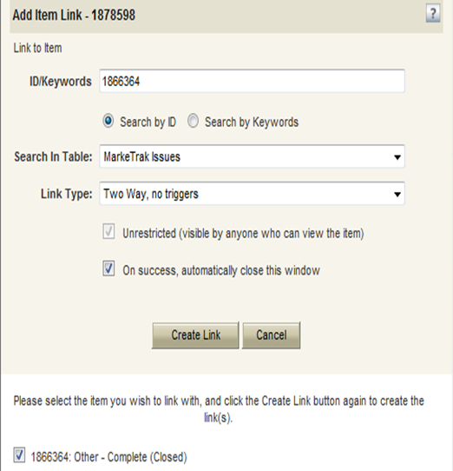

Fig 2.1.3.2b
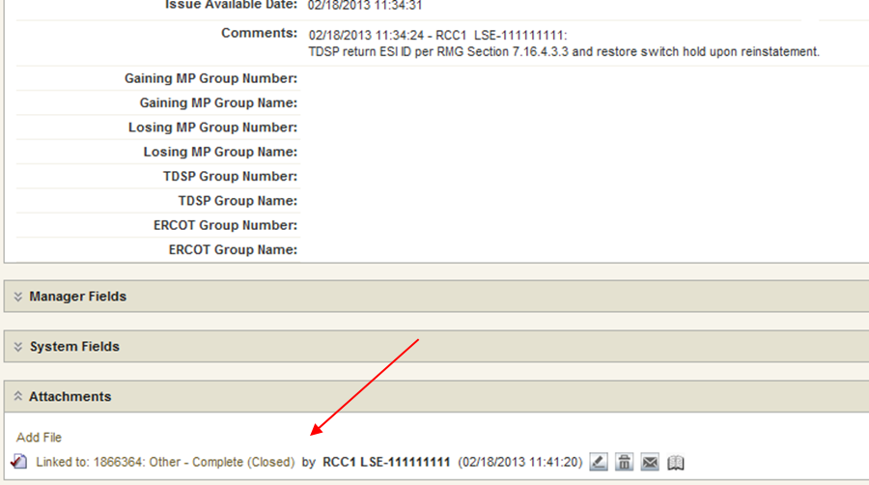

- ERCOT will select Begin Working to provide the Gaining CR Start Date, if the Gaining CR is still the rep of record (Gaining CR ROR), assign CR2 (Gaining CR) and TDSP. ERCOT will then select “OK” to move the issue to CR2 (Gaining CR).

NOTE: If the Gaining CR ROR field is NO then the Gaining CR is not the current rep of record at the time the IAG was submitted. The service order is still pending and the date provided in the Gaining CR Start Date field is the requested MVI date or the Scheduled meter read date. ERCOT will indicate in comments when this scenario happens and that the order may not complete for this date. The Losing CR and Gaining CR should take this into consideration when proposing the regain date.

- At this point, the Submitting CR can no longer Withdraw the issue.

NOTE: After the initial “Begin Working” is selected and the “Withdraw” is not available or the issue is not in a “Regaining Transaction Submitted (PC)”, “Unexecutable (PC)”, or “Complete” state, if the submitting MP feels a resolution is no longer needed, the “Close” button can be selected. Comments will be required with this transition. All work will stop on the issue at this point.
- CR2 (Gaining CR) will select Begin Working and click Agree if the Losing CR and TDSP were not each afforded a full business hour to review the original MarkeTrak issue, as detailed in RMG 7.16.4.3.3(2).
- If CR2 (Gaining CR) determines that this issue is not valid, they have the option to select “Unexecutable” to stop the Inadvertent Gain process. Invalid IAG Reason is required, enter one of the following:
- Valid Reject Reasons within the Inadvertent Losing sub-type, applicable to this process are as indicated in RMG Section 7.3.2.4(1)::
    - 3rd party CR involved
    - Duplicate Issue
    - Other (should require comments; possible reject reasons below)
  - Issue is not filed for the reason of inadequate time for market participants as outlined in RMG
  - Further review of original Switch Hold Removal issue, verified through State Change History, reveals both the Losing CR and TDSP were each given the required one business hour, as Responsible MP, to review the issue
  - Losing CR did not assign the original Switch Hold Removal issue to the Gaining CR within one business hour as required by the RMG, verified by the issue’s State Change History
  - Losing CR used the Return to Submitter transition within the original Switch Hold Removal issue, preventing the TDSP from again becoming Responsible MP

NOTE: Unexecutable ends the ability to do any other work on the issue.

- CR2 (Gaining CR) will select Agree, enter comments and select “OK” to move issue to CR1 (Losing/Original CR).

NOTE: Selecting Agree, the Gaining CR is agreeing to all fees associated with transitioning the premise back to the Losing CR.

- CR1 (Losing/Original CR) will select Begin Working and Investigate Market Conditions to determine the appropriate regain date.
- CR1 (Losing/Original CR) will select Send to TDSP, enter the proposed regain date, add comments and select “OK” to move the issue to the TDSP.

NOTE: The Reinstatement date shall be a day beyond the date of loss or any subsequent date chosen by the Losing/Original CR but no greater than 10 days past the date the MarkeTrak issue was logged.

- If CR1 (Losing/Original CR) determines that the issue does not meet the requirements set forth in RMG 7.16.4.3.3, they have the option to select Unexecutable.

NOTE: Before selecting the Unexecutable Transition, as a courtesy please contact the CR to state reason for choosing Unexecutable. Once selected this stops the Inadvertent Gain process if any of the Valid Reject Reasons per the RMG Section 7.3.2.4 are present.

- If CR1 (Losing/Original CR) determines they will need more information from CR2 (Gaining CR), then they will need to select Send to Gaining CR. This transition allows both CRs to talk back and forth while transitioning the issue back and forth before a resolution is made.

NOTE: The following validation will occur on the Proposed Regain Date: Validate that the date is less than “Submit Date” + 15 days. If not the following error message will be displayed “Proposed Regain Date is greater than 15 Calendar days from the submittal of MarkeTrak Issue, please update with valid Proposed Regain date.”

- The TDSP will select Begin Working, investigate the issue details, then select one of the following
- Ready to Receive to send the issue back to CR1 (Losing/Original CR).

NOTE: It is extremely important that CR1 (Losing/Original CR) wait for the TDSP to select Ready to Receive indicating TDSP’s systems have been prepared to receive the Original MP’s transaction before the EDI is actually sent. If not, the EDI will be rejected at the TDSP.

- Send To Submitting CR – The TDSP would select this transition if they needed further information from CR1 (Losing/Original CR).
- Request Updated Proposed Regain Date – The TDSP would select this transition if they do not agree with the proposed regain date that was provided. They would suggest a new date and send the issue back to CR1 (Losing/Original CR).

- CR1 (Losing/Original CR) will select Begin Working then select Provide Regaining BGN 02. CR1 (Losing/Original CR) will provide the Regaining BGN02 for the submitted transaction and then select “OK”. When the regaining transaction processes into ERCOT’s registration system, the Regaining Transaction Submit Date, Regaining BGN Requested Date and Regaining BGN Priority Code will be auto-populated.

NOTE: Once the Regaining BGN02 field is populated, the issue will appear to be in the Regaining Transaction Submitted (PC) state. At this point in the process, the Losing CR should NOT click the Send to TDSP transition with the intent of the TDSP closing the issue. This will prevent the issue from Auto-completion.

- All parties should continue to monitor MIS and internal systems for the successful delivery and completion of the EDI transaction being sent by CR1 (Losing/Original CR) to the Market to regain a premise and resolve the associated Inadvertent Gain MarkeTrak issue.
- Once the regaining transaction has been successfully sent to the Market by CR1 (Losing/Original CR), Siebel will automatically:
- Check Regaining Transaction Siebel Status every 30 minutes using the BGN 02 from the new initiating transaction
- Update the issue with the current Regaining Transaction Siebel Status
- Assign the state of Complete with the Submitting MP as the Responsible Party once the Regaining Transaction Siebel Status is Complete.
- Issues remaining in a state of ‘Regaining Transaction Submitted (PC)’ for 14 calendar days will be transitioned by MarkeTrak to ‘New (Losing CR Re-Submit)’ with the following comment: “Regaining Transaction has been idle for too long. Please review and re-submit transaction.”

NOTE – Auto Close Transition If an IAG issue (either type) is in “New (Losing CR submit)” or “In Progress (Submit Regaining)” and remains unmodified for 20 days the issue will Auto Close and transition to a state of “Closed – Inactive”

- Example: CR Submits Inadvertent Losing – Gaining CR Selects Send To Losing CR and then Selects Agree

- Select “Submit to my Preferred Projects” under Basic Tasks under the Submit Icon. (for this example, the Submitter is the CR1 (Losing/Original CR)) (Fig 2.1.3.3a)
- From the Submit Tree, select IAG – Inadvertent Losing

Fig 2.1.3.3a

- CR1 (Losing/Original CR) will enter all required information. (Fig 2.1.3.3b)
ESIID
Original Tran ID – The original tran id of the other CR’s enrollment. (BGN06 of the 814_06).

CRITICAL: The Comments field is technically optional; however, not providing the required information referenced in RMG Section 7.3.2(1) could result in a delay of issue resolution.. Please include any additional information in this box.

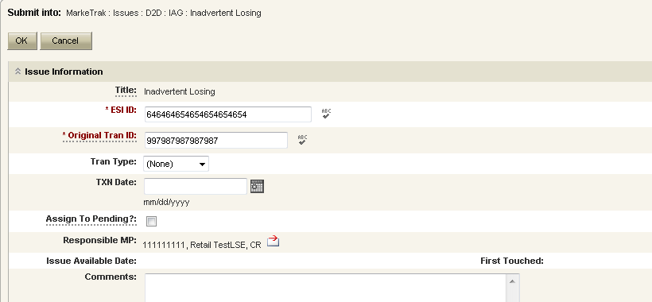
- Select OK to create the IAG – Inadvertent Losing MarkeTrak Issue. (Fig 2.1.3.3b)

- The Premise Type and Siebel Status/Sub-status are now populated on the issue and it enters ERCOT’s queue in a state of New and is visible only by the Submitting CR and ERCOT.

Fig 2.1.3.1b

- The Submitting CR has the option to Withdraw the issue at this point. (Fig 2.1.3.1d)

Fig 2.1.3.1d

- ERCOT will select Begin Working to provide the Gaining CR Start Date, if the Gaining CR is still the rep of record (Gaining CR ROR), assign CR2 (Gaining CR) and TDSP. ERCOT will then select “OK” to move the issue to CR2 (Gaining CR).

NOTE: If the Gaining CR ROR field is NO then the Gaining CR is not the current rep of record at the time the IAG was submitted. The service order is still pending and the date provided in the Gaining CR Start Date field is the requested MVI date or the Scheduled meter read date. ERCOT will indicate in comments when this scenario happens and that the order may not complete for this date. The Losing CR and Gaining CR should take this into consideration when proposing the regain date.

- At this point, the Submitting CR can no longer Withdraw the issue.

NOTE: After the initial Begin Working is selected and Withdraw is not available or the issue is not in a Regaining Transaction Submitted (PC), Unexecutable (PC), or Complete state, if the submitting MP feels a resolution is no longer needed, the “Close button can be selected (Fig 2.1.3.3c). Comments will be required with this transition. All work will stop on the issue at this point.

Fig 2.1.3.3c

- CR2 (Gaining CR) will select Begin Working and investigate the Inadvertent Gain issue details to determine if CR1 (Losing/Original CR) should regain ESI ID as of their date of loss. (Fig 2.1.3.3d)

Fig 2.1.3.3d
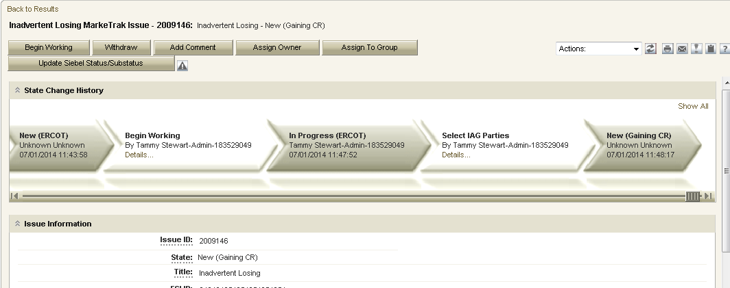

- If CR2 (Gaining CR) determines that additional information is needed from the Losing CR before a decision can be made, the Gaining CR they will select ‘Send To Losing CR’ and enter comments when prompted. (Fig 2.1.3.3e/f).

Fig 2.1.3.3e

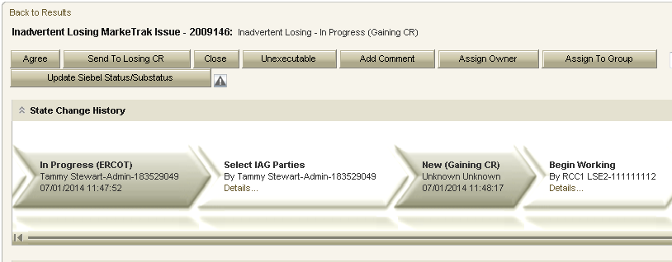

Fig 2.1.3.3f

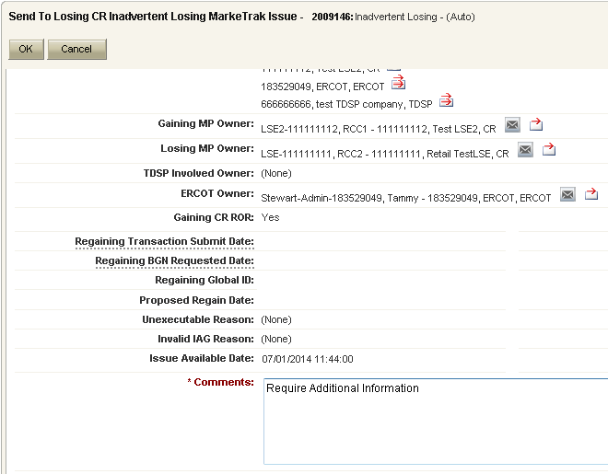

- The MarkeTrak issue transitions back to the Losing CR in a state of ‘New (Losing CR)’. The Losing CR selects ‘Begin Working’ and the issue transitions to ‘In Progress (Losing CR)’. (Fig 2.1.3.3g)
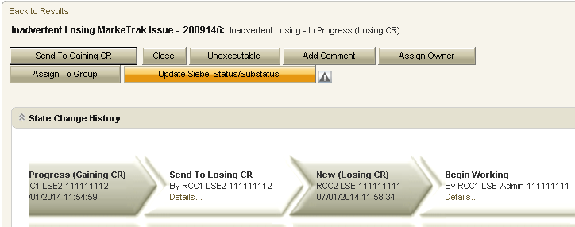

- The Losing CR provides the additional information requested by the Gaining CR and selects ‘Send to Gaining CR’. NOTE: Because the ‘Agree’ transition was not executed by the Gaining CR, the issue CANNOT be transitioned to the TDSP. The ‘Send To TDSP’ transition is only available if the ‘Agree’ transition has been executed.
- The issue transitions back to the Gaining CR in a state of ‘New (Gaining CR)’. The Gaining CR selects ‘Begin Working’ and the issue transitions to a state of ‘In Progress (Gaining CR)’..
- The Gaining CR reviews the information and, if in agreement with the Inadvertent Loss, selects the ‘Agree’ transition. The issue transitions back to the Losing CR in a state of ‘New (Losing CR)’.
- The Losing CR selects ‘Begin Working’ and the issue is once again in a state of ‘In Progress (Losing CR)’. The ‘Send To TDSP’ transition is now available. The Losing CR selects ‘Send To TDSP’, provides the required information, and the issue transitions to a state of ‘New (TDSP)’. (Fig. 2.1.3.3h)

Fig 2.1.3.3h

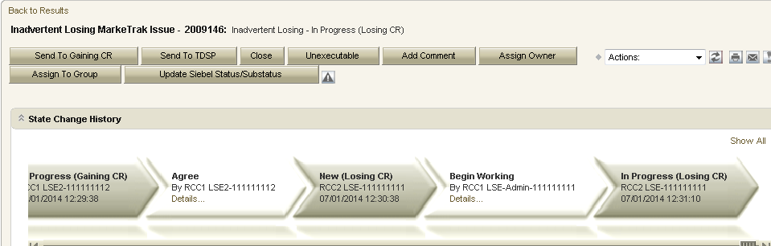

- Example: CR Submits Inadvertent Gain as the Gaining CR

- Select “Submit to my Preferred Projects” under Basic Tasks under the Submit Icon. (for this example, the Submitter is the CR1 (Gaining CR))
- From the Submit Tree select the IAG – Inadvertent Gaining sub-type (Fig 2.1.3.4a)

Fig 2.1.3.4a
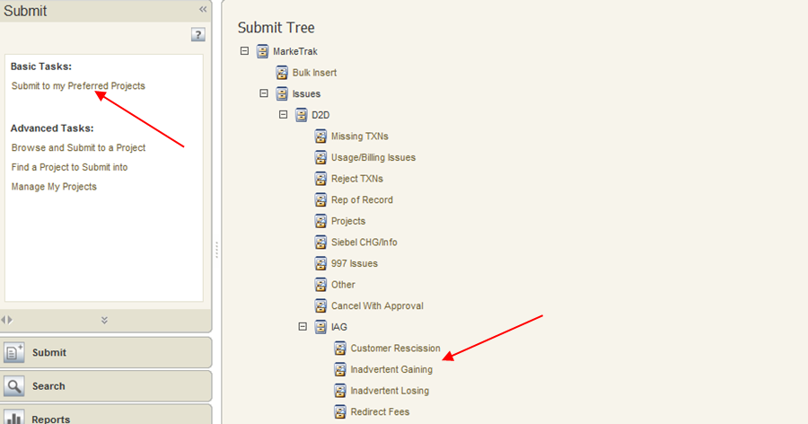

- CR1 (Gaining CR) will enter all required information:
ESIID
Original Tran ID - The original tran id of the Gaining CR’s enrollment. (BGN02 of the 814_01/814_16).

- Select "OK" to create the Inadvertent Gain MarkeTrak Issue. (Fig 2.1.3.4b)

Fig 2.1.3.4b
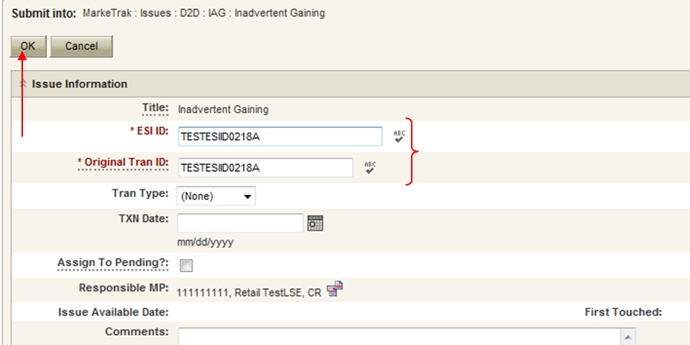

- By selecting OK, the Premise Type and Siebel Status/Sub-status will be populated on the issue and it enters ERCOT’s queue in a state of New (ERCOT) and is visible only by the Submitting CR and ERCOT. (Fig 2.1.3.4c)

Fig 2.1.3.4c
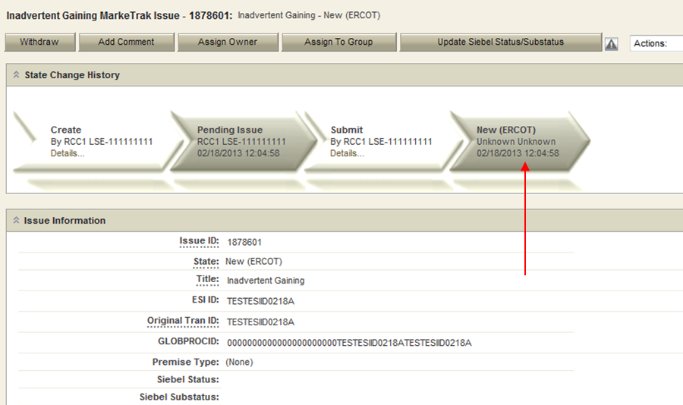

- The Submitting CR has the option to Withdraw the issue at this point. (Fig 2.1.3.4d)

Fig 2.1.3.4d
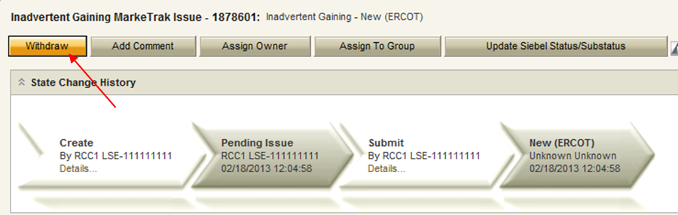

- ERCOT will select Begin Working and provide the Gaining CR Start Date, if the Gaining CR is still the rep of record (Gaining CR ROR), to assign CR2 (Losing/Original CR) and TDSP. ERCOT will then select “OK” to move the issue to CR2 (Losing/Original CR).

NOTE: If the Gaining CR ROR field is NO then the Gaining CR is not the current rep of record at the time the IAG was submitted. The service order is still pending and the date provided in the Gaining CR Start Date field is the requested MVI date or the Scheduled meter read date. ERCOT will indicate in comments when this scenario happens and that the order may not complete for this date. The Losing CR and Gaining CR should take this into consideration when proposing the regain date.

- At this point, the Submitting CR can no longer Withdraw the issue.

NOTE: After the initial Begin Working is selected and the Withdraw is not available or the issue is not in a Regaining Transaction Submitted (PC), Unexecutable (PC), or Complete state, if the submitting MP feels a resolution is no longer needed the Close button can be selected. Comments will be required with this transition. All work will stop on the issue at this point.

- CR2 (Losing/Original CR) will select Begin Working and Issue details and Investigate Market Conditions to determine the appropriate regain date. (Fig 2.1.3.4e)

Fig 2.1.3.4e
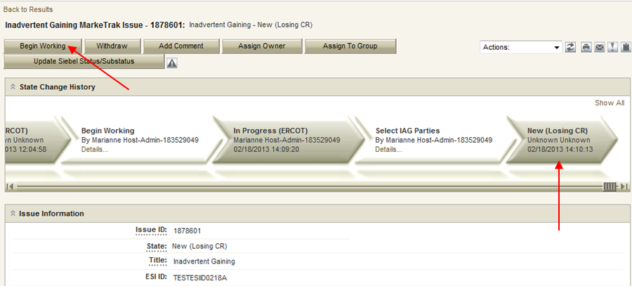

- If CR2 (Losing/Original CR) determines that an Inadvertent Gain has NOT taken place, they have the option to select Unexecutable.

NOTE: Before selecting the Unexecutable Transition, as a courtesy please contact the CR to state reason for choosing Unexecutable. Once selected, this stops the Inadvertent Gain process. Invalid IAG Reason is required, enter one of the following: (Fig 2.1.3.4f)

Valid Reject Reasons are described in the RMG Section 7.3.2.4(2) and are as follows:
3rd party CR involved
Authorized Enrollment Confirmed
Duplicate Issue
Other (should require comments)

NOTE: Unexecutable ends the ability to do any other work on the issue. Also when an issue has been Closed by Submitter the Reject Reason and the Invalid IAG reason will show as None. No further action can be taken.

Fig 2.1.3.4f
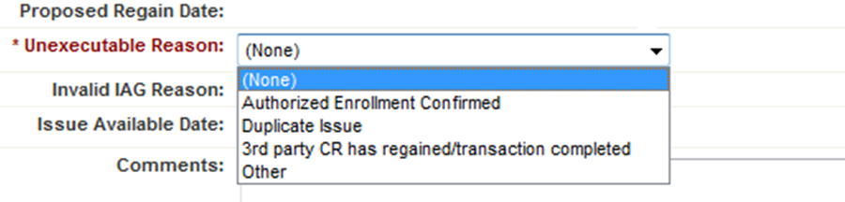

- If CR2 (Losing/Original CR) determines they will need more information from CR2 (Gaining CR), then they will need to select Send to Gaining CR. This transition allows both CR’s to talk back and forth while transitioning the issue back and forth before a resolution is made.
- If CR2 (Losing/Original CR) determines that an Inadvertent Gain has taken place, they will select Send to TDSP, enter the proposed regain date, add comments and select “OK” to move the issue to the TDSP. (Fig 2.1.3.4g)
NOTE: The Reinstatement date shall be a day beyond the date of loss or any subsequent date chosen by the Losing/Original CR but no greater than 10 days past the date of the MarkeTrak issue was logged.

Fig 2.1.3.4g
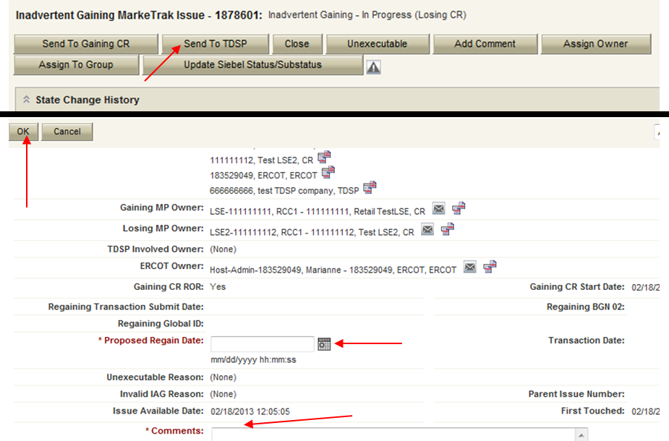

- The TDSP will select Begin Working, investigate the issue details, then select one of the following: (Fig 2.1.3.4h)

- Ready to Receive to send the issue back to CR2 (Losing/Original CR).

NOTE: It is extremely important that CR2 (Losing/Original CR) wait for the TDSP to select Ready to Receive indicating TDSP’s systems have been prepared to receive the Original MP’s transaction before the EDI is actually sent. If not, the EDI will be rejected at the TDSP.

- Send To Submitting CR – The TDSP would select this transition if they needed further information from CR2 (Losing/Original CR).
- Request Updated Proposed Regain Date – The TDSP would select this transition if they do not agree with the proposed regain date that was provided. They would suggest a new date and send the issue back to CR2 (Losing/Original CR).

Fig 2.1.3.4h
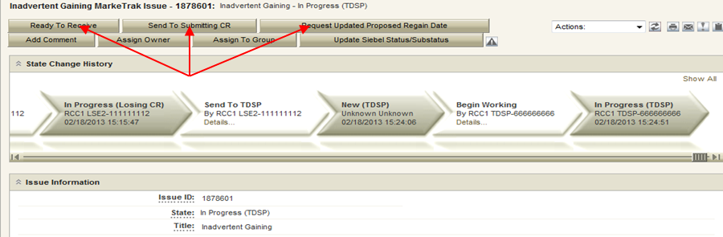

- CR2 (Losing/Original CR) will select Begin Working, then select Provide Regaining BGN 02. CR2 (Losing/Original CR) will provide the Regaining BGN02 then select ‘OK’. (Fig 2.1.3.4i) When the regaining transaction processes into ERCOT’s registration system, the Regaining Transaction Submit Date, Regaining BGN Requested Date and Regaining BGN Priority Code will be auto-populated to the MarkeTrak issue.

NOTE: Once the Regaining BGN02 field is populated, the issue will appear to be in the Regaining Transaction Submitted (PC) state. At this point in the process, the Losing CR should NOT click the Send to TDSP transition with the intent of the TDSP closing the issue. This will prevent the issue from Auto-completion.

Fig 2.1.3.4i
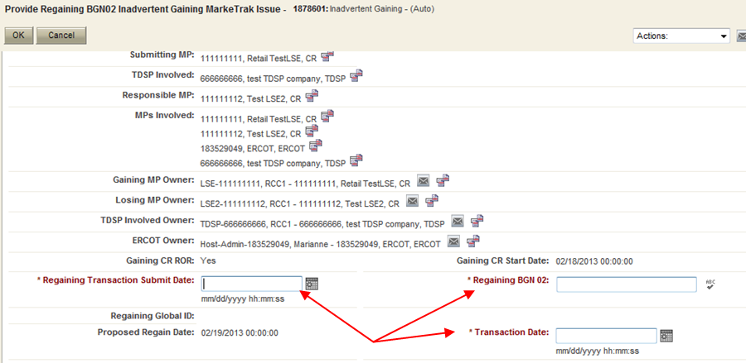

- All parties should continue to monitor MIS and internal systems for the successful delivery and completion of the EDI transaction being sent by CR2 (Losing/Original CR) to the Market to regain a premise and resolve the associated Inadvertent Gain MarkeTrak issue.

- Once the regaining transaction has been successfully sent to the Market by CR2 (Losing/Original CR), Siebel Will Automatically:
- Check Regaining Transaction Siebel Status every 30 minutes using the BGN 02 from the new initiating transaction
- Update the issue with the current Regaining Transaction Siebel Status
- Assign the state of Complete with the Submitting MP as the Responsible Party once the Regaining Transaction Siebel Status is Complete.
- Issues remaining in a state of ‘Regaining Transaction Submitted (PC)’ for 14 calendar days will be transitioned by MarkeTrak to a state of ‘New (Losing CR Re-Submit)’ with the following comment: “Regaining Transaction has been idle for too long. Please review and re-submit transaction.”

NOTE – Auto Close Transition If an IAG issue (either type) is in New (Losing CR submit) or In Progress (Submit Regaining) and remains unmodified for 20 days the issue will Auto Close and transition to a state of Closed – Inactive

2.1.4 Submitting a Customer Rescission Issue
Per the Retail Market Guide Section 7.3.5, only the gaining CR in a rescission scenario may utilize the rescission-based MarkeTrak process to initiate reinstatement of a customer to its original CR. If, upon contact with the customer, the gaining CR receives or has received a valid rescission per PUC Rule 25.474(j), the gaining CR should proceed with submission through the Customer Rescission subtype.
In order for an issue to be submitted through this subtype, it must be submitted on or before the twenty-fifth (25th) calendar day following ERCOT’s established First Available Switch Date (FASD). Should a matter of rescission need to be resolved, but a Customer Rescission issue has not been submitted for this purpose within the specified timeframe, the two CRs should work to resolve this issue through the Inadvertent Gaining subtype as outlined in Section 2.1.3.2.
The submitter should include any details, (ex. customer name), which may expedite resolution of the issue.

- Main Success Scenario:

Gaining CR submits issue, Losing CR agrees to regain, Losing CR submits BDMI, reinstates ESIID one day following DOL

- Select “Submit to my Preferred Projects” under Basic Tasks under the Submit Icon. (for this example, the Submitter is the CR1 (Gaining CR))
- From the Submit Tree select “Customer Rescission” sub-type (Fig 2.1.4.1a)

Fig 2.1.4.1a
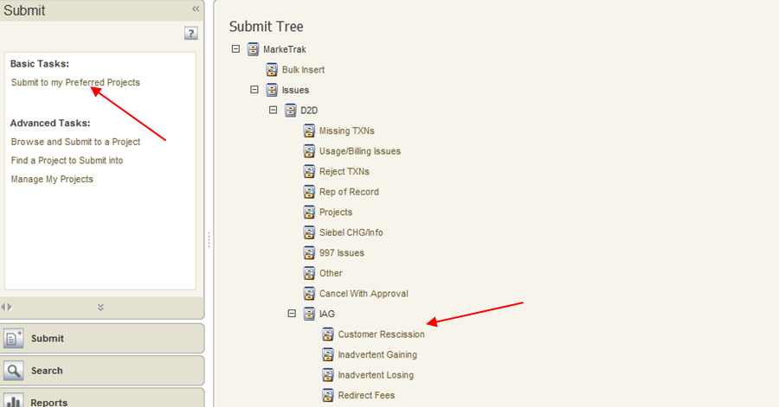

- Gaining CR populates Comments (optional), Original Tran ID, ESIID, and selects OK (Fig 2.1.4.1b)

Fig 2.1.4.1b
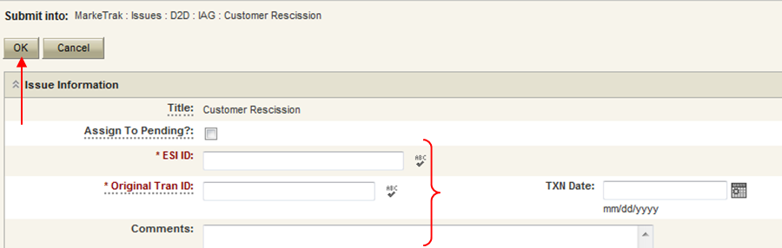

- ERCOT validates ESIID, submission timeframe and valid originating transaction.
- Once validation is complete, MarkeTrak Issue is created and ERCOT updates the issue with the following information:
- Losing CR Name and Duns
- TDSP Name and Duns
- Gaining CR ROR = Y or N
- Gaining CR Start Date
- Regain Date – auto populated by ERCOT. Calculation is Gaining CR Start Date plus 1 calendar day.
- MarkeTrak issue is assigned to the state of New (Losing CR) with the Losing CR as the Responsible Party. NOTE: Upon receiving the Customer Rescission MarkeTrak issue, the Losing CR shall agree to the Customer Rescission MarkeTrak issue within two Business Days unless a valid reason for rejecting a rescission-based issue under Section 7.3.5.1, Additional Valid Reasons for Rejection of a Rescission-based Issue, is met.
- Losing CR user selects Begin Working (Fig 2.1.4.1c)

Fig 2.1.4.1c
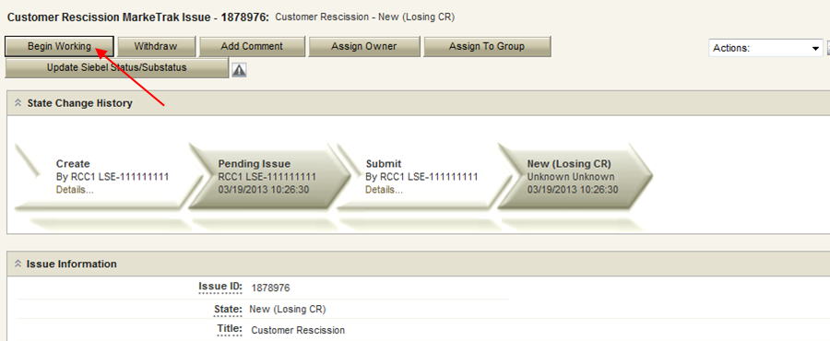

- MarkeTrak issue is assigned to the state of In Progress (Losing CR) with the Losing CR as the Responsible Party
- Losing CR selects Send to TDSP (Fig 2.1.4.1d)

Fig 2.1.4.1d
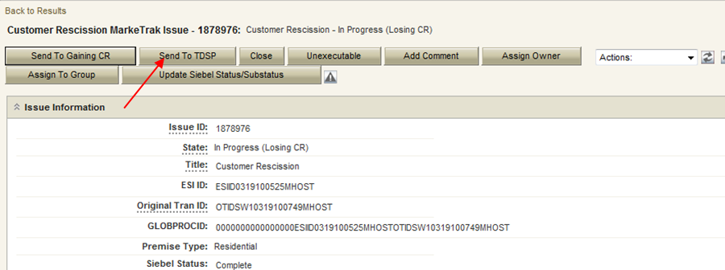

- Losing CR adds Comments then selects OK (Fig 2.1.4.1e)

Fig 2.1.4.1e
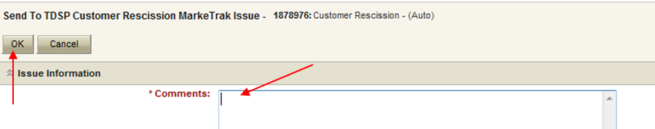

- Issue is in a state of New (TDSP) with TDSP as Responsible MP
- TDSP selects Begin Working
- Issue is in a state of In Progress (TDSP) with TDSP as Responsible MP
- TDSP selects Ready to Receive (Fig 2.1.4.1f)

Fig 2.1.4.1f
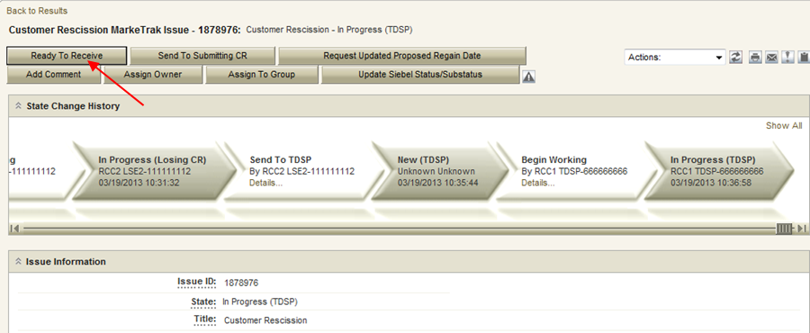

- Issue is in a state of New (Losing CR Submit) with the Losing CR as Responsible MP.
- Losing CR selects Begin Working
- Issue is in a state of In Progress (Submit Regaining) with the Losing CR as Responsible MP
- Losing CR selects Provide Regaining BGN02 (Fig 2.1.4.1g)

Fig 2.1.4.1g
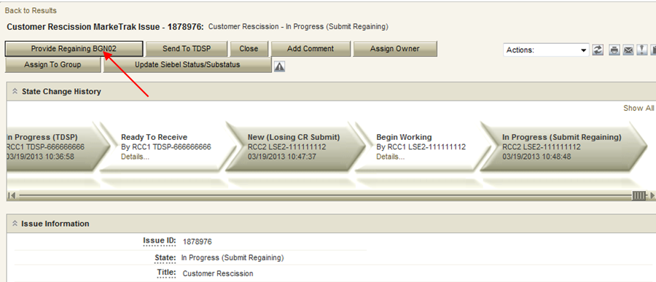

Losing CR populates required information and select OK

- Issue is in a state of Regaining Transaction Submitted (PC) with the Gaining (Submitting CR) as Responsible MP
- Once the regaining transaction has been successfully sent to the Market by (Losing/Original CR), Siebel will automatically:
- Check Regaining Transaction Siebel Status every 30 minutes using the BGN 02 from the new initiating transaction
- Update the issue with the current Regaining Transaction Siebel Status
- The issue will move to a state of Complete with the Submitting MP as the Responsible Party once the Regaining Transaction Siebel Status is Complete.
- Issues remaining in a state of ‘Regaining Transaction Submitted (PC)’ for 5 calendar days will be transitioned by MarkeTrak to ‘New (Losing CR Re-Submit)’ with the following comment: “Regaining Transaction has been idle for too long. Please review and re-submit transaction.”

- Example: CR Submits Customer Rescission Issue Outside Allowed Timeframe, or for a BGN which was not an 814_01 transaction.

If the user attempts to submit an ESIID/BGN combination where the originating transaction is outside the 25 calendar day window, or is not an 814_01, MarkeTrak will not allow the issue to proceed. The user may either cancel the submission, or enter a valid ESIID/BGN combination and attempt to proceed.

Extension Scenario: Gaining CR attempts to submit issue, ERCOT displays error message, Gaining CR enters new ESIID which passes validation, issue proceeds.

- Select “Submit to my Preferred Projects” under Basic Tasks under the Submit Icon. (for this example, the Submitter is the CR1 (Gaining CR))
- From the Submit Tree select “Customer Rescission” sub-type
- Gaining CR populates comments (optional), enters ESIID, Original Tran ID, and selects OK
- ERCOT validates ESIID, submission timeframe and originating tran type; determines ESIID/BGN did not pass validation for one of these reasons (814_01 or 25 calendar day error)
- Error message is displayed: “This issue is unable to proceed because the current REP of Record did not enroll this premise [via 814_01 or within 25 calendar days]. Please enter a different ESIID or consult the Retail Market Guide to determine the proper course of action.” (Fig 2.1.4.2a)

Fig 2.1.4.2a
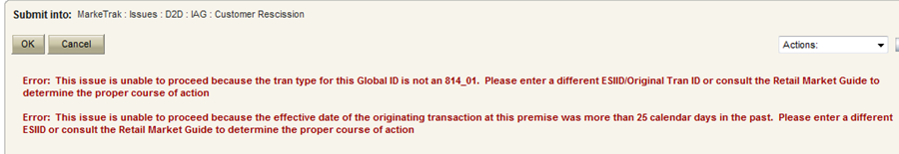

- Gaining CR enters new ESIID/Original Tran ID and clicks “OK”
- ERCOT validates submission timeframe and originating tran type.
- Validation is successful and the issue is created and follows normal Customer Rescission workflow.

- Losing CR Unexecutes MarkeTrak Customer Rescission issue

The Losing CR may choose to Unexecute the issue upon receipt. This does not automatically end the ability to do any further work within the issue; the Gaining CR may choose to accept the Unexecutable transition, or may proceed.

Extension Scenario: Gaining CR submits issue, Losing CR clicks Unexecutable, Gaining CR returns issue to Losing CR, Losing CR agrees to regain

- Select “Submit to my Preferred Projects” under Basic Tasks under the Submit Icon. (for this example, the Submitter is the CR1 (Gaining CR))
- From the Submit Tree select “Customer Rescission” sub-type (Fig 2.1.4.3a)

Fig 2.1.4.3a

- Gaining CR populates Comments (optional), Original Tran ID, ESIID, and selects OK (Fig 2.1.4.3b)

Fig 2.1.4.3b

- ERCOT validates ESIID, submission timeframe and valid originating transaction.
- Once validation is complete, MarkeTrak Issue is created and ERCOT updates the issue with the following information:
- Losing CR Name and Duns
- TDSP Name and Duns
- Gaining CR ROR = Y or N
- Gaining CR Start Date
- Regain Date – auto populated by ERCOT. Calculation is Gaining CR Start Date plus 1 calendar day.
- MarkeTrak issue is assigned to the state of New (Losing CR) with the Losing CR as the Responsible Party
- Losing CR user selects Begin Working (Fig 2.1.4.3c)

Fig 2.1.4.3c

- MarkeTrak issue is assigned to the state of In Progress (Losing CR) with the Losing CR as the Responsible Party
- Losing CR selects Unexecutable and enters required comments (Fig 2.1.4.3d)
- Examples of valid reject reasons include third party enrollment where evaluation has already occurred, or duplicate issue (Fig 2.1.4.3e)

Fig 2.1.4.3d
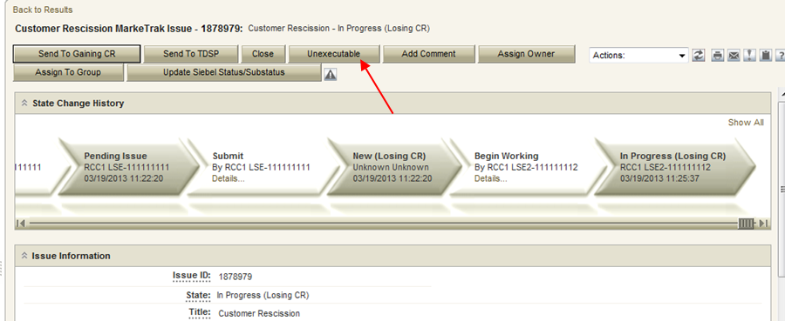

Fig 2.1.4.3e
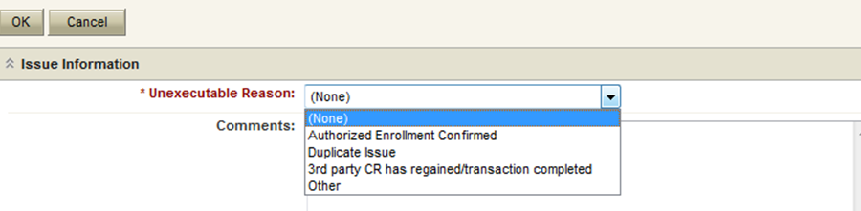

- Issue is in a state of Unexecutable (PC) with Gaining CR as Responsible MP
- Gaining CR selects Return to Losing CR and enters required comments. (Fig 2.1.4.3f)
- Gaining CR may choose Accept transition to close issue (Fig 2.1.4.3f)

Fig 2.1.4.3f
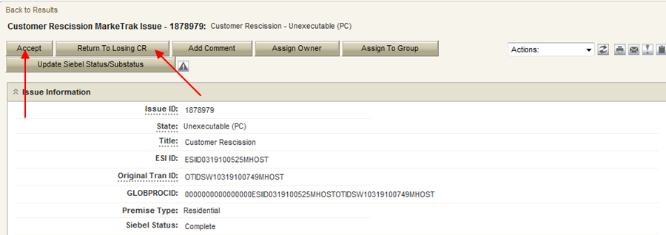

- Issue is in a state of New (Losing CR) with the Losing CR as Responsible MP.
- Losing CR selects Begin Working
- Issue is in a state of In Progress (Losing CR) with the Losing CR as Responsible MP
- Losing CR selects Send to TDSP (Fig 2.1.4.3g)

Fig 2.1.4.3g

- Issue is in a state of New (TDSP) with TDSP as Responsible MP
- TDSP selects Begin Working
- Issue is in a state of In Progress (TDSP) with TDSP as Responsible MP
- TDSP selects Ready to Receive (Fig 2.1.4.3h)

Fig 2.1.4.3h

- Issue is in a state of New (Losing CR Submit) with the Losing CR as Responsible MP.
- Losing CR selects Begin Working
- Issue is in a state of In Progress (Submit Regaining) with the Losing CR as Responsible MP
- Losing CR selects Provide Regaining BGN02 (Fig 2.1.4.3i)

Fig 2.1.4.3i

Losing CR populates all required information and selects OK

- Issue is in a state of Regaining Transaction Submitted (PC) with the Gaining (Submitting CR) as Responsible MP
- Once the regaining transaction has been successfully sent to the Market by (Losing/Original CR), Siebel will automatically:
- Check Regaining Transaction Siebel Status every 30 minutes using the BGN 02 from the new initiating transaction
- Update the issue with the current Regaining Transaction Siebel Status
- The issue will move to a state of Complete with the Submitting MP as the Responsible Party once the Regaining Transaction Siebel Status is Complete.
- Issues remaining in a state of ‘Regaining Transaction Submitted (PC)’ for 5 calendar days will be transitioned by MarkeTrak to ‘New (Losing CR Re-Submit)’ with the following comment: “Regaining Transaction has been idle for too long. Please review and re-submit transaction.”

2.1.5 Redirect Fees Subtype
During instances where an inadvertent gain causes a lights-out scenario (due to Move-out or disconnect for non-pay), the Losing CR must use the Redirect Fees subtype to request that charges associated with the IAG are directed to the Gaining CR and the MarkeTrak must be submitted within three Retail Business Days following receipt of the 810_02 TDSP invoice containing discretionary fees as a result of the Inadvertent Gain. If the lights-out scenario occurs while an existing IAG issue is underway, the Losing CR must still create a separate issue under this subtype, and “item link” the existing IAG issue. If the gaining CR agrees that an inadvertent gain has occurred, including agreement within a related inadvertent gain issue, then the gaining CR shall agree to the losing CR’s Redirect Fees MarkeTrak issue and shall not dispute any of the valid TDSP fees associated with returning the ESI ID to the losing CR.

The submitter should include any details, (ex. customer name), which may expedite resolution of the issue.

- Main Success Scenario: Losing CR creates issue, Gaining CR agrees, TDSP confirms reversal of fees.

  - Select “Submit to my Preferred Projects” under Basic Tasks under the Submit Icon. (for this example, the Submitter is the CR1 (Losing/Original CR))
  - From the Submit Tree, select IAG – Redirect Fees (Fig 2.1.5.1a)

Fig 2.1.5.1a
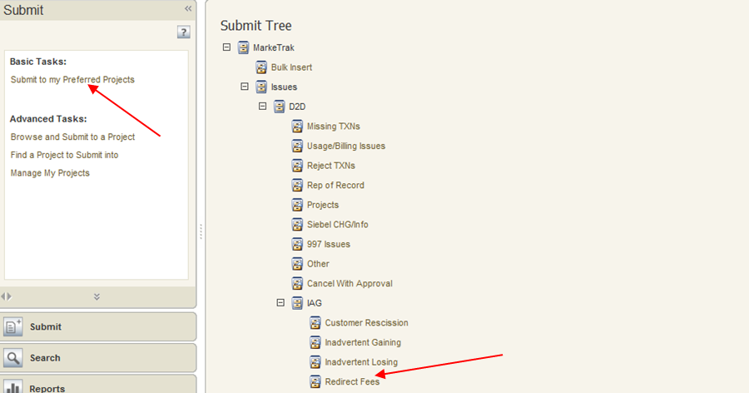

  - Losing CR populates all required information and select OK (Fig 2.1.5.1b)
ESIID
Original Tran ID
Priority BGN02
PMVI Requested Date

Fig 2.1.5.1b
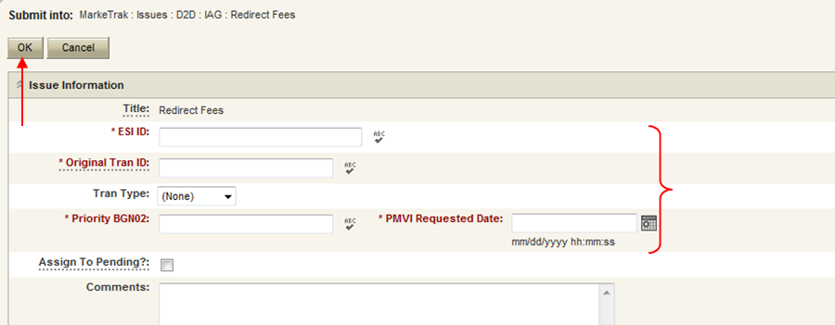

  - User selects OK to create the issue
  - Premise Type is populated
  - MarkeTrak Issue is created and ERCOT provides applicable information
  - MarkeTrak issue is assigned to the state of New (Gaining CR) with the Gaining CR as the Responsible Party
  - Gaining CR selects Begin Working
  - MarkeTrak issue is assigned to the state of In Progress (Gaining CR) with the Gaining CR as the Responsible Party
  - Gaining CR selects Agree (Fig 2.1.5.1c)

Fig 2.1.5.1c
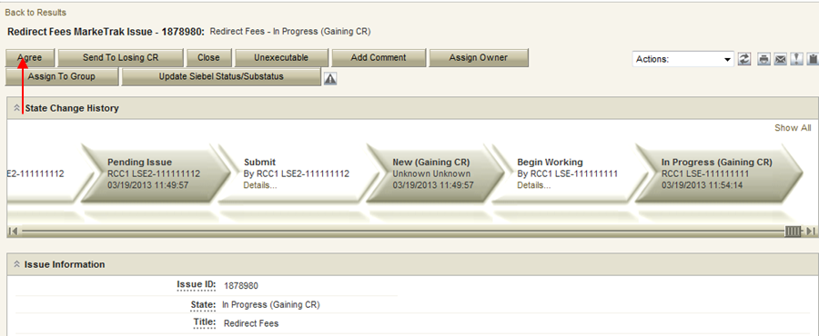

  - The issue is in a state of New (TDSP) with the TDSP as Responsible MP
  - The TDSP selects Begin Working
  - The issue is now in a state of In Progress (TDSP) with the TDSP as Responsible MP
  - The TDSP selects Redirect Fees (Fig 2.1.5.1d)

Fig 2.1.5.1d
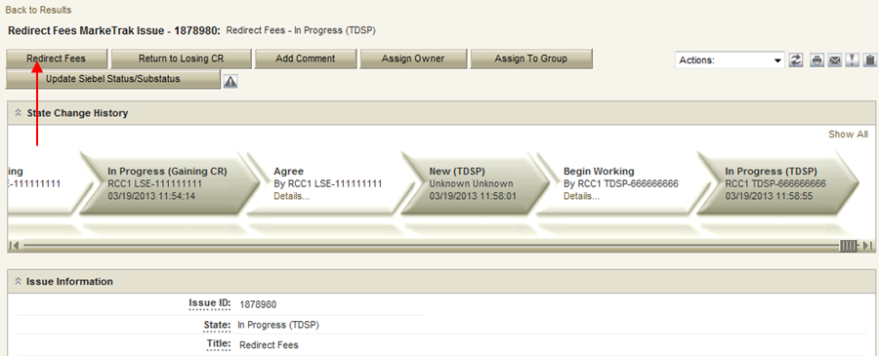

  - Issue is in a state of Regaining Transaction Submitted (PC) with the Losing CR as Responsible MP
  - Once the regaining transaction has been successfully sent to the Market by (Losing/Original CR), Siebel will automatically:
      - Check Regaining Transaction Siebel Status every 30 minutes using the BGN 02 from the new initiating transaction
      - Update the issue with the current Regaining Transaction Siebel Status
      - Assign the state of Complete with the Submitting MP as the Responsible Party once the Regaining Transaction Siebel Status is Complete.

- Extension Scenario: Losing CR creates issue, Gaining CR agrees, TDSP chooses “Send to Losing CR”, Losing CR closes issue

- Select “Submit to my Preferred Projects” under Basic Tasks under the Submit Icon. (for this example, the Submitter is the CR1 (Losing/Original CR))
- From the Submit Tree, select IAG – Redirect Fees (Fig 2.1.5.2a)

Fig 2.1.5.2a

- Losing CR populates all required information and selects OK (Fig 2.1.5.2b)
ESIID
Original Tran ID
Priority BGN02
PMVI Requested Date

Fig 2.1.5.2b

- User selects OK to create the issue
- Premise Type is populated
- MarkeTrak Issue is created and ERCOT provides applicable information
- MarkeTrak issue is assigned to the state of New (Gaining CR) with the Gaining CR as the Responsible Party
- Gaining CR selects Begin Working
- MarkeTrak issue is assigned to the state of In Progress (Gaining CR) with the Gaining CR as the Responsible Party
- Gaining CR selects Agree (Fig 2.1.5.2c)
Fig 2.1.5.2c

- The issue is in a state of New (TDSP) with the TDSP as Responsible MP
- The TDSP selects Begin Working
- The issue is now in a state of In Progress (TDSP) with the TDSP as Responsible MP
- The TDSP selects Return to Losing CR (Fig 2.1.2.2d)

NOTE: Comments required for this transition.

Fig 2.1.2.2d
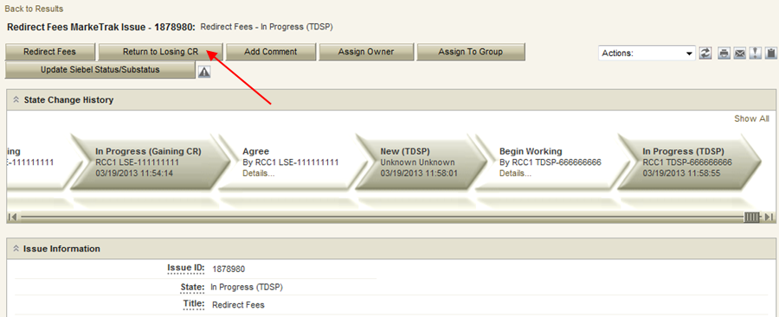

- Issue is in a state of Return to Losing CR (PC) with the Losing CR as Responsible MP
- Losing CR selects the Accept transition. (Fig 2.1.5.2e) Issue is now closed.

Fig 2.1.5.2e
