October 2019 ERCOT Monthly Operations Report
Reliability and Operations Subcommittee Meeting
Dec 5, 2019

Table of Contents
1. Report Highlights 2
2. Frequency Control 3
2.1. Frequency Events 3
2.2. Responsive Reserve Events 4
2.3. Load Resource Events 4
3. Reliability Unit Commitment 4
4. Wind Generation as a Percent of Load 5
5. Largest Net-Load Ramp 5
6. COP Error Analysis 6
7. Congestion Analysis 8
7.1. Notable Constraints 8
7.2. Generic Transmission Constraint Congestion 16
7.3. Manual Overrides 16
7.4. Congestion Costs for Calendar Year 2019 16
8. System Events 17
8.1. ERCOT Peak Load 17
8.2. Load Shed Events 17
8.3. Stability Events 17
8.4. Notable PMU Events 18
8.5. DC Tie Curtailment 18
8.6. TRE/DOE Reportable Events 18
8.7. New/Updated Constraint Management Plans 18
8.8. New/Modified/Removed RAS 18
8.9. New Procedures/Forms/Operating Bulletins 18
9. Emergency Conditions 18
9.1. OCNs 18
9.2. Advisories 18
9.3. Watches 18
9.4. Emergency Notices 19
10. Application Performance 19
10.1. TSAT/VSAT Performance Issues 19
10.2. Communication Issues 19
10.3. Market System Issues 19
11. Model Updates 19
Appendix A: Real-Time Constraints 22

Report Highlights
- The unofficial ERCOT peak was 65,197 MW.
- There were 3 frequency events.
- There were 2 instances where Responsive Reserves were deployed.
- There were 7 RUC commitments.
- Congestion in the West Load Zone (LZ) can be mostly attributed to planned outages. Congestion in the South LZ was mostly due to planned outages and high wind generation in the area. Congestion in the North and Houston LZs was mostly due to planned outages. There were 27 days of congestion on the Panhandle GTC, 20 days on the Tredwell GTC, 5 days on the Raymondivlle – Rio Hondo GTC and 1 day on the North Edinburg to Lobo GTC.
- There were 2 DC Tie curtailments. They were associated with DC-L and DC-R ties and both were due to unplanned outage.

Frequency Control

Frequency Events

The ERCOT Interconnection experienced four frequency events, all of which resulted from a unit trip. The average event duration was approximately 00:04:19.

A summary of the frequency events is provided below. The reported frequency events meet one of the following criteria: Delta Frequency is 60 mHz or greater; the MW loss is 350 MW or greater; resource trip event triggered RRS deployment. Frequency events that have been identified as Frequency Measurable Events (FME) for purposes of BAL-001-TRE-1 analysis are highlighted in blue. When analyzing frequency events, ERCOT evaluates PMU data according to industry standards. Events with an oscillating frequency of less than 1 Hz are considered to be inter-area, while higher frequencies indicate local events. Industry standards specify that damping ratio for inter-area oscillations should be 3.0% or greater. For the frequency events listed below, the ERCOT system met these standards and transitioned well after each disturbance.

Date and Time | Delta Frequency | Max/Min Frequency | Duration of Event | PMU Data |  | MW Loss | Load | Wind | Inertia
 | (Hz) | (Hz) |  | Oscillation Mode (Hz) | Damping Ratio |  | (MW) | % | (GW-s)
10/14/2019 15:31 | 0.119 | 59.896 | 0:04:25 | No PMU data available |  | 575.77 | 49,398 | 12% | 281,850
10/15/2019 1:53 | 0.073 | 59.906 | 0:04:02 | No PMU data available |  | 363.602 | 36,071 | 35% | 215,139
10/30/2019 21:29 | 0.164 | 59.841 | 0:04:31 | No PMU data available |  | 745.7 | 44,392 | 33% | 204,249

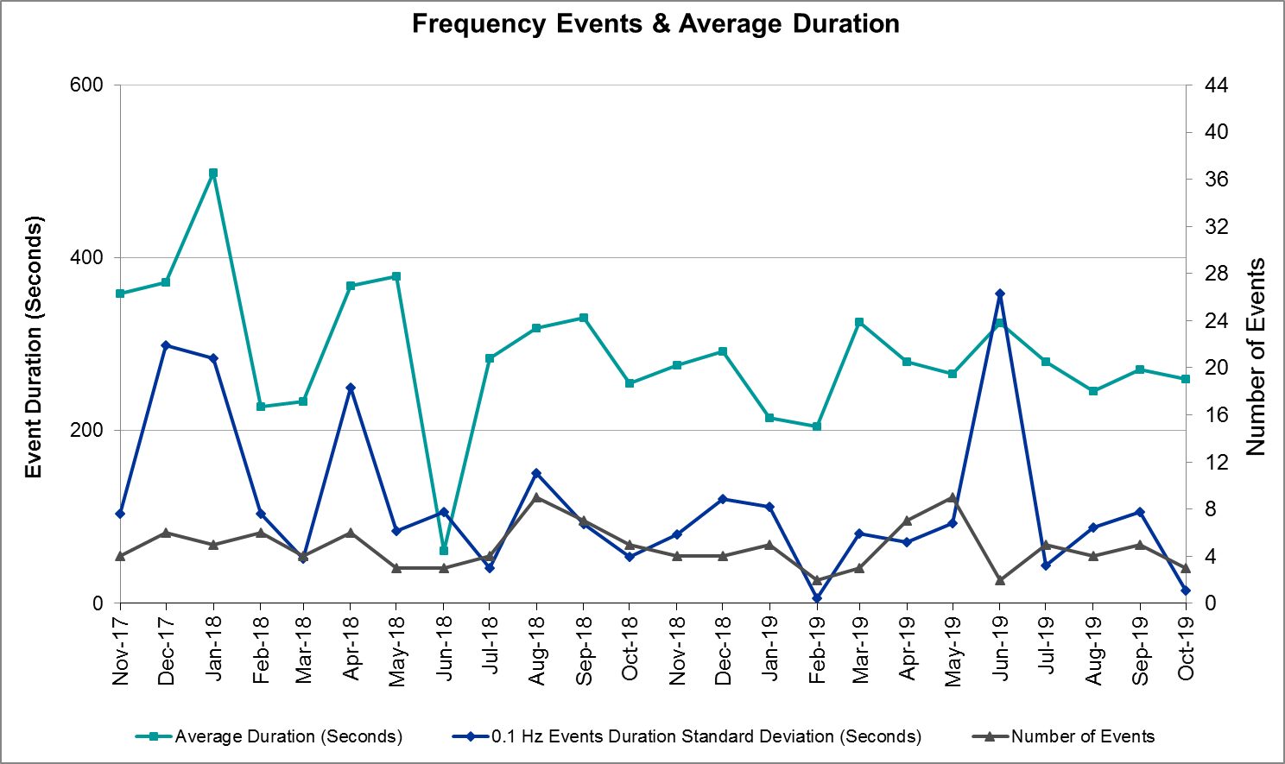 (Note: All data on this graph encompasses frequency event analysis based on BAL-001-TRE-1.)

Note that the large standard deviation in June 2019 is due to coincidental extreme high and low durations for a small set of events (2).

Responsive Reserve Events
There were two events where Responsive Reserve MWs were released to SCED. The events highlighted in blue were related to frequency events reported in Section 2.1 above.

Date and Time Released to SCED | Date and Time Recalled | Duration of Event | Maximum MWs Released | Comments
10/14/2019 15:31 | 10/14/2019 15:35 | 00:03:52 | 457
10/30/2019 21:29 | 10/30/2019 21:33 | 00:03:28 | 933

Load Resource Events
None.

Reliability Unit Commitment
ERCOT reports on Reliability Unit Commitments (RUC) on a monthly basis. Commitments are reported grouped by operating day and weather zone. The total number of hours committed is the sum of the hours for all the units in the specified region. Additional information on RUC commitments can be found on the MIS secure site at Grid Generation Reliability Unit Commitment.

There were no DRUC commitments.

There were 7 HRUC commitments.

Resource Location | # of Resources | Operating Day | Total # of Hours Committed | Total MWhs | Reason for Commitment
Far West | 1 | 10/21/2019 | 4 | 281 | SHACPB38
Far West | 2 | 10/22/2019 | 16 | 1,125 | SHACPB38
Far West | 1 | 10/23/2019 | 1 | 69 | SHACPB38
Far West | 3 | 10/25/2019 | 15 | 1,113 | SECNMO28

Wind Generation as a Percent of Load
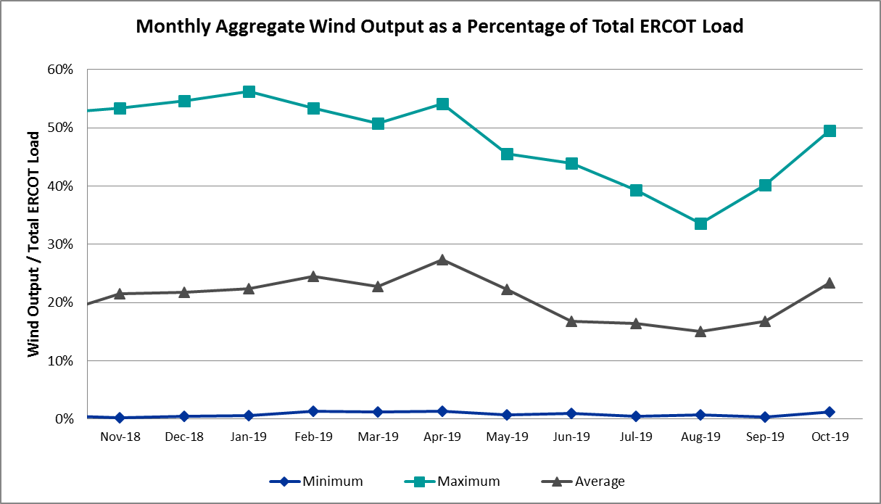

Wind Generation Record: 19,672 MW on 01/21/2019 at 19:19
Wind Penetration Record: 56.16% on 01/19/2019 03:10

Largest Net-Load Ramp
The net-load ramp is defined as the change in net-load (load minus wind and PVGR generation) during the defined time horizon. Such a variation in net-load needs to be accommodated in grid operations to ensure that the reliability of the grid is satisfactorily maintained. The largest net-load ramp during 5-min, 10-min, 15-min, 30-min and 60-min in Oct 2019 is 1192 MW, 1728 MW, 2465 MW, 3537 MW, and 6408 MW, respectively. The comparison with respect to the historical values is given in the table below.

Month and Year | 5 min | 10 min | 15 min | 30 min | 60 min
Oct 2019 | 1192 MW | 1728 MW | 2465 MW | 3537 MW | 6408 MW
Oct 2014 | 780 MW | 1796 MW | 2152 MW | 2780 MW | 4579 MW
Oct 2015 | 1141 MW | 1553 MW | 1839 MW | 2779 MW | 4606 MW
Oct 2016 | 863 MW | 1543 MW | 2035 MW | 3213 MW | 5335 MW
Oct 2017 | 812 MW | 1338 MW | 1820 MW | 3029 MW | 5347 MW
Oct 2018 | 860 MW | 1386 MW | 1907 MW | 2824 MW | 5346 MW
2014-2018 | 1494 MW | 1991 MW | 2780 MW | 4109 MW | 7218 MW

COP Error Analysis
COP Error is calculated as the capacity difference between the COP HSL and real-time HSL of the unit. Mean Absolute Error (MAE) stayed high over 7,000 MW until Day-Ahead at 12:00, then dropped significantly to 1,212 MW by Day-Ahead at 14:00. In the following chart, Under-Scheduling Error indicates that COP had less generation capacity than real-time and Over-Scheduling Error indicates that COP had more generation capacity than real-time. Under-Scheduling persisted from beginning of Day-Ahead to end of the Operating Day with the exception of eight hours. However, COP error for the Operating Hour freezes after the Adjustment Period.

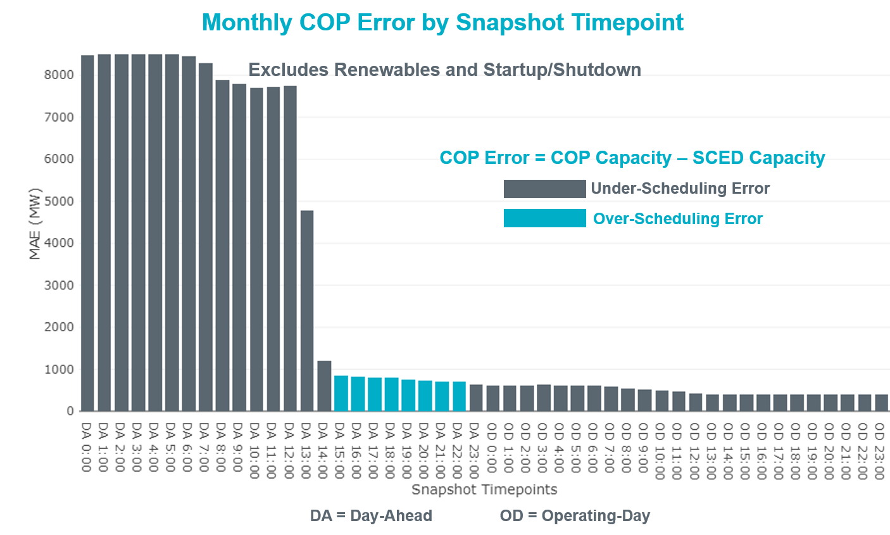

Monthly MAE for the Latest COP at the end of the Adjustment Period was 391 MW with median ranging from -411 MW for Hour-Ending (HE) 20 to 60.4 MW for HE 7. HE 14 on the 12th had the largest Over-Scheduling Error (1,318 MW) and HE 20 on the 5th had the largest Under-Scheduling Error (-3,685 MW).

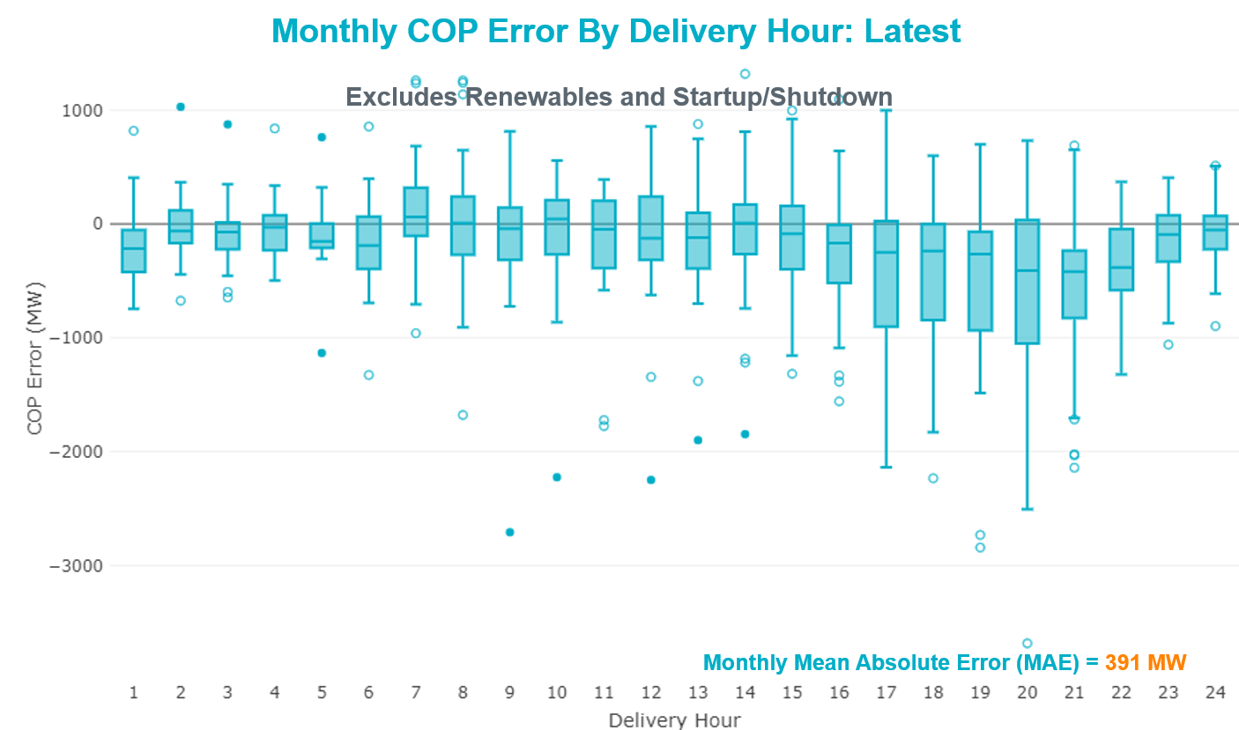

Monthly MAE for the Day-Ahead COP at 12:00 was 7,753 MW with median ranging from -11,334 MW for Hour-Ending (HE) 17 to -2,695 MW for HE 3. HE 17 on the 4th had the largest Under-Scheduling Error (-20,915 MW).

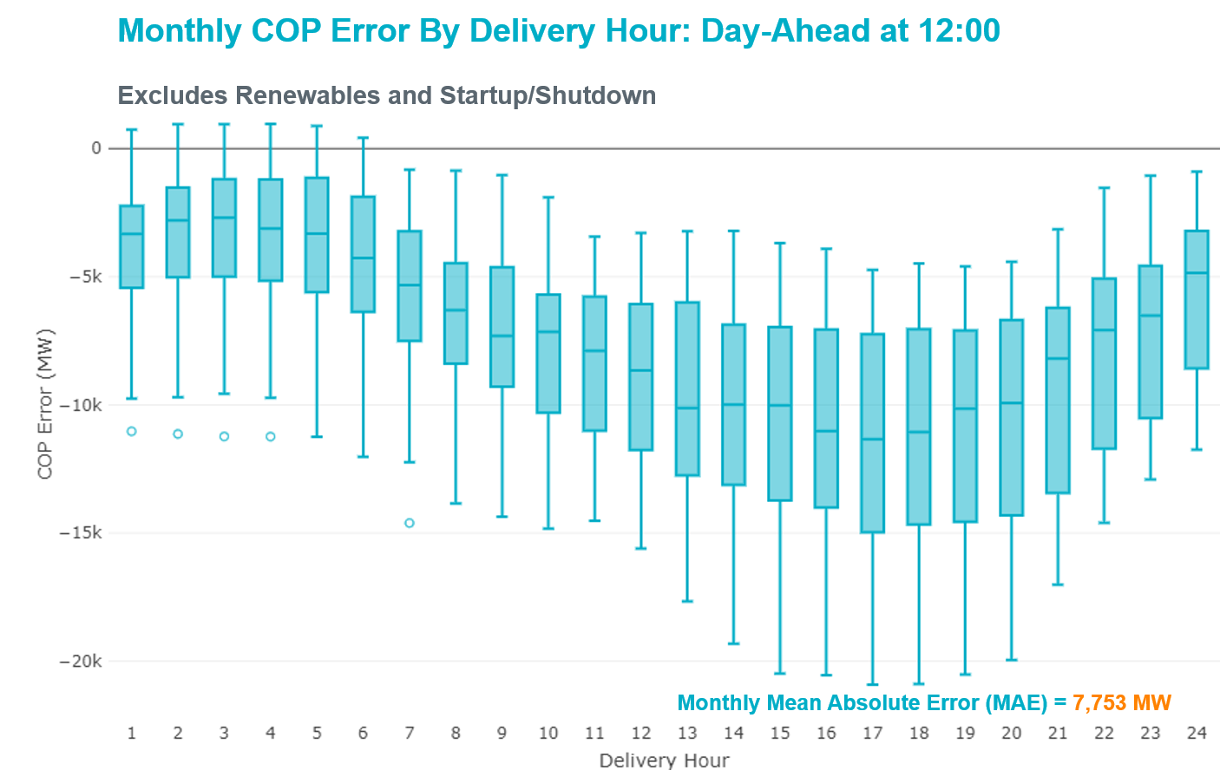

Congestion Analysis

Notable Constraints
Nodal protocol section 3.20 specifies that ERCOT shall identify transmission constraints that are active or binding three or more times within a calendar month. As part of this process, ERCOT reports congestion that meets this criterion to ROS. In addition ERCOT also highlights notable constraints that have an estimated congestion rent exceeding $1,000,000 for a calendar month. These constraints are detailed in the table below. Rows highlighted in blue indicate the congestion was affected by one or more outages. For a list of all constraints activated in SCED, please see Appendix A at the end of this report.

Contingency Name | Overloaded Element | # of Days Constraint Active | Congestion Rent | Transmission Project
MOSS SWITCH to ECTOR COUNTY NORTH SWITCHING STATION LIN _A | Dollarhide - No Trees Switch 138kV | 26 | $34,486,603.21 | Andrews County South Switch - No Trees Switch 138 kV Line (7171)
GAS PAD to FLAT TOP TNP LIN 1 | Woodward 2 - Rio Pecos 138kV | 9 | $26,410,372.57 | Lynx: Expand 138 kV station (45503)
MIDESSA SOUTH SW TRX MDSSW_1_1 345/138 | Trigas Odessa Tap - Odessa Ehv Switch 138kV | 13 | $21,809,837.71
CAGNON to KENDALL LIN 1 | Cico - Comfort 138kV | 23 | $13,426,742.40 | Boerne Cico - Comfort - Kendall Transmission Line Upgrade (6982)
WINK to DUNE SWITCH and YUKON | Dollarhide - No Trees Switch 138kV | 13 | $12,918,895.42 | Andrews County South Switch - No Trees Switch 138 kV Line (7171)
Manual LOTEBUSH toYUCSW 138 kV | Woodward 2 - Rio Pecos 138kV | 7 | $11,618,638.30 | Lynx: Expand 138 kV station (45503)
MOSS SWITCH to ECTOR COUNTY NORTH SWITCHING STATION LIN _A | Andrews County South - Amoco Three Bar Tap 138kV | 19 | $9,553,205.89 | Andrews County South Switch - No Trees Switch 138 kV Line (7171)
Basecase | PNHNDL GTC | 27 | $8,798,778.06 | LP&L Integration Tie Lines (43367 A,B,C) and Panhandle Loop
NORTH EDINBURG TRX 1382 345/138 | North Edinburg 345kV | 1 | $7,204,433.72 | North Edinburg: 345 kV Reconfigure (50878)
CRLNW-LWSSW 345kV | Jones Street Tnp - Lakepointe Tnp 138kV | 12 | $5,869,514.83 | Lewisville - Lewisville Jones - Lakepointe 138 kV Line (45537)
WINK to DUNE SWITCH and YUKON | Andrews County South - Amoco Three Bar Tap 138kV | 11 | $5,504,515.32 | Andrews County South Switch - No Trees Switch 138 kV Line (7171)
Bbses-Rchbr 345kV | Seagoville - Kleberg Tap 138kV | 8 | $4,605,002.03
ODESSA EHV SWITCH TRX ODEHV_3_1 345/138 | Odessa Ehv Switch 345kV | 9 | $3,891,691.26 | Riverton-Odessa EHV/Moss 345 kV Line (5445)
DMTSW-SCOSW 345KV | Knapp - Scurry Chevron 138kV | 12 | $3,716,987.76 | Ennis Creek - Cogdell 69 kV Line (4554) & Ennis Creek 138 kV Switching Station (6269)
Vensw-Evrsw 345kV | Fish Creek Switch - Cedar Hill Switch 138kV | 6 | $3,563,984.53
ODESSA EHV SWITCH to MOSS SWITCH LIN _A | Woodward 2 - Rio Pecos 138kV | 8 | $3,023,331.40 | Lynx: Expand 138 kV station (45503)
Hcksw-Sagna-138kv | #N/A | 3 | $2,894,409.05
CPSES-JONSW&EVRSW 345kV | Mitchell Bend Switch - Decordova Ses 345kV | 10 | $2,874,469.91
BIG SPRING SWITCH to CHALK_69kV and McDonald Road_138kV | Odessa Ehv Switch 345kV | 3 | $2,792,537.94 | Riverton-Odessa EHV/Moss 345 kV Line (5445)
YUKON SWITCH to Wink and Dune Sw | Dollarhide - No Trees Switch 138kV | 4 | $2,589,341.85 | Andrews County South Switch - No Trees Switch 138 kV Line (7171)
Fergus-Gilles & Horsba 138kV | Flat Rock Lcra - Wirtz 138kV | 3 | $2,566,722.60 | Wirtz to FlatRock to Paleface Transmission Line Upgrade (4465)
TWR (345) HLJ-WAP64 & BLY-WAP72 | Jones Creek - South Texas Project 345kV | 2 | $2,550,524.80 | Freeport Master Plan (6668A)
VICTORIA TRX 69A1 138/69 | Victoria 138kV | 12 | $2,003,436.34 | Refugio: Install 138/69 kV Auto(7172) & Airport 69 kV Substation (12TIPIT0124)
POMELO to NORTH EDINBURG LIN 1 | Lobo - Freer 69kV | 8 | $1,525,686.48 | Lobo to Freer: Rebuild 69 kV line (3901)
BIG SPRING SWITCH to CHALK_69kV and McDonald Road_138kV | Big Three Odessa Tap - Odessa Ehv Switch 138kV | 1 | $1,363,889.82
CRLNW-LWSSW 345kV | Cooper Creek Substation - Arco 138kV | 7 | $1,206,765.49 | 138kV Cooper Creek - Arco Line Reconstruction (44181)
POMELO to NORTH EDINBURG LIN 1 | North Laredo Switch - Piloncillo 138kV | 6 | $1,131,624.25
COLETO CREEK to PAWNEE SWITCHING STATION LIN 1 | Coleto Creek - Rosata Tap 138kV | 5 | $1,106,791.85 | Coleto Creek to Tuleta: New 138 kV Line (16TPIT0034)
FORT LANCASTER to ILLINOIS #4 LIN 1 | Ozona - Ozona Rea 69kV | 13 | $1,097,201.61
POMELO to NORTH EDINBURG LIN 1 | Laredo Vft North - Las Cruces 138kV | 9 | $1,073,613.47
YUKON SWITCH to Wink and Dune Sw | Amoco Three Bar Tap - Dollarhide 138kV | 1 | $1,029,514.33 | Permian Basin Area Upgrade (51245)
ODLAW SWITCHYARD to ASPHALT MINES LIN 1 | Hamilton Road - Maverick 138kV | 20 | $1,008,738.43 | Brackettville to Escondido: Construct 138 kV line (5206)
YUKON SWITCH to Wink and Dune Sw | Moss Switch - Ector Harper 138kV | 3 | $962,809.40 | Riverton-Odessa EHV/Moss 345 kV Line (5445)
Fppyd1-Lostpine 345kV | Fayette Plant 138 - La Grange 138kV | 19 | $849,867.74
CHB-KG & CBY-JOR 345kV | Langston - Mont Belvieu 138kV | 4 | $847,281.06 | HOPSON - New 138kV Substation (43245)
BIG SPRING SWITCH to CHALK_69kV and McDonald Road_138kV | Odessa Ehv Switch - Yarbrough Sub 138kV | 4 | $829,816.46
BAKERSFIELD SWITCHYARD to Big HiLL LIN 1 | Fort Stockton Plant - Solstice 138kV | 7 | $824,252.78 | Solstice: Build 345 kV station (5530)
MOSS SWITCH to ECTOR COUNTY NORTH SWITCHING STATION LIN _A | #N/A | 5 | $819,684.92
Everman to KENNEDALE &coutland | Everman Switch - Venus Switch 345kV | 5 | $792,358.43 | Everman - Venus 345 kV Double-circuit line (5310)
SAN MIGUEL 345_138 KV SWITCHYARDS to PAWNEE SWITCHING STATION LIN 1 | San Miguel Gen 138kV | 3 | $761,477.31 | San Miguel 345/138 kV autotransformer replacements (5218A, 5218B)
WOODWARD 1 TAP to WOODWARD 1 LIN 1 | Woodward 2 - Rio Pecos 138kV | 7 | $724,793.84 | Lynx: Expand 138 kV station (45503)
HAMILTON ROAD TRX PS2 138/138 | Sonora 138kV | 10 | $698,584.28 | Carver: Build new 138 kV station (5979)  Friess Ranch to Sonora: Rebuild 69 kV line (51001)  Rocksprings to Friess Ranch: Rebuild 69 kV line (51005)
WOODWARD 1 TAP to WOODWARD 1 LIN 1 | 16th Street Tnp - Woodward 2 138kV | 3 | $671,671.24 | Solstice: Build 345 kV station (5530) and Solstice to Bakersfield: Build 345 kV line (5539)
MOSS SWITCH to ECTOR COUNTY NORTH SWITCHING STATION LIN _A | Cheyenne Tap - Wink Sub 138kV | 11 | $556,069.65 | Rebuild Wink Sw. Sta. - No Trees Sw. Sta. 138 kV Line (7101)  Andrews County South Switch - No Trees Switch 138 kV Line (7171)  Add Wink to Andrews County South 138 kV Second Circuit (51236)
BOSQUE SWITCH to ELM MOTT LIN 1 | Whitney 138kV | 6 | $535,263.38
BIG SPRING SWITCH to CHALK_69kV and McDonald Road_138kV | Lamesa - Jim Payne Poi 138kV | 8 | $514,304.88
SAN MIGUEL 345_138 KV SWITCHYARDS TRX SANMGL8_3_2 345/138 | Pawnee Switching Station 345kV | 3 | $507,873.53
Pdses-Cnrsw 138kV | Prairie Creek - Scyene Road 138kV | 3 | $504,138.41 | Sargent Road 345/138 kV autotransformer (11TPIT0034)
Pig Creek to Solstice LIN 1 | Woodward 2 - Rio Pecos 138kV | 19 | $433,868.91 | Lynx: Expand 138 kV station (45503)
SAN MIGUEL 345_138 KV SWITCHYARDS TRX SANMGL8_3_2 345/138 | San Miguel Gen 345kV | 4 | $425,461.46 | San Miguel 345/138 kV autotransformer replacements (5218A, 5218B)
LOFTIN to COTTONWOOD ROAD SWITCH LIN 1 | Bowie 138kV | 26 | $406,612.75
Pig Creek to Solstice LIN 1 | Odessa Ehv Switch - Yarbrough Sub 138kV | 3 | $381,091.09
Mgses-Qalsw&Lngsw-Mdssw 345kV | Lamesa - Jim Payne Poi 138kV | 5 | $371,363.09
BIG SPRING SWITCH to CHALK_69kV and McDonald Road_138kV | Woodward 2 - Rio Pecos 138kV | 3 | $367,233.70 | Lynx: Expand 138 kV station (45503)
CHB-KG & CBY-JOR 345kV | Cedar Bayou - Cedar Bayou Plant 138kV | 3 | $335,384.04 | Baytown Area Upgrades (43284)
WOODWARD 2 GEN WOODWRD2 | Woodward 2 - Rio Pecos 138kV | 3 | $308,655.83 | Lynx: Expand 138 kV station (45503)
BOWMAN SWITCH TRX BOMSW_3_1 345/138 | Fisher Road Switch - Wichita Falls 138kV | 4 | $302,591.36
Fppyd1-Lostpine 345kV | Fayetteville - Fayette Plant 138 138kV | 17 | $299,036.58 | Fayette Area Upgrades (5286)
SAN MIGUEL 345_138 KV SWITCHYARDS to LOBO LIN 1 | North Laredo Switch - Piloncillo 138kV | 3 | $297,522.02
Basecase | TRDWEL GTC | 20 | $253,518.50
CALF CREEK POI to NATURAL DAM LIN _A | Big Spring West - Stanton East 138kV | 10 | $251,026.12
Austro-Daffin&Dunlap-Decker 138kV | Ashton Woods Aen - Howard Lane Aen 138kV | 3 | $239,425.62 | New TR-AW Ckt 1032 AW-JV Ckt 961 (4425)
Mgses-Qalsw&Lngsw-Mdssw 345kV | Polecat Creek Switch - Rebel Poi 138kV | 4 | $229,037.22
TWIN BUTTES to HARGROVE LIN 1 | Sonora 138kV | 3 | $223,845.74 | Carver: Build new 138 kV station (5979)  Friess Ranch to Sonora: Rebuild 69 kV line (51001)  Rocksprings to Friess Ranch: Rebuild 69 kV line (51005)
FORT MASON to YELLOW JACKET LIN 1 | Yellow Jacket - Hext Lcra 69kV | 16 | $208,579.39
ODLAW SWITCHYARD to ASPHALT MINES LIN 1 | Escondido - Ganso 138kV | 5 | $182,019.75 | Brackettville to Escondido: Construct 138 kV line (5206)
Solstice to FORT STOCKTON PLANT LIN 1 | Alpine - Bronco 69kV | 16 | $165,079.07
Mbdsw-Dcses&Rkcrk 345kV | Concord 345kV | 6 | $159,532.78
RIO HONDO to LAS PULGAS LIN 1 | Raymondville 2 138kV | 11 | $158,822.57 | Harlingen SS - Raymondville #2: Convert to 138 kV (6167)
Lostpi-Austro&Dunlap 345kV | Fayetteville - Fayette Plant 138 138kV | 17 | $148,624.79 | Fayette Area Upgrades (5286)
Riley-Krwsw 345kV | Bowie 138kV | 9 | $147,469.90
LAQUINTA to LOBO LIN 1 | Bruni Sub 138kV | 7 | $124,545.96
SAN MIGUEL 345_138 KV SWITCHYARDS TRX SANMGL8_3_2 345/138 | North Laredo Switch - Piloncillo 138kV | 3 | $114,396.56
SWESW-TKWSW 345KV | Tonkawa Switch - Morgan Creek Ses 345kV | 3 | $113,770.38
Bighil-Kendal 345kV | Hamilton Road - Maxwell 138kV | 10 | $109,746.32 | Brackettville to Escondido: Construct 138 kV line (5206)
EVERMAN SWITCH to ELMONT_RC SUB LIN _A | Bonham Switch 138kV | 4 | $96,179.73
LON HILL to COLETO CREEK LIN 1 | Pettus - Normanna 69kV | 4 | $92,430.95 | Borglum: Construct a new 138/69 kV station (5165)  Borglum to Three Rivers: Rebuild 69 kV line (5166)
Lostpi-Austro&Dunlap 345kV | Fayette Plant 138 - La Grange 138kV | 16 | $87,454.26
WICHITA FALLS SOUTH SWITCH to NEWPORT BEPC LIN _E | Bowie 138kV | 9 | $86,680.44
LISTON to BATES LIN 1 | Garza 138kV | 11 | $79,909.44
WINK to DUNE SWITCH and YUKON | #N/A | 3 | $79,287.13
Hecker_White_Pt 138kv | Dupont Switch - Ingleside - Rincon 138kV | 7 | $76,815.41
FRIEND RANCH to SONORA LIN 1 | Sonora 138kV | 13 | $72,188.99 | Carver: Build new 138 kV station (5979)  Friess Ranch to Sonora: Rebuild 69 kV line (51001)  Rocksprings to Friess Ranch: Rebuild 69 kV line (51005)
Fergus-Granmo&Wirtz-Starck 138kV | Flat Rock Lcra - Wirtz 138kV | 3 | $63,425.05 | Wirtz to FlatRock to Paleface Transmission Line Upgrade (4465)
DESOTO SWITCH to ENNIS SWITCH LIN _D | Ennis West Switch - Waxahachie 138kV | 5 | $62,505.40
Basecase | RV_RH GTC | 5 | $60,838.26
Cenizo-Delsol(345)&Lopeno-Zapata(138) | Asherton - Catarina 138kV | 4 | $52,077.92 | Brackettville to Escondido: Construct 138 kV line (5206)
GAS PAD to FLAT TOP TNP LIN 1 | 16th Street Tnp - Woodward 2 138kV | 5 | $51,685.47 | Solstice: Build 345 kV station (5530) and Solstice to Bakersfield: Build 345 kV line (5539)
SAM RAYBURN SWITCHING STATION to VANDERBILT SWITCHING STATION LIN 1 | Sam Rayburn Switching Station 138kV | 4 | $50,866.57
HAMILTON ROAD to Maxwell LIN 1 | Sonora 138kV | 4 | $50,494.47 | Carver: Build new 138 kV station (5979)  Friess Ranch to Sonora: Rebuild 69 kV line (51001)  Rocksprings to Friess Ranch: Rebuild 69 kV line (51005)
Bighil-Kendal 345kV | Yellow Jacket - Treadwell 138kV | 6 | $47,643.02
PH ROBINSON to MEADOW LIN A | Mainland Tnp - Alvin Tnp 138kV | 5 | $47,035.03
Cenizo-Delsol(345)&Lopeno-Zapata(138) | Lobo - Freer 69kV | 6 | $46,127.52
Cenizo-Delsol(345)&Lopeno-Zapata(138) | North Laredo Switch - Piloncillo 138kV | 4 | $31,771.65
W_CW_345-DMTSW 345kV | Liberty Rea - Lake Pauline 69kV | 5 | $30,019.86
Cenizo-Delsol(345)&Garza-Roma_Sw(138) | Garza 138kV | 3 | $29,710.63
ROMA SWITCH to GARZA LIN 1 | Garza 138kV | 5 | $28,654.90
Delsol-Pomelo (345) & Garza-Liston (138) | Lobo - Freer 69kV | 4 | $25,346.34 | Lobo to Freer: Rebuild 69 kV line (3901)
Fergus-Granmo&Wirtz-Starck 138kV | Ferguson - Sherwood Shores 138kV | 3 | $24,898.74
CAGNON TRX CAGNON_3_3 345/138 | Cagnon 345kV | 6 | $23,340.42
Hecker_White_Pt 138kv | Whitepoint - Rincon 138kV | 3 | $19,106.75 | Whitepoint Area Improvements (50950)
Solstice to LINTERNA LIN 1 | Woodward 2 - Rio Pecos 138kV | 3 | $17,983.28 | Lynx: Expand 138 kV station (45503)
Basecase | Randado Aep - Zapata 138kV | 10 | $17,655.01
Ferguson-Sherwood Shores & Ferguson-Granite Mountain 138kV | Paleface - Phillips Johnson City 138kV | 3 | $17,439.46
HAMILTON ROAD to WHITING LIN 1 | Sonora 138kV | 3 | $15,338.60 | Carver: Build new 138 kV station (5979)  Friess Ranch to Sonora: Rebuild 69 kV line (51001)  Rocksprings to Friess Ranch: Rebuild 69 kV line (51005)
YUKON SWITCH to Wink and Dune Sw | #N/A | 3 | $13,485.38
POMELO to DEL SOL LIN 1 | Lobo - Freer 69kV | 6 | $12,923.66 | Lobo to Freer: Rebuild 69 kV line (3901)
Basecase | NE_LOB GTC | 7 | $10,614.77
FRIEND RANCH TRX FMR1 138/69 | Sonora 138kV | 3 | $9,843.21 | Carver: Build new 138 kV station (5979)  Friess Ranch to Sonora: Rebuild 69 kV line (51001)  Rocksprings to Friess Ranch: Rebuild 69 kV line (51005)
HAMILTON ROAD to CORRAL LIN 1 | Hamilton Road - Maxwell 138kV | 5 | $8,454.26 | Brackettville to Escondido: Construct 138 kV line (5206)
POMELO to DEL SOL LIN 1 | North Laredo Switch - Piloncillo 138kV | 3 | $7,253.81
Cenizo-Delsol(345)&Lopeno-Zapata(138) | Asherton - Catarina 138kV | 4 | $2,105.29 | Brackettville to Escondido: Construct 138 kV line (5206)
Fppyd1-Lostpine 345kV | Bellville South - Peters 138kV | 3 | $1,602.45
Hecker_White_Pt 138kv | Dupont Switch - Ingleside - Rincon 138kV | 7 | $1,195.80

Generic Transmission Constraint Congestion
There were 27 days of congestion on the Panhandle GTC, 20 days on the Tredwell GTC, 5 days on the Raymondivlle – Rio Hondo GTC and 1 day on the North Edinburg to Lobo GTC. There was no activity on the remaining GTCs during the month.

Note: This is how many times a constraint has been activated to avoid exceeding a GTC limit, it does not imply an exceedance of the GTC occurred or that the GTC was binding.

Manual Overrides
None.

Congestion Costs for Calendar Year 2019
The following table represents the top twenty active constraints for the calendar year based on the estimated congestion rent attributed to the congestion. ERCOT updates this list on a monthly basis.

Contingency | Binding Element | # of 5-min SCED Intervals | Estimated Congestion Rent | Transmission Project
Basecase | PNHNDL GTC | 29,700 | 63,701,933.69 | LP&L Integration Tie Lines (43367 A,B,C) and Panhandle Loop
MOSS SWITCH to ECTOR COUNTY NORTH SWITCHING STATION LIN _A | Dollarhide - No Trees Switch 138kV | 3,826 | 37,064,261.82 | Andrews County South Switch - No Trees Switch 138 kV Line (7171)
MOSS SWITCH to ECTOR COUNTY NORTH SWITCHING STATION LIN _A | Andrews County South - Amoco Three Bar Tap 138kV | 3,377 | 33,911,017.76 | Andrews County South Switch - No Trees Switch 138 kV Line (7171)
GAS PAD to FLAT TOP TNP LIN 1 | Woodward 2 - Rio Pecos 138kV | 2,032 | 31,254,543.67
Hcksw-Sagna-138kv | Eagle Mountain Ses - Morris Dido 138kV | 3,036 | 28,140,366.16 | Eagle Mountain-Calmont 138 kV Line (4253)
CAGNON to KENDALL LIN 1 | Cico - Comfort 138kV | 8,246 | 27,467,121.10 | Boerne Cico - Comfort - Kendall Transmission Line Upgrade (6982)
Elmcreek-Skyline 345kV | Hill Country - Marion 345kV | 961 | 26,958,430.36 | Zorn to Marion 2nd 345-kV Transmission Line Addition (4473)
TWR (345) HLJ-WAP64 & BLY-WAP72 | Jones Creek - South Texas Project 345kV | 6,446 | 25,411,174.07 | Freeport Master Plan (6668A)
MIDESSA SOUTH SW TRX MDSSW_1_1 345/138 | Trigas Odessa Tap - Odessa Ehv Switch 138kV | 1,425 | 23,474,467.62 | Riverton-Odessa EHV/Moss 345 kV Line (5445)
Solstice to FORT STOCKTON PLANT LIN 1 | Barrilla - Fort Stockton Switch 69kV | 15,075 | 23,366,135.59 | Solstice: Build 345 kV station (5530) and Solstice to Bakersfield: Build 345 kV line (5539)  Pecos County Modification Project (7028, 44359)
CRLNW-LWSSW 345kV | Jones Street Tnp - Lakepointe Tnp 138kV | 6,567 | 19,390,196.42 | Lewisville - Lewisville Jones - Lakepointe 138 kV Line (45537)
CRLNW-LWSSW 345kV | Ti Tnp - West Tnp 138kV | 2,668 | 19,162,035.36
FRIEND RANCH TRX FMR1 138/69 | Sonora 138kV | 4,982 | 18,574,808.81 | Carver: Build new 138 kV station (5979)
WINK to DUNE SWITCH and YUKON | Andrews County South - Amoco Three Bar Tap 138kV | 2,225 | 18,140,706.01 | Andrews County South Switch - No Trees Switch 138 kV Line (7171)
TWR (345) HLJ-WAP64 & BLY-WAP72 | South Texas Project - Wa Parish 345kV | 902 | 15,903,156.70 | Freeport Master Plan (6668A)
Hcksw-Sagna-138kv | #N/A | 1,171 | 14,755,180.28
Manual LOTEBUSH toYUCSW 138 kV | 16th Street Tnp - Woodward 2 138kV | 4,906 | 14,675,595.13 | Solstice: Build 345 kV station (5530) and Solstice to Bakersfield: Build 345 kV line (5539)
DMTSW-SCOSW 345KV | Knapp - Scurry Chevron 138kV | 4,760 | 14,601,372.86 | Ennis Creek - Cogdell 69 kV Line (4554) & Ennis Creek 138 kV Switching Station (6269)
Manual LOTEBUSH toYUCSW 138 kV | Woodward 2 - Rio Pecos 138kV | 2,881 | 14,583,204.58
WINK to DUNE SWITCH and YUKON | Dollarhide - No Trees Switch 138kV | 1,150 | 13,166,773.10 | Andrews County South Switch - No Trees Switch 138 kV Line (7171)

System Events

ERCOT Peak Load
The unofficial ERCOT peak load for the month was 65,197 MW and occurred on the 2nd, during hour ending 17:00.

Load Shed Events
None.

Stability Events
None.

Notable PMU Events
ERCOT analyzes PMU data for any significant system disturbances that do not fall into the Frequency Events category reported in section 2.1. The results are summarized in this section once the analysis has been completed.

There were no PMU events outside of those reported in section 2.1.

DC Tie Curtailment
Date | DC Tie | Curtailing Period | # of Tags Curtailed | Initiating Event | Curtailment Reason
10/2/2019 | DC-L | HE 06-HE13 | 10 | Unplanned outage | Unplanned outage
10/6/2019 | DC-R | HE15– HE16 | 3 | Unplanned outage | Unplanned outage

TRE/DOE Reportable Events
- AEP submitted an OE-417 for October 06, 2019 Reportable Event Type: Unexpected Transmission loss, contrary to design, of three or more Bulk Electric System Facilities.
- AEP submitted an OE-417 for October 12, 2019 Reportable Event Type: Unexpected Transmission loss, contrary to design, of three or more Bulk Electric System Facilities.
- ONCOR submitted an OE-417 for October 20, 2019 Reportable Event Type: Loss of electric service to more than 50,000 customers for 1 hour or more.

New/Updated Constraint Management Plans
None.

New/Modified/Removed RAS
None.

New Procedures/Forms/Operating Bulletins
None.

Emergency Conditions

OCNs
None.

Advisories
None.

Watches
None.

Emergency Notices

Date and Time | Message
Oct 21 2019 19:30 CPT | ERCOT issued a Transmission Emergency Notice for Far West Texas
Oct 22 2019 18:55 CPT | ERCOT issued a Transmission Emergency Notice for Far West Texas
Oct 25 2019 01:32 CPT | ERCOT issued a Transmission Emergency Notice for Far West Texas

Application Performance

TSAT/VSAT Performance Issues
None.

Communication Issues
None.

Market System Issues
None.

Model Updates
The Downstream Production Change (DPC) process allows ERCOT to make changes in the on-line Network Operations Model without loading a completely new model. The purpose of this process is to allow for reliable grid operations as system conditions change between designated Network Operations Model database loads. The DPC process is limited in scope to just those items listed below, with equipment ratings updates being the most common. ERCOT has seen a rise in the use of the DPC process to make on-line updates to the Network Operations Model in recent years, instead of through the standard Network Operations Model Change Request process.

- Static Line ratings (Interim Update)
- Dynamic Line ratings (non-Interim Update)
- Autotransformer ratings (non-Interim Update)
- Breaker and Switch Normal status (Interim Update)
- Contingency Definitions (Interim Update)
- RAP and RAS changes or additions (Interim Update)
- Net Dependable and Reactive Capability (NDCRC) values (Interim Update)
- Impedance Updates (non-Interim)

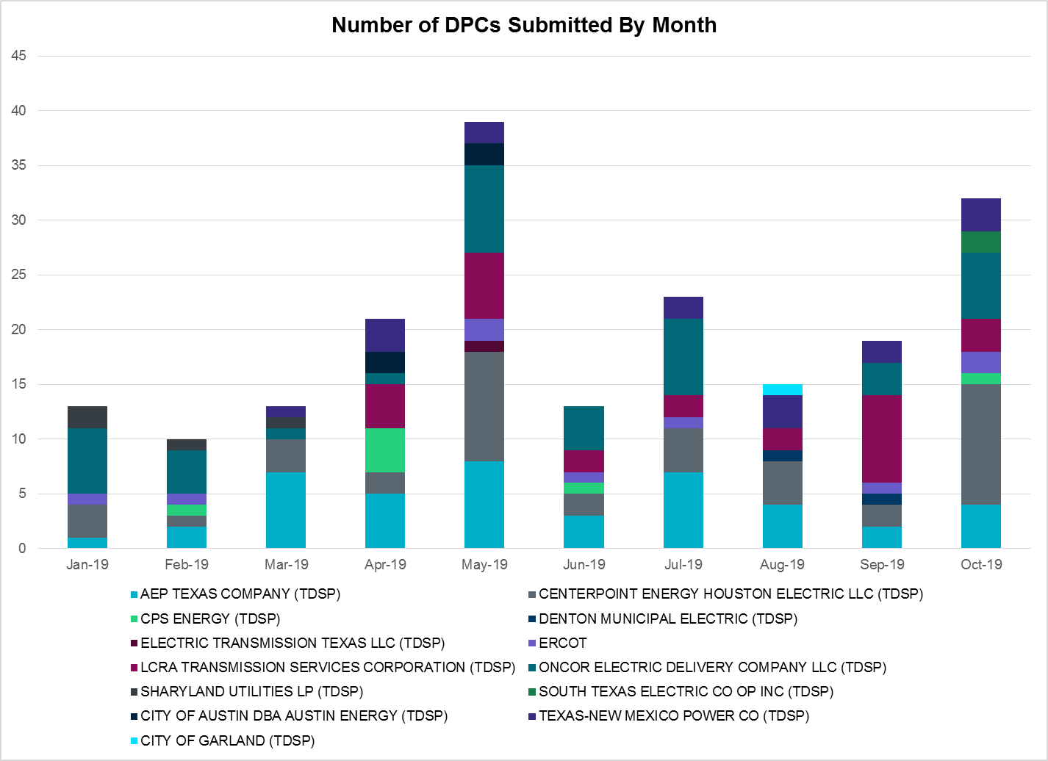

Transmission Operator | Number of DPCs
AEP TEXAS COMPANY (TDSP) | 4
BRAZOS ELECTRIC POWER CO OP INC (TDSP) | 0
CENTERPOINT ENERGY HOUSTON ELECTRIC LLC (TDSP) | 11
CITY OF AUSTIN DBA AUSTIN ENERGY (TDSP) | 0
CITY OF GARLAND (TDSP) | 0
CPS ENERGY (TDSP) | 1
DENTON MUNICIPAL ELECTRIC (TDSP) | 0
ELECTRIC TRANSMISSION TEXAS LLC (TDSP) | 0
ERCOT | 2
LCRA TRANSMISSION SERVICES CORPORATION (TDSP) | 3
ONCOR ELECTRIC DELIVERY COMPANY LLC (TDSP) | 6
SHARYLAND UTILITIES LP (TDSP) | 0
SOUTH TEXAS ELECTRIC CO OP INC (TDSP) | 2
TEXAS MUNICIPAL POWER AGENCY (TDSP) | 0
TEXAS-NEW MEXICO POWER CO (TDSP) | 3

Appendix A: Real-Time Constraints
The following is a complete list of constraints activated in SCED. Full contingency descriptions can be found in the Standard Contingencies List located on the MIS secure site at Grid Generation Reliability Unit Commitment.

Contingency | Constrained Element | From Station | To Station | # of Days Constraint Active
BASE CASE | PNHNDL | n/a | n/a | 27
SECNMO28 | 6100__F | DHIDE | NOTSW | 26
SCRDLOF9 | BOW_FMR1 | BOW | BOW | 26
SCAGKEN5 | 74T148_1 | COMFOR | CICO | 23
BASE CASE | TRDWEL | n/a | n/a | 20
SBRAUVA8 | HAMILT_MAVERI1_1 | HAMILTON | MAVERICK | 20
SPIGSOL8 | RIOPEC_WOODW21_1 | WOODWRD2 | RIOPECOS | 19
SPIGSOL8 | RIOPEC_WOODW21_1 | RIOPECOS | WOODWRD2 | 19
SECNMO28 | 6100__G | ACSSW | AMTBT | 19
DFPPLOS5 | 169T263_1 | FPP138 | LAGRAN | 19
DAUSLOS5 | 171T253_1 | FAYETT | FPP138 | 17
DCAGCO58 | 583T583_1 | BANDER | MASOCR | 17
DFPPLOS5 | 171T253_1 | FAYETT | FPP138 | 17
SFORYEL8 | HEXT_YELWJC1_1 | YELWJCKT | HEXT | 16
SSOLFTS8 | ALPINE_BRONCO1_1 | BRONCO | ALPINE | 16
SFORYEL8 | HEXT_YELWJC1_1 | HEXT | YELWJCKT | 16
DAUSLOS5 | 169T263_1 | FPP138 | LAGRAN | 16
XMDS58 | 6475__C | ODEHV | TROTP | 13
SSONFRI8 | SONR_69-1 | SONR | SONR | 13
DWINDUN8 | 6100__F | DHIDE | NOTSW | 13
SILLFTL8 | OZNR_OZONA1_1 | OZONA | OZNR | 13
DMTSCOS5 | 6437__F | SCRCV | KNAPP | 12
DCRLLSW5 | 590__B | LWVJS | LKPNT | 12
XVI2C89 | VICTORIA_69A2 | VICTORIA | VICTORIA | 12
SRAYRI28 | RAYMND2_69A1 | RAYMND2 | RAYMND2 | 11
SLISBAT8 | GARZA_69A1 | GARZA | GARZA | 11
SECNMO28 | 6101__B | CHEYT | WINKS | 11
DWINDUN8 | 6100__G | ACSSW | AMTBT | 11
DCPSJON5 | 6017__A | MBDSW | DCSES | 10
BASE CASE | RANDAD_ZAPATA1_1 | ZAPATA | RANDADO | 10
BASE CASE | RANDAD_ZAPATA1_1 | RANDADO | ZAPATA | 10
SSTABS18 | 6144__A | BSPRW | STASW | 10
DBIGKEN5 | HAMILT_MAXWEL1_1 | MAXWELL | HAMILTON | 10
XHAM88 | SONR_69-1 | SONR | SONR | 10
DRILKRW5 | BOW_FMR1 | BOW | BOW | 9
SLKAWFS8 | BOW_FMR1 | BOW | BOW | 9
SHACPB38 | RIOPEC_WOODW21_1 | RIOPECOS | WOODWRD2 | 9
SPOMNED5 | LARDVN_LASCRU1_1 | LARDVNTH | LASCRUCE | 9
XOD2E58 | ODEHV_MR2H | ODEHV | ODEHV | 9
DBBSRCH5 | 1750__B | SGOVL | KLBTP | 8
SMDLODE5 | RIOPEC_WOODW21_1 | RIOPECOS | WOODWRD2 | 8
DFLCMGS5 | 6095__D | LMESA | JPPOI | 8
SPOMNED5 | FREER_LOBO1_1 | LOBO | FREER | 8
SBAKBIG5 | FTST_SOLSTI1_1 | FTST | SOLSTICE | 7
SWOORI38 | RIOPEC_WOODW21_1 | RIOPECOS | WOODWRD2 | 7
SLAQLOB8 | BRUNI_69_1 | BRUNI | BRUNI | 7
DHECWHI8 | I_DUPS_RINCON1_1 | RINCON | I_DUPSW | 7
BASE CASE | NE_LOB | n/a | n/a | 7
DCRLLSW5 | COOPERCK_ARCO_1 | COOPERCK | ARCO | 7
DHECWHI8 | I_DUPS_RINCON1_1 | I_DUPSW | RINCON | 7
MLOTYUC8 | RIOPEC_WOODW21_1 | RIOPECOS | WOODWRD2 | 7
XCAG158 | CAGNON_MR4H | CAGNON | CAGNON | 6
DMDBDCS5 | CRD_CRD2 | CRD | CRD | 6
DBIGKEN5 | TREADW_YELWJC1_1 | TREADWEL | YELWJCKT | 6
SPOMDEL5 | FREER_LOBO1_1 | LOBO | FREER | 6
DCE_LO58 | FREER_LOBO1_1 | LOBO | FREER | 6
SBOSELM5 | WHTNY_MR2L | WHTNY | WHTNY | 6
SPOMNED5 | NLARSW_PILONC1_1 | NLARSW | PILONCIL | 6
DVENEVR5 | 3180__A | FCRSW | CDHSW | 6
DBIGKEN5 | TREADW_YELWJC1_1 | YELWJCKT | TREADWEL | 6
SPOMNED5 | NLARSW_PILONC1_1 | PILONCIL | NLARSW | 6
BASE CASE | RV_RH | n/a | n/a | 5
DEVRCRT5 | 495__A | EVRSW | VENSW | 5
DMGSQAL5 | 6095__D | LMESA | JPPOI | 5
SMCEESK8 | 6780__A | ESKSW | LONGWRTH | 5
SBRAUVA8 | ESCOND_GANSO1_1 | GANSO | ESCONDID | 5
SHACPB38 | 16TH_WRD2_1 | WOODWRD2 | 16TH_ST | 5
SCOLPAW5 | COLETO_ROSATA1_1 | COLETO | ROSATA | 5
SCOMHA38 | HAMILT_MAXWEL1_1 | MAXWELL | HAMILTON | 5
DCOTDMT5 | LIBR_PAUL1_1 | PAUL | LIBR | 5
SMDOPHR5 | 138_ALV_MNL_1 | ALVIN | MAINLAND | 5
SECNMO28 | 6101__A | NOTSW | CHEYT | 5
SRDODES8 | 940__C | WXHCH | ENWSW | 5
SGARROM8 | GARZA_69A1 | GARZA | GARZA | 5
SRDODES8 | 940__C | ENWSW | WXHCH | 5
XBOM58 | 6558__B | FSHSW | WFALS | 4
SCOLLON5 | NORMAN_PETTUS1_1 | PETTUS | NORMANNA | 4
SCOLLON5 | NORMAN_PETTUS1_1 | NORMANNA | PETTUS | 4
DMGSQAL5 | 14040__A | PCTSW | RBPOI | 4
SVANRAY8 | RAYBURN_69_2 | RAYBURN | RAYBURN | 4
DCE_LO58 | ASHERT_CATARI1_1 | ASHERTON | CATARINA | 4
DCE_LO58 | ASHERT_CATARI1_1 | CATARINA | ASHERTON | 4
DCHBJOR5 | LANMB_86_A | MB | LAN | 4
DCE_LO58 | NLARSW_PILONC1_1 | NLARSW | PILONCIL | 4
XSAN58 | SANMIGL_ATBH | SANMIGL | SANMIGL | 4
SHAMMAX8 | SONR_69-1 | SONR | SONR | 4
DYKNWIN8 | 6100__F | DHIDE | NOTSW | 4
SMEMANA8 | BNMSW_FMR1 | BNMSW | BNMSW | 4
DDELGA58 | FREER_LOBO1_1 | LOBO | FREER | 4
DFLCMGS5 | 6520__E | ODEHV | YARBR | 4
DFPPLOS5 | 155T217_1 | BELLSO | PT | 3
DFLCMGS5 | RIOPEC_WOODW21_1 | RIOPECOS | WOODWRD2 | 3
SPOMDEL5 | NLARSW_PILONC1_1 | PILONCIL | NLARSW | 3
DHCKSAG8 | 6265__A | EMSES | MRSDO | 3
SPIGSOL8 | 6520__E | ODEHV | YARBR | 3
DHECWHI8 | RINCON_WHITE_2_1 | WHITE_PT | RINCON | 3
SPAWSAN5 | SANMIGL_ATAL | SANMIGL | SANMIGL | 3
SCTHHA38 | SONR_69-1 | SONR | SONR | 3
DWINDUN8 | 6101__A | NOTSW | CHEYT | 3
SECNMO28 | 6480__A | MOSSW | ECTHP | 3
DHCKSAG8 | 6260__C | EMSES | EMMCP | 3
DELMTEX5 | 7T246_1 | ZORN | LYTTON_S | 3
DFERGRM8 | 247T124_1 | PHILJC | PALEFA | 3
DPDSCNR8 | 3665__C | PRCRK | SCYEN | 3
DFERSTA8 | 38T365_1 | WIRTZ | FLATRO | 3
DSWETKW5 | 6036__A | TKWSW | MGSES | 3
DCE_GA58 | GARZA_69A1 | GARZA | GARZA | 3
SLOBSA25 | NLARSW_PILONC1_1 | NLARSW | PILONCIL | 3
XSAN58 | NLARSW_PILONC1_1 | NLARSW | PILONCIL | 3
SBGLTWI8 | SONR_69-1 | SONR | SONR | 3
DYKNWIN8 | 6480__A | MOSSW | ECTHP | 3
DFLCMGS5 | ODEHV_MR2H | ODEHV | ODEHV | 3
SWCSBOO8 | RIOPEC_WOODW21_1 | RIOPECOS | WOODWRD2 | 3
UWO2WOO1 | RIOPEC_WOODW21_1 | RIOPECOS | WOODWRD2 | 3
XFRI89 | SONR_69-1 | SONR | SONR | 3
SWOORI38 | 16TH_WRD2_1 | WOODWRD2 | 16TH_ST | 3
DFERSTA8 | 37T187_1 | FERGUS | SHERSH | 3
DMARPA_8 | 38T365_1 | WIRTZ | FLATRO | 3
DAUSDUN8 | CKT_1032_1 | HWRDLN | ASHWDS | 3
DFERGRM8 | 247T124_1 | PALEFA | PHILJC | 3
DFERHOR8 | 38T365_1 | WIRTZ | FLATRO | 3
DYKNWIN8 | 6101__A | NOTSW | CHEYT | 3
DCHBJOR5 | CBYCD_84_A | CBY | CD | 3
XSAN58 | PAWNEE_XF1 | PAWNEE | PAWNEE | 3
SPOMDEL5 | NLARSW_PILONC1_1 | NLARSW | PILONCIL | 3
DFPPLOS5 | 700T700_1 | LAGRAN | RIVERS | 2
BASE CASE | SPE_DEN_1 | SPNCER | DENTON | 2
BASE CASE | FTST_SOLSTI1_1 | FTST | SOLSTICE | 2
SCOLPAW5 | LOOP_VICTORIA_1 | VICTORIA | L_463S | 2
DCRMO218 | 6500__B | ODEHV | BTHOT | 2
DWH_STP5 | GRETA_REFUGI1_1 | REFUGIO | GRETA | 2
SI_DWHI8 | HECKER_MCCAMP1_1 | MCCAMPBE | HECKER | 2
SKLELOY8 | LOYOLA_69_1 | LOYOLA | LOYOLA | 2
SPAWSAN5 | PAWNEE_XF1 | PAWNEE | PAWNEE | 2
SWO2PYO8 | RIOPEC_WOODW21_1 | RIOPECOS | WOODWRD2 | 2
SPAWSAN5 | SANMIGL_ATAH | SANMIGL | SANMIGL | 2
DBIGKEN5 | SONR_69-1 | SONR | SONR | 2
DFERHOR8 | 247T124_1 | PALEFA | PHILJC | 2
DJACALV8 | BOW_FMR1 | BOW | BOW | 2
SWCSBOO8 | FTST_SOLSTI1_1 | FTST | SOLSTICE | 2
SFTLMES8 | HARGRO_TWINBU1_1 | TWINBU | HARGROVE | 2
SNORODE5 | HARGRO_TWINBU1_1 | TWINBU | HARGROVE | 2
DVICEDN8 | LOOP_VICTORIA_1 | VICTORIA | L_463S | 2
DMGSMDS5 | MDSSW_MR1H | MDSSW | MDSSW | 2
DDELGA58 | NLARSW_PILONC1_1 | NLARSW | PILONCIL | 2
SSCUSU28 | ROTN_WOLFGA1_1 | WOLFGANG | ROTN | 2
SBEVASH8 | TURTLECK_WCRYS_1 | TURTLCRK | WCRYSTS | 2
DWINDUN8 | 6101__B | CHEYT | WINKS | 2
DCE_RI58 | ASHERT_CATARI1_1 | ASHERTON | CATARINA | 2
SSONFRI8 | FDR_OZNC_1 | OZNC | FRIEND_R | 2
SDUKNED8 | HEC_NEDIN2_1 | HEC | NEDIN | 2
SSIEMOL8 | LARDVN_LASCRU1_1 | LARDVNTH | LASCRUCE | 2
SMDLODE5 | ODEHV_MR2H | ODEHV | ODEHV | 2
SARMRA38 | RAYMND2_69A1 | RAYMND2 | RAYMND2 | 2
DCAGCI58 | V3_W1_1 | W1 | V3 | 2
SMEMANA8 | 1940__C | STNSW | BELLS | 2
SMGIENW8 | 921__D | ENSSW | TRU | 2
DZORHAY5 | BERGHE_AT1H | BERGHE | BERGHE | 2
SLGDSAP8 | FDR_OZNC_1 | FRIEND_R | OZNC | 2
DCAGTA58 | 74T148_1 | COMFOR | CICO | 2
SLOBSA25 | BRUNI_69_1 | BRUNI | BRUNI | 2
DLONWAR5 | GRETA_REFUGI1_1 | REFUGIO | GRETA | 2
DWAPHLJ5 | JCKSTP18_A | STP | JCK | 2
SVICCO28 | MELONC_RINCON1_1 | RINCON | MELONCRE | 2
DLONWAR5 | NORMAN_PETTUS1_1 | PETTUS | NORMANNA | 2
DCAGCO58 | 392T392_1 | MASOCR | PIPECR | 2
DWSHNAV5 | 495__A | EVRSW | VENSW | 2
SVICCO28 | COLETO_VICTOR2_1 | COLETO | VICTORIA | 2
DMGSQAL5 | HARGRO_TWINBU1_1 | TWINBU | HARGROVE | 2
XASP89 | ONYXRE_QUAINT1_1 | ONYXREA | QUAINT | 2
SWOORI28 | TOMBST_WDWRDT1_1 | WDWRDTP | TOMBSTNE | 2
DCRLLSW5 | 588_A_1 | LWSVW | LWVTI | 2
DMGSMDS5 | 6475__C | ODEHV | TROTP | 2
DCE_RI58 | ASHERT_CATARI1_1 | CATARINA | ASHERTON | 2
SPOMDEL5 | CATARI_PILONC1_1 | PILONCIL | CATARINA | 2
SN_SLON5 | CELANE_KLEBER1_1 | CELANEBI | KLEBERG | 2
DCE_RI58 | FREER_LOBO1_1 | LOBO | FREER | 2
DJEWSNG5 | JK_TOKSW_1 | TOKSW | JK_CK | 2
SVANRAY8 | NUR_FORT_1 | NURSRYS | FORTRSW | 2
SSONFRI8 | FDR_OZNC_1 | FRIEND_R | OZNC | 2
DRENCRL5 | CRLNW_MR1H | CRLNW | CRLNW | 1
SLV4DEL5 | FREER_LOBO1_1 | LOBO | FREER | 1
SMNWORA8 | JYBRD_STV_1 | JAYBIRD | STV | 1
DLCRKIN8 | LCRANE_RIOPEC1_1 | RIOPECOS | LCRANE | 1
DMGSQAL5 | SONR_69-1 | SONR | SONR | 1
DTWIBGL8 | SONR_69-1 | SONR | SONR | 1
SPIGSOL8 | TNAF_FTS_1 | FTST | TNAF | 1
DCAGCI58 | 342T195_1 | GRANMO | MARBFA | 1
DNAVLEG5 | 35050__A | VENSW | SAMSW | 1
BASE CASE | 38T365_1 | WIRTZ | FLATRO | 1
DWIRGRA8 | 38T365_1 | WIRTZ | FLATRO | 1
SSCLWF18 | 6840__B | NVKSW | ANARN | 1
DKENCOM8 | 72T120_1 | KENDAL | HOLLMI | 1
XHAM88 | ATSO_OZNC1_1 | ATSO | OZNC | 1
DFLAPLU8 | BELLSO_AT2 | BELLSO | BELLSO | 1
DSWECBF5 | BLUF_C_MULBER1_1 | MULBERRY | BLUF_CRK | 1
SGEOORN8 | CSA_SAN_1 | CASA_BLA | SANDIAS | 1
SHAMMAX8 | FDR_OZNC_1 | FRIEND_R | OZNC | 1
SNEDLON5 | NORMAN_PETTUS1_1 | PETTUS | NORMANNA | 1
SW_GODE5 | SONR_69-1 | SONR | SONR | 1
SPALSTA8 | 38T365_1 | WIRTZ | FLATRO | 1
DMGSBIT5 | 6036__A | TKWSW | MGSES | 1
DYKNWIN8 | 6100__G | ACSSW | AMTBT | 1
DHCKSAG8 | 6265__C | RHTP2 | SAGNA | 1
SECNMO28 | 6518__A | MOSSW | SOPOD | 1
DZORHAY5 | BERGHE_AT1L | BERGHE | BERGHE | 1
SCOLPAW5 | BLESSI_LOLITA1_1 | LOLITA | BLESSING | 1
SSCUSU28 | GIRA_T_SPUR1_1 | SPUR | GIRA_TAP | 1
SBRAHAM8 | HAMILT_MAVERI1_1 | HAMILTON | MAVERICK | 1
SKBBI8 | HOCHOC90_1 | HOC | HOC | 1
DDUPHE18 | I_DUPS_MCCAMP2_1 | I_DUPSW | MCCAMPBE | 1
XNED258 | NEDIN_138H | NEDIN | NEDIN | 1
STITSCA8 | OCB_2175_1 | SCARBIDE | LOMA_ALT | 1
DFPPLOS5 | 105T105_1 | SALEM | HIGH36 | 1
DPHRCTR5 | 138_ALV_MNL_1 | ALVIN | MAINLAND | 1
DFERWIR8 | 342T195_1 | GRANMO | MARBFA | 1
BASE CASE | 6064__A | TRENT | ESKSW | 1
DWINDUN8 | 6480__A | MOSSW | ECTHP | 1
SCMNCPS5 | 651__B | CMNSW | CMNTP | 1
DYKNWIN8 | 6520__E | ODEHV | YARBR | 1
DBOMPLV8 | 6558__B | FSHSW | WFALS | 1
SSONFRI8 | ATSO_SONR1_1 | SONR | ATSO | 1
DCHBJOR5 | CBYCVN86_A | CBY | CVN | 1
BASE CASE | ESKSW_STRENT_1 | STWF | ESKSW | 1
DRIOHAR5 | HAINE__LA_PAL1_1 | LA_PALMA | HAINE_DR | 1
SLV4DEL5 | NLARSW_PILONC1_1 | NLARSW | PILONCIL | 1
SSCALOM8 | PALOAL_TITAN_1_1 | TITAN_SU | PALOALTO | 1
DBERWE58 | R5_KENDL_1 | KENDAL | CAGNON | 1
SSCUSU28 | SPUR_69_1 | SPUR | SPUR | 1
DWAPHLJ5 | STPWAP39_1 | STP | WAP | 1
SBAKBIG5 | TOMBST_WDWRDT1_1 | WDWRDTP | TOMBSTNE | 1
DFERHOR8 | 342T195_1 | GRANMO | MARBFA | 1
DMGSBTR5 | 6036__A | TKWSW | MGSES | 1
SECNMO28 | 6100__B | AMTBT | DHIDE | 1
DSCOTKW5 | 6215__A | BCKSW | CGRSW | 1
DENWSTE8 | 921__D | ENSSW | TRU | 1
SPIGSOL8 | ALMC_T2 | ALMC | ALMC | 1
SWRDYN8 | G138_17_1 | BRAZORIA | RT | 1
SPOMDEL5 | LARDVN_LASCRU1_1 | LARDVNTH | LASCRUCE | 1
XTHR89 | NORMAN_PETTUS1_1 | PETTUS | NORMANNA | 1
XPUT89 | ONYXRE_QUAINT1_1 | ONYXREA | QUAINT | 1
SPY2WIC8 | RIOPEC_WOODW21_1 | RIOPECOS | WOODWRD2 | 1
SMEMANA8 | 1130__C | WBJDN | GET38 | 1
SMEMANA8 | 1580__B | PAYNE | PNKHL | 1
DNAVWTR5 | 530__C | VENSW | BRTRD | 1
XFSH58 | 6171__B | WFCOG | PLVSW | 1
SMDLMOS5 | 6462__A | MDLNE | ADMDS | 1
DFLCMGS5 | 6500__B | ODEHV | BTHOT | 1
SESMFRI8 | BARNHR_BIGLAK1_1 | BIGLAKE | BARNHRT | 1
DCHBJOR5 | BRNWIN86_A | BRN | WIN | 1
SFTLMES8 | CONCHO_SAMATH1_1 | CONCHO | SAMATHIS | 1
SALIKIN8 | FALFUR_PREMON1_1 | FALFUR | PREMONT | 1
SFREGIL8 | FREDER_AT2 | FREDER | FREDER | 1
SODLBRA8 | HAMILT_MAVERI1_1 | HAMILTON | MAVERICK | 1
SBAKSCH5 | HARGRO_TWINBU1_1 | TWINBU | HARGROVE | 1
SMOLLOB8 | LARDVN_LASCRU1_1 | LARDVNTH | LASCRUCE | 1
DWH_STP5 | MELONC_RINCON1_1 | RINCON | MELONCRE | 1
STHOVIC8 | VICTORIA_69A2 | VICTORIA | VICTORIA | 1
SBOSELM5 | WHTNY_MR2H | WHTNY | WHTNY | 1
DAUSLOS5 | 155T217_1 | BELLSO | PT | 1
DFLCMGS5 | 16TH_WRD2_1 | WOODWRD2 | 16TH_ST | 1
XFSH58 | 6170__A | BOMSW | PRKWY | 1
DBTHOD58 | 6520__E | ODEHV | YARBR | 1
DWINDUN8 | 6520__E | ODEHV | YARBR | 1
SSONFRI8 | ATSO_SONR1_1 | ATSO | SONR | 1
DBIGKEN5 | BALLIN_PAINTR1_1 | BALLINGE | PAINTROC | 1
DAUSDUN8 | CKT_1012_1 | JOLLYVIL | NORTHWES | 1
XDCS58 | CRD_CRD2 | CRD | CRD | 1
SGLDSUN8 | ECRSW_FMR1 | ECRSW | ECRSW | 1
XHAM88 | FDR_OZNC_1 | FRIEND_R | OZNC | 1
SPOMNED5 | FREER_SAN_DI1_1 | FREER | SAN_DIEG | 1
SCASPIT8 | FRPHIL_GILLES1_1 | GILLES | FRPHILLT | 1
SRINRIN8 | INGLES_I_DUPS1_1 | I_DUPSW | INGLESID | 1
SN_SAJO5 | NLARSW_PILONC1_1 | NLARSW | PILONCIL | 1
SASPPAI8 | ONYXRE_QUAINT1_1 | ONYXREA | QUAINT | 1
SCISPUT8 | ONYXRE_QUAINT1_1 | ONYXREA | QUAINT | 1
SFLCMGS5 | RIOPEC_WOODW21_1 | RIOPECOS | WOODWRD2 | 1
XBLE89 | SLTDM_SHRPSH_1 | SALTDOME | SHROPSHI | 1
SCISPUT8 | SOUTHA_VINSON1_1 | SOUTHABI | VINSON | 1
SSPUMW18 | SPUR_69_1 | SPUR | SPUR | 1
DLONWAR5 | VICTORIA_69A2 | VICTORIA | VICTORIA | 1
SMEMANA8 | 1130__G | WBOSE | WHTBR | 1
DTRSENT5 | 1255__B | SCSES | STCKY | 1
SFERSHE8 | 38T365_1 | WIRTZ | FLATRO | 1
DGILHOR8 | 43T365_1 | FLATRO | PALEPE | 1
DYKNWIN8 | 6100__B | AMTBT | DHIDE | 1
SSNDPB48 | 6520__E | ODEHV | YARBR | 1
SWOORI28 | 6520__E | ODEHV | YARBR | 1
XBOM358 | 6558__B | FSHSW | WFALS | 1
SLOBSA25 | ASHERT_CATARI1_1 | ASHERTON | CATARINA | 1
SWHISTP5 | BLESSI_LOLITA1_1 | LOLITA | BLESSING | 1
SBIGTWI5 | CRMW1T_EDEN1_1 | EDEN | CRMW1TP | 1
SCTHHA38 | FDR_OZNC_1 | FRIEND_R | OZNC | 1
DBIGKEN5 | FTST_SOLSTI1_1 | FTST | SOLSTICE | 1
SOXYIN28 | I_DUPP_I_DUPS2_1 | I_DUPP1 | I_DUPSW | 1
DLONWAR5 | MELONC_RINCON1_1 | RINCON | MELONCRE | 1
SBTPBNT8 | MYRA_VAL_1 | MYRA | VALYVIEW | 1
DELMSAN5 | PAWNEE_SPRUCE_1 | PAWNEE | CALAVERS | 1
DZORHAY5 | R5_KENDL_1 | KENDAL | CAGNON | 1
DBBSRCH5 | 1255__B | SCSES | STCKY | 1
DMGSLNG5 | 6095__D | LMESA | JPPOI | 1
DDMTGLD8 | 6240__C | SACRC | DPCRK | 1
DMTSCOS5 | 6240__C | SACRC | DPCRK | 1
SRXAODE8 | 6520__E | ODEHV | YARBR | 1
DCC1DUKE | ASHERT_CATARI1_1 | ASHERTON | CATARINA | 1
SBGLTWI8 | CONCHO_SAMATH1_1 | CONCHO | SAMATHIS | 1

The Duration of Event is defined as the time it takes for the frequency to recover to pre-disturbance frequency or 60 Hz as applicable.
PMU reports are typically generated when frequency drops below 59.9, but PMU data is available for other events.
Delta Frequency is defined as the difference between the starting point of the frequency event (t(0) or “A-point”) and minimum/maximum frequency (“C-Point”).
Currently, the Critical Inertia Level for ERCOT is approximately 100,000 MW-s
This is the hourly integrated peak demand as published in the ERCOT D&E report.
All DC Tie Curtailments are posted publically on the ERCOT Market Information System. See that posting for additional details for the event(s) in question.
See DC Tie Operating Procedure (http://www.ercot.com/mktrules/guides/procedures) for more details.

