System Planning

Monthly Status Report
October 2019

Report Highlights
- ERCOT is currently reviewing proposed transmission improvements with a total estimated cost of $1,333.34 Million as of October 31, 2019.
- Transmission Projects endorsed in 2019 total $478.5 Million as of October 31, 2019.
- All projects (in engineering, routing, licensing and construction) total approximately $3.41 Billion as of October 1, 2019.
- Transmission Projects energized in 2019 total about $1.30 Billion as of October 1, 2019.

Regional Planning Group Project Reviews
- AEPSC has submitted the LRGV Import Project. This is a Tier 1 project that is estimated to cost $73.4 million. AEPSC has also requested that ERCOT provide conditional endorsement for an additional $357.2 million project. This project is currently under ERCOT Independent Review.
- STEC has submitted the Lower Rio Grande Valley Transmission Expansion Project. This is a Tier 1 project that is estimated to cost $511 million. This project is currently under ERCOT Independent Review.
- AEPSC has submitted the Lon Hill to Warburton 138 kV Line Rebuild Transmission Project. This is a Tier 3 project that is estimated to cost $62.2 million. This project completed the RPG review on October 7, and ERCOT has issued the acceptance letter.
- AEPSC has submitted the Corpus North Shore Project. This is a Tier 1 project that is estimated to cost $259.57 million. This project is currently under ERCOT Independent Review.
- CNP has submitted the Jordan Area Load Addition Project. This is a Tier 3 project that is estimated to cost $30.97 million. This project is currently in the RPG comment period.
- AEPSC has submitted the Rocksprings to Sonora 69 kV Line Rebuild Transmission Project. This is a Tier 3 project that is estimated to cost $56.2 million. This project is currently in the RPG comment period.
- AEPSC has submitted the Mason to North Brady Line Rebuild Transmission Project. This is a Tier 3 project that is estimated to cost $45 million. This project is currently in the RPG comment period.

More information on current and past RPG projects can be found on the ERCOT MIS Secure (digital certificate required): https://mis.ercot.com/pps/tibco/mis/Pages/Grid+Information/RegionalPlanning
Past email communication on RPG projects can be found on the ERCOT listserve by signing up for the REGPLANGROUP list: http://lists.ercot.com/scripts/wa-ERCOT.exe?A0=REGPLANGROUP

Planning Model Activities
The short-term calendar of major planning model events is as follows:
- October 31, 2019 Post 19SSWG Update 1 Contingency definitions and Planning Data Dictionary
The following table shows interconnection projects that met Planning Guide section 6.9(1) and 6.9(2) and were modeled in the SSWG cases as a full model or as a simple model in accordance with Planning Guide section 6.9.
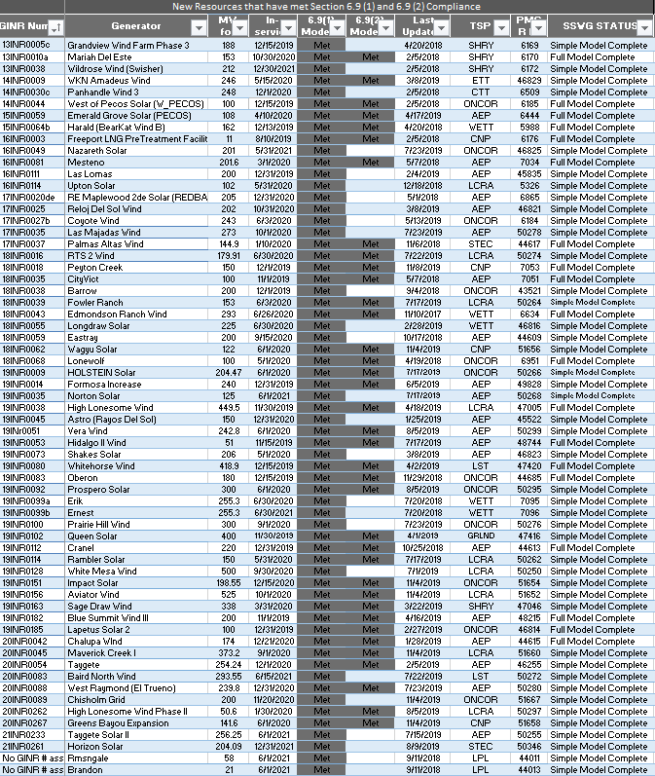

Permian Basin Oil Rig Count
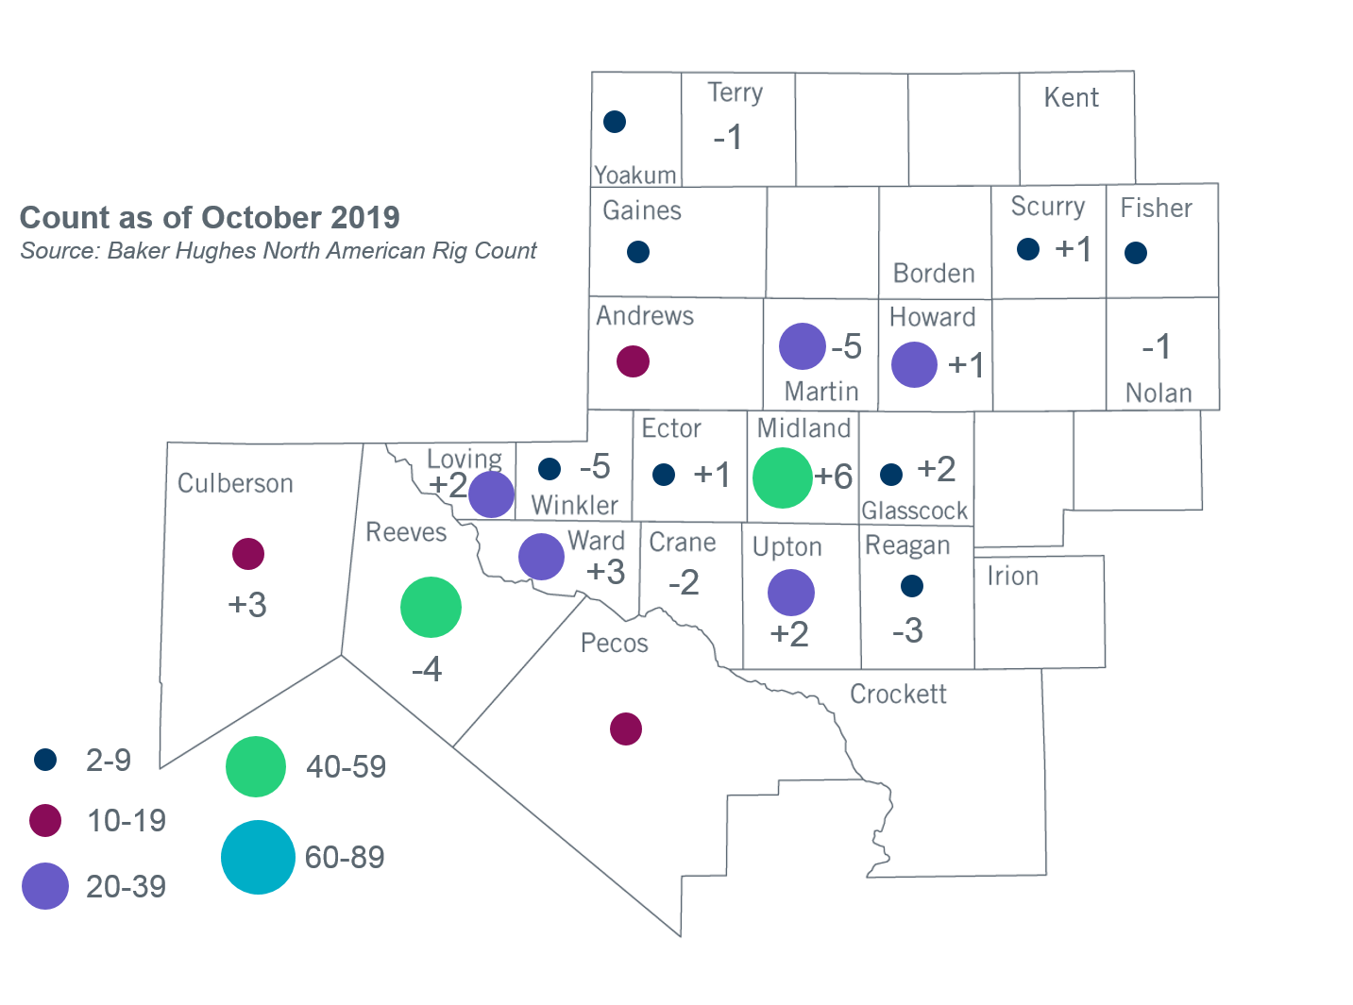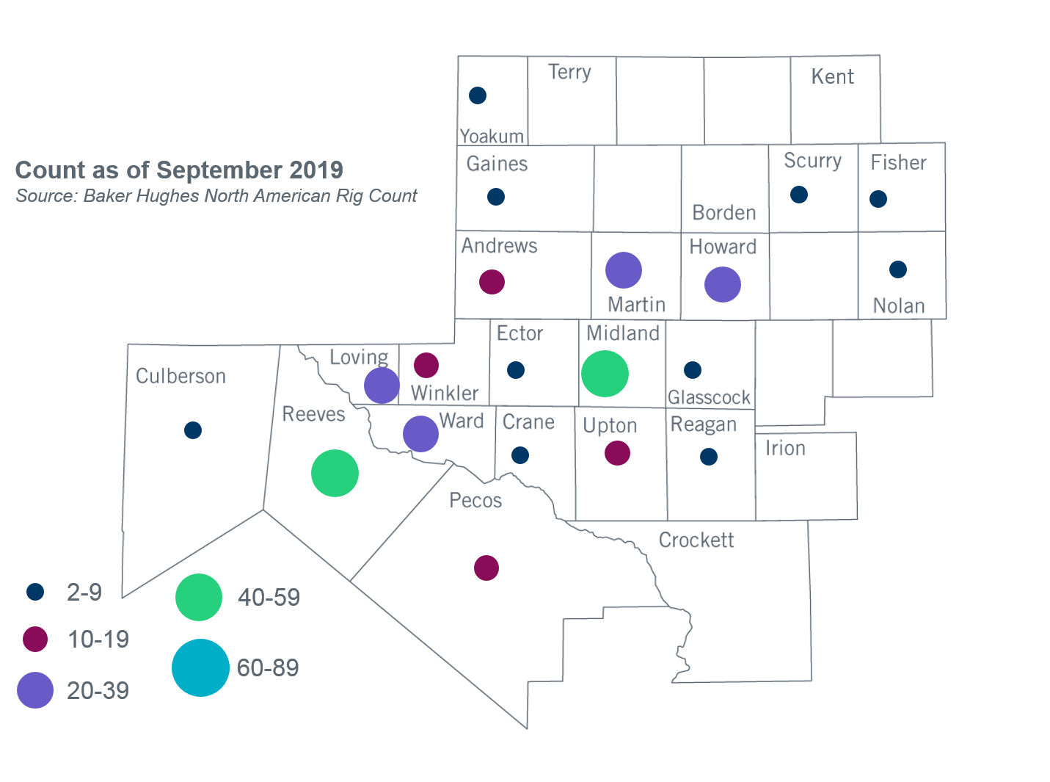

Other Notable Activities
- ERCOT is conducting the 2019 Regional Transmission Plan (RTP). Preliminary reliability projects have been identified for the base cases. ERCOT is currently working on additional reliability analysis for the base cases, sensitivity analysis, and economic analysis. ERCOT presented plans for sensitivity analysis to the Regional Planning Group (RPG) in September.
- ERCOT presented updated results for the 2020 Long-Term System Assessment (LTSA) to the Regional Planning Group (RPG) in September. The updates considered feedback gathered from stakeholder surveys following the May RPG meeting. ERCOT is continuing to develop the Current Trends scenario.
- The SPWG completed the 2019 CY base case on March 29 and the 2020 - 2024 Future Year (FY) case build was completed on July 19.
- ERCOT is currently conducting the Delaware Basin area load integration study. The purpose of the study is to identify potential reliability needs and transmission upgrades for the load (planned and conceptual) that may appear in the area in the longer term planning horizon.

+/- symbol indicates the increase or decrease from the previous month in oil rigs present in each county. There are 303 rigs, including a total decrease of 1 oil rig, in the Permian Basin from September to October 2019.

