September 2019 ERCOT Monthly Operations Report
Reliability and Operations Subcommittee Meeting
November 7, 2019

Table of Contents
1. Report Highlights 2
2. Frequency Control 3
2.1. Frequency Events 3
2.2. Responsive Reserve Events 4
2.3. Load Resource Events 4
3. Reliability Unit Commitment 4
4. Wind Generation as a Percent of Load 5
5. Largest Net-Load Ramp 6
6. COP Error Analysis 6
7. Congestion Analysis 8
7.1. Notable Constraints 8
7.2. Generic Transmission Constraint Congestion 13
7.3. Manual Overrides 13
7.4. Congestion Costs for Calendar Year 2019 13
8. System Events 15
8.1. ERCOT Peak Load 15
8.2. Load Shed Events 15
8.3. Stability Events 15
8.4. Notable PMU Events 15
8.5. DC Tie Curtailment 15
8.6. TRE/DOE Reportable Events 16
8.7. New/Updated Constraint Management Plans 16
8.8. New/Modified/Removed RAS 16
8.9. New Procedures/Forms/Operating Bulletins 16
9. Emergency Conditions 16
9.1. OCNs 16
9.2. Advisories 17
9.3. Watches 17
9.4. Emergency Notices 17
10. Application Performance 17
10.1. TSAT/VSAT Performance Issues 17
10.2. Communication Issues 17
10.3. Market System Issues 17
11. Model Updates 17
Appendix A: Real-Time Constraints 20

Report Highlights
- The unofficial ERCOT peak was 68,959 MW.
- There were 5 frequency events.
- There were 5 instances where Responsive Reserves were deployed.
- There were 10 RUC commitments.
- Congestion in the West Load Zone (LZ) can be mostly attributed to either high far west load/ low renewable generation in the area or high renewable generation. Congestion in the South LZ was mostly due to planned outages or high renewable generation in the area. Congestion in the North and Houston LZs was mostly due to planned outages. There were 27 days of congestion on the Panhandle GTC, 2 days on the Raymondivlle – Rio Hondo GTC, 1 day on the North to Houston GTC and 1 day on the McCamey GTC.
- There were 6 DC Tie curtailments. Most were associated with the DC-L tie and most were due to an unplanned outage.

Frequency Control

Frequency Events
The ERCOT Interconnection experienced four frequency events, all of which resulted from a unit trip. The average event duration was approximately 00:05:30.

A summary of the frequency events is provided below. The reported frequency events meet one of the following criteria: Delta Frequency is 60 mHz or greater; the MW loss is 350 MW or greater; resource trip event triggered RRS deployment. Frequency events that have been identified as Frequency Measurable Events (FME) for purposes of BAL-001-TRE-1 analysis are highlighted in blue. When analyzing frequency events, ERCOT evaluates PMU data according to industry standards. Events with an oscillating frequency of less than 1 Hz are considered to be inter-area, while higher frequencies indicate local events. Industry standards specify that damping ratio for inter-area oscillations should be 3.0% or greater. For the frequency events listed below, the ERCOT system met these standards and transitioned well after each disturbance.

Date and Time | Delta Frequency | Max/Min Frequency | Duration of Event | PMU Data |  | MW Loss | Load | Wind | Inertia
 | (Hz) | (Hz) |  | Oscillation Mode (Hz) | Damping Ratio |  | (MW) | % | (GW-s)
9/3/2019 16:45 | 0.078 | 59.898 | 0:04:46 | No PMU data available |  | 391.47 | 68,703 | 4% | 384,791
9/21/2019 3:00 | 0.089 | 59.890 | 0:03:48 | No PMU data available |  | 461.814 | 40,544 | 37% | 234,748
9/22/2019 14:44 | 0.071 | 59.895 | 0:03:13 | No PMU data available |  | 325.48 | 60,049 | 7% | 342,837
9/22/2019 14:49 | 0.126 | 59.899 | 0:07:27 | No PMU data available |  | 696.817 | 60,082 | 6% | 343,617
9/22/2019 15:27 | 0.091 | 59.905 | 0:03:18 | No PMU data available |  | 418.403 | 61,094 | 6% | 344,593

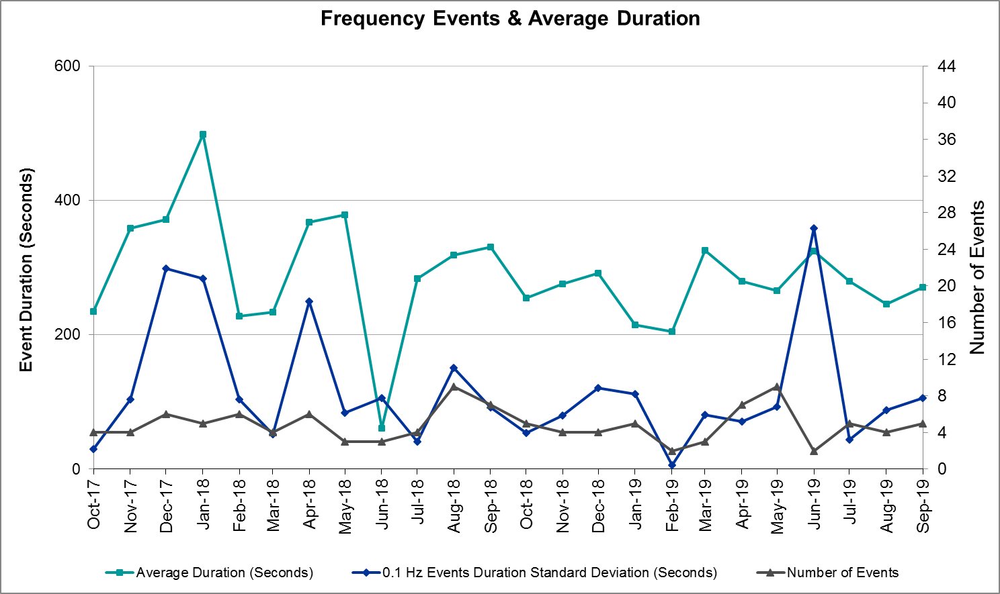 (Note: All data on this graph encompasses frequency event analysis based on BAL-001-TRE-1.)

Note that the large standard deviation in June 2019 is due to coincidental extreme high and low durations for a small set of events (2).

Responsive Reserve Events
There were five events where Responsive Reserve MWs were released to SCED. The events highlighted in blue were related to frequency events reported in Section 2.1 above.

Date and Time Released to SCED | Date and Time Recalled | Duration of Event | Maximum MWs Released | Comments
9/3/2019 16:45 | 9/3/2019 16:50 | 00:04:40 | 606
9/21/2019 3:00 | 9/21/2019 3:03 | 00:03:20 | 497
9/22/2019 14:44 | 9/22/2019 14:47 | 00:03:08 | 653
9/22/2019 14:49 | 9/22/2019 14:50 | 00:00:24 | 498
9/22/2019 15:27 | 9/22/2019 15:30 | 00:02:44 | 521

Load Resource Events
None.

Reliability Unit Commitment
ERCOT reports on Reliability Unit Commitments (RUC) on a monthly basis. Commitments are reported grouped by operating day and weather zone. The total number of hours committed is the sum of the hours for all the units in the specified region. Additional information on RUC commitments can be found on the MIS secure site at Grid Generation Reliability Unit Commitment.

There were no DRUC commitments.

There were 10 HRUC commitments.

Resource Location | # of Resources | Operating Day | Total # of Hours Committed | Total MWhs | Reason for Commitment
East | 1 | 9/6/2019 | 3 | 2,040 | Capacity
North | 1 | 9/6/2019 | 2 | 370 | Capacity
North | 1 | 9/6/2019 | 2 | 108 | Capacity
South Central | 1 | 9/14/2019 | 6 | 1,302 | Capacity
East | 1 | 9/16/2019 | 1 | 495 | Capacity
North Central | 1 | 9/16/2019 | 1 | 51 | DHCKSAG8
North | 1 | 9/18/2019 | 9 | 996 | DCOMPRS8
North | 1 | 9/19/2019 | 3 | 332 | DCOMPRS8
Coast | 1 | 9/23/2019 | 1 | 247 | Capacity
South Central | 1 | 9/23/2019 | 1 | 44 | Capacity

Wind Generation as a Percent of Load
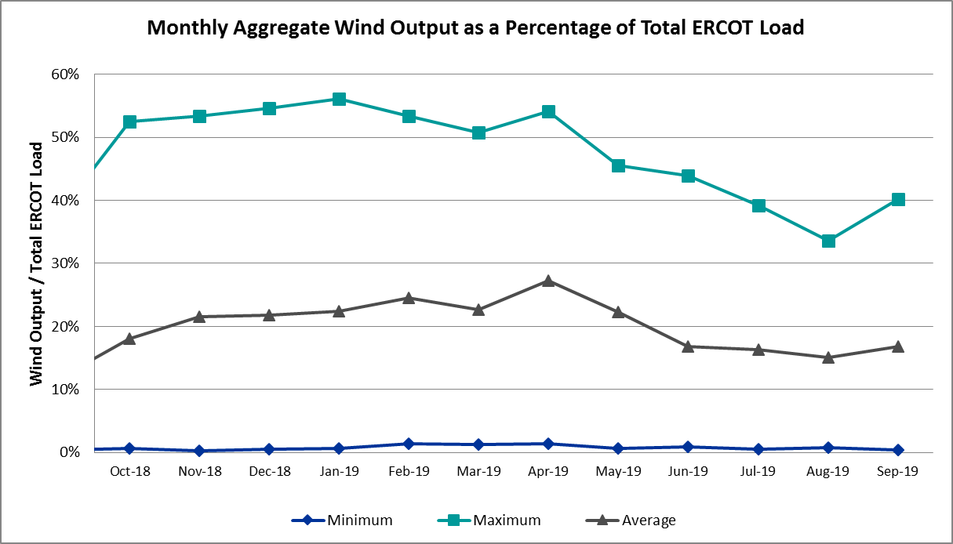

Wind Generation Record: 19,672 MW on 01/21/2019 at 19:19
Wind Penetration Record: 56.16% on 01/19/2019 03:10

Largest Net-Load Ramp
The net-load ramp is defined as the change in net-load (load minus wind and PVGR generation) during the defined time horizon. Such a variation in net-load needs to be accommodated in grid operations to ensure that the reliability of the grid is satisfactorily maintained. The largest net-load ramp during 5-min, 10-min, 15-min, 30-min and 60-min in September 2019 is 867 MW, 1207 MW, 1643 MW, 3134 MW, 5716 MW respectively. The comparison with respect to the historical values is given in the table below.

Month and Year | 5 min | 10 min | 15 min | 30 min | 60 min
September 2019 | 867 MW | 1207 MW | 1643 MW | 3134 MW | 5716 MW
September 2014 | 1054 MW | 1531 MW | 1695 MW | 2628 MW | 4898 MW
September 2015 | 993 MW | 1457 MW | 1779 MW | 2952 MW | 5659 MW
September 2016 | 827 MW | 1260 MW | 1688 MW | 2880 MW | 5464 MW
September 2017 | 730 MW | 1251 MW | 1758 MW | 3298 MW | 5716 MW
September 2018 | 1129 MW | 1991 MW | 2372 MW | 3391 MW | 6015 MW
2014-2018 | 1494 MW | 1991 MW | 2780 MW | 4109 MW | 7218 MW

COP Error Analysis
COP Error is calculated as the capacity difference between the COP HSL and real-time HSL of the unit. Mean Absolute Error (MAE) stayed high over 10,500 MW until Day-Ahead at 12:00, then dropped significantly to 2,016 MW by Day-Ahead at 14:00. In the following chart, Under-Scheduling Error indicates that COP had less generation capacity than real-time and Over-Scheduling Error indicates that COP had more generation capacity than real-time. Under-Scheduling persisted from beginning of Day-Ahead to end of the Operating Day. Snapshot on the Operating Day considers all Operating Hours, including past hours. However, COP error for the Operating Hour freezes after the Adjustment Period.

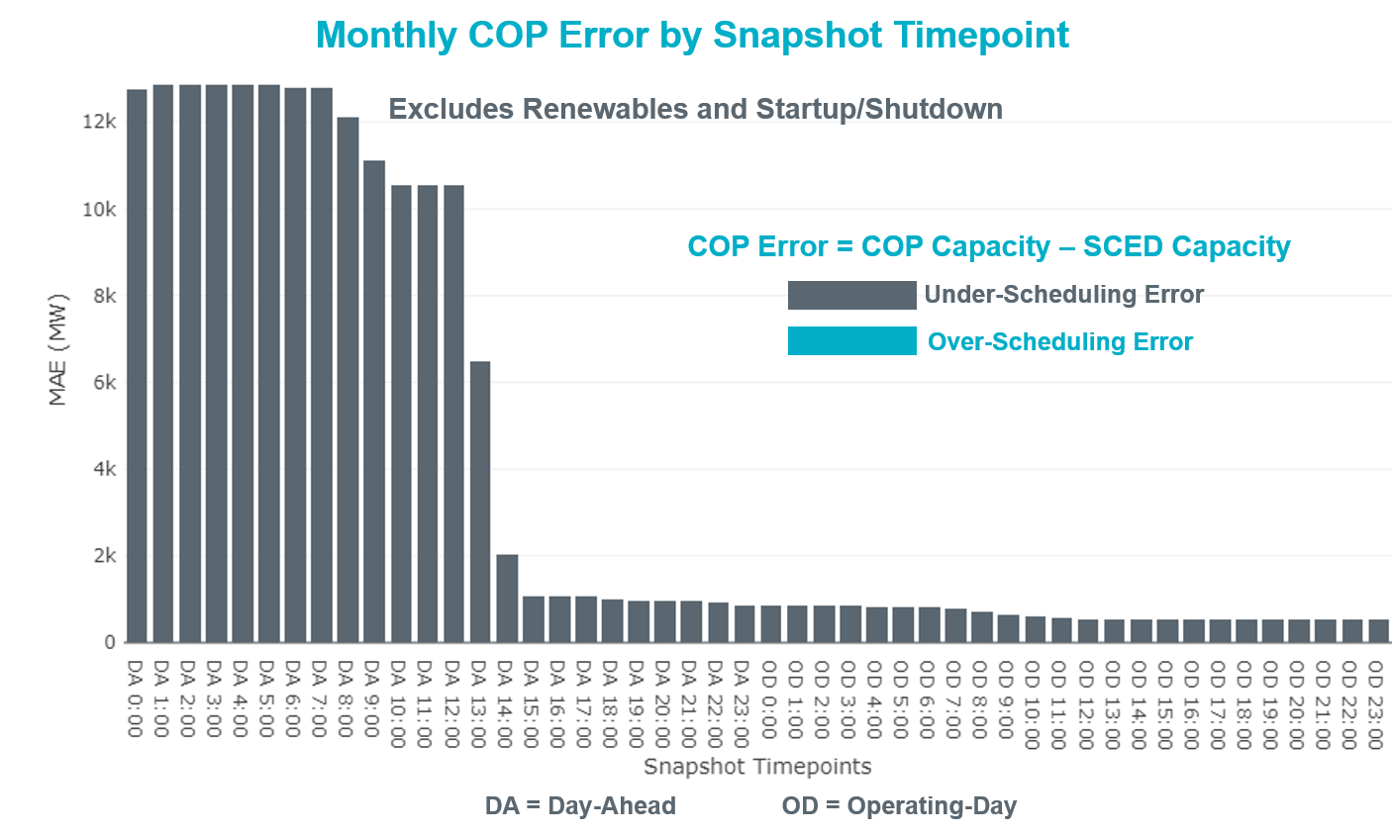

Monthly MAE for the Latest COP at the end of the Adjustment Period was 520 MW with median ranging from 170.2 MW for Hour-Ending (HE) 7 to -1276 MW for HE 20. HE 24 on the 25th had the largest Over-Scheduling Error (4,222 MW) and HE 21 on the 18th had the largest Under-Scheduling Error (-4,119 MW).

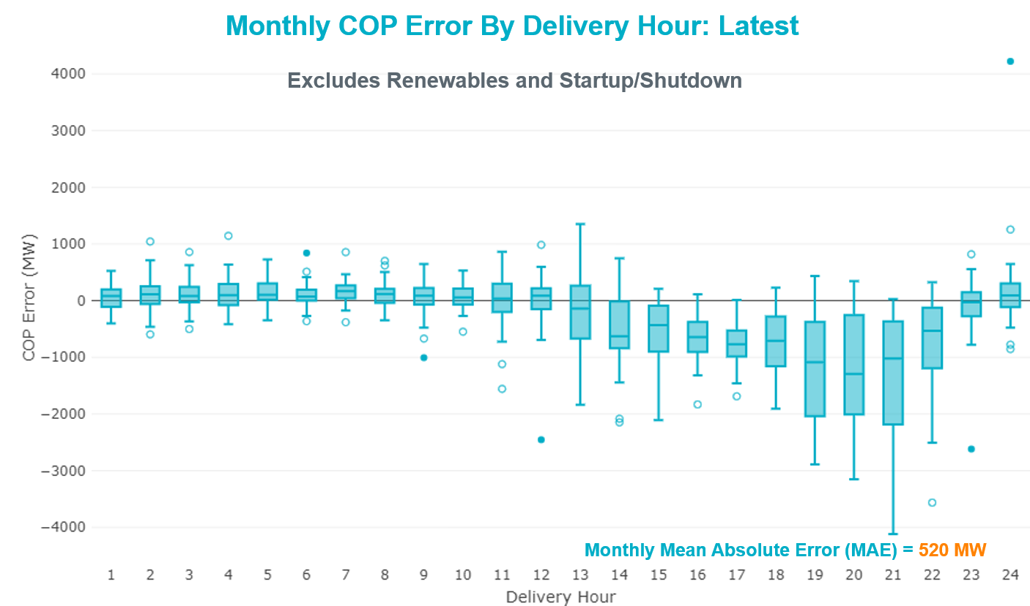

Monthly MAE for the Day-Ahead COP at 12:00 was 10,676 MW with median ranging from -4772 MW for Hour-Ending (HE) 3 to -17,058 MW for HE 17. HE 16 on the 26th had the largest Under-Scheduling Error (-20,370 MW).

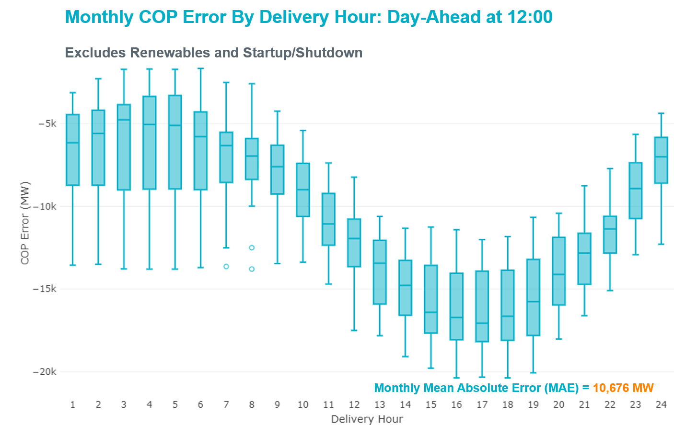

Congestion Analysis

Notable Constraints
Nodal protocol section 3.20 specifies that ERCOT shall identify transmission constraints that are active or binding three or more times within a calendar month. As part of this process, ERCOT reports congestion that meets this criterion to ROS. In addition ERCOT also highlights notable constraints that have an estimated congestion rent exceeding $1,000,000 for a calendar month. These constraints are detailed in the table below. Rows highlighted in blue indicate the congestion was affected by one or more outages. For a list of all constraints activated in SCED, please see Appendix A at the end of this report.

Contingency Name | Overloaded Element | # of Days Constraint Active | Congestion Rent | Transmission Project
Hcksw-Sagna-138kv | Eagle Mountain Ses - Morris Dido 138kV | 16 | $24,700,392.78 | Eagle Mountain-Calmont 138 kV Line (4253)
MOSS SWITCH to ECTOR COUNTY NORTH SWITCHING STATION LIN _A | Andrews County South - Amoco Three Bar Tap 138kV | 24 | $15,816,065.33 | Andrews County South Switch - No Trees Switch 138 kV Line (7171)
Basecase | PNHNDL GTC | 27 | $13,232,331.56 | LP&L Integration Tie Lines (43367 A,B,C) and Panhandle Loop
Navarro - WTRML 345KV | Britton Road - Venus Switch 345kV | 2 | $11,479,687.58 | Venus - Webb/Cedar Hill Sw. Sta. 345 kV DCKT Line (5492)
BUTTERCUP to WHITESTONE LIN 1 | Gabriel - Glasscock 138kV | 2 | $10,050,770.63 | Leander - Round Rock Transmission Line Addition (3967)
WINK to DUNE SWITCH and YUKON | Andrews County South - Amoco Three Bar Tap 138kV | 23 | $8,392,417.47 | Andrews County South Switch - No Trees Switch 138 kV Line (7171)
CHB-KG & CBY-JOR 345kV | Langston - Mont Belvieu 138kV | 12 | $5,721,208.39 | HOPSON - New 138kV Substation (43245)
TWR (345) HLJ-WAP64 & BLY-WAP72 | Jones Creek - South Texas Project 345kV | 7 | $5,027,513.00 | Freeport Master Plan (6668A)
CAGNON to KENDALL LIN 1 | Cico - Comfort 138kV | 9 | $3,647,044.38 | Boerne Cico - Comfort - Kendall Transmission Line Upgrade (6982)
Pdses-Cnrsw 138kV | Prairie Creek - Scyene Road 138kV | 4 | $3,538,763.77 | Sargent Road 345/138 kV autotransformer (11TPIT0034)
SAN ANGELO RED CREEK to SAN ANGELO PAULANN LIN 1 | San Angelo Concho - San Angelo Emerson Street 69kV | 7 | $3,186,930.29
MOSS SWITCH to ECTOR COUNTY NORTH SWITCHING STATION LIN _A | No Trees Switch - Cheyenne Tap 138kV | 27 | $3,032,397.37 | Wink Sw. Sta. - No Trees Sw. Sta. 138 kV Line (7101)
GARFIELD LCRA to LYTTON SPRINGS LIN 1 | Garfield Aen - Stoney Ridge 138kV | 8 | $2,801,767.66
Austro-Daffin&Dunlap-Decker 138kV | Aen Dunlap - Techridge 138kV | 1 | $2,561,651.14 | Gilleland to Techridge 138kV Circuit (08TIPT0033)
HILL COUNTRY TRX HILLCTRY_3_2 345/138 | Hill Country 345kV | 3 | $2,277,584.54 | Skyline - Install a Fourth 345kV Autotransformer (3298)
MARSHALL FORD to LAGO VISTA LIN 1 | Blockhouse - Whitestone 138kV | 1 | $2,254,116.16 | Whitestone - Leander 138kV Transmission Line Upgrade (5491)
ODESSA EHV SWITCH to MOSS SWITCH LIN _A | Odessa Ehv Switch 345kV | 6 | $2,250,071.76 | Riverton-Odessa EHV/Moss 345 kV Line (5445)
MOSS SWITCH to ECTOR COUNTY NORTH SWITCHING STATION LIN _A | Moss Switch - Ector Harper 138kV | 8 | $2,171,110.76 | Riverton-Odessa EHV/Moss 345 kV Line (5445)
TWR (345) HLJ-WAP64 & BLY-WAP72 | South Texas Project - Wa Parish 345kV | 3 | $1,995,009.86 | Freeport Master Plan (6668A)
CRLNW-LWSSW 345kV | Jones Street Tnp - Lakepointe Tnp 138kV | 12 | $1,707,912.24 | Lewisville - Lewisville Jones - Lakepointe 138 kV Line (45537)
Hcksw-Sagna-138kv | Eagle Mountain Ses - Eagle Mountain Compressor 138kV | 1 | $1,661,171.57 | Eagle Mountain-Calmont 138 kV Line (4253)
NORTH PHARR to POLK AVENUE LIN 1 | North Mcallen - West Mcallen 138kV | 4 | $1,649,173.31 | North McAllen (8368) - West McAllen (8367) - South McAllen (8371) 138-kV line upgrades (2017-S9)/ South McAllen-Bentsen and North Edinburg-West Edinburg (5621)
VICTORIA TRX 69A1 138/69 | Victoria 138kV | 7 | $1,438,709.07 | Refugio: Install 138/69 kV Auto(7172) & Airport 69 kV Substation (12TIPIT0124)
SAN ANGELO RED CREEK to SAN ANGELO COKE STREET LIN 1 | San Angelo Power Station - San Angelo South 69kV | 6 | $1,418,845.96
ASHERTON to Bevo Substation LIN 1 | Turtle Creek Switching Station - West Crystal City Sub 69kV | 5 | $1,408,208.98 | Chaparrosa: Construct New 138 kV Box Bay (48407)
MOSS SWITCH to ECTOR COUNTY NORTH SWITCHING STATION LIN _A | Amoco Three Bar Tap - Dollarhide 138kV | 2 | $1,246,391.71 | Permian Basin Area Upgrade (51245)
Tmecr-Blton 138kV | Temple Switch - Temple Southeast 138kV | 1 | $1,164,404.96
ODLAW SWITCHYARD to ASPHALT MINES LIN 1 | Hamilton Road - Maverick 138kV | 17 | $1,118,744.55 | Brackettville to Escondido: Construct 138 kV line (5206)
Lytton_S-Slaughte&Turner 138kV | Lytton Springs - Pilot Knob 138kV | 5 | $1,077,786.16
BAKERSFIELD SWITCHYARD to Big HiLL LIN 1 | Fort Stockton Plant - Solstice 138kV | 4 | $978,102.67 | Solstice: Build 345 kV station (5530)
DMTSW-SCOSW 345KV | Knapp - Scurry Chevron 138kV | 7 | $971,902.53 | Ennis Creek - Cogdell 69 kV Line (4554) & Ennis Creek 138 kV Switching Station (6269)
CPSES-JONSW&EVRSW 345kV | Mitchell Bend Switch - Decordova Ses 345kV | 8 | $937,336.89
MOSS SWITCH to ECTOR COUNTY NORTH SWITCHING STATION LIN _A | Dollarhide - No Trees Switch 138kV | 4 | $835,393.36 | Andrews County South Switch - No Trees Switch 138 kV Line (7171)
COMANCHE SWITCH (Oncor) to COMANCHE PEAK SES LIN _A | Comanche Tap - Comanche Switch (Oncor) 138kV | 4 | $807,950.10
Lostpi-Austro&Dunlap 345kV | Fayette Plant 138 - La Grange 138kV | 9 | $804,059.41
COLETO CREEK to PAWNEE SWITCHING STATION LIN 1 | Coleto Creek - Rosata Tap 138kV | 15 | $756,065.48 | Coleto Creek to Tuleta: New 138 kV Line (16TPIT0034)
YUKON SWITCH to Wink and Dune Sw | Andrews County South - Amoco Three Bar Tap 138kV | 3 | $620,449.50 | Andrews County South Switch - No Trees Switch 138 kV Line (7171)
YUKON SWITCH to Wink and Dune Sw | Dollarhide - No Trees Switch 138kV | 3 | $614,558.00 | Andrews County South Switch - No Trees Switch 138 kV Line (7171)
RIO HONDO to LAS PULGAS LIN 1 | Raymondville 2 138kV | 18 | $591,764.20 | Harlingen SS - Raymondville #2: Convert to 138 kV (6167)
WINK to DUNE SWITCH and YUKON | No Trees Switch - Cheyenne Tap 138kV | 13 | $581,096.13 | Wink Sw. Sta. - No Trees Sw. Sta. 138 kV Line (7101)
HAMILTON ROAD TRX PS2 138/138 | Sonora 138kV | 17 | $467,527.76 | Carver: Build new 138 kV station (5979)
FORT LANCASTER to ILLINOIS #4 LIN 1 | Ozona - Ozona Rea 69kV | 8 | $464,704.21
LAQUINTA to LOBO LIN 1 | Bruni Sub 138kV | 15 | $444,797.31
SAN MIGUEL 345_138 KV SWITCHYARDS to LOBO LIN 1 | Laredo Vft North - Las Cruces 138kV | 5 | $375,547.84
WOODWARD 1 TAP to WOODWARD 1 LIN 1 | 16th Street Tnp - Woodward 2 138kV | 3 | $351,285.75 | Solstice: Build 345 kV station (5530) and Solstice to Bakersfield: Build 345 kV line (5539)
Basecase | Pleasanton Sub - Tordillo 138_69 69kV | 4 | $306,281.84
Bbses-Rchbr 345kV | Seagoville - Kleberg Tap 138kV | 6 | $274,890.77
Pig Creek to Solstice LIN 1 | Woodward 2 - Rio Pecos 138kV | 16 | $173,749.28 | Lynx: Expand 138 kV station (45503)
ROMA SWITCH to GARZA LIN 1 | Garza 138kV | 7 | $161,413.85
ENNIS WEST SWITCH to WAXAHACHIE PUMP 1 LIN _C | Trumbull - Ennis Switch 138kV | 3 | $155,676.97
FORT MASON to YELLOW JACKET LIN 1 | Yellow Jacket - Hext Lcra 69kV | 14 | $145,482.05
COLETO CREEK to KENEDY SWITCH LIN 1 | Magruder - Victoria 138kV | 4 | $143,473.81
WXHCH-WXOCF_69kV & ENWSW-STERT_138kV | Trumbull - Ennis Switch 138kV | 3 | $132,402.03
Fergus-Granmo&Wirtz-Starck 138kV | Coronado 138kV | 3 | $130,977.27
ASHERTON to Bevo Substation LIN 1 | Big Wells Sub - Brundage Sub 69kV | 3 | $124,199.01 | Rebuild BEVO to Brundage to Big Wells 69 kV lines (6255B)
South Texas # 1 & # 2 | Blessing - Lolita 138kV | 6 | $110,174.21
Ferguson-Sherwood Shores & Ferguson-Granite Mountain 138kV | Sandy Creek 138kV | 4 | $109,566.79
Solstice to FORT STOCKTON PLANT LIN 1 | Alpine - Bronco 69kV | 20 | $103,814.31
SAN MIGUEL 345_138 KV SWITCHYARDS to LOBO LIN 1 | North Laredo Switch - Piloncillo 138kV | 4 | $54,427.80
Hecker_White_Pt 138kv | Whitepoint - Rincon 138kV | 3 | $53,949.60 | Whitepoint Area Improvements (50950)
WOODWARD 1 TAP to WOODWARD 1 LIN 1 | Woodward 2 - Rio Pecos 138kV | 3 | $48,489.74 | Lynx: Expand 138 kV station (45503)
ZORN - HAYSEN 345KV | Bergheim 138kV | 4 | $42,158.74
HAMILTON ROAD to Maxwell LIN 1 | Sonora 138kV | 7 | $39,063.73 | Carver: Build new 138 kV station (5979)
I_DUPSW-MCCAMPBE #1 & HECKER | Dupont Switch - Ingleside - Mccampbell 138kV | 6 | $31,224.62
Mgses-Qalsw&Lngsw-Mdssw 345kV | Polecat Creek Switch - Rebel Poi 138kV | 4 | $29,708.72
DUPONT SWITCH - INGLESIDE to HECKER LIN 1 | Hecker - Mccampbell 138kV | 4 | $25,929.18 | Resnik: Construct New Distribution Station (49546)
TWIN BUTTES to HARGROVE LIN 1 | San Angelo Concho - San Angelo Mathis Field 69kV | 3 | $25,552.52
FRIEND RANCH to SONORA LIN 1 | Sonora 138kV | 3 | $24,315.48 | Carver: Build new 138 kV station (5979)
PH ROBINSON to MEADOW LIN A | Mainland Tnp - Alvin Tnp 138kV | 4 | $23,052.17
Shrsw-Webb&Evrsw 345kV | Everman Switch - Oakhill Tap 1 138kV | 3 | $20,941.84
CAGNON TRX CAGNON_3_3 345/138 | Cagnon 345kV | 3 | $15,674.47
FRIEND RANCH to SONORA LIN 1 | Friend Ranch - Crockett Heights 69kV | 3 | $12,335.22
HAMILTON ROAD to CORRAL LIN 1 | Hamilton Road - Maxwell 138kV | 6 | $8,059.39 | Brackettville to Escondido: Construct 138 kV line (5206)
BRACKETTVILLE to HAMILTON ROAD LIN 1 | Hamilton Road - Maverick 138kV | 3 | $7,207.01 | Brackettville to Escondido: Construct 138 kV line (5206)
Basecase | Randado Aep - Zapata 138kV | 7 | $1,896.37
COLETO CREEK to PAWNEE SWITCHING STATION LIN 1 | Loop 463 Sub - Victoria 138kV | 6 | $1,420.01

Generic Transmission Constraint Congestion
There were 27 days of congestion on the Panhandle GTC, 2 days on the Raymondivlle – Rio Hondo GTC, 1 day on the North to Houston GTC and 1 day on the McCamey GTC. There was no activity on the remaining GTCs during the month.

Note: This is how many times a constraint has been activated to avoid exceeding a GTC limit, it does not imply an exceedance of the GTC occurred or that the GTC was binding.

Manual Overrides
None.

Congestion Costs for Calendar Year 2019
The following table represents the top twenty active constraints for the calendar year based on the estimated congestion rent attributed to the congestion. ERCOT updates this list on a monthly basis.

Contingency | Binding Element | # of 5-min SCED Intervals | Estimated Congestion Rent | Transmission Project
Basecase | PNHNDL GTC | 25,436 | 51,367,311.90 | LP&L Integration Tie Lines (43367 A,B,C) and Panhandle Loop
Hcksw-Sagna-138kv | Eagle Mountain Ses - Morris Dido 138kV | 2,907 | 28,140,366.16 | Eagle Mountain-Calmont 138 kV Line (4253)
Elmcreek-Skyline 345kV | Hill Country - Marion 345kV | 961 | 26,958,430.36 | Zorn to Marion 2nd 345-kV Transmission Line Addition (4473)
TWR (345) HLJ-WAP64 & BLY-WAP72 | Jones Creek - South Texas Project 345kV | 6,446 | 25,411,174.07 | Freeport Master Plan (6668A)
Solstice to FORT STOCKTON PLANT LIN 1 | Barrilla - Fort Stockton Switch 69kV | 15,075 | 23,366,135.59 | Solstice: Build 345 kV station (5530) and Solstice to Bakersfield: Build 345 kV line (5539)  Pecos County Modification Project (7028, 44359)
MOSS SWITCH to ECTOR COUNTY NORTH SWITCHING STATION LIN _A | Andrews County South - Amoco Three Bar Tap 138kV | 2,239 | 23,266,710.87 | Andrews County South Switch - No Trees Switch 138 kV Line (7171)
CRLNW-LWSSW 345kV | Ti Tnp - West Tnp 138kV | 2,496 | 18,908,859.77
FRIEND RANCH TRX FMR1 138/69 | Sonora 138kV | 4,982 | 18,574,808.81 | Carver: Build new 138 kV station (5979)
TWR (345) HLJ-WAP64 & BLY-WAP72 | South Texas Project - Wa Parish 345kV | 902 | 15,903,156.70 | Freeport Master Plan (6668A)
CAGNON to KENDALL LIN 1 | Cico - Comfort 138kV | 5,225 | 15,122,456.54 | Boerne Cico - Comfort - Kendall Transmission Line Upgrade (6982)
Manual LOTEBUSH toYUCSW 138 kV | 16th Street Tnp - Woodward 2 138kV | 4,906 | 14,675,595.13 | Solstice: Build 345 kV station (5530) and Solstice to Bakersfield: Build 345 kV line (5539)
Hcksw-Sagna-138kv | Eagle Mountain Ses - Eagle Mountain Compressor 138kV | 1,026 | 14,155,081.24 | Eagle Mountain-Calmont 138 kV Line (4253)
CRLNW-LWSSW 345kV | Jones Street Tnp - Lakepointe Tnp 138kV | 5,063 | 14,062,793.46 | Lewisville - Lewisville Jones - Lakepointe 138 kV Line (45537)
MIDESSA SOUTH SW TRX MDSSW_1_1 345/138 | Trigas Odessa Tap - Odessa Ehv Switch 138kV | 697 | 12,271,575.76 | Riverton-Odessa EHV/Moss 345 kV Line (5445)
Navarro - WTRML 345KV | Britton Road - Venus Switch 345kV | 304 | 11,803,370.22 | Venus - Webb/Cedar Hill Sw. Sta. 345 kV DCKT Line (5492)
DMTSW-SCOSW 345KV | Knapp - Scurry Chevron 138kV | 3,744 | 10,882,815.70 | Ennis Creek - Cogdell 69 kV Line (4554) & Ennis Creek 138 kV Switching Station (6269)
WINK to DUNE SWITCH and YUKON | Andrews County South - Amoco Three Bar Tap 138kV | 1,509 | 10,741,687.08 | Andrews County South Switch - No Trees Switch 138 kV Line (7171)
ODLAW SWITCHYARD to ASPHALT MINES LIN 1 | Hamilton Road - Maverick 138kV | 15,935 | 10,555,019.56 | Brackettville to Escondido: Construct 138 kV line (5206)
BUTTERCUP to WHITESTONE LIN 1 | Gabriel - Glasscock 138kV | 194 | 10,050,770.63
COLETO CREEK to PAWNEE SWITCHING STATION LIN 1 | Coleto Creek - Rosata Tap 138kV | 4,768 | 9,850,617.60 | Coleto Creek to Tuleta: New 138 kV Line (16TPIT0034)

System Events

ERCOT Peak Load
The unofficial ERCOT peak load for the month was 68,959 MW and occurred on the 6th, during hour ending 17:00.

Load Shed Events
None.

Stability Events
None.

Notable PMU Events
ERCOT analyzes PMU data for any significant system disturbances that do not fall into the Frequency Events category reported in section 2.1. The results are summarized in this section once the analysis has been completed.

There were no PMU events outside of those reported in section 2.1.

DC Tie Curtailment
Date | DC Tie | Curtailing Period | # of Tags Curtailed | Initiating Event | Curtailment Reason
9/18/2019 | DC-S | HE16 – HE22 | 3 | SBEVSHA8 | Local Congestion
9/18/2019 | DC-L | HE 19 - HE24 | 5 | Unplanned outage | Unplanned outage
9/19/2019 | DC- L | HE07 – HE09 | 6 | Unplanned outage | Unplanned outage
9/19/2019 | DC- L | HE10 – HE13 | 1 | Tie would not ramp above 70 MW. | Derated to 70 MW
9/19/2019 | DC- L | HE14 | 4 | Unplanned outage | Unplanned outage
9/20/2019 | DC- L | HE15 – HE19 | 7 | Micro switch sensor | Unplanned outage

TRE/DOE Reportable Events
- ERCOT ISO submitted an OE-417 for September 04, 2019 Reportable Event Type: Media Appeal.
- AEP submitted an OE-417 for September 25, 2019 Reportable Event Type: Damage or Destruction of a Facility.

New/Updated Constraint Management Plans
None.

New/Modified/Removed RAS
None.

New Procedures/Forms/Operating Bulletins
None.

Emergency Conditions

OCNs
Date and Time | Message
Sep 03 2019 09:00 CPT | ERCOT issued an OCN for extreme hot weather with forecasted temperatures to be above 103°F in the North Central and South Central weather zones, from September 5, 2019 through September 7, 2019.
Sep 05 2019 05:00 CPT | ERCOT issued an OCN for a projected reserve capacity shortage for hours ending 14:00 to HE 19:00.
Sep 06 2019 05:00 CPT | ERCOT issued an OCN for a projected reserve capacity shortage for hours ending 14:00 through 18:00.
Sep 13 2019 05:30 CPT | ERCOT issued an OCN for a projected reserve capacity shortage for hours ending 14:00 through 18:00.
Sep 14 2019 04:45 CPT | ERCOT issued an OCN for a projected reserve capacity shortage for hours ending 15:00 through 18:00.
Sep 16 2019 05:30 CPT | ERCOT issued an OCN for a projected reserve capacity shortage for hours ending 14:00 through 17:00.
Sep 17 2019 05:30 CPT | ERCOT issued an OCN for a projected reserve capacity shortage for hours ending 15:00 through 17:00.
Sep 18 2019 05:00 CPT | ERCOT issued an OCN for a projected reserve capacity shortage for hours ending 14:00 through 18:00.
Sep 19 2019 00:05 CPT | ERCOT issued an OCN for a projected reserve capacity shortage for hours ending 15:00 through 17:00.
Sep 23 2019 00:10 CPT | ERCOT issued an OCN for a projected reserve capacity shortage for hours ending 14:00 through 18:00.
Sep 25 2019 05:00 CPT | ERCOT issued an OCN for a projected reserve capacity shortage for hours ending 15:00 through 18:00.
Sep 26 2019 05:00 CPT | ERCOT issued an OCN for a projected reserve capacity shortage for hours ending 13:00 through 18:00.
Sep 30 2019 09:00 CPT | ERCOT issued an OCN for extreme hot weather with forecasted temperatures to be above 94°F in the North Central and South Central weather zones, from October 1, 2019 through October 3, 2019.

Advisories
Date and Time | Message
Sep 01 2019 15:05 CPT | ERCOT issued an Advisory due to Physical Responsive Capability being below 3,000 MW.
Sep 06 2019 14:40 CPT | ERCOT issued an Advisory due to Physical Responsive Capability being below 3,000 MW.
Sep 14 2019 14:45 CPT | ERCOT issued an Advisory due to Physical Responsive Capability being below 3,000 MW.
Sep 17 2019 13:23 CPT | ERCOT postponed the deadline for posting of the DAM Solution for Operating Day 09/18/2019 until 14:30 due to internal issue that has been resolved.
Sep 18 2019 13:23 CPT | ERCOT postponed the deadline for posting of the DAM Solution for Operating Day 9/19/2019 due to long iteration run time.
Sep 22 2019 15:45 CPT | ERCOT issued an Advisory due to Physical Responsive Capability being below 3,000 MW.

Watches
None.

Emergency Notices
None.

Application Performance

TSAT/VSAT Performance Issues
None.

Communication Issues
None.

Market System Issues
None.

Model Updates
The Downstream Production Change (DPC) process allows ERCOT to make changes in the on-line Network Operations Model without loading a completely new model. The purpose of this process is to allow for reliable grid operations as system conditions change between designated Network Operations Model database loads. The DPC process is limited in scope to just those items listed below, with equipment ratings updates being the most common. ERCOT has seen a rise in the use of the DPC process to make on-line updates to the Network Operations Model in recent years, instead of through the standard Network Operations Model Change Request process.

- Static Line ratings (Interim Update)
- Dynamic Line ratings (non-Interim Update)
- Autotransformer ratings (non-Interim Update)
- Breaker and Switch Normal status (Interim Update)
- Contingency Definitions (Interim Update)
- RAP and RAS changes or additions (Interim Update)
- Net Dependable and Reactive Capability (NDCRC) values (Interim Update)
- Impedance Updates (non-Interim)

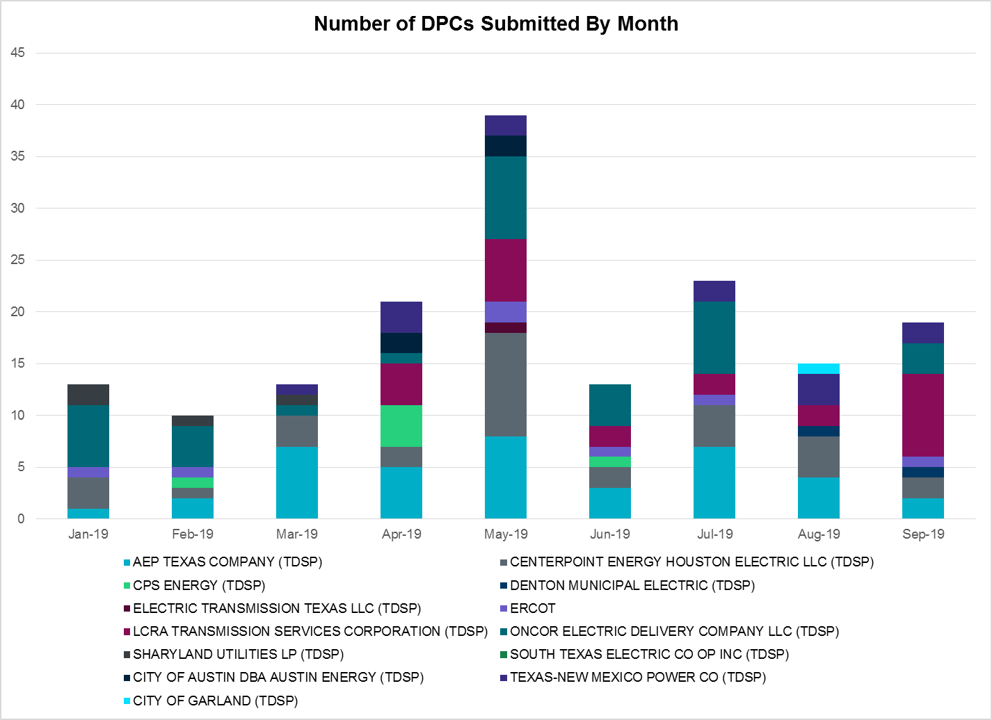

Transmission Operator | Number of DPCs
AEP TEXAS COMPANY (TDSP) | 2
BRAZOS ELECTRIC POWER CO OP INC (TDSP) | 0
CENTERPOINT ENERGY HOUSTON ELECTRIC LLC (TDSP) | 2
CITY OF AUSTIN DBA AUSTIN ENERGY (TDSP) | 0
CITY OF GARLAND (TDSP) | 0
CPS ENERGY (TDSP) | 0
DENTON MUNICIPAL ELECTRIC (TDSP) | 1
ELECTRIC TRANSMISSION TEXAS LLC (TDSP) | 0
ERCOT | 1
LCRA TRANSMISSION SERVICES CORPORATION (TDSP) | 8
ONCOR ELECTRIC DELIVERY COMPANY LLC (TDSP) | 3
SHARYLAND UTILITIES LP (TDSP) | 0
SOUTH TEXAS ELECTRIC CO OP INC (TDSP) | 0
TEXAS MUNICIPAL POWER AGENCY (TDSP) | 0
TEXAS-NEW MEXICO POWER CO (TDSP) | 2

Appendix A: Real-Time Constraints
The following is a complete list of constraints activated in SCED. Full contingency descriptions can be found in the Standard Contingencies List located on the MIS secure site at Grid Generation Reliability Unit Commitment.

Contingency | Constrained Element | From Station | To Station | # of Days Constraint Active
SECNMO28 | 6101__A | NOTSW | CHEYT | 27
BASE CASE | PNHNDL | n/a | n/a | 27
SECNMO28 | 6100__G | ACSSW | AMTBT | 24
DWINDUN8 | 6100__G | ACSSW | AMTBT | 23
SSOLFTS8 | ALPINE_BRONCO1_1 | BRONCO | ALPINE | 20
SRAYRI28 | RAYMND2_69A1 | RAYMND2 | RAYMND2 | 18
SBRAUVA8 | HAMILT_MAVERI1_1 | HAMILTON | MAVERICK | 17
XHAM88 | SONR_69-1 | SONR | SONR | 17
SPIGSOL8 | RIOPEC_WOODW21_1 | WOODWRD2 | RIOPECOS | 16
DHCKSAG8 | 6265__A | EMSES | MRSDO | 16
SCOLPAW5 | COLETO_ROSATA1_1 | COLETO | ROSATA | 15
SLAQLOB8 | BRUNI_69_1 | BRUNI | BRUNI | 15
SFORYEL8 | HEXT_YELWJC1_1 | YELWJCKT | HEXT | 14
DWINDUN8 | 6101__A | NOTSW | CHEYT | 13
DCHBJOR5 | LANMB_86_A | MB | LAN | 12
DCRLLSW5 | 590__B | LWVJS | LKPNT | 12
DAUSLOS5 | 169T263_1 | FPP138 | LAGRAN | 9
SCAGKEN5 | 74T148_1 | COMFOR | CICO | 9
SGARLYT5 | CKT_962_1 | GARFIELD | STONEY_R | 8
SILLFTL8 | OZNR_OZONA1_1 | OZONA | OZNR | 8
SECNMO28 | 6480__A | MOSSW | ECTHP | 8
DCPSJON5 | 6017__A | MBDSW | DCSES | 8
XVI2C89 | VICTORIA_69A2 | VICTORIA | VICTORIA | 7
DWAPHLJ5 | JCKSTP18_A | STP | JCK | 7
DHECWHI8 | RINCON_WHITE_2_1 | WHITE_PT | RINCON | 7
SPAUSAR8 | CONCHO_SAEM1_1 | CONCHO | SAEM | 7
DHECWHI8 | RINCON_WHITE_2_1 | RINCON | WHITE_PT | 7
BASE CASE | RANDAD_ZAPATA1_1 | RANDADO | ZAPATA | 7
SHAMMAX8 | SONR_69-1 | SONR | SONR | 7
DMTSCOS5 | 6437__F | SCRCV | KNAPP | 7
SGARROM8 | GARZA_69A1 | GARZA | GARZA | 7
DBBSRCH5 | 1750__B | SGOVL | KLBTP | 6
SCOMHA38 | HAMILT_MAXWEL1_1 | MAXWELL | HAMILTON | 6
SCOLPAW5 | LOOP_VICTORIA_1 | VICTORIA | L_463S | 6
SMDLODE5 | ODEHV_MR2H | ODEHV | ODEHV | 6
DDUPHE18 | I_DUPS_MCCAMP2_1 | I_DUPSW | MCCAMPBE | 6
SSACRED8 | SAPOWE_SASOUT1_1 | SAPOWER | SASOUTH | 6
DSTEXP12 | BLESSI_LOLITA1_1 | LOLITA | BLESSING | 6
SBEVASH8 | TURTLECK_WCRYS_1 | TURTLCRK | WCRYSTS | 5
DLYTTUN8 | CKT_943_1 | LYTTON_S | PILOT | 5
SLOBSA25 | LARDVN_LASCRU1_1 | LARDVNTH | LASCRUCE | 5
DMGSQAL5 | 14040__A | PCTSW | RBPOI | 4
SCOLKEN8 | MAGRUD_VICTOR2_1 | VICTORIA | MAGRUDER | 4
SECNMO28 | 6100__F | DHIDE | NOTSW | 4
SRDODES8 | 940__C | ENWSW | WXHCH | 4
BASE CASE | PLESNTN_TORDLO_1 | TORDILLO | PLSNTOS | 4
DFERGRM8 | SANDCR_AT1 | SANDCR | SANDCR | 4
SPOLPHA8 | GCB_100_1 | N_MCALLN | W_MCALLN | 4
SBAKBIG5 | FTST_SOLSTI1_1 | FTST | SOLSTICE | 4
SI_DWHI8 | HECKER_MCCAMP1_1 | MCCAMPBE | HECKER | 4
SLOBSA25 | NLARSW_PILONC1_1 | NLARSW | PILONCIL | 4
SMDOPHR5 | 138_ALV_MNL_1 | ALVIN | MAINLAND | 4
DPDSCNR8 | 3665__C | PRCRK | SCYEN | 4
DCAGCO58 | 583T583_1 | BANDER | MASOCR | 4
DZORHAY5 | BERGHE_AT1L | BERGHE | BERGHE | 4
SCMNCPS5 | 651__B | CMNSW | CMNTP | 4
SWOORI38 | 16TH_WRD2_1 | WOODWRD2 | 16TH_ST | 3
XCAG158 | CAGNON_MR4H | CAGNON | CAGNON | 3
SSONFRI8 | FDR_OZNC_1 | OZNC | FRIEND_R | 3
SBRAHAM8 | HAMILT_MAVERI1_1 | HAMILTON | MAVERICK | 3
DYKNWIN8 | 6100__G | ACSSW | AMTBT | 3
DENWSTE8 | 921__D | ENSSW | TRU | 3
SBEVASH8 | BIG_BRUN_1 | BIGWELS | BRUNDGS | 3
SGARGA35 | CKT_1026_1 | ONION | STONEY_R | 3
DWAPHLJ5 | STPWAP39_1 | STP | WAP | 3
DSHREVR5 | 6310__A | EVRSW | OAKT1 | 3
DYKNWIN8 | 6100__F | DHIDE | NOTSW | 3
SBGLTWI8 | CONCHO_SAMATH1_1 | CONCHO | SAMATHIS | 3
DFERSTA8 | CORONA_AT4 | CORONA | CORONA | 3
DMARPA_8 | CORONA_AT4 | CORONA | CORONA | 3
SWOORI38 | RIOPEC_WOODW21_1 | RIOPECOS | WOODWRD2 | 3
SSONFRI8 | SONR_69-1 | SONR | SONR | 3
SGARGA35 | CKT_1026_1 | STONEY_R | ONION | 3
XHIL158 | HILLCTRY_MR4H | HILLCTRY | HILLCTRY | 3
SMGIENW8 | 921__D | ENSSW | TRU | 3
SSONFRI8 | FDR_OZNC_1 | FRIEND_R | OZNC | 3
DCDHMCS8 | 3160__A | CDCSW | OKCLS | 2
DELMSAN5 | PAWNEE_SPRUCE_1 | PAWNEE | CALAVERS | 2
DBIGKEN5 | HAMILT_MAXWEL1_1 | MAXWELL | HAMILTON | 2
SNORODE5 | HARGRO_TWINBU1_1 | TWINBU | HARGROVE | 2
DFPPFAY5 | MAGRUD_VICTOR2_1 | VICTORIA | MAGRUDER | 2
DNEDWED8 | NEDIN_N_MCAL1_1 | NEDIN | N_MCALLN | 2
BASE CASE | RV_RH | n/a | n/a | 2
DCPSJON5 | 152__A | MBDSW | RKCRK | 2
SSTABS18 | 6144__A | BSPRW | STASW | 2
DAUSDES8 | DUNLAP_AT1 | DUNLAP | DUNLAP | 2
BASE CASE | HAMILT_MAXWEL1_1 | MAXWELL | HAMILTON | 2
SN_MN_M8 | PHARR_POLK_A1_1 | PHARR | POLK_AVE | 2
SREDMCC8 | 102T375_1 | MCCALA | RNRD12 | 2
DFERSTA8 | 37T187_1 | FERGUS | SHERSH | 2
DNAVWTR5 | 530__C | VENSW | BRTRD | 2
SECNMO28 | 6100__B | AMTBT | DHIDE | 2
SSANSAN8 | PLESNTN_TORDLO_1 | TORDILLO | PLSNTOS | 2
DAUSLOS5 | 355T255_1 | FPPYD2 | LYTTON_S | 2
DBUZLME8 | 6610__A | BUZSW | CHATP | 2
DGARLYT5 | CKT_1026_1 | STONEY_R | ONION | 2
DHECWHI8 | I_DUPS_RINCON1_1 | I_DUPSW | RINCON | 2
DCAGCI58 | 342T195_1 | GRANMO | MARBFA | 2
DYKNWIN8 | 6100__B | AMTBT | DHIDE | 2
DVICEDN8 | LOOP_VICTORIA_1 | VICTORIA | L_463S | 2
SPORNCA9 | NCARBI_PV_TAP1_1 | NCARBIDE | PV_TAP | 2
SWHIBUT8 | 372T359_1 | GABRIE | GLASSC | 2
SCISPUT8 | SOUTHA_VINSON1_1 | SOUTHABI | VINSON | 2
SMNWORA8 | BNK_MIL_1 | MIL | BNK | 2
DKOCNUE8 | CHAMPL_WEIL_T1_1 | WEIL_TRC | CHAMPLIN | 2
DCE_GA58 | GARZA_69A1 | GARZA | GARZA | 2
XDUN58 | AUSTRO_AT1H | AUSTRO | AUSTRO | 2
DNAVLEG5 | 10__A | BBSES | NAVARRO | 1
DFPPFAY5 | 190T152_1 | GIDEON | WINCHE | 1
SSOLFTS8 | BARL_FTSW1_1 | FTSW | BARL | 1
DELMSAN5 | COLETO_ROSATA1_1 | COLETO | ROSATA | 1
DCRLLSW5 | COP_COPE_G1 | CPL | COPEL | 1
SCRNLC38 | FTST_SOLSTI1_1 | FTST | SOLSTICE | 1
SKLEKLE8 | LOYOLA_69_1 | LOYOLA | LOYOLA | 1
BASE CASE | MCCAMY | n/a | n/a | 1
DFORELK5 | SGVSW_MR2L | SGVSW | SGVSW | 1
XRIN89 | WHITE_PT_69A1 | WHITE_PT | WHITE_PT | 1
XPH2R58 | 138_ALV_MNL_1 | ALVIN | MAINLAND | 1
DFORELK5 | 1400__G | LWSNR | BSPTP | 1
SMEMANA8 | 1590__E | STNSW | SHMNE | 1
DFLCMGS5 | 6095__G | JPPOI | ALKLK | 1
DWINDUN8 | 6100__B | AMTBT | DHIDE | 1
DENWSTE8 | 921__B | TRU | RDOAK | 1
XFTS89 | BARL_FMR1 | BARL | BARL | 1
DAUSDUN8 | CKT_1032_1 | HWRDLN | ASHWDS | 1
DAUSDUN8 | CKT_975_1 | DUNLAP | TRIDGE | 1
BASE CASE | FTST_SOLSTI1_1 | FTST | SOLSTICE | 1
DAUSGAR5 | GARFIELD_AT1 | GARFIELD | GARFIELD | 1
BASE CASE | N_TO_H | n/a | n/a | 1
SLAGMAR8 | 469T469_1 | WHITES | BLOCKH | 1
DHCKSAG8 | 6265__C | RHTP2 | SAGNA | 1
DZORHAY5 | BERGHE_AT1H | BERGHE | BERGHE | 1
DRILKRW5 | BOW_FMR1 | BOW | BOW | 1
SGARAUS5 | CKT_1026_1 | STONEY_R | ONION | 1
SGARLYT5 | CKT_1026_1 | STONEY_R | ONION | 1
SBRAUVA8 | GANSO_MAVERI1_1 | MAVERICK | GANSO | 1
SSCUSU28 | GIRA_T_SPUR1_1 | SPUR | GIRA_TAP | 1
XRAD89 | ONYXRE_QUAINT1_1 | ONYXREA | QUAINT | 1
SSCUSU28 | SPUR_69_1 | SPUR | SPUR | 1
SHCKRNK5 | 106__A | HCKSW | ALLNC | 1
DFLCMGS5 | 6095__D | LMESA | JPPOI | 1
SAVMBSP8 | 6095__D | LMESA | JPPOI | 1
DTMEBLT8 | 610__B | TMPSW | TMPSE | 1
DHCKSAG8 | 6260__C | EMSES | EMMCP | 1
DEVRCRT5 | 6310__A | EVRSW | OAKT1 | 1
SWLFWIC8 | 6710__A | YUCSW | WICKETT | 1
SBEVASH8 | CARIZOSPG_BEVO_1 | CARIZOS | BEVO | 1
SN_SLON5 | CELANE_N_SHAR1_1 | N_SHARPE | CELANEBI | 1
SFTLMES8 | CROSSO_NORTMC1_1 | NORTMC | CROSSOVE | 1
SBIGTWI5 | FTST_SOLSTI1_1 | FTST | SOLSTICE | 1
SBEVASH8 | HAMILT_MAVERI1_1 | HAMILTON | MAVERICK | 1
XFRI89 | SONR_69-1 | SONR | SONR | 1
STENCR28 | TEN_CRD1_1 | TEN | CRD | 1
SWOORI28 | TOMBST_WDWRDT1_1 | WDWRDTP | TOMBSTNE | 1
DMGSQAL5 | 6095__D | LMESA | JPPOI | 1
DCRMO218 | 6500__B | ODEHV | BTHOT | 1
SBRAUVA8 | ESCOND_GANSO1_1 | GANSO | ESCONDID | 1
SWCSBOO8 | FTST_SOLSTI1_1 | FTST | SOLSTICE | 1
DWORNLA8 | LARDVN_LASCRU1_1 | LARDVNTH | LASCRUCE | 1
DWH_STP5 | MELONC_RINCON1_1 | RINCON | MELONCRE | 1
XPH3R58 | 138_ALV_MNL_1 | ALVIN | MAINLAND | 1
DCPSMBD5 | 150__A | DCSES | BNBSW | 1
DHUTGEA8 | 211T147_1 | GILLCR | MCNEIL_ | 1
SBNDRYS5 | 568__A | RYSSW | NEVADA | 1
DYKNWIN8 | 6101__A | NOTSW | CHEYT | 1
DEVRCRT5 | 6410__D | HLSES | LKWOD | 1
XMDS58 | 6475__C | ODEHV | TROTP | 1
SLOBSA25 | BRUNI_69_1 | BRUNI | BRUNI | 1
XNED258 | BURNS_RIOHONDO_1 | RIOHONDO | MV_BURNS | 1
UAMIAMI1 | DEL_RI_HAMILT1_1 | HAMILTON | DEL_RIO | 1
SNORODE5 | FTST_SOLSTI1_1 | FTST | SOLSTICE | 1
SSPUMW18 | SPUR_69_1 | SPUR | SPUR | 1
SMDOOAS5 | AE_LV_04_A | AE | LV | 1
SCRDLOF9 | BOW_FMR1 | BOW | BOW | 1
DGARLYT5 | CKT_962_1 | GARFIELD | STONEY_R | 1
SPHRCTR5 | DIBMNT21_A | DIB | MNT | 1
SCRNODE8 | FTST_SOLSTI1_1 | FTST | SOLSTICE | 1
SPLEODE8 | HARGRO_TWINBU1_1 | TWINBU | HARGROVE | 1
DELMSAN5 | MAGRUD_VICTOR2_1 | VICTORIA | MAGRUDER | 1
SSCUSU28 | ROTN_WOLFGA1_1 | WOLFGANG | ROTN | 1
DAUSLOS5 | 367T347_1 | MAXZUE | GAYHIL | 1
DMTSCOS5 | 6240__C | SACRC | DPCRK | 1
SMCEESK8 | 6780__A | ESKSW | LONGWRTH | 1
SCOLBAL8 | BALLIN_HUMBLT1_1 | BALLINGE | HUMBLTAP | 1
DAUSGAR5 | CKT_962_1 | GARFIELD | STONEY_R | 1
SSOLFTS8 | FTST_69T1 | FTST | FTST | 1
BASE CASE | SPE_DEN_1 | SPNCER | DENTON | 1

The Duration of Event is defined as the time it takes for the frequency to recover to pre-disturbance frequency or 60 Hz as applicable.
PMU reports are typically generated when frequency drops below 59.9, but PMU data is available for other events.
Delta Frequency is defined as the difference between the starting point of the frequency event (t(0) or “A-point”) and minimum/maximum frequency (“C-Point”).
Currently, the Critical Inertia Level for ERCOT is approximately 100,000 MW-s
This is the hourly integrated peak demand as published in the ERCOT D&E report.
All DC Tie Curtailments are posted publically on the ERCOT Market Information System. See that posting for additional details for the event(s) in question.
See DC Tie Operating Procedure (http://www.ercot.com/mktrules/guides/procedures) for more details.

