System Planning

Monthly Status Report
September 2019

Report Highlights
- ERCOT is currently reviewing proposed transmission improvements with a total estimated cost of $1,003.8 Million as of September 30, 2019.
- Transmission Projects endorsed in 2019 total $416.3 Million as of September 30, 2019.
- All projects (in engineering, routing, licensing and construction) total approximately $3.41 Billion as of October 1, 2019.
- Transmission Projects energized in 2019 total about $1.30 Billion as of October 1, 2019.

Regional Planning Group Project Reviews
- AEPSC has submitted the LRGV Import Project. This is a Tier 1 project that is estimated to cost $73.4 million. AEPSC has also requested that ERCOT provide conditional endorsement for an additional $357.2 million project. This project is currently under ERCOT Independent Review.
- TNMP has submitted the Ward and Winkler County Transmission Improvement Project. This is a Tier 2 project that is estimated to cost $60 million. ERCOT completed the independent review and presented study results at the September 18 RPG meeting. ERCOT posted the study report in the MIS Secure Area on September 19 and is currently preparing the ERCOT endorsement letter.
- STEC has submitted the Lower Rio Grande Valley Transmission Expansion Project. This is a Tier 1 project that is estimated to cost $511 million. This project is currently under ERCOT Independent Review.
- AEPSC has submitted the Nueces 69 kV Reinforcement Project. This is a Tier 2 project that is estimated to cost $17.6 million. ERCOT completed the independent review and presented study results at the September 18 RPG meeting. ERCOT posted the study report in the MIS Secure Area on September 19 and is currently preparing the ERCOT endorsement letter.
- AEPSC has submitted the Lon Hill to Warburton 138 kV Line Rebuild Transmission Project. This is a Tier 3 project that is estimated to cost $62.2 million. This project is currently under RPG study period.
- Oncor has submitted the Permian Basin Area Upgrades Project. This is a Tier 3 project that is estimated to cost $39.8 million. This project completed the RPG review on September 6, and ERCOT issued the RPG acceptance letter.

More information on current and past RPG projects can be found on the ERCOT MIS Secure (digital certificate required): https://mis.ercot.com/pps/tibco/mis/Pages/Grid+Information/RegionalPlanning
Past email communication on RPG projects can be found on the ERCOT listserve by signing up for the REGPLANGROUP list: http://lists.ercot.com/scripts/wa-ERCOT.exe?A0=REGPLANGROUP

Planning Model Activities
The short-term calendar of major planning model events is as follows:
- October 31, 2019 Post 19SSWG Update 1 Contingency definitions and Planning Data Dictionary
The following table shows interconnection projects that met Planning Guide section 6.9(1) and 6.9(2) and were modeled in the SSWG cases as a full model or as a simple model in accordance with Planning Guide section 6.9.
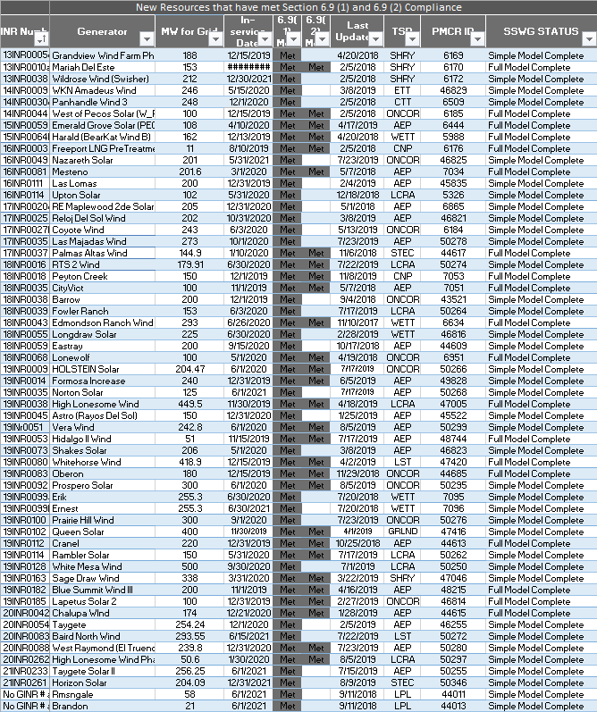

Permian Basin Oil Rig Count
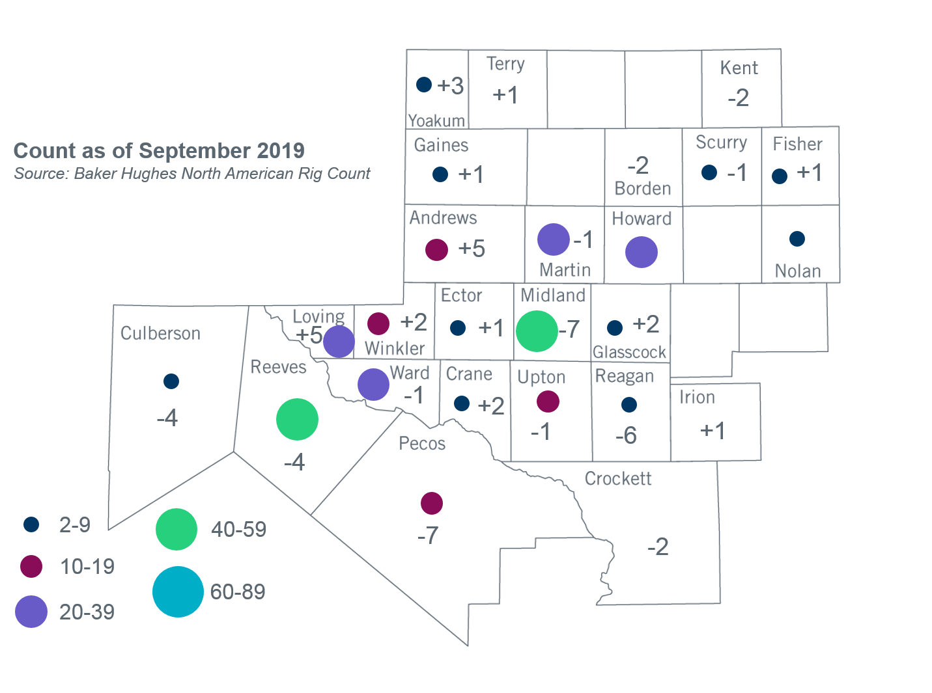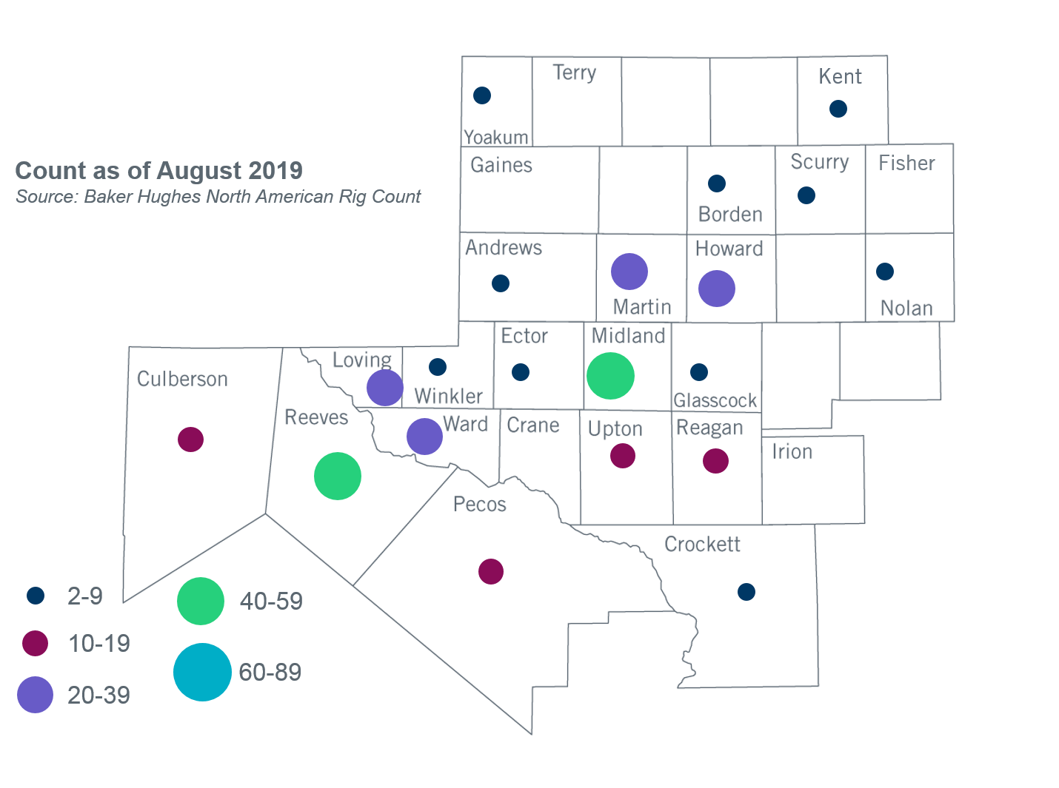

Other Notable Activities
- ERCOT is conducting the 2019 Regional Transmission Plan (RTP). Preliminary reliability projects have been identified for the base cases. ERCOT is currently working on additional reliability analysis for the base cases, sensitivity analysis, and economic analysis. ERCOT presented plans for sensitivity analysis to the Regional Planning Group (RPG) in September.
- ERCOT presented updated results for the 2020 Long-Term System Assessment (LTSA) to the Regional Planning Group (RPG) in September. The updates considered feedback gathered from stakeholder surveys following the May RPG meeting. ERCOT is continuing to develop the Current Trends scenario.
- The SPWG completed the 2019 CY base case on March 29 and the 2020 - 2024 Future Year (FY) case build was completed on July 19.
- ERCOT is currently conducting the Delaware Basin area load integration study. The purpose of the study is to identify potential reliability needs and transmission upgrades for the load (planned and conceptual) that may appear in the area in the longer term planning horizon.

+/- symbol indicates the increase or decrease from the previous month in oil rigs present in each county. There are 304 rigs, including a total decrease of 15 oil rigs, in the Permian Basin from August to September 2019.

