PWG Meeting Notes – May 10, 2019
WebEx only
9:30 am

Attendees:

Sam Pak – Oncor
Sheri Wiegand – TXU
Kathy Scott – CNP
Diana Rehfeldt – TNMP
Carolyn Reed – CNP
Bill Boswell - ERCOT
Jim Lee – AEP
Eric Blakey – Just Energy
Randy Roberts - ERCOT
Phil Bracy – ERCOT
David Detelich – CPS Energy
Jordan Troublefield - ERCOT

- Sheri Wiegand, Chair 2018, read Antitrust Admonition and reviewed the agenda
- Meeting minutes from March 29th were reviewed and approved

- NPRR 923 Revision to Weather Responsiveness Determination Process - will be taken up at the May TAC and June Board meetings; anticipate approval

- Business Annual Validation Update
  - REVISED Matrix: (taking into consideration WG and Randy Roberts suggested edits)

- TDSPs provided the following status on sending 814_20s:
  - CNP – 65% complete
  - Oncor – sending 814_20s on cycle
  - AEP – sending 814_20s on cycle
  - TNMP – has sent on cycle ~2700 have been submitted

- 2018 UFE Report – Randy presented the 2018 report. Below are highlights…
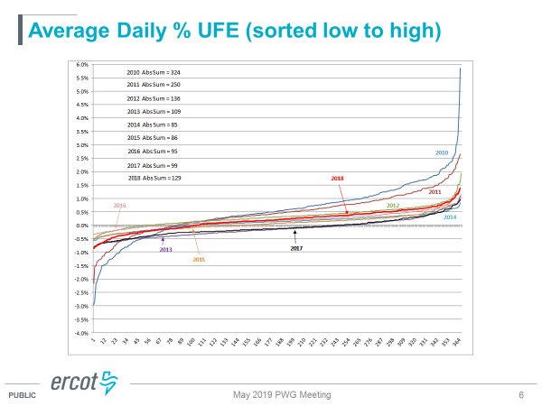

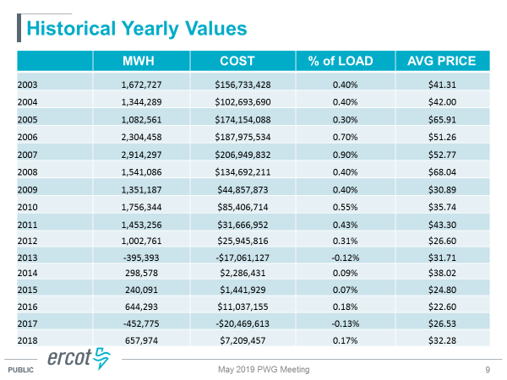

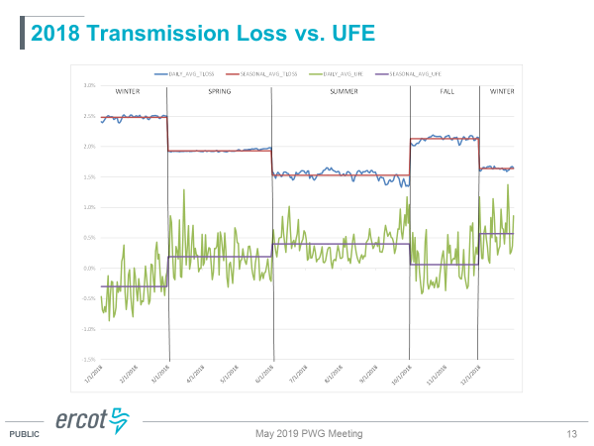
- ACTION: Randy will follow up with MSWG to see if this report should fall under the jurisdiction of this working group given the wholesale impacts. Depending on outcome, Randy will draft possible protocol language revisions.

- Other Business –
  - Sheri requested an update of NPRR 877 and the grey box language regarding the BUSIDRRQ language and daily reads and Randy’s follow up. Given the schedule of the pending AEP and CNP rate cases, we will review once again at the next meeting (November) to determine if any action should be taken.
  - Carolyn inquired about the status of the Lubbock addition to the ERCOT market. Randy indicated this is expected to occur. The question currently at hand is if they will transition to ERCOT initially as a NOIE, then transition to competition OR if they will move straight to competition. The analysis is still underway. Randy also provided Lubbock is currently deploying AMS metering.

- Reviewed Meeting Plan for 2019
    - Review Randy’s presentation on BUSIDRRQ and daily settlement data
  - November 8th @ 9:30 am, WebEx
    - Update on Business Annual Validation
    - Discussion on BUSIDRRQ and daily settlement data – grey box language
    - 2019 Accomplishments / 2020 Goals
    - Weather Sensitivity report

- Meeting adjourned @ 10:16 am

