August 2019 ERCOT Monthly Operations Report
Reliability and Operations Subcommittee Meeting
October 3, 2019

Table of Contents
1. Report Highlights 2
2. Frequency Control 3
2.1. Frequency Events 3
2.2. Responsive Reserve Events 4
2.3. Load Resource Events 4
3. Reliability Unit Commitment 5
4. Wind Generation as a Percent of Load 5
5. Largest Net-Load Ramp 6
6. COP Error Analysis 6
7. Congestion Analysis 8
7.1. Notable Constraints 8
7.2. Generic Transmission Constraint Congestion 12
7.3. Manual Overrides 12
7.4. Congestion Costs for Calendar Year 2019 12
8. System Events 14
8.1. ERCOT Peak Load 14
8.2. Load Shed Events 14
8.3. Stability Events 14
8.4. Notable PMU Events 14
8.5. DC Tie Curtailment 14
8.6. TRE/DOE Reportable Events 15
8.7. New/Updated Constraint Management Plans 15
8.8. New/Modified/Removed RAS 15
8.9. New Procedures/Forms/Operating Bulletins 15
8.10. Emergency Events 15
9. Emergency Conditions 16
9.1. OCNs 16
9.2. Advisories 16
9.3. Watches 16
9.4. Emergency Notices 17
10. Application Performance 17
10.1. TSAT/VSAT Performance Issues 17
10.2. Communication Issues 17
10.3. Market System Issues 17
11. Model Updates 17
Appendix A: Real-Time Constraints 20

Report Highlights
- The unofficial ERCOT peak was 74,666 MW, which is a new record. The previous record was 73,308 MW, which was set in July 2018. ERCOT also set a new peak weekend demand record at 71,915 MW.
- There were 4 frequency events.
- There were 7 instances where Responsive Reserves were deployed.
- There were 9 RUC commitments.
- Congestion in the West Load Zone (LZ) can be attributed to forced outages and to high Panhandle wind generation during times of high load in the Dallas area. Congestion in the South LZ was mostly due to the outage of generators in the San Antonio area, along with high load. Congestion in the North and Houston LZs was minimal. Congestion across zones was primarily due to a single constraint associated with the forced outage of generators in the Houston area. There were 23 days of congestion on the Panhandle GTC, 2 days on the Nedin – Lobo GTC, and 1 on the Raymondville – Rio Hondo GTC.
- There was 12 DC Tie curtailments. All were associated with the DC-L tie and most were due to an unplanned outage.

For more about the EEA 1 events in August, please see the slides presented at the previous ROS meeting.

Frequency Control

Frequency Events
The ERCOT Interconnection experienced four frequency events, all of which resulted from a unit trip. The average event duration was approximately 00:04:05.

A summary of the frequency events is provided below. The reported frequency events meet one of the following criteria: Delta Frequency is 60 mHz or greater; the MW loss is 350 MW or greater; resource trip event triggered RRS deployment. Frequency events that have been identified as Frequency Measurable Events (FME) for purposes of BAL-001-TRE-1 analysis are highlighted in blue. When analyzing frequency events, ERCOT evaluates PMU data according to industry standards. Events with an oscillating frequency of less than 1 Hz are considered to be inter-area, while higher frequencies indicate local events. Industry standards specify that damping ratio for inter-area oscillations should be 3.0% or greater. For the frequency events listed below, the ERCOT system met these standards and transitioned well after each disturbance.

Date and Time | Delta Frequency | Max/Min Frequency | Duration of Event | PMU Data |  | MW Loss | Load | Wind | Inertia
 | (Hz) | (Hz) |  | Oscillation Mode (Hz) | Damping Ratio |  | (MW) | % | (GW-s)
8/2/2019 14:07 | 0.062 | 59.894 | 0:06:16 | No PMU data available |  | 285.6 | 67,527 | 4% | 386,480
8/10/2019 6:49 | 0.122 | 59.869 | 0:03:08 | 0.64 | 10% | 1081.29 | 44,191 | 21% | 313,403
8/11/2019 6:18 | 0.086 | 59.933 | 0:03:36 | No PMU data available |  | 503.902 | 43,469 | 29% | 311,274
8/14/2019 20:31 | 0.068 | 59.899 | 0:03:21 | No PMU data available |  | 432.7 | 63,612 | 7% | 373,030

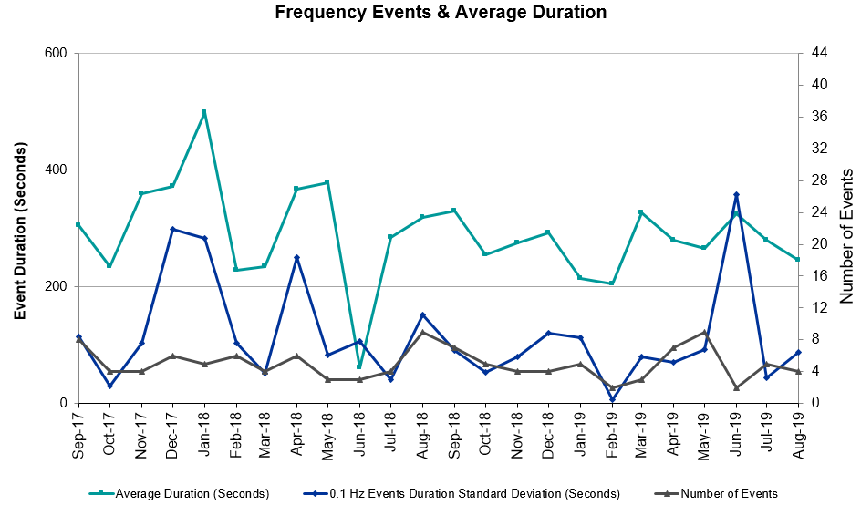 (Note: All data on this graph encompasses frequency event analysis based on BAL-001-TRE-1.)

Note that the large standard deviation in June 2019 is due to coincidental extreme high and low durations for a small set of events (2).

Responsive Reserve Events
There were seven events where Responsive Reserve MWs were released to SCED. The events highlighted in blue were related to frequency events reported in Section 2.1 above.

Date and Time Released to SCED | Date and Time Recalled | Duration of Event | Maximum MWs Released | Comments
8/2/2019 14:07 | 8/2/2019 14:14 | 00:06:32 | 520
8/10/2019 6:49 | 8/10/2019 6:52 | 00:02:28 | 429
8/12/2019 14:41 | 8/12/2019 15:12 | 00:30:48 | 250 | RRS Manually Deployed
8/13/2019 14:34 | 8/13/2019 16:02 | 01:28:09 | 750 | EEA1 RRS Manually Deployed
8/14/2019 20:31 | 8/14/2019 20:34 | 00:03:24 | 627
8/15/2019 14:48 | 8/15/2019 16:10 | 01:22:40 | 600 | EEA1 RRS Manually Deployed
8/15/2019 16:19 | 8/15/2019 16:41 | 00:22:32 | 300 | EEA1 RRS Manually Deployed

Load Resource Events
None.

Reliability Unit Commitment
ERCOT reports on Reliability Unit Commitments (RUC) on a monthly basis. Commitments are reported grouped by operating day and weather zone. The total number of hours committed is the sum of the hours for all the units in the specified region. Additional information on RUC commitments can be found on the MIS secure site at Grid Generation Reliability Unit Commitment.

There were no DRUC commitments.

There were 9 HRUC commitments.

Resource Location | # of Resources | Operating Day | Total # of Hours Committed | Total MWhs | Reason for Commitment
North Central | 1 | 8/6/2019 | 5 | 2,550 | Capacity
East | 1 | 8/9/2019 | 3 | 1,440 | Capacity
West | 3 | 8/13/2019 | 3 | 34 | EEA 1
South Central | 2 | 8/13/2019 | 2 | 43 | EEA 1
South Central | 2 | 8/15/2019 | 2 | 48 | EEA 1

Wind Generation as a Percent of Load
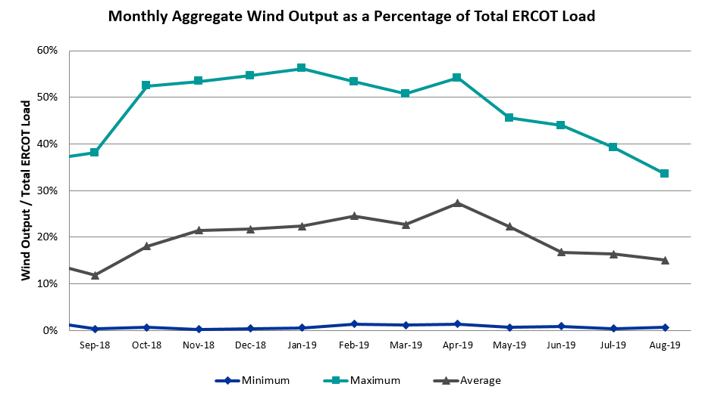

Wind Generation Record: 19,672 MW on 01/21/2019 at 19:19
Wind Penetration Record: 56.16% on 01/19/2019 03:10

Largest Net-Load Ramp
The net-load ramp is defined as the change in net-load (load minus wind and PVGR generation) during the defined time horizon. Such a variation in net-load needs to be accommodated in grid operations to ensure that the reliability of the grid is satisfactorily maintained. The largest net-load ramp during 5-min, 10-min, 15-min, 30-min and 60-min intervals is 744 MW, 1271 MW, 1630 MW, 2813 MW, and 4586 MW respectively. The comparison with respect to the historical values is given in the table below.

Month and Year | 5 min | 10 min | 15 min | 30 min | 60 min
August 2019 | 744 MW | 1271 MW | 1630 MW | 2813 MW | 4586 MW
August 2014 | 674 MW | 1169 MW | 1589 MW | 2854 MW | 5201 MW
August 2015 | 776 MW | 1231 MW | 1754 MW | 3303 MW | 6260 MW
August 2016 | 834 MW | 1350 MW | 1881 MW | 3230 MW | 6319 MW
August 2017 | 797 MW | 1421 MW | 1953 MW | 3167 MW | 5798 MW
August 2018 | 1333 MW | 1854 MW | 2780 MW | 3205 MW | 6604 MW
2014-2018 | 1494 MW | 1991 MW | 2780 MW | 4109 MW | 7218 MW

COP Error Analysis
COP Error is calculated as the capacity difference between the COP HSL and real-time HSL of the unit. Mean Absolute Error (MAE) stayed high over 12,900 MW until Day-Ahead at 12:00, then dropped significantly to 1,628 MW by Day-Ahead at 14:00. In the following chart, Under-Scheduling Error indicates that COP had less generation capacity than real-time and Over-Scheduling Error indicates that COP had more generation capacity than real-time. Under-Scheduling persisted from beginning of Day-Ahead to end of the Operating Day. Snapshot on the Operating Day considers all Operating Hours, including past hours. However, COP error for the Operating Hour freezes after the Adjustment Period.

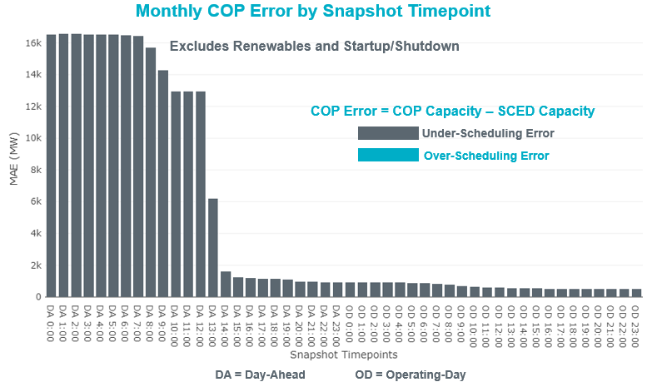

Monthly MAE for the Latest COP at the end of the Adjustment Period was 485 MW with median ranging from 210 MW for Hour-Ending (HE) 2 to -986 MW for HE 19. HE 9 on the 10th had the largest Over-Scheduling Error (1,583 MW) and HE 19 on the 6th had the largest Under-Scheduling Error (-2,942 MW).

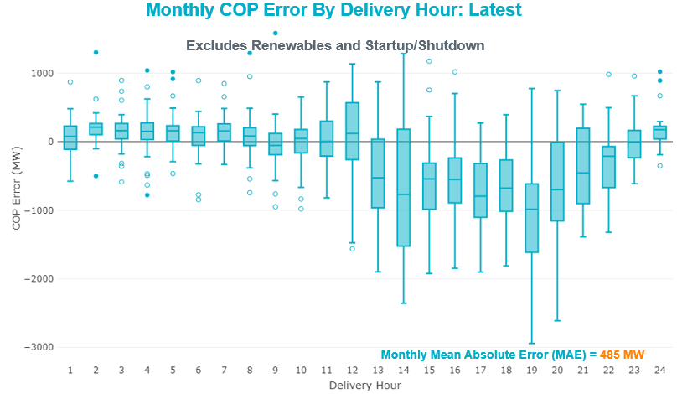

Monthly MAE for the Day-Ahead COP at 12:00 was 12,961 MW with median ranging from -9,208MW for Hour-Ending (HE) 2 to -18,055 MW for HE 18. HE 3 on the 2nd had the largest Over-Scheduling Error (-3,999 MW) and HE 19 on the 14th had the largest Under-Scheduling Error (-20,494 MW).

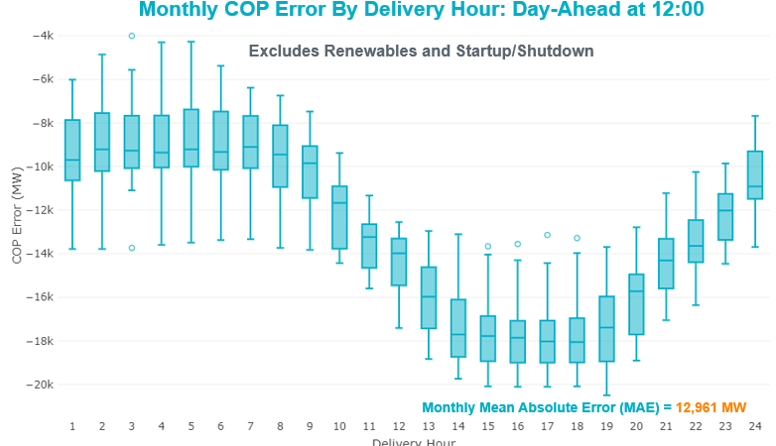

Congestion Analysis

Notable Constraints
Nodal protocol section 3.20 specifies that ERCOT shall identify transmission constraints that are active or binding three or more times within a calendar month. As part of this process, ERCOT reports congestion that meets this criterion to ROS. In addition ERCOT also highlights notable constraints that have an estimated congestion rent exceeding $1,000,000 for a calendar month. These constraints are detailed in the table below. Rows highlighted in blue indicate the congestion was affected by one or more outages. For a list of all constraints activated in SCED, please see Appendix A at the end of this report.

Contingency Name | Overloaded Element | # of Days Constraint Active | Congestion Rent | Transmission Project
TWR (345) HLJ-WAP64 & BLY-WAP72 | South Texas Project - Wa Parish 345kV | 5 | $13,387,674.16 | Freeport Master Plan (6668A)
MOSS SWITCH to ECTOR COUNTY NORTH SWITCHING STATION LIN _A | Moss Switch - Shin Oak Pod 138kV | 2 | $7,619,533.08 | Riverton-Odessa EHV/Moss 345 kV Line (5445) & Riverton - Sand Lake 138 kV Line (4759)
ODESSA EHV SWITCH to MOSS SWITCH LIN _A | Trigas Odessa Tap - Odessa Ehv Switch 138kV | 5 | $6,290,437.11 | Riverton-Odessa EHV/Moss 345 kV Line (5445)
COLETO CREEK to PAWNEE SWITCHING STATION LIN 1 | Coleto Creek - Rosata Tap 138kV | 21 | $5,880,301.12 | Coleto Creek to Tuleta: New 138 kV Line (16TPIT0034)
MOSS SWITCH to ECTOR COUNTY NORTH SWITCHING STATION LIN _A | No Trees Switch - Cheyenne Tap 138kV | 12 | $5,328,699.83 | Wink Sw. Sta. - No Trees Sw. Sta. 138 kV Line (7101)
WINK to DUNE SWITCH and YUKON | Moss Switch - Shin Oak Pod 138kV | 1 | $2,941,170.25 | Riverton-Odessa EHV/Moss 345 kV Line (5445)
Basecase | PNHNDL GTC | 23 | $2,856,674.68
COLETO CREEK to KENEDY SWITCH LIN 1 | Magruder - Victoria 138kV | 16 | $2,612,820.91
Koch_Up-Gila&Lon_Hill-Nueces_B 138kV | Champlin - Weil Tract 138kV | 5 | $2,209,230.53 | Nueces Area 69kV Reinforcement (4487)
DEL MAR to LAREDO PLANT LIN 1 | Laredo Vft North - Las Cruces 138kV | 20 | $1,877,919.47
ASHERTON to Bevo Substation LIN 1 | Big Wells Sub - Brundage Sub 69kV | 11 | $1,851,085.72 | Rebuild BEVO to Brundage to Big Wells 69 kV lines (6255B)
Riohondo-Nedin 345kV&Harlnsw 138kV | Burns Sub - Rio Hondo 138kV | 10 | $1,404,854.81
RIO HONDO to LAS PULGAS LIN 1 | Raymondville 2 138kV | 25 | $1,329,956.08 | Harlingen SS - Raymondville #2: Convert to 138 kV (6167)
CRLNW-LWSSW 345kV | Jones Street Tnp - Lakepointe Tnp 138kV | 12 | $1,311,493.10 | Lewisville - Lewisville Jones - Lakepointe 138 kV Line (45537)
MOSS SWITCH to ECTOR COUNTY NORTH SWITCHING STATION LIN _A | Andrews County South - Amoco Three Bar Tap 138kV | 6 | $1,293,201.09 | Andrews County South Switch - No Trees Switch 138 kV Line (7171)
NORTH PHARR to POLK AVENUE LIN 1 | North Mcallen - West Mcallen 138kV | 8 | $1,286,395.06 | North McAllen (8368) - West McAllen (8367) - South McAllen (8371) 138-kV line upgrades (2017-S9)/ South McAllen-Bentsen and North Edinburg-West Edinburg (5621)
WINK to DUNE SWITCH and YUKON | Andrews County South - Amoco Three Bar Tap 138kV | 9 | $1,157,001.85 | Andrews County South Switch - No Trees Switch 138 kV Line (7171)
LAQUINTA to LOBO LIN 1 | Bruni Sub 138kV | 26 | $1,148,807.47
South Texas # 1 & # 2 | Blessing - Lolita 138kV | 5 | $772,656.22
SAN MIGUEL 345_138 KV SWITCHYARDS to LOBO LIN 1 | Laredo Vft North - Las Cruces 138kV | 4 | $727,398.81
ODLAW SWITCHYARD to ASPHALT MINES LIN 1 | Hamilton Road - Maverick 138kV | 19 | $624,635.92 | Brackettville to Escondido: Construct 138 kV line (5206)
Hcksw-Sagna-138kv | Eagle Mountain Ses - Morris Dido 138kV | 3 | $622,309.32 | Eagle Mountain-Calmont 138 kV Line (4253)
NORTH CARBIDE to SEADRIFT SUB LIN 1 | North Carbide - Port Lavaca Tap 69kV | 7 | $612,047.35
Solstice to ALAMITO CREEK LIN 1 | Barrilla 138kV | 6 | $521,399.18 | Ft. Stockton SW to Rio Pecos: Rebuild 69 kV line (7028)
HAMILTON ROAD TRX PS2 138/138 | Sonora 138kV | 20 | $519,907.54 | Carver: Build new 138 kV station (5979)
FORT LANCASTER to ILLINOIS #4 LIN 1 | Ozona - Ozona Rea 69kV | 14 | $470,215.69
Flaton- Engle-Schule & Plum 138 kV | Magruder - Victoria 138kV | 6 | $429,127.08
South Texas # 1 & # 2 | Spencer Switch - Denton Steam 69kV | 15 | $365,212.26
OKLAUNION TRX OKLA_3_1 345/138 | Southwest Vernon - Sand Road 69kV | 5 | $347,363.74
MCCARTY LANE to REDWOOD LIN 1 | Mccarty Lane - Ranch Road 12 138kV | 5 | $245,206.26
Jewet-Sng 345kV | Btu_Jack_Creek - Twin Oak Switch 345kV | 3 | $237,534.50
SAN MIGUEL 345_138 KV SWITCHYARDS to LOBO LIN 1 | North Laredo Switch - Piloncillo 138kV | 10 | $164,507.61
DMTSW-SCOSW 345KV | Knapp - Scurry Chevron 138kV | 3 | $155,579.79 | Ennis Creek - Cogdell 69 kV Line (4554) & Ennis Creek 138 kV Switching Station (6269)
Falcon Seaboard to MIDLAND EAST LIN _A | Moss Switch - Odessa Ehv Switch 345kV | 3 | $118,651.20 | Riverton-Odessa EHV/Moss 345 kV Line (5445)
GAS PAD to FLAT TOP TNP LIN 1 | Fort Stockton Plant - Solstice 138kV | 6 | $94,066.83 | Solstice: Build 345 kV station (5530)
Pig Creek to Solstice LIN 1 | Woodward 2 - Rio Pecos 138kV | 10 | $89,753.71 | Lynx: Expand 138 kV station (45503)
HAMILTON ROAD to Maxwell LIN 1 | Sonora 138kV | 8 | $76,394.77 | Carver: Build new 138 kV station (5979)
Bighil-Kendal 345kV | Bondroad - Sonora 69kV | 3 | $55,786.76
HAMILTON ROAD to CORRAL LIN 1 | Hamilton Road - Maxwell 138kV | 8 | $50,661.51 | Brackettville to Escondido: Construct 138 kV line (5206)
Bighil-Kendal 345kV | Hamilton Road - Maxwell 138kV | 13 | $45,506.69 | Brackettville to Escondido: Construct 138 kV line (5206)
FORT LANCASTER to ILLINOIS #4 LIN 1 | Hamilton Road - Maxwell 138kV | 3 | $35,746.49 | Brackettville to Escondido: Construct 138 kV line (5206)
ZORN - HAYSEN 345KV | Bergheim 138kV | 6 | $27,728.87
FORT MASON to YELLOW JACKET LIN 1 | Yellow Jacket - Hext Lcra 69kV | 5 | $25,071.19
Ferguson-Sherwood Shores & Ferguson-Granite Mountain 138kV | Sandy Creek 138kV | 11 | $22,208.62
Basecase | Randado Aep - Zapata 138kV | 11 | $20,353.29
VICTORIA TRX 69A2 138/69 | Magruder - Victoria 138kV | 4 | $19,454.83
ODESSA EHV SWITCH to MOSS SWITCH LIN _A | Fort Stockton Plant - Solstice 138kV | 3 | $11,780.88 | Solstice: Build 345 kV station (5530)
Basecase | Spencer Switch - Denton Steam 69kV | 8 | $11,527.95
WINK to DUNE SWITCH and YUKON | No Trees Switch - Cheyenne Tap 138kV | 5 | $9,881.40 | Wink Sw. Sta. - No Trees Sw. Sta. 138 kV Line (7101)
Solstice to FORT STOCKTON PLANT LIN 1 | Alpine - Bronco 69kV | 8 | $8,275.14
BOSQUE SWITCH to ELM MOTT LIN 1 | Bosque Switch - Rogers Hill Bepc 138kV | 3 | $6,735.56
Basecase | Hamilton Road - Maxwell 138kV | 3 | $5,568.58 | Brackettville to Escondido: Construct 138 kV line (5206)
Basecase | Re Roserock Solar Plant - Linterna 138kV | 3 | $3,693.57 | Solstice to Clovis: Build 138 kV line (4531)

Generic Transmission Constraint Congestion
There were 23 days of congestion on the Panhandle GTC, 2 days on the Nedin – Lobo GTC, and 1 on the Raymondville – Rio Hondo GTC. There was no activity on the remaining GTCs during the month.

Note: This is how many times a constraint has been activated to avoid exceeding a GTC limit, it does not imply an exceedance of the GTC occurred or that the GTC was binding.

Manual Overrides
None.

Congestion Costs for Calendar Year 2019
The following table represents the top twenty active constraints for the calendar year based on the estimated congestion rent attributed to the congestion. ERCOT updates this list on a monthly basis.

Contingency | Binding Element | # of 5-min SCED Intervals | Estimated Congestion Rent | Transmission Project
Basecase | PNHNDL GTC | 21,441 | 38,062,871.41
Elmcreek-Skyline 345kV | Hill Country - Marion 345kV | 961 | 26,958,430.36 | Zorn to Marion 2nd 345-kV Transmission Line Addition (4473)
Solstice to FORT STOCKTON PLANT LIN 1 | Barrilla - Fort Stockton Switch 69kV | 15,074 | 23,360,440.48 | Solstice: Build 345 kV station (5530) and Solstice to Bakersfield: Build 345 kV line (5539); Pecos County Modification Project (7028, 44359)
CRLNW-LWSSW 345kV | Ti Tnp - West Tnp 138kV | 2,496 | 18,908,859.77
FRIEND RANCH TRX FMR1 138/69 | Sonora 138kV | 4,564 | 18,535,545.60 | Carver: Build new 138 kV station (5979)
TWR (345) HLJ-WAP64 & BLY-WAP72 | Jones Creek - South Texas Project 345kV | 4,905 | 17,833,136.27 | Freeport Master Plan (6668A)
TWR (345) HLJ-WAP64 & BLY-WAP72 | South Texas Project - Wa Parish 345kV | 731 | 15,413,961.72 | Freeport Master Plan (6668A)
Manual LOTEBUSH toYUCSW 138 kV | 16th Street Tnp - Woodward 2 138kV | 4,906 | 14,675,595.13 | Solstice: Build 345 kV station (5530) and Solstice to Bakersfield: Build 345 kV line (5539)
CRLNW-LWSSW 345kV | Jones Street Tnp - Lakepointe Tnp 138kV | 3,713 | 11,701,609.16 | Lewisville - Lewisville Jones - Lakepointe 138 kV Line (45537)
MOSS SWITCH to ECTOR COUNTY NORTH SWITCHING STATION LIN _A | Andrews County South - Amoco Three Bar Tap 138kV | 1,336 | 10,972,023.68 | Andrews County South Switch - No Trees Switch 138 kV Line (7171)
CAGNON to KENDALL LIN 1 | Cico - Comfort 138kV | 3,247 | 10,393,334.32 | Boerne Cico - Comfort - Kendall Transmission Line Upgrade (6982)
Hcksw-Sagna-138kv | Eagle Mountain Ses - Eagle Mountain Compressor 138kV | 773 | 10,199,599.65 | Eagle Mountain-Calmont 138 kV Line (4253)
DMTSW-SCOSW 345KV | Knapp - Scurry Chevron 138kV | 3,391 | 9,906,522.03 | Ennis Creek - Cogdell 69 kV Line (4554) & Ennis Creek 138 kV Switching Station (6269)
Solstice to LINTERNA LIN 1 | Barrilla - Fort Stockton Switch 69kV | 14,077 | 9,251,017.29 | Solstice: Build 345 kV station (5530) and Solstice to Bakersfield: Build 345 kV line (5539); Pecos County Modification Project (7028, 44359)
SAN MIGUEL 345_138 KV SWITCHYARDS to LOBO LIN 1 | North Laredo Switch - Piloncillo 138kV | 6,280 | 9,239,795.47
ODLAW SWITCHYARD to ASPHALT MINES LIN 1 | Hamilton Road - Maverick 138kV | 13,553 | 9,237,949.71 | Brackettville to Escondido: Construct 138 kV line (5206)
CRLNW-LWSSW 345kV | Carrollton Northwest - Lakepointe Tnp 138kV | 1,344 | 9,028,752.71 | Northwest Carrollton - LakePointe TNP 138 kV Line (5548)
COLETO CREEK to PAWNEE SWITCHING STATION LIN 1 | Coleto Creek - Rosata Tap 138kV | 3,893 | 8,186,320.85 | Coleto Creek to Tuleta: New 138 kV Line (16TPIT0034)
TWR (345) HLJ-WAP64 & BLY-WAP72 | Dow Chemical - South Texas Project 345kV | 2,599 | 8,035,399.22 | Freeport Master Plan (6668A)
CPSES-JONSW&EVRSW 345kV | Hood - Decordova Dam 138kV | 172 | 7,948,529.13

System Events

ERCOT Peak Load
The unofficial ERCOT peak load for the month was 74,666 MW and occurred on the 12th, during hour ending 17:00. As it stands, this is an all-time record for ERCOT. The previous record was 73,308 MW, which was set on July 19, 2018, hour ending 17:00.

The unofficial ERCOT peak weekend load for the month was 71,915 MW and occurred on the 11th, during hour ending 17:00. As it stands, this is an all-time record for ERCOT. The previous record was 71,445 MW, which was set on July 22, 2018, hour ending 18:00.

Load Shed Events
None.

Stability Events
None.

Notable PMU Events
ERCOT analyzes PMU data for any significant system disturbances that do not fall into the Frequency Events category reported in section 2.1. The results are summarized in this section once the analysis has been completed.

There were no PMU events outside of those reported in section 2.1.

DC Tie Curtailment
Date | DC Tie | Curtailing Period | # of Tags Curtailed | Initiating Event | Curtailment Reason
8/6/2019 | DC-L | HE03 - HE13 | 2 | Cooling fan | Derated to 70 MW
8/6/2019 | DC-L | HE19 - HE24 | 1 | Cooling fan | Derated to 70 MW
8/7/2019 | DC- L | HE01 – HE08 | 3 | DC Tie Trip | Unplanned outage
8/7/2019 | DC- L | HE13 | 2 | Unplanned outage | Unplanned outage
8/7/2019 | DC- L | HE20 - HE24 | 4 | Unplanned outage | Unplanned outage
8/9/2019 | DC-L | HE20 – HE24 | 8 | Controller drive issues | Unplanned outage
8/10/2019 | DC- L | HE20 - HE24 | 4 | Controller drive issues | Unplanned outage
8/14/2019 | DC- L | HE18 – HE20 | 4 | Controller drive issues | Unplanned outage
8/16/2019 | DC- L | HE20- HE24 | 2 | Controller drive issues | Unplanned outage
8/18/2019 | DC- L | HE02 | 1 | Unplanned outage | Unplanned outage
8/18/2019 | DC- L | HE14 – HE17 | 2 | Unplanned outage | Unplanned outage
8/18/2019 | DC- L | HE23 – HE24 | 2 | Unplanned outage | Unplanned outage

TRE/DOE Reportable Events
- AEN submitted an OE-417 for August 09, 2019 Reportable Event Type: Physical Threat to its Facilities.
- ERCOT submitted an OE-417 for August 13, 2019 Reportable Event Type: Media Appeal.
- ERCOT submitted an OE-417 for August 15, 2019 Reportable Event Type: Media Appeal.
- BPUB submitted an EOP-004 for August 20, 2019 Reportable Event Type: Physical Threat to its Facilities.

New/Updated Constraint Management Plans
None.

New/Modified/Removed RAS
None.

New Procedures/Forms/Operating Bulletins
None.

Emergency Events
ERCOT procures Emergency Response Service (ERS) by selecting qualified loads and generators (including aggregations of loads and generators) to make themselves available for deployment in an electric grid emergency. ERS is a valuable emergency service designed to decrease the likelihood of the need for firm Load shedding. ERCOT procures ERS three times annually for four-month Standard Contract Terms (SCT). In each SCT, ERCOT procures ERS according to two different response times—thirty minutes (“ERS-30”) and ten minutes (“ERS-10”).

On August 13, both 30-minute ERS-30 and ERS-10 were deployed, and, on August 15, ERS-30 was deployed. A summary of these events is provided in the table below. Details of actual performance will not be known until after the time of publishing.

Date | Type | Deployment Start | Start of Sustained Response Period | Recall Time | Total Deployment Time | Fleet Obligation (MWs) – Time Period 3 | Fleet Obligation (MWs) – Time Period 4
8/13/2019 | ERS-30 | 15:25:24 | 15:55:24 | 16:18:29 | 00:23:05 | 833.057 | 714.960
8/13/2019 | ERS-10 | 15:34:12 | 15:44:12 | 15:58:26 | 00:14:14 | 92.915 | N/A
8/15/2019 | ERS-30 | 15:13:24 | 15:43:24 | 16:55:49 | 01:12:25 | 833.057 | 714.960

Emergency Conditions

OCNs
Date and Time | Message
Aug 02 2019 05:15 CPT | ERCOT issued an OCN for a projected reserve capacity shortage for hours ending 14:00 through 18:00.
Aug 06 2019 05:00 CPT | ERCOT issued an OCN for a projected reserve capacity shortage for hours ending 13:00 through 18:00.
Aug 07 2019 10:00 CPT | ERCOT issued an OCN for extreme hot weather from 08/08/2019 to 08/13/2019
Aug 09 2019 08:30 CPT | ERCOT issued an OCN for a projected reserve capacity shortage for hours ending 14:00 through 18:00.
Aug 12 2019  05:00 CPT | ERCOT issued an OCN for a projected reserve capacity shortage for hours ending 14:00 through 18:00.
Aug 13 2019 05:00 CPT | ERCOT issued an OCN for a projected reserve capacity shortage for hours ending 14:00 through 18:00.
Aug 14 2019  05:00 CPT | ERCOT issued an OCN for a projected reserve capacity shortage for hours ending 14:00 through 18:00.
Aug 15 2019 05:00 CPT | ERCOT issued an OCN for a projected reserve capacity shortage for hours ending 14:00 through 18:00.
Aug 16 2019 11:30 CPT | ERCOT issued an OCN for a projected reserve capacity shortage for hours ending 15:00 through 17:00.

Advisories
Date and Time | Message
Aug 02 2019 15:45: CPT | ERCOT issued an Advisory due to Physical Responsive Capability being below 3,000 MW.
Aug 05 2019 15:00 CPT | ERCOT issued an Advisory due to Physical Responsive Capability being below 3,000 MW.
Aug 12 2019 13:50 CPT | ERCOT issued an Advisory due to Physical Responsive Capability being below 3,000 MW.
Aug 13 2019 13:50 CPT | ERCOT issued an Advisory due to Physical Responsive Capability being below 3,000 MW.
Aug 14 2019 17:05 CPT | ERCOT issued an Advisory due to Physical Responsive Capability being below 3,000 MW.
Aug 15 2019 13:30 CPT | ERCOT issued an Advisory due to Physical Responsive Capability being below 3,000 MW.
Aug 16 2019 14:10:10 CPT | ERCOT issued an Advisory due to Physical Responsive Capability being below 3,000 MW.
Aug 22 2019 14:55 CPT | ERCOT issued an Advisory due to Physical Responsive Capability being below 3,000 MW.

Watches
Date and Time | Message
Aug 13 2019 14:55 CPT | ERCOT issued a Watch due to Physical Responsive Capability being below 2,500 MW.
Aug 15 2019  15:00 CPT | ERCOT issued a Watch due to Physical Responsive Capability being below 2,500 MW.

Emergency Notices
Date and Time | Message
Aug 13 2019 15:10:00 CPT | ERCOT declared EEA 1 - Reserves below 2,300 MW.
Aug 15 2019 15:05:00 CPT | ERCOT declared EEA 1 - Reserves below 2,300 MW.

Application Performance

TSAT/VSAT Performance Issues
None.

Communication Issues
None.

Market System Issues
None.

Model Updates
The Downstream Production Change (DPC) process allows ERCOT to make changes in the on-line Network Operations Model without loading a completely new model. The purpose of this process is to allow for reliable grid operations as system conditions change between designated Network Operations Model database loads. The DPC process is limited in scope to just those items listed below, with equipment ratings updates being the most common. ERCOT has seen a rise in the use of the DPC process to make on-line updates to the Network Operations Model in recent years, instead of through the standard Network Operations Model Change Request process.

- Static Line ratings (Interim Update)
- Dynamic Line ratings (non-Interim Update)
- Autotransformer ratings (non-Interim Update)
- Breaker and Switch Normal status (Interim Update)
- Contingency Definitions (Interim Update)
- RAP and RAS changes or additions (Interim Update)
- Net Dependable and Reactive Capability (NDCRC) values (Interim Update)
- Impedance Updates (non-Interim)

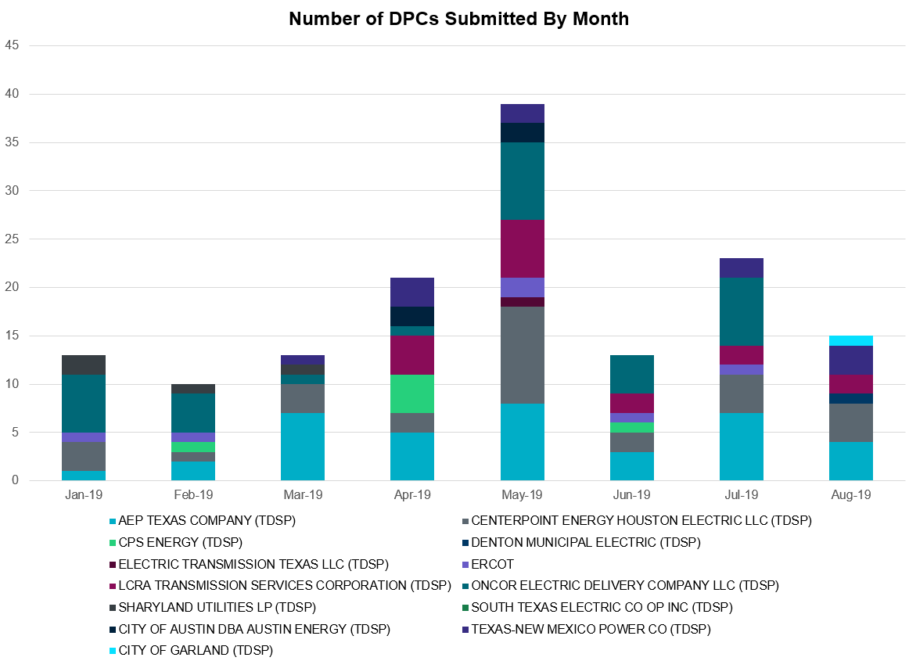

Transmission Operator | Number of DPCs
AEP TEXAS COMPANY (TDSP) | 4
BRAZOS ELECTRIC POWER CO OP INC (TDSP) | 0
CENTERPOINT ENERGY HOUSTON ELECTRIC LLC (TDSP) | 4
CITY OF AUSTIN DBA AUSTIN ENERGY (TDSP) | 0
CITY OF GARLAND (TDSP) | 1
CPS ENERGY (TDSP) | 0
DENTON MUNICIPAL ELECTRIC (TDSP) | 1
ELECTRIC TRANSMISSION TEXAS LLC (TDSP) | 0
ERCOT | 0
LCRA TRANSMISSION SERVICES CORPORATION (TDSP) | 2
ONCOR ELECTRIC DELIVERY COMPANY LLC (TDSP) | 0
SHARYLAND UTILITIES LP (TDSP) | 0
SOUTH TEXAS ELECTRIC CO OP INC (TDSP) | 0
TEXAS MUNICIPAL POWER AGENCY (TDSP) | 0
TEXAS-NEW MEXICO POWER CO (TDSP) | 3

Appendix A: Real-Time Constraints
The following is a complete list of constraints activated in SCED. Full contingency descriptions can be found in the Standard Contingencies List located on the MIS secure site at Grid Generation Reliability Unit Commitment.

Contingency | Constrained Element | From Station | To Station | # of Days Constraint Active
SLAQLOB8 | BRUNI_69_1 | BRUNI | BRUNI | 26
SRAYRI28 | RAYMND2_69A1 | RAYMND2 | RAYMND2 | 25
BASE CASE | PNHNDL | n/a | n/a | 23
SCOLPAW5 | COLETO_ROSATA1_1 | COLETO | ROSATA | 21
SDELLAR8 | LARDVN_LASCRU1_1 | LARDVNTH | LASCRUCE | 20
XHAM88 | SONR_69-1 | SONR | SONR | 20
SBRAUVA8 | HAMILT_MAVERI1_1 | HAMILTON | MAVERICK | 19
SCOLKEN8 | MAGRUD_VICTOR2_1 | VICTORIA | MAGRUDER | 16
DSTEXP12 | SPE_DEN_1 | SPNCER | DENTON | 15
SILLFTL8 | OZNR_OZONA1_1 | OZONA | OZNR | 14
DBIGKEN5 | HAMILT_MAXWEL1_1 | MAXWELL | HAMILTON | 13
DCRLLSW5 | 590__B | LWVJS | LKPNT | 12
SECNMO28 | 6101__A | NOTSW | CHEYT | 12
BASE CASE | RANDAD_ZAPATA1_1 | RANDADO | ZAPATA | 11
SBEVASH8 | BIG_BRUN_1 | BIGWELS | BRUNDGS | 11
DFERGRM8 | SANDCR_AT1 | SANDCR | SANDCR | 11
SLOBSA25 | NLARSW_PILONC1_1 | NLARSW | PILONCIL | 10
SPIGSOL8 | RIOPEC_WOODW21_1 | WOODWRD2 | RIOPECOS | 10
DRIOHAR5 | BURNS_RIOHONDO_1 | RIOHONDO | MV_BURNS | 10
DWINDUN8 | 6100__G | ACSSW | AMTBT | 9
SCOMHA38 | HAMILT_MAXWEL1_1 | MAXWELL | HAMILTON | 8
BASE CASE | SPE_DEN_1 | SPNCER | DENTON | 8
SPOLPHA8 | GCB_100_1 | N_MCALLN | W_MCALLN | 8
SSOLFTS8 | ALPINE_BRONCO1_1 | BRONCO | ALPINE | 8
SHAMMAX8 | SONR_69-1 | SONR | SONR | 8
SPORNCA9 | NCARBI_PV_TAP1_1 | NCARBIDE | PV_TAP | 7
DFLAPLU8 | MAGRUD_VICTOR2_1 | VICTORIA | MAGRUDER | 6
SHACPB38 | FTST_SOLSTI1_1 | FTST | SOLSTICE | 6
DZORHAY5 | BERGHE_AT1L | BERGHE | BERGHE | 6
SALMBA28 | BARL_FMR1 | BARL | BARL | 6
SECNMO28 | 6100__G | ACSSW | AMTBT | 6
SREDMCC8 | 102T375_1 | MCCALA | RNRD12 | 5
DWINDUN8 | 6101__A | NOTSW | CHEYT | 5
DWAPHLJ5 | STPWAP39_1 | STP | WAP | 5
DSTEXP12 | BLESSI_LOLITA1_1 | LOLITA | BLESSING | 5
SPIGSOL8 | TNAF_FTS_1 | FTST | TNAF | 5
DKOCNUE8 | CHAMPL_WEIL_T1_1 | WEIL_TRC | CHAMPLIN | 5
SFORYEL8 | HEXT_YELWJC1_1 | YELWJCKT | HEXT | 5
SMDLODE5 | 6475__C | ODEHV | TROTP | 5
XOKL58 | SANDRO_VERS1_1 | VERS | SANDROAD | 5
SLOBSA25 | LARDVN_LASCRU1_1 | LARDVNTH | LASCRUCE | 4
XVIC89 | MAGRUD_VICTOR2_1 | VICTORIA | MAGRUDER | 4
MNLALAR8 | DEL_MA_LAREDO1_1 | LAREDO | DEL_MAR | 4
SMDLODE5 | FTST_SOLSTI1_1 | FTST | SOLSTICE | 3
DJEWSNG5 | JK_TOKSW_1 | TOKSW | JK_CK | 3
SBOSELM5 | 1030__B | BOSQUESW | RGH | 3
SFLCMDL5 | 34600__A | ODEHV | MOSSW | 3
DBIGKEN5 | BONDRO_SONR1_1 | SONR | BONDROAD | 3
BASE CASE | REROCK_TLINE_1 | REROCK | LINTERNA | 3
DHCKSAG8 | 6265__A | EMSES | MRSDO | 3
DMTSCOS5 | 6437__F | SCRCV | KNAPP | 3
BASE CASE | BURNS_RIOHONDO_1 | RIOHONDO | MV_BURNS | 3
SILLFTL8 | HAMILT_MAXWEL1_1 | MAXWELL | HAMILTON | 3
BASE CASE | HAMILT_MAXWEL1_1 | MAXWELL | HAMILTON | 3
DWINDUN8 | 6480__A | MOSSW | ECTHP | 2
XHAR89 | OLEANDER_AUT1 | OLEANDER | OLEANDER | 2
DHUTGEA8 | 211T147_1 | GILLCR | MCNEIL_ | 2
SECNMO28 | 6100__F | DHIDE | NOTSW | 2
DRIOHAR5 | HAINE__LA_PAL1_1 | LA_PALMA | HAINE_DR | 2
BASE CASE | NE_LOB | n/a | n/a | 2
SECNMO28 | 6518__A | MOSSW | SOPOD | 2
SGEOORN8 | CSA_SAN_1 | CASA_BLA | SANDIAS | 2
SKINKLE8 | LOYOLA_69_1 | LOYOLA | LOYOLA | 2
SMCEABS8 | MKLT_TRNT1_1 | TRNT | MKLT | 2
DNEDWED8 | NEDIN_N_MCAL1_1 | NEDIN | N_MCALLN | 2
DMCEBUT8 | MKLT_TRNT1_1 | TRNT | MKLT | 2
SWOORI38 | RIOPEC_WOODW21_1 | WOODWRD2 | RIOPECOS | 2
SLOBSA25 | BRUNI_69_1 | BRUNI | BRUNI | 2
SWOORI38 | RIOPEC_WOODW21_1 | RIOPECOS | WOODWRD2 | 2
DDUPHE18 | I_DUPS_MCCAMP2_1 | I_DUPSW | MCCAMPBE | 2
SLONLON8 | LON_HILL_69A1 | LON_HILL | LON_HILL | 2
SN_SLON5 | CELANE_N_SHAR1_1 | N_SHARPE | CELANEBI | 2
SECNMO28 | 6100__B | AMTBT | DHIDE | 1
DGBY_GS8 | MIDMID90A_1 | MID | MID | 1
DMARZOR5 | CLEASP_AT2H | CLEASP | CLEASP | 1
XCOL58 | COLETO_ROSATA1_1 | COLETO | ROSATA | 1
SLAQLOB8 | FALFUR_PREMON1_1 | FALFUR | PREMONT | 1
DWINDUN8 | 6100__B | AMTBT | DHIDE | 1
BASE CASE | FTST_SOLSTI1_1 | FTST | SOLSTICE | 1
SARRLOT8 | FTST_SOLSTI1_1 | FTST | SOLSTICE | 1
DHUTHUT5 | HUTTO_MR1H | HUTTO | HUTTO | 1
SKLELOY8 | LOYOLA_69_1 | LOYOLA | LOYOLA | 1
DGRMGRS8 | OLN_FMR2 | OLN | OLN | 1
XSA2N58 | PAWNEE_XF1 | PAWNEE | PAWNEE | 1
DBIGKEN5 | TREADW_YELWJC1_1 | TREADWEL | YELWJCKT | 1
SN_SAJO5 | WES_MV_W_1 | WESLACO | MV_WESL4 | 1
SHACPB38 | 138_WIC_PYT_1 | WICKETT | PYOTE | 1
DTMPBE58 | 213T378_1 | RNDRK | CHIEBR | 1
DWINDUN8 | 6100__F | DHIDE | NOTSW | 1
SWLFWIC8 | 6710__A | YUCSW | WICKETT | 1
SPAWCAL5 | COLETO_ROSATA1_1 | COLETO | ROSATA | 1
SALIKIN8 | FALFUR_PREMON1_1 | FALFUR | PREMONT | 1
XCOL58 | MAGRUD_VICTOR2_1 | VICTORIA | MAGRUDER | 1
DELMSAN5 | PAWNEE_SPRUCE_1 | PAWNEE | CALAVERS | 1
BASE CASE | RV_RH | n/a | n/a | 1
DFLCMGS5 | 34600__A | ODEHV | MOSSW | 1
XPAU89 | 6855__E | SMRTP | SMOUR | 1
SCRDLOF9 | BOW_FMR1 | BOW | BOW | 1
DCHBJOR5 | CBYCVN86_A | CBY | CVN | 1
SKBBI8 | HOCHOC90_1 | HOC | HOC | 1
DYKNWIN8 | 6100__G | ACSSW | AMTBT | 1
SMDOOAS5 | AE_LV_04_A | AE | LV | 1
DWH_STP5 | BONIVI_RINCON1_1 | RINCON | BONIVIEW | 1
DAUSLOS5 | CKT_3122_1 | FPPYD2 | HOLMAN | 1
SLAQLOB8 | FRE_BRUN_1 | BRUNI | FREERS | 1
BASE CASE | MAGRUD_VICTOR2_1 | VICTORIA | MAGRUDER | 1
DWH_STP5 | MELONC_RINCON1_1 | RINCON | MELONCRE | 1
SILLFTL8 | MIDW_OZONA1_1 | MIDW | OZONA | 1
SWHIBUT8 | 228T333_1 | LAGOVI | NAMELE | 1
DWINDUN8 | 6518__A | MOSSW | SOPOD | 1
XOK2L58 | 6855_D_1 | SMR | SMRTP | 1
BASE CASE | BEEVIL_ERALIO1_1 | ERALIO | BEEVILLE | 1
SN_SLON5 | CELANE_KLEBER1_1 | CELANEBI | KLEBERG | 1
SCOLPAW5 | MAGRUD_VICTOR2_1 | VICTORIA | MAGRUDER | 1
SMDLODE5 | ODEHV_MR1H | ODEHV | ODEHV | 1
DNEDWED8 | MCOLL__NEDIN1_1 | NEDIN | MCOLL_RD | 1
SMCEESK8 | MKLT_TRNT1_1 | TRNT | MKLT | 1
DBIGKEN5 | SONR_69-1 | SONR | SONR | 1
SBRAHAM8 | HAMILT_MAVERI1_1 | HAMILTON | MAVERICK | 1
SKMCKWA5 | KMCHI_KWASS2_1 | KMCHI | KWASS | 1
XPAU89 | 6855_D_1 | SMR | SMRTP | 1

The Duration of Event is defined as the time it takes for the frequency to recover to pre-disturbance frequency or 60 Hz as applicable.
PMU reports are typically generated when frequency drops below 59.9, but PMU data is available for other events.
Delta Frequency is defined as the difference between the starting point of the frequency event (t(0) or “A-point”) and minimum/maximum frequency (“C-Point”).
Currently, the Critical Inertia Level for ERCOT is approximately 100,000 MW-s
This is the hourly integrated peak demand as published in the ERCOT D&E report.
All DC Tie Curtailments are posted publically on the ERCOT Market Information System. See that posting for additional details for the event(s) in question.
See DC Tie Operating Procedure (http://www.ercot.com/mktrules/guides/procedures) for more details.
ERS is authorized by Public Utility Commission Substantive Rule §25.507.
ERS deployment is initiated by Verbal Dispatch Instruction (VDI).
ERS time period 3 is hours ending 14:00 through 16:00, and period 4 is hours ending 17:00 through 19:00.

