System Planning

Monthly Status Report
August 2019

Report Highlights
- ERCOT is currently reviewing proposed transmission improvements with a total estimated cost of $1,121.21 Million as of August 31, 2019.
- Transmission Projects endorsed in 2019 total $295.6 Million as of August 31, 2019.
- All projects (in engineering, routing, licensing and construction) total approximately $3.86 Billion as of June 1, 2019.
- Transmission Projects energized in 2019 total about $1.06 Billion as of June 1, 2019.

Regional Planning Group Project Reviews
- AEPSC has submitted the LRGV Import Project. This is a Tier 1 project that is estimated to cost $73.4 million. AEPSC has also requested that ERCOT provide conditional endorsement for an additional $357.2 million project. This project is currently under ERCOT Independent Review.
- TNMP has submitted the Ward and Winkler County Transmission Improvement Project. This is a Tier 2 project that is estimated to cost $60 million. This project is currently under ERCOT Indepdent Review.
- STEC has submitted the Lower Rio Grande Valley Transmission Expansion Project. This is a Tier 1 project that is estimated to cost $511 million. This project is currently under ERCOT Independent Review.
- AEPSC has submitted the Nueces 69 kV Reinforcement Project. This is a Tier 2 project that is estimated to cost $17.6 million. This project is currently under ERCOT Independent Review.
- AEPSC has submitted the Lon Hill to Warburton 138 kV Line Rebuild Transmission Project. This is a Tier 3 project that is estimated to cost $62.2 million. This project is currently under RPG comment period.
- Oncor has submitted the Permian Basin Area Upgrades Project. This is a Tier 3 project that is estimated to cost $39.81 million. This project is currently under RPG comment period.

More information on current and past RPG projects can be found on the ERCOT MIS Secure (digital certificate required): https://mis.ercot.com/pps/tibco/mis/Pages/Grid+Information/RegionalPlanning
Past email communication on RPG projects can be found on the ERCOT listserve by signing up for the REGPLANGROUP list: http://lists.ercot.com/scripts/wa-ERCOT.exe?A0=REGPLANGROUP

Planning Model Activities
The short-term calendar of major planning model events is as follows:
- October 15, 2019 Post 19SSWG Update 1 Base Cases and TPIT
- October 31, 2019 Post 19SSWG Update 1 Contingency definitions and Planning Data Dictionary
The following table shows interconnection projects that met Planning Guide section 6.9(1) and 6.9(2) and were modeled in the SSWG cases as a full model or as a simple model in accordance with Planning Guide section 6.9.
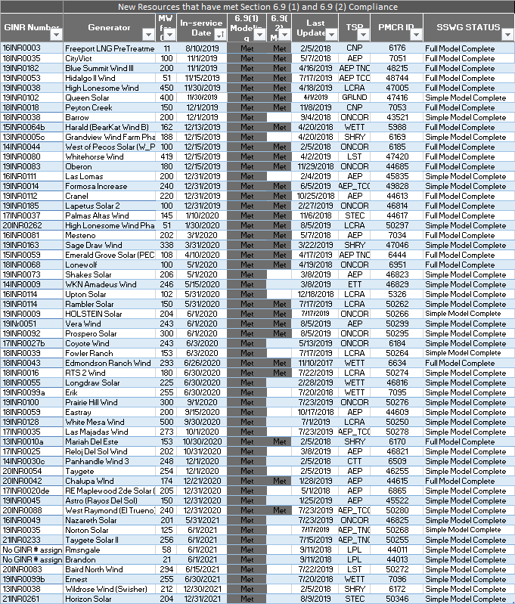

Permian Basin Oil Rig Count
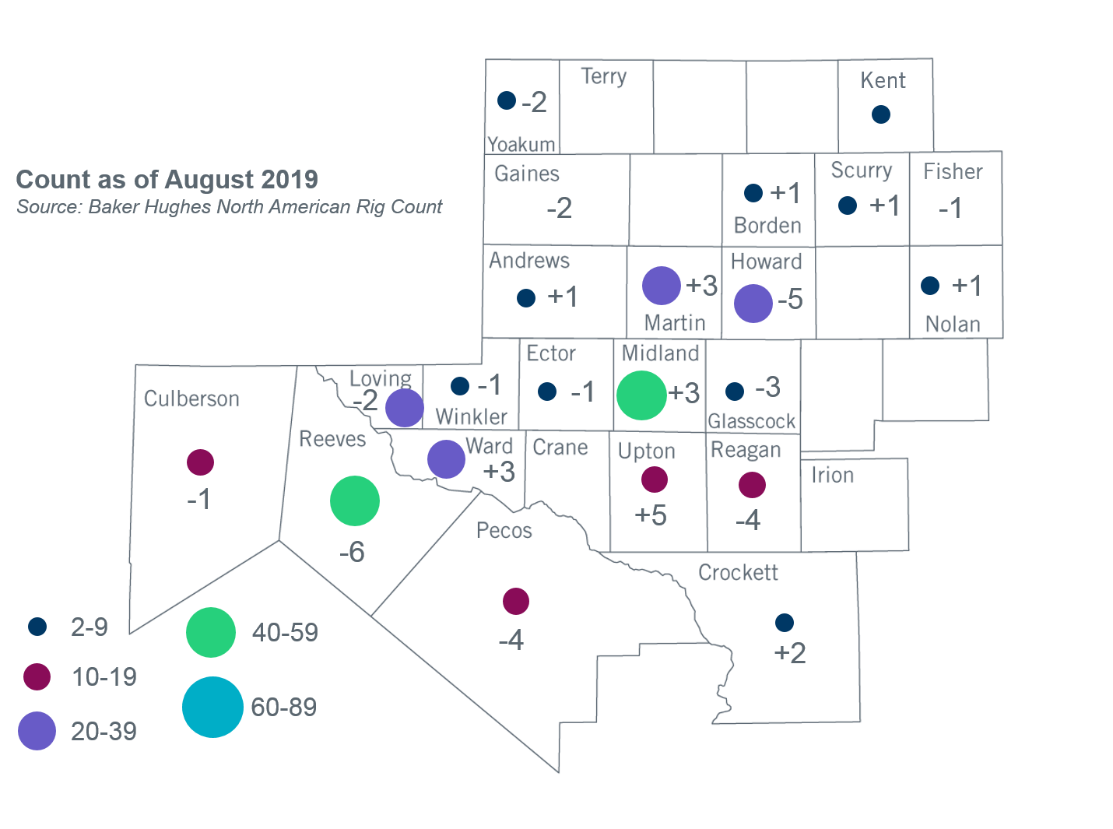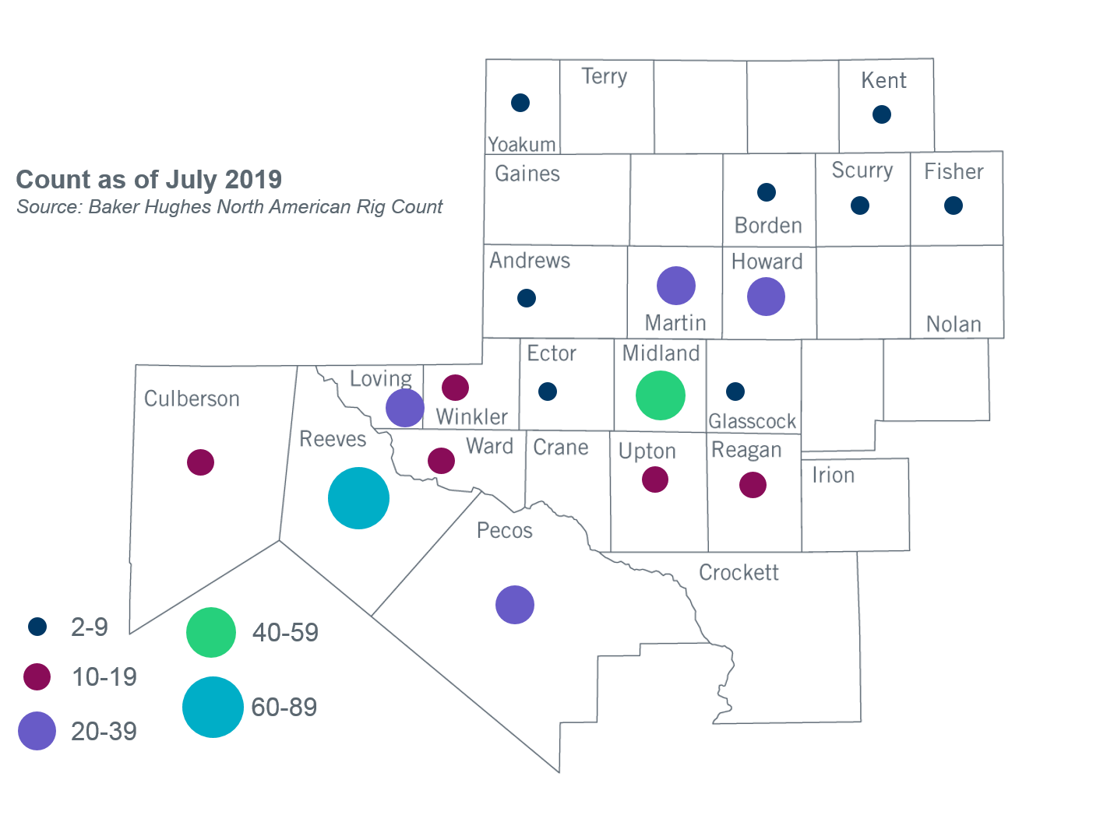

Other Notable Activities
- ERCOT is conducting the 2019 Regional Transmission Plan (RTP). The N-1 secure reliability cases for the 2019 RTP were posted on the MIS Secure Website on June 10. The economic start cases for the 2019 RTP were posted on the MIS Secure Website on July 16. ERCOT is currently working on G-1 and X-1 reliability analysis.
- ERCOT presented preliminary results to the Regional Planning Group (RPG) in May for the 2020 Long-Term System Assessment (LTSA). ERCOT also sent a survey to the RPG to gather feedback on the LTSA assumptions and drivers. ERCOT is currently developing the Current Trends scenario.
- ERCOT presented preliminary results of the Panhandle Stability and System Strength Assessment to the Reliability and Operations Subcommittee (ROS) in May and provided an update in August. The next steps include reaching out to Resource Entities and vendors in regards to updating the models and evaluating the proper approach to manage the constraints in real-time.
- The SPWG completed the 2019 CY base case on March 29 and the 2020 - 2024 Future Year (FY) case build was completed on July 19.
- ERCOT is currently conducting the Delaware Basin area load integration study. The purpose of the study is to identify potential reliability needs and transmission upgrades for the load (planned and conceptual) that may appear in the area for the longer term planning horizon.

+/- symbol indicates the increase or decrease from the previous month in oil rigs present in each county. There are 319 rigs, including a total decrease of 12 oil rigs, in the Permian Basin from July to August 2019.

