July 2019 ERCOT Monthly Operations Report
Reliability and Operations Subcommittee Meeting
September 5, 2019

Table of Contents
1. Report Highlights 2
2. Frequency Control 3
2.1. Frequency Events 3
2.2. Responsive Reserve Events 3
2.3. Load Resource Events 4
3. Reliability Unit Commitment 4
4. Wind Generation as a Percent of Load 4
5. Largest Net-Load Ramp 5
6. COP Error Analysis 5
7. Congestion Analysis 7
7.1. Notable Constraints 7
7.2. Generic Transmission Constraint Congestion 10
7.3. Manual Overrides 10
7.4. Congestion Costs for Calendar Year 2019 10
8. System Events 12
8.1. ERCOT Peak Load 12
8.2. Load Shed Events 12
8.3. Stability Events 12
8.4. Notable PMU Events 12
8.5. DC Tie Curtailment 12
8.6. TRE/DOE Reportable Events 13
8.7. New/Updated Constraint Management Plans 13
8.8. New/Modified/Removed RAS 13
8.9. New Procedures/Forms/Operating Bulletins 13
9. Emergency Conditions 13
9.1. OCNs 13
9.2. Advisories 13
9.3. Watches 13
9.4. Emergency Notices 14
10. Application Performance 14
10.1. TSAT/VSAT Performance Issues 14
10.2. Communication Issues 14
10.3. Market System Issues 14
11. Model Updates 14
Appendix A: Real-Time Constraints 17

Report Highlights
- The unofficial ERCOT peak was 70,855 MW.
- There were 5 frequency events.
- There were 4 instances where Responsive Reserves were deployed.
- There were 0 RUC commitments.
- Congestion in the West Load Zone (LZ) can be attributed to a combination of low generation and high load (often during off peak hours) and to high Panhandle wind generation. Congestion in the Houston LZ was mostly due to a single forced outage. Congestion in the South LZ was mostly due to outages. Congestion in the North and South LZs were related to planned outages and generation and load pattern. Congestion across zones was minimal. There were 21 days of congestion on the Panhandle GTC.
- There was 1 DC Tie curtailment.

Frequency Control

Frequency Events
The ERCOT Interconnection experienced five frequency events, all of which resulted from a unit trip. The average event duration was approximately 00:04:40.

A summary of the frequency events is provided below. The reported frequency events meet one of the following criteria: Delta Frequency is 60 mHz or greater; the MW loss is 350 MW or greater; resource trip event triggered RRS deployment. Frequency events that have been identified as Frequency Measurable Events (FME) for purposes of BAL-001-TRE-1 analysis are highlighted in blue. When analyzing frequency events, ERCOT evaluates PMU data according to industry standards. Events with an oscillating frequency of less than 1 Hz are considered to be inter-area, while higher frequencies indicate local events. Industry standards specify that damping ratio for inter-area oscillations should be 3.0% or greater. For the frequency events listed below, the ERCOT system met these standards and transitioned well after each disturbance.

Date and Time | Delta Frequency | Max/Min Frequency | Duration of Event | PMU Data |  |  | MW Loss | Load | Wind | Inertia
 | (Hz) | (Hz) |  | Oscillation Mode (Hz) |  | Damping Ratio |  | (MW) | % | (GW-s)
7/15/2019 14:37 | 0.067 | 59.904 | 0:04:44 | No PMU data available |  |  | 586.812 | 65,437 | 4% | 370,442
7/22/2019 10:34 | 0.132 | 59.878 | 0:04:17 | 0.78 | 7% |  | 736.46 | 54,911 | 10% | 336,792
7/23/2019 9:10 | 0.096 | 59.887 | 0:04:36 | 0.62 | 13% |  | 624.9 | 46,685 | 7% | 318,639
7/23/2019 13:47 | 0.070 | 59.910 | 0:03:52 | No PMU data available |  |  | 470.17 | 57,192 | 8% | 342,129
7/29/2019 17:59 | 0.138 | 59.834 | 0:05:50 | 0.65 | 5% |  | 817.34 | 64,952 | 11% | 354,610

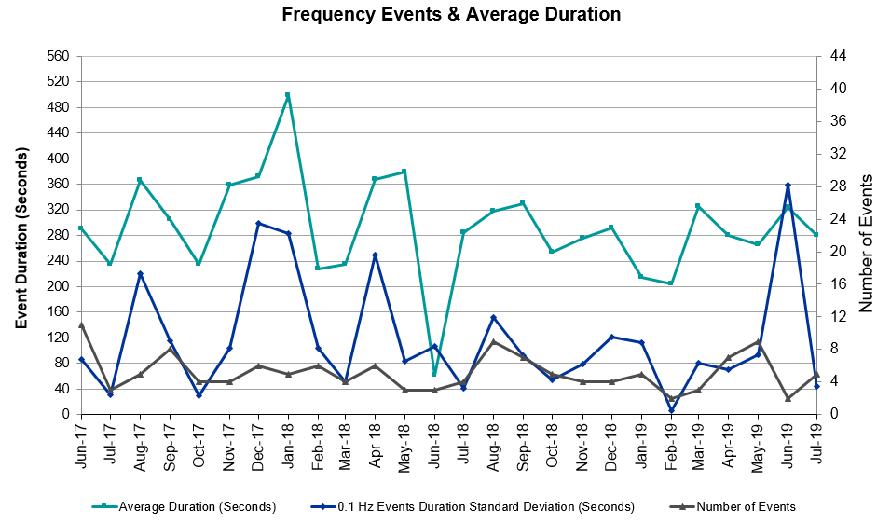 (Note: All data on this graph encompasses frequency event analysis based on BAL-001-TRE-1.)

Note that the large standard deviation in the previous month is due to coincidental extreme high and low durations for a small set of events (2).

Responsive Reserve Events
There were four events where Responsive Reserve MWs were released to SCED. The events highlighted in blue were related to frequency events reported in Section 2.1 above.

Date and Time Released to SCED | Date and Time Recalled | Duration of Event | Maximum MWs Released | Comments
7/15/2019 14:37 | 7/15/2019 14:41 | 00:04:36 | 564
7/22/2019 10:34 | 7/22/2019 10:38 | 00:03:44 | 332
7/23/2019 9:10 | 7/23/2019 9:14 | 00:04:00 | 271
7/29/2019 17:59 | 7/29/2019 18:04 | 00:05:47 | 1157

Load Resource Events
None.

Reliability Unit Commitment
ERCOT reports on Reliability Unit Commitments (RUC) on a monthly basis. Commitments are reported grouped by operating day and weather zone. The total number of hours committed is the sum of the hours for all the units in the specified region. Additional information on RUC commitments can be found on the MIS secure site at Grid Generation Reliability Unit Commitment.

There were no DRUC commitments.

There were no HRUC commitments.

Wind Generation as a Percent of Load
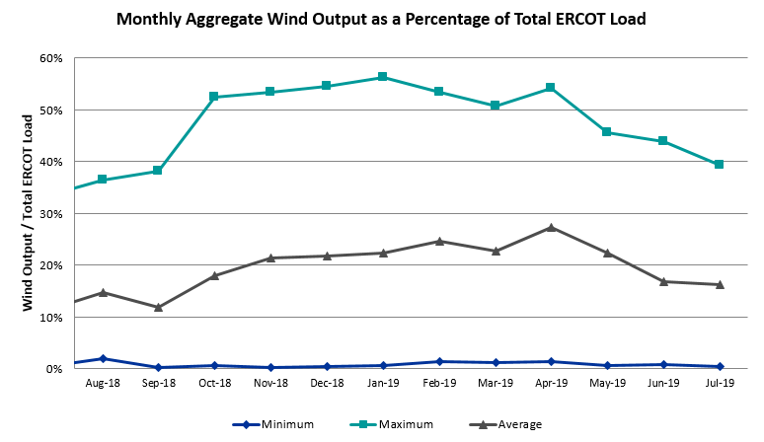

Wind Generation Record: 19,672 MW on 01/21/2019 at 19:19
Wind Penetration Record: 56.16% on 01/19/2019 03:10

Largest Net-Load Ramp
The net-load ramp is defined as the change in net-load (load minus wind and PVGR generation) during the defined time horizon. Such a variation in net-load needs to be accommodated in grid operations to ensure that the reliability of the grid is satisfactorily maintained. The largest net-load ramp during 5-min, 10-min, 15-min, 30-min and 60-min intervals is 913 MW, 1279 MW, 1803 MW, 3328 MW and 6546 MW respectively. The comparison with respect to the historical values is given in the table below.

Month and Year | 5 min | 10 min | 15 min | 30 min | 60 min
July 2019 | 913 MW | 1279 MW | 1803 MW | 3328 MW | 6546 MW
July 2014 | 1070 MW | 1420 MW | 1707 MW | 2806 MW | 5389 MW
July 2015 | 890 MW | 1251 MW | 1678 MW | 3062 MW | 5797 MW
July 2016 | 863 MW | 1660 MW | 1885 MW | 3390 MW | 5900 MW
July 2017 | 880 MW | 1243 MW | 1746 MW | 3037 MW | 5732 MW
July 2018 | 1399 MW | 1790 MW | 2192 MW | 3550 MW | 6677 MW
2014-2018 | 1494 MW | 1991 MW | 2780 MW | 4109 MW | 7218 MW

COP Error Analysis
COP Error is calculated as the capacity difference between the COP HSL and real-time HSL of the unit. Mean Absolute Error (MAE) stayed high over 11,000 MW until Day-Ahead at 12:00, then dropped significantly to 1,177 MW by Day-Ahead at 14:00. In the following chart, Under-Scheduling Error indicates that COP had less generation capacity than real-time and Over-Scheduling Error indicates that COP had more generation capacity than real-time. Under-Scheduling persisted from beginning of Day-Ahead to end of the Operating Day. Snapshot on the Operating Day considers all Operating Hours, including past hours. However, COP error for the Operating Hour freezes after the Adjustment Period.

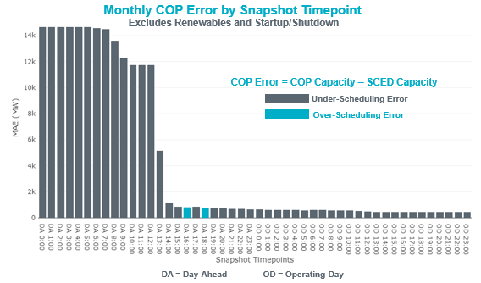

Monthly MAE for the Latest COP at the end of the Adjustment Period was 439 MW with median ranging from 230 MW for Hour-Ending (HE) 2 to -655 MW for HE 19. HE 2 on the 13th had the largest Over-Scheduling Error (1,534 MW) and HE 19 on the 15th had the largest Under-Scheduling Error (-2,804 MW).

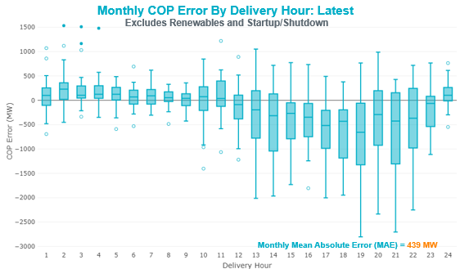

Monthly MAE for the Day-Ahead COP at 12:00 was 1,151 MW with median ranging from 399 MW for Hour-Ending (HE) 4 to -8,050 MW for HE 1. HE 2 on the 21st had the largest Over-Scheduling Error (2,392 MW) (not shown in the chart) and HE 1 on the 12th had the largest Under-Scheduling Error (-11,533 MW).

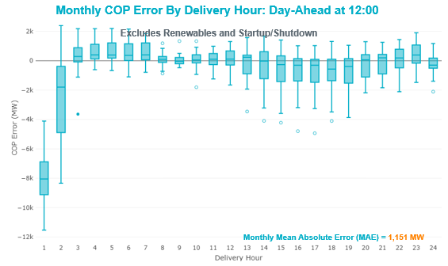

Congestion Analysis

Notable Constraints
Nodal protocol section 3.20 specifies that ERCOT shall identify transmission constraints that are active or binding three or more times within a calendar month. As part of this process, ERCOT reports congestion that meets this criterion to ROS. In addition ERCOT also highlights notable constraints that have an estimated congestion rent exceeding $1,000,000 for a calendar month. These constraints are detailed in the table below. Rows highlighted in blue indicate the congestion was affected by one or more outages. For a list of all constraints activated in SCED, please see Appendix A at the end of this report.

Contingency Name | Overloaded Element | # of Days Constraint Active | Congestion Rent | Transmission Project
TWR (345) JN-WAP64 & JN-WAP72 | Bellaire - Wa Parish 345kV | 1 | $6,697,780.97 | Upgrade limiting equipment for Bellaire auto A1(5886)
Hcksw-Sagna-138kv | Eagle Mountain Ses - Morris Dido 138kV | 6 | $1,933,521.70 | Eagle Mountain-Calmont 138 kV Line (4253)
MOSS SWITCH to ECTOR COUNTY NORTH SWITCHING STATION LIN _A | Andrews County South - Amoco Three Bar Tap 138kV | 8 | $1,782,664.80 | Upgrade 138kV Ckt.04 Amoco to Mustang Bayou to increase thermal ratings (6097)
CRLNW-LWSSW 345kV | Jones Street Tnp - Lakepointe Tnp 138kV | 8 | $1,499,513.52 | Lewisville - Lewisville Jones - Lakepointe 138 kV Line (45537)
Basecase | PNHNDL GTC | 21 | $1,480,593.05
WINK to DUNE SWITCH and YUKON | Moss Switch - Ector Harper 138kV | 1 | $1,238,428.71 | Riverton-Odessa EHV/Moss 345 kV Line (5445)
GAS PAD to FLAT TOP TNP LIN 1 | Fort Stockton Plant - Solstice 138kV | 7 | $1,006,351.91 | Solstice: Build 345 kV station (5530) and Solstice to Bakersfield: Build 345 kV line (5539) and Pecos County Modification Project (7028, 44359)
WINK to DUNE SWITCH and YUKON | Andrews County South - Amoco Three Bar Tap 138kV | 8 | $980,783.11 | Andrews County South Switch - No Trees Switch 138 kV Line (7171)
FORT LANCASTER to ILLINOIS #4 LIN 1 | Ozona - Ozona Rea 69kV | 14 | $979,003.46 | Replace existing Ozona 69 kV station with a new 69 kV ring bus (49556)
ODLAW SWITCHYARD to ASPHALT MINES LIN 1 | Hamilton Road - Maverick 138kV | 15 | $941,585.10 | Brackettville to Escondido: Construct 138 kV line (5206)
HAMILTON ROAD TRX PS2 138/138 | Sonora 138kV | 15 | $858,335.40 | Carver: Build new 138 kV station (5979)
LAQUINTA to LOBO LIN 1 | Bruni Sub 138kV | 19 | $824,291.08
Solstice to LINTERNA LIN 1 | Fort Stockton Plant - Solstice 138kV | 13 | $541,932.42 | Solstice: Build 345 kV station (5530) and Solstice to Bakersfield: Build 345 kV line (5539) and Pecos County Modification Project (7028, 44359)
TWR (345) HLJ-WAP64 & BLY-WAP72 | South Texas Project - Wa Parish 345kV | 4 | $520,452.81
Basecase | Burns Sub - Rio Hondo 138kV | 5 | $424,584.87 | Rebuild the 138 kV line from Rio Hondo to East Rio Hondo (6687)
RIO HONDO to LAS PULGAS LIN 1 | Raymondville 2 138kV | 17 | $417,193.35 | Harlingen SS - Raymondville #2: Convert to 138 kV (6167)
COLETO CREEK to PAWNEE SWITCHING STATION LIN 1 | Coleto Creek - Rosata Tap 138kV | 13 | $412,233.98 | Coleto Creek to Tuleta: New 138 kV Line (16TPIT0034)
ASHERTON to Bevo Substation LIN 1 | Big Wells Sub - Brundage Sub 69kV | 7 | $411,887.24 | Rebuild BEVO to Brundage to Big Wells 69 kV lines (6255A)
MOSS SWITCH to ECTOR COUNTY NORTH SWITCHING STATION LIN _A | No Trees Switch - Cheyenne Tap 138kV | 11 | $403,245.76 | Wink Sw. Sta. - No Trees Sw. Sta. 138 kV Line (7101)
SAN MIGUEL 345_138 KV SWITCHYARDS to LOBO LIN 1 | Laredo Vft North - Las Cruces 138kV | 9 | $380,058.61
PH ROBINSON to MEADOW LIN A | Mainland Tnp - Alvin Tnp 138kV | 10 | $276,610.51
Riohondo-Nedin 345kV&Harlnsw 138kV | Burns Sub - Rio Hondo 138kV | 5 | $162,043.12 | Rebuild the 138 kV line from Rio Hondo to East Rio Hondo (6687)
South Texas # 1 & # 2 | Blessing - Lolita 138kV | 7 | $146,296.64
Pig Creek to Solstice LIN 1 | Woodward 2 - Rio Pecos 138kV | 11 | $123,165.24 | Lynx: Expand 138 kV station (45503)
HAMILTON ROAD to Maxwell LIN 1 | Sonora 138kV | 7 | $120,704.24 | Carver: Build new 138 kV station (5979)
SANTIAGO to LANGFORD WIND POWER LLC LIN 1 | Friend Ranch - Crockett Heights 69kV | 4 | $116,994.66 | Rehab Friend Ranch to Crockett Heights 69 kV line (6351)
Solstice to FORT STOCKTON PLANT LIN 1 | Alpine - Bronco 69kV | 18 | $116,753.81 | Rehab Alpine to Alpine REA 69 kV line (5968)
ODESSA EHV SWITCH to MOSS SWITCH LIN _A | Fort Stockton Plant - Solstice 138kV | 7 | $86,143.85 | Solstice: Build 345 kV station (5530) and Solstice to Bakersfield: Build 345 kV line (5539) and Pecos County Modification Project (7028, 44359)
FORT LANCASTER to ILLINOIS #4 LIN 1 | Friend Ranch 138kV | 5 | $80,252.02 | Rehab Friend Ranch to Crockett Heights 69 kV line (6351)
Bronco to ALPINE LIN 1 | Fort Stockton Plant - Solstice 138kV | 5 | $79,520.25 | Solstice: Build 345 kV station (5530) and Solstice to Bakersfield: Build 345 kV line (5539) and Pecos County Modification Project (7028, 44359)
SAN MIGUEL 345_138 KV SWITCHYARDS to LOBO LIN 1 | North Laredo Switch - Piloncillo 138kV | 10 | $76,113.36
Ferguson-Sherwood Shores & Ferguson-Granite Mountain 138kV | Sandy Creek 138kV | 11 | $35,600.22
Bighil-Kendal 345kV | Yellow Jacket - Treadwell 138kV | 6 | $31,473.26 | Treadwell: Build new 138 kV station (6397)
Basecase | Randado Aep - Zapata 138kV | 16 | $31,280.29 | Add Reactor at Zapata 138 kV (44393)
Bighil-Kendal 345kV | Hamilton Road - Maxwell 138kV | 7 | $25,470.34 | Brackettville to Escondido: Construct 138 kV line (5206)
Jewet-Sng 345kV | Btu_Jack_Creek - Twin Oak Switch 345kV | 5 | $22,029.27
Basecase | Spencer Switch - Denton Steam 69kV | 4 | $19,773.07
DEL MAR to LAREDO PLANT LIN 1 | Laredo Vft North - Las Cruces 138kV | 4 | $17,081.14 | Las Cruces: Build new distribution station (6161)
COLETO CREEK to KENEDY SWITCH LIN 1 | Magruder - Victoria 138kV | 4 | $17,077.77
WINK to DUNE SWITCH and YUKON | No Trees Switch - Cheyenne Tap 138kV | 5 | $15,897.11 | Wink Sw. Sta. - No Trees Sw. Sta. 138 kV Line (7101)
HAMILTON ROAD to CORRAL LIN 1 | Hamilton Road - Maxwell 138kV | 4 | $14,226.98 | Brackettville to Escondido: Construct 138 kV line (5206)
BOSQUE SWITCH to ELM MOTT LIN 1 | Bosque Switch - Rogers Hill Bepc 138kV | 5 | $4,360.14
Basecase | Fort Stockton Plant - Solstice 138kV | 4 | $2,431.64 | Solstice: Build 345 kV station (5530) and Solstice to Bakersfield: Build 345 kV line (5539) and Pecos County Modification Project (7028, 44359)
CAGNON TRX CAGNON_3_3 345/138 | Cagnon 345kV | 3 | $1,022.92

Generic Transmission Constraint Congestion
There were 21 days of congestion on the Panhandle GTC. There was no activity on the remaining GTCs during the month.

Note: This is how many times a constraint has been activated to avoid exceeding a GTC limit, it does not imply an exceedance of the GTC occurred or that the GTC was binding.

Manual Overrides
None.

Congestion Costs for Calendar Year 2019
The following table represents the top twenty active constraints for the calendar year based on the estimated congestion rent attributed to the congestion. ERCOT updates this list on a monthly basis.

Contingency | Binding Element | # of 5-min SCED Intervals | Estimated Congestion Rent | Transmission Project
Basecase | PNHNDL GTC | 19,599 | 35,381,273
Elmcreek-Skyline 345kV | Hill Country - Marion 345kV | 961 | 26,958,430 | Zorn to Marion 2nd 345-kV Transmission Line Addition (4473)
Solstice to FORT STOCKTON PLANT LIN 1 | Barrilla - Fort Stockton Switch 69kV | 15,074 | 23,360,440 | Solstice: Build 345 kV station (5530) and Solstice to Bakersfield: Build 345 kV line (5539) and Pecos County Modification Project (7028, 44359)
CRLNW-LWSSW 345kV | Ti Tnp - West Tnp 138kV | 2,496 | 18,908,860
FRIEND RANCH TRX FMR1 138/69 | Sonora 138kV | 4,564 | 18,535,546 | Carver: Build new 138 kV station (5979)
TWR (345) HLJ-WAP64 & BLY-WAP72 | Jones Creek - South Texas Project 345kV | 4,905 | 17,833,136 | Freeport Master Plan (6668A)
Manual LOTEBUSH toYUCSW 138 kV | 16th Street Tnp - Woodward 2 138kV | 4,906 | 14,675,595 | Solstice: Build 345 kV station (5530) and Solstice to Bakersfield: Build 345 kV line (5539)
CAGNON to KENDALL LIN 1 | Cico - Comfort 138kV | 3,247 | 10,393,334 | Boerne Cico - Comfort - Kendall Transmission Line Upgrade (6982)
CRLNW-LWSSW 345kV | Jones Street Tnp - Lakepointe Tnp 138kV | 2,666 | 10,390,116 | Lewisville - Lewisville Jones - Lakepointe 138 kV Line (45537)
Hcksw-Sagna-138kv | Eagle Mountain Ses - Eagle Mountain Compressor 138kV | 773 | 10,199,600 | Eagle Mountain-Calmont 138 kV Line (4253)
DMTSW-SCOSW 345KV | Knapp - Scurry Chevron 138kV | 3,254 | 9,750,942 | Ennis Creek - Cogdell 69 kV Line (4554) & Ennis Creek 138 kV Switching Station (6269)
Solstice to LINTERNA LIN 1 | Barrilla - Fort Stockton Switch 69kV | 14,077 | 9,251,017 | Solstice: Build 345 kV station (5530) and Solstice to Bakersfield: Build 345 kV line (5539) and Pecos County Modification Project (7028, 44359)
SAN MIGUEL 345_138 KV SWITCHYARDS to LOBO LIN 1 | North Laredo Switch - Piloncillo 138kV | 5,908 | 9,032,410
CRLNW-LWSSW 345kV | Carrollton Northwest - Lakepointe Tnp 138kV | 1,344 | 9,028,753 | Northwest Carrollton - LakePointe TNP 138 kV Line (5548)
ODLAW SWITCHYARD to ASPHALT MINES LIN 1 | Hamilton Road - Maverick 138kV | 12,595 | 8,798,846 | Brackettville to Escondido: Construct 138 kV line (5206)
TWR (345) HLJ-WAP64 & BLY-WAP72 | Dow Chemical - South Texas Project 345kV | 2,599 | 8,035,399 | Freeport Master Plan (6668A)
CPSES-JONSW&EVRSW 345kV | Hood - Decordova Dam 138kV | 172 | 7,948,529
WHITEPOINT TRX 345A 345/138 | Lon Hill 345kV | 847 | 7,109,227 | Lon Hill: Replace 345/138 kV autotransformers (6101)
DCRMOD28 Odesa-Mdssw&Odehv 138 kV | Big Three Odessa Tap - Odessa Ehv Switch 138kV | 765 | 6,873,912 | Riverton-Odessa EHV/Moss 345 kV Line (5445)
TWR (345) JN-WAP64 & JN-WAP72 | Bellaire - Wa Parish 345kV | 78 | 6,697,781 | Upgrade limiting equipment for Bellaire auto A1(5886)

System Events

ERCOT Peak Load
The unofficial ERCOT peak load for the month was 70,855 MW and occurred on the 30th, during hour ending 17.

Load Shed Events
None.

Stability Events
None.

Notable PMU Events
ERCOT analyzes PMU data for any significant system disturbances that do not fall into the Frequency Events category reported in section 2.1. The results are summarized in this section once the analysis has been completed.

There were no PMU events outside of those reported in section 2.1.

DC Tie Curtailment
Date | DC Tie | Curtailing Period | # of Tags Curtailed | Initiating Event | Curtailment Reason
07/18/2019 | DC-R | HE11 | 3 | Gas pressure issue | Unplanned outage

TRE/DOE Reportable Events
- Oncor submitted an OE-417 for July 10, 2019 Reportable Event Type: Loss of electric service to more than 50,000 customers for 1 hour or more.

New/Updated Constraint Management Plans
None.

New/Modified/Removed RAS
None.

New Procedures/Forms/Operating Bulletins
Procedure Title | POB
Transmission and Security Desk | 907
Shift Supervisor Desk | 906
Scripts | 905
Reliability Risk Desk | 904
Real Time Desk | 903
DC Tie Desk | 902

Emergency Conditions

OCNs
None.

Advisories
Date and Time | Description
Jul 01 2019 14:40 CPT | ERCOT issued an Advisory due to Physical Responsive Capability being below 3000 MW.
Jul 02 2019 15:30 CPT | ERCOT issued an Advisory due to Physical Responsive Capability being below 3000 MW.
Jul 06 2019 15:45 CPT | ERCOT issued an Advisory due to Physical Responsive Capability being below 3000 MW.
Jul 09 2019 16:35 CPT | ERCOT issued an Advisory due to Physical Responsive Capability being below 3000 MW.
Jul 10 2019 15:00 CPT | ERCOT issued an Advisory due to Physical Responsive Capability being below 3000 MW.
Jul 11 2019 15:00 CPT | ERCOT issued an Advisory due to Physical Responsive Capability being below 3000 MW.
Jul 24 2019 16:05 CPT | ERCOT issued an Advisory due to Physical Responsive Capability being below 3000 MW.
Jul 25 2019 15:05 CPT | ERCOT issued an Advisory due to Physical Responsive Capability being below 3000 MW.
Jul 26 2019 15:35 CPT | ERCOT issued an Advisory due to Physical Responsive Capability being below 3000 MW.
Jul 27 2019 15:55 CPT | ERCOT issued an Advisory due to Physical Responsive Capability being below 3000 MW.
Jul 28 2019 16:45 CPT | ERCOT issued an Advisory due to Physical Responsive Capability being below 3000 MW.
Jul 30 2019 13:40 CPT | ERCOT issued an Advisory due to Physical Responsive Capability being below 3000 MW.

Watches
None.

Emergency Notices
None.

Application Performance

TSAT/VSAT Performance Issues
None.

Communication Issues
None.

Market System Issues
None.

Model Updates
The Downstream Production Change (DPC) process allows ERCOT to make changes in the on-line Network Operations Model without loading a completely new model. The purpose of this process is to allow for reliable grid operations as system conditions change between designated Network Operations Model database loads. The DPC process is limited in scope to just those items listed below, with equipment ratings updates being the most common. ERCOT has seen a rise in the use of the DPC process to make on-line updates to the Network Operations Model in recent years, instead of through the standard Network Operations Model Change Request process.

- Static Line ratings (Interim Update)
- Dynamic Line ratings (non-Interim Update)
- Autotransformer ratings (non-Interim Update)
- Breaker and Switch Normal status (Interim Update)
- Contingency Definitions (Interim Update)
- RAP and RAS changes or additions (Interim Update)
- Net Dependable and Reactive Capability (NDCRC) values (Interim Update)
- Impedance Updates (non-Interim)

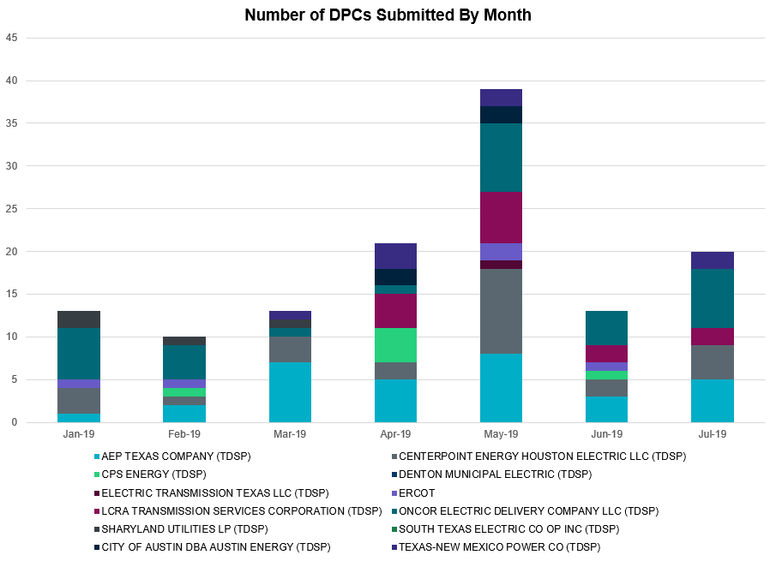

Transmission Operator | Number of DPCs
AEP TEXAS COMPANY (TDSP) | 5
BRAZOS ELECTRIC POWER CO OP INC (TDSP) | 0
CENTERPOINT ENERGY HOUSTON ELECTRIC LLC (TDSP) | 4
CITY OF AUSTIN DBA AUSTIN ENERGY (TDSP) | 0
CPS ENERGY (TDSP) | 0
DENTON MUNICIPAL ELECTRIC (TDSP) | 0
ELECTRIC TRANSMISSION TEXAS LLC (TDSP) | 0
ERCOT | 0
LCRA TRANSMISSION SERVICES CORPORATION (TDSP) | 2
ONCOR ELECTRIC DELIVERY COMPANY LLC (TDSP) | 7
SHARYLAND UTILITIES LP (TDSP) | 0
SOUTH TEXAS ELECTRIC CO OP INC (TDSP) | 0
TEXAS MUNICIPAL POWER AGENCY (TDSP) | 0
TEXAS-NEW MEXICO POWER CO (TDSP) | 2

Appendix A: Real-Time Constraints
The following is a complete list of constraints activated in SCED. Full contingency descriptions can be found in the Standard Contingencies List located on the MIS secure site at Grid Generation Reliability Unit Commitment.

Contingency | Constrained Element | From Station | To Station | # of Days Constraint Active
BASE CASE | PNHNDL | n/a | n/a | 21
SLAQLOB8 | BRUNI_69_1 | BRUNI | BRUNI | 19
SSOLFTS8 | ALPINE_BRONCO1_1 | BRONCO | ALPINE | 18
SRAYRI28 | RAYMND2_69A1 | RAYMND2 | RAYMND2 | 17
BASE CASE | RANDAD_ZAPATA1_1 | RANDADO | ZAPATA | 16
SBRAUVA8 | HAMILT_MAVERI1_1 | HAMILTON | MAVERICK | 15
XHAM88 | SONR_69-1 | SONR | SONR | 15
SILLFTL8 | OZNR_OZONA1_1 | OZONA | OZNR | 14
SCOLPAW5 | COLETO_ROSATA1_1 | COLETO | ROSATA | 13
SWCSBOO8 | FTST_SOLSTI1_1 | FTST | SOLSTICE | 13
DFERGRM8 | SANDCR_AT1 | SANDCR | SANDCR | 11
SECNMO28 | 6101__A | NOTSW | CHEYT | 11
SPIGSOL8 | RIOPEC_WOODW21_1 | RIOPECOS | WOODWRD2 | 11
SPIGSOL8 | RIOPEC_WOODW21_1 | WOODWRD2 | RIOPECOS | 11
SLOBSA25 | NLARSW_PILONC1_1 | NLARSW | PILONCIL | 10
SMDOPHR5 | 138_ALV_MNL_1 | ALVIN | MAINLAND | 10
SLOBSA25 | LARDVN_LASCRU1_1 | LARDVNTH | LASCRUCE | 9
DCRLLSW5 | 590__B | LWVJS | LKPNT | 8
SECNMO28 | 6100__G | ACSSW | AMTBT | 8
DWINDUN8 | 6100__G | ACSSW | AMTBT | 8
SHAMMAX8 | SONR_69-1 | SONR | SONR | 7
SBEVASH8 | BIG_BRUN_1 | BIGWELS | BRUNDGS | 7
DSTEXP12 | BLESSI_LOLITA1_1 | LOLITA | BLESSING | 7
SMDLODE5 | FTST_SOLSTI1_1 | FTST | SOLSTICE | 7
DBIGKEN5 | HAMILT_MAXWEL1_1 | MAXWELL | HAMILTON | 7
SHACPB38 | FTST_SOLSTI1_1 | FTST | SOLSTICE | 7
DHCKSAG8 | 6265__A | EMSES | MRSDO | 6
DBIGKEN5 | TREADW_YELWJC1_1 | TREADWEL | YELWJCKT | 6
SBROALP9 | FTST_SOLSTI1_1 | FTST | SOLSTICE | 5
SBOSELM5 | 1030__B | BOSQUESW | RGH | 5
BASE CASE | BURNS_RIOHONDO_1 | RIOHONDO | MV_BURNS | 5
DJEWSNG5 | JK_TOKSW_1 | TOKSW | JK_CK | 5
DRIOHAR5 | BURNS_RIOHONDO_1 | RIOHONDO | MV_BURNS | 5
DWINDUN8 | 6101__A | NOTSW | CHEYT | 5
SILLFTL8 | FRIEND_R_FMR1 | FRIEND_R | FRIEND_R | 5
SCOLKEN8 | MAGRUD_VICTOR2_1 | VICTORIA | MAGRUDER | 4
SDELLAR8 | LARDVN_LASCRU1_1 | LARDVNTH | LASCRUCE | 4
BASE CASE | SPE_DEN_1 | SPNCER | DENTON | 4
SCOMHA38 | HAMILT_MAXWEL1_1 | MAXWELL | HAMILTON | 4
DWAPHLJ5 | STPWAP39_1 | STP | WAP | 4
SLGDSAP8 | FDR_OZNC_1 | FRIEND_R | OZNC | 4
BASE CASE | FTST_SOLSTI1_1 | FTST | SOLSTICE | 4
XCAG158 | CAGNON_MR4H | CAGNON | CAGNON | 3
SKBBI8 | HOCHOC90_1 | HOC | HOC | 2
SCTHHA38 | HAMILT_MAXWEL1_1 | MAXWELL | HAMILTON | 2
DFPPFAY5 | MAGRUD_VICTOR2_1 | VICTORIA | MAGRUDER | 2
SPORNCA9 | NCARBI_PV_TAP1_1 | NCARBIDE | PV_TAP | 2
SWOORI38 | RIOPEC_WOODW21_1 | WOODWRD2 | RIOPECOS | 2
DZORHAY5 | BERGHE_AT1H | BERGHE | BERGHE | 2
XVIC89 | MAGRUD_VICTOR2_1 | VICTORIA | MAGRUDER | 2
DMTSCOS5 | 6437__F | SCRCV | KNAPP | 2
SMDLODE5 | 6475__C | ODEHV | TROTP | 2
SN_SLON5 | CELANE_N_SHAR1_1 | N_SHARPE | CELANEBI | 2
SNORODE5 | FTST_SOLSTI1_1 | FTST | SOLSTICE | 2
SKINKLE8 | LOYOLA_69_1 | LOYOLA | LOYOLA | 2
XSAN58 | SANMIGL_ATBH | SANMIGL | SANMIGL | 2
DGRSPKR5 | 6377__A | BRTSW | ORANS | 2
DELMSAN5 | COLETO_ROSATA1_1 | COLETO | ROSATA | 2
DSTEXP12 | SPE_DEN_1 | SPNCER | DENTON | 2
SSOLFTS8 | BARL_FTSW1_1 | FTSW | BARL | 2
DZORHAY5 | BERGHE_AT1L | BERGHE | BERGHE | 2
SN_SLON5 | CELANE_KLEBER1_1 | CELANEBI | KLEBERG | 2
SECNMO28 | 6480__A | MOSSW | ECTHP | 1
SPIGSOL8 | RIOPEC_WDWRDT1_1 | WDWRDTP | RIOPECOS | 1
SPOLPHA8 | GCB_100_1 | N_MCALLN | W_MCALLN | 1
XLA_89 | HAINE__LA_PAL1_1 | LA_PALMA | HAINE_DR | 1
SPORWH38 | I_DUPS_MCCAMP2_1 | I_DUPSW | MCCAMPBE | 1
SKLELOY8 | LOYOLA_69_1 | LOYOLA | LOYOLA | 1
BASE CASE | REROCK_TLINE_1 | REROCK | LINTERNA | 1
DWAP_JN5 | BI_WAP50_A | WAP | BI | 1
DBIGKEN5 | FORTMA_YELWJC1_1 | YELWJCKT | FORTMA | 1
SMGIENW8 | TRU_UAT1 | TRU | TRU | 1
BASE CASE | BR_HOC09_A | BR | HOC | 1
SAJORI25 | CELANE_KLEBER1_1 | CELANEBI | KLEBERG | 1
DWINDUN8 | FTST_SOLSTI1_1 | FTST | SOLSTICE | 1
DYKNWIN8 | 6100__G | ACSSW | AMTBT | 1
SBRAHAM8 | HAMILT_MAVERI1_1 | HAMILTON | MAVERICK | 1
DELMSAN5 | PAWNEE_SPRUCE_1 | PAWNEE | CALAVERS | 1
XLON58 | LON_HILL_382H | LON_HILL | LON_HILL | 1
SCOLPAW5 | LOOP_VICTORIA_1 | VICTORIA | L_463S | 1
DBIGKEN5 | BONDRO_SONR1_1 | SONR | BONDROAD | 1
BASE CASE | HAMILT_MAXWEL1_1 | MAXWELL | HAMILTON | 1
SPIGSOL8 | TNAF_FTS_1 | FTST | TNAF | 1
DFLAPLU8 | MAGRUD_VICTOR2_1 | VICTORIA | MAGRUDER | 1
SRAYRI28 | RAYMND_RAYMON1_1 | RAYMND2 | RAYMOND1 | 1
DB_DAIR8 | VALADE_WOOLRI3_1 | VALADEZ | WOOLRIDG | 1
SWOORI38 | 16TH_WRD2_1 | WOODWRD2 | 16TH_ST | 1
DWINDUN8 | 6480__A | MOSSW | ECTHP | 1
SBAKBIG5 | FTST_SOLSTI1_1 | FTST | SOLSTICE | 1
DRIOHAR5 | HAINE__LA_PAL1_1 | LA_PALMA | HAINE_DR | 1
SDUKNED8 | ADERHO_ELSA1_1 | ADERHOLD | ELSA | 1

The Duration of Event is defined as the time it takes for the frequency to recover to pre-disturbance frequency or 60 Hz as applicable.
PMU reports are typically generated when frequency drops below 59.9, but PMU data is available for other events.
Delta Frequency is defined as the difference between the starting point of the frequency event (t(0) or “A-point”) and minimum/maximum frequency (“C-Point”).
Currently, the Critical Inertia Level for ERCOT is approximately 100,000 MW-s (Source: link)
This is the hourly integrated peak demand as published in the ERCOT D&E report.
All DC Tie Curtailments are posted publically on the ERCOT Market Information System. See that posting for additional details for the event(s) in question.
See DC Tie Operating Procedure (http://www.ercot.com/mktrules/guides/procedures) for more details.

