**TDTMS**

**July 19, 2019**

**ERCOT MET CENTER #168**

|  |  |  |  |  |  |
| --- | --- | --- | --- | --- | --- |
| Attendee | Company | Attendee | Company | Attendee | Company |
| *Diana Rehfeldt | TNMP |  |  |  |  |
| *Sam Pak | Oncor |  |  |  |  |
| *Kathy Scott | CenterPoint |  |  |  |  |
| *Sheri Weigand | TXU |  |  |  |  |
| *Jordan Troublefield | ERCOT |  |  |  |  |
| *Kyle Patrick | NRG |  |  |  |  |
| Dave Michelsen | ERCOT |  |  |  |  |
| *In Person | | | | | |

**Minutes**

* May minutes/recap for TDTMS were approved by the working group

**RMS Update**

* ERCOT System Instances and MarkeTrak Monthly Performance Review
* MarkeTrak API delays were resolved after the database optimization by ERCOT was performed

**MarkeTrak Subtype Discussion**

* Reviewed MT Subtype volumes
* TDTMS noted the climb of IAG/IAL figures and suggested that IAG/IAL training would be

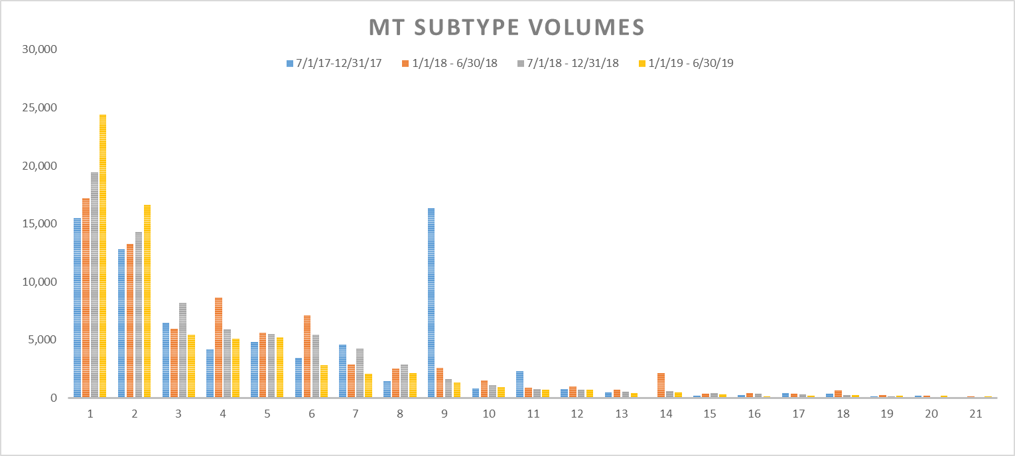

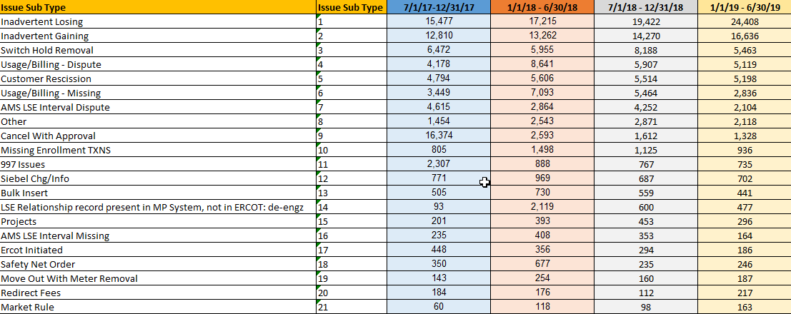

* IAL/IAG Sub Type Review

**Report 1**: Report 1: CR Transition Times (How long does it take to close an issue?)

**Report 2:** TDSP Volumes

**Report 3:** CR Volumes

**Data Requirements**: Issue Type, Issue Status, transition, submitting MP

**Initial Findings**: While reviewing MT submissions

* + - Approximately 77% of IAS regain MTs are submitted within 12 days
    - Approximately 13% are over submitted 30 days of greater
    - Approximately 26% are submitted within 3 days
    - Approximately 19% are within 4 – 7 days

**Suggested MT Enhancement**: 180 day reject

**Next Meeting**

* TDTMS WG will next meet at the ERCOT MetCenter on August 22
* The next MT Subtype to be reviewed by the working group will be Inadvertent Gains

|  |  |
| --- | --- |
| Action Items | Due Date |
| Who created and what are the purpose of the MT Workflows that are posted on ERCOT.com? (TDTMS Leadership) | **TBD** |
|  |  |
| NAESB Testing Discussion (TDTMS Leadership) | **TDB** |
| MT Timestamps. How can TDTMS follow transitions per a single issue? | **7/19/19** |
| Clean up MT Enhancement Document and send to TDTMS Listserve (Kyle) |  |