System Planning

Monthly Status Report
July 2019

Report Highlights
- ERCOT is currently reviewing proposed transmission improvements with a total estimated cost of $1,019.2 Million as of July 31, 2019.
- Transmission Projects endorsed in 2019 total $295.6 Million as of July 31, 2019.
- All projects (in engineering, routing, licensing and construction) total approximately $3.86 Billion as of June 1, 2019.
- Transmission Projects energized in 2019 total about $1.06 Billion as of June 1, 2019.

Regional Planning Group Project Reviews
- Garland Power & Light (GPL) and Oncor have submitted a request to withdraw the North Garland Reliability Infrastructure Project (N-GRIP). This project is no longer under ERCOT Independent Review.
- AEPSC has submitted the LRGV Import Project. This is a Tier 1 project that is estimated to cost $73.4 million. AEPSC has also requested that ERCOT provide conditional endorsement for an additional $357.2 million project. This project is currently under ERCOT Independent Review.
- TNMP has submitted the Ward and Winkler County Transmission Improvement Project. This is a Tier 2 project that is estimated to cost $60 million. This project is currently under ERCOT Indepdent Review.
- STEC has submitted the Lower Rio Grande Valley Transmission Expansion Project. This is a Tier 1 project that is estimated to cost $511 million. This project is currently under ERCOT Independent Review.
- AEPSC has submitted the Nueces 69 kV Reinforcement Project. This is a Tier 2 project that is estimated to cost $17.6 million. This project is currently under ERCOT Independent Review.
- AEPSC has submitted the Crane Area Transmission Project. This is a Tier 3 project that is estimated to cost $38 million. This project completed the RPG review on July 17, and ERCOT has issued the RPG acceptance letter.

More information on current and past RPG projects can be found on the ERCOT MIS Secure (digital certificate required): https://mis.ercot.com/pps/tibco/mis/Pages/Grid+Information/RegionalPlanning
Past email communication on RPG projects can be found on the ERCOT listserve by signing up for the REGPLANGROUP list: http://lists.ercot.com/scripts/wa-ERCOT.exe?A0=REGPLANGROUP

Planning Model Activities
The short-term calendar of major planning model events is as follows:
- October 15, 2019 Post 19SSWG Update 1 Base Cases and TPIT
- October 31, 2019 Post 19SSWG Update 1 Contingency definitions and Planning Data Dictionary
The following table shows interconnection projects that met Planning Guide section 6.9(1) and 6.9(2) and were modeled in the SSWG cases as a full model or as a simple model in accordance with Planning Guide section 6.9.
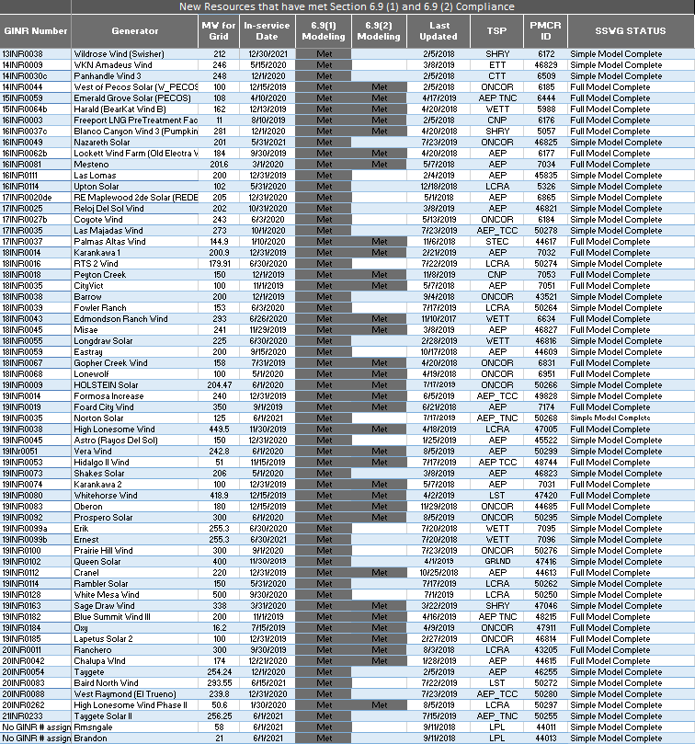

Permian Basin Oil Rig Count
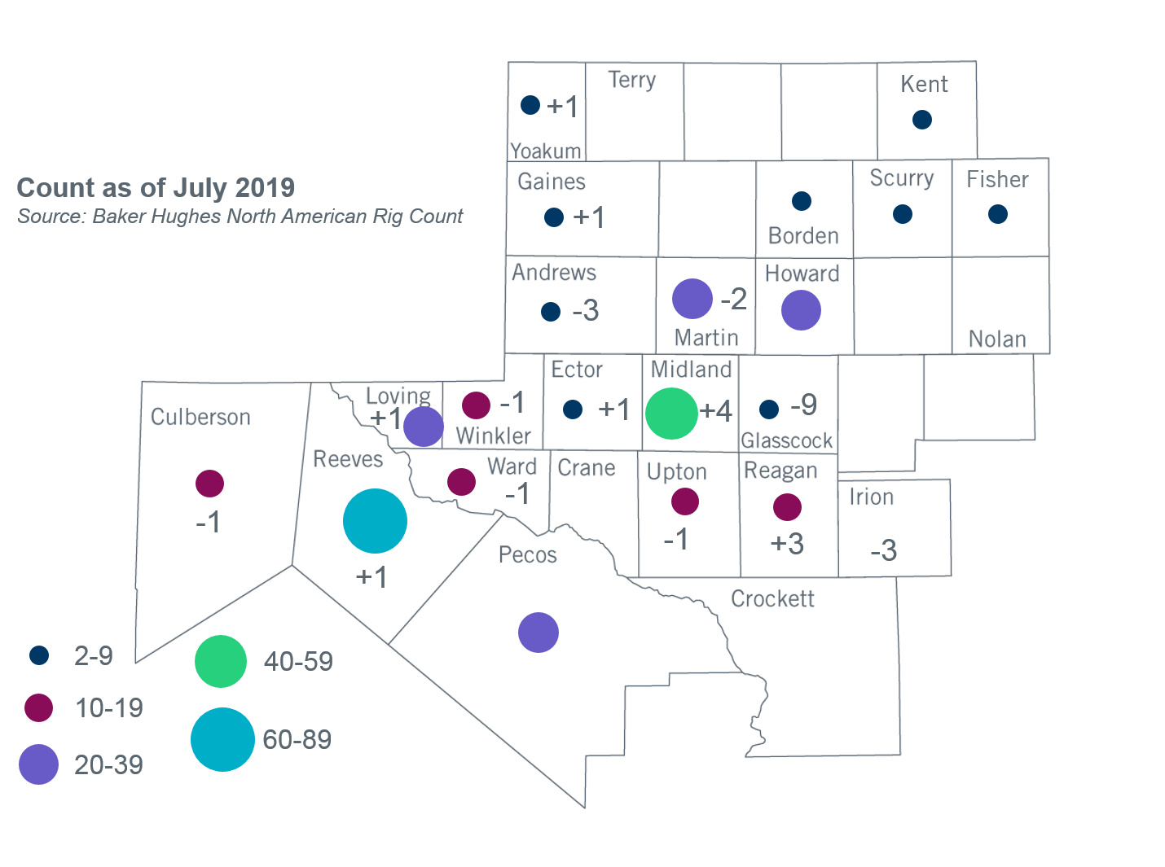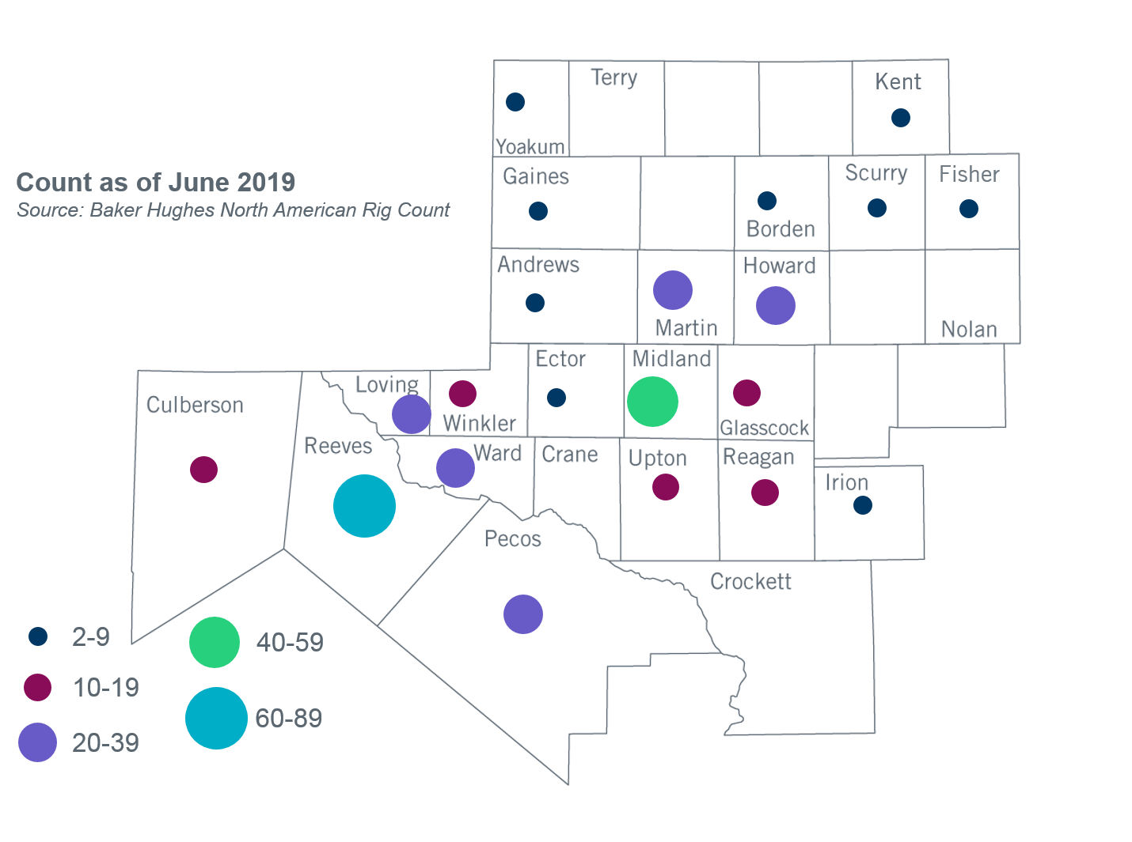

Other Notable Activities
- ERCOT is conducting the 2019 Regional Transmission Plan (RTP). The start cases for the 2019 RTP were posted on the MIS Secure Website on March 15, 2019.
- ERCOT presented preliminary results to the Regional Planning Group (RPG) in May for the 2020 Long-Term System Assessment (LTSA). ERCOT also sent a survey to the RPG to gather feedback on the LTSA assumptions and drivers.
- ERCOT has completed the transmission planning study for PUC Order 46304 Directives 6 and 8. The study report was posted in the following locations on May 31, 2019:
- http://www.ercot.com/mktrules/puctDirectives/southernCross/159973#keydocs
- https://mis.ercot.com/pps/tibco/mis/Pages/Grid+Information/RegionalPlanning
- ERCOT presented preliminary results of the Panhandle Stability and System Strength Assessment to the Reliability and Operations Subcommittee (ROS) in May.
- The SPWG completed the 2019 CY base case on March 29th and the 2020 - 2024 Future Year (FY) case build was completed on July 19th.
- ERCOT is currently conducting the Delaware Basin area load integration study. The purpose of the study is to identify potential reliability needs and transmission upgrades for the load (planned and conceptual) that may appear in the area for the longer term planning horizon.
- ERCOT completed the annual SSR review (using a 2022 SSWG base case) as required by Protocol 3.22.1.4, Annual SSR Review.

+/- symbol indicates the increase or decrease from the previous month in oil rigs present in each county. There are 331 rigs, including a total decrease of 9 oil rigs, in the Permian Basin from June to July 2019.

