June 2019 ERCOT Monthly Operations Report
Reliability and Operations Subcommittee Meeting
August 8, 2019

Table of Contents
1. Report Highlights 2
2. Frequency Control 3
2.1. Frequency Events 3
2.2. Responsive Reserve Events 4
2.3. Load Resource Events 4
3. Reliability Unit Commitment 4
4. Wind Generation as a Percent of Load 5
5. Largest Net-Load Ramp 5
6. COP Error Analysis 6
7. Congestion Analysis 8
7.1. Notable Constraints 8
7.2. Generic Transmission Constraint Congestion 11
7.3. Manual Overrides 11
7.4. Congestion Costs for Calendar Year 2019 11
8. System Events 12
8.1. ERCOT Peak Load 12
8.2. Load Shed Events 12
8.3. Stability Events 13
8.4. Notable PMU Events 13
8.5. DC Tie Curtailment 13
8.6. TRE/DOE Reportable Events 13
8.7. New/Updated Constraint Management Plans 13
8.8. New/Modified/Removed RAS 13
8.9. New Procedures/Forms/Operating Bulletins 13
9. Emergency Conditions 14
9.1. OCNs 14
9.2. Advisories 14
9.3. Watches 14
9.4. Emergency Notices 14
10. Application Performance 14
10.1. TSAT/VSAT Performance Issues 14
10.2. Communication Issues 14
10.3. Market System Issues 14
11. Model Updates 14
Appendix A: Real-Time Constraints 17

Report Highlights
- The unofficial ERCOT peak was 68,124 MW.
- There were 2 frequency events.
- There were 0 instances where Responsive Reserves were deployed.
- There were 4 RUC commitments.
- Congestion in the West Load Zone (LZ) can be mostly attributed to high Panhandle wind generation, as well as a combination of low generation and high load (often during off peak hours). Congestion in the South LZ was mostly due to outages. Congestion in the North and Houston LZs were relatively minimal. Congestion across zones was mostly due to planned outages near the Coast. There were 28 days on the Panhandle GTC and 1 day on the North – Houston GTC.
- There were 2 DC Tie curtailments.

Frequency Control

Frequency Events
The ERCOT Interconnection experienced 2 frequency events, both of which resulted from a unit trip. The average event duration was approximately 00:05:24.

A summary of the frequency events is provided below. The reported frequency events meet one of the following criteria: Delta Frequency is 60 mHz or greater; the MW loss is 350 MW or greater; resource trip event triggered RRS deployment. Frequency events that have been identified as Frequency Measurable Events (FME) for purposes of BAL-001-TRE-1 analysis are highlighted in blue. When analyzing frequency events, ERCOT evaluates PMU data according to industry standards. Events with an oscillating frequency of less than 1 Hz are considered to be inter-area, while higher frequencies indicate local events. Industry standards specify that damping ratio for inter-area oscillations should be 3.0% or greater. For the frequency events listed below, the ERCOT system met these standards and transitioned well after each disturbance.

Date and Time | Delta Frequency | Max/Min Frequency | Duration of Event | PMU Data |  | MW Loss | Load | Wind | Inertia
 | (Hz) | (Hz) |  | Oscillation Mode (Hz) | Damping Ratio |  | (MW) | % | (GW-s)
6/9/2019 19:35 | 0.079 | 59.925 | 0:09:38 | No PMU data available |  | 503.315 | 55,942 | 28% | 320,206
6/18/2019 4:05 | 0.093 | 59.925 | 0:01:11 | No PMU data available |  | 415.962 | 36,430 | 21% | 263,944

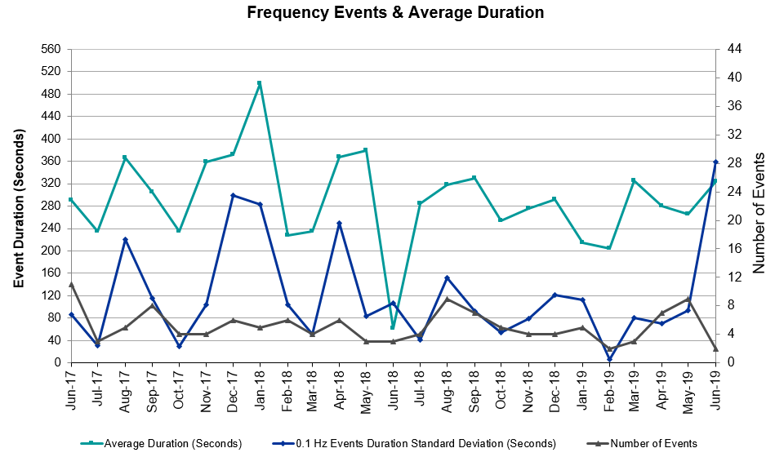 (Note: All data on this graph encompasses frequency event analysis based on BAL-001-TRE-1.)

Note that the large standard deviation is due to coincidental extreme high and low durations for a small set of events (2).

Responsive Reserve Events
There were no events where Responsive Reserve MWs were released to SCED. The events highlighted in blue were related to frequency events reported in Section 2.1 above.

Load Resource Events
None.

Reliability Unit Commitment
ERCOT reports on Reliability Unit Commitments (RUC) on a monthly basis. Commitments are reported grouped by operating day and weather zone. The total number of hours committed is the sum of the hours for all the units in the specified region. Additional information on RUC commitments can be found on the MIS secure site at Grid Generation Reliability Unit Commitment.

There were no DRUC commitments.

There were 4 HRUC commitments.

Resource Location | # of Resources | Operating Day | Total # of Hours Committed | Total MWhs | Reason for Commitment
Far West | 1 | 6/6/2019 | 2 | 136 | Congestion
Far West | 1 | 6/7/2019 | 2 | 138 | Congestion
Far West | 1 | 6/11/2019 | 8 | 559 | Congestion
Far West | 1 | 6/17/2019 | 3 | 195 | Congestion

Wind Generation as a Percent of Load
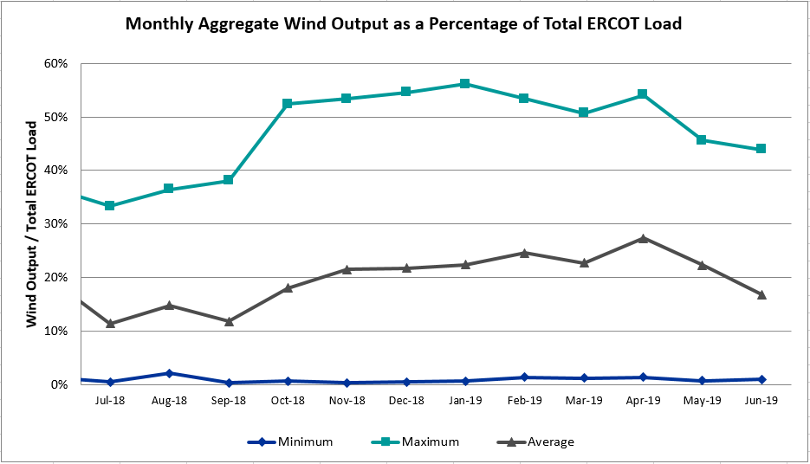

Wind Generation Record: 19,672 MW on 01/21/2019 at 19:19
Wind Penetration Record: 56.16% on 01/19/2019 03:10

Largest Net-Load Ramp
The net-load ramp is defined as the change in net-load (load minus wind and PVGR generation) during the defined time horizon. Such a variation in net-load needs to be accommodated in grid operations to ensure that the reliability of the grid is satisfactorily maintained. The largest net-load ramp during 5-min, 10-min, 15-min, 30-min and 60-min intervals is 24 MW, 1284 MW, 1706 MW, 2985 MW and 5684 MW, respectively. The comparison with respect to the historical values is given in the table below.

Month and Year | 5 min | 10 min | 15 min | 30 min | 60 min
June 2019 | 824 MW | 1284 MW | 1706 MW | 2985 MW | 5684 MW
June 2014 | 921 MW | 1310 MW | 1871 MW | 3486 MW | 4331 MW
June 2015 | 1045 MW | 1786 MW | 2489 MW | 3101 MW | 5319 MW
June 2016 | 952 MW | 1291 MW | 1808 MW | 3146 MW | 4897 MW
June 2017 | 751 MW | 1202 MW | 1772 MW | 3108 MW | 5348 MW
June 2018 | 971 MW | 1370 MW | 2032 MW | 3584 MW | 6480 MW
2014-2018 | 1494 MW | 1991 MW | 2780 MW | 4109 MW | 7218 MW

COP Error Analysis
COP Error is calculated as the capacity difference between the COP HSL and real-time HSL of the unit. Mean Absolute Error (MAE) stayed high over 11,000 MW until Day-Ahead at 12:00, then dropped significantly to 1,077 MW by Day-Ahead at 14:00. In the following chart, Under-Scheduling Error indicates that COP had less generation capacity than real-time and Over-Scheduling Error indicates that COP had more generation capacity than real-time. Under-Scheduling persisted from beginning of Day-Ahead to end of the Operating Day. Snapshot on the Operating Day considers all Operating Hours, including past hours. However, COP error for the Operating Hour freezes after the Adjustment Period.

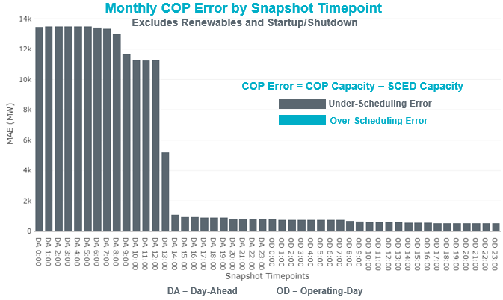

Monthly MAE for the Latest COP at the end of the Adjustment Period was 529 MW with median ranging from -959 MW for Hour-Ending (HE) 19 to -107 MW for HE 4. HE 23 on the 20th had the largest Over-Scheduling Error (16,226 MW) (not shown in the chart) and HE 22 on the 7th had the largest Under-Scheduling Error (-2,868 MW).

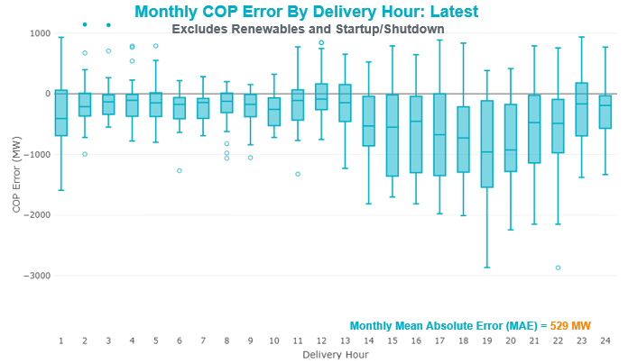

Monthly MAE for the Day-Ahead COP at 12:00 was 11,269 MW with median ranging from -16,602 MW for Hour-Ending (HE) 17 to -7,728 MW for HE 2. HE 23 on the 20th had the largest Over-Scheduling Error (7,791 MW) (not shown in the chart) and HE 16 on the 19th had the largest Under-Scheduling Error (-20,738 MW).

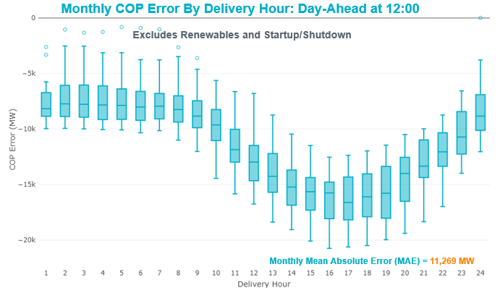

Congestion Analysis
The total number of congestion events experienced by the ERCOT system decreased compared to the previous month. There were 28 instances over 28 days on the Generic Transmission Constraints (GTCs).

Notable Constraints
Nodal protocol section 3.20 specifies that ERCOT shall identify transmission constraints that are active or binding three or more times within a calendar month. As part of this process, ERCOT reports congestion that meets this criterion to ROS. In addition ERCOT also highlights notable constraints that have an estimated congestion rent exceeding $1,000,000 for a calendar month. These constraints are detailed in the table below. Rows highlighted in blue indicate the congestion was affected by one or more outages. For a list of all constraints activated in SCED, please see Appendix A at the end of this report.

Contingency Name | Overloaded Element | # of Days Constraint Active | Congestion Rent | Transmission Project
TWR (345) HLJ-WAP64 & BLY-WAP72 | Jones Creek - South Texas Project 345kV | 14 | $13,679,686.36 | Freeport Master Plan (6668A)
Solstice to FORT STOCKTON PLANT LIN 1 | Barrilla - Fort Stockton Switch 69kV | 28 | $9,762,988.45 | Solstice: Build 345 kV station (5530) and Solstice to Bakersfield: Build 345 kV line (5539)  Pecos County Modification Project (7028, 44359)
Basecase | PNHNDL GTC | 28 | $8,502,541.19
TWR (345) HLJ-WAP64 & BLY-WAP72 | Dow Chemical - South Texas Project 345kV | 8 | $5,829,734.92 | Freeport Master Plan (6668A)
LON HILL TRX LON_HILL_3_1 345/138 | Lon Hill 138kV | 9 | $5,488,122.37 | Lon Hill: Replace 345/138 kV autotransformers (6101)
GAS PAD to FLAT TOP TNP LIN 1 | Woodward 2 - Rio Pecos 138kV | 5 | $4,844,171.10 | Lynx: Expand 138 kV station (45503)
FRIEND RANCH TRX FMR1 138/69 | Sonora 138kV | 11 | $4,044,583.09 | Carver: Build new 138 kV station (5979)
MOSS SWITCH to ECTOR COUNTY NORTH SWITCHING STATION LIN _A | Andrews County South - Amoco Three Bar Tap 138kV | 10 | $3,762,694.58 | Andrews County South Switch - No Trees Switch 138 kV Line (7171)
MOSS SWITCH to YUCCA DRIVE SWITCH LIN _A | Moss Switch - Ector Harper 138kV | 4 | $2,929,107.41 | Riverton-Odessa EHV/Moss 345 kV Line (5445)
KLEBERG AEP to KINGSVILLE LIN 1 | Loyola Sub 138kV | 5 | $2,009,933.36 | Lon Hill: Replace 345/138 kV autotransformers (6101)
ODLAW SWITCHYARD to ASPHALT MINES LIN 1 | Hamilton Road - Maverick 138kV | 23 | $1,559,605.90 | Brackettville to Escondido: Construct 138 kV line (5206)
Solstice to FORT STOCKTON PLANT LIN 1 | Fort Stockton Plant 138kV | 18 | $1,542,215.92 | Ft. Stockton SW: Build 138 kV station (44361)
Bighil-Kendal 345kV | Yellow Jacket - Treadwell 138kV | 9 | $793,923.06 | Treadwell: Build new 138 kV station (6397)
YUKON SWITCH to ECTOR COUNTY NORTH SWITCHING STATION LIN _B | No Trees Switch - Cheyenne Tap 138kV | 17 | $749,512.63 | Wink Sw. Sta. - No Trees Sw. Sta. 138 kV Line (7101)
Hcksw-Sagna-138kv | Eagle Mountain Ses - Morris Dido 138kV | 5 | $689,761.22 | Eagle Mountain-Calmont 138 kV Line (4253)
NORTH PHARR to POLK AVENUE LIN 1 | North Mcallen - West Mcallen 138kV | 3 | $642,386.62 | North McAllen (8368) - West McAllen (8367) - South McAllen (8371) 138-kV line upgrades (2017-S9)/ South McAllen-Bentsen and North Edinburg-West Edinburg (5621)
Trses-Scses&Entpr 345kV | Pleasant Springs (Hcec) - Grapeland Magnolia Tap 138kV | 6 | $573,845.56
LON HILL TRX LON_HILL_3_1 345/138 | Lon Hill 345kV | 9 | $505,806.99 | Lon Hill: Replace 345/138 kV autotransformers (6101)
MOSS SWITCH to ECTOR COUNTY NORTH SWITCHING STATION LIN _A | Dollarhide - No Trees Switch 138kV | 3 | $472,313.21 | Andrews County South Switch - No Trees Switch 138 kV Line (7171)
PH ROBINSON to MEADOW LIN A | Mainland Tnp - Alvin Tnp 138kV | 4 | $455,096.70
FORT LANCASTER to ILLINOIS #4 LIN 1 | Ozona - Ozona Rea 69kV | 5 | $371,919.96
BRACKETTVILLE to HAMILTON ROAD LIN 1 | Hamilton Road - Maverick 138kV | 7 | $272,020.83 | Brackettville to Escondido: Construct 138 kV line (5206)
RIO HONDO to LAS PULGAS LIN 1 | Raymondville 2 138kV | 19 | $243,530.89 | Harlingen SS - Raymondville #2: Convert to 138 kV (6167)
LAQUINTA to LOBO LIN 1 | Bruni Sub 138kV | 11 | $234,404.07
Pig Creek to Solstice LIN 1 | Woodward 2 - Rio Pecos 138kV | 21 | $231,462.41 | Lynx: Expand 138 kV station (45503)
BELLAIRE to BRAYS LIN A | Series device at HOC station | 3 | $216,628.04
LON HILL TRX LON_HILL_3_2 345/138 | Lon Hill 138kV | 3 | $153,684.27 | Lon Hill: Replace 345/138 kV autotransformers (6101)
Jewet-Sng 345kV | Btu_Jack_Creek - Twin Oak Switch 345kV | 7 | $139,408.77
CRLNW-LWSSW 345kV | Jones Street Tnp - Lakepointe Tnp 138kV | 4 | $109,601.35 | Lewisville - Lewisville Jones - Lakepointe 138 kV Line (45537)
HAMILTON ROAD to CORRAL LIN 1 | Hamilton Road - Maxwell 138kV | 6 | $93,205.28 | Brackettville to Escondido: Construct 138 kV line (5206)
HAMILTON ROAD TRX PS2 138/138 | Sonora 138kV | 7 | $64,417.84 | Carver: Build new 138 kV station (5979)
SAN MIGUEL 345_138 KV SWITCHYARDS to LOBO LIN 1 | North Laredo Switch - Piloncillo 138kV | 5 | $54,433.01
Pig Creek to Solstice LIN 1 | Fort Stockton Plant - Airport Tnp 138kV | 5 | $54,005.22 | Solstice: Build 345 kV station (5530) and Solstice to Bakersfield: Build 345 kV line (5539)  Pecos County Modification Project (7028, 44359)
Bighil-Kendal 345kV | Hamilton Road - Maxwell 138kV | 8 | $49,310.61 | Brackettville to Escondido: Construct 138 kV line (5206)
BOSQUE SWITCH to ELM MOTT LIN 1 | Bosque Switch - Rogers Hill Bepc 138kV | 4 | $40,231.93
Ferguson-Sherwood Shores & Ferguson-Granite Mountain 138kV | Sandy Creek 138kV | 6 | $34,970.25
COLETO CREEK to PAWNEE SWITCHING STATION LIN 1 | Coleto Creek - Rosata Tap 138kV | 3 | $33,753.29 | Coleto Creek to Tuleta: New 138 kV Line (16TPIT0034)
HAMILTON ROAD to Maxwell LIN 1 | Sonora 138kV | 6 | $27,736.48 | Carver: Build new 138 kV station (5979)
CAGNON TRX CAGNON_3_3 345/138 | Cagnon 345kV | 3 | $27,302.98
FORT MASON to YELLOW JACKET LIN 1 | Mason Aep - Fredricksburg Phillips Tap 69kV | 4 | $23,961.65 | Yellowjckt to Menard Phillips T 69 kV line: Rebld 69 kV line (6345)  Mason to Fort Mason: Rebuild 69 kV line (5794) - 138 kV conversion
JIM PAYNE POI to Jim Payne Breaker Station LIN _D | Gunsight Switch - Getty Vealmoor 138kV | 3 | $10,683.64
WINK to DUNE SWITCH and YUKON | No Trees Switch - Cheyenne Tap 138kV | 4 | $10,282.83 | Wink Sw. Sta. - No Trees Sw. Sta. 138 kV Line (7101)
Basecase | Randado Aep - Zapata 138kV | 8 | $2,386.29
WOODWARD 1 TAP to WOODWARD 1 LIN 1 | Woodward 2 - Rio Pecos 138kV | 4 | $1,242.23 | Lynx: Expand 138 kV station (45503)

Generic Transmission Constraint Congestion
There were 28 days on the Panhandle GTC and 1 day on the North – Houston GTC. There was no activity on the remaining GTCs during the month.

Note: This is how many times a constraint has been activated to avoid exceeding a GTC limit, it does not imply an exceedance of the GTC occurred or that the GTC was binding.

Manual Overrides
None.

Congestion Costs for Calendar Year 2019
The following table represents the top twenty active constraints for the calendar year based on the estimated congestion rent attributed to the congestion. ERCOT updates this list on a monthly basis.

Contingency | Binding Element | # of 5-min SCED Intervals | Estimated Congestion Rent | Transmission Project
Basecase | PNHNDL GTC | 17,629.00 | 33,333,563.37
Elmcreek-Skyline 345kV | Hill Country - Marion 345kV | 961.00 | 26,958,430.36 | Zorn to Marion 2nd 345-kV Transmission Line Addition (4473)
Solstice to FORT STOCKTON PLANT LIN 1 | Barrilla - Fort Stockton Switch 69kV | 14,619.00 | 23,044,042.52 | Solstice: Build 345 kV station (5530) and Solstice to Bakersfield: Build 345 kV line (5539)  Pecos County Modification Project (7028, 44359)
CRLNW-LWSSW 345kV | Ti Tnp - West Tnp 138kV | 2,496.00 | 18,908,859.77
FRIEND RANCH TRX FMR1 138/69 | Sonora 138kV | 4,564.00 | 18,535,545.60 | Carver: Build new 138 kV station (5979)
TWR (345) HLJ-WAP64 & BLY-WAP72 | Jones Creek - South Texas Project 345kV | 4,905.00 | 17,833,136.27 | Freeport Master Plan (6668A)
Manual LOTEBUSH toYUCSW 138 kV | 16th Street Tnp - Woodward 2 138kV | 4,906.00 | 14,675,595.13 | Solstice: Build 345 kV station (5530) and Solstice to Bakersfield: Build 345 kV line (5539)
CAGNON to KENDALL LIN 1 | Cico - Comfort 138kV | 3,247.00 | 10,393,334.32 | Boerne Cico - Comfort - Kendall Transmission Line Upgrade (6982)
Hcksw-Sagna-138kv | Eagle Mountain Ses - Eagle Mountain Compressor 138kV | 773.00 | 10,199,599.65 | Eagle Mountain-Calmont 138 kV Line (4253)
DMTSW-SCOSW 345KV | Knapp - Scurry Chevron 138kV | 3,203.00 | 9,750,942.24 | Ennis Creek - Cogdell 69 kV Line (4554) & Ennis Creek 138 kV Switching Station (6269)
Solstice to LINTERNA LIN 1 | Barrilla - Fort Stockton Switch 69kV | 14,077.00 | 9,251,017.29 | Solstice: Build 345 kV station (5530) and Solstice to Bakersfield: Build 345 kV line (5539)  Pecos County Modification Project (7028, 44359)
CRLNW-LWSSW 345kV | Carrollton Northwest - Lakepointe Tnp 138kV | 1,344.00 | 9,028,752.71 | Northwest Carrollton - LakePointe TNP 138 kV Line (5548)
SAN MIGUEL 345_138 KV SWITCHYARDS to LOBO LIN 1 | North Laredo Switch - Piloncillo 138kV | 5,673.00 | 8,956,296.88
CRLNW-LWSSW 345kV | Jones Street Tnp - Lakepointe Tnp 138kV | 1,773.00 | 8,890,602.54 | Lewisville - Lewisville Jones - Lakepointe 138 kV Line (45537)
TWR (345) HLJ-WAP64 & BLY-WAP72 | Dow Chemical - South Texas Project 345kV | 2,599.00 | 8,035,399.22 | Freeport Master Plan (6668A)
CPSES-JONSW&EVRSW 345kV | Hood - Decordova Dam 138kV | 172.00 | 7,948,529.13
ODLAW SWITCHYARD to ASPHALT MINES LIN 1 | Hamilton Road - Maverick 138kV | 10,873.00 | 7,670,043.31 | Brackettville to Escondido: Construct 138 kV line (5206)
WHITEPOINT TRX 345A 345/138 | Lon Hill 345kV | 847.00 | 7,109,227.27 | Lon Hill: Replace 345/138 kV autotransformers (6101)
DCRMOD28 Odesa-Mdssw&Odehv 138 kV | Big Three Odessa Tap - Odessa Ehv Switch 138kV | 765.00 | 6,873,912.15 | Riverton-Odessa EHV/Moss 345 kV Line (5445)
LON HILL TRX LON_HILL_3_1 345/138 | Lon Hill 138kV | 1,040.00 | 6,680,073.80 | Lon Hill: Replace 345/138 kV autotransformers (6101)

System Events

ERCOT Peak Load
The unofficial ERCOT peak load for the month was 68,124 MW and occurred on the 19th, during hour ending 18:00.

Load Shed Events
None.

Stability Events
None.

Notable PMU Events
ERCOT analyzes PMU data for any significant system disturbances that do not fall into the Frequency Events category reported in section 2.1. The results are summarized in this section once the analysis has been completed.

There were no PMU events outside of those reported in section 2.1.

DC Tie Curtailment
Date | DC Tie | Curtailing Period | # of Tags Curtailed | Initiating Event | Curtailment Reason
06/19/2019 | DC-S | HE20-21 | 5 | SBEVSHA8, loss of the Bevo to Asherton 138 kV loads the Bigwells to Brundage Sub 69 kV | Local congestion
06/27/2019 | DC-S | HE18-24 | 1 | DC tie trip | Unplanned outage

TRE/DOE Reportable Events
- CPS submitted an OE-417 for June 06, 2019 Reportable Event Type: Loss of electric service to more than 50,000 customers for 1 hour or more.
- Oncor submitted an OE-417 for June 09, 2019 Reportable Event Type: Loss of electric service to more than 50,000 customers for 1 hour or more.
- Oncor submitted an OE-417 for June 16, 2019 Reportable Event Type: Loss of electric service to more than 50,000 customers for 1 hour or more.
- Oncor submitted an OE-417 for June 23, 2019 Reportable Event Type: Loss of electric service to more than 50,000 customers for 1 hour or more.

New/Updated Constraint Management Plans
Annual review completed.
- No RAPs removed, modified, or added.
- 6 MPs removed and 3 added.
- 1 PCAP removed.

New/Modified/Removed RAS
None.

New Procedures/Forms/Operating Bulletins
None.

Emergency Conditions

OCNs
None.

Advisories
Date and Time | Description
Jun 06 2019  15:00 CPT | ERCOT issued an Advisory due to Physical Responsive Capability being below 3000 MW.
Jun 07 2019  15:00 CPT | ERCOT issued an Advisory due to Physical Responsive Capability being below 3000 MW.
Jun 17 2019  17:45 CPT | ERCOT issued an Advisory due to Physical Responsive Capability being below 3000 MW.
Jun 18 2019  16:55 CPT | ERCOT issued an Advisory due to Physical Responsive Capability being below 3000 MW.
Jun 23 2019  14:35 CPT | ERCOT issued an Advisory due to Physical Responsive Capability being below 3000 MW.

Watches
None.

Emergency Notices
None.

Application Performance

TSAT/VSAT Performance Issues
None.

Communication Issues
None.

Market System Issues
None.

Model Updates
The Downstream Production Change (DPC) process allows ERCOT to make changes in the on-line Network Operations Model without loading a completely new model. The purpose of this process is to allow for reliable grid operations as system conditions change between designated Network Operations Model database loads. The DPC process is limited in scope to just those items listed below, with equipment ratings updates being the most common. ERCOT has seen a rise in the use of the DPC process to make on-line updates to the Network Operations Model in recent years, instead of through the standard Network Operations Model Change Request process.

- Static Line ratings (Interim Update)
- Dynamic Line ratings (non-Interim Update)
- Autotransformer ratings (non-Interim Update)
- Breaker and Switch Normal status (Interim Update)
- Contingency Definitions (Interim Update)
- RAP and RAS changes or additions (Interim Update)
- Net Dependable and Reactive Capability (NDCRC) values (Interim Update)
- Impedance Updates (non-Interim)

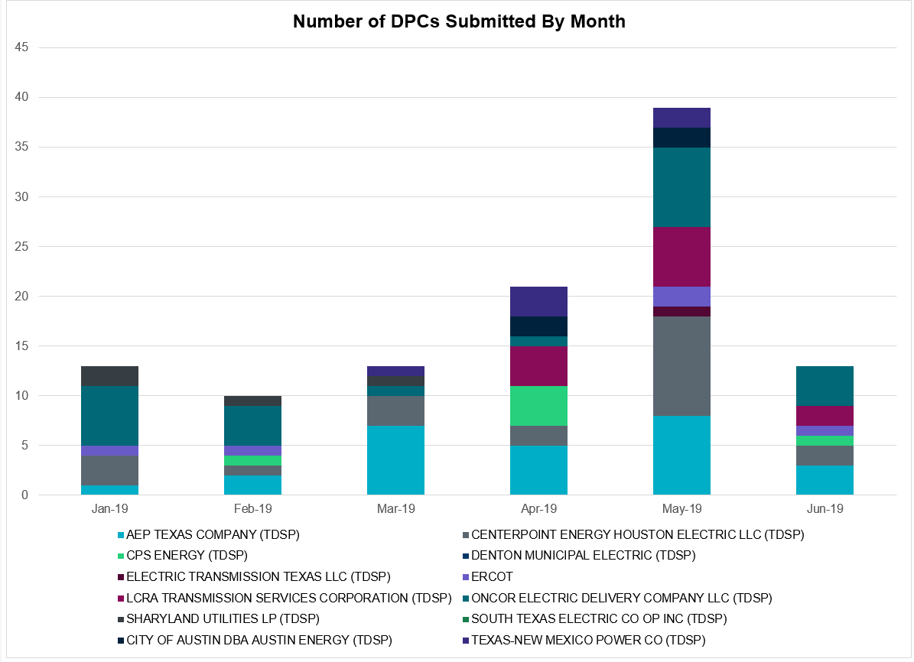

Transmission Operator | Number of DPCs in June 2019
AEP TEXAS COMPANY (TDSP) | 3
BRAZOS ELECTRIC POWER CO OP INC (TDSP) | 0
CENTERPOINT ENERGY HOUSTON ELECTRIC LLC (TDSP) | 2
CITY OF AUSTIN DBA AUSTIN ENERGY (TDSP) | 0
CPS ENERGY (TDSP) | 1
DENTON MUNICIPAL ELECTRIC (TDSP) | 0
ELECTRIC TRANSMISSION TEXAS LLC (TDSP) | 0
ERCOT | 1
LCRA TRANSMISSION SERVICES CORPORATION (TDSP) | 2
ONCOR ELECTRIC DELIVERY COMPANY LLC (TDSP) | 4
SHARYLAND UTILITIES LP (TDSP) | 0
SOUTH TEXAS ELECTRIC CO OP INC (TDSP) | 0
TEXAS MUNICIPAL POWER AGENCY (TDSP) | 0
TEXAS-NEW MEXICO POWER CO (TDSP) | 3

Appendix A: Real-Time Constraints
The following is a complete list of constraints activated in SCED. Full contingency descriptions can be found in the Standard Contingencies List located on the MIS secure site at Grid Generation Reliability Unit Commitment.

Contingency | Constrained Element | From Station | To Station | # of Days Constraint Active
SSOLFTS8 | BARL_FTSW1_1 | FTSW | BARL | 28
BASE CASE | PNHNDL | n/a | n/a | 28
SBRAUVA8 | HAMILT_MAVERI1_1 | HAMILTON | MAVERICK | 23
SPIGSOL8 | RIOPEC_WOODW21_1 | RIOPECOS | WOODWRD2 | 21
SPIGSOL8 | RIOPEC_WOODW21_1 | WOODWRD2 | RIOPECOS | 21
SRAYRI28 | RAYMND2_69A1 | RAYMND2 | RAYMND2 | 19
SSOLFTS8 | FTST_69T1 | FTST | FTST | 18
SYKNECN8 | 6101__A | NOTSW | CHEYT | 17
DWAPHLJ5 | JCKSTP18_A | STP | JCK | 14
SLAQLOB8 | BRUNI_69_1 | BRUNI | BRUNI | 11
XFRI89 | SONR_69-1 | SONR | SONR | 11
SECNMO28 | 6100__G | ACSSW | AMTBT | 10
DBIGKEN5 | TREADW_YELWJC1_1 | TREADWEL | YELWJCKT | 9
XLON58 | LON_HILL_382H | LON_HILL | LON_HILL | 9
XLON58 | LON_HILL_382L | LON_HILL | LON_HILL | 9
BASE CASE | RANDAD_ZAPATA1_1 | RANDADO | ZAPATA | 8
BASE CASE | RANDAD_ZAPATA1_1 | ZAPATA | RANDADO | 8
DBIGKEN5 | HAMILT_MAXWEL1_1 | MAXWELL | HAMILTON | 8
DWAPHLJ5 | DOWSTP27_A | STP | DOW | 8
XHAM88 | SONR_69-1 | SONR | SONR | 7
DJEWSNG5 | JK_TOKSW_1 | TOKSW | JK_CK | 7
SBRAHAM8 | HAMILT_MAVERI1_1 | HAMILTON | MAVERICK | 7
DFERGRM8 | SANDCR_AT1 | SANDCR | SANDCR | 6
SCOMHA38 | HAMILT_MAXWEL1_1 | MAXWELL | HAMILTON | 6
SHAMMAX8 | SONR_69-1 | SONR | SONR | 6
DTRSENT5 | 1230__G | GPMTP | PLSSP | 6
DHCKSAG8 | 6265__A | EMSES | MRSDO | 5
SLOBSA25 | NLARSW_PILONC1_1 | NLARSW | PILONCIL | 5
SKINKLE8 | LOYOLA_69_1 | LOYOLA | LOYOLA | 5
SHACPB38 | RIOPEC_WOODW21_1 | RIOPECOS | WOODWRD2 | 5
SPIGSOL8 | TNAF_FTS_1 | FTST | TNAF | 5
SILLFTL8 | OZNR_OZONA1_1 | OZONA | OZNR | 5
SSCUSU28 | ROTN_WOLFGA1_1 | WOLFGANG | ROTN | 4
SMDOPHR5 | 138_ALV_MNL_1 | ALVIN | MAINLAND | 4
SBOSELM5 | 1030__B | BOSQUESW | RGH | 4
DCRLLSW5 | 590__B | LWVJS | LKPNT | 4
SFORYEL8 | FRPHIL_MASN1_1 | MASN | FRPHILLT | 4
SMOSYUC8 | 6480__A | MOSSW | ECTHP | 4
DWINDUN8 | 6101__A | NOTSW | CHEYT | 4
SWOORI38 | RIOPEC_WOODW21_1 | RIOPECOS | WOODWRD2 | 4
XLO2N58 | LON_HILL_381L | LON_HILL | LON_HILL | 3
XCAG158 | CAGNON_MR4H | CAGNON | CAGNON | 3
SPLDLME8 | 6135__A | GUNSW | GYVLM | 3
SECNMO28 | 6100__F | DHIDE | NOTSW | 3
SBRBI8 | HOCHOC25_1 | HOC | HOC | 3
SCOLPAW5 | COLETO_ROSATA1_1 | COLETO | ROSATA | 3
SILLFTL8 | HAMILT_MAXWEL1_1 | MAXWELL | HAMILTON | 3
SPOLPHA8 | GCB_100_1 | N_MCALLN | W_MCALLN | 3
STI2WES8 | 837T21482_1 | INDNNWP | FOURMI | 3
SCAGKEN5 | 74T148_1 | COMFOR | CICO | 2
SBRHOC8 | HOCHOC25_1 | HOC | HOC | 2
SYK2WIN8 | 6101__A | NOTSW | CHEYT | 2
SSPUMW18 | ROTN_WOLFGA1_1 | WOLFGANG | ROTN | 2
SBEVASH8 | BIG_BRUN_1 | BIGWELS | BRUNDGS | 2
DNEDWED8 | NEDIN_N_MCAL1_1 | NEDIN | N_MCALLN | 2
DWLFARY8 | 6100__G | ACSSW | AMTBT | 2
SHACPB38 | 16TH_WRD2_1 | WOODWRD2 | 16TH_ST | 2
DZORHAY5 | BERGHE_AT1L | BERGHE | BERGHE | 2
SECNMO28 | 6101__A | NOTSW | CHEYT | 2
SGILNU78 | GILA_HIWAY_1_1 | GILA | HIWAY_9 | 2
SYKNECN8 | 6480__A | MOSSW | ECTHP | 2
SLOBSA25 | ASHERT_CATARI1_1 | ASHERTON | CATARINA | 2
SVICCO28 | COLETO_VICTOR2_1 | COLETO | VICTORIA | 2
SCOLKEN8 | MAGRUD_VICTOR2_1 | VICTORIA | MAGRUDER | 2
XLO2N58 | LON_HILL_381H | LON_HILL | LON_HILL | 1
SCITNUE8 | MORRIS_NUECES1_1 | NUECES_B | MORRIS | 1
DWIRSTA8 | SANDCR_AT1 | SANDCR | SANDCR | 1
BASE CASE | WDWRDT_WOODWR1_1 | WOODWRD1 | WDWRDTP | 1
DREAPWE8 | 1610__A | PWEST | RCHAT | 1
STUNRIO8 | 687T687_1 | INDNENR | DESEME | 1
SMNWORA8 | BNK_MIL_1 | MIL | BNK | 1
SCTHHA38 | HAMILT_MAXWEL1_1 | MAXWELL | HAMILTON | 1
DGARBRA8 | HOCHOC25_1 | HOC | HOC | 1
SDELLAR8 | LARDVN_LASCRU1_1 | LARDVNTH | LASCRUCE | 1
SSONFRI8 | SONR_69-1 | SONR | SONR | 1
DVENLIG5 | 530__C | VENSW | BRTRD | 1
XCAG158 | CAGNON_MR4L | CAGNON | CAGNON | 1
SAZTDUK8 | HEC_NEDIN2_1 | HEC | NEDIN | 1
SHAMMAX8 | MAXWEL_WHITIN1_1 | MAXWELL | WHITING | 1
SBTPBNT8 | MYRA_VAL_1 | MYRA | VALYVIEW | 1
SMDLODE5 | RIOPEC_WOODW21_1 | RIOPECOS | WOODWRD2 | 1
SKINKLE8 | RVI_LOYO_1 | LOYOLA | RVIERAS | 1
SPIGSOL8 | TNAF_TNFS_1 | TNAF | 16TH_ST | 1
SMSHNH28 | 3740__A | MSLSW | MSHLN | 1
XSBY89 | 6620__F | MDBSN | SBYSW | 1
SDUKNE28 | ADERHO_ELSA1_1 | ADERHOLD | ELSA | 1
SBROALP9 | BARL_FTSW1_1 | FTSW | BARL | 1
SAJORI25 | CELANE_N_SHAR1_1 | N_SHARPE | CELANEBI | 1
SN_SLON5 | CELANE_N_SHAR1_1 | N_SHARPE | CELANEBI | 1
DHUTHUT5 | HUTTO_MR1H | HUTTO | HUTTO | 1
SKLELOY8 | LOYOLA_69_1 | LOYOLA | LOYOLA | 1
BASE CASE | N_TO_H | n/a | n/a | 1
XSAN58 | SANMIGL_ATBH | SANMIGL | SANMIGL | 1
SLCSTH25 | 505__A | SAMSW | THSES | 1
DHCKSAG8 | 6260__C | EMSES | EMMCP | 1
DGRSPKR5 | 6377__A | BRTSW | ORANS | 1
DRIOHAR5 | BURNS_RIOHONDO_1 | RIOHONDO | MV_BURNS | 1
DAUSDUN8 | CKT_972_1 | HWRDLN | MCNEIL | 1
SODLBRA8 | GANSO_MAVERI1_1 | MAVERICK | GANSO | 1
SBUNKN8 | HOCHOC90_1 | HOC | HOC | 1
DLB_GBY8 | HR_NS_91_A | HR | NS | 1
DNEDWED8 | MCOLL__NEDIN1_1 | NEDIN | MCOLL_RD | 1
DFORCN85 | 200__A | FORSW | RYSSW | 1
DWINDUN8 | 6100__G | ACSSW | AMTBT | 1
SPIGSOL8 | 6100__G | ACSSW | AMTBT | 1
SENSENS8 | 940__C | ENWSW | WXHCH | 1
DCHBJOR5 | CD_TX_87_A | CD | TX | 1
SCISPUT8 | ESTES_PECAN_1_1 | PECAN_BY | ESTES | 1
SW_BW_25 | ESTILE_STLWRNC_1 | STLWRNCE | ESTILES | 1
SSOLFTS8 | FTS_FTS3_1 | FTST | TNFSTP | 1
SBEVASH8 | HAMILT_MAVERI1_1 | HAMILTON | MAVERICK | 1
SCISPUT8 | LENSW_PUTN2_1 | PUTN | LENSW | 1
DBIGKEN5 | SAPOWE_TREADW1_1 | SAPOWER | TREADWEL | 1
BASE CASE | WDWRDT_WOODWR1_1 | WDWRDTP | WOODWRD1 | 1
SPAWCAL5 | COLETO_ROSATA1_1 | COLETO | ROSATA | 1
DBIGKEN5 | FRIR_ROCKSP1_1 | FRIR | ROCKSPRS | 1
DELMSAN5 | PAWNEE_SPRUCE_1 | CALAVERS | PAWNEE | 1
DFERSTA8 | 38T365_1 | WIRTZ | FLATRO | 1
DMARPA_8 | 38T365_1 | WIRTZ | FLATRO | 1
DWLFARY8 | 6518__A | MOSSW | YUCSW | 1
SCMNCPS5 | 651__B | CMNSW | CMNTP | 1
DBIGKEN5 | FORTMA_YELWJC1_1 | YELWJCKT | FORTMA | 1
SODLBRA8 | HAMILT_MAVERI1_1 | HAMILTON | MAVERICK | 1
BASE CASE | HAMILT_MAXWEL1_1 | MAXWELL | HAMILTON | 1
SILLFTL8 | ILLN_PANDAL1_1 | PANDALE | ILLN | 1
DFLAPLU8 | MAGRUD_VICTOR2_1 | VICTORIA | MAGRUDER | 1
SAVMBSP8 | 6095__D | LMESA | JPPOI | 1
DGRMGRS8 | 6830__B | CRDSW | OLNEY | 1
DSWECBF5 | BLUF_C_MULBER1_1 | MULBERRY | BLUF_CRK | 1
SPOMNED5 | FREER_LOBO1_1 | LOBO | FREER | 1
DGBY_GS8 | HOCHOC90_1 | HOC | HOC | 1
DHOCGV89 | HOCHOC90_1 | HOC | HOC | 1

The Duration of Event is defined as the time it takes for the frequency to recover to pre-disturbance frequency or 60 Hz as applicable.
PMU reports are typically generated when frequency drops below 59.9, but PMU data is available for other events.
Delta Frequency is defined as the difference between the starting point of the frequency event (t(0) or “A-point”) and minimum/maximum frequency (“C-Point”).
Currently, the Critical Inertia Level for ERCOT is approximately 100,000 MW-s (Source: link)
This is the hourly integrated peak demand as published in the ERCOT D&E report.
All DC Tie Curtailments are posted publically on the ERCOT Market Information System. See that posting for additional details for the event(s) in question.
See DC Tie Operating Procedure (http://www.ercot.com/mktrules/guides/procedures) for more details.

