Methodology for Assessing GMD Impacts
on ERCOT Power Systems
Version 1.0

Document Revisions
Date | Version | Description | Author(s)
08/08/2019 | 1.0 | First Draft | PGDTF

Table of Contents
1. Introduction 1
2. Definitions and Acronyms 1
2.1. Definitions 1
2.2. Acronyms 2
3. GMD Background 2
4. Harmonics due to GMD 4
5. GMD effects on Protection System 6
5.1. Generator Protection 6
5.2. Transformer Protection 6
5.3. Shunt Capacitor Protection 7
5.4. Reactor Protection 8
5.5. Transmission Lines Protection 8
5.6. Series Capacitor Compensated Transmission Lines Protection 8
5.7. HVDC Transmission System Protection 8
5.8. Surge Arrester Protection 9
5.9. Static VAR Compensators (SVCs) and Harmonic Filter Protection 9
5.10. High Voltage Bus Protection 9
6. References 10

Introduction
The Planning Geomagnetic Disturbance Task Force (PGDTF) is a task force that reports to the Reliability and Operations Subcommittee (ROS). One of the purposes of the PGDTF is to formalize the requirements and criteria for performing GMD Vulnerability Assessments.
The applicable version of NERC Standard TPL-007 requires the responsible entity as determined in Requirement R1 (ERCOT) to complete a benchmark and supplemental GMD Vulnerability Assessment for the system. In this assessment, the system is subjected to the GMD Event described in the standard Attachment 1 to determine whether the system meets the performance requirements for the steady state planning benchmark and supplemental GMD Event contained in Table 1. The GMD Event with outages described in Table 1 is removing reactive power compensation devices and other transmission facilities as a result of protection system operation or misoperation due to harmonics during GMD Event. The purpose of this methodology is to provide guidance on assessing susceptibility of protection systems to harmonics caused by a GMD Event on the ERCOT system. There are no commercially available tools to analyze the harmonics order and magnitude during a GMD Event. This methodology is based on a qualitative approach.
On a periodic basis, PGDTF will review this methodology for needed updates. Any member of the PGDTF can submit proposed changes. The PGDTF will strive to develop consensus on the proposed changes. If consensus cannot be achieved, alternative proposed changes will be developed with an explanation of the alternatives and will be provided to the ROS for its consideration. A redlined version and a final version will be provided to the ROS for its review and approval.
In the event of any conflicts between this methodology and the ERCOT Nodal Protocols, the Protocols shall control in all respects.

Definitions and Acronyms
In the event of a conflict between any definitions or acronyms included in this manual and any definitions or acronyms established in the ERCOT Nodal Protocols and Planning Guide, the definitions and acronyms established in the ERCOT Nodal Protocols and Planning Guide take precedence.

Definitions
Near-Term Transmission The transmission planning period that covers year
Planning Horizon one through five.
GMD Geomagnetic Disturbance (GMD) is a geomagnetic storm caused by Coronal Mass Ejection (CME), which is associated with enormous changes and disturbances in the coronal magnetic field of the sun. If CMEs contact the earth, they create a disruption in the earth’s magnetic field and induce electric fields in the earth. These electric fields in-turn cause Geomagnetically Induced Currents (GICs) flow in the earth and high voltage grid.
IDEV A script file recognized by the PSS®E application used for transporting and applying network model changes in PSS®E.
GIC DC Model Direct current resistance model of the transmission system used to calculate geomagnetically induced currents and reactive power losses.
GIC AC Model The base AC power flow case used to create the GIC DC Model. It will be created from the selected SSWG case, and include any changes necessary to synchronize the GIC AC Model with the GIC DC Model.
GIC System Model The GIC System Model that is composed of both the GIC DC Model and GIC AC Model. The GIC System Model refers to both models necessary to run a GIC study. The GIC System Model consists of a summer peak load model and a minimum load model.

Acronyms
AC Alternating Current
DC Direct Current
ERCOT Electric Reliability Council of Texas
GIC Geomagnetically Induced Current
PGDTF Planning Geomagnetic Disturbance Task Force
SSWG Steady State Working Group
RARF Resource Asset Registration Form
RE Resource Entity
MCOV Maximum Continuous Operating Voltage
MOV Metal-oxide Varistor

GMD Background
GMD is a phenomenon where charged particles emitted from the sun interact with the Earth’s magnetic field and induces electric fields in the Earth. The geoelectric field at Earth’s surface drives electric currents. It is determined by the intensity of the GMD, which is based on changes in Earth’s magnetic field and the resistivity of Earth, which is based on geology and varies with depth and location. These geoelectric fields can drive GIC in large conducting structures, such as transmission lines. This electric field induces voltage in the transmission line, and creates a GIC flow through the line to the wye-grounded transformer winding and other wye-grounded power system equipment, and closes the loop through the Earth. The GIC flow is low frequency compared to power system frequency and is considered quasi DC. The amount of GIC flow in the power system depends on the magnitude and orientation of the geoelectric field and the characteristics of the electric grid, including the type, length, and orientation of transmission lines. Since GIC can be approximated as DC, the DC resistance of transmission lines, transformers, and substation ground grid impact the level of GIC. High levels of GIC have the potential to disrupt the reliable operation of the transmission system, as discussed below.
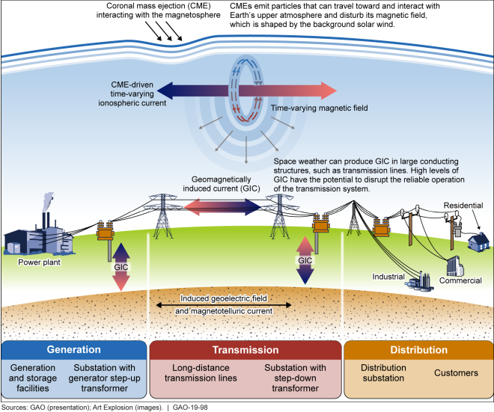
Figure 3-1 GIC flow in power system
The GMD severity is measured by a K-index factor. The K-index is a code based on maximum geomagnetic fluctuations over a 3-hour period. The “planetary” Kp index is derived by calculating a weighted average of K- indices from a network of international geomagnetic observatories and is a daily average of geomagnetic activity. K-indices are generally published by institutions working on geosciences, national observatories, space weather services, or in some instances, by military. One example is NOAA (National Oceanic and Atmospheric Administration) in the United States.
During a GMD Event, the flows of these quasi-DC GIC currents in transformer windings results in asymmetric or half-cycle saturation of transformer cores. This could lead to increased hot spot heating of transformer metallic parts, increased transformer reactive power absorption from the system and generation of harmonics.
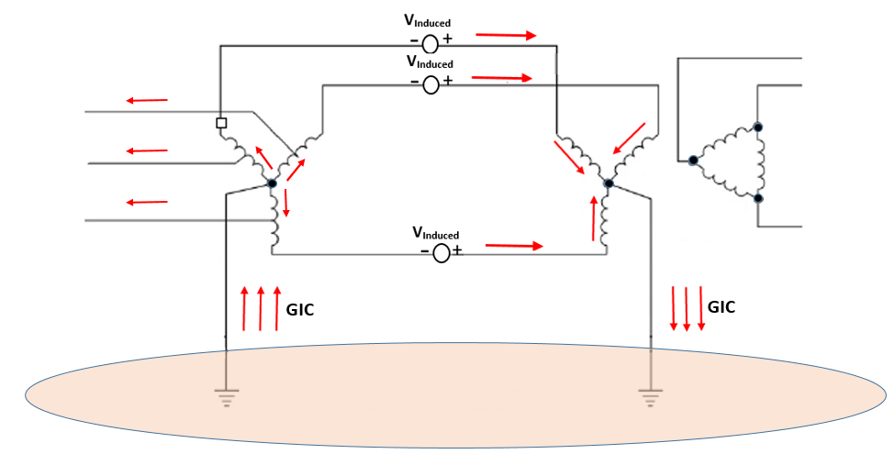
Figure 3-2 GIC flow in a simplified power system

High-voltage transformers are more susceptible to saturation when exposed to GMD. Transformers connected to the electric transmission grid are typically wye-configured on the high-voltage side with an electrical “neutral” connection to Earth, which allows GIC to flow through the high- voltage transmission grid. Design variation throughout the electric grid presents certain transformer designs that are less susceptible to GIC-related damage and some older, inherently vulnerable transformer designs. It is worth noting, that transformers that sustained damage during geomagnetic storms may have been more prone to failure. The effects of GMD could cause damage of the transformer(s), loss of reactive power sources, increased reactive power demand, and misoperation(s), the combination of which may result in voltage collapse and blackout.
GMD impacts may be immediate or may present themselves over time. Protection system reliability (security and/or dependability) may be affected depending on the severity of the GMD (as measured by K-index). The ability to detect the effects of GIC on transformers is useful in mitigating the effects of GMD on the reliable operation of the transmission system.

Harmonics due to GMD
When transformers saturate, current into transformers is distorted and harmonics are generated. The distorted currents and harmonics can physically stress electric grid equipment through heating and could result in damage or failure of transformers, generators, and capacitors. The distorted currents and harmonics may also interfere with the proper operation of protective relays causing them to misoperate which may result in power interruption. When protective relay operation occurs during a GMD Event, it is difficult for system operators to know whether the operation was purposeful or not. These consequences were observed during GMD Events in March 1989 and October 2003.
The distorted current includes both even and odd order harmonics and the total rms magnitude of the harmonic components exceeds the fundamental component. The second harmonic component is always the largest, and the magnitude of the components has a generally decreasing trend with increasing harmonic order. The magnetizing current from GIC is essentially the same as caused by transformer energization inrush, except that the GIC saturation can persist for an extended period.
Per EPRI’s GMD Harmonic Assessment presentation from May 16, 2019:
- The harmonic current injected by a GIC saturated transformer is of similar magnitude as the fundamental-frequency reactive current demand
V (h) = Z(h) * I (h)
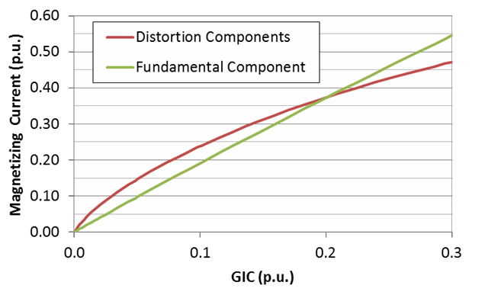
- System impedance Z(h) generally increases with frequency
Figure 4-1 Exciting current fundamental and harmonic components as a function of GIC
Harmonic distortion during a severe GMD is far more than a “power quality” issue. Harmonic impacts can substantially accelerate system voltage collapse.
The Harmonic Spectrum from each saturated transformer depends on the magnitude and polarity of GIC, the transformer design parameters and the distortion of the applied voltage. Generally:
- The harmonics are even- and odd-order harmonics
- 2nd harmonic is nearly as large as fundamental reactive current
- Magnitude generally decreases with harmonic order
- Harmonics of concern are of less than 11th order
- Even-order harmonic polarities reverse with change in GIC polarity
- Odd-order harmonic polarities do not reverse with GIC polarity
- The harmonic currents at any location are the aggregate of contributions from many transformers over a wide area
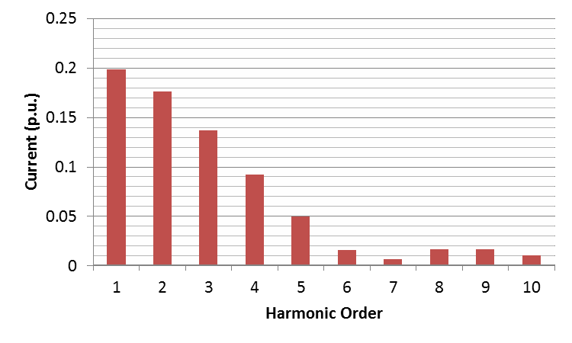
Figure 4-2 Exciting current harmonic components for a typical transformer

GMD effects on Protection System

Generator Protection
Generators with a Point of Interconnection (POI) voltage level below 60 kV do not need to be assessed for susceptibility to harmonics during benchmark and supplemental GMD events.
Negative-sequence overcurrent relaying is sometimes used for synchronous generator protection, but this scheme does not identify currents at harmonic frequencies due to inaccurate phase shifts, which may -over or -under protect the generator. Negative-sequence overcurrent relaying is not intended to protect from harmonic currents and may incorrectly trip due to the relay harmonic response. Protection that uses electromechanical relays and thermal based sensors are susceptible. Some, especially vintage, solid-sate relays are also susceptible to GMD impacts. Even if microprocessor based relays are used, they must be reviewed to ensure harmonic restraint or blocking is a feature that is enabled properly in the settings. Back-up relaying should also be considered when evaluating the appropriateness of the relay and scheme response in a GMD Event.
For some wind and solar photovoltaic resources, the harmonic protection functions applied to prevent the resources from injecting harmonic currents exceeding power quality limits, are non-directional and may operate for grid-produced distortion during a GMD Event.

Transformer Protection
GIC flows affect wye-grounded transformers because of the half-cycle saturation enough of this flow can produce. This increased current flow consists of fundamental and even/odd harmonics. The transformer at that point can become the source of harmonics to the rest of the power system, hence potentially affecting relay operation. The effects are different depending on the transformer construction. In decreasing sensitivity to GMD, transformer susceptibility has been ranked by others in the following order.
- Single-phase, shell or core design
- Three-phase shell form, seven-leg core design
- Three-phase shell form, conventional design
- Three-phase core form, five-leg core design
- Three-phase core form, three-leg core design
Differential relay scheme issues depend on the magnitude of the GIC. If the magnetizing current is below the relay pickup current, then no operation will occur. Hence, reviewing the pickup current of your differential element would be beneficial. However, if the scheme employs harmonic restraint the relay is not susceptible to GMD. Differential scheme is also not susceptible to harmonic currents from other saturated transformers. Reviewing the differential slope setting is also necessary to ensure the current transformer (CT) accuracy required to handle GMD Events. The primary CTs of a transformer could become saturated during an external fault, due to GIC currents acting like residual currents for this scheme. Another potential issue in a differential relay scheme is that some harmonic blocking relays may inhibit detection of internal faults during a GMD Event.
Overcurrent relay scheme issues arise mainly when the transformer is overloaded due to the higher magnetizing current during a GMD Event, which reduces the overcurrent security margin. However, if the relay settings comply with PRC-025-2 standard, the relay is not vulnerable to GMD. Neutral Overcurrent relays are also not vulnerable if they can distinguish harmonics. During a fault condition in this same scheme, the issue that may arise is the primary CT’s security performance may be compromised if the rms current is used as the operating current.
Overcurrent protection that uses electromechanical relays and thermal based sensors is susceptible. Some, especially vintage, solid-sate relays are also susceptible to GMD impacts. Even if microprocessor based relays are used, they must be reviewed to ensure harmonic restraint or blocking is a feature that is enabled properly in the settings. Back-up relaying should also be considered when evaluating the appropriateness of the relay and scheme response in a GMD Event.

Shunt Capacitor Protection
During GMD capacitors will block GIC flows but harmonics from saturated transformers will have low impedance path through the capacitor banks, as the capacitor impedance is inversely proportional to frequency.
5.3.1 Capacitor Unbalance Protection
The unbalance protection relays protect the capacitor banks from internal faults of the individual capacitor elements. The unbalance protection relays that do not filter harmonics or only filter certain order of harmonics are vulnerable to GMD. Those protection schemes include zero sequence and ground current relays in a grounded single-wye capacitor banks.
5.3.2 Capacitor System Overvoltage Protection
The over voltage protection relays protect the capacitor from system voltages above the rating of the capacitor banks. Overvoltage relays that do not filter the voltage harmonics and have conservative settings are susceptible to GMD harmonics.
5.3.3 Capacitor Overcurrent Protection
The overcurrent relays that protect from faults on the bus and feeders are usually set to multiples of the rated current and are not susceptible to GMD harmonics.
5.3.4 Capacitor Overload Protection
The overload relays protect the capacitor bank from thermal damage due to loading over the rating of the capacitors. Overload relays with conservative settings and do not filter harmonics are susceptible to GMD.

Reactor Protection
Transmission level shunt reactors are iron core reactors and are less likely to saturate due to GIC flow and as shunt reactors impedance increases with frequency, harmonic current flow is limited. The typical protections used for these reactors like phase overcurrent, winding differential, and restricted earth fault protection are not susceptible to GMD.

Transmission Lines Protection
Line protection schemes based on zero crossings (ex phase comparison protection) and negative sequence quantities applied to electromechanical or static relays are susceptible to GMD.
Transmission line relays that tripped in past GMD storms and have a potential to trip if the relay types do not filter harmonics include phase time overcurrent, ground overcurrent and overvoltage relays.

Series Capacitor Compensated Transmission Lines Protection
The series capacitors in the compensated lines blocks GIC flows when the bypass switch is open, but the line harmonics from nearby saturated transformer might affect the equipment and protection system.

HVDC Transmission System Protection
HVDC systems are designed to handle inrush current generally given by faults on the neighboring AC system. GMD Events and inrush currents are similar but with one major difference- GMD induced currents last much longer than inrush. Most HVDC systems are not designed to handle this increase in current for prolonged periods of time.
HVDC systems are protected from grid disturbances by DC and AC filters. These filters are generally a series of capacitor banks and tuning reactors and are designed and tuned to protect against 11th harmonic and above. Considering that GMD harmonics are in the lower harmonic range, many filter designs are left susceptible to tripping or even further damage. Harmonic filters are often connected in a way that a low impedance path can occurred if there are GIC-saturated transformers in the area. This could cause filters to overload. It is also possible for these filters to have a low capacitive or inductive reactance. If these values resonate with the grid inductive or capacitive reactance, harmonic currents within the filters can be amplified. Most HVDC designers focus more on the odd-ordered harmonics in their protection schemes but most GIC saturated transformers inject even-ordered harmonics into HVDC systems.
GMD Events do not affect the communication systems of HVDC systems directly, but if there are already GIC-saturated transformers in the area, inverter communication margin regulator may trip off more equipment than it needs to.
In short, GMD harmonics can cause a shortage of reactive capability within the HVDC system. Coupled with the fact that there is a demand for reactive capability in GMD Events, the consequences of not taking appropriate measures to protect the HVDC system can cause serious issues within the ERCOT system. HVDC designers must take into account of the increased demand for reactive capability during GMD Events as well as what reactive capability will be lost during these events. Places where DC filters are tuned to the 11th harmonic must screen for possible overload if a GMD Event was to occur in that area.

Surge Arrester Protection
Arresters are designed to protect equipment from lightning strikes or sudden spikes in voltage. Harmonic resonances from GIC saturated transformers can cause the harmonic voltage to rise above the MCOV of the arrester. If this voltage persists for a prolonged period of time, the MOV will experience temperatures above the thermal stability point, thus causing failure of the arrester. Arresters should be screened to handle a 1.35 p.u. peak voltage for a 30-second period. Even though most arresters meet this requirement, it is still important to screen for those that do not considering arrestors involved in almost every transmission design.

Static VAR Compensators (SVCs) and Harmonic Filter Protection
Similar to capacitor protection schemes the over current and overvoltage protection relays of SVCs and Harmonic filters are susceptible to GMD if they cannot distinguish harmonics from the fundamental frequency.

High Voltage Bus Current Differential Protection
Bus current differential relays detect faults occurring on a high voltage bus based on Kirchhoff’s current law that states the sum of the currents entering a given node is equal to the currents leaving that node. During a GMD Event, the currents including the harmonics into the bus, are equal to the currents from the bus and will not affect the differential protection except where current transformers respond differently to harmonics.

References
- B. Bozoki et al., "The effects of GIC on protective relaying," in IEEE Transactions on Power Delivery, vol. 11, no. 2, pp. 725-739, April 1996.
- J. Taylor,” Assessment Guide: GMD Harmonic Impacts and Asset Withstand Capabilities,” EPRI, Palo Alto, CA: 2016.
- A. K. Mattei and W. M. Grady, "Response of Power System Protective Relays to Solar and HEMP MHD-E3 GIC."
- D. H. Boteler, R. M. Shier, T. Watanabe and R. E. Horita, "Effects of geomagnetically induced currents in the BC Hydro 500 kV system," in IEEE Transactions on Power Delivery, vol. 4, no. 1, pp. 818-823, Jan. 1989
- Fenghai Sui, A. Rezaei-Zare, M. Kostic and P. Sharma, "A method to assess GIC impact on zero sequence overcurrent protection of transmission lines," 2013 IEEE Power & Energy Society General Meeting, Vancouver, BC, 2013, pp. 1-5.
- S. Meliopoulos, J. Xie and G. Cokkinides, "Power system harmonic analysis under geomagnetic disturbances," 2018 18th International Conference on Harmonics and Quality of Power (ICHQP), Ljubljana, 2018, pp. 1-6.
- A. Pulkkinen, S. Lindahl, A. Viljanen and R. Pirjola, "Geomagnetic storm of 29–31 October 2003: Geomagnetically induced currents and their relation to problems in the Swedish high-voltage power transmission system," in Space Weather, vol. 3, no. 8, pp. 1-19, Aug. 2005.
- T. I. A. H. Mustafa, S. H. L. Cabral, L. B. Puchale, M. G. Fuch, L. E. C. Lima and F. T. Flores, "A study of correlation between protection trips and geomagnetically induced currents in a power transmission line in Brazil," 2013 International Symposium on Electromagnetic Compatibility, Brugge, 2013, pp. 837-840.

