2019 Responsive Reserve Service Study Scope
For Determining 2020 Ancillary Service RRS Requirements

Operations Analysis Staff
ERCOT

Report Date: July. 01, 2019

Executive Summary
ERCOT uses Responsive Reserve Service (RRS) to arrest and recover frequency during large frequency deviations (typically triggered by Generation Resource trips). In 2015, a major revision was made to the Ancillary Service methodology that ERCOT uses to determine the minimum RRS requirements. As a part of this revision RRS requirements were modified to account for historical system inertia condition. In 2015, ERCOT had conducted a dynamic study (2015 RRS Study) to determine RRS requirements for under frequency events. Considering the evolution of the system, in terms of the transmission topology, generation addition, and load growth, an updated study was conducted in 2017 to take into account all the changes to assess if the 2015 RRS study results are still applicable. The 2017 RRS study used historical conditions from 2013 to 2017 to identify levels of inertia that best represent expected operating conditions and also reduced the incremental steps between consecutive conditions.

For determining 2020 RRS requirement, ERCOT will investigate various potential adjustments to the dynamic cases used for RRS study along with conducting a new benchmark study with selected recent events to validate the simulated dynamic frequency response against the actual response of ERCOT system.
Table of Contents
Executive Summary 1
1. Background 2
2. Current RRS Study – Summary 3
3. 2019 RRS Study Scope 6
3.1. Event Benchmark 6
3.2. RRS Mix Change 6
3.3. Unchanged Modelling Assumptions 6
3.3.1. Modeling generations resources that provide minimum PFR 6
3.3.2. Modeling Load Resources that provide RRS 7
3.3.3. Load Damping 7
3.4. Study Methodology 7

Background
ERCOT procures minimum RRS quantities to arrest and recover frequency during large frequency deviations (typically triggered by Generation Resource trips). As a part of BAL-003, the North American Electric Reliability Corporation (NERC) assigns an Interconnection Frequency Response Obligation (IFRO) to all Balancing Authorities/Frequency Reserve Sharing Groups – this IFRO represents the minimum Frequency Response required for reliable operations of an Interconnection. This IFRO is based on the region’s Resource Contingency Criteria (2750 MW for ERCOT) and the first-stage triggering frequency of Under-Frequency Load Shed (UFLS) Program (59.3 Hz for ERCOT). ERCOT is establishing 1150 MW of PFR as a minimum quantity needed to provide continuous governor response. Historically, ERCOT studies have used minimum 1150 MW of RRS from generators providing governor response. The minimum 1150 MW of RRS from generators providing governor response allows ERCOT to sufficiently perform above its IFRO obligation.

To meet NERC’s criteria for Frequency Response, ERCOT conducted dynamic studies at varying inertia levels that simulate the simultaneous trip of 2750 MW to determine the quantities of RRS (from Generation & Load Resources) needed to respond and arrest the frequency such that the frequency nadir stays at/or above 59.40 Hz (~0.1 Hz margin prior to the first-stage UFLS trip). Section 2 provides a brief summary of the 2017 RRS Study and Section 3 discusses the potential scope of a new 2019 RRS study that ERCOT plans to conduct for determining 2020 RRS requirement.

2017 RRS Study – Summary
System inertia is a key factor in determining how much RRS is needed. Recent real-time cases between 2013 and 2017 with inertia levels varying between 134 GW·s thru 380 GW·s were used in current RRS study. A 130 GW·s case (Case 1) was built from the 134 GW·s real time TSAT case by turning off some of the on-line generators and reducing loads. In all the 2017 RRS Study used a total of sixteen cases representing sixteen different inertia conditions to determine the corresponding RRS requirements. Detailed information of the sixteen cases is summarized in Table 1.

Table 1 Information for the cases selected to be included in the 2017 RRS Study
Case No. | Time | Inertia (GW*s)
Case1 | 02/10/17 01:00:00 | 130
Case2 | 03/31/14 02:00:00 | 140
Case3 | 03/21/14 02:00:00 | 150
Case4 | 10/23/16 00:00:00 | 160
Case5 | 11/20/16 01:00:00 | 170
Case6 | 10/28/13 00:00:00 | 180
Case7 | 02/23/16 23:00:00 | 190
Case8 | 11/24/16 15:00:00 | 200
Case9 | 04/02/14 10:00:00 | 220
Case10 | 01/18/17 11:00:00 | 230
Case11 | 10/05/13 18:00:00 | 260
Case12 | 06/01/16 22:00:00 | 270
Case13 | 05/28/14 18:00:00 | 290
Case14 | 08/11/16 05:00:00 | 300
Case15 | 09/03/13 18:00:00 | 359
Case16 | 08/07/13 17:00:00 | 376

Dynamic simulations were performed for each of the sixteen cases to identify the minimum RRS requirement; Table 2 below summarizes the simulations results for all sixteen cases used in 2017 RRS study obtained from TSAT dynamic simulations.

Table 2 Dynamic Simulation Results in the 2017 RRS Study
Case No. | Inertia (GW·s) | PFR (MW) | LR (MW) | LR/PFR | PFR (No LR)  (MW)
Case1 | 130 | 1150 | 1900 | 2.39 | 5691
Case2 | 140 | 1150 | 1800 | 2.17 | 5056
Case3 | 150 | 1150 | 1750 | 1.85 | 4388
Case4 | 160 | 1150 | 1700 | 1.85 | 4295
Case5 | 170 | 1150 | 1700 | 2.00 | 4550
Case6 | 180 | 1150 | 1650 | 1.71 | 3972
Case7 | 190 | 1150 | 1500 | 1.53 | 3445
Case8 | 200 | 1150 | 1450 | 1.43 | 3224
Case9 | 220 | 1150 | 1500 | 1.55 | 3475
Case10 | 230 | 1150 | 1400 | 1.30 | 2970
Case11 | 260 | 1150 | 1450 | 1.10 | 2745
Case12 | 270 | 1150 | 1300 | 1.10 | 2580
Case13 | 290 | 1150 | 1300 | 1.00 | 2450
Case14 | 300 | 1150 | 1250 | 1.20 | 2650
Case15 | 359 | 1150 | 1150 | 1.00 | 2300
Case16 | 376 | 1150 | 1050 | 1.00 | 2085

Simulation results show a strong correlation between PFR (No LR) and inertia. A power function was derived to determine PFR (No LR) requirement based on a given inertia. Likewise, a similar trend for LR/PFR equivalency ratio related to inertia can also be observed. A different power function was also derived to determine LR/PFR equivalency ratio as a function of inertia. Table 4 provides a summary of the quantities for PFR (No LR), LR/PFR ratio and RRS for various inertia conditions between 130 GW·s and 370 GW·s at an incremental step of 10 GW·s (which results in a total of 25 inertia scenarios). In Table 3, the quantities in red identify scenarios when the amount of RRS needed is less than 2300 MW; per Nodal Operating Guides, a floor of 2300 MW is in effect when determining RRS requirements.

Table 3 RRS Table (2017 Study)
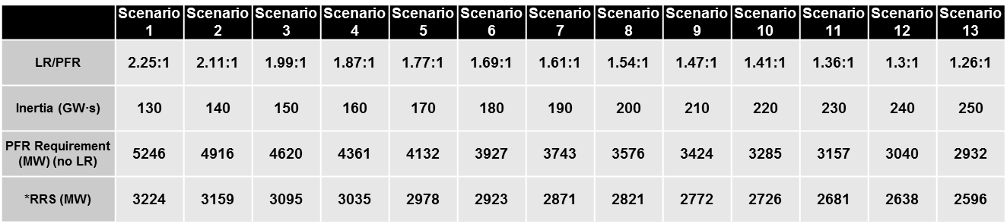
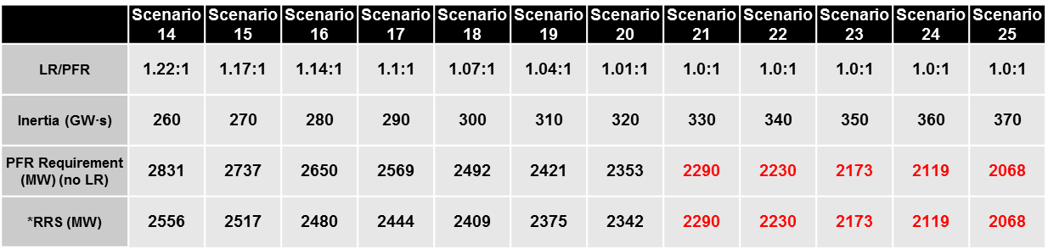

2019 RRS Study Scope
The 2019 RRS Study will use the same sixteen inertia cases as used in 2017 RRS study as they are still effectively able to cover the inertia range observed in 2018 and 2019. These cases represent varying inertia levels to cover a wide range of expected inertia conditions for future years. For determining 2020 RRS quantities, ERCOT will focus on validating dynamic response of ERCOT system as wells as understanding the need of changing the assumption of PFR unit mix if needed. The scope will include a new benchmark study with recent events and a statistical analysis of RRS unit mix change over the years. ERCOT will rerun dynamic simulations for all sixteen cases with the necessary changes applied.

Event Benchmark
To ensure the accuracy of dynamic models used in RRS study, ERCOT will conduct a new study to benchmark the model performance against historical large events. Event details are summarized in table 4. Corresponding real-time cases will be used for this study. When performing event validation, all of governor responses from generation units running online at the time of event will be enabled in the simulation. EROCT will compare the simulated frequency response at the system level with the actual event frequency profile.

Table 4 Selected Events for Benchmark Study
 | Event Time | MW Loss | Inertia | Load | Wind
No.1 | 11/25/2017 20:24 | 1,228MW | 186.4GWs | 35,122 MW | 8,370 MW
No.2 | 9/1/2017 21:46 | 1,209 MW | 290.3 GWs | 47,534 MW | 4,333 MW
No.3 | 3/2/2019 3:18 | 1,224 MW | 211.9 GWs | 33,942 MW | 6,833 MW

RRS Mix Change
In 2017 RRS study, for each of the sixteen Cases, governors were activated for those Generation Resources that were needed to provide the minimum PFR of 1150 MW. In Cases where total inertia was lower than 250 GW·s, approximately 30% of the minimum PFR responsibility was provided by coal units and in Cases with an inertia greater than or equal to 250 GW·s, approximately 15% of the minimum PFR responsibility was provided by coals units. The remaining PFR responsibility was provided by gas units. This configuration is consistent with the trends observed in the system operations prior to coal retirement in 2018. To have a better understanding of PFR resource mix post coal retirement, ERCOT will conduct a statistic analysis to determine if it is necessary to redistribute the PFR responsibility between coal and gas units in the provision of 1150 MW PFR.

Unchanged Modelling Assumptions
In the 2017 RRS study, initial conditions including but not limited to Generation Resources with online governors, Load Resource trip settings and tripped resource were setup consistently across all sixteen Cases. The following modelling assumptions are to be kept in the 2019 RRS study.

Modeling generations resources that provide minimum PFR
In each of the sixteen Cases, governors were activated for those Generation Resources that were needed to provide the minimum PFR of 1150 MW. The response from each Generation Resource that was used to contribute to the minimum PFR was limited to 20% of its High Sustained Limit (i.e. this assumes that the governors have 5% droop). Governors for all other Generation Resources which do not provide PFR were disabled.

Modeling Load Resources that provide RRS
In these studies, it was assumed that all Load Resources providing RRS will trip at 59.7 Hz, with a delay of 0.416 s (relay delay = 0.333 s; breaker action = 0.083 s). Nodal Operating Guide section 2.3.1.2(6) requires Load Resources providing RRS to set up the initiation/pickup setting of under-frequency relay to be no lower than 59.70 Hz and similarly time delay for the relay to be no more than 20 cycles (~ 0.333 s). In practice, some of the under-frequency relays for Load Resources providing RRS are setup to respond slightly earlier and/or slightly faster than these requirements. That said, in analyzing the pickup and time delay settings for the current Load Resources that provide RRS, under-frequency relay pickup settings for two-thirds of the current Load Resources that provide RRS is at 59.7 Hz. Similarly, time delay settings for two-thirds of the current Load Resources that provide RRS is between 14.5 cycles and 20 cycles. Thus the trip setting assumptions in simulation ensure that a response simulated from Load Resources that provide RRS is conservative relative to their actual behavior.

Load Damping
Load damping factor was assumed to be 2% at the system level, consistent with Dynamics Working Group (DWG) flat start cases.

Study Methodology
Upon changes being identified, if any, ERCOT will rerun dynamic simulations for each of the sixteen cases. The following study methodology was followed on each of the sixteen TSAT Cases to identify the minimum RRS requirement.

- Trip 2750 MW of generation simultaneously.
- Identify the minimum amount of LRs with a PFR of 1150 MW required to ensure that the frequency nadir remains at/or above 59.40 Hz in response to the loss of 2750 MW of generation.
- Repeat Step 1 and Step 2 with varying minimum PFR amounts to identify LRs/PFR Equivalency Ratio. This Equivalency Ratio will then be used to compare the effectiveness of 1 MW of LRs relative to 1 MW of PFR in arresting the frequency decline in the response to 2750 MW generation loss.

Note that the cases listed in Table 1 may be subject to modification based on inertia conditions. In cases wherein there was a need to reduce inertia to match the target value as listed in the third column of Table 2, some of the on-line generators were turned off or treated as a constant power source with no inertial contribution similar to how wind generators are modeled.
PFR (No LR) = PFR + LR * LR/ PFR

