NPRR Number | 952 | NPRR Title | Use of Katy Hub for the Fuel Index Price
Date |  | July 16, 2019
Submitter’s Information
Name |  | Beth Garza
E-mail Address |  | bgarza@potomaceconomics.com
Company |  | Potomac Economics / ERCOT Independent Market Monitor (IMM)
Phone Number |  | 512-225-7077
Cell Number |  | 512-762-5905
Market Segment

Comments

The Independent Market Monitor (IMM) is supportive of this Nodal Protocol Revision Request (NPRR) and offers no revisions to ERCOT’s initial submittal.

The Houston Ship Channel has been the single natural gas price index location since the advent of the competitive wholesale market in ERCOT. Presumably this location was selected due to a high volume of commercial activity transacting at that point, making the index immune to the effects of the actions of a single buyer or seller, therefore providing confidence that an index price at that location is a fair and appropriate reflection of daily natural gas prices in the ERCOT market.

Through the years, natural gas market activity has declined at the Houston Ship Channel location, such that current volumes traded and number of deals at that location pale in comparison to others nearby. As seen in the chart below, the Katy Hub location is much more actively traded and as such should be the preferred location for the natural gas price which is intended to be a fair representation of the daily natural gas price for use in various ERCOT market mechanisms.

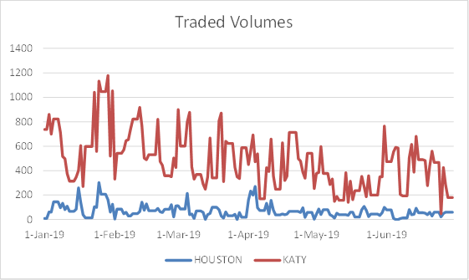

Source: Argus Media

Historically, the difference in prices between the two locations has been very small; detectable, but typically not meaningful. The ERCOT staff presentation to the Wholesale Market Working Group (WMWG) in April of this year contains various volume and price comparisons, and is available here: http://www.ercot.com/content/wcm/key_documents_lists/169148/Fuel_Index_Price_Data_Comparisons_v2.pptx

With the increased potential for manipulative actions or simply the decrease in representation due to smaller trading volumes, it is time for the ERCOT market to move its fuel price index to a more actively traded location.

