May 2019 ERCOT Monthly Operations Report
Reliability and Operations Subcommittee Meeting
June 11, 2019

Table of Contents
1. Report Highlights 2
2. Frequency Control 3
2.1. Frequency Events 3
2.2. Responsive Reserve Events 4
2.3. Load Resource Events 4
3. Reliability Unit Commitment 4
4. Wind Generation as a Percent of Load 6
5. Largest Net-Load Ramp 6
6. COP Error Analysis 7
7. Congestion Analysis 9
7.1. Notable Constraints 9
7.2. Generic Transmission Constraint Congestion 13
7.3. Manual Overrides 13
7.4. Congestion Costs for Calendar Year 2019 13
8. System Events 15
8.1. ERCOT Peak Load 15
8.2. Load Shed Events 15
8.3. Stability Events 15
8.4. Notable PMU Events 15
8.5. DC Tie Curtailment 15
8.6. TRE/DOE Reportable Events 16
8.7. New/Updated Constraint Management Plans 16
8.8. New/Modified/Removed RAS 16
8.9. New Procedures/Forms/Operating Bulletins 16
9. Emergency Conditions 16
9.1. OCNs 16
9.2. Advisories 16
9.3. Watches 17
9.4. Emergency Notices 17
10. Application Performance 17
10.1. TSAT/VSAT Performance Issues 17
10.2. Communication Issues 17
10.3. Market System Issues 17
11. Model Updates 17
Appendix A: Real-Time Constraints 20

Report Highlights
- The unofficial ERCOT peak for May was 60,817 MW.
- There were nine frequency events.
- There were seven instances where Responsive Reserves were deployed.
- There were 43 RUC commitments.
- Congestion in the West Load Zone (LZ) can be mostly attributed to outages and high Panhandle wind generation. Congestion in the South LZ was mostly due to outages and DC tie exports. Congestion in the North and Houston LZs were relatively minimal. There were 25 days on the Panhandle GTC and 3 days on the North Edinburg – Lobo GTC.
- There were three DC Tie curtailments.

Frequency Control

Frequency Events
The ERCOT Interconnection experienced nine frequency events in May, all of which resulted from a Resource trip. The average event duration was approximately 0:04:26.

A summary of the frequency events is provided below. The reported frequency events meet one of the following criteria: Delta Frequency is 60 mHz or greater; the MW loss is 350 MW or greater; resource trip event triggered RRS deployment. Frequency events that have been identified as Frequency Measurable Events (FME) for purposes of BAL-001-TRE-1 analysis are highlighted in blue. When analyzing frequency events, ERCOT evaluates PMU data according to industry standards. Events with an oscillating frequency of less than 1 Hz are considered to be inter-area, while higher frequencies indicate local events. Industry standards specify that damping ratio for inter-area oscillations should be 3.0% or greater. For the frequency events listed below, the ERCOT system met these standards and transitioned well after each disturbance.

Date and Time | Delta Frequency | Max/Min Frequency | Duration of Event | PMU Data |  |  | MW Loss | Load | Wind | Inertia
 | (Hz) | (Hz) |  | Oscillation Mode (Hz) |  | Damping Ratio |  | (MW) | % | (GW-s)
5/1/2019 10:17 | 0.103 | 59.904 | 0:05:12 | No PMU data available |  |  | 396.933 | 44,059 | 16% | 259,953
5/8/2019 12:15 | 0.079 | 59.910 | 0:07:22 | No PMU data available |  |  | 406 | 43,230 | 17% | 259,473
5/12/2019 8:57 | 0.109 | 59.902 | 0:03:19 | No PMU data available |  |  | 374.76 | 32,072 | 3% | 233,592
5/16/2019 21:42 | 0.110 | 59.910 | 0:04:51 | No PMU data available |  |  | 722.37 | 47,916 | 30% | 250,435
5/18/2019 15:24 | 0.148 | 59.871 | 0:02:57 | None | None |  | 728.84 | 45,588 | 27% | 244,967
5/23/2019 16:41 | 0.110 | 59.869 | 0:03:48 | None | None |  | 568.977 | 61,048 | 30% | 288,788
5/30/2019 2:56 | 0.111 | 59.855 | 0:04:23 | None | None |  | 596.9 | 36,106 | 22% | 242,769
5/31/2019 11:56 | 0.095 | 59.854 | 0:02:20 | None | None |  | 367.64 | 49,835 | 3% | 310,129
5/31/2019 21:06 | 0.165 | 59.813 | 0:05:41 | None | None |  | 848.837 | 50,284 | 13% | 292,026

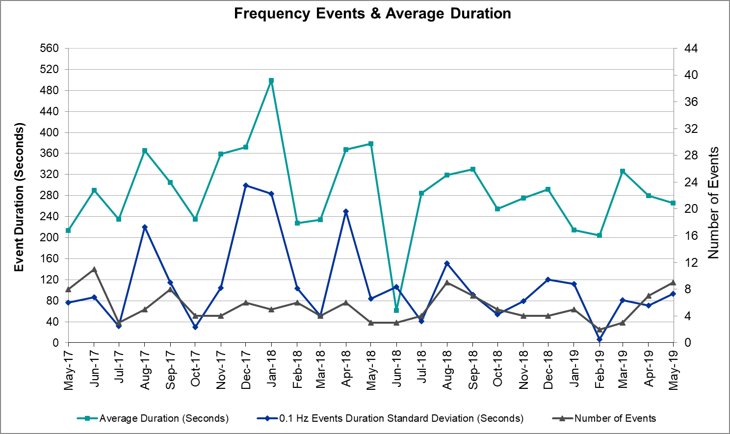
(Note: All data on this graph encompasses frequency event analysis based on BAL-001-TRE-1.)

Responsive Reserve Events

There were seven events where Responsive Reserve MWs were released to SCED in May. The events highlighted in blue were related to frequency events reported in Section 2.1 above.

Date and Time Released to SCED | Date and Time Recalled | Duration of Event | Maximum MWs Released | Comments
5/1/2019 10:17 | 5/1/2019 10:20 | 00:02:28 | 144
5/12/2019 8:57 | 5/12/2019 8:58 | 00:01:16 | 180
5/18/2019 15:25 | 5/18/2019 15:27 | 00:02:28 | 593
5/23/2019 16:41 | 5/23/2019 16:45 | 00:03:47 | 664
5/30/2019 2:56 | 5/30/2019 3:00 | 00:04:24 | 723
5/31/2019 11:56 | 5/31/2019 12:00 | 00:03:08 | 733
5/31/2019 21:06 | 5/31/2019 21:12 | 00:05:24 | 1138

Load Resource Events
None.

Reliability Unit Commitment

ERCOT reports on Reliability Unit Commitments (RUC) on a monthly basis. Commitments are reported grouped by operating day and weather zone. The total number of hours committed is the sum of the hours for all the units in the specified region. Additional information on RUC commitments can be found on the MIS secure site at Grid Generation Reliability Unit Commitment.

There were no DRUC commitments in May.

There were 43 HRUC commitments in May.

Resource Location | # of Resources | Operating Day | Total # of Hours Committed | Total MWhs | Reason for Commitment
North Central | 1 | 5/6/2019 | 7 | 3661 | Congestion
North Central | 1 | 5/7/2019 | 6 | 3370 | Congestion
Southern | 1 | 5/7/2019 | 3 | 111 | Congestion
Southern | 1 | 5/9/2019 | 1 | 89.2 | Congestion
Southern | 1 | 5/9/2019 | 1 | 90.2 | Congestion
Coast | 1 | 5/9/2019 | 1 | 752 | Congestion
Far West | 1 | 5/11/2019 | 2 | 142 | Congestion
Far West | 1 | 5/11/2019 | 2 | 141 | Congestion
Far West | 1 | 5/11/2019 | 2 | 138 | Congestion
Far West | 1 | 5/12/2019 | 7 | 493 | Congestion
Far West | 1 | 5/12/2019 | 1 | 71 | Congestion
Far West | 1 | 5/12/2019 | 1 | 71 | Congestion
Far West | 1 | 5/12/2019 | 2 | 132 | Congestion
Far West | 1 | 5/12/2019 | 5 | 332 | Congestion
Far West | 1 | 5/12/2019 | 2 | 136 | Congestion
Far West | 1 | 5/13/2019 | 7 | 484 | Congestion
Far West | 1 | 5/16/2019 | 1 | 69 | Congestion
Far West | 1 | 5/24/2019 | 1 | 68 | Congestion
Far West | 1 | 5/24/2019 | 1 | 68 | Congestion
Far West | 1 | 5/25/2019 | 1 | 68 | Congestion
Far West | 1 | 5/25/2019 | 1 | 67 | Congestion
Far West | 1 | 5/25/2019 | 1 | 68 | Congestion
Far West | 1 | 5/25/2019 | 1 | 67 | Congestion
Far West | 1 | 5/25/2019 | 1 | 68 | Congestion
Far West | 1 | 5/25/2019 | 1 | 67 | Congestion
Far West | 1 | 5/25/2019 | 1 | 66 | Congestion
Far West | 1 | 5/25/2019 | 1 | 66 | Congestion
Far West | 1 | 5/25/2019 | 1 | 66 | Congestion
Far West | 1 | 5/25/2019 | 1 | 66 | Congestion
Far West | 1 | 5/25/2019 | 1 | 66 | Congestion
Far West | 1 | 5/25/2019 | 1 | 66 | Congestion
Far West | 1 | 5/25/2019 | 1 | 66 | Congestion
Far West | 1 | 5/25/2019 | 1 | 66 | Congestion
Far West | 1 | 5/25/2019 | 1 | 66 | Congestion
Far West | 1 | 5/25/2019 | 1 | 66 | Congestion
Far West | 1 | 5/25/2019 | 1 | 68 | Congestion
Far West | 1 | 5/25/2019 | 1 | 67 | Congestion
Far West | 1 | 5/25/2019 | 1 | 68 | Congestion
Far West | 1 | 5/25/2019 | 1 | 67 | Congestion
Far West | 1 | 5/30/2019 | 1 | 68 | Congestion
Far West | 1 | 5/31/2019 | 1 | 66 | Congestion
Far West | 1 | 5/31/2019 | 1 | 65 | Congestion
Far West | 1 | 5/31/2019 | 1 | 65 | Congestion

Wind Generation as a Percent of Load
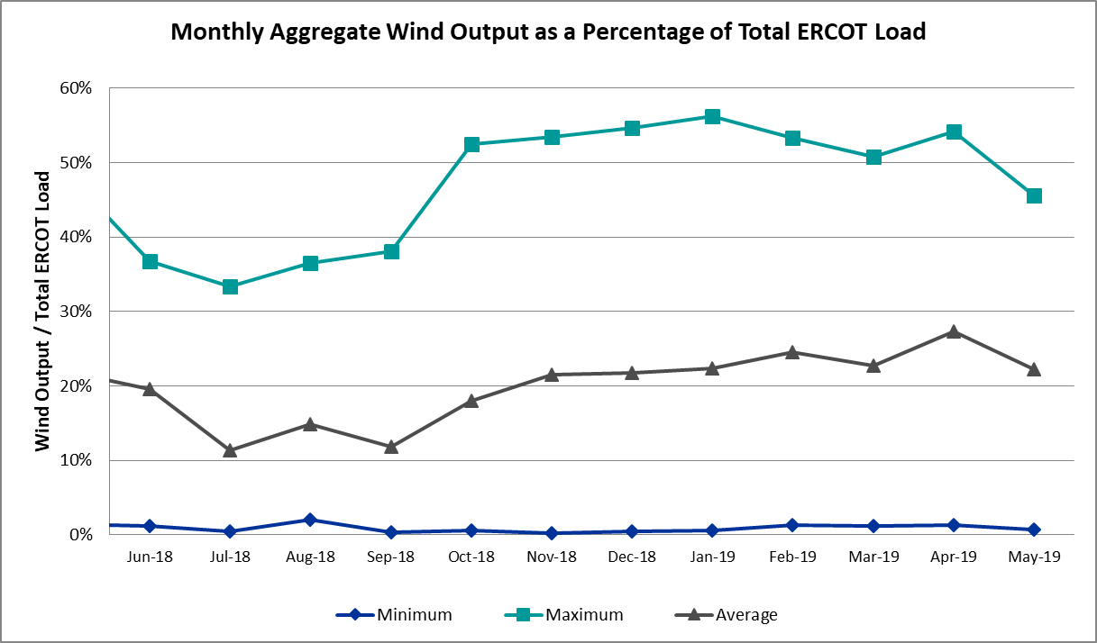

Wind Generation Record: 19,672 MW on 01/21/2019 at 19:19
Wind Penetration Record: 56.16% on 01/19/2019 03:10

Largest Net-Load Ramp
The net-load ramp is defined as the change in net-load (load minus wind and PVGR generation) during the defined time horizon. Such a variation in net-load needs to be accommodated in grid operations to ensure that the reliability of the grid is satisfactorily maintained. The largest net-load ramp during 5-min, 10-min, 15-min, 30-min and 60-min in May 2019 is 1,198 MW, 1,686 MW, 2,484 MW, 4,180 MW, and 5,123 MW, respectively. The comparison with respect to the historical values is given in the table below.

Month and Year | 5 min | 10 min | 15 min | 30 min | 60 min
May 2019 | 1198 MW | 1686 MW | 2484 MW | 4180 MW | 5123 MW
May 2014 | 914 MW | 1360 MW | 2264 MW | 3123 MW | 4331 MW
May 2015 | 1156 MW | 1770 MW | 2088 MW | 3235 MW | 5319 MW
May 2016 | 867 MW | 1331 MW | 1804 MW | 2945 MW | 4897 MW
May 2017 | 1109 MW | 1334 MW | 1883 MW | 3149 MW | 5348 MW
May 2018 | 1190 MW | 1335 MW | 1841 MW | 3372 MW | 6480 MW
2014-2018 | 1494 MW | 1991 MW | 2780 MW | 4109 MW | 7218 MW

COP Error Analysis
COP Error is calculated as the capacity difference between the COP HSL and real-time HSL of the unit. Mean Absolute Error (MAE) stayed high over 6,000 MW until Day-Ahead at 12:00, then dropped significantly to 2,061 MW by Day-Ahead at 14:00. In the following chart, Under-Scheduling Error indicates that COP had less generation capacity than real-time and Over-Scheduling Error indicates that COP had more generation capacity than real-time. Under-Scheduling persisted from beginning of Day-Ahead to end of the Operating Day. Snapshot on the Operating Day considers all Operating Hours, including past hours. However, COP error for the Operating Hour freezes after the Adjustment Period.

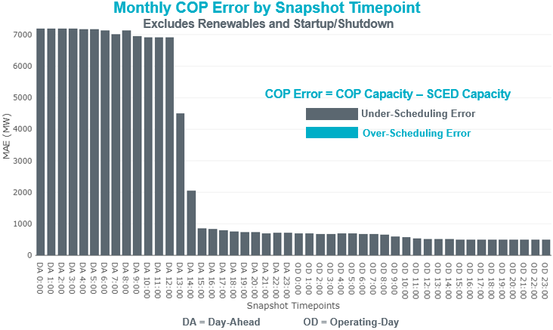

Monthly MAE for the Latest COP at the end of the Adjustment Period was 495 MW with median ranging from -456 MW for Hour-Ending (HE) 21 to -142 MW for HE 7. May 16th HE 7 had the largest Over-Scheduling Error (2,002 MW) and May 1st HE 1 had the largest Under-Scheduling Error (-2,735 MW).

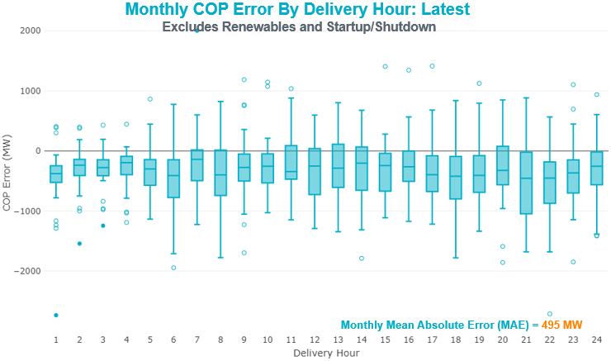

Monthly MAE for the Day-Ahead COP at 12:00 was 6,919 MW with median ranging from -10,500 MW for Hour-Ending (HE) 18 to -3,607 MW for HE 4. May 21st HE 7 had the largest Over-Scheduling Error (1,771 MW) and May 1st HE 8 had the largest Under-Scheduling Error (-15,922 MW).

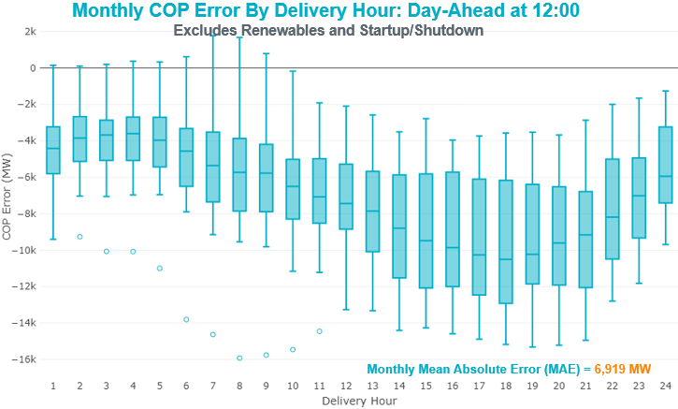

Congestion Analysis
The total number of congestion events experienced by the ERCOT system decreased in May. There were 28 instances over 28 days on the Generic Transmission Constraints (GTCs) in May.

Notable Constraints

Nodal protocol section 3.20 specifies that ERCOT shall identify transmission constraints that are active or binding three or more times within a calendar month. As part of this process, ERCOT reports congestion that meets this criterion to ROS. In addition ERCOT also highlights notable constraints that have an estimated congestion rent exceeding $1,000,000 for a calendar month. These constraints are detailed in the table below. Rows highlighted in blue indicate the congestion was affected by one or more outages. For a list of all constraints activated in SCED for this month, please see Appendix A at the end of this report.

Contingency Name | Overloaded Element | # of Days Constraint Active | Congestion Rent | Transmission Project
FRIEND RANCH TRX FMR1 138/69 | Sonora 138/69kV | 14 | $14,490,962.51 | Carver: Build new 138 kV station (5979)
Basecase | PNHNDL GTC | 25 | $13,379,847.35
Solstice to FORT STOCKTON PLANT LIN 1 | Barrilla - Fort Stockton Switch 69kV | 31 | $10,518,219.07 | Solstice: Build 345 kV station (5530) and Solstice to Bakersfield: Build 345 kV line (5539)  Pecos County Modification Project (7028, 44359)
CRLNW-LWSSW 345kV | Carrollton Northwest - Lakepointe Tnp 138kV | 5 | $4,688,897.02 | Northwest Carrollton - LakePointe TNP 138 kV Line (5548)
BOWMAN SWITCH TRX BOMSW_3_1 345/138 | Lake Wichita Switch - Bowman Switch 138kV | 3 | $4,611,937.71 | Wichita Falls South 345/138 kV autotransformer (4804)
NORTH PHARR to POLK AVENUE LIN 1 | Palmhurst Tap - Key Switch 138kV | 1 | $3,886,580.74 | North McAllen (8368) - West McAllen (8367) - South McAllen (8371) 138-kV line upgrades (2017-S9)/ South McAllen-Bentsen and North Edinburg-West Edinburg (5621)
NORTH PHARR to POLK AVENUE LIN 1 | North Mcallen - West Mcallen 138kV | 3 | $3,202,345.29 | North McAllen (8368) - West McAllen (8367) - South McAllen (8371) 138-kV line upgrades (2017-S9)/ South McAllen-Bentsen and North Edinburg-West Edinburg (5621)
NORTH EDINBURG TRX 1382 345/138 | North Edinburg 138/1kV | 6 | $3,012,599.79 | Stewart Road: Construct 345 kV cut-in (5604)
Fergus-Granmo&Wirtz-Starck 138kV | Flat Rock Lcra - Wirtz 138kV | 2 | $2,677,167.94 | Wirtz to FlatRock to Paleface Transmission Line Upgrade (4465)
Basecase | Odessa Ehv Switch 345/1kV | 1 | $2,511,269.06
PH ROBINSON to MEADOW LIN A | Mainland Tnp - Alvin Tnp 138kV | 17 | $2,477,410.00
DCRMOD28 Odesa-Mdssw&Odehv 138 kV | Big Three Odessa Tap - Odessa Ehv Switch 138kV | 3 | $2,378,710.58
LOLITA to FORMOSA LIN 1 | Victoria Dupont Switch - Victoria 138kV | 4 | $1,804,539.67
ODLAW SWITCHYARD to ASPHALT MINES LIN 1 | Hamilton Road - Maverick 138kV | 22 | $1,766,056.73 | Brackettville to Escondido: Construct 138 kV line (5206)
FRONTERA to KEY SWITCH LIN 1 | Hall Acres - South Mcallen 138kV | 1 | $1,719,570.81 | South McAllen-Bentsen and North Edinburg-West Edinburg (5621)
Lon_Hill-Coleto 345kV&Warburtn 138kV | Pettus - Normanna 69kV | 6 | $1,595,885.35
TWR(138) MRN-RUS84 & AZ-SL85 | Cardiff - Deer Park 138kV | 1 | $1,301,044.79
LON HILL to COLETO CREEK LIN 1 | Warburton Road Switching Station - Victoria 138kV | 4 | $1,192,338.21
LON HILL TRX LON_HILL_3_1 345/138 | Lon Hill 138/1kV | 3 | $1,191,951.44 | Lon Hill: Replace 345/138 kV autotransformers (6106)
SAN MIGUEL 345_138 KV SWITCHYARDS to LOBO LIN 1 | North Laredo Switch - Piloncillo 138kV | 13 | $1,161,852.60
Dermott to SCURRY CHEVRON and ENNIS CREEK SWITCH | Morgan Creek Ses - Sun Switch 138kV | 1 | $1,128,817.47
Riohondo-Nedin 345kV&Harlnsw 138kV | Burns Sub - Rio Hondo 138kV | 10 | $1,085,079.48
LAQUINTA to LOBO LIN 1 | Bruni Sub 138/69kV | 16 | $1,007,084.03 | Holland 69 kV Capacitors (5805)
Marbfa-Lakewy &Wirtz-Palefa 138kV | Flat Rock Lcra - Wirtz 138kV | 3 | $835,766.98 | Wirtz to FlatRock to Paleface Transmission Line Upgrade (4465)
CRLNW-LWSSW 345kV | Jones Street Tnp - Lakepointe Tnp 138kV | 5 | $816,900.38 | Lewisville - Lewisville Jones - Lakepointe 138 kV Line (45537)
Basecase | Burns Sub - Heidelburg Sub 138kV | 7 | $779,035.37
BLUFF CREEK TRX BLUF_CRK_3_1 345/138 | Tennyson - Nicole 138kV | 10 | $730,949.99
TWR (345) HLJ-WAP64 & BLY-WAP72 | Jones Creek - South Texas Project 345kV | 3 | $633,343.40
CAGNON to KENDALL LIN 1 | Cico - Comfort 138kV | 3 | $593,013.01 | Boerne Cico - Comfort - Kendall Transmission Line Upgrade (6982)
LON HILL TRX LON_HILL_3_1 345/138 | Lon Hill 345/1kV | 5 | $518,891.20 | Lon Hill: Replace 345/138 kV autotransformers (6106)
ZORN - HAYSEN 345KV | Kendall - Cagnon 345kV | 4 | $481,185.04 | Boerne Cico - Comfort - Kendall Transmission Line Upgrade (6982)
Pig Creek to Solstice LIN 1 | Woodward 2 - Rio Pecos 138kV | 21 | $430,929.15 | Lynx: Expand 138 kV station (45503)
CHB-KG & CBY-JOR 345kV | Texas - Cedar Bayou 138kV | 6 | $425,280.93
BLUFF CREEK to ABILENE SOUTH LIN 1 | Callahan Windfarm Fpl - Abilene Northwest 138kV | 8 | $325,245.52
RIO HONDO to LAS PULGAS LIN 1 | Raymondville 2 138/69kV | 11 | $320,053.23 | Harlingen SS- Raymondville #2: Convert to 138 kV (6167)
COLETO CREEK to PAWNEE SWITCHING STATION LIN 1 | Coleto Creek - Rosata Tap 138kV | 10 | $301,174.23 | Coleto Creek to Tuleta: New 138 kV Line (16TPIT0034)
Jewet-Sng 345kV | Btu_Jack_Creek - Twin Oak Switch 345kV | 3 | $291,690.18
Basecase | Burns Sub - Rio Hondo 138kV | 8 | $245,048.51
Esmeralda to WOLFBERRY LIN 1 | Barnhart - Big Lake 69kV | 3 | $241,921.38
MOORE SWITCHING STATION to DOWNIE SWITCHING STATION LIN 1 | Downie Switching Station 138/69kV | 8 | $155,697.05
FRIEND RANCH to SONORA LIN 1 | Sonora 138/69kV | 5 | $153,603.65 | Carver: Build new 138 kV station (5979)
YUKON SWITCH to Wink Sub LIN _A | No Trees Switch - Cheyenne Tap 138kV | 4 | $144,120.05
OAK CREEK AEP to FORT CHADBOURNE TAP LIN 1 | Steamboat - Climax Bradshaw 69kV | 4 | $128,450.90
HAMILTON ROAD to Maxwell LIN 1 | Sonora 138/69kV | 7 | $114,740.29 | Carver: Build new 138 kV station (5979)
BIG SPRING SWITCH to CHALK_69kV and McDonald Road_138kV | Lamesa - Jim Payne Poi 138kV | 5 | $92,578.96
Pig Creek to Solstice LIN 1 | Airport Tnp - 16th Street Tnp 138kV | 5 | $88,842.64 | Solstice: Build 345 kV station (5530) and Solstice to Bakersfield: Build 345 kV line (5539)
Bighil-Kendal 345kV | Hamilton Road - Maxwell 138kV | 4 | $86,810.81 | Brackettville to Escondido: Construct 138 kV line (5206)
Bighil-Kendal 345kV | Yellow Jacket - Fort Mason 138kV | 5 | $84,828.76 | Yellowjckt to Menard Phillips T 69 kV line: Rebld 69 kV line (6345)  Mason to Fort Mason: Rebuild 69 kV line (5794) - 138 kV conversion
Grses-Pkrsw 345kV | Barton Chapel Wind Farm - Oran Sub 138kV | 5 | $82,712.62
COLETO CREEK to VICTORIA LIN 1 | Coleto Creek - Victoria 138kV | 7 | $81,222.35 | Coleto Creek to Tuleta: New 138 kV Line (16TPIT0034)
Solstice to FORT STOCKTON PLANT LIN 1 | Fort Stockton Plant 138/69kV | 6 | $72,140.39
Fergus-Gilles & Horsba 138kV | Starcke - Wirtz 138kV | 13 | $66,844.31 | Wirtz to FlatRock to Paleface Transmission Line Upgrade (4465)
BLUFF CREEK TRX BLUF_CRK_3_2 345/138 | Bluff Creek 345/1kV | 6 | $63,489.50
Marbfa-Lakewy &Wirtz-Palefa 138kV | Bertram - Burnet 69kV | 4 | $59,476.85
COMANCHE SWITCH (Oncor) to COMANCHE PEAK SES LIN _A | Comanche Tap - Comanche Switch (Oncor) 138kV | 4 | $56,897.92
BRACKETTVILLE to HAMILTON ROAD LIN 1 | Hamilton Road - Maverick 138kV | 6 | $45,992.18 | Brackettville to Escondido: Construct 138 kV line (5206)
FRIEND RANCH to SONORA LIN 1 | Hamilton Road - Maxwell 138kV | 8 | $44,585.34 | Brackettville to Escondido: Construct 138 kV line (5206)
YUKON SWITCH to Wink Sub LIN _A | No Trees Switch - Cheyenne Tap 138kV | 3 | $37,210.42
SWESW-ABMB&LNCRK 345KV | Bluff Creek - Abilene Mulberry Creek 345kV | 3 | $33,787.72
BRACKETTVILLE to ODLAW SWITCHYARD LIN 1 | Hamilton Road - Maverick 138kV | 3 | $33,438.50 | Brackettville to Escondido: Construct 138 kV line (5206)
MOLINA to WORMSER ROAD LIN 1 | Laredo Vft North - Las Cruces 138kV | 3 | $23,303.54 | Laredo - Del Mar: 138 kV Line Rebuild (45511)
KLEBERG AEP to LOYOLA SUB LIN 1 | Loyola Sub 138/69kV | 3 | $19,463.30
Basecase | Randado Aep - Zapata 138kV | 7 | $17,581.24 | Zapata Reactor (44393)
HAMILTON ROAD TRX PS2 138/138 | Sonora 138/69kV | 5 | $15,152.80 | Carver: Build new 138 kV station (5979)
Bighil-Kendal 345kV | Rocksprings - Friess Ranch 69kV | 3 | $14,699.45
FORT LANCASTER to ILLINOIS #4 LIN 1 | Hamilton Road - Maxwell 138kV | 3 | $5,279.21 | Brackettville to Escondido: Construct 138 kV line (5206)
Basecase | RV_RH GTC | 3 | $1,464.47

Generic Transmission Constraint Congestion
There were 25 days on the Panhandle GTC and 3 days on the North Edinburg – Lobo GTC in May. There was no activity on the remaining GTCs during the month.

Note: This is how many times a constraint has been activated to avoid exceeding a GTC limit, it does not imply an exceedance of the GTC occurred or that the GTC was binding.

Manual Overrides
None.

Congestion Costs for Calendar Year 2019
The following table represents the top twenty active constraints for the calendar year based on the estimated congestion rent attributed to the congestion. ERCOT updates this list on a monthly basis.

Contingency | Binding Element | # of 5-min SCED Intervals | Estimated Congestion Rent | Transmission Project
Elmcreek-Skyline 345kV | Hill Country - Marion 345kV | 961 | 26,958,430.36 | Zorn to Marion 2nd 345-kV Transmission Line Addition (4473)
Basecase | PNHNDL GTC | 14,659 | 24,967,377.14
CRLNW-LWSSW 345kV | Ti Tnp - West Tnp 138kV | 2,496 | 18,908,859.77
FRIEND RANCH TRX FMR1 138/69 | Sonora 138/69kV | 3,290 | 15,395,656.61 | Carver: Build new 138 kV station (5979)
Manual LOTEBUSH toYUCSW 138 kV | 16th Street Tnp - Woodward 2 138kV | 4,906 | 14,675,595.13 | Solstice: Build 345 kV station (5530) and Solstice to Bakersfield: Build 345 kV line (5539)
Solstice to FORT STOCKTON PLANT LIN 1 | Barrilla - Fort Stockton Switch 69kV | 8,864 | 13,576,412.32 | Solstice: Build 345 kV station (5530) and Solstice to Bakersfield: Build 345 kV line (5539)  Pecos County Modification Project (7028, 44359)
Hcksw-Sagna-138kv | Eagle Mountain Ses - Eagle Mountain Compressor 138kV | 650 | 9,797,393.10 | Eagle Mountain-Calmont 138 kV Line (4253)
DMTSW-SCOSW 345KV | Knapp - Scurry Chevron 138kV | 3,203 | 9,750,942.24 | Ennis Creek - Cogdell 69 kV Line (4554) & Ennis Creek 138 kV Switching Station (6269)
CAGNON to KENDALL LIN 1 | Cico - Comfort 138kV | 3,052 | 9,726,100.36 | Boerne Cico - Comfort - Kendall Transmission Line Upgrade (6982)
Solstice to LINTERNA LIN 1 | Barrilla - Fort Stockton Switch 69kV | 14,077 | 9,251,017.29 | Solstice: Build 345 kV station (5530) and Solstice to Bakersfield: Build 345 kV line (5539)  Pecos County Modification Project (7028, 44359)
CRLNW-LWSSW 345kV | Carrollton Northwest - Lakepointe Tnp 138kV | 1,344 | 9,028,752.71 | Northwest Carrollton - LakePointe TNP 138 kV Line (5548)
SAN MIGUEL 345_138 KV SWITCHYARDS to LOBO LIN 1 | North Laredo Switch - Piloncillo 138kV | 5,544 | 8,931,307.06
CRLNW-LWSSW 345kV | Jones Street Tnp - Lakepointe Tnp 138kV | 1,381 | 8,781,001.19 | Lewisville - Lewisville Jones - Lakepointe 138 kV Line (45537)
TWR (345) HLJ-WAP64 & BLY-WAP72 | Jones Creek - South Texas Project 345kV | 2,607 | 8,444,547.36
CPSES-JONSW&EVRSW 345kV | Hood - Decordova Dam 138kV | 172 | 7,948,529.13
WHITEPOINT TRX 345A 345/138 | Lon Hill 345/1kV | 847 | 7,109,227.27 | Lon Hill: Replace 345/138 kV autotransformers (6106)
DCRMOD28 Odesa-Mdssw&Odehv 138 kV | Big Three Odessa Tap - Odessa Ehv Switch 138kV | 765 | 6,873,912.15
WHITEPOINT TRX 345A 345/138 | Lon Hill 345/1kV | 744 | 6,251,701.79 | Lon Hill: Replace 345/138 kV autotransformers (6106)
ODLAW SWITCHYARD to ASPHALT MINES LIN 1 | Hamilton Road - Maverick 138kV | 8,537 | 6,118,524.74 | Brackettville to Escondido: Construct 138 kV line (5206)
Fergus-Granmo&Wirtz-Starck 138kV | Flat Rock Lcra - Wirtz 138kV | 11,723 | 6,055,041.81 | Wirtz to FlatRock to Paleface Transmission Line Upgrade (4465)

System Events

ERCOT Peak Load
The unofficial ERCOT peak load for the month was 60,817 MW and occurred on May 23rd, during hour ending 17:00.

Load Shed Events
None.

Stability Events
None.

Notable PMU Events
ERCOT analyzes PMU data for any significant system disturbances that do not fall into the Frequency Events category reported in section 2.1. The results are summarized in this section once the analysis has been completed.

There were no PMU events outside of those reported in section 2.1 this month

DC Tie Curtailment
Date | DC Tie | Curtailing Period | # of Tags Curtailed | Initiating Event | Curtailment Reason
05/06/2019 | DC-S | HE04-14 | 4 | DC tie trip | Planned or unplanned outage
05/07/2019 | DC-R | HE13-15 | 1 | SPOLPHA8, loss of Polk Ave - North Pharr 138 kV overloads North McAllen - West McAllen 138 kV.. | Local Congestion
05/14/2019 | DC-L | HE23-24 | 1 | DC-L Tie de-rated from 100MW to 90MW | DC-L Tie de-rated from 100MW to 90MW

TRE/DOE Reportable Events
- CenterPoint submitted an OE-417 for May 09, 2019 Reportable Event Type: Loss of electric service to more than 50,000 customers for 1 hour or more.
- CenterPoint submitted an OE-417 for May 09, 2019 Reportable Event Type: Loss of 3 or more BES Elements

New/Updated Constraint Management Plans
None.

New/Modified/Removed RAS
None.

New Procedures/Forms/Operating Bulletins
Procedure Title | POB
Scripts Desk | 890, 895, 899
Shift Supervisor Desk | 891, 896, 900
Transmission and Security Desk | 892, 901
DC Tie Desk | 893, 897
Reliability Unit Commitments Desk | 894, 898

Emergency Conditions

OCNs
Date and Time | Description
05/02/2019 09:17:57 | An OCN has been issued due to ERCOT modifying a Generic Transmission Constraint due to dynamic voltage stability issues that become more limiting than steady state voltage issues, under Transmission Outage conditions for the Panhandle Generic Transmission Constraint (GTC).

Advisories
Date and Time | Description
05/05/2019 13:25:38 | ERCOT has postponed the deadline for the posting of the DAM solution for Operating Day May 6th, 2019 due to an internal issue, which is under investigation.
05/14/2019 04:21:09 | Advisory issued for a geomagnetic disturbance of K-7 until May 14, 2019 1200 UTC.
05/14/2019 13:25:50 | ERCOT has postponed the deadline for posting of the DAM Solution for Operating Day May 15th, 2019 due to an internal issue, which is being resolved. The delay is anticipated for 15 minutes.

Watches
Date and Time | Description
05/05/2019 17:04:58 | ERCOT is issuing a Watch due to DRUC not completing by 1800 due to delay of the Day Ahead Market.

Emergency Notices
None.

Application Performance

TSAT/VSAT Performance Issues
None.

Communication Issues
None.

Market System Issues
None.

Model Updates
The Downstream Production Change (DPC) process allows ERCOT to make changes in the on-line Network Operations Model without loading a completely new model. The purpose of this process is to allow for reliable grid operations as system conditions change between designated Network Operations Model database loads. The DPC process is limited in scope to just those items listed below, with equipment ratings updates being the most common. ERCOT has seen a rise in the use of the DPC process to make on-line updates to the Network Operations Model in recent years, instead of through the standard Network Operations Model Change Request process.

- Static Line ratings (Interim Update)
- Dynamic Line ratings (non-Interim Update)
- Autotransformer ratings (non-Interim Update)
- Breaker and Switch Normal status (Interim Update)
- Contingency Definitions (Interim Update)
- RAP and RAS changes or additions (Interim Update)
- Net Dependable and Reactive Capability (NDCRC) values (Interim Update)
- Impedance Updates (non-Interim)

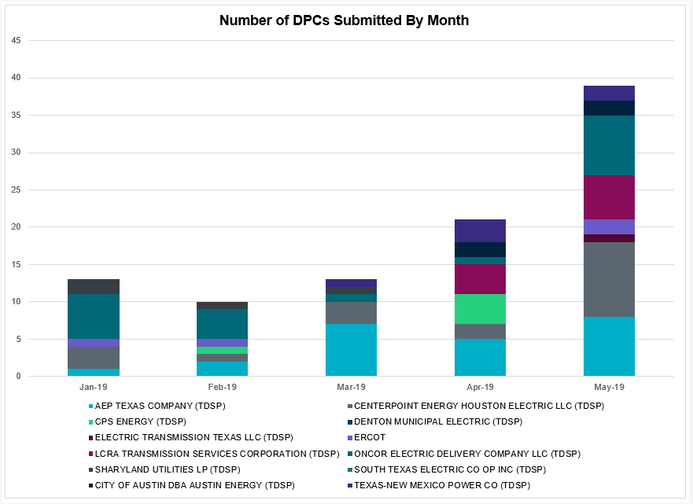

Transmission Operator | Number of DPCs in May
AEP TEXAS COMPANY (TDSP) | 5
BRAZOS ELECTRIC POWER CO OP INC (TDSP) | 0
CENTERPOINT ENERGY HOUSTON ELECTRIC LLC (TDSP) | 2
 | 2
CPS ENERGY (TDSP) | 4
DENTON MUNICIPAL ELECTRIC (TDSP) | 0
ELECTRIC TRANSMISSION TEXAS LLC (TDSP) | 0
ERCOT | 0
LCRA TRANSMISSION SERVICES CORPORATION (TDSP) | 4
ONCOR ELECTRIC DELIVERY COMPANY LLC (TDSP) | 1
SHARYLAND UTILITIES LP (TDSP) | 0
SOUTH TEXAS ELECTRIC CO OP INC (TDSP) | 0
TEXAS MUNICIPAL POWER AGENCY (TDSP) | 0
TEXAS-NEW MEXICO POWER CO (TDSP) | 3

Appendix A: Real-Time Constraints
The following is a complete list of constraints activated in SCED for the month of May. Full contingency descriptions can be found in the Standard Contingencies List located on the MIS secure site at Grid Generation Reliability Unit Commitment.

Contingency | Constrained Element | From Station | To Station | # of Days Constraint Active
SSOLFTS8 | BARL_FTSW1_1 | FTSW | BARL | 31
BASE CASE | PNHNDL | n/a | n/a | 25
SBRAUVA8 | HAMILT_MAVERI1_1 | HAMILTON | MAVERICK | 22
SPIGSOL8 | RIOPEC_WOODW21_1 | RIOPECOS | WOODWRD2 | 21
SPIGSOL8 | RIOPEC_WOODW21_1 | WOODWRD2 | RIOPECOS | 21
SMDOPHR5 | 138_ALV_MNL_1 | ALVIN | MAINLAND | 17
SLAQLOB8 | BRUNI_69_1 | BRUNI | BRUNI | 16
XFRI89 | SONR_69-1 | SONR | SONR | 14
SLOBSA25 | NLARSW_PILONC1_1 | PILONCIL | NLARSW | 13
DFERHOR8 | 654T654_1 | WIRTZ | STARCK | 13
SLOBSA25 | NLARSW_PILONC1_1 | NLARSW | PILONCIL | 13
SRAYRI28 | RAYMND2_69A1 | RAYMND2 | RAYMND2 | 11
SCOLPAW5 | COLETO_ROSATA1_1 | COLETO | ROSATA | 10
XBL2U58 | NICOLE_TENNYS1_1 | NICOLE | TENNYSON | 10
DRIOHAR5 | BURNS_RIOHONDO_1 | RIOHONDO | MV_BURNS | 10
SSONFRI8 | HAMILT_MAXWEL1_1 | MAXWELL | HAMILTON | 8
BASE CASE | BURNS_RIOHONDO_1 | RIOHONDO | MV_BURNS | 8
SABSBLU8 | ABNTHW_CALLAH1_1 | CALLAHAN | ABNTHWST | 8
SDOWMOO8 | DOWNIES_AX1H | DOWNIES | DOWNIES | 8
SSONFRI8 | HAMILT_MAXWEL1_1 | HAMILTON | MAXWELL | 8
BASE CASE | BURNS_HEIDLBRG_1 | MV_BURNS | MV_HBRG4 | 7
SHAMMAX8 | SONR_69-1 | SONR | SONR | 7
BASE CASE | RANDAD_ZAPATA1_1 | RANDADO | ZAPATA | 7
SVICCO28 | COLETO_VICTOR2_1 | COLETO | VICTORIA | 7
SCTHHA38 | HAMILT_MAXWEL1_1 | MAXWELL | HAMILTON | 6
SSOLFTS8 | FTST_69T1 | FTST | FTST | 6
XBLU58 | BLUF_CRK_T2_H | BLUF_CRK | BLUF_CRK | 6
DLONWAR5 | NORMAN_PETTUS1_1 | PETTUS | NORMANNA | 6
DCHBJOR5 | CD_TX_87_A | CD | TX | 6
SBRAHAM8 | HAMILT_MAVERI1_1 | HAMILTON | MAVERICK | 6
XNED258 | NEDIN_138L | NEDIN | NEDIN | 6
XLON58 | LON_HILL_382H | LON_HILL | LON_HILL | 5
SPIGSOL8 | TNAF_TNFS_1 | TNAF | 16TH_ST | 5
DCRLLSW5 | 591__A | LKPNT | CRLNW | 5
DCRLLSW5 | 590__B | LWVJS | LKPNT | 5
DBIGKEN5 | FORTMA_YELWJC1_1 | YELWJCKT | FORTMA | 5
DFLCMGS5 | 6095__D | LMESA | JPPOI | 5
XHAM88 | SONR_69-1 | SONR | SONR | 5
SSONFRI8 | SONR_69-1 | SONR | SONR | 5
DGRSPKR5 | 6377__A | BRTSW | ORANS | 5
SPIGSOL8 | TNAF_TNFS_1 | 16TH_ST | TNAF | 5
SYK2WIN8 | 6101__A | NOTSW | CHEYT | 4
DBIGKEN5 | HAMILT_MAXWEL1_1 | MAXWELL | HAMILTON | 4
DMARPA_8 | 32T311_1 | BURNET | BERTRA | 4
DZORHAY5 | 459T459_1 | KENDAL | CAGNON | 4
SCOLLON5 | VICTO_WARBU_1A_1 | VICTORIA | WARBURTN | 4
SCMNCPS5 | 651__B | CMNSW | CMNTP | 4
SBRAUVA8 | ESCOND_GANSO1_1 | GANSO | ESCONDID | 4
SFT_BAL8 | CLIM_STMBOA1_1 | CLIM | STMBOAT | 4
SLOLFOR8 | VICTOR_V_DUPS1_1 | VICTORIA | V_DUPSW | 4
SECNMO28 | 6100__G | ACSSW | AMTBT | 4
SPOLPHA8 | GCB_100_1 | N_MCALLN | W_MCALLN | 3
SSIEMOL8 | LARDVN_LASCRU1_1 | LARDVNTH | LASCRUCE | 3
SCAGKEN5 | 74T148_1 | COMFOR | CICO | 3
SODLBRA8 | HAMILT_MAVERI1_1 | HAMILTON | MAVERICK | 3
DJEWSNG5 | JK_TOKSW_1 | TOKSW | JK_CK | 3
SKLELOY8 | LOYOLA_69_1 | LOYOLA | LOYOLA | 3
BASE CASE | RV_RH | n/a | n/a | 3
DMARPA_8 | 38T365_1 | WIRTZ | FLATRO | 3
DCRMO228 | 6500__B | ODEHV | BTHOT | 3
DSWELNC5 | BLUF_C_MULBER1_1 | BLUF_CRK | MULBERRY | 3
DBIGKEN5 | FRIR_ROCKSP1_1 | FRIR | ROCKSPRS | 3
XLON58 | LON_HILL_382L | LON_HILL | LON_HILL | 3
SESMFRI8 | BARNHR_BIGLAK1_1 | BIGLAKE | BARNHRT | 3
SILLFTL8 | HAMILT_MAXWEL1_1 | MAXWELL | HAMILTON | 3
SYKNWIN8 | 6101__A | NOTSW | CHEYT | 3
DWAPHLJ5 | JCKSTP18_A | STP | JCK | 3
DHECWHI8 | RINCON_WHITE_2_1 | WHITE_PT | RINCON | 3
XBOM58 | 6160__A | BOMSW | LKWSW | 3
SAVMBSP8 | 6095__D | LMESA | JPPOI | 2
SFORYEL8 | FRPHIL_MASN1_1 | MASN | FRPHILLT | 2
SDOWMOO8 | UVLD_DOWI_1 | DOWNIES | UVLDES | 2
DFERSTA8 | 32T311_1 | BURNET | BERTRA | 2
DLONWAR5 | VICTOR_V_DUPS1_1 | VICTORIA | V_DUPSW | 2
DPHRAL58 | 138_FWP_MNL_1 | MAINLAND | FRWYPARK | 2
DAUSDUN8 | CKT_972_1 | HWRDLN | MCNEIL | 2
SALIKIN8 | FALFUR_PREMON1_1 | FALFUR | PREMONT | 2
SDOWUVA8 | DOWNIES_AX1H | DOWNIES | DOWNIES | 2
BASE CASE | HHGTOM_1 | HHGT | OMEGA | 2
DCAGBRA5 | N5_P4_2_1 | CALAVERS | SKYLINE | 2
DCRLLSW5 | 590__A | LWSSW | LWVJS | 2
DENWSTE8 | 941__C | ENWSW | ENSSO | 2
DWH_STP5 | BLESSI_LOLITA1_1 | BLESSING | LOLITA | 2
DRIOHAR5 | HAINE__LA_PAL1_1 | LA_PALMA | HAINE_DR | 2
XLO2N58 | LON_HILL_381H | LON_HILL | LON_HILL | 2
SVANRAY8 | RAYBURN_69_2 | RAYBURN | RAYBURN | 2
SSCUSU28 | ROTN_WOLFGA1_1 | WOLFGANG | ROTN | 2
SCISPUT8 | SOUTHA_VINSON1_1 | SOUTHABI | VINSON | 2
DWAPHLJ5 | STPWAP39_1 | STP | WAP | 2
DFERSTA8 | 38T365_1 | WIRTZ | FLATRO | 2
SBOSELM5 | 1030__B | BOSQUESW | RGH | 2
SCLNWLC8 | 562__B | MEMWT | VANAL | 2
DFERHOR8 | 83T196_1 | STARCK | PALEFA | 2
SLOBSA25 | ASHERT_CATARI1_1 | ASHERTON | CATARINA | 2
SCITNUE8 | MORRIS_NUECES1_1 | NUECES_B | MORRIS | 2
SBTPBNT8 | MYRA_VAL_1 | MYRA | VALYVIEW | 2
XBL2U58 | ORNT_TENNYS1_1 | TENNYSON | ORNT | 2
SCISPUT8 | ESTES_PECAN_1_1 | PECAN_BY | ESTES | 2
DCHBJOR5 | LANMB_86_A | MB | LAN | 1
SLOBSA25 | LARDVN_LASCRU1_1 | LARDVNTH | LASCRUCE | 1
SCOLPAW5 | MAGRUD_VICTOR2_1 | VICTORIA | MAGRUDER | 1
DMCEBUT8 | MKLT_TRNT1_1 | TRNT | MKLT | 1
DWH_STP5 | NORMAN_PETTUS1_1 | PETTUS | NORMANNA | 1
DB_DAIR8 | NVLBASE_NBA1 | NVLBASE | NVLBASE | 1
SHPDT9 | THW_AT2H | THW | THW | 1
DWIRSTA8 | 497T497_1 | MARBFA | LAKEWY | 1
DGRSLNC5 | 6380__D | PAINTCRE | MURRAY | 1
DZORHAY5 | 74T148_1 | COMFOR | CICO | 1
DLONWAR5 | BEEVIL_NORMAN1_1 | NORMANNA | BEEVILLE | 1
DELMSAN5 | BLESSI_LOLITA1_1 | BLESSING | LOLITA | 1
DBIGKEN5 | BONDRO_SONR1_1 | SONR | BONDROAD | 1
DEAB_WR8 | EL_CAM_LANCTY1_1 | LANCTYPM | EL_CAMPO | 1
DCE_GA58 | GARZA_69A1 | GARZA | GARZA | 1
SCOMHA38 | HAMILT_MAXWEL1_1 | MAXWELL | HAMILTON | 1
DFLAPLU8 | MAGRUD_VICTOR2_1 | VICTORIA | MAGRUDER | 1
SCOLLON5 | NORMAN_PETTUS1_1 | PETTUS | NORMANNA | 1
BASE CASE | ODEHV_MR2H | ODEHV | ODEHV | 1
DFERHOR8 | 26T109_1 | CORONA | GRAPMI | 1
DPDSWTR8 | 3750__A | MSLSW | MSHLN | 1
SGILFER8 | 49T191_1 | FERGUS | HORSBA | 1
SMCEESK8 | 6780__A | ESKSW | LONGWRTH | 1
BASE CASE | ALPINE_BRONCO1_1 | BRONCO | ALPINE | 1
SWCSBOO8 | ALPINE_BRONCO1_1 | BRONCO | ALPINE | 1
DSTEXP12 | BLESSI_LOLITA1_1 | LOLITA | BLESSING | 1
SBLUCBF5 | BLUF_CRK_T2_H | BLUF_CRK | BLUF_CRK | 1
XBLU58 | BLUF_CRK_T2_L | BLUF_CRK | BLUF_CRK | 1
DLONWAR5 | FANNIN_GOLIAD1_1 | FANNINS | GOLIAD | 1
XVIC89 | GREENL_WEAVER1_1 | GREENLK | WEAVERRD | 1
DLONWAR5 | NCARBI_SEADRF1_1 | NCARBIDE | SEADRFTC | 1
DFLCMGS5 | 6095__G | JPPOI | ALKLK | 1
DFERGRM8 | 654T654_1 | WIRTZ | STARCK | 1
SLAKMA28 | 654T654_1 | WIRTZ | STARCK | 1
DSTPWHI5 | BLESSI_LOLITA1_1 | BLESSING | LOLITA | 1
SNEDRIO5 | BURNS_RIOHONDO_1 | RIOHONDO | MV_BURNS | 1
BASE CASE | DOW69_1 | DOWGEN | DOWGEN | 1
SWRDYN8 | EL_CAM_LANCTY1_1 | LANCTYPM | EL_CAMPO | 1
DELMSAN5 | PAWNEE_SPRUCE_1 | PAWNEE | CALAVERS | 1
SALMBA28 | TNAF_FTS_1 | FTST | TNAF | 1
SALMBA28 | TNAF_FTS_1 | TNAF | FTST | 1
DMARPA_8 | 43T365_1 | FLATRO | PALEPE | 1
BASE CASE | 562__B | MEMWT | VANAL | 1
DMRN_SL8 | CA_DE_96_A | DE | CA | 1
SNORODE5 | CONCHO_SAMATH1_1 | CONCHO | SAMATHIS | 1
SBRAHAM8 | ESCOND_GANSO1_1 | GANSO | ESCONDID | 1
SRAYRI28 | LOYOLA_69_1 | LOYOLA | LOYOLA | 1
SMCEESK8 | MKLT_TRNT1_1 | TRNT | MKLT | 1
SHPDT9 | THW_AT2 | THW | THW | 1
DVICEDN8 | VICTOR_V_DUPS1_1 | VICTORIA | V_DUPSW | 1
SCOLLON5 | VICTOR_V_DUPS1_1 | VICTORIA | V_DUPSW | 1
SFLCMDL5 | 6095__D | LMESA | JPPOI | 1
DSCOFAR5 | 6437__F | SCRCV | KNAPP | 1
SCRDLOF9 | BOW_FMR1 | BOW | BOW | 1
SMDOOAS5 | CD_TX_87_A | CD | TX | 1
SPALFRO8 | HALL_A_S_MCAL1_1 | HALL_ACR | S_MCALLN | 1
DTWIDIV5 | NICOLE_TENNYS1_1 | NICOLE | TENNYSON | 1
XVIC89 | VICTOR_V_DUPS1_1 | VICTORIA | V_DUPSW | 1
DPDSWTR8 | 3070__D | NNETT | NNTWK | 1
DFERHOR8 | 46T193_1 | FERGUS | SANDCR | 1
SECNMO28 | 6100__F | DHIDE | NOTSW | 1
SPIGSOL8 | 6345__B | GNTSW | SPRTP | 1
XMDS58 | 6475__C | ODEHV | TROTP | 1
SZEPCMN8 | 670__C | CMPBW | BRNSO | 1
SNORODE5 | ALPINE_BRONCO1_1 | BRONCO | ALPINE | 1
SLKAWFS8 | BOW_FMR1 | BOW | BOW | 1
BASE CASE | HAMILT_MAXWEL1_1 | MAXWELL | HAMILTON | 1
SMCEABS8 | MKLT_TRNT1_1 | TRNT | MKLT | 1
XNED258 | NEDIN_138H | NEDIN | NEDIN | 1
SPIGSOL8 | RIOPEC_WDWRDT1_1 | WDWRDTP | RIOPECOS | 1
SDOWUVA8 | UVLD_DOWI_1 | DOWNIES | UVLDES | 1
SDOWMOO8 | UVL_UVAL_1 | UVLDES | UVALDSW | 1
DWIRSTA8 | 342T195_1 | GRANMO | MARBFA | 1
DPDSWTR8 | 3440__B | SLOTM | NNTWK | 1
DMGSQAL5 | 6095__D | LMESA | JPPOI | 1
DDMTGLD8 | 6474__A | MGSES | SUNSW | 1
XSBY89 | 6620__A | STASW | MRCAP | 1
DENWSTE8 | 941__B | ENNIS | ENSSW | 1
SCOLLON5 | BEEVIL_NORMAN1_1 | NORMANNA | BEEVILLE | 1
SBEVASH8 | BIG_BRUN_1 | BIGWELS | BRUNDGS | 1
DCHBJOR5 | BT_CBY88_A | CBY | BT | 1
SCOLLON5 | FANNIN_GOLIAD1_1 | FANNINS | GOLIAD | 1
DHOCGV89 | HOCHOC90_1 | HOC | HOC | 1
BASE CASE | LGD_SANTIA1_1 | LGD | SANTIAGO | 1
XLO2N58 | LON_HILL_381L | LON_HILL | LON_HILL | 1
DELMSAN5 | NORMAN_PETTUS1_1 | PETTUS | NORMANNA | 1
SMVRLA_8 | PHARR_POLK_A1_1 | PHARR | POLK_AVE | 1
SCOLLON5 | RAY_ALOE_1 | RAYBURN | ALOES | 1
SALMBA28 | TNAF_TNFS_1 | TNAF | 16TH_ST | 1
UFO2FOR1 | VICTOR_V_DUPS1_1 | VICTORIA | V_DUPSW | 1
DCAGCO58 | 122T122_1 | COMFOR | RAYBAR | 1
SPIGSOL8 | COCS_FTST1_1 | COCS | FTST | 1
XVIC89 | GREENL_WEAVER1_1 | WEAVERRD | GREENLK | 1
DGARBRA8 | HOCHOC25_1 | HOC | HOC | 1
SPOLPHA8 | KEY_SW_PALMHR1_1 | KEY_SW | PALMHRTP | 1

The Duration of Event is defined as the time it takes for the frequency to recover to pre-disturbance frequency or 60 Hz as applicable.
PMU reports are typically generated when frequency drops below 59.9, but PMU data is available for other events.
Delta Frequency is defined as the difference between the starting point of the frequency event (t(0) or “A-point”) and minimum/maximum frequency (“C-Point”).
Currently, the Critical Inertia Level for ERCOT is approximately 100,000 MW-s (Source: link)
This is the hourly integrated peak demand as published in the ERCOT D&E report.
All DC Tie Curtailments are posted publically on the ERCOT Market Information System. See that posting for additional details for the event(s) in question.
See DC Tie Operating Procedure (http://www.ercot.com/mktrules/guides/procedures) for more details.

